SOCS Comparison Posttest: Order Fulfillment Times at Two Distribution Centers
Show all your work. Indicate clearly the methods you use, because you will be graded on the correctness of your methods as well as on the accuracy of your results and explanation.
An online retailer ships customer orders from two distribution centers. For each day, the company calculates the average order fulfillment time, defined as the number of hours from order placement to shipment. The histograms show the daily average fulfillment times for 48 randomly selected days at the Taichung center and 44 randomly selected days at the Kaohsiung center in 2026.
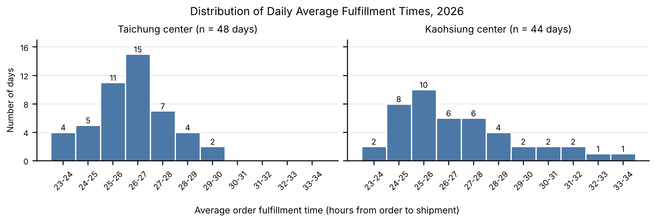
Center | n | Mean | SD | Min | Q1 | Median | Q3 | Max
Taichung | 48 | 26.19 | 1.49 | 23.0 | 25.2 | 26.2 | 27.0 | 29.4
Kaohsiung | 44 | 26.89 | 2.48 | 23.4 | 25.0 | 26.2 | 28.0 | 33.6
Summary statistics are calculated from the raw data, in hours. Extreme values: Taichung — two smallest 23.0, 23.3; two largest 29.1, 29.4. Kaohsiung — two smallest 23.4, 23.8; three largest 31.9, 32.8, 33.6.
Task (20 points): Compare the distributions of daily average order fulfillment times at the Taichung and Kaohsiung distribution centers. Address shape, outliers, center, and spread, justify your answers with appropriate calculations, and interpret your results in context.

