Chris Banci

Dr. Hadaegh

CS443

3/8/17

Assignment #1

**Question #1**

**1A) Write the tables**

Receipt (ReceiptNum, SalesDate)

Product (ProductID, ProductDescription)

Item (ItemNum, ItemDescription)

Sold (ProductID*, ReceiptNum*, QuantitySold)

Used (ProductID*, ItemNum*, QuantityUsed)

**1B) Place the table in 3rd normal form (if necessary)**

The initial table contains transitive dependencies

* It can be split into 5 tables: Receipt, Product, Item, Sold and Used.

The tables are now in third normal form because they do not contain any transitive or derived dependencies.

**1C) Create ERD based on the normalized tables.**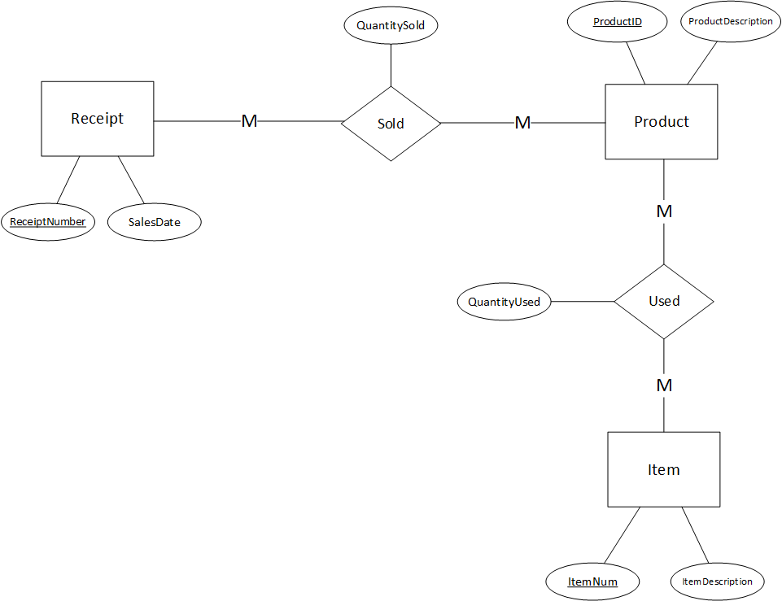

**1D) Write a script to create database (saved in q1_sql.txt)**

CREATE TABLE Item (

ItemNum NUMBER,

ItemDescription VARCHAR2(200),

CONSTRAINT Item_PK PRIMARY KEY(ItemNum)

);

CREATE TABLE Product (

ProductID NUMBER,

ProductDescription VARCHAR2(200),

CONSTRAINT Product_PK PRIMARY KEY(ProductID)

);

CREATE TABLE Receipt (

ReceiptNumber NUMBER,

SalesDate DATE,

CONSTRAINT Receipt_PK PRIMARY KEY(ReceiptNumber)

);

CREATE TABLE Used (

ProductID NUMBER,

ItemNum NUMBER,

QuantityUsed NUMBER,

CONSTRAINT Used_PK PRIMARY KEY(ProductID, ItemNum),

CONSTRAINT Used_FK1 FOREIGN KEY(ProductID) REFERENCES Product(ProductID),

CONSTRAINT Used_FK2 FOREIGN KEY(ItemNum) REFERENCES Item(ItemNum),

CONSTRAINT QuantityUsed_CK CHECK(QuantityUsed >= 0)

);

CREATE TABLE Sold (

ProductID NUMBER,

ReceiptNumber NUMBER,

QuantitySold NUMBER,

CONSTRAINT Sold_PK PRIMARY KEY(ProductID, ReceiptNumber),

CONSTRAINT Sold_FK1 FOREIGN KEY(ProductID) REFERENCES Product(ProductID),

CONSTRAINT Sold_FK2 FOREIGN KEY(ReceiptNumber) REFERENCES Receipt(ReceiptNumber),

CONSTRAINT QuantitySold_CK CHECK(QuantitySold >= 0)

);

**Question #2**

**2A) Change the ERD to tables**

Physician (PhysID, PhysName, PhysDept, DeptSupervisorID, TreatCost, TreatDesc,TreatID)

Patient (PatientID, RoomPhone, RoomNo, RoomRate, HospitalStayDay, PatientName, PatientAddress, AdminDate, AmountOwing, PhysID*)

**2B) Place the tables in 3rd normal form (if necessary)**

Physician (PhysID, PhysName, PhysDept*, TreatID*)

Department (PhysDept, DeptSupervisorID*)

Treatment (TreatID,TreatCost,TreatDesc)

Patient (PatientID, PatientName, PatientAddress, AdminDate, HospitalStaydays, RoomNo*, PhysID*)

Room (RoomNo, RoomPhone, RoomRate)

The initial Physician table contains transitive dependencies.

* it can split into 3 tables: Physician, Department and Treatment.

The initial Patient table contains transitive and derived dependencies.

* it can be split into 2 tables: Patient and Room.
* AmountOwing attribute is removed from the table because it can be derived from attributes using the formula (RoomRate * HospitalStayDays + TreatCost).

The tables are now in third normal form because they do not contain any transitive or derived dependencies.

**2C) Revise the given ERD based on the normalized tables (if necessary)**

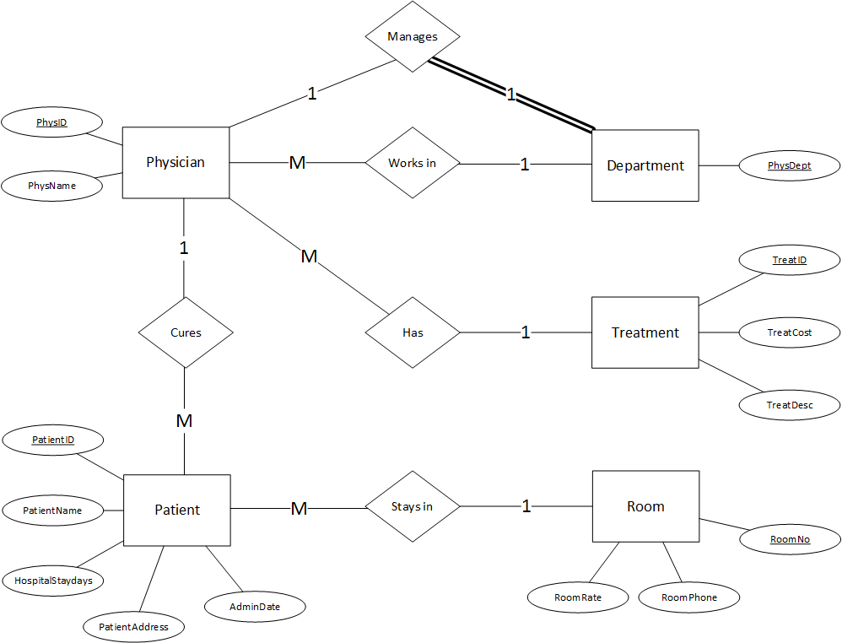

**2D) Write a script to create database (saved in q2_sql.txt)**

CREATE TABLE Treatment (

TreatID NUMBER,

TreatCost NUMBER(10, 2),

TreatDesc VARCHAR2(200),

CONSTRAINT Treatment_PK PRIMARY KEY(TreatID),

CONSTRAINT TreatCost_CK CHECK(TreatCost >= 50.00)

);

CREATE TABLE Department (

PhysDept NUMBER,

DeptSupervisorID NUMBER,

CONSTRAINT Department_PK PRIMARY KEY(PhysDept)

);

CREATE TABLE Room (

RoomNo NUMBER,

RoomPhone VARCHAR(8),

RoomRate NUMBER(10, 2),

CONSTRAINT Room_PK PRIMARY KEY(RoomNo),

CONSTRAINT RoomRate_CK CHECK(RoomRate >= 30.00 AND RoomRate <= 100.00),

CONSTRAINT RoomNo_CK CHECK(RoomNo >= 100 AND RoomNo <= 999)

);

CREATE TABLE Physician (

PhysID NUMBER,

PhysName VARCHAR2(50) CONSTRAINT PhysName_Null NOT NULL,

PhysDept NUMBER,

TreatID NUMBER,

CONSTRAINT Physician_PK PRIMARY KEY(PhysID),

CONSTRAINT Physician_FK1 FOREIGN KEY(PhysDept) REFERENCES Department(PhysDept),

CONSTRAINT Physician_FK2 FOREIGN KEY(TreatID) REFERENCES Treatment(TreatID)

);

CREATE TABLE Patient (

PatientID NUMBER,

PatientName VARCHAR2(50) CONSTRAINT PatientName_Null NOT NULL,

PatientAddress VARCHAR2(200) CONSTRAINT PatientAddress_Null NOT NULL,

AdminDate DATE,

HospitalStayDays NUMBER,

RoomNo NUMBER,

PhysID NUMBER,

CONSTRAINT Patient_PK PRIMARY KEY(PatientID),

CONSTRAINT Patient_FK1 FOREIGN KEY(RoomNo) REFERENCES Room(RoomNo),

CONSTRAINT Patient_FK2 FOREIGN KEY(PhysID) REFERENCES Physician(PhysID),

CONSTRAINT HospitalStayDays_CK CHECK(HospitalStayDays >= 0)

);

ALTER TABLE DEPARTMENT

ADD CONSTRAINT Department_FK1 FOREIGN KEY(DeptSupervisorID) REFERENCES Physician(PhysID);

**Question #3**

Create the table related to the following ERD

A (A1, A2 )

B (B1, B2, A1, C1)

C (C1, C2)

R3 (C1*, (D1, D5)*, AttOfR3)

D (D1, D5, D2, D3, D4)

E (E1, (D1, D5)*, E2, AttOfR4)

F (F1, F2, (E1, D1, D5)*, F3, F4, AttOfR5)

**Question #4**

Create the tables related to the following ERD

Bank (Code, Name, Addr)

Bank-Branch (BranchNo, Code*, Addr)

Loan (LoanNo, Amount, Type, BranchNo*, Code*)

Account (AcctNo, Balance, Type, BranchNo*, Code*)

Customer (SSN, Phone, Name, Addr)

A-C (AcctNo*, SSN*)

L-C (LoanNo*, SSN*)

**Question #5**

Create ERD based on the following tables.

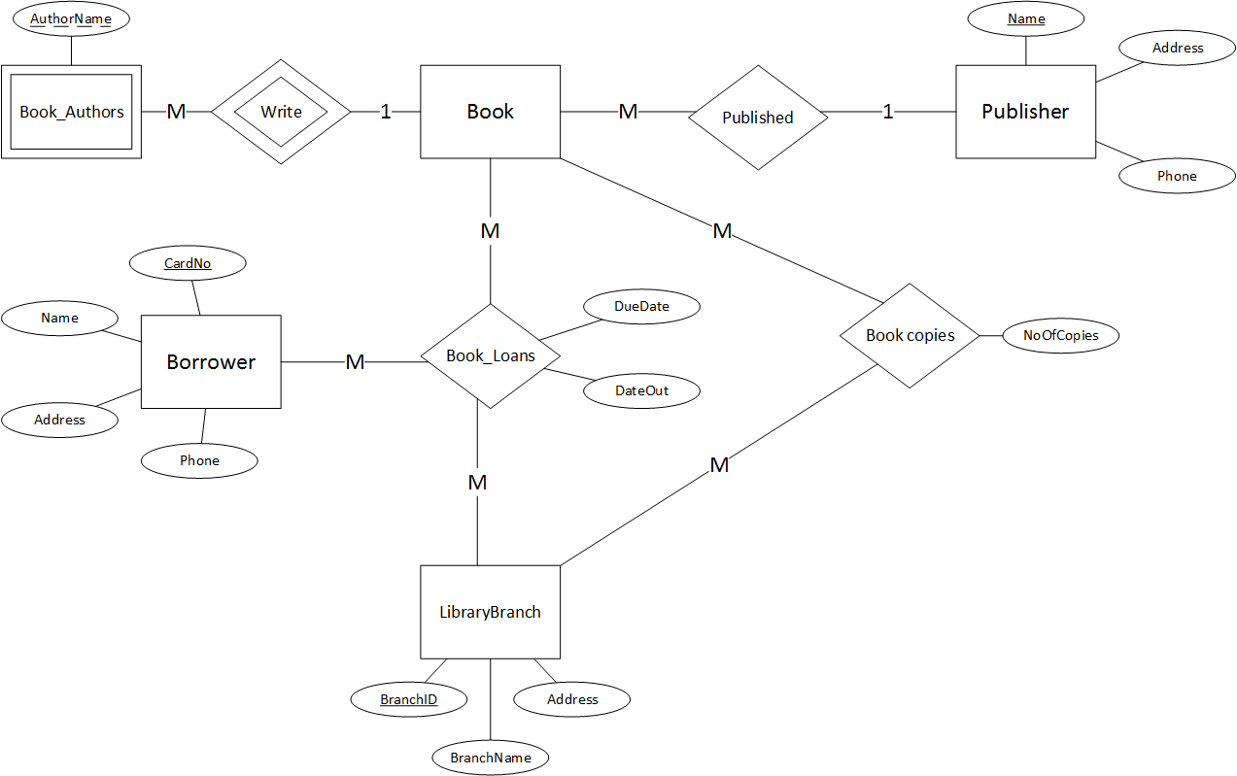

**Question #6**

Create ERD based on the following tables.

