Chris Banci

CS443  
Prof. Hadaegh

2/8/17

Lab 2

1a)

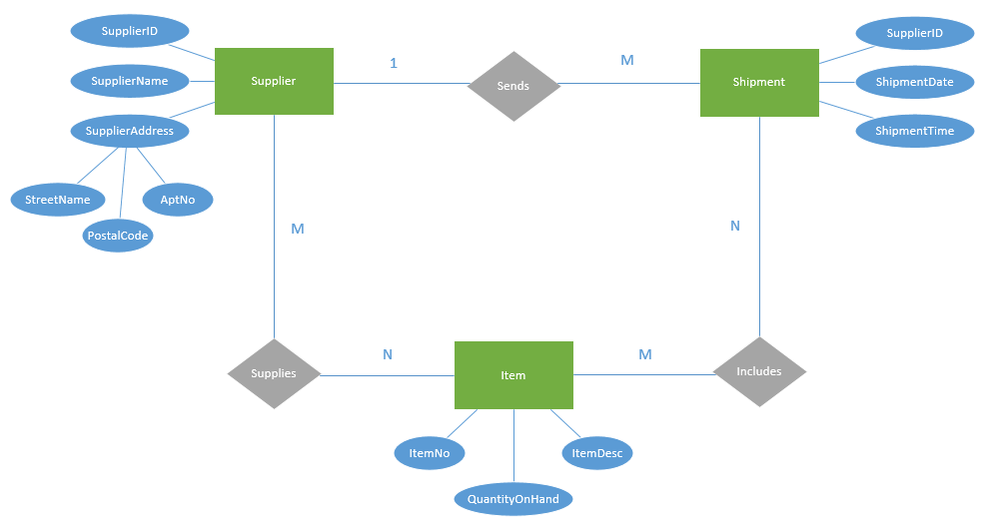

1b)

**Supplier (*1*) - *Sends* - (*M*) Shipment**

* Table 1: Shipment (ShipmentID, ShipmentDate, ShipmentTime, SupplierID)
* Table 2: Supplier (SupplierID, SupplierAddress, SupplierName)

**Supplier (*M*) - *Supplies* - (*N*) Item**

* Table 1: Supplier (SupplierID, SupplierAddress, SupplierName)
* Table 2: Item (ItemNo, ItemDescription, QuantityOnHand)
* Table 3: Supplies (SupplierID, ItemNo)

**Shipment (*N*) - *Includes* - (*M*) Item**

* Table 1: Shipment (ShipmentID, ShipmentDate, ShipmentTime)
* Table 2: Item (ItemNo, ItemDescription, QuantityOnHand)
* Table 3: Includes (ShipmentID, ItemNo)

2)

**Student (*N*) - *Takes* - (*M*) Course**

* Table 1: Student (S-id, S-name, S-age, S-email)
* Table 2: Course (C-CRN, C-name, C-des)
* Table 3: Takes (S-id, C-CRN)

**Faculty (*1*) - *Teaches* - (*M*) Course**

* Table 1: Faculty (F-id, F-name, F-major, F-office)
* Table 2: Course (C-CRN, C-name, C-des, F-id)

**Faculty (*N*) - *Has* - (*1*) Department**

* Table 1: Faculty (F-id, F-name, F-major, F-office, D-id)
* Table 2: Department (D-id, D-name, D-loc)

**Department (*1*) - *Offers* - (*1*) Major**

* Table 1: Department (D-id, D-name, D-loc, M-name)
* Table 2: Major (M-name)

**Faculty (*1*) - *Teaches* - (*M*) Dependent**

* Table 1: Dependent (Name, F-id, Gender, Age)