Nguyễn Lan Chi – 22DH114466
Bài 1:
internal class Program
{
private static void Main(string[] args)
{
Point2D point1 = new Point2D();
point1.Input();

Point2D point2 = new Point2D();
point2.Input();

Console.WriteLine("Toa do diem A1: " + point1.ToString());
Console.WriteLine("Toa do diem A2: " + point2.ToString());

point1.Move(5,2);
Console.WriteLine("Di chuyen diem A1 den toa do moi: " + point1.ToString());

if (point1.isOrigin()) Console.WriteLine("Diem A1 la goc toa do");
else Console.WriteLine("Diem A1 khong phai la goc toa do");

Console.WriteLine("--------------------");
Point2D p = new Point2D();
p.Input();
Console.WriteLine("Toa do diem p: " + p.ToString());
Console.WriteLine("Khoang cach tu diem A1 toi diem p: " + point1.Distance(p));
Console.WriteLine("Khoach cach giua 2 diem A1 va A2 la: " + Point2D.Distance(point1,point2));

}
}

class Point2D {
private int x, y;
public Point2D() { }
public Point2D(int x, int y) {
this.x = x;
this.y = y;
}
public Point2D(Point2D p) {
this.x = p.x;
this.y = p.y;
}
public void Input() {
Console.WriteLine("Nhap toa do cho diem: ");
Console.Write("x: ");
x = int.Parse(Console.ReadLine());
Console.Write("y: ");
y = int.Parse(Console.ReadLine());
}
public string ToString() => $"({x},{y})";
public void Move(int x, int y) {
this.x = x;
this.y = y;
}
public bool isOrigin() {
if (x == 0 && y == 0) return true;
else return false;
}
public double Distance(Point2D p) {
double kc = Math.Pow((p.x - this.x), 2) + Math.Pow((p.y - this.y), 2);
return Math.Sqrt(kc);
}
public static double Distance(Point2D p1, Point2D p2) {
double kc = Math.Pow((p2.x - p1.x), 2) + Math.Pow((p2.y - p1.y), 2);
return Math.Sqrt(kc);
}
}

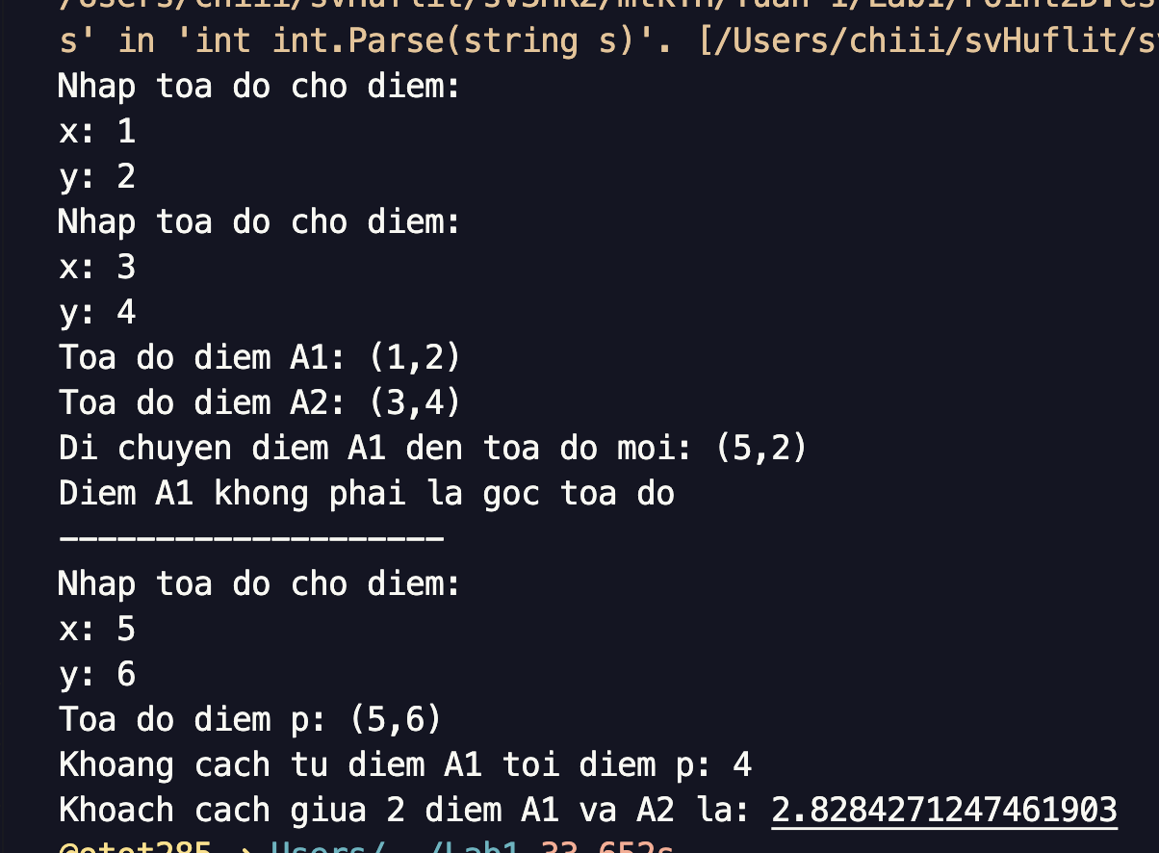

Bài 2:
class Line {
private Point2D p1, p2;
public Line(Point2D p1, Point2D p2) {
this.p1 = p1;
this.p2 = p2;
}
public double Magnitude() => Point2D.Distance(p1, p2);
public Point2D Center() => new Point2D((p1.x + p2.x) / 2, (p1.y + p2.y) / 2);
}
internal class Program
{
private static void Main(string[] args)
{
Point2D point1 = new Point2D();
point1.Input();

Point2D point2 = new Point2D();
point2.Input();

Console.WriteLine("Toa do diem A1: " + point1.ToString());
Console.WriteLine("Toa do diem A2: " + point2.ToString());

Line line = new Line(point1, point2);
Console.WriteLine("Do dai cua duong thang: " + line.Magnitude());
Console.WriteLine("Toa do trung diem cua duong thang: " + line.Center().ToString());
}
}

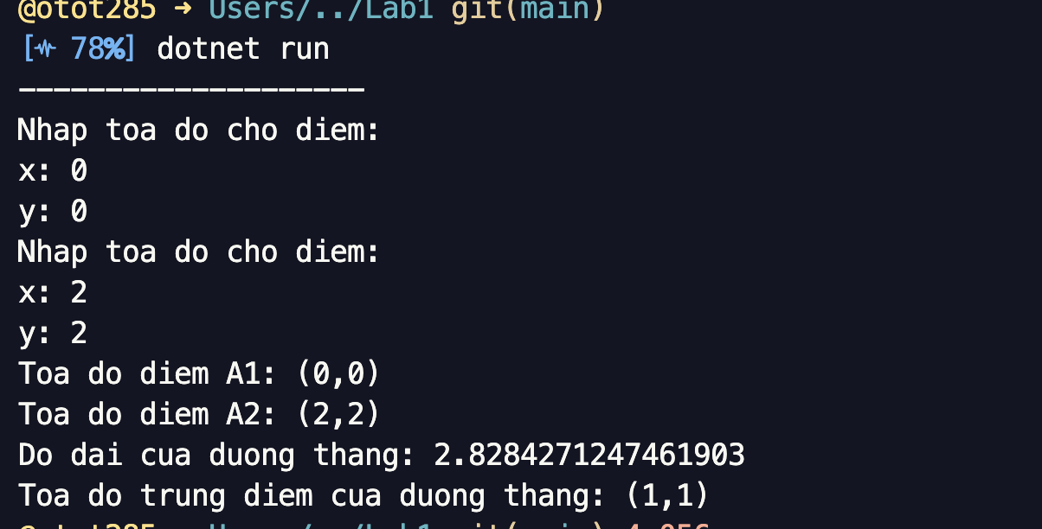

Bài 3:
class Triangle {
private Point2D p1, p2, p3;
public Triangle(Point2D p1, Point2D p2, Point2D p3) {
this.p1 = p1;
this.p2 = p2;
this.p3 = p3;
}
public double Perimeter()
=> Point2D.Distance(p1, p2) + Point2D.Distance(p2, p3) + Point2D.Distance(p3, p1);
public double Area() {
double p = Perimeter() / 2;
double area = p * (p - Point2D.Distance(p1, p2)) * (p - Point2D.Distance(p2, p3)) * (p - Point2D.Distance(p1, p3));
return Math.Round(Math.Sqrt(area), 2);
}
}
internal class Program
{
private static void Main(string[] args)
{
Point2D point1 = new Point2D();
point1.Input();

Point2D point2 = new Point2D();
point2.Input();

Point2D point3 = new Point2D();
point3.Input();

Console.WriteLine("Toa do diem A1: " + point1.ToString());
Console.WriteLine("Toa do diem A2: " + point2.ToString());
Console.WriteLine("Toa do diem A3: " + point3.ToString());

Triangle triangle = new Triangle(point1, point2, point3);
Console.WriteLine("Chu vi tam giac: " + triangle.Perimeter());
Console.WriteLine("Dien tich tam giac: " + triangle.Area());
}
}

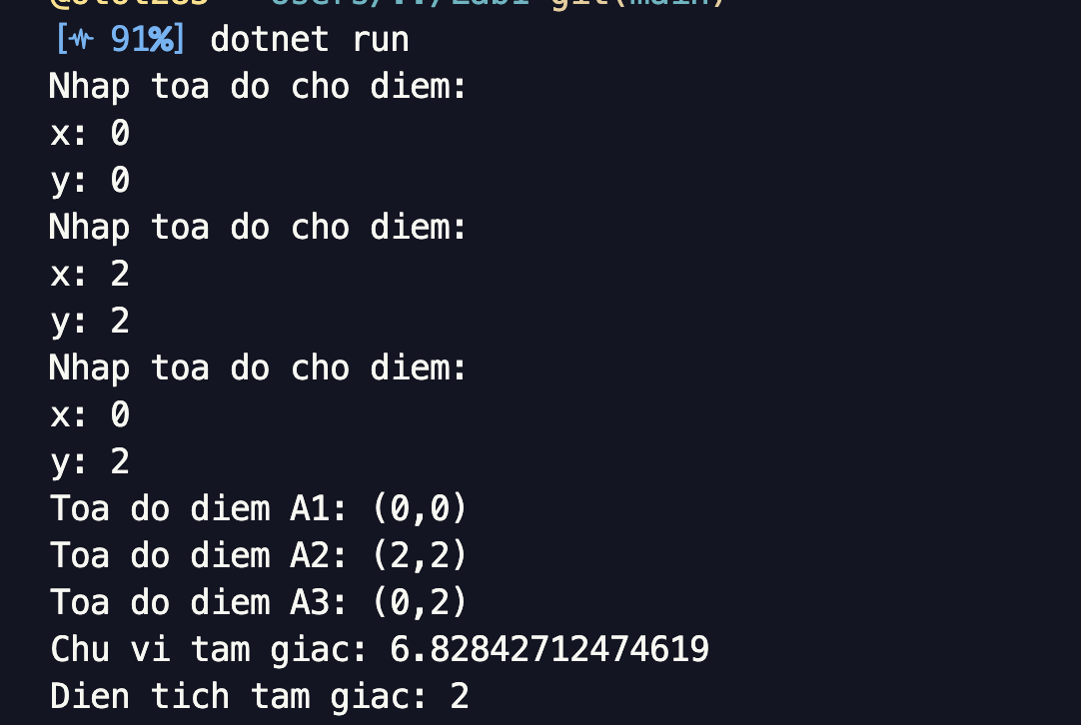

Bài 4:
class Computer {
private string maMay, tenMay;
private int namSX;
private double gia;
public string MaMay {
set => maMay = value;
get => maMay;
}
public string TenMay {
set => tenMay = value;
get => tenMay;
}

public int NamSX {
set {
if (value < 1970) this.namSX = 1970;
else namSX = value;
}
get {
return namSX;
}
}
public double Gia {
set {
if (value < 0) this.gia = 0;
else this.gia = value;
}
get {
return gia;
}
}

public Computer() {
MaMay = "";
TenMay = "";
NamSX = 1970;
Gia = 0;
}
public Computer(string maMay, string tenMay, int namSX, double gia) {
MaMay = maMay;
TenMay = tenMay;
NamSX = namSX;
Gia = gia;
}
public virtual void Input() {
Console.WriteLine("Nhap thong tin may: ");
Console.Write("Ma may: ");
MaMay = Console.ReadLine();
Console.Write("Ten may: ");
TenMay = Console.ReadLine();
Console.Write("Nam san xuat: ");
NamSX = int.Parse(Console.ReadLine());
Console.Write("Gia: ");
Gia = double.Parse(Console.ReadLine());
}
public virtual void Output()
=> Console.WriteLine($"Ma may: {MaMay} | Ten may: {TenMay} | Nam san xuat: {NamSX} | Gia: {Gia}");
public void Running() => Console.WriteLine($"{TenMay} is running...");
}
using System.Security.Cryptography.X509Certificates;

class Desktop : Computer {
private int namBH;
public int NamBH {
set {
if (value < 0) this.namBH = 0;
else this.namBH = value;
}
get {
return namBH;
}
}
public Desktop() : base() => namBH = 0;
public Desktop(string maMay, string tenMay, int namSX, double gia, int namBH) : base(maMay, tenMay, namSX, gia) {
NamBH = namBH;
}
public override void Input() {
base.Input();
Console.Write("Nam bao hanh: ");
NamBH = int.Parse(Console.ReadLine());
}
public override void Output() {
base.Output();
Console.WriteLine($"Nam bao hanh: {NamBH}");
}

}

using System.Security.Cryptography.X509Certificates;
class Laptop : Computer {
private double weight;
public double Weight {
set {
if (value < 1) this.weight = 1;
else this.weight = value;
}
get {
return weight;
}
}
public Laptop() : base() => weight = 1;
public Laptop(string maMay, string tenMay, int namSX, double gia, double weight) : base(maMay, tenMay, namSX, gia) {
Weight = weight;
}
public override void Input() {
base.Input();
Console.Write("Trong luong: ");
Weight = double.Parse(Console.ReadLine());
}
public override void Output() {
base.Output();
Console.WriteLine($"Trong luong: {Weight}");
}

}

internal class Program
{
private static void Main(string[] args)
{
Console.Write("Nhap so luong may tinh: ");
int n = int.Parse(Console.ReadLine());
Computer[] arrC = new Computer[n];
for (int i = 0; i < n; i++) {
Console.Write("Chon loai may: “D” de chon Desktop, nguoc lai la Laptop. ");
string choose = Console.ReadLine();
if (choose == "D" || choose == "d") {
Desktop desktop = new Desktop();
desktop.Input();
arrC[i] = desktop;
}
else {
Laptop laptop = new Laptop();
laptop.Input();
arrC[i] = laptop;
}
}
Console.WriteLine("-----------------------------");
Console.WriteLine("Thong tin cac may tinh: ");
for (int i = 0; i < n; i++) {
arrC[i].Output();
if (arrC[i] is Laptop) {
Laptop _laptop = (Laptop)arrC[i];
_laptop.Running();
}
}
Console.WriteLine("-----------------------------");
double sum = 0;
for (int i = 0; i < n; i++) {
sum += arrC[i].Gia;
}
Console.WriteLine($"Tong gia tri cua tat ca cac may tinh la: {sum}");
for (int i = 0; i < n; i++) {
sum += arrC[i].Gia;
}
Console.WriteLine("-----------------------------");
Console.WriteLine("Cac may Desktop co so nam bao hanh it hon 3: ");
for (int i = 0; i < n; i++) {
if (arrC[i] is Desktop && (arrC[i] as Desktop).NamBH < 3) {
Desktop _desktop = (Desktop)arrC[i];
Console.WriteLine($"Ma may: {_desktop.MaMay}");
}
}
}
}

