Nguyễn Lan Chi – 22DH114466
Bài 1:
interface IEmployee {
// To set an employee name
string Name { get; set; }
// To set an employee department
string Dept { get; set; }
// To set an employee designation
string Designation { get; set; }
// To display an employee details
void DisplayDetails();
}

class Employee : IEmployee {
public string Name { get; set; }
public string Dept { get; set; }
public string Designation { get; set; }
public void DisplayDetails() {
Console.WriteLine($"\t{Name} works in {Dept} department. Designation:{Designation}");
}
}
class CompositeEmployee : IEmployee {
public string Name { get; set; }
public string Dept { get; set; }
public string Designation { get; set; }
// The container for child objects
private List<IEmployee> subordinateList = new List<IEmployee>();
// To add an employee
public void AddEmployee(IEmployee e) {
subordinateList.Add(e);
}
// To remove an employee
public void RemoveEmployee(IEmployee e) {
subordinateList.Remove(e);
}
// Details of a composite node
public void DisplayDetails() {
Console.WriteLine($"\n{Name} works in {Dept} department. Designation:{Designation}");
foreach (IEmployee e in subordinateList) {
e.DisplayDetails();
}
}

}

internal class Program
{
private static void Main(string[] args)
{
Console.WriteLine("***Composite Pattern Demo. ***");
#region Mathematics department
// 2 lecturers work in Mathematics department
Employee mathTeacher1 = new Employee
{
Name = "M.Joy",
Dept = "Mathematic",
Designation = "Lecturer"
};
Employee mathTeacher2 = new Employee
{
Name = "M.Roony",
Dept = "Mathematics",
Designation = "Lecturer"
};
// The college has a Head of Department in Mathematics
CompositeEmployee hodMaths = new CompositeEmployee
{
Name = "Mrs.S.Das",
Dept = "Maths",
Designation = "HOD-Maths"
};
// Lecturers of Mathematics directly reports to HOD-Maths
hodMaths.AddEmployee(mathTeacher1);
hodMaths.AddEmployee(mathTeacher2);
#endregion
#region Computer Science department
// 3 lecturers work in Computer Sc. department
Employee cseTeacher1 = new Employee {
Name = "C.Sam",
Dept = "Computer Science",
Designation = "Lecturer"
};
Employee cseTeacher2 = new Employee {
Name = "C.Jones",
Dept = "Computer Science.",
Designation = "Lecturer"
};
Employee cseTeacher3 = new Employee {
Name = "C.Marium",
Dept = "Computer Science",
Designation = "Lecturer"
};
CompositeEmployee hodCompSc = new CompositeEmployee { Name = "Mr. V.Sarcar", Dept = "Computer Sc.", Designation = "HOD-Computer Sc." };
hodCompSc.AddEmployee(cseTeacher1);
hodCompSc.AddEmployee(cseTeacher2);
hodCompSc.AddEmployee(cseTeacher3);
#endregion
#region Top level management
// The college also has a Principal
CompositeEmployee principal = new CompositeEmployee { Name = "Dr.S.Som", Dept =
"Planning-Supervising-Managing", Designation = "Principal" };
/* Head of Departments's of Maths and Computer Science directly
reports to Principal.*/
principal.AddEmployee(hodMaths);
principal.AddEmployee(hodCompSc);
#endregion
/*
* Printing the leaf-nodes and branches in the same way. i.e.
in each case, we are calling DisplayDetails() method.
*/
Console.WriteLine("\nDetails of a Principal object is as follows:"); // Prints the complete structure()
principal.DisplayDetails();
Console.WriteLine("\nDetails of a HOD object is as follows:");
/* Prints the details of Computer Science department */
hodCompSc.DisplayDetails();
// Leaf node
Console.WriteLine("\nDetails of an individual employee(leaf node) is as follows:");
mathTeacher1.DisplayDetails();
/*
* Suppose, one Computer Science lecturer(C.Jones)
* is leaving now from the organization.
*/
hodCompSc.RemoveEmployee(cseTeacher2);
Console.WriteLine("\nAfter the resignation of C.Jones, the organization has the following members: ");
principal.DisplayDetails();
}
}

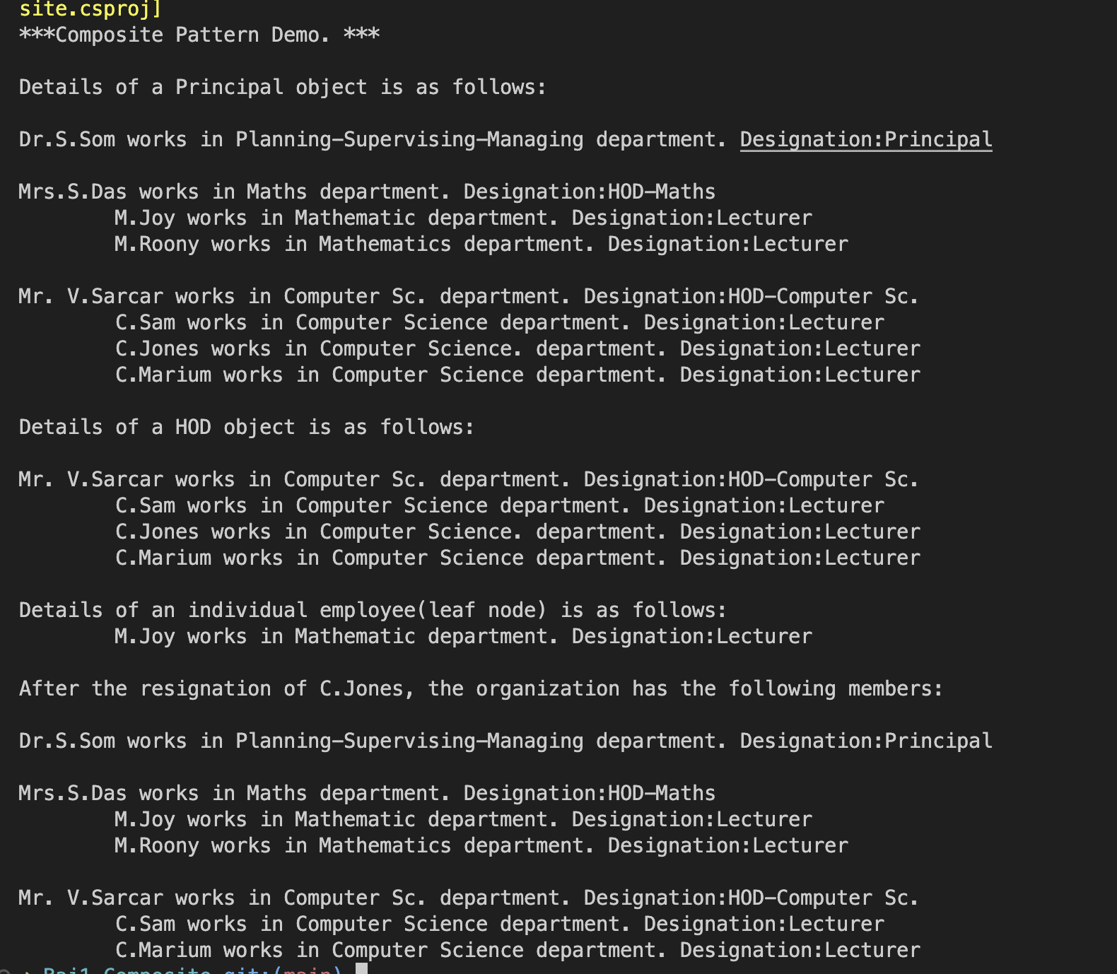

- Nhận xét:
• Composite Pattern rất phù hợp để quản lý cấu trúc phân cấp như tổ chức, công ty, hệ thống thư mục.
• Dễ dàng thêm hoặc xóa nhân viên mà không cần thay đổi nhiều trong hệ thống.
• Nhược điểm: Có thể làm tăng độ phức tạp của code khi hệ thống có nhiều cấp bậc.

Bài 2:
interface IPrice {
void DisplayDetails(string product, double price);
// additional method
void GetDiscount(int percentage);
}
abstract class ElectronicGoods {
private IPrice price;
public string type;
public double cost;
public ElectronicGoods(IPrice price) {
this.price = price;
}
public void Details() {
price.DisplayDetails(type, cost);
}
// additional method
public void Discount(int percentage) {
price.GetDiscount(percentage);
}

}

class Television : ElectronicGoods {
public Television(IPrice price) : base(price) {
this.type = "Television";
this.cost = 2000;
}
}

class DVD : ElectronicGoods {
public DVD(IPrice price) : base(price) {
this.type = "DVD";
this.cost = 3000;
}

public void DoubleDiscount() {
// Normal discount(10%)
Discount(10);
// Festive season additional discount
Discount(5);
}
}

class ShowroomPrice : IPrice {
public virtual void DisplayDetails(string productType, double price) {
Console.Write($"\n{productType} price at showroom is : {price + 300}$");
}
public void GetDiscount(int percentage) {
Console.Write($"\nAt showroom, additional {percentage}% discount can be approved.");
}
}

class OnlinePrice : IPrice {

public void DisplayDetails(string productType, double price) {
Console.Write($"\n{productType} price at online is : {price}$");
}
public void GetDiscount(int percentage) {
Console.Write($"\nAt online, you can get upto {percentage}% discount.");
}
}

internal class Program
{
private static void Main(string[] args)
{
Console.WriteLine("***Alternative Implementation of Bridge Pattern.* **");
#region Television details
Console.WriteLine("Verifying the market price of a television.");
ElectronicGoods eItem = new Television(new OnlinePrice());
// Verifying online price details
eItem.Details();
// Giving 10% discount
eItem.Discount(10);
// Verifying showroom price
eItem = new Television(new ShowroomPrice());
eItem.Details();
// Giving 10% discount
eItem.Discount(10);
#endregion
#region DVD details
Console.WriteLine("\n\nNow checking the DVD details.");
eItem = new DVD(new OnlinePrice());
eItem.Details();
// Giving 10% discount
eItem.Discount(10);
// Verifying showroom price
eItem = new DVD(new ShowroomPrice());
eItem.Details();
Console.WriteLine("\nIn showroom, you want to give double discounts at festive season.");
Console.WriteLine("For DVD, you can get double discounts using the DoubleDiscount() method.");
//eItem.Discount();
Console.WriteLine("For example, in festive season:");
((DVD)eItem).DoubleDiscount();
#endregion

}
}

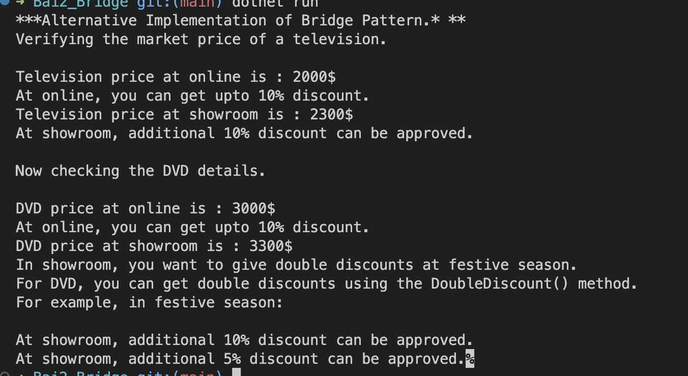

- Nhận xét:
• Bridge Pattern giúp tách phần hiển thị giá và giảm giá khỏi phần mô tả sản phẩm, giúp hệ thống linh hoạt hơn.
• Dễ dàng mở rộng mà không cần thay đổi nhiều code.
• Giảm sự phụ thuộc giữa các lớp, giúp bảo trì dễ dàng.

