1. **BigO_orginal_ver**

**Test with array [1]:**

Different running produces different results

**Test with array [2]:**

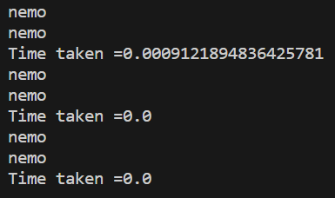

Different running produces different results

**-----------------------------------------------------------------------------------------------**

**Big_O_version_2**

1. **Test with second elements**

1. **Test with third elements**

1. **Test with 10th elements**

