ToasterCode Final Tech Requirements for PowerLevel

1. 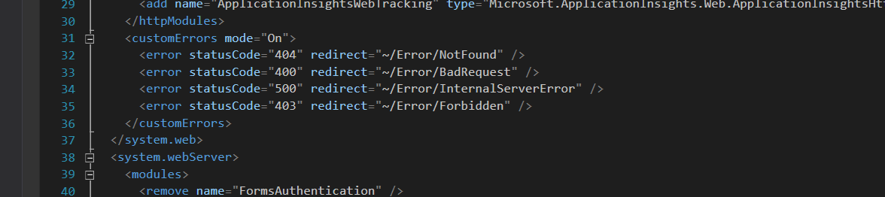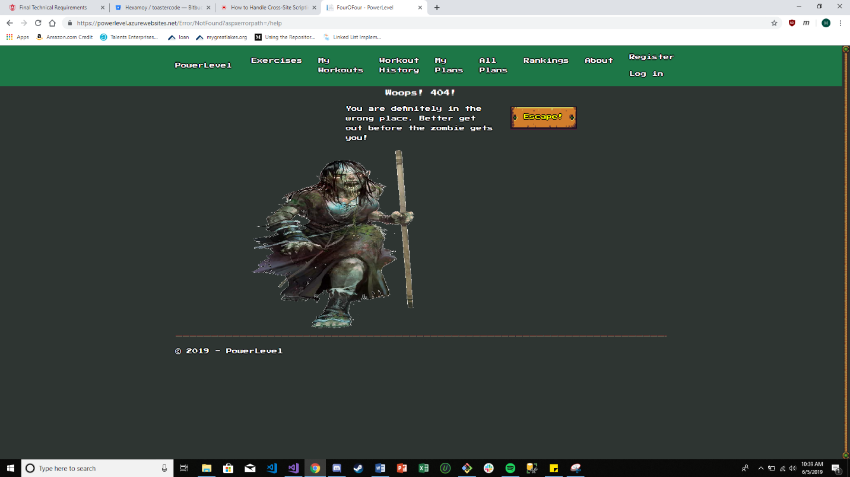We have custom error pages for multiple different values (404, 500, 400, etc.), as well as custom error pages turned on.
2. Visual Studio’s template for the website that uses user accounts as well as the input validation tags are handling the security for the XSS and XSRF attacks.
3. To access any of the forms or submissions on our site, a user must be logged in. This is protecting all input forms behind logins.
4. 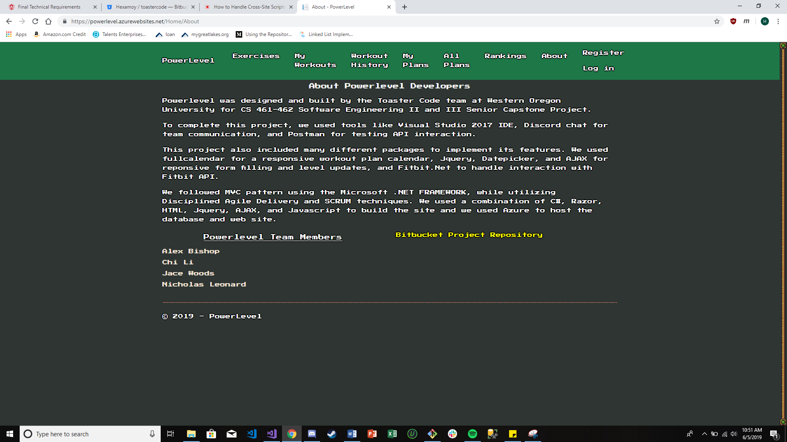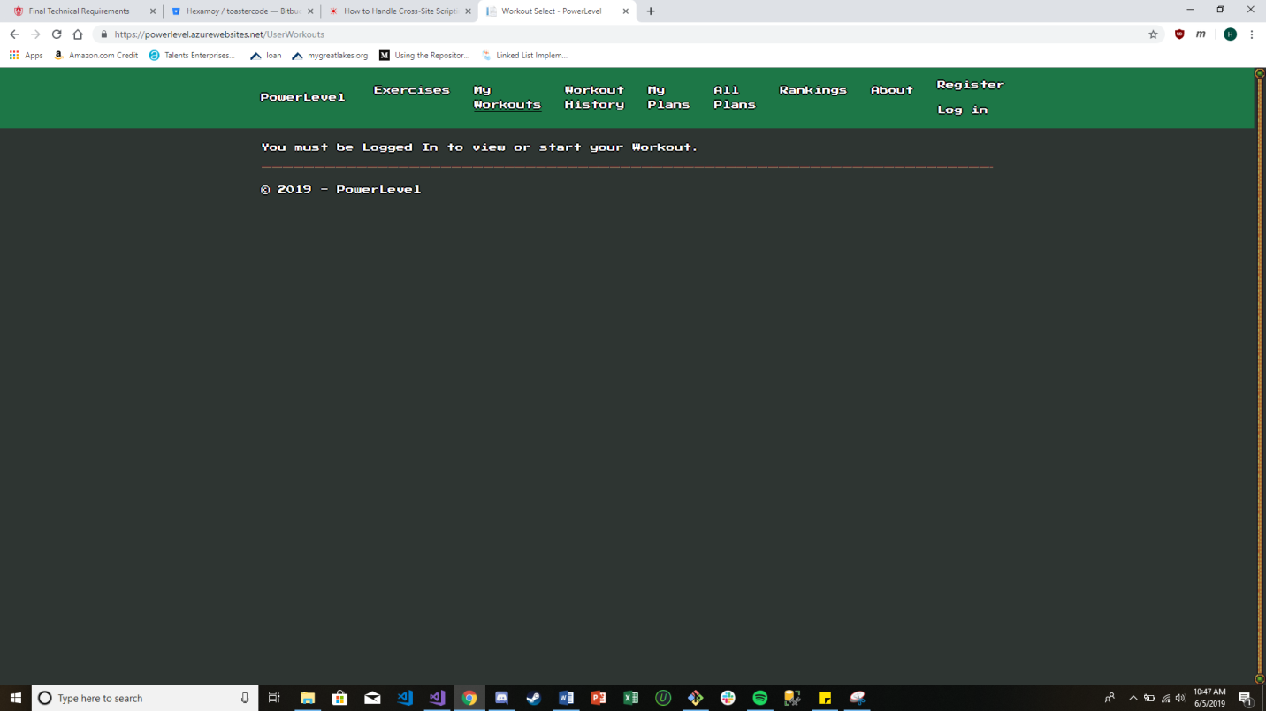The credits page is linked by the about link on Powerlevel’s main navbar. This page contains the description for the reason of the project, as well as a general overview of the tools and packages we used. It also contains a link to ToasterCode’s bitbucket repository and each team members name.
5. We changed all passwords that we used for database access and send grid functionality. The API Secrets never entered the repository.
6. All up scripts have been compiled into one big up script for the database. We also added all the necessary seeding files to the up script so running that one file completely sets up the database. All down scripts have been added to one solitary down script. Running the down script destroys the database.
7. 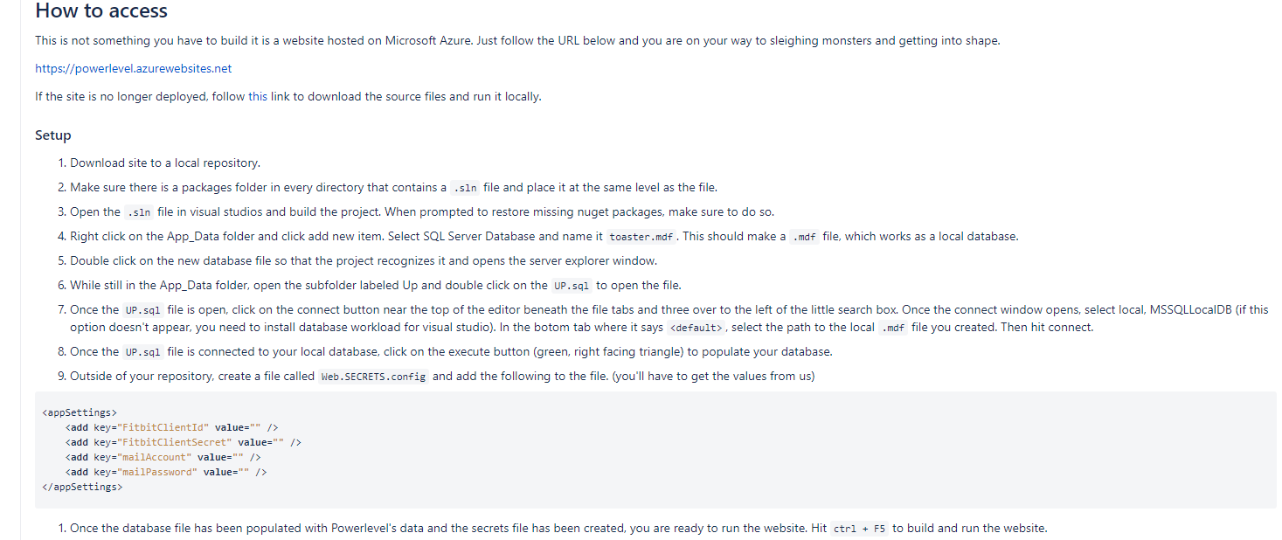I added a section to our main README on how to set up the project locally.
8. 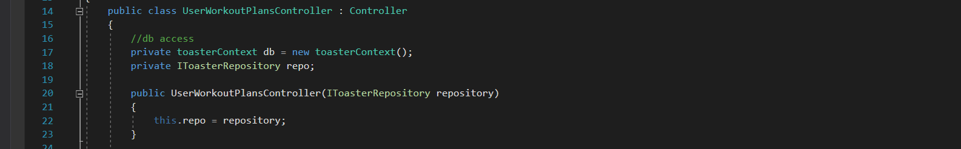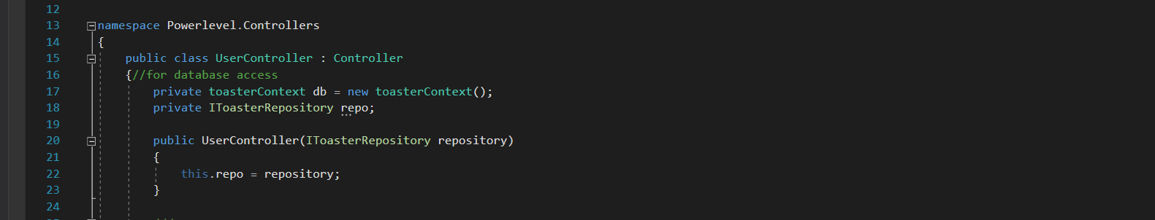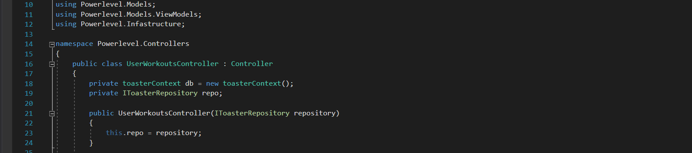Almost all our controllers have been refactored to use the repository pattern and any database access we use that is read only utilizes the repository pattern.
9. 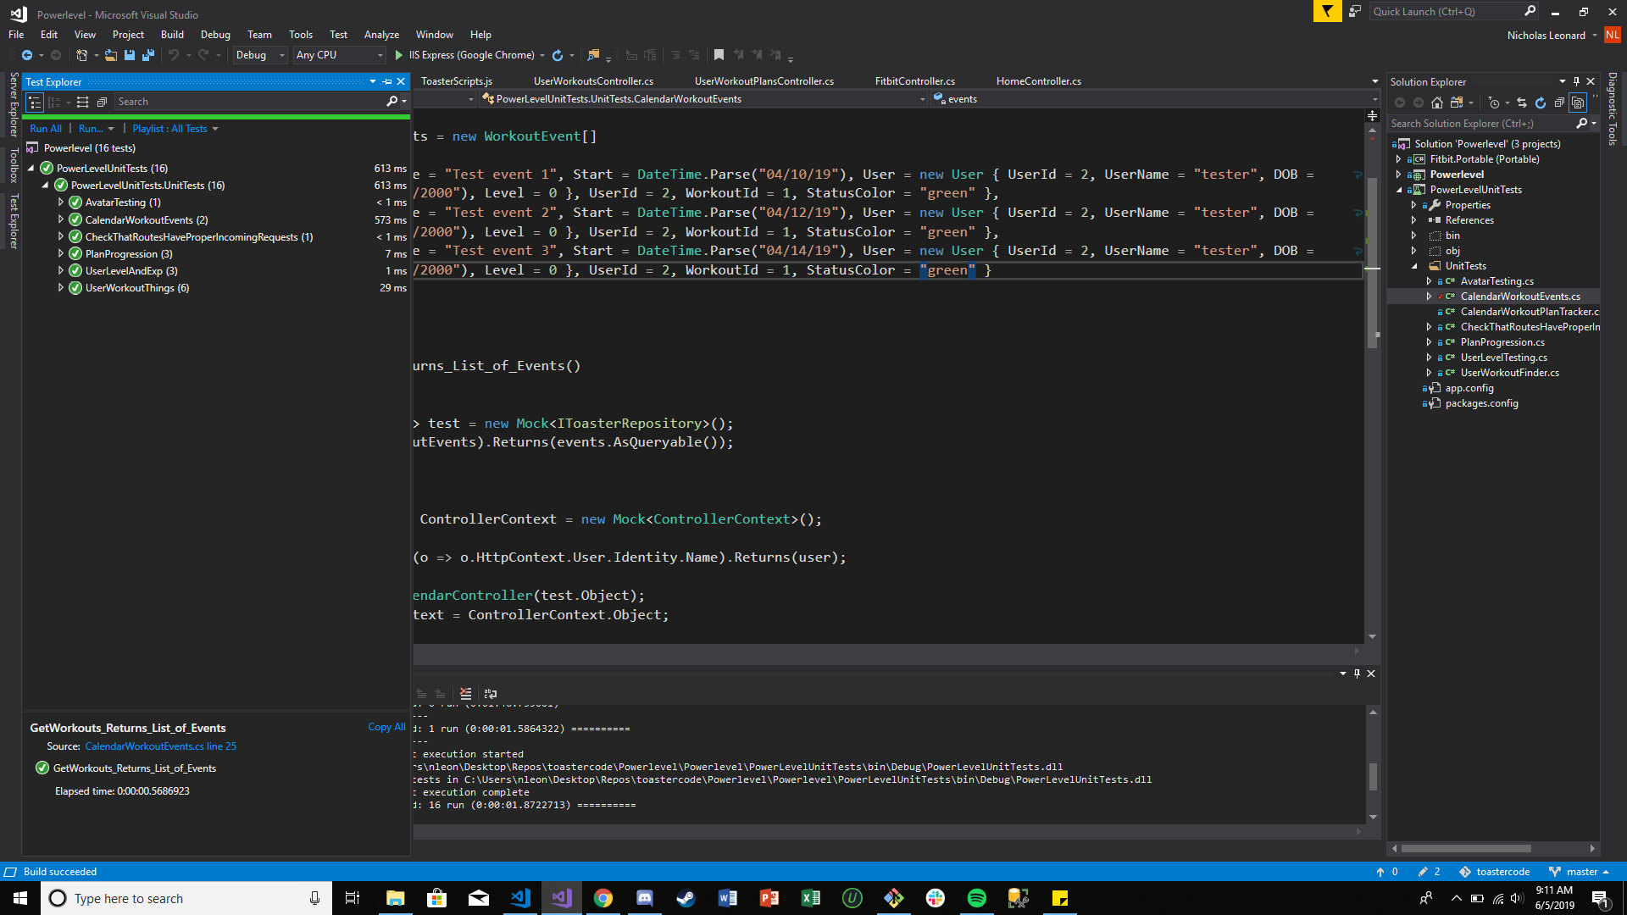Here are our Unit Tests for Powerlevel
10. 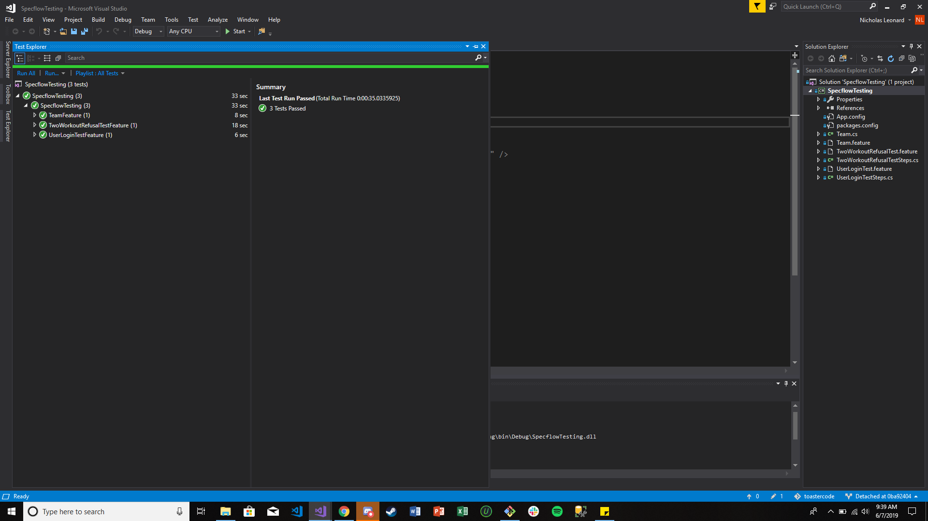Here is the screen grab of our selenium tests passing. (Thank God)
11. 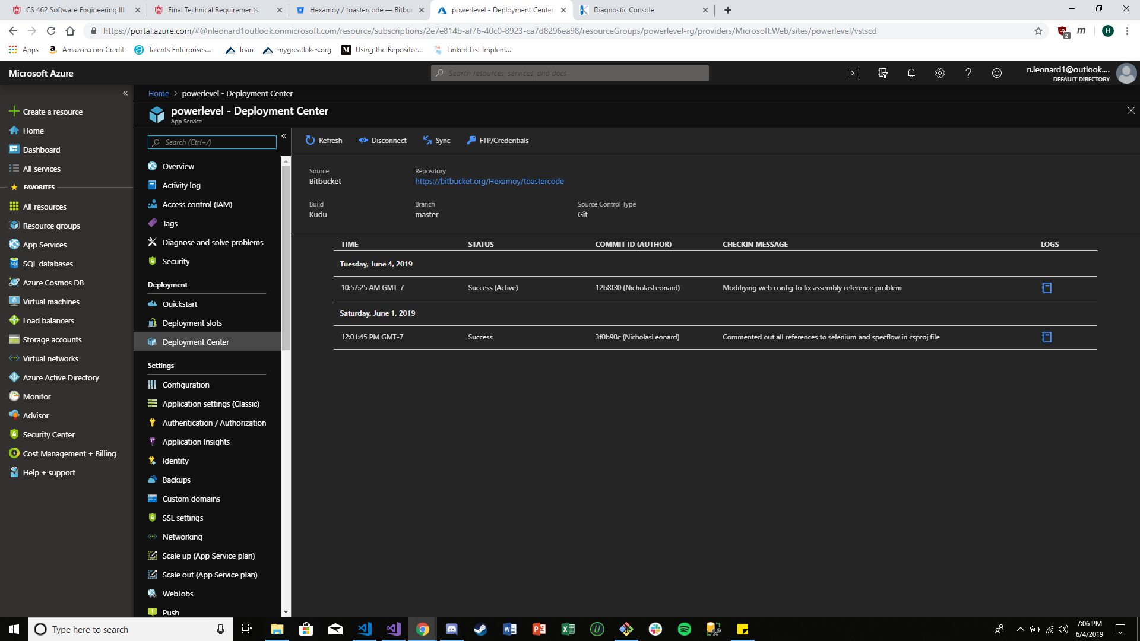Our continuous deployment broke but I was able to grab a screen shot of some past deployments utilizing continuous deployment.
12. 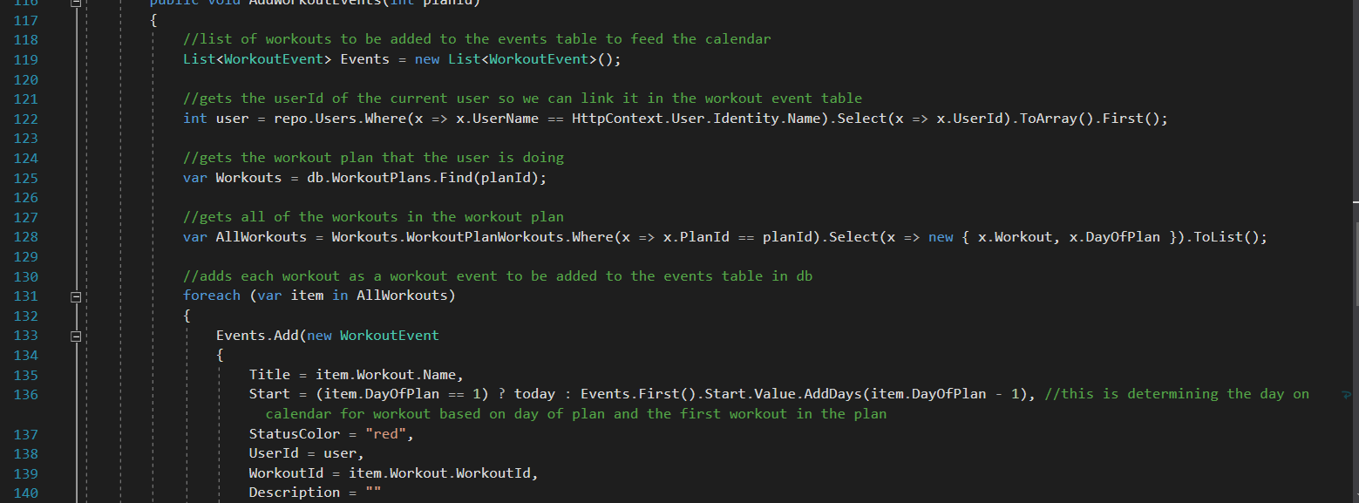We made sure to comment our code as best as we could. Here is a quick example of some comments.
13. We do not utilize user generated files, images, etc.
14. We have a Gource video that we put on youtube and added a link on our repositories main README page. <https://youtu.be/LO2lEgHMjlo>
15. 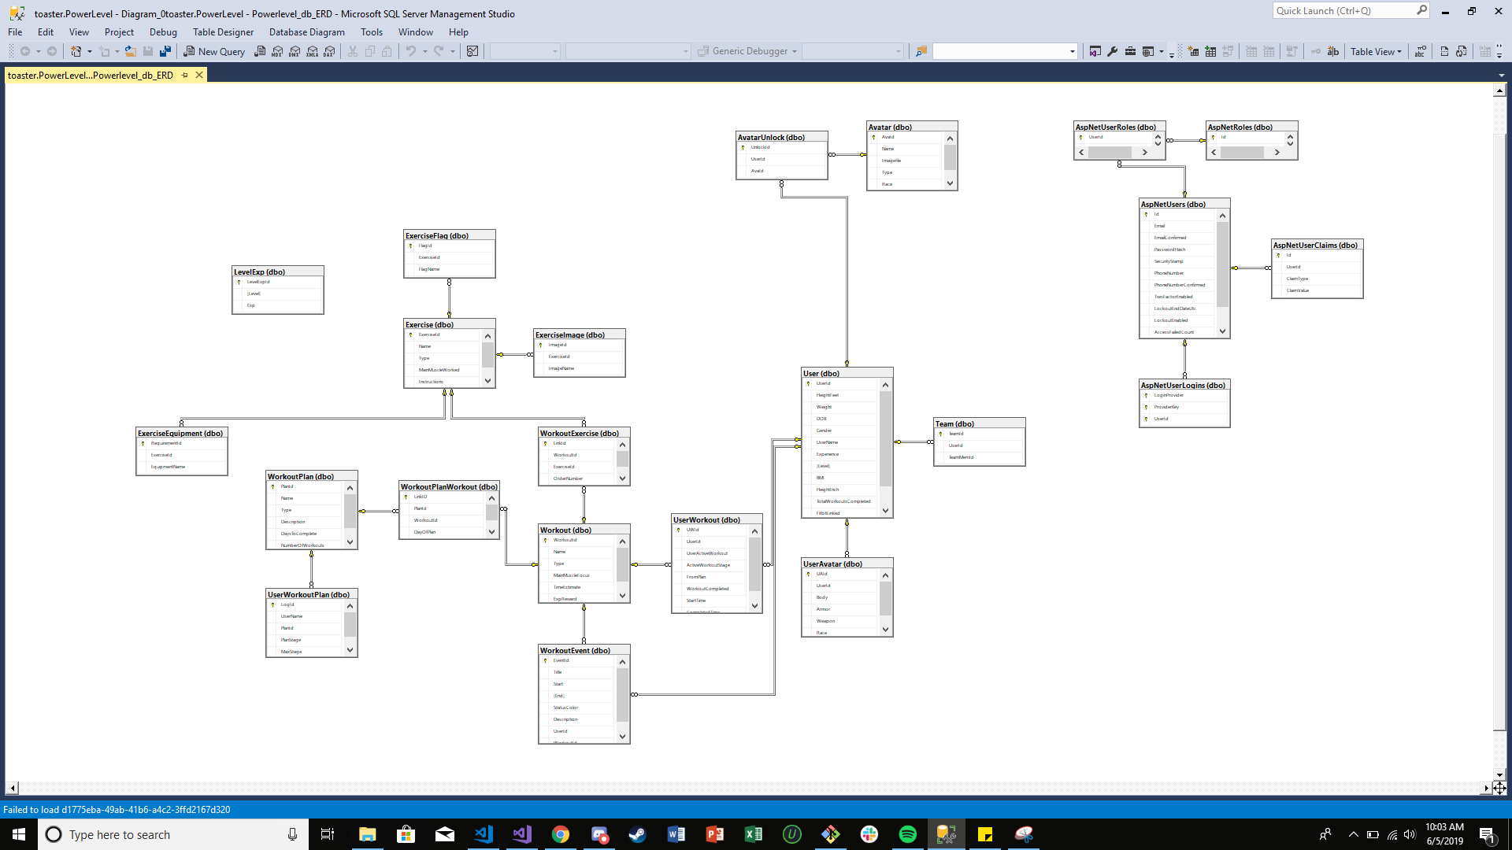Here is the ERD for our database.