# Binary

**Math formula:**

Cross-entropy:

$-1/N * \sum_{i = 1}^{N}{}(y^{(i)}log(h^{(i)}) +(1-y^{(i)})log((1-h^{(i)}))$

Cross-entropy grad:

$1/N * X^{T}∙(\hat{y} - y)$

**Code functions:**

Sig: The sigmoid function

Hypo: calculate H based on x and w

Cost_function: to calculate cost of current w

Cost_function_grad: calculate the grad of current w

Gradient_descent: calculate the next w based on grad and step size

**Results:**

Synthetic-easy:

Training Score: 1.0

Test Score: 1.0

Time 0m0.508s

Synthetic-medium:

Training Score: 0.86

Test Score: 0.88

Time 0m0.435s

Synthetic-hard:

Training Score: 0.74

Test Score: 0.74

Time 0m0.428s

Moons:

Training Score: 0.88

Test Score: 0.86

Time 0m0.422s

Circles:

Training Score: 0.6

Test Score: 0.4

Time 0m0.416s

Breast_cancer:

Training Score: 0.901408450704

Test Score: 0.943859649123

Time 0m0.727s

**Graph:**

Easy, 0.1

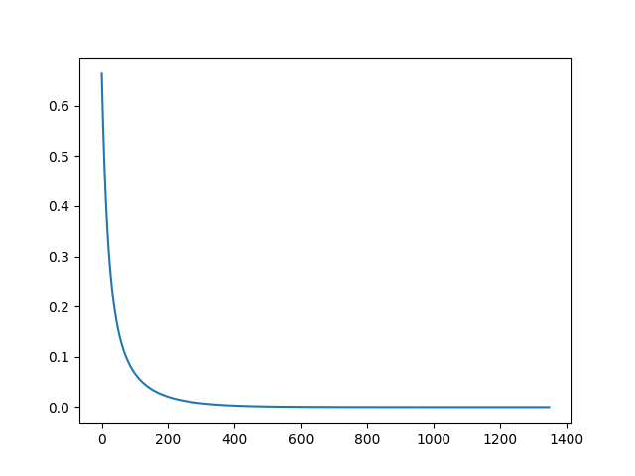

Easy, 0.5

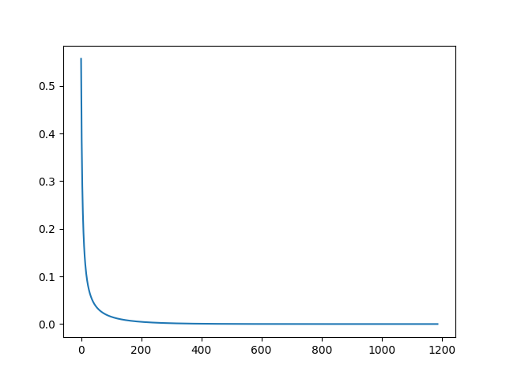

Easy, 0.05

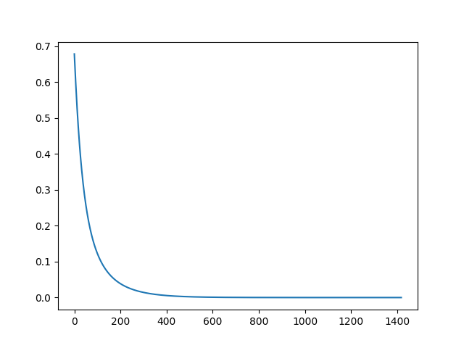

Medium, 0.1

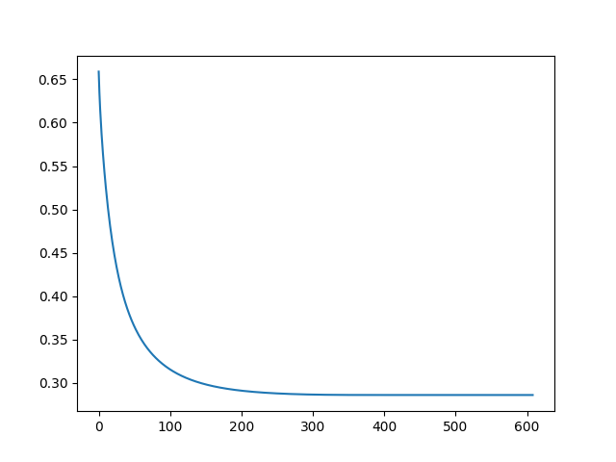

Medium, 0.5

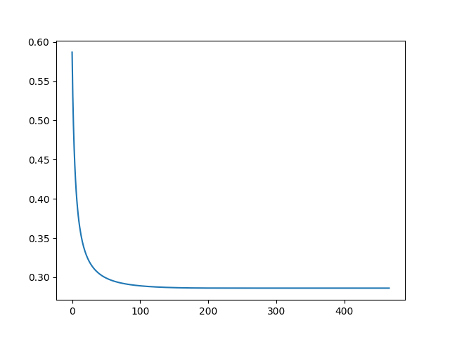

Medium, 0.05

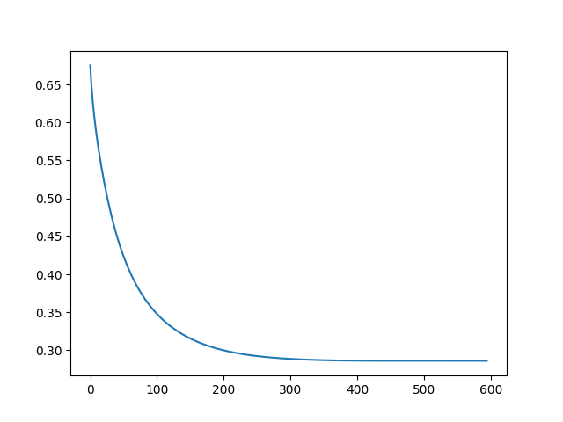

Hard, 0.1

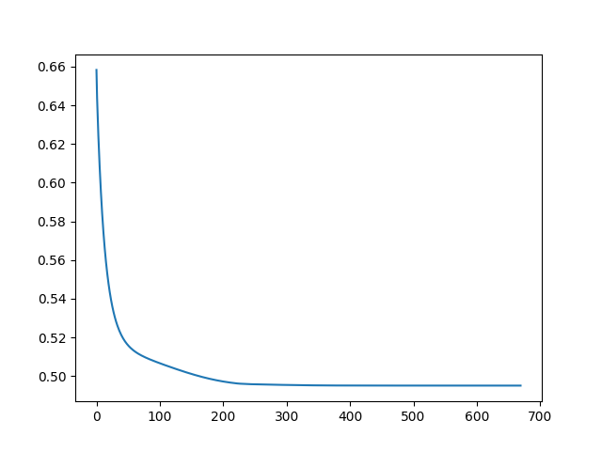

Hard, 0.5

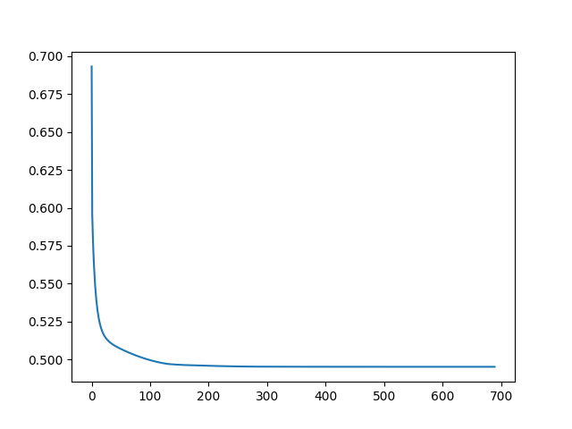

Hard, 0.05

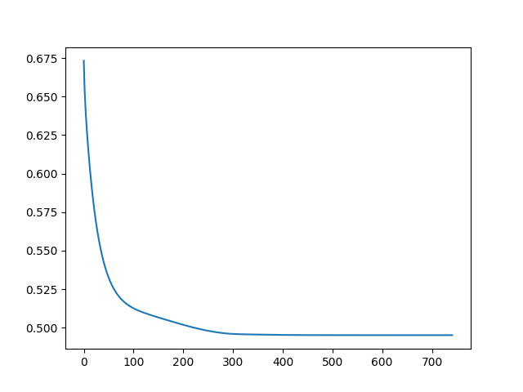

# Multi-label

**Math formula:**

Cross-entropy:

$-1/N * \sum_{i = 1}^{N}{}(y^{(i)}log(h^{(i)}))$

Cross-entropy grad:

$1/N * X^{T}∙(\hat{y} - y)$

**Code functions:**

Softmax: The softmax function

Pred: calculate H based on x and w

Cost_function_multi: to calculate cost of current w

Cost_function_grad_multi: calculate the grad of current w

Gradient_descent_multi: calculate the next w based on grad and step size

**Results:**

Synthetic-easy:

Training Score: 1.0

Test Score: 0.98

Time 0m0.617s

Synthetic-medium:

Training Score: 0.82

Test Score: 0.72

Time 0m0.468s

Synthetic-hard:

Training Score: 0.68

Test Score: 0.56

Time 0m0.485s

iris:

Training Score: 0.986666666667

Test Score: 0.96

Time 0m0.777s

digits:

Training Score: 1.0

Test Score: 0.948832035595

Time 0m6.441s

**Graph:**

Easy, 0.1

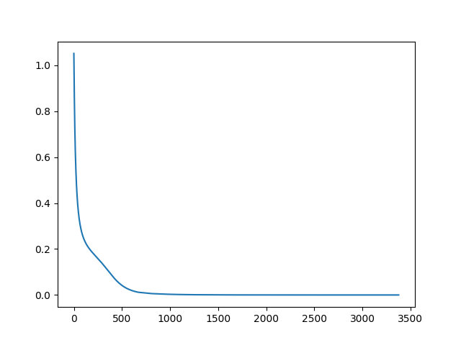

Easy, 0.5

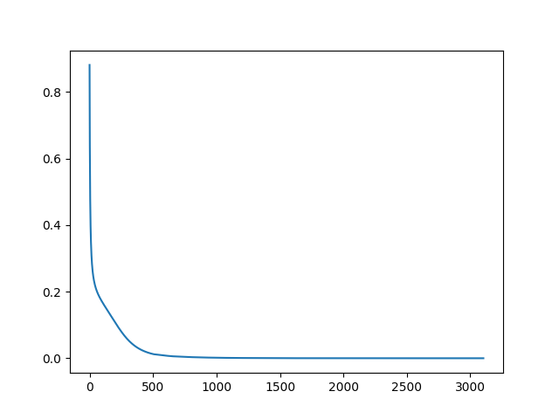

Easy, 0.05

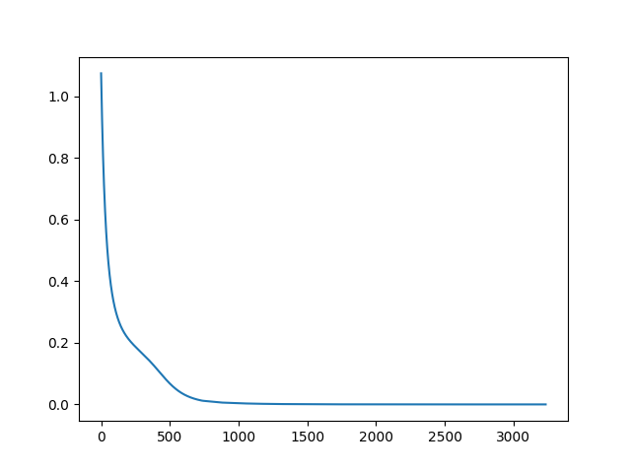

Medium, 0.1

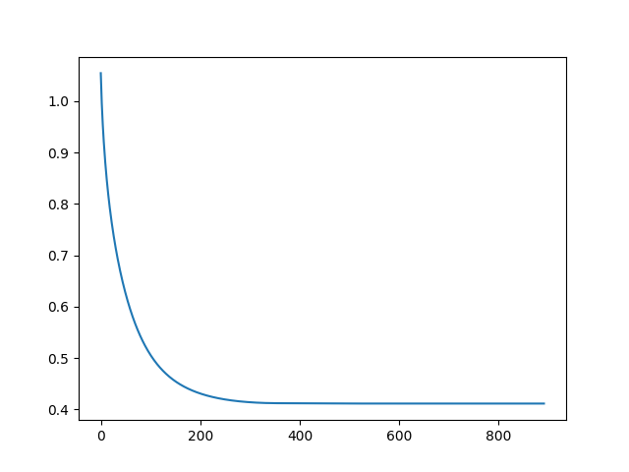

Medium, 0.5

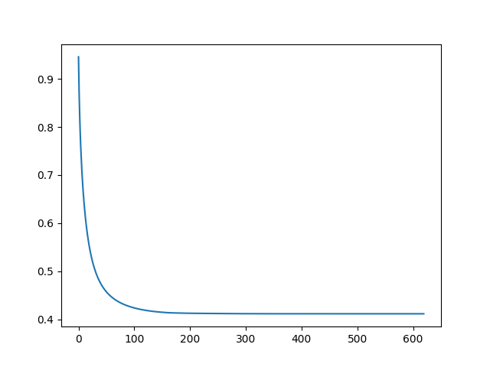

Medium, 0.05

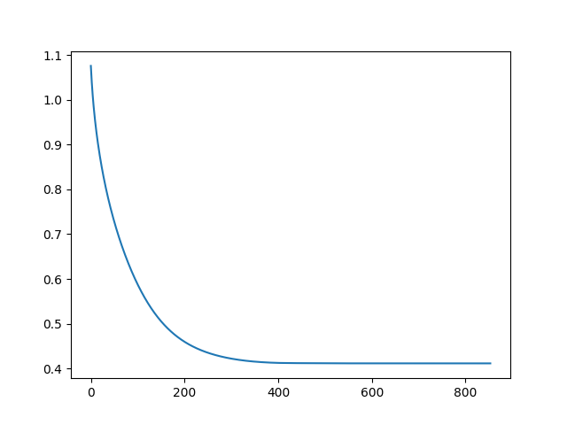

Hard, 0.1

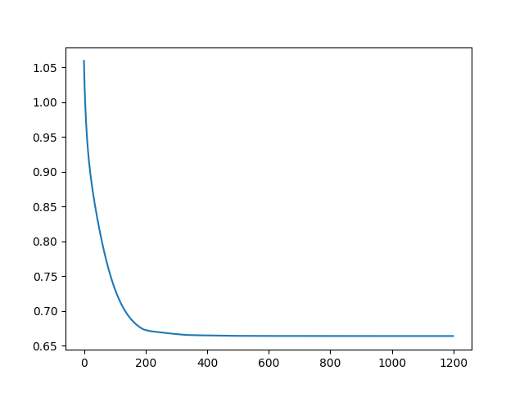

Hard, 0.05

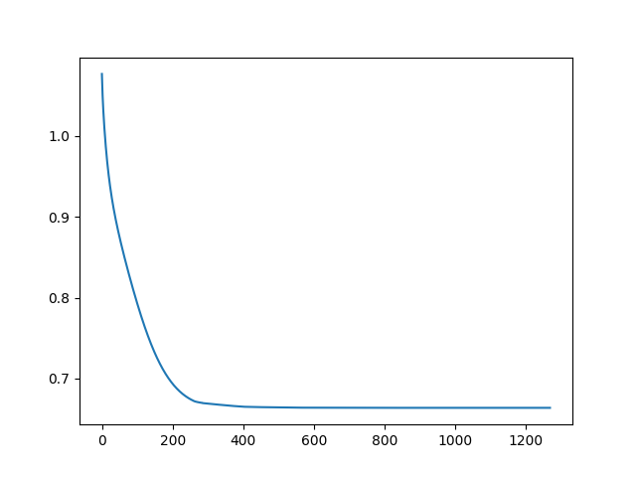

Hard, 0.5

