**The participation of Facebook group members with Social network analysis**

***Student name: Chia Wei Tu***

***Student ID:300289967***

purpose

Use python to write an automated program to capture the activity records of each group member in the Facebook Cypress snowboarding ride shared community within one month, including: the number of posts, the number of comments, and the number of emojis answered. Try to know who have more participation in the group. If there is a request want to go snowboarding with the shared ride, it is more convenient way to reach to the cypress mountain resort.

Capture who and when from the posts, messages, and emoji replies in the community. If the time is within this month, keep this record, and finally count the participation of each person.

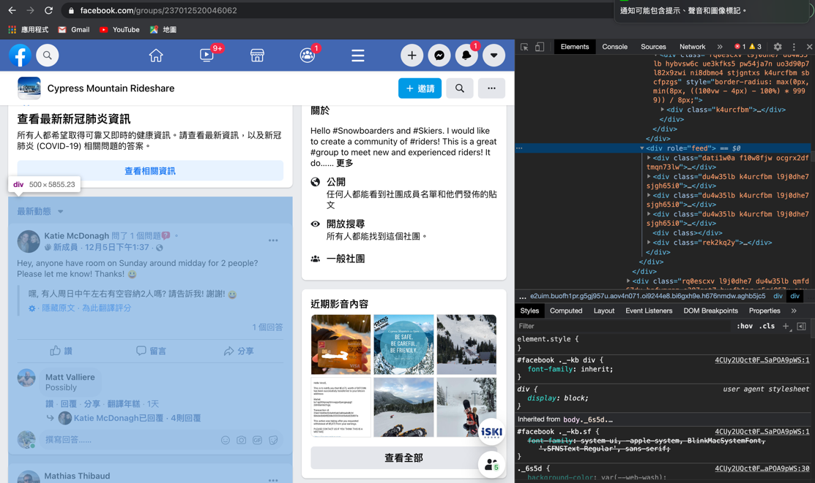

Many information needs to be clicked on to display

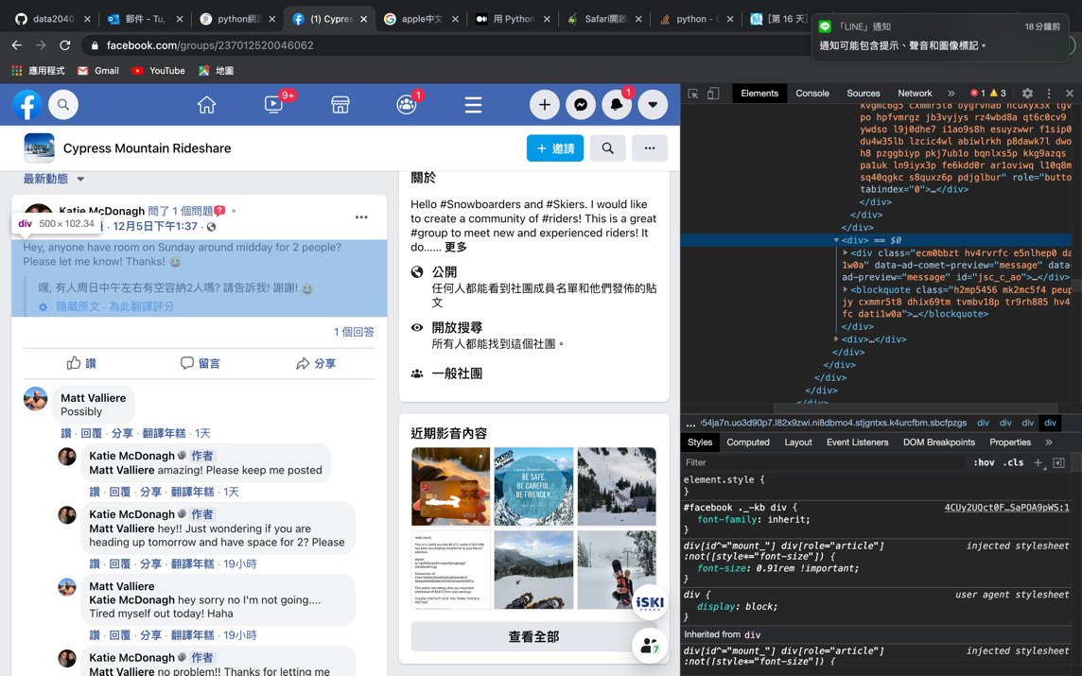

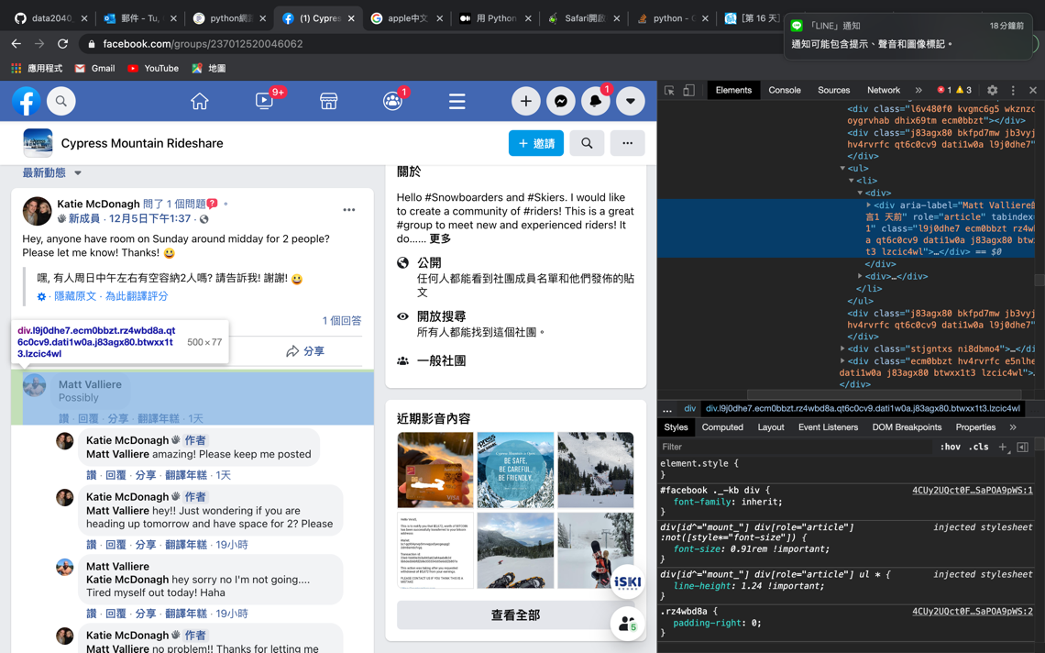

For the emoji part, I have to go to another tab to see those people who responded to this article or message at that time.

After clicking on the emoji, another small window will open, showing one by one what emoji the people responded to. We can also save the hyperlink here and go directly to the browser.

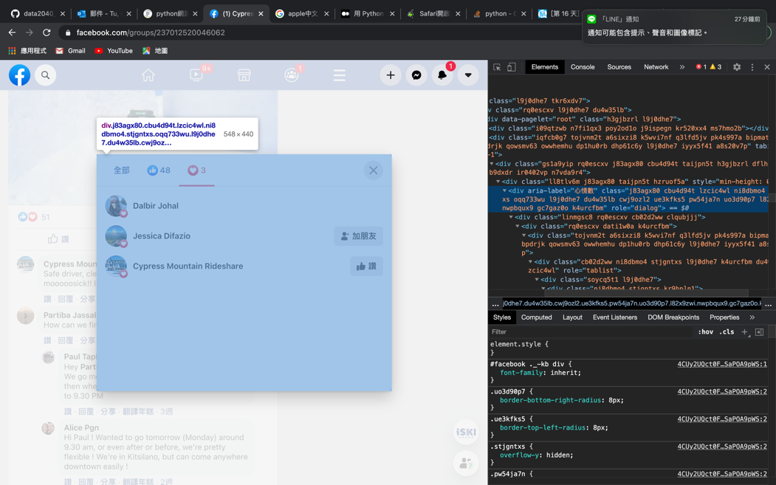

Steps:

1.Use selenium to log in to Facebook and go to the target club.

2.Operate selenium to scroll the page continuously. (The page of Facebook must be pulled down continuously, the old content will be displayed)

3.Operation selenium will view other X messages, OOO has replied, XX will reply, etc., open one by one.

4.Save the html source code of the current page.

5.Use beautifulsoup, re and other packages to parse the source code, and capture who posted and messages when.

6.If a post or message is within one month, the hyperlink of the reply emoji will be additionally stored.

7.Use selenium to go to the hyperlinks of the emoji one by one and record all the members in it.

8.Consolidate all the information and output the community meals and status of each member during this time.

Login facebook

Use selenium to open the browser, go to Facebook, enter the account password, and click login.

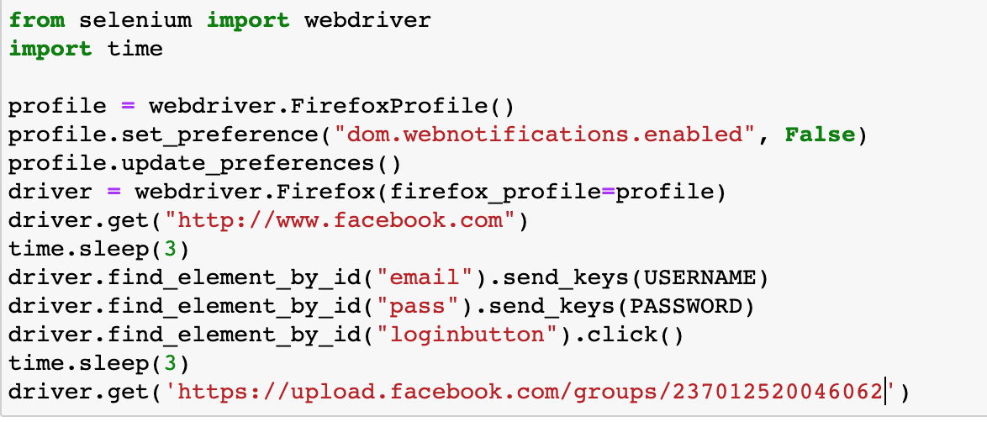

Scroll the window and click to hide the message

You need to scroll down the window so that the content will appear on the page source code. According to the enthusiasm of the community, if there are many posts, you must continue to scroll down to include all the posts within a month.



Parse the source code

To obtain the source code of the website and analyze it, I first use beautifulsoup to select the area of ​​each post and message, and then compare the crawling time and member ID with the regex string. The source code has the time in unix format. I use datetime for simple comparison and set the start and end dates to set the time range. If there is an emoji reply, leave the link URL and need to crawl again with selenium.

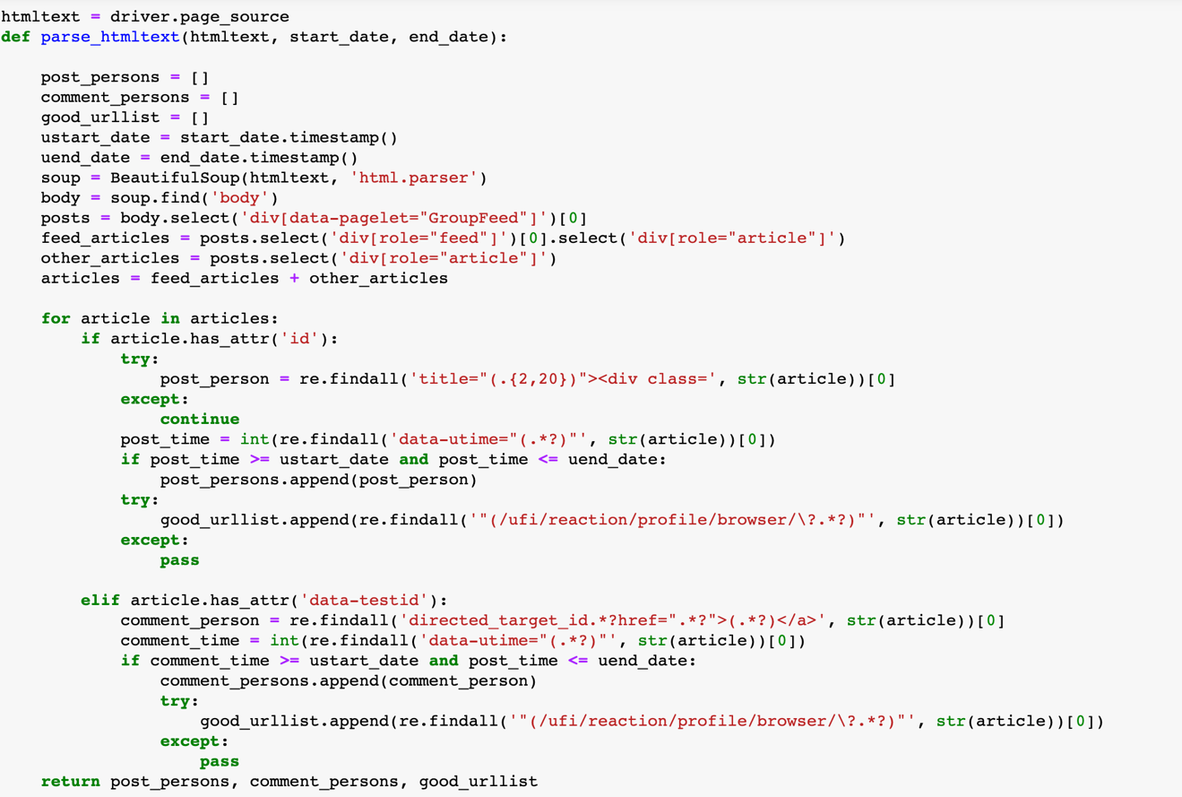

Get the emoji again

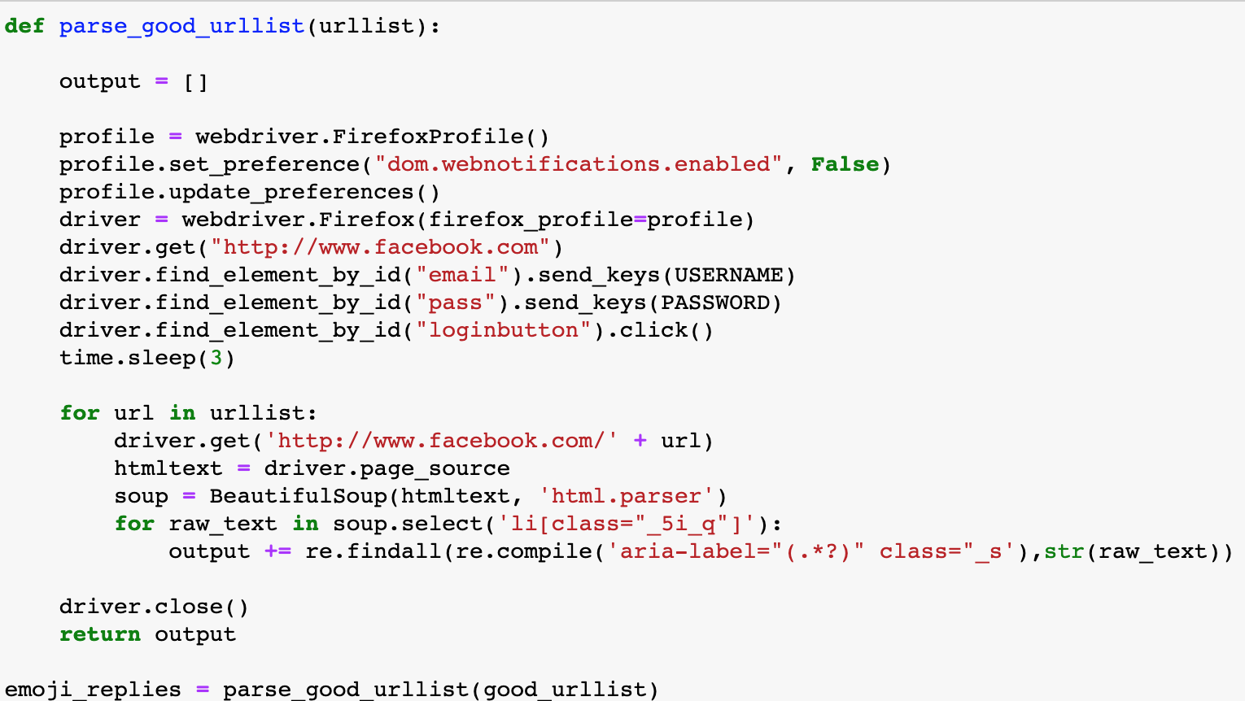

Organize data and output the data to excel

Convert the post_persons, comment_persons, and emoji_persons produced earlier into counts, and then package the results into excel files for output.

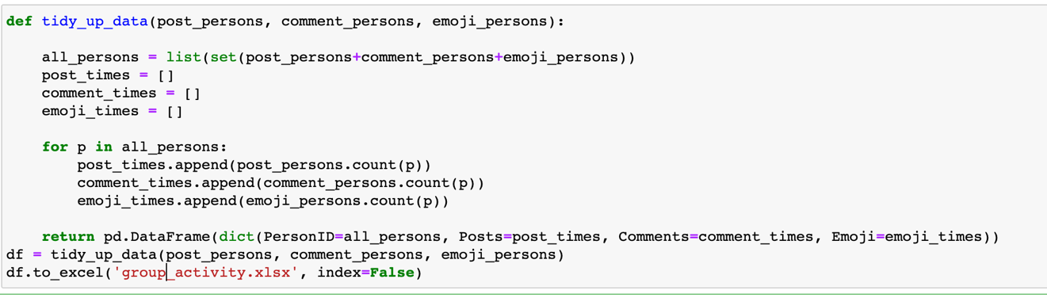

Output the final result as group_activity.xlsx, the output data is as follows:

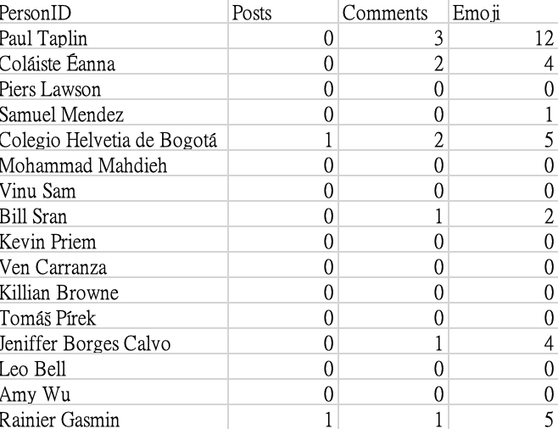

**Result**

Hence, we can through the dataset to know who has most posts (provide seats or asking the available ride) or comments and try to get in touch with the person and shared the ride to cypress mountain.