Machine Learning Homework 7
Kernel Eigenfaces, t-SNE
ChiaLiang Kuo 310552027
Github :

I. Kernel Eigenfaces

Code and Experiments Results

- PCA , LDA
For PCA, we are going to find the projection matrix W and find 25 first eigenvectors with largest eigenvalues, where the eigenvector is also named as eigenfaces. The x in the function below is a N*(W*H) matrix, where N stands for the number of images and W and H are the width and height of the image. Here I provide 2 versions of PCA implementation which will get the same results. The key idea is that A@A_T and A_T@A have the same non-zero eigenvalues.

First implementation of PCA:
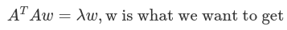
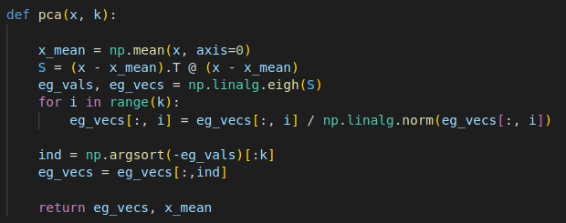

Second implementation of LDA:
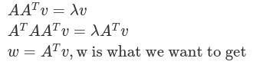
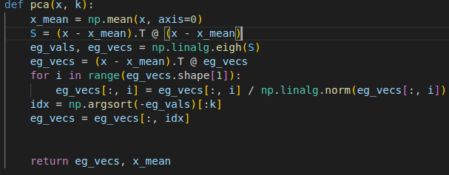
The first implementation compute the eigenvectors by the covariance matrix (X - mean).T @ (X - mean) of size (W*H, W*H). Due to the time complexity issue and the capacity issue, we can use more efficient approach : first compute the eigenvectors of matrix (X - mean) @ (X - mean).T of size N*N, then get the true eigenfaces by computing (x - mean).T @ eigenvectors.

The 25 eigenfaces are shown below :
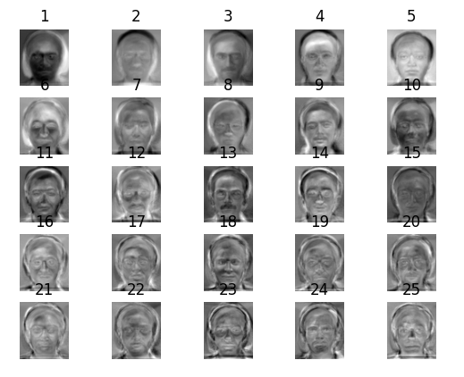
Face reconstruction for random 10 images :

We can reconstruct the face by the code snippet below. Which will first reduce the dimension from W*H to 25 then recover to W*H by using the same eigenvectors set.
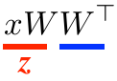

true faces
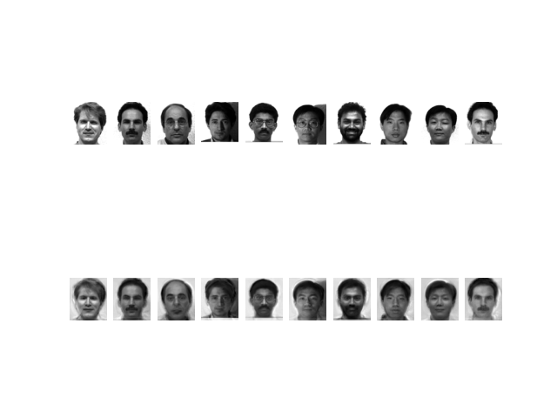
reconstructed faces
In LDA, we will also use eigenvectors corresponding to the first 25 largest eigenvalues to compute the fisherfaces and do the face reconstruction process.

In order to compute the W matrix like what PCA does, we need to compute two scatters : within-class scatter and between-class scatter:

within-class scatter:
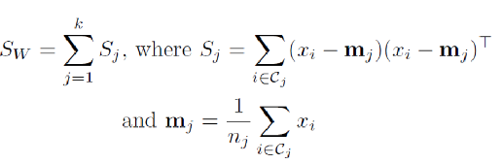
between-class scatter:
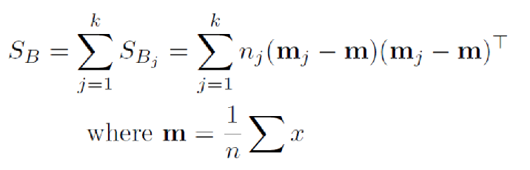
and then we will get :
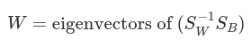
The full implementation of LDA:
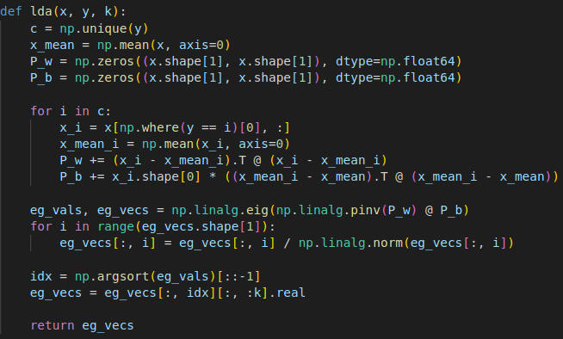

In practice, I will first reduce the image dimension to 50 by PCA, and then use both the eigenvectors of PCA and LDA to compute the true fisherfaces. See the code snippet below:
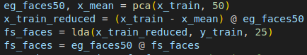

The 25 eigenfaces are shown below :
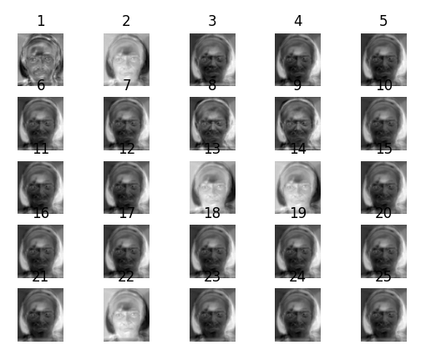
Face reconstruction for random 10 images:
(Top : true faces, bottom : reconstructed faces)
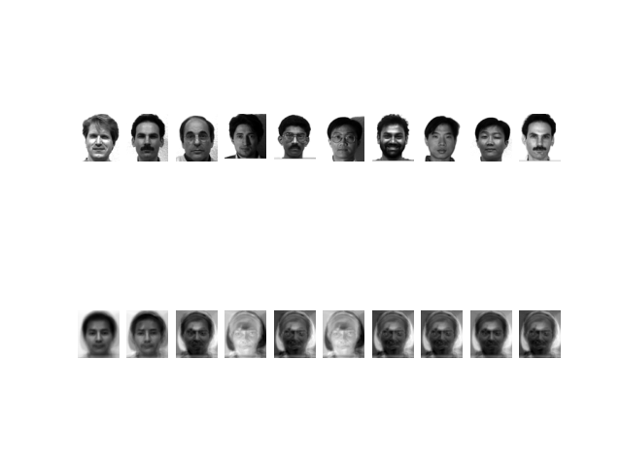

- Face recogntion
This part we will use KNN algorithm to judge that each face belongs to which subject.
The KNN implementation is shown below. Here I will use different k to do the prediction (k = 1 ~ 10) and compare the results

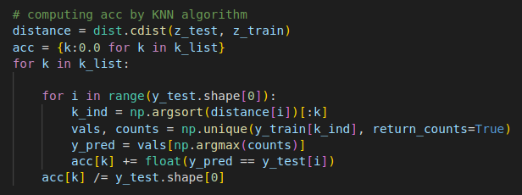
Next I will use bar chart to visualize the prediction result accuracy for each k

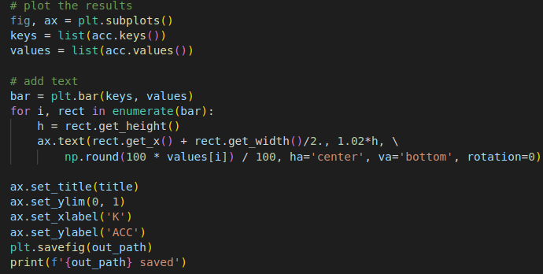

Accuracy of PCA face recognition:
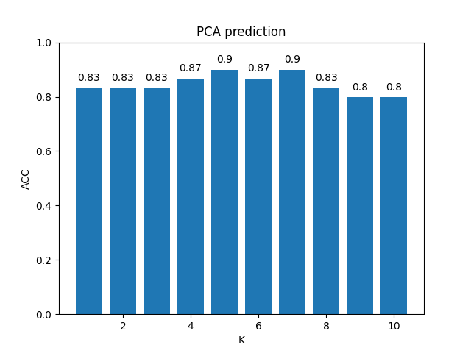

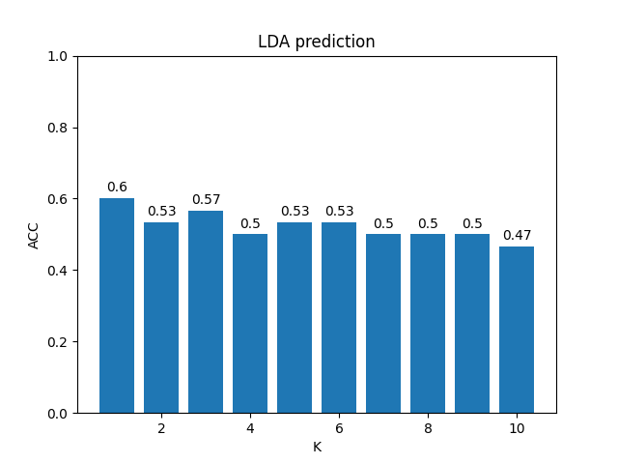
Accuracy of LDA face recognition:

- Kernel PCA/ Kernel LDA

In my implementation, I will use linear kernel, polynomial kernel with degree 3 and gamma 0.001 and RBF kernel with gamma 0.001.

For kernel PCA, an important thing is that after computing the gram matrix of the original data, we need to do the following mapping to the final matrix that we will use it to compute the eigenvectors:
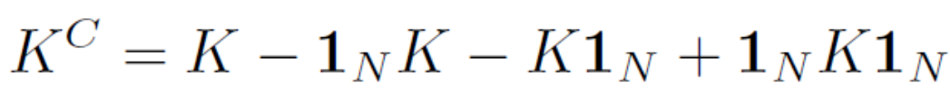
The code is shown below :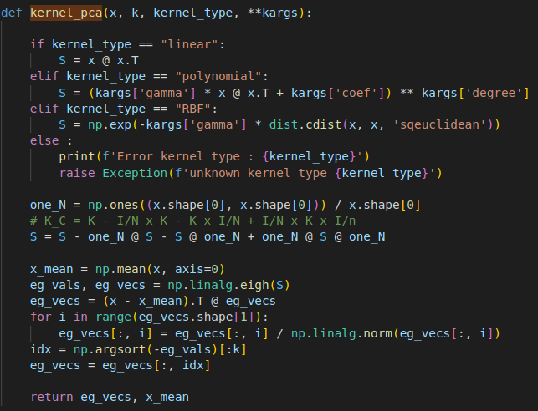

For kernel LDA, like mentioned in the previous section, I will use the dimension reduction result as the input of PCA (from W*H to 50), so the kernel type of LDA is followed by kernel PCA. Actually, the LDA function is the same as the original LDA, the only difference is the input comes from the kernel PCA.
See the code snippet below:

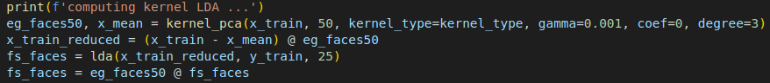

First 25 eigenfaces and 10 face reconstructions by Kernel PCA(Linear):
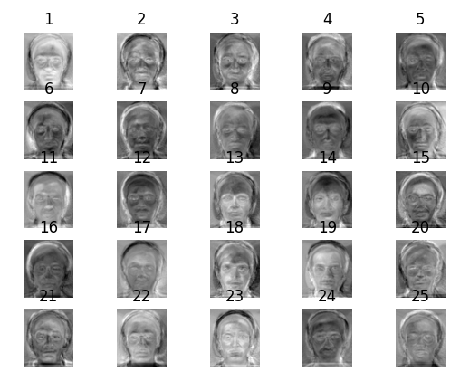
(Top : true faces, bottom : reconstructed faces)
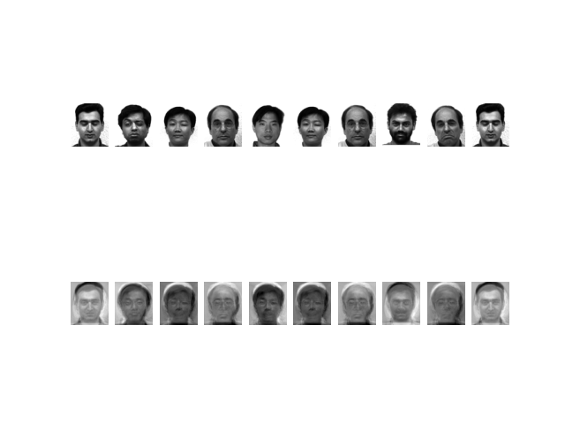
Face reconstruction by Kernel PCA (Linear):
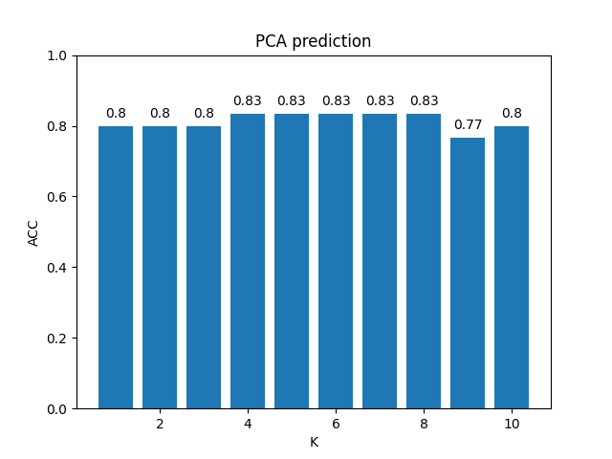
First 25 fisherfaces and 10 face reconstructions by Kernel LDA(Linear):

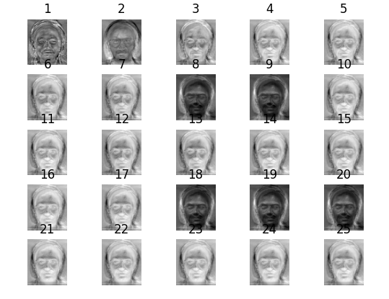
(Top : true faces, bottom : reconstructed faces)
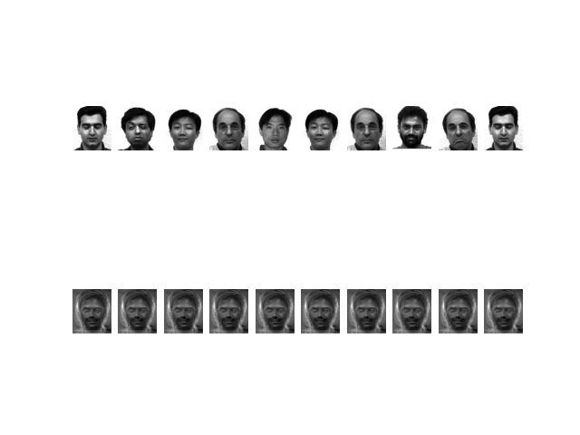
Face reconstruction by Kernel LDA (Linear):
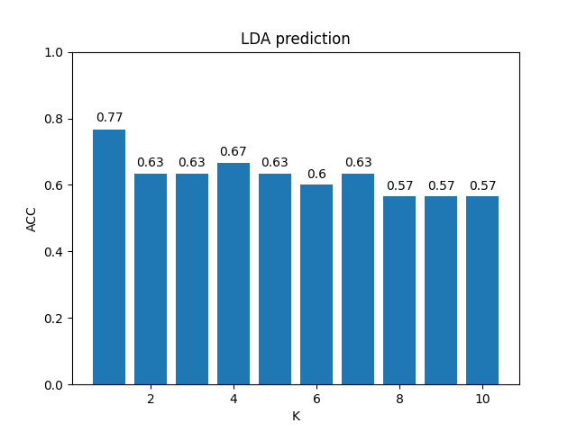
First 25 eigenfaces and 10 face reconstructions by Kernel PCA(Polynomial):
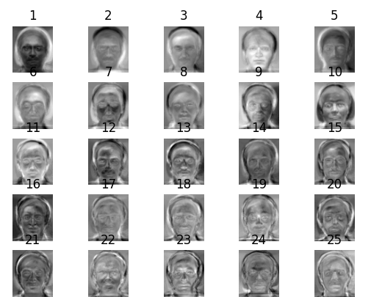
(Top : true faces, bottom : reconstructed faces)
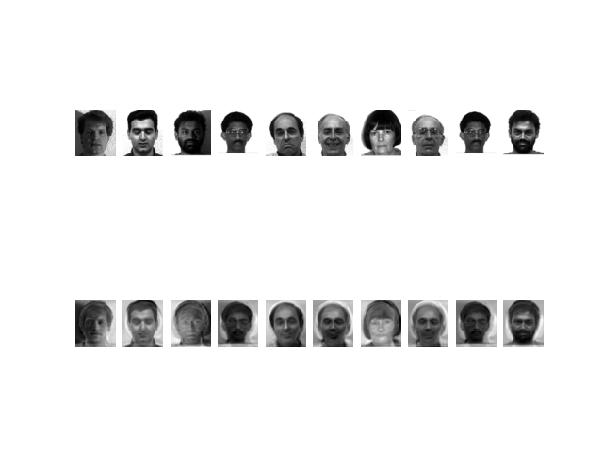
Face reconstruction by Kernel PCA (Polynomial):
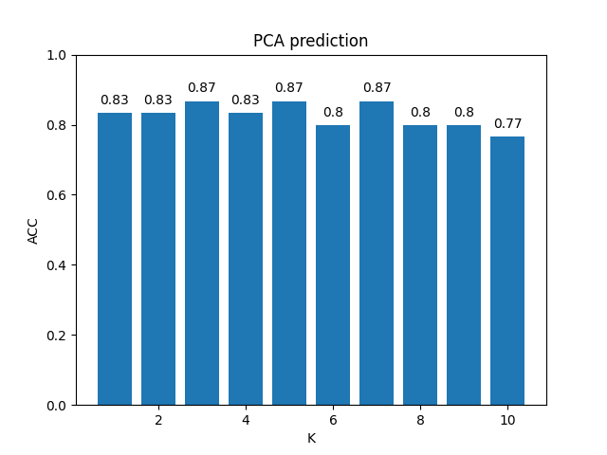
First 25 fisherfaces and 10 face reconstructions by Kernel LDA(Polynomial):
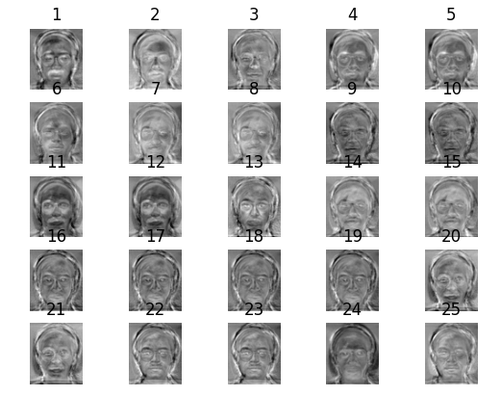
(Top : true faces, bottom : reconstructed faces)
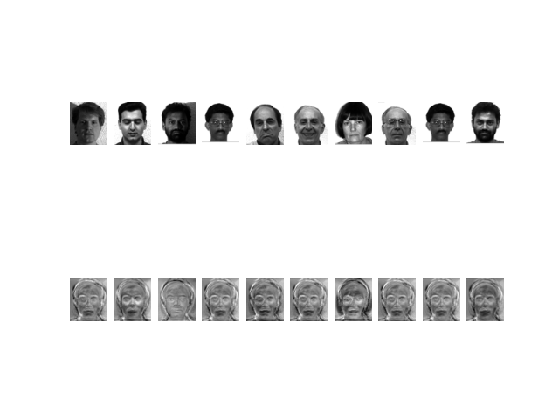
Face reconstruction by Kernel LDA (Polynomial):
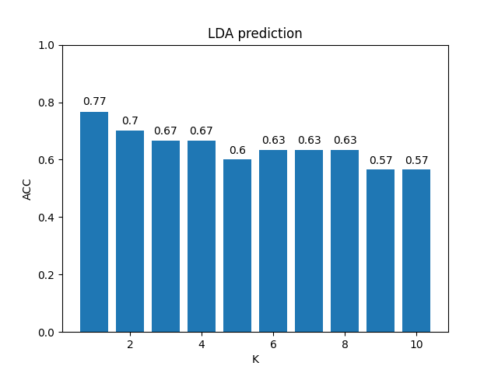
First 25 eigenfaces and 10 face reconstructions by Kernel PCA(RBF):
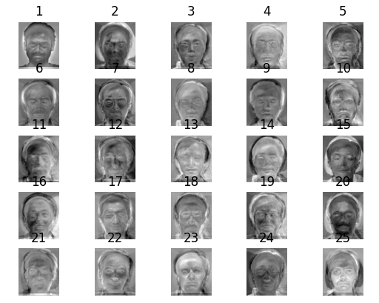
(Top : true faces, bottom : reconstructed faces)
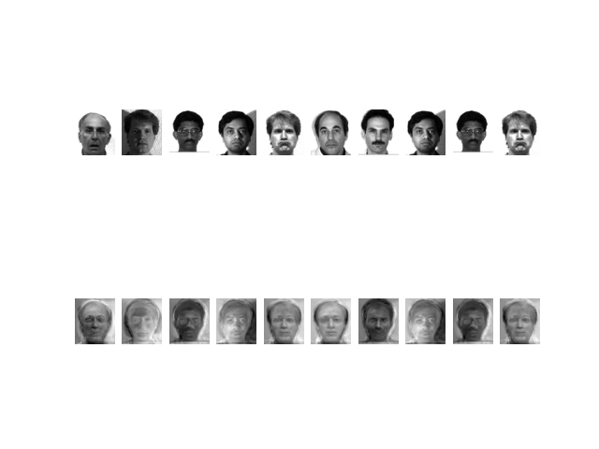
Face reconstruction by Kernel PCA (RBF):
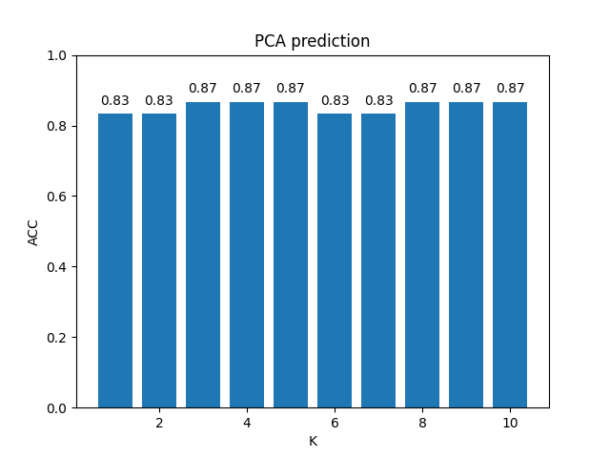
First 25 fisherfaces and 10 face reconstructions by Kernel LDA(RBF):
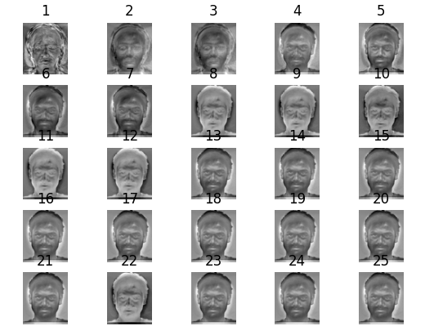
(Top : true faces, bottom : reconstructed faces)
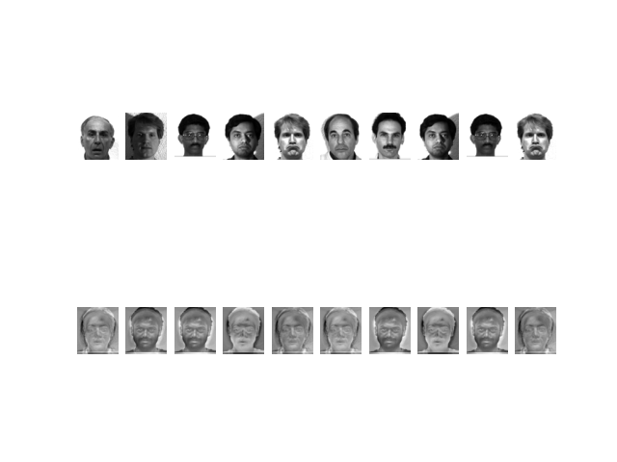
Face reconstruction by Kernel LDA (RBF):
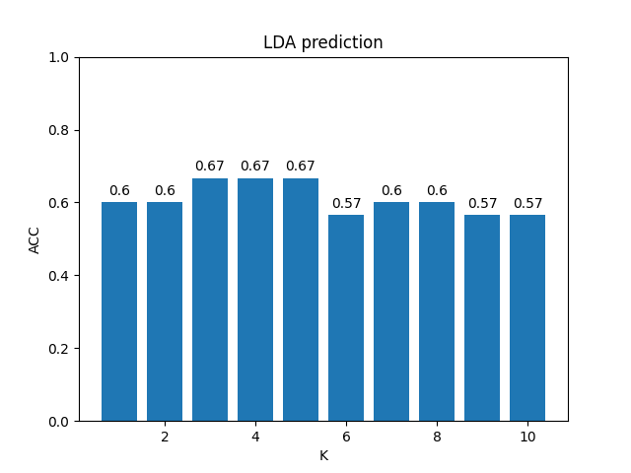
- Discussion

  - PCA and LDA

For PCA, the second implementation mentioned in the previous section is a good choice. Because no matter what resolution I chose, the matrix to compute the eigenvectors is in a constant size (135 * 135), which 135 is the image numbers. As a result, computing the eigenfaces is quite efficient.

For LDA, I also try to input the original data instead of the output of PCA, the top 25 fisherfaces and the face recognition results are shown below:

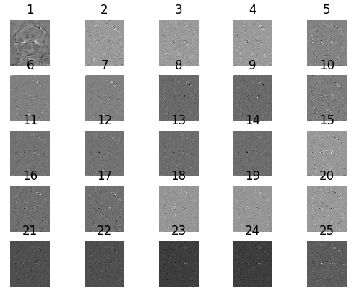
(Top : true faces, bottom : reconstructed faces)
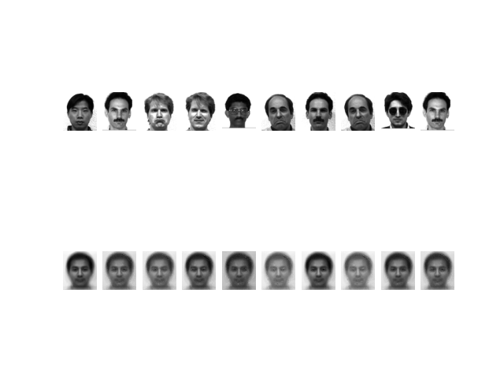
We can see the top 25 fisherfaces are quite noisy that only the first fisherface
can be recognized as a human face. The face reconstruction results seem hard
to distinguish the faces belonging to which subject.

  - Face recognition

From the results image shown in the previous section about face recognition,
I discovered that PCA outperforms LDA by using KNN as the prediction
method. PCA prediction results are about 0.8 in accuracy, while LDA are
about 0.6 in accuracy. Besides, k in 1~10 doesn’t affect the PCA results a lot,
while LDA performed the best when k is the smallest (k = 1). The larger k
would lead to worse prediction results in LDA.

  - Kernl PCA, Kernel LDA

On Average, different kernels in PCA don't perform much differently.
Besides, I found that the original PCA performed no worse than the kernel
PCA. In contrast, linear kernel or polynomial kernel for LDA seemed better
than the RBF kernel according to the prediction accuracy. Furthermore, I also
found that kernel LDA outperformed LDA a lot on the prediction accuracy.
The prediction accuracies of kernel LDA are averagely 0.1 higher than the
original LDA.

Actually, I also tried another way to implement the kernel LDA. I read this
(https://en.wikipedia.org/wiki/Kernel_Fisher_discriminant_analysis) to get the
formula of the kernel LDA, which we need to compute two matrix M, N :

N matrix :
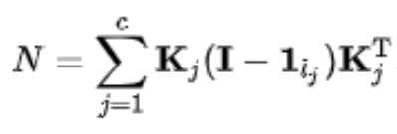
M matrix :
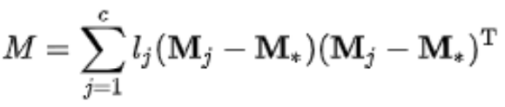
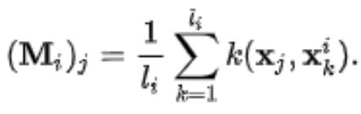
where
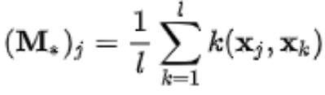
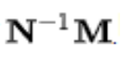
and the target eigenvectors can be computed from the matrix :
The implementation code :

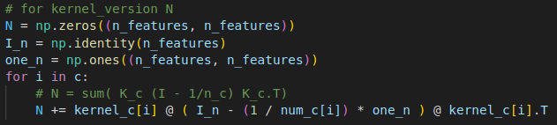
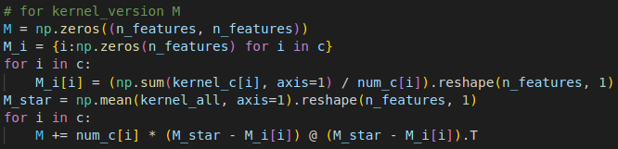
The results of this implementation is like what I mentioned previously :
fisherfaces will be quite noisy (see example below), I’s not sure is this result
correct or not, maybe I mislead the meaning of the wiki page.

25 fisherfaces by LDA with polynomial kernel:

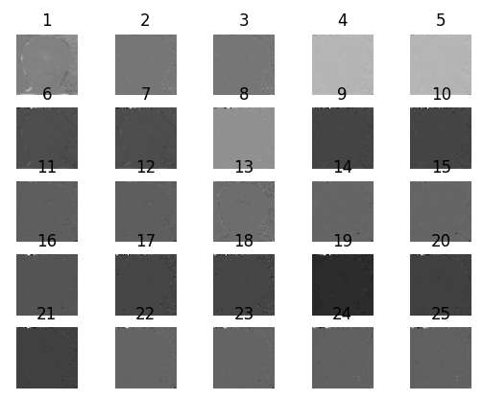

10 random subjects’ face reconstruction:

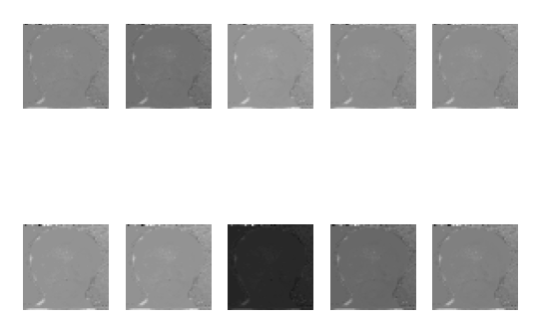

II. t-SNE

Code and Experiment Results

- Code modification for symmetric SNE
There are two things we need to modify in the example t-SNE python
code:

(1) the low dimensional distribution function q.

in t-SNE :
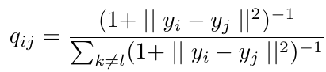

in symmetric SNE
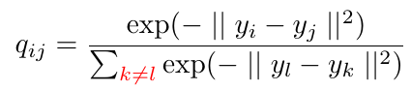

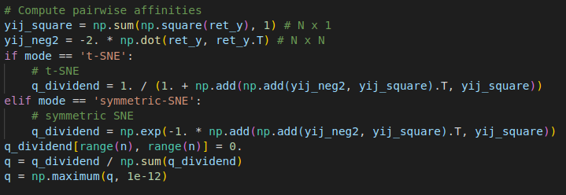

(2) the gradient of the cost function (KL divergence between p and q).

in t-SNE :
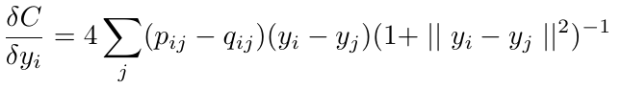

in symmetric SNE
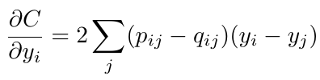
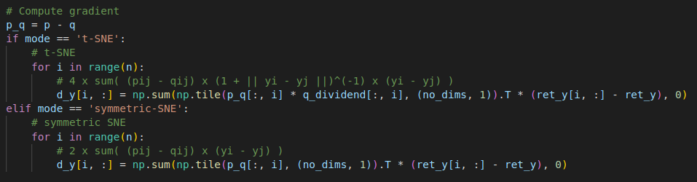

- Visualize the embedding of both t-SNE and symmetric SNE

For visualization, I used the code snippet below to show the two dimensional embedding for both SNE methods. Additionally, I store the image frames per 10 iterations and then save them to the .gif files. Because .gif files cannot shown in pdf format, I will put them in the assignment folder.

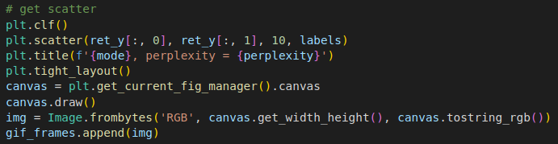
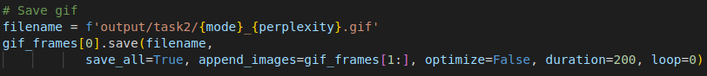

Two dimensional embedding by both symmetric SNE and t-SNE:

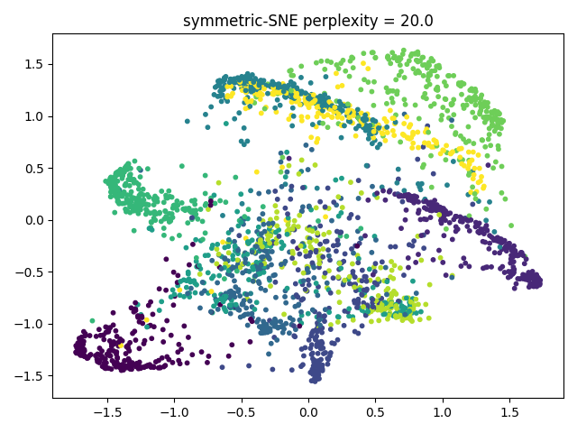
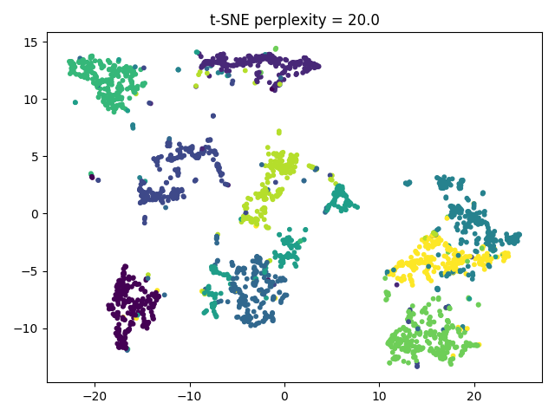

- Visualize the distribution of pairwise similarities

I used the following code to visualize the pairwise similarities for both high
dimensional results and low dimensional results.

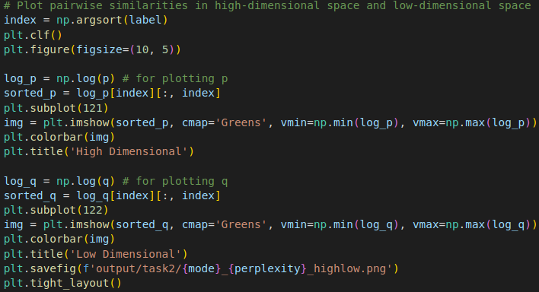

High dimension vs Low dimension by symmetric SNE:
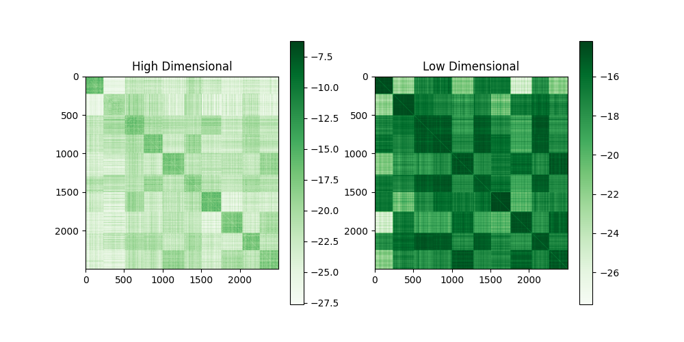
High dimension vs Low dimension by t-SNE:

- Try different perplexity values (PNG)

In this section, I applied 20, 30, 40, 50 as the perplexity values.

Two dimensional embedding by symmetric SNE and t-SNE (perplexity = 20) :

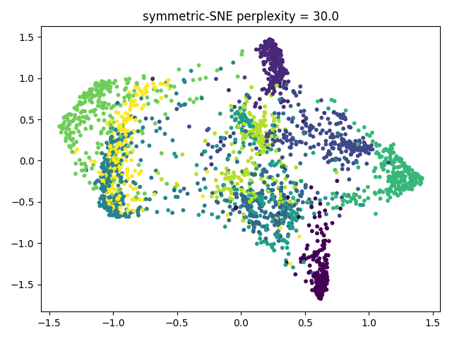
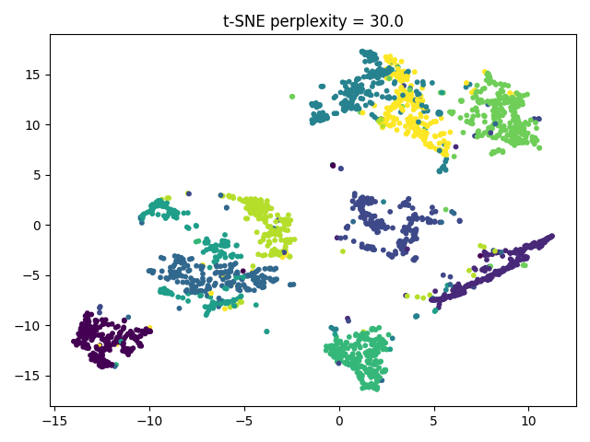
Two dimensional embedding by symmetric SNE and t-SNE (perplexity = 30) :

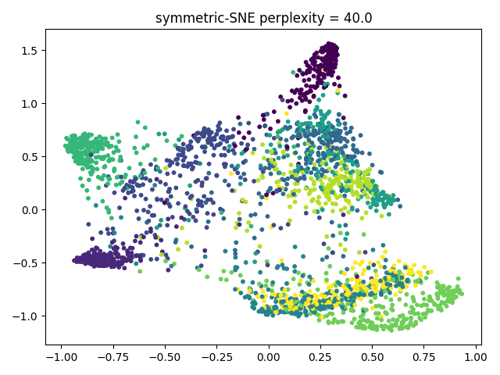
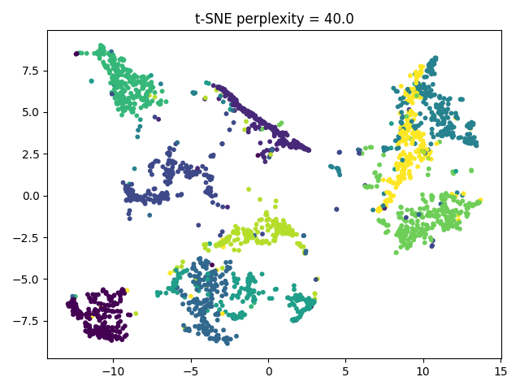
Two dimensional embedding by symmetric SNE and t-SNE (perplexity = 40) :

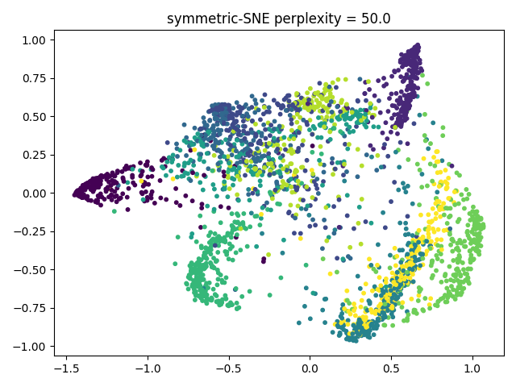
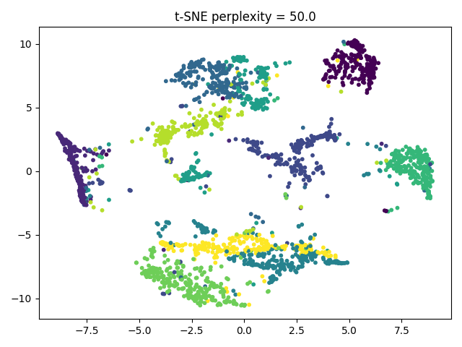
Two dimensional embedding by symmetric SNE and t-SNE (perplexity = 50) :

Try different perplexity values (GIF)

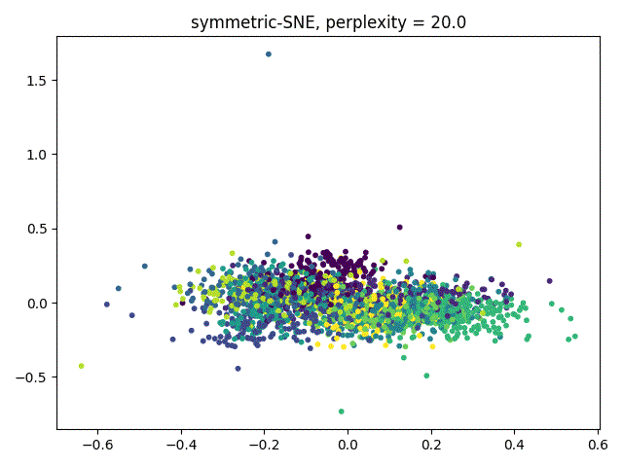
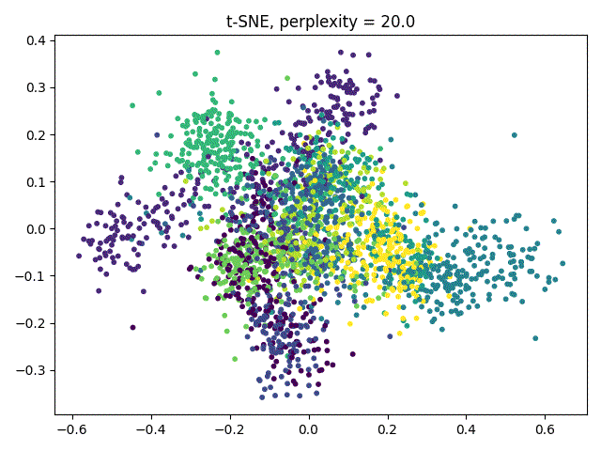
Two dimensional embedding by symmetric SNE and t-SNE (perplexity = 20) :

Two dimensional embedding by symmetric SNE and t-SNE (perplexity = 30) :
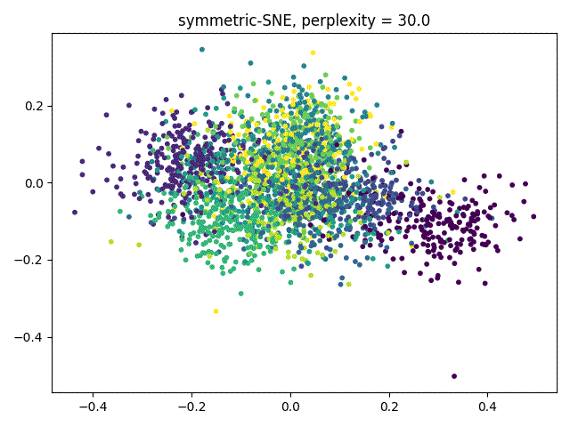
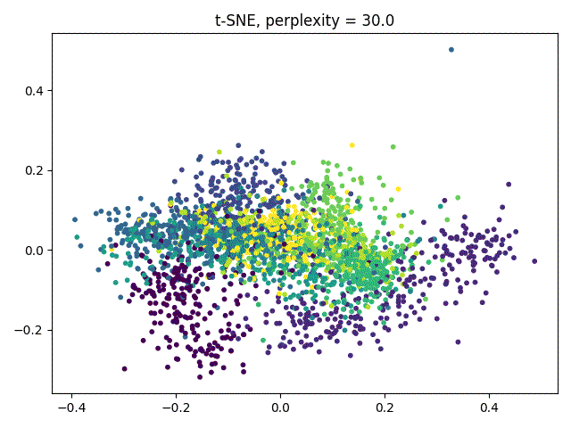

Two dimensional embedding by symmetric SNE and t-SNE (perplexity = 40) :
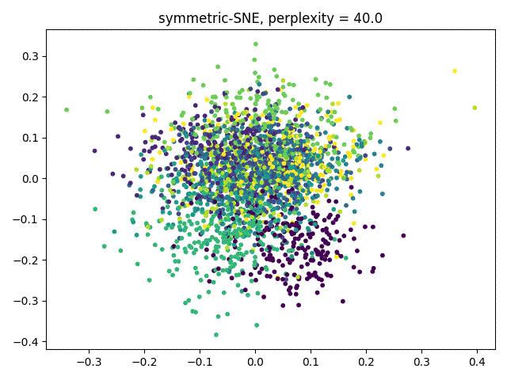
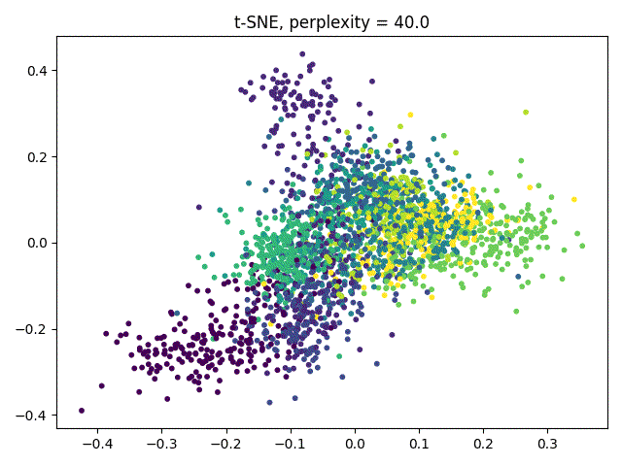

Two dimensional embedding by symmetric SNE and t-SNE (perplexity = 50) :
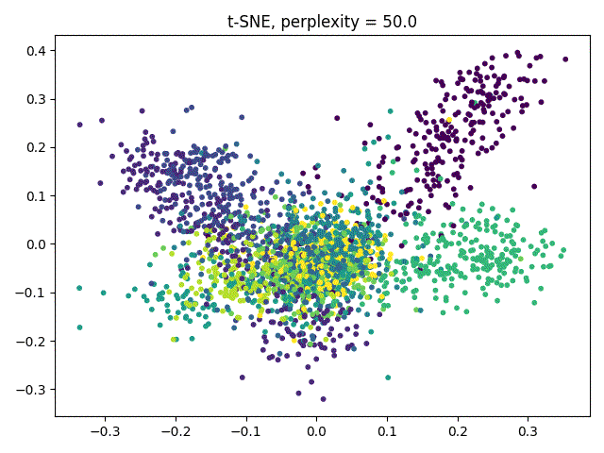
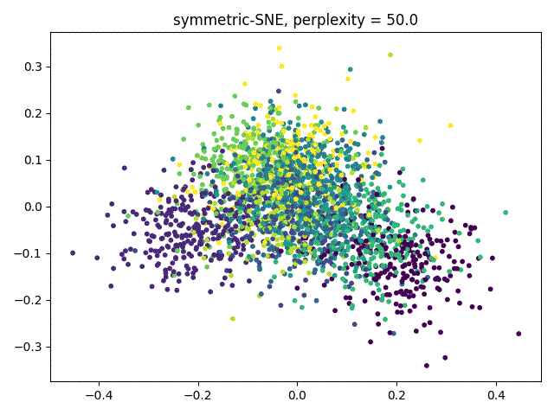

- Discussion
Based on the experimental results shown above, I will list some observations.

From the scatter graphs above, we can learn that symmetric SNE suffers from the
crowded problem. On the other hand, t-SNE uses t-distribution to alleviate the
crowded problem. Points that are far away from each other in high-dimensional space still have far distances from each other in low-dimensional space.

Perplexity in SNE will affect the number of neighbors to be considered. Theoretically, larger perplexity numbers will make the algorithm less sensitive to the smaller group. Because symmetric SNE suffers from the crowded problem, the effect of perplexity is not clear. However, the effect of perplexity is clear in t-SNE as it gets larger.

