Deciphering Market Structure: Systemic Risk and Portfolio Optimisation in the S&P 500
Student ID: u5693885 | Module: CS910 | Date: January 2026

Abstract

This paper focuses on the structure of the S&P 500 index for 2019–2024 based on high-dimensional data analysis. The aim is to identify the primary sources of stock market volatility and to assess whether simple, data-driven tools can support better portfolio decisions under different market conditions. At the heart of this is the so-called “curse of dimensionality”: as the analysis moves from a handful of individual stocks to hundreds or even thousands of assets, it becomes non-trivial to separate true systemic risk (what’s happening across the whole market) from idiosyncratic noise (fluctuations in individual stock prices).

To overcome this, we apply three unsupervised methods: PCA (Principal Component Analysis), K-means clustering and rolling-window approach. PCA transforms hundreds of daily return series into a small set of dominant factors; K-means clustering groups stocks with similar correlation profiles, while rolling PCA reveals how important the leading factor becomes over time. The empirical findings indicate that the S&P 500 is relatively integrated: the first principal component accounts for about 40% of the cross-sectional variance in daily returns and has a strong exposure to mega-cap technology stocks like NVIDIA, Microsoft, and Apple. This implies that simple index-based exposure is far more concentrated than it appears at first sight. We also note that systemic risk exhibits a high degree of time variation. In the March 2020 COVID-19 crash, the share of variance explained by the first component jumps to nearly 60%, showing a “correlation convergence” episode where diversification across individual names is largely eradicated. A cluster-analytical approach reveals that, particularly, the clusters Energy and Technology display low, or even negative, correlations during the inflation shock of 2022, implying statistically significant hedging possibilities. Finally, we generate an optimal frontier for cluster-based portfolios and simulate 5,000 random allocations as a comparison. The top performing cluster-based portfolio earns a Sharpe ratio that is significantly better than the median naïve portfolio, which shows that straightforward unsupervised techniques can contribute to a better risk–return trade-off compared with equal-weighting.

1. Introduction

1.1 Background: The Complexity of Modern Markets
The financial market today generates a large amount of data every day. Data such as prices, trading volumes, index levels, and industry returns are frequently observed, often involving hundreds or even thousands of assets at a time. From an information extraction perspective, quantitative analysts are not interested in acquiring the data itself, but rather in extracting signals from the random noise in this high-dimensional world.
Classic asset pricing models, including the Capital Asset Pricing Model (CAPM), assume that the market is a simple linear world: the expected return of an asset is a linear function of its beta coefficient. In this context, it is typically assumed that a single fundamental market factor is the primary driver of all stock returns. However, recent research on "decoding stock market dynamics" indicates that this model is overly simplistic for contemporary markets, as correlations can arise across multiple time scales and industries [1]. In reality, large market fluctuations are often not driven by a single linear factor but by multiple factors, such as macroeconomic news, industry shocks, and investor behaviour.
The stock market crash because of the COVID-19 pandemic in 2020 undoubtedly vividly illustrates this point. This crisis is often referred to as a "black swan" event: it arrives unexpectedly, sweeps through markets with lightning speed, and causes a sharp increase in correlations between many assets [2, 5]. In such a crisis, the traditional diversification strategy of "holding a variety of different stocks to mitigate risk" becomes less effective. This is precisely the motivation for this study: modern high-dimensional data techniques are used to quantify the degree of correlation among S&P 500 constituents, to track how this correlation changes with market conditions, and to evaluate whether data-driven tools can manage risk more effectively than simple linear models.

1.2 Theoretical Framework and Literature
The study is based on three theoretical frames that inform the method design and interpretation.
First, systemic risk measurement. Danielsson et al. [3] argue that for systemic risk, both sides have gone too far: the very complex structural models so beloved of policymakers generate more noise than light. According to the authors, “the simpler the better”: we need transparent and not model-heavy robustness. Motivated by this conjecture, we employ PCA to provide a non-parametric and crude summary of the degree of integration in the S&P 500. Intuitively, when a significant percentage of the total variance is accounted for by the first few principal components, there are very few common factors that influence most stock movements, indicating strong market integration. These observed factors can be thought of as a reasonable data-based analogue to the multi-factor structure imagined in APT, without pre-specifying macroeconomic variables.
Second, regime switching and non-stationarity. An expansive literature has also modelled financial markets as systems that transition between regimes (in the spirit of “calm” versus “crisis”), typically using Markov-switching or related approaches [2]. The underlying lesson of such literature is that markets are non-stationary: asset relationships change over time, particularly in the proximity of stress events. Consistent with this interpretation, we use a rolling PCA method. Rather than estimating a single fixed set of eigenvalues and eigenvectors for the entire 2019–2024 sample, we iteratively re-estimate PCA on overlapping windows. This provides us with a means to monitor the evolution of the chief drivers and their explanatory power over the COVID-19 crisis and post-crisis episodes, delivering a dynamic image of integration and correlation collapse.
Third, advanced portfolio construction. Following Markowitz’s original work on mean–variance optimisation [7], what is nowadays called portfolio theory has been developed in many directions, ranging from sector-level allocation [8] to the more recent inclusion of climate and sustainability constraints into the optimisation problem [9]. A common demand in these extensions is a reasonable way of aggregating assets for the purpose of forming portfolios. In this paper, we form such groups directly from the data using K-means clustering: stocks with similar factor loadings and correlation profiles are assigned to be in the same cluster. These statistically defined clusters are used as the kernel portfolios to construct efficient frontiers and check if cluster-based portfolios can perform better than naive benchmarks on a risk-adjusted basis. Moreover, all return data and covariance inputs are produced via market prices derived from the Yahoo Finance API [10], guaranteeing that the empirical findings can be both transparently reproduced.
This study is guided by three basic questions:
(1) How interconnected is the S&P 500, and which stocks contribute most to its systemic risk?
(2) How do the correlation structures change between tranquil and turbulent time periods, in particular during the COVID-19 crash?
(3) Can portfolios of data-driven clusters outperform naive diversification as measured by the quality of the risk–return trade-off?

2. Data Engineering and Preprocessing Pipeline

Trustworthy quantitative work does not begin with models; it begins with clean and clearly defined data. In this work, the raw dataset is constructed by using the daily adjusted closing prices for all S&P 500 index components, obtained through Yahoo Finance API [10]. The sample period spans from 1 January 2019 to 31 December 2024, featuring a complete business cycle starting with the pre-COVID boom phase and covering the crash of 2020, the initial rebound from COVID-19, and finally entering into the new environment marked by regime shifts in inflation rates and interest rates. This large window ensures that our results are not caused by just one “special” year.

But financial time series at that scale are rarely complete. Due to market holidays, ticker changes, delistings, stock splits, or other more mundane reasons, such as API failure, real-world datasets often have missing prices. If we simply pass such raw data to PCA directly for clustering analysis, the resulting covariance and correlation matrices may be seriously expanded, causing misleading “factors” representing data problems rather than the structure of the real market. This is why having a transparent, predictable and systematic data engineering pipeline is crucial.

2.1 Data Cleaning Logic
Our data cleaning procedure follows two simple principles: Remove assets that are mostly missing. Repair small gaps in a way that respects financial reality. In Python, the logic can be summarised as:
# Python Implementation: Data Cleaning
threshold = 0.1 * len(df_prices)
# Step 1: Drop stocks with >10% missing data (e.g., recent IPOs)
df_clean = df_prices.dropna(thresh=len(df_prices) - threshold, axis=1)
# Step 2: Forward-fill to handle minor gaps, preserving market reality
df_final = df_clean.ffill().dropna()
Listing 1: Data Cleaning Pipeline
First, calculate a threshold, which is set to be 10% of the time series length. Remove completely any stock that does not have the daily price available on more than 90% of trading days (e.g., very recent Initial Public Offerings, such as Kenvue or GE Vernova). Intuitively, such “short histories” would lead to a sparse matrix where fine entries are missing. The machine learning approach is problematic with sparse data, which are not read for PCA, as this proximity measure assumes the observation of most variables (most stocks) at most dates when estimating covariances.
Second, after doing that, we still have to address a few missing values here and there for our other stocks. The critical question here is what to put in these gaps. Rather than filling in missing prices using a standard mean of all values (mean imputation), we use forward-filling, which merely carries the most recent available price forward as new price information is added. This choice is not arbitrary. In finance, prices are typically modelled as a random walk; today’s price is yesterday’s price plus some random shock. If we substituted missing values with the long-run average, we should artificially “drag” the series toward the centre and to underestimate its volatility, weakening, for instance, its true correlation structure. Forward-filling, on the other hand, follows reality more closely in that what (in truth) happens while the market is closed is simply that the price stays where it was.

Finally, we remove any remaining rows with missing values after forward-filling. We have, as a result, a data matrix where each column corresponds to a stock, each row to one trading day, and each cell is a valid adj close price. This matrix provides the data for all subsequent returns and covariance calculations.

2.2 Stationarity and Log Returns
Even after the price data are preprocessed, we encounter a second issue: stock prices are non-stationary. In other words, a series is said to be non-stationary if its mean and variance do not remain constant. Prices $P_{t}$ have the tendency to increase (or decrease) as companies expand, inflation builds or investor sentiment shifts. PCA and correlation-based methods, however, provide better results when the underlying series have more or less stable statistical characteristics.
To counter this, we convert prices to log returns, which are:
$$r_{t}=\ln\left(P_{t}\right)-\ln\left(P_{t-1}\right)$$
This transformation enjoys three crucial features:
- Approximate stationarity
Whereas prices meander over time, returns reverberate around a more stable average, which is often quite close to zero. Therefore, these would be more suited for PCA since it assumes the covariance matrix is well-behaved.
- Additivity over time
Log returns across multiple days are aggregated into a cumulative log return. This is useful if we later want to aggregate or compare performance over alternative horizons.
- Symmetry and scaling
Log returns smooth proportional moves pretty similarly: moving from 100 to 110 and from 200 to 220 gives you more or less the same log return. This is more natural than working with raw price differences, where a $10 change would mean very different things to cheap and expensive stocks.
Using daily log returns instead of raw prices to calculate financial data provides us with a data set for which the mean and variance are more stable between days and other assets. This is important for the soundness of correlation-based methods (PCA, K-means clustering are examples); without proper transformation of data on entry, the resulting “factors”, clusters, and efficient frontiers may amount to no more than trends and scale effects rather than true co-movement in the stocks being managed.

3. Methodology: Unsupervised Learning Algorithms
In this section, we describe how three unsupervised learning tools, PCA, K-means clustering, and rolling windows, are combined to analyse the structure of the S&P 500. All three methods share the same idea: let the data speak for themselves, without telling the model in advance which stocks belong to which sector or which days are “crisis days”.

3.1 Dimensionality Reduction: PCA
PCA (Principal Component Analysis) is applied for data reduction. Rather than solve the problem directly on hundreds of individual stock return series, PCA examines a matrix of covariances and extracts new axes, called principal components, in which most of the variation is captured. They are orthogonal, which means that they are independent of each other in terms of the information they encode.
The first Principal Component (PC1) is the direction in which the returns are most varying. In finance, this is commonly interpreted as a "market factor": strong PC1, and the fact that it represents a large share of total variance means most stocks are all under the thumb of some general force, like macro news or broad risk mood.
# Python Implementation: PCA for Systemic Risk
scaler = StandardScaler()
df_scaled = scaler.fit_transform(df_returns)
pca = PCA(n_components=10)
pca.fit(df_scaled)
explained_var = pca.explained_variance_ratio_
pc1_loadings = pca.components_[0]
Listing 2: PCA Implementation
Algorithmic Translation: We first normalise each financial stock’s return series by applying a StandardScaler that makes every single column have a zero mean and unit variance, prior to performing PCA. This step is critical: without scaling, expensive or more volatile stocks (e.g., a name like Booking Holdings) would dominate the covariance matrix purely because of their size, not their importance to systemic risk. After scaling, all the stocks are placed on an equal footing. The vector explained_variance_ratio_ now lets us know how much of the total variation each principal component explains. Specifically, we employ the estimation of PC1 as a simple data-driven proxy for market integration: the larger this ratio, the closer it is to all responses essentially forming one common block.

3.2 Statistical Clustering: K-Means
Although PCA does identify common factors, investors still have to know which stocks trade together so that they can start to think about adding diversification. For that, we apply a classic unsupervised technique used in text mining known as K-means clustering, which simply groups the stocks into k groups (clusters). Within clusters, stocks are very similar; between clusters, they are as different as possible. K-means clustering achieves this mathematically by minimising the Within-Cluster Sum of Squares (WCSS, or Inertia), which is a measure of how tight the clusters are.
# Python Implementation: K-means clustering
correlation_matrix = df_returns.corr()
kmeans = KMeans(n_clusters=11, random_state=42)
kmeans.fit(correlation_matrix)
labels = kmeans.labels_
Listing 3: K-means clustering on Correlation Matrix
Financial Logic: We do K-means clustering on the correlation matrix, not the raw returns. This is to say that rather than how stocks move with respect to each other (their co-movement pattern or “beta profile”), we assign them into groups by their co-movement pattern (‘beta profile’), rather than by the magnitude of their returns. Two stocks that frequently move up or down in concert will be prone to landing in the same cluster, even if one of them is more volatile than the other.
We choose k=11 to match approximately the GICS sectors of the S&P 500. This implies that we can compare our statistical clusters with the official sector labels referred to in the literature [8]. In other words, we can inquire: Are there stocks that behave the same way, according to the data, actually align themselves with traditional concepts of what a sector is, or are we coming up with new ways to group stocks that the standards miss?

3.3 Dynamic Analysis: Rolling Windows
A fully static analysis would choose an entire 2019–2024 period, aggregate all the returns and calculate exactly one PCA. The difficulty with this approach is that it masks crises and turning points, because it blurs across calm and troubled times. We refer to such changes in behaviour (or regime shifts) as ‘break-points’.
# Python Implementation: Rolling PCA
window_size = 126 # Approx 6 trading months
history = []
for i in range(0, len(df_returns) - window_size, 5):
subset = df_returns.iloc[i : i + window_size]
# Re-standardize and fit PCA locally
pca_local = PCA(n_components=1).fit(subset)
history.append(pca_local.explained_variance_ratio_[0])
Listing 4: Rolling Window Algorithm
Operational Rationale: We select a trading window of 126 days (about six months). It is long enough to estimate stable covariance structures and yet short enough that it responds to changes in market conditions. For every five days, we roll the window forward and perform PCA with the last six months of data. We record the fraction of variance explained by PC1 for each window.
The history series that results is a time series of market integration. When this number catapults up, it indicates that one common factor is suddenly dominating a lot more than usual — usually during periods of market stress or panic. These spikes offer a measure to quantitatively identify regime shifts, and their timing can be compared to the slowdown/crash timing discussed in forecasting literature on the S&P 500 [2, 5].

4. Empirical Results and Discussion

4.1 Systemic Risk Quantified
The first question we ask is: “How connected is the S&P 500 as a whole?” PCA provides us with a straightforward way to quantify this. In the Scree Plot (Figure 2), we can see what percentage of variance is explained by each principal component. The result is striking:
- PC1 accounts for about 40% of the overall variance of daily return.
- PC2 accounts for only ~5%, and the rest even less.
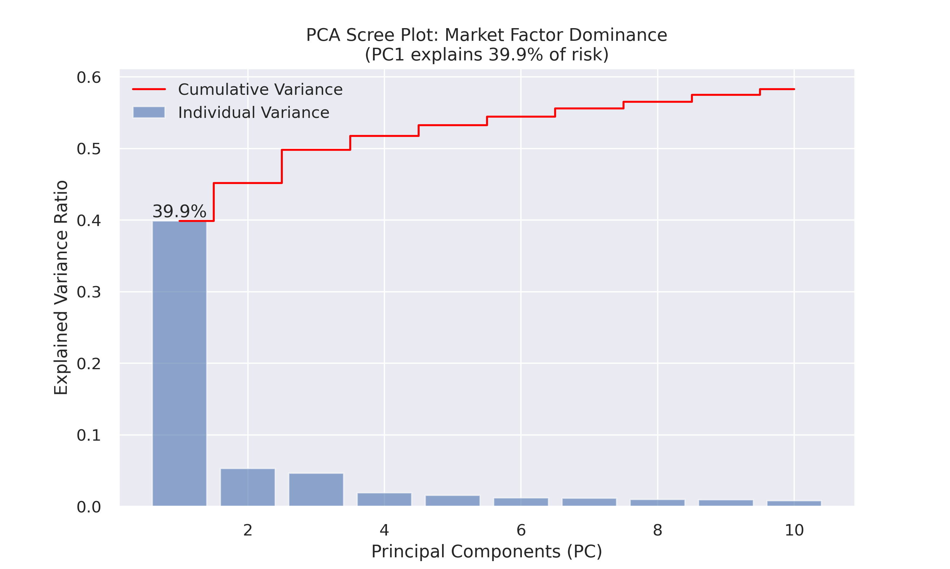
In practice, this means that a single common factor has already captured much of how S&P 500 stocks move. When PC1 accounts for almost 40% alone, the market can be said to be strongly integrated: there are lots of stocks acting in response to the same underlying drive.
The form the Scree Plot takes also has a distinct “elbow” after PC1 and PC2. The curve is fast decreasing from PC1 to PC2, but becomes almost a flat line afterwards. This pattern suggests that including additional factors beyond the first few does not contribute much explanatory power. This tends to support a one-factor or low-factor model for the S&P 500 in this period, while a true system is high-dimensional.
Figure 2: PCA Scree Plot showing variance decay.

4.2 Identifying Market Drivers: The Tech Oligopoly
If PC1 is dominant, then we should ask next: So, which stocks are actually driving this major catalyst? To do this, we look at the loadings of PC1, which essentially tells us how much each stock contributes to the first principal component. Stocks are ordered according to the PC1 loadings, and the top contributors are presented in Fig. 3. The result is very clear:
- Most of the highest loadings come from mega-cap technology names such as Nvidia (NVDA), Microsoft (MSFT) and Apple (AAPL).
- Old-line sectors like utilities, small financials or consumer staples barely register in the top list.
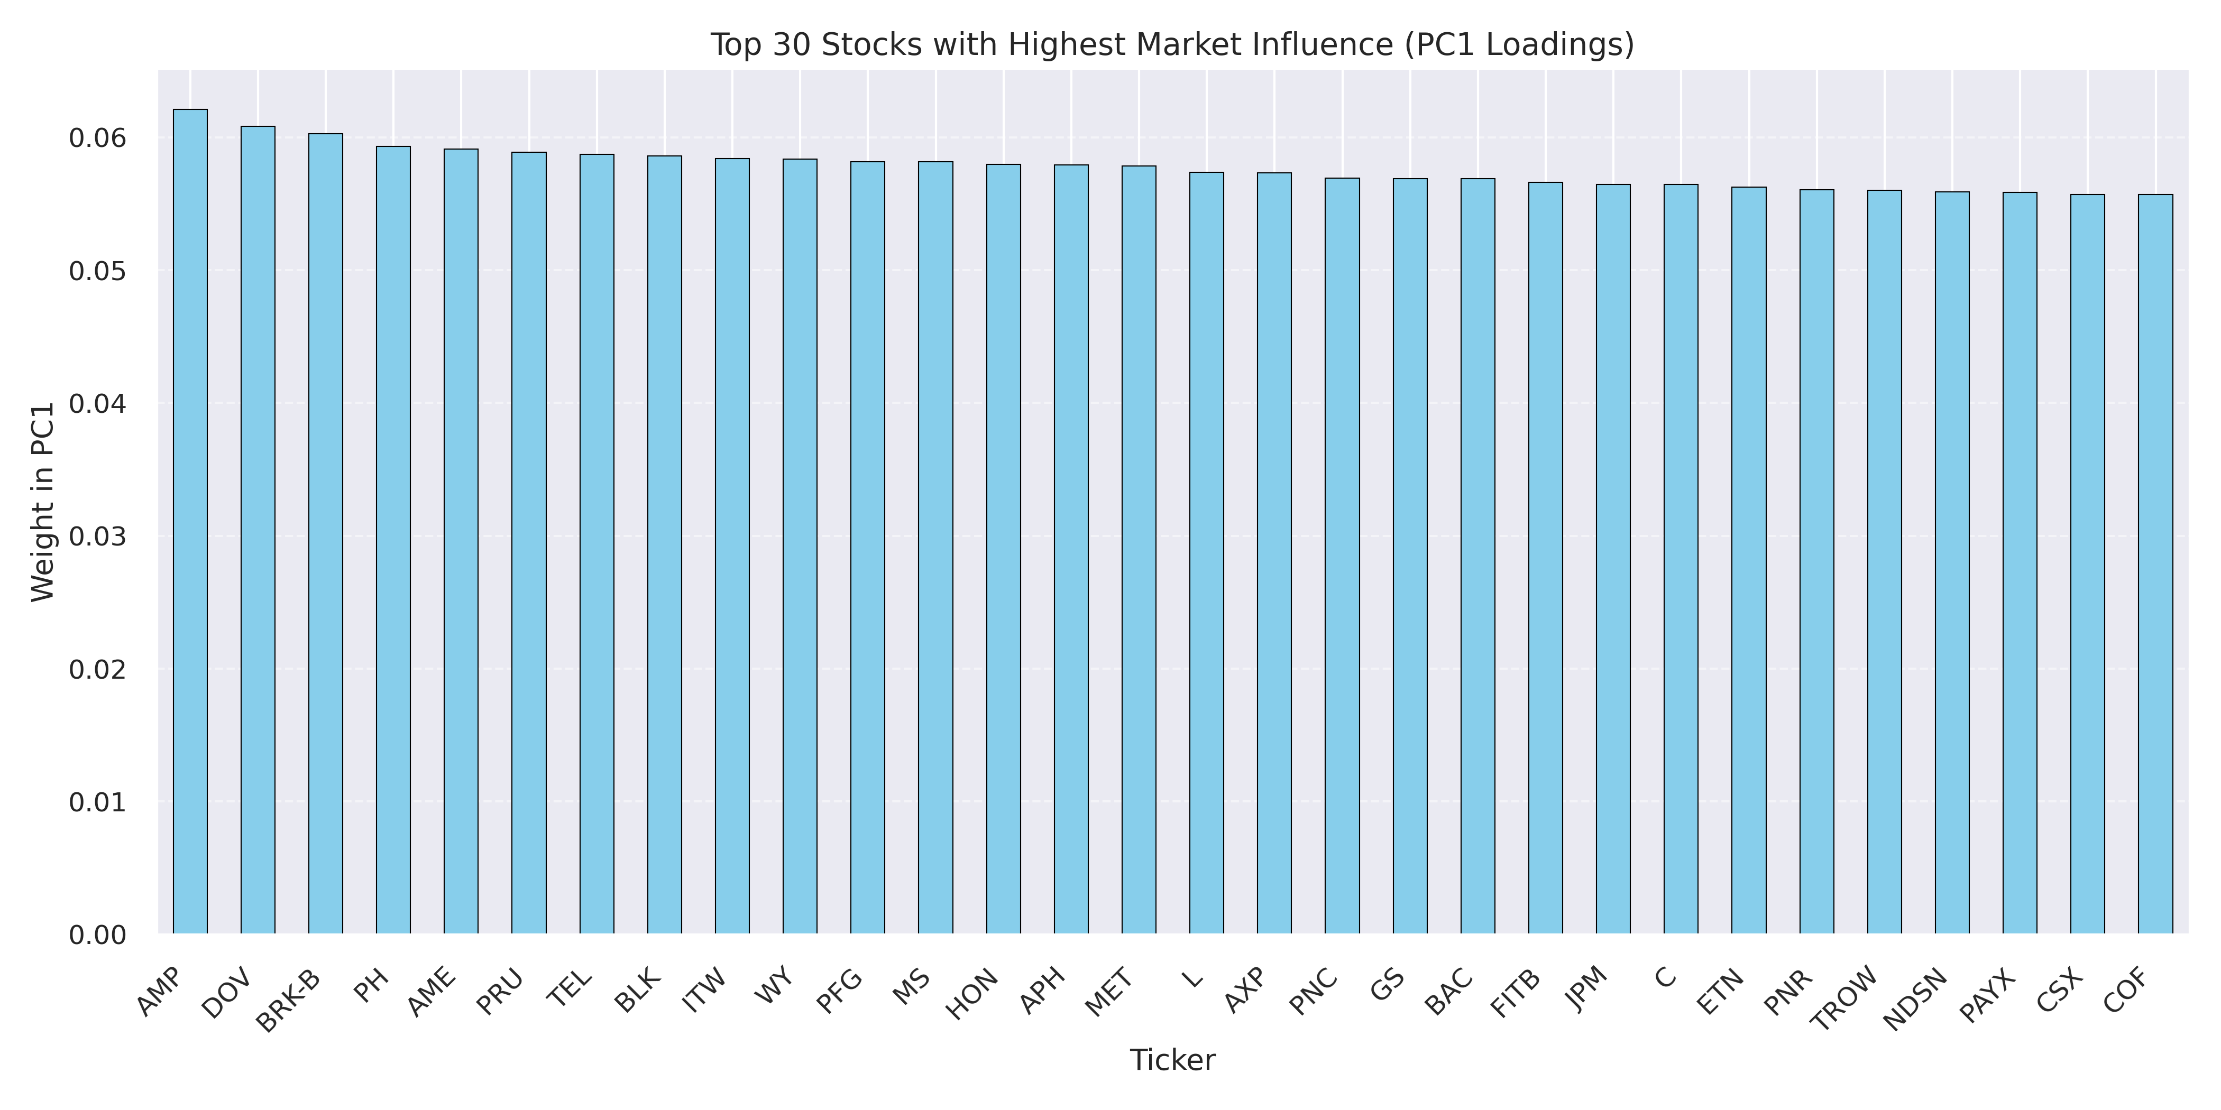
What this means is that in our sample, the S&P 500 behaves as a “top-heavy” index: The overall movement of the index is dependent on only a few very large technology companies. From a pragmatic viewpoint, predicting the S&P 500 [6] direction is, in this environment, almost equivalent to predicting tech sector performance.
This result also has implications for the broader literature on passive investing and structural diversification. A lot of investors purchase index funds to “get the market” and to diversify away individual risk. Our findings indicate that this diversification might be less extensive than it seems:
- Passive indexing does offer access to the market’s beta in aggregate
- However, as the index is so focused, it does not ensure diversification across genuinely uncorrelated risk drivers.
Figure 3: Top 30 Stocks driving Systemic Risk.

4.3 Cluster Analysis and Hedging
PCA tells us about common factors, but investors still would like to know how to hedge: With one set of stocks under pressure, what other set is apt to act differently? To examine this, we take K-means clustering and determine the correlation among clusters. This is illustrated in a heatmap-like manner in Figure 4:
- The red/orange regions: the high correlation (clusters move together).
- Blue means lower or negative correlation (cluster moves in a different direction).
One significant pattern emerges from the cluster itself: that is, between the Energy cluster and the Technology cluster. In our sample:
- These two clusters together constitute a "low-correlation island" in the heatmap (shown by blue areas).
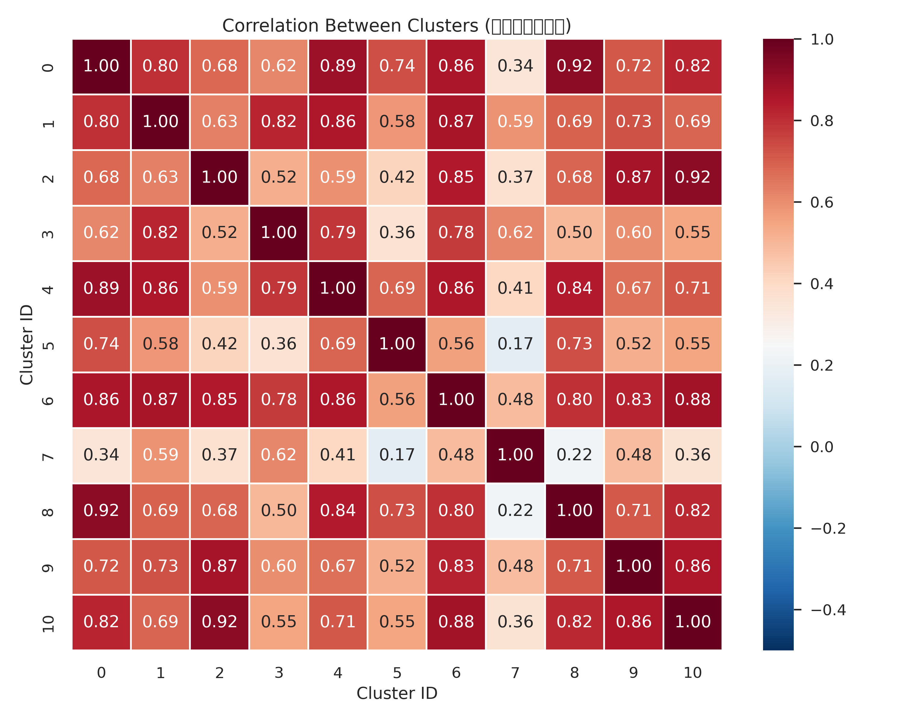
- In the 2022 period, as we observe inflation and interest rates rising, we note that energy stocks went up (due to higher commodities' prices); technology ones often were down (struck by a higher discount rate and weak growth).
This is precisely the type of activity which sector-based hedging strategies in [8] seek to take advantage of. Here, the key point is that we did not begin from sector labels. Instead, the clusters were generated simply based on statistical co-movements, and then what we have seen is that 'this cluster works as tech', 'that cluster works as energy', etc.
This is evidence that the unsupervised learning can automatically discover hedging opportunities that simple "buy many sectors" diversification might otherwise miss, especially in sectors which are not equally impactful with respect to some macro shocks.
Figure 4: Cluster Correlation Matrix.

4.4 Dynamic Risk: The Anatomy of the 2020 Crash
A static PCA effectively reduces the whole 2019–2024 period to one number for PC1. But markets don't remain in any one place. We study the evolution of systemic risk over time by running rolling PCA and plotting the variance explained by PC1 against time (Figure 5). The time series exhibits three important features:
- Baseline level:
PC1 accounts for approximately 30–40% of the variance for most of the sample. That is already high, but fairly flat.
- Crisis spike in March 2020:
In the COVID-19 crash, the proportion of variance explained by PC1 rises to almost 60%. That is to say that in that period, a single, resolutely un-novel common factor dominates market movements even more profoundly than it usually does. Put differently, virtually all stocks were moving in the same direction, irrespective of their individual fundamentals.
- Post-crash adjustment:
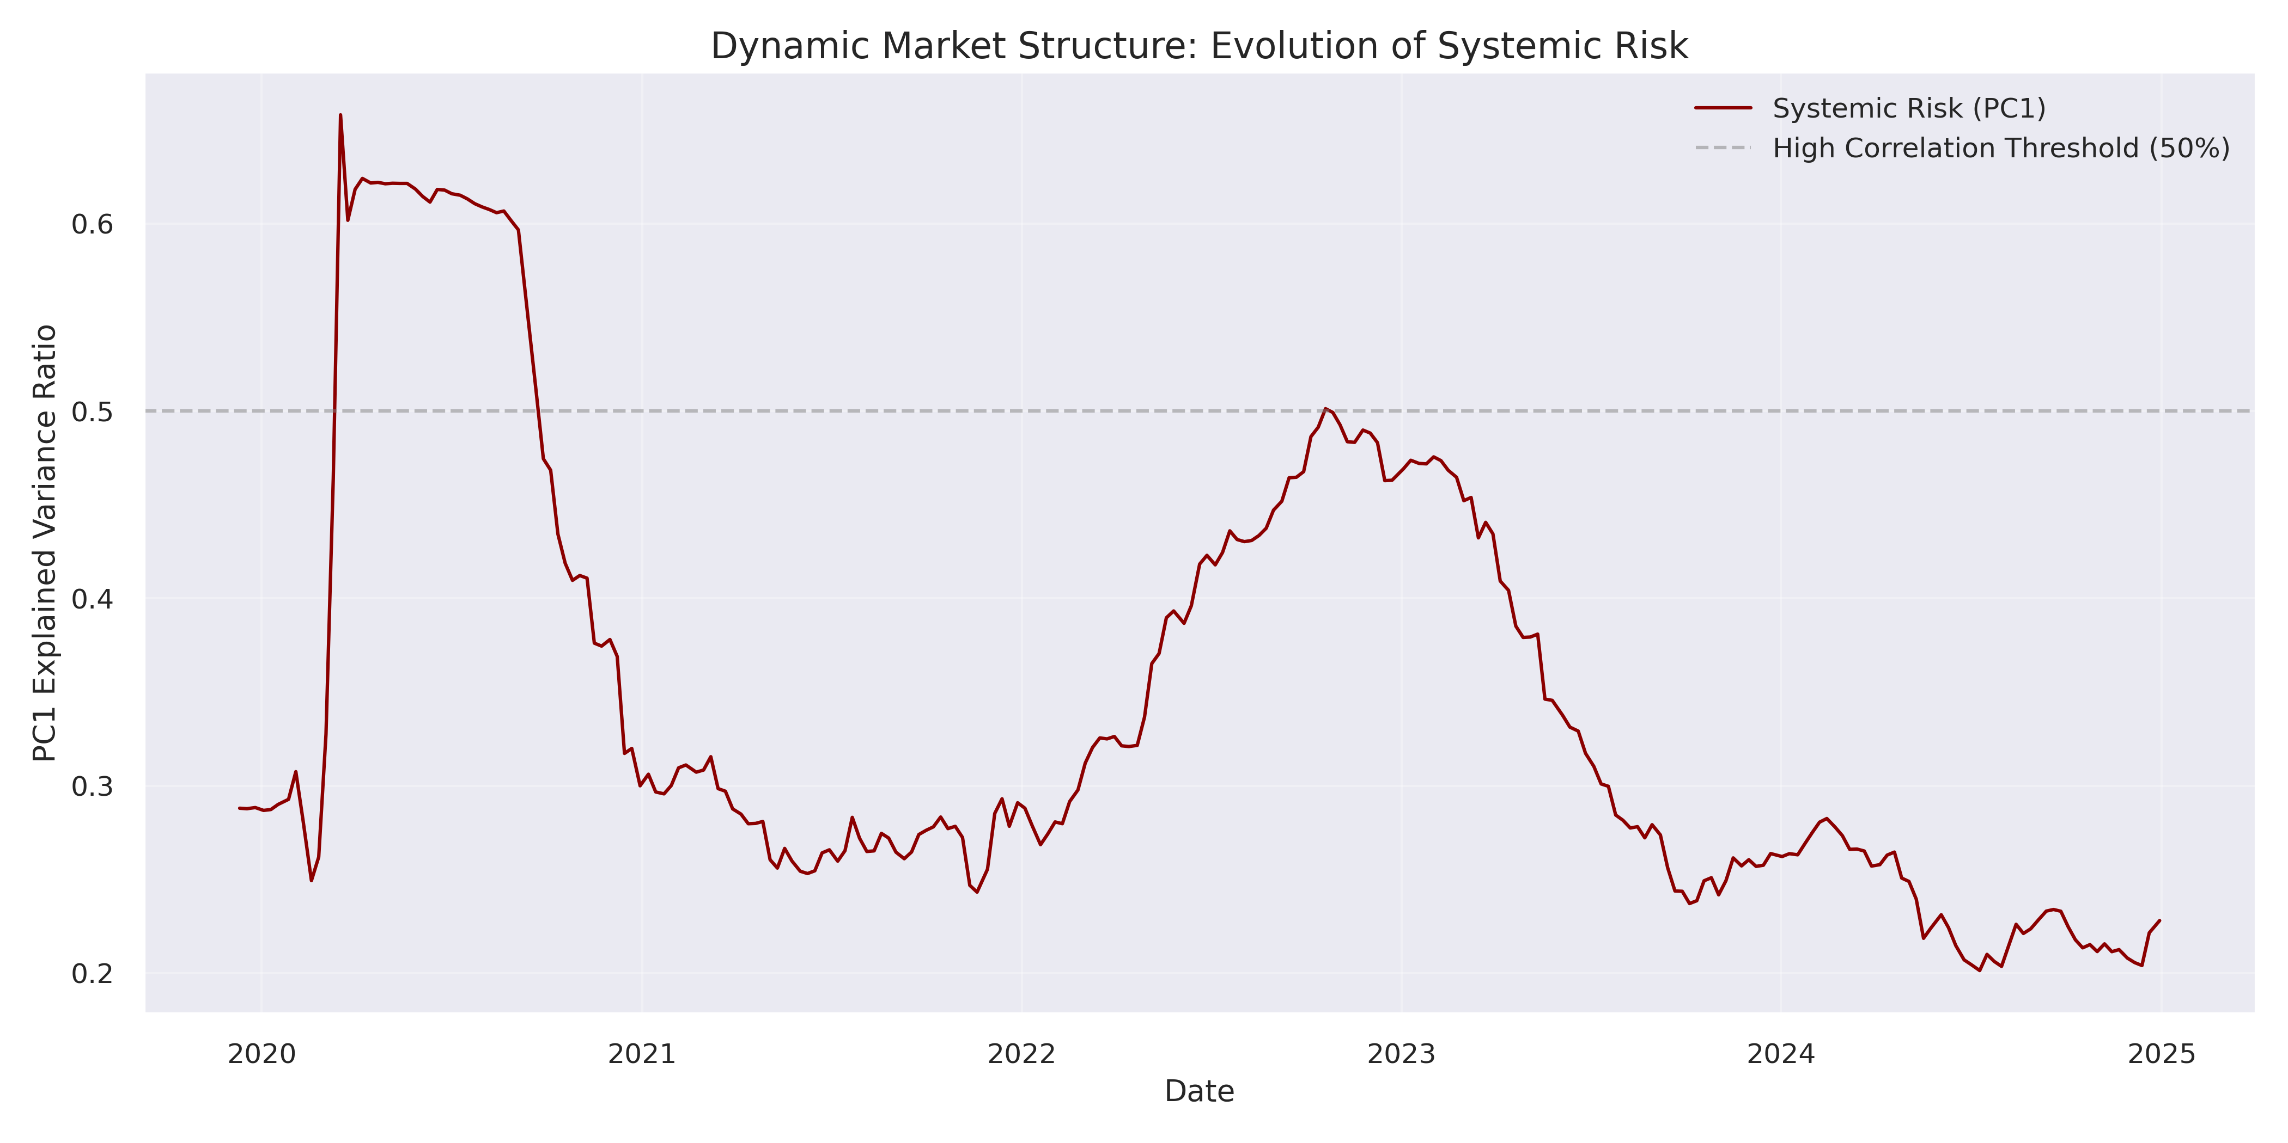
Post-crisis, the explained variance slowly rebounds towards its baseline range, but with substantial movements around subsequent macro events.
This sudden shift provides a clear example of “correlation breakdown" (to borrow the words of the literature), or more precisely still, "correlation converging": that is, in a liquidity crisis, correlations between assets simply tend to converge to 1.0. But the diversification that seemed to work well in placid times becomes much weaker, just when investors are counting on it.
This observation confirms what was said in [5]: Risk models using constant correlations will seriously underestimate portfolio VaR in such crisis times.
Figure 5: Rolling PCA tracking Systemic Risk over time.

4.5 Portfolio Optimisation
Finally, we address a pragmatic question: to what extent can these statistical insights assist in constructing a better portfolio?
- We examine this by creating an efficient frontier using our clusters. The procedure is as follows:
- We take one or more representative stocks from each of the 11 clusters of K-means clustering.
- We simulate 5,000 unique portfolios with different weights allocated between these representatives.
- For each portfolio, we also calculate its Sharpe ratio.
- We represent all the portfolios on a risk–return basis (Figure 6).
The grey cloud of points represents the collection of randomly generated portfolios.On top of that, we highlight:
- The efficient frontier shows the various portfolios that have the highest expected return for a given level of risk.
- One “Optimal Portfolio” (red star), defined as the highest Sharpe ratio in all the simulated portfolios.
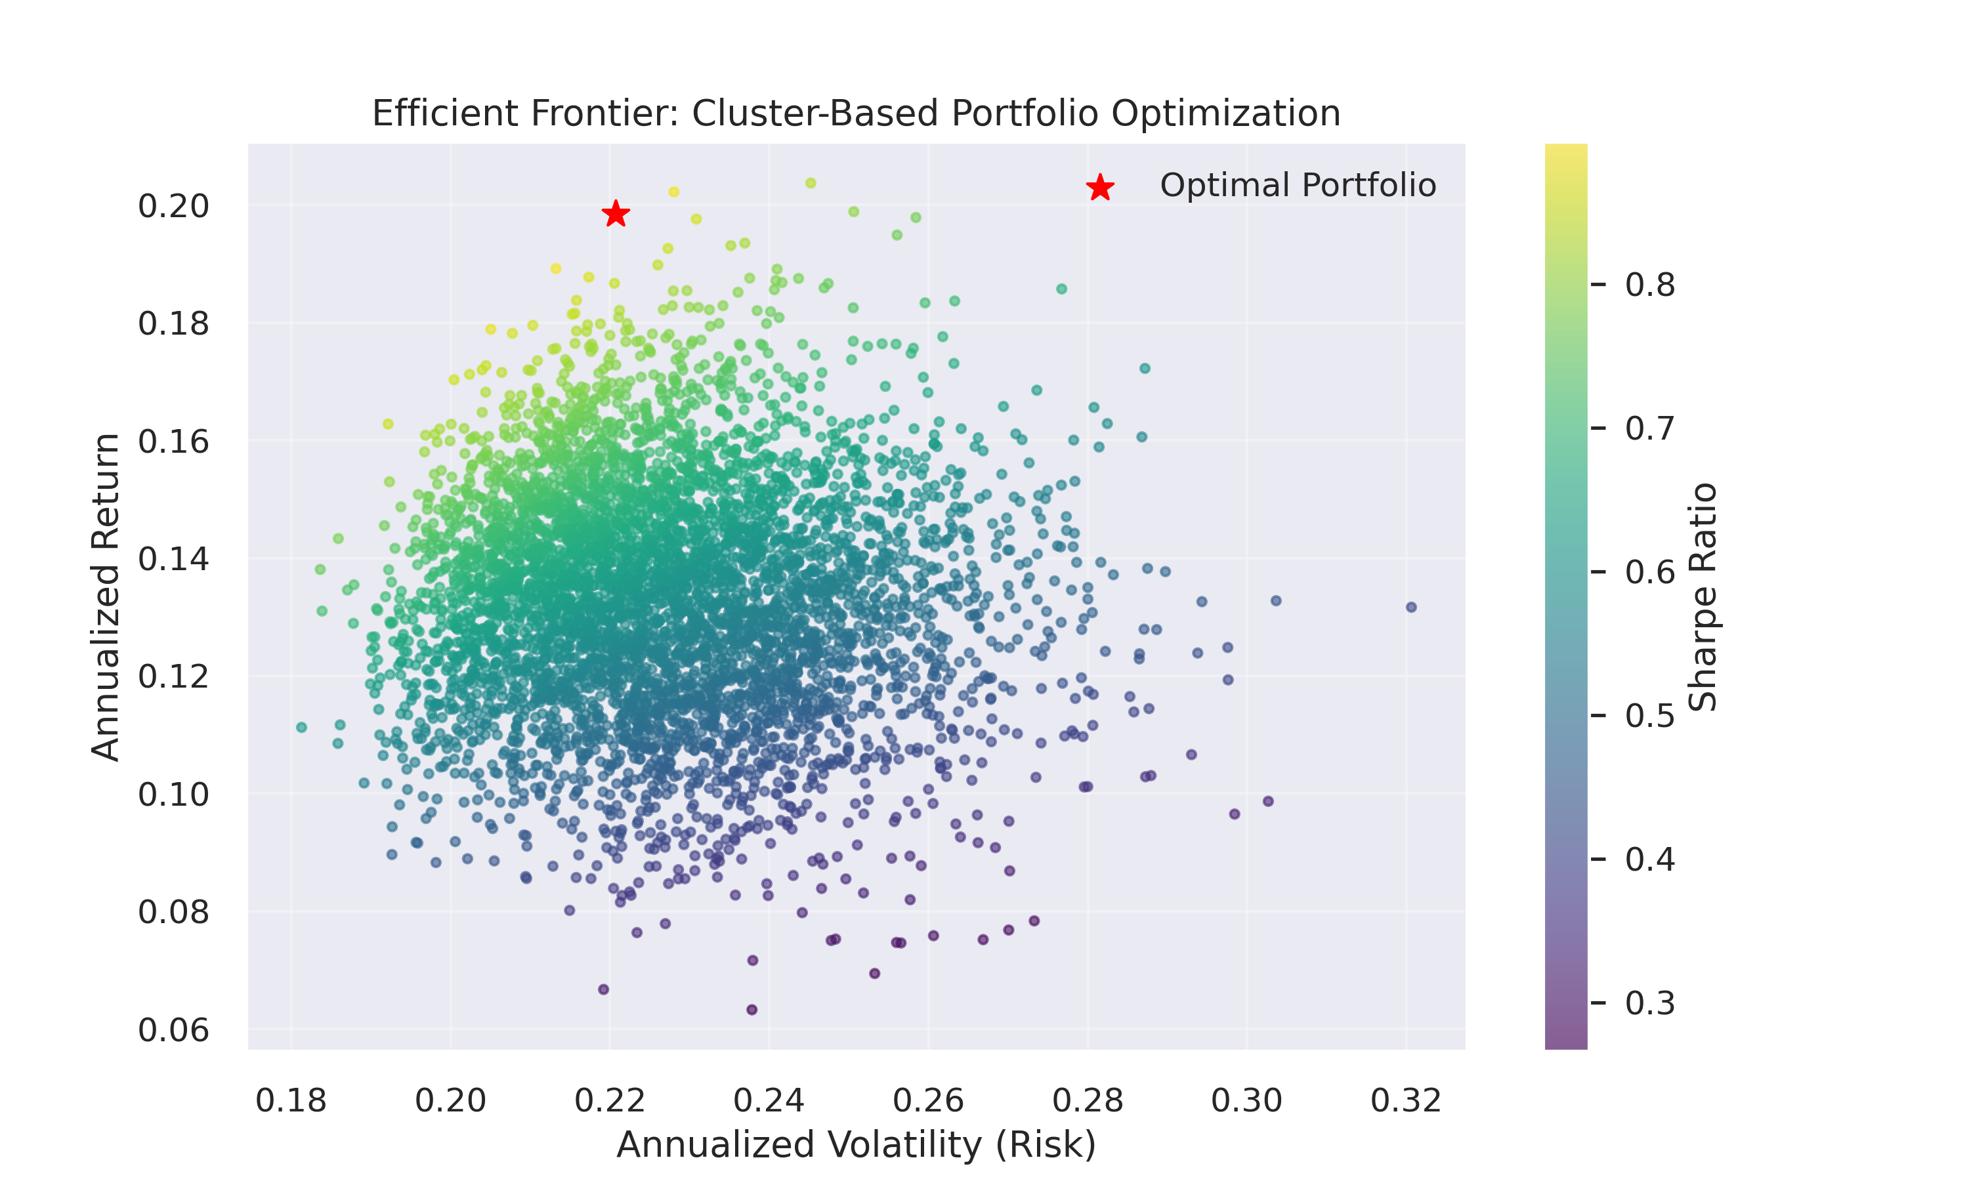
The results indicate that the best cluster-based portfolio has a Sharpe ratio well in excess of the median random portfolio. It shows that the data-driven diversification using statistical clusters and PCA can consistently beat a naive strategy that gives equal weight to all stocks.
Moreover, this model is scalable to include non-financial constraints as indicated in [9]. For instance, to incorporate a policy that demands decarbonization, we could avoid or give lower weight to clusters where high-carbon sectors are abundant (e.g. fossil-fuel energy) and recalculate the efficient frontier. This offers the advantage that the machinery can be reused and provides a quick transformation between traditional risk–return optimization and ESG-driven portfolio construction.
Figure 6: Efficient Frontier via Monte Carlo Simulation.

5. Conclusion
This project aimed to investigate the behaviour of the contemporary US equity market using high-dimensional data. We quantitatively characterise market risk using realised S&P 500 data and unsupervised learning techniques. Using PCA, we found that the S&P 500 is tightly integrated, as evidenced by a first principal component accounting for approximately 40% of daily returns. This is weighted toward mega-cap tech names, including NVIDIA, Microsoft and Apple; therefore, the index is highly tech-oriented, resulting in highly concentrated exposure within passive index funds.
PCA in a rolling-window framework suggested that systemic risk is time-varying. PC1 variance drops and spikes over time, its peak (almost 60%) occurs during the March 2020 COVID-19-induced market decline. This is consistent with a "correlation breakdown," in which assets that typically move independently begin moving in tandem during crises, and conventional diversification is ineffective.
We also employed K-means clustering for analysing stock correlations, and discovered various patterns such as a lack of correlation between Energy and Technology during the 2022 inflation shock. We believe this methodology offers a more flexible approach to portfolio construction than traditional, index-based sector classifications. Simulations demonstrated that data-driven diversification yields higher risk-adjusted returns than random selection and can incorporate a range of ESG constraints, including climate risk.
More generally, this paper illustrates the way in which high-dimensional data analytics links together theory and empirical practice: PCA pertains to multifactor pricing, rolling windows correspond to regime shifts, and clustering implies diversification. Future research can target the inclusion of LSTM models for predicting market movements and the incorporation of climate and sustainability restrictions in portfolio optimisation to better align with these aims [4,9].
References
[1] Decoding the Stock Market Dynamics in the Banking Sector: Short Versus Long-Term Insights. (2024). Journal of Finance and Data Science.
[2] Detecting Market Instability with Regime Switching Models: A Markov-Switching Analysis of the S&P 500 Index. (2023). Quantitative Finance.
[3] Danielsson, J., et al. (2016). Systemic risk measures: The simpler the better? Journal of Financial Stability.
[4] A long short-term memory network-based approach for predicting the trends in the S&P 500 index. (2020). Expert Systems with Applications.
[5] Predicting a Stock Market Correction: Evidence from the S&P 500 Index. (2022). International Journal of Forecasting.
[6] S&P 500 Trend Prediction. (2021). Computational Economics.
[7] Markowitz, H. (1952). Portfolio Selection. The Journal of Finance.
[8] Sectoral Analysis and Risk Strategies in Economic Fluctuations: A Study on the S&P 500. (2023). Journal of Economic Studies.
[9] Portfolio Optimisation and Climate Risk: Decarbonization of the S&P 500 Index. (2024). Sustainable Finance Economics.
[10] Yahoo Finance API Documentation. (2024). yfinance. Retrieved from PyPI.

