CVHW1

資管三b11705033江睿宸

* (a) upside-down lena.bmp
* 

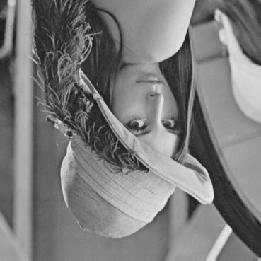

* (b) right-side-left lena.bmp
* 



* (c) diagonally flip lena.bmp
* 



* (d) rotate lena.bmp 45 degrees clockwise



* (e) shrink lena.bmp in half

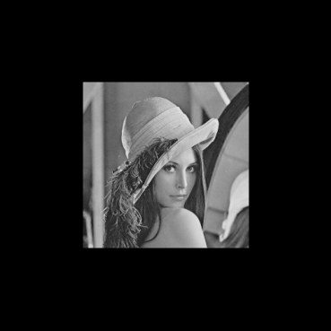

* (f) binarize lena.bmp at 128 to get a binary image

