* (a) Laplace Mask 1, threshold:15
* 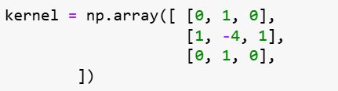
* 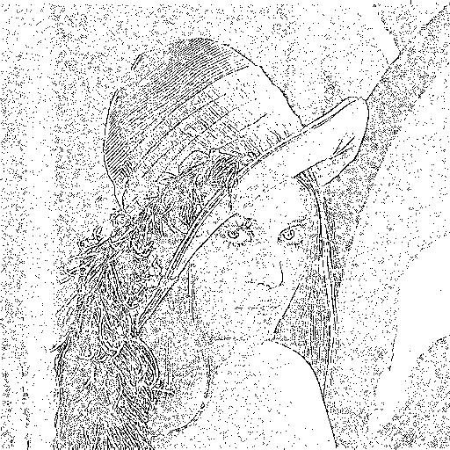
* (b) Laplace Mask2, threshold:15
* 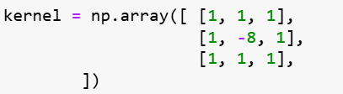
* 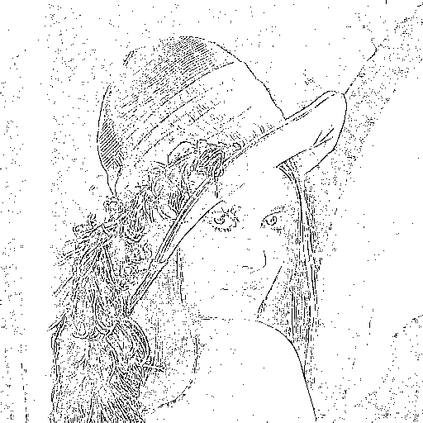
* (c) Minimum variance Laplacian, threshold:11
* 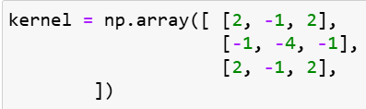
* 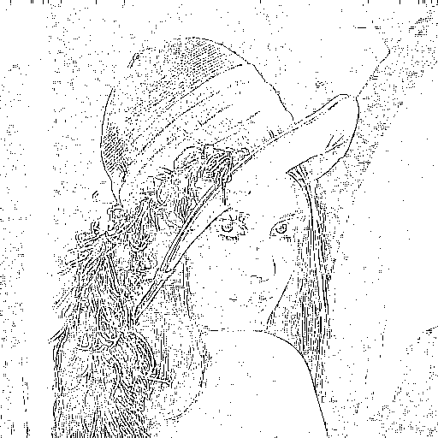
* (d) Laplace of Gaussian, threshold:2000
* 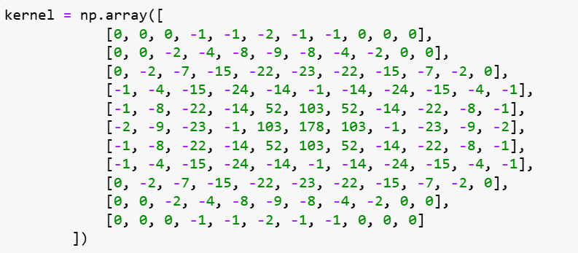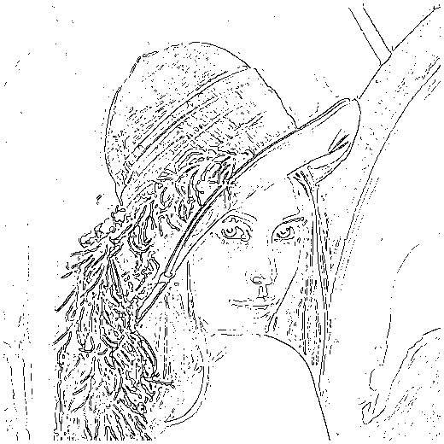
* (e) Difference of Gaussian, threshold: 1
* 
 