* (a) original image and its histogram

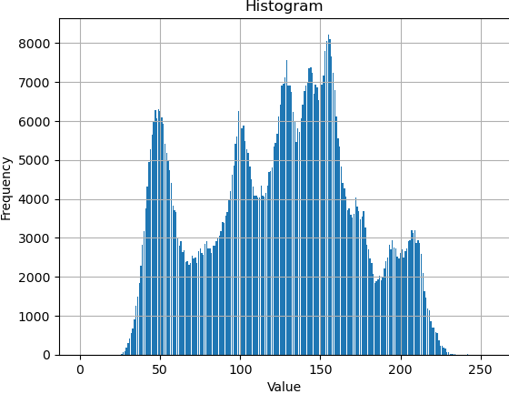

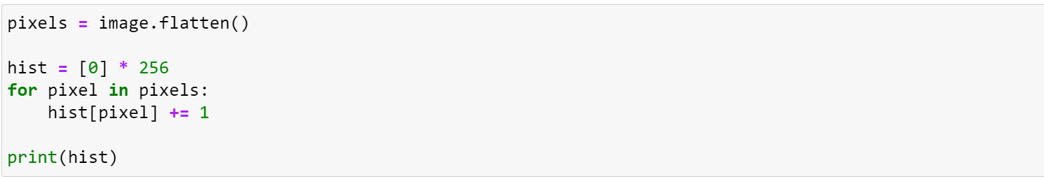

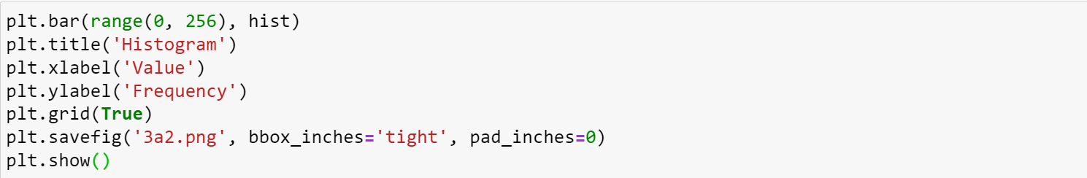

讀入照片後轉成array，遍歷每個pixel計算各亮度出現次數，統計後用plt顯示直方圖。

* (b) image with intensity divided by 3 and its histogram
* 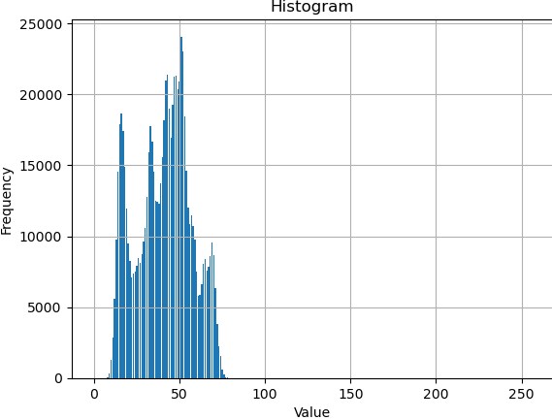

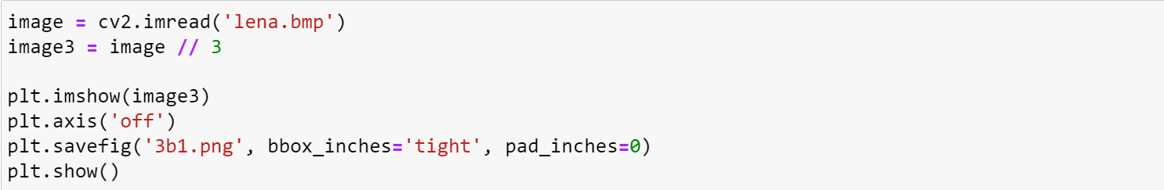

將原始照片除以三

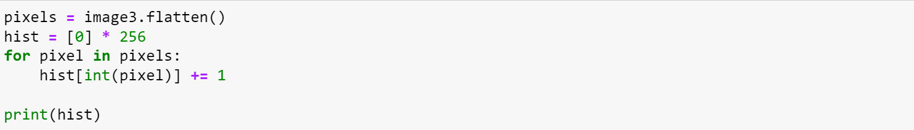

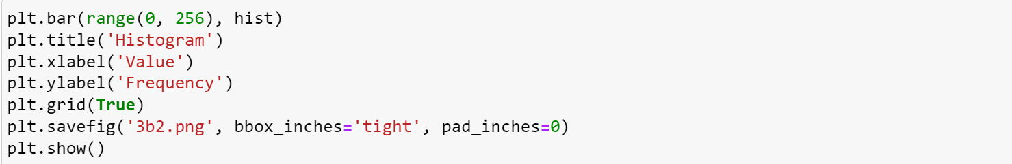

統計各亮度出現次數後轉成直方圖貼上

* (c) image after applying histogram equalization to (b) and its histogram
* 
* 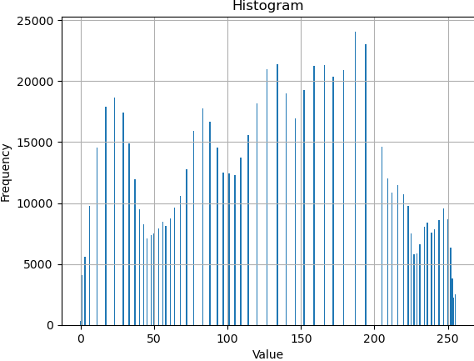

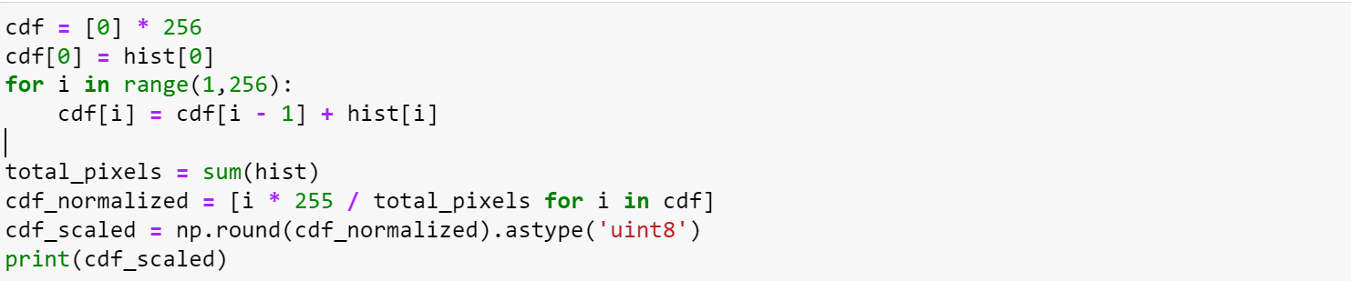

計算cdf from (b)

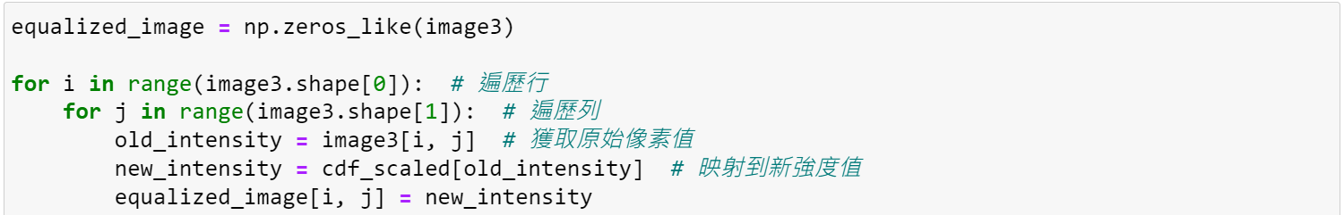

Equalize image from (b)

顯示圖片

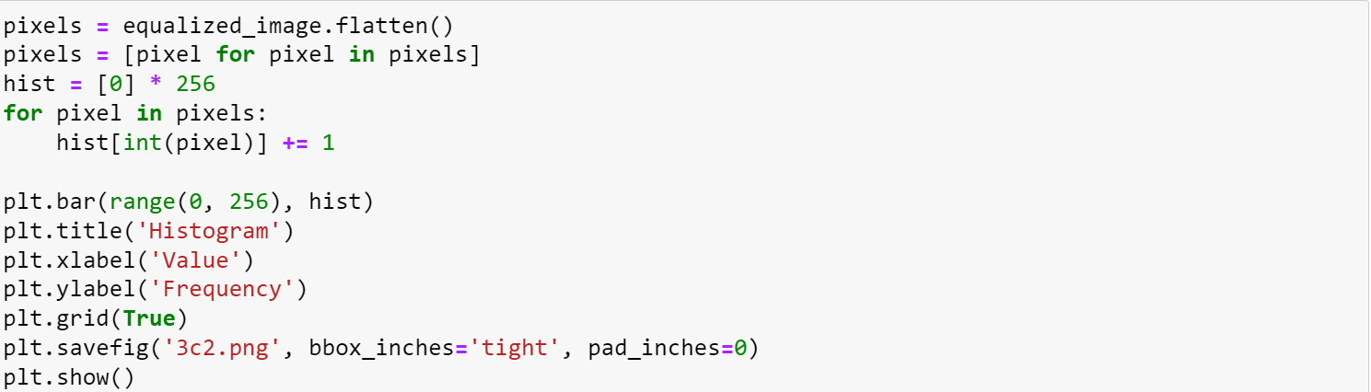

統計計算直方圖