* (a) Robert's Operator: 12

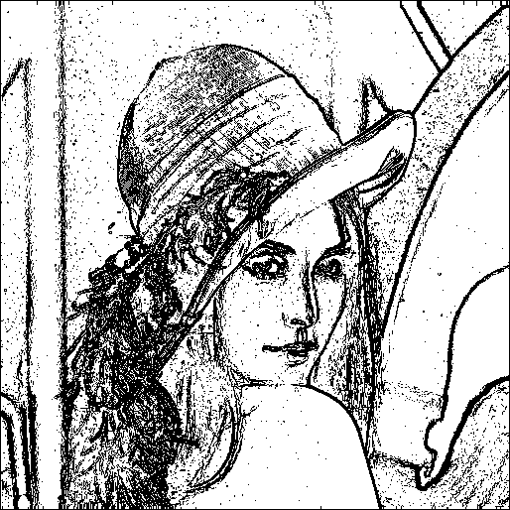

* (b) Prewitt's Edge Detector: 24

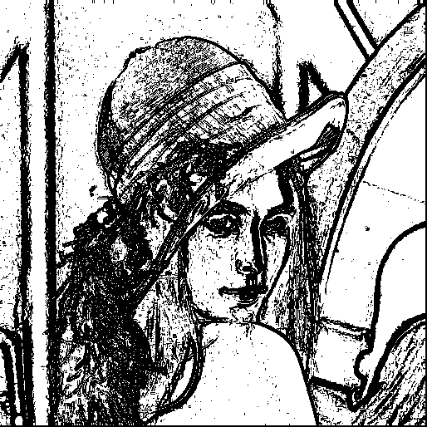

* (c) Sobel's Edge Detector: 38

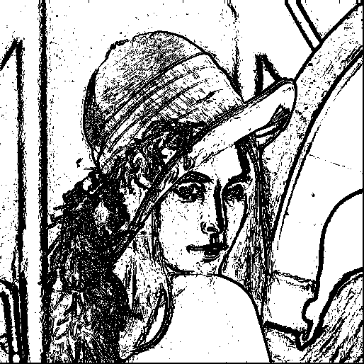

* (d) Frei and Chen's Gradient Operator: 38



(e) Kirsch's Compass Operator: 200

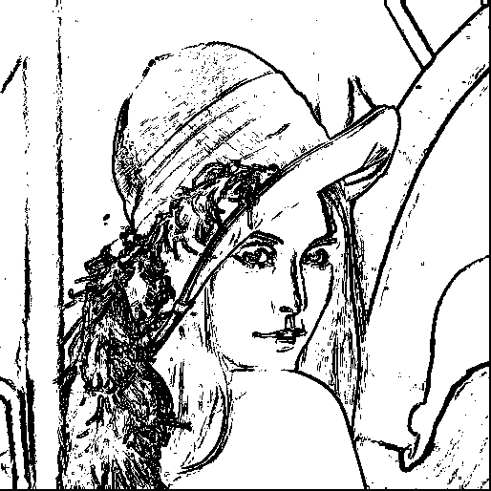

* (f) Robinson's Compass Operator: 43

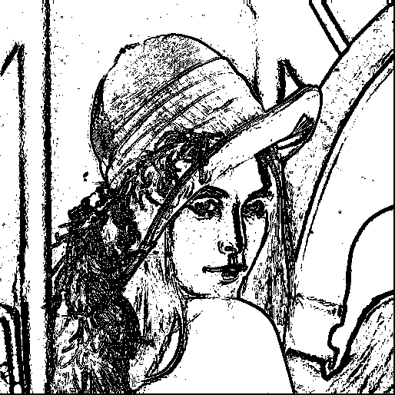

(g) Nevatia-Babu 5x5 Operator: 12500

