班級:通訊碩一 學號:110523064 姓名:徐巧庭

指導教授: 蔡佩芸 教授

**Lab. 1**

**Pseudo Noise Sequence and Gold Code**

Contents

Ans. 8 2

8-1 Block diagram of the LFSR with coefficients 23oct. 2

8-2 Verilog code 2

8-3 The timing diagram of RTL simulation 3

Ans. 9 4

9-1 Block diagram of Gold code generator. 4

9-2 Verilog Code 4

9-3 The timing diagram of three code sequences. 5

9-4 Mathematic result by Matlab. 6

Ans. 10 6

# 

## Block diagram of the LFSR with coefficients 23oct.

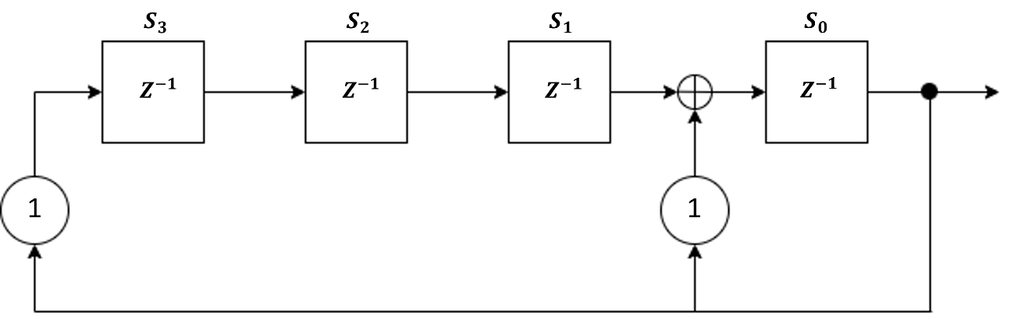

## Verilog code

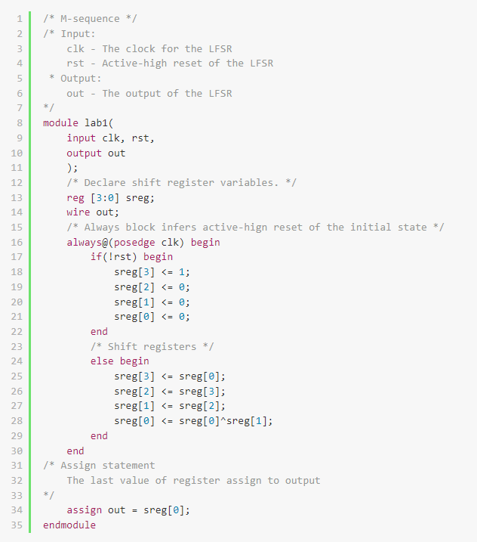

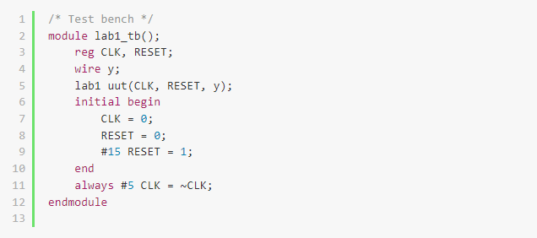

## The timing diagram of RTL simulation

Initial state: 1 0 0 0

M-sequence (generated by Matlab):

0 0 0 1 1 1 1 0 1 0 1 1 0 0 1



M-sequence (implement by Verilog code):

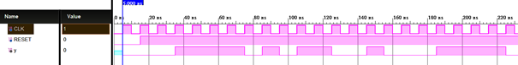

0 0 0 1 1 1 1 0 1 0 1 1 0 0 1

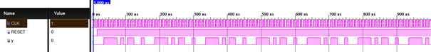

The sequence of 4-stage LFSR has a period of $2^{4}-1$.

# 

## Block diagram of Gold code generator.

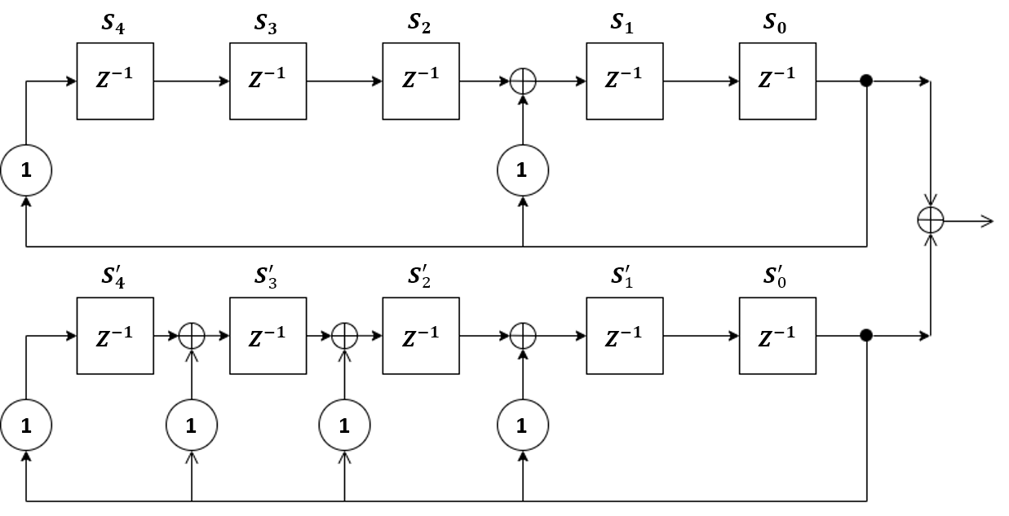

## Verilog Code

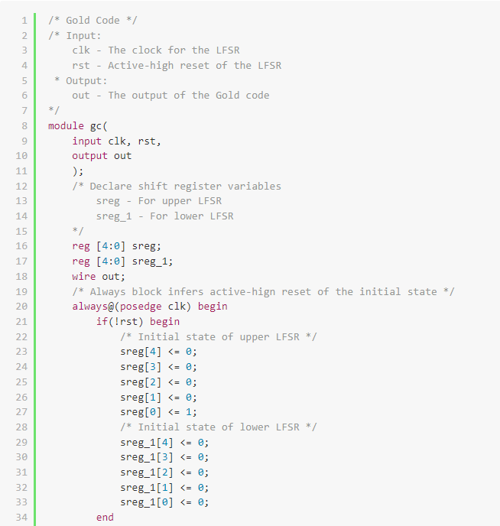

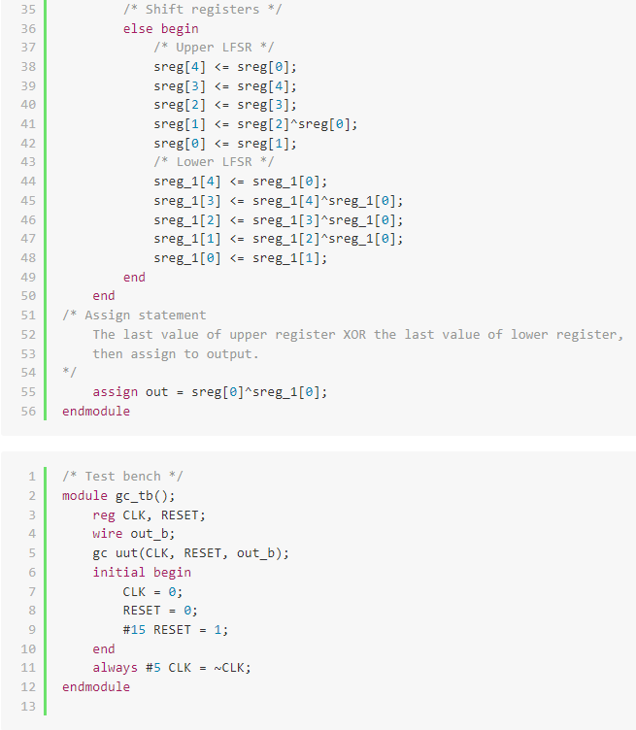

## The timing diagram of three code sequences.

Initial state: Upper LFSR – 0 0 0 0 1 ; Lower LFSR – 0 0 0 0 0

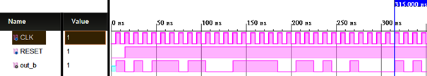

**1 0 1 0 1 1 1 0 1 1 0 0 0 1 1 1 1 1 0 0 1 1 0 1 0 0 1 0 0 0 0**

$b$– sequence:

Initial state: Upper LFSR – 0 0 0 0 0 ; Lower LFSR – 0 0 0 0 1

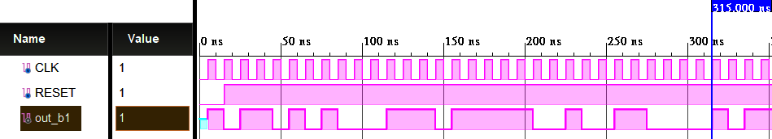

**1 0 1 1 0 1 0 1 0 0 0 1 1 1 0 1 1 1 1 1 0 0 1 0 0 1 1 0 0 0 0**

$b^{’}$– sequence:

Initial state: Upper LFSR – 0 0 0 0 1 ; Lower LFSR – 0 0 1 0 1

**0 0 1 1 0 1 1 0 1 0 0 1 1 1 0 1 0 1 0 0 0 0 1 1 1 1 0 1 1 0 0**

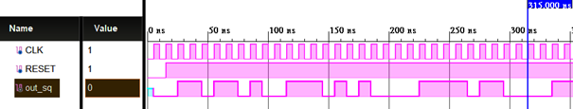

Third sequence:

## Mathematic result by Matlab.

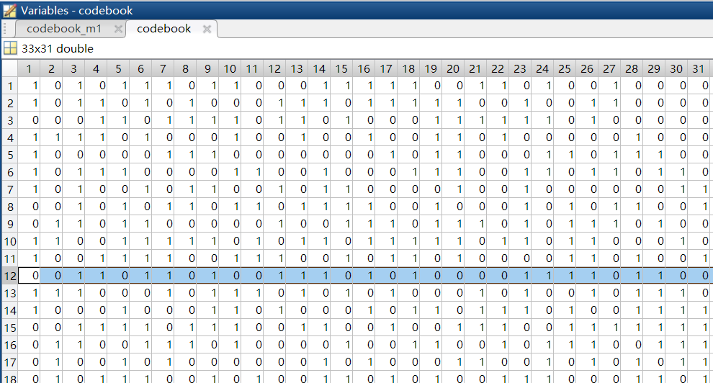

Third sequence

$b^{’}$-sequence

$b$-sequence

# 

Gold code 產生器，是基於M序列設計，由於五次本質多項式係數 ${45}_{oct}$ 和 ${75}_{oct}$ 是完美對，分別可以產生 $b$ 序列和 $b^{’}$ 序列，再以固定產生 $b$ 序列的初始值，和產生 $b^{’}$ 序列的初始值做互斥或，對 $b^{’}$ 序列的初始值做相移有 $2^{5}-1$ 種，所以得到共33組不同的Gold code序列。

以上驗證結果後，可以得到硬體的產生方式和數學理論產生出的33組Gold code序列是一樣的。