**Lab. 3 Digital Filter_2**

班級:通訊碩一 學號:110523064 姓名:徐巧庭 指導教授: 蔡佩芸 教授

Floating-point:

The magnitude of the frequency response



The phase of frequency response versus normalized frequency



Fixed-point for direct form:

The magnitude of the frequency response



The phase of frequency response versus normalized frequency



Fixed-point for transposed form:

The magnitude of the frequency response



The phase of frequency response versus normalized frequency



Direct form的filter word-length我使用17 bits，transposed form的filter word-length我使用18 bits，從頻率響應的結果得知，floating-point和fixed-point只有微小的差距，又由於transposed form取的位元數較多，頻率響應的結果更接近floating-point的結果。

## Behavior simulation

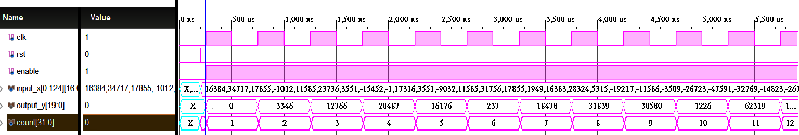

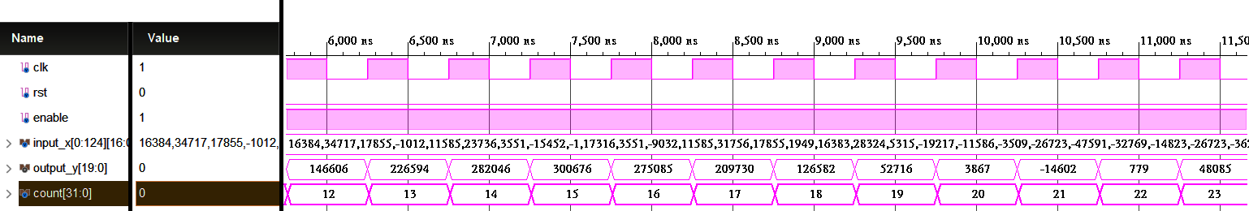

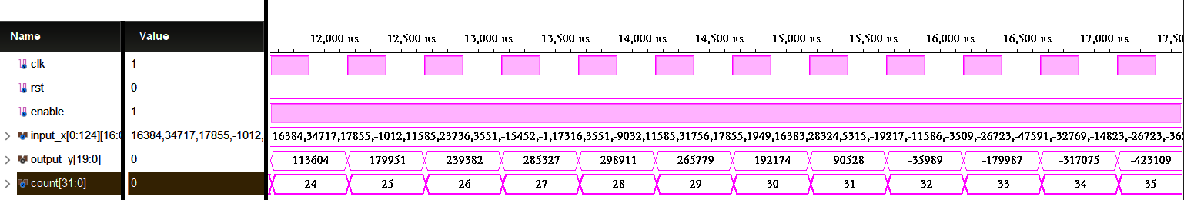

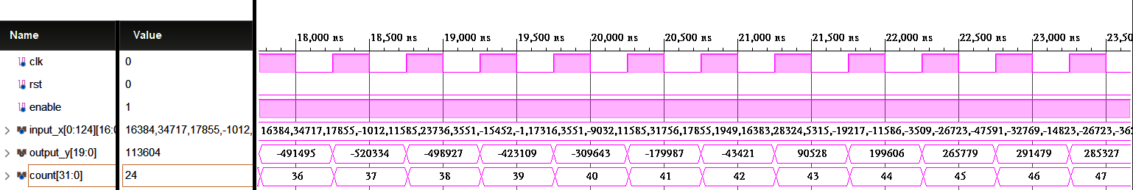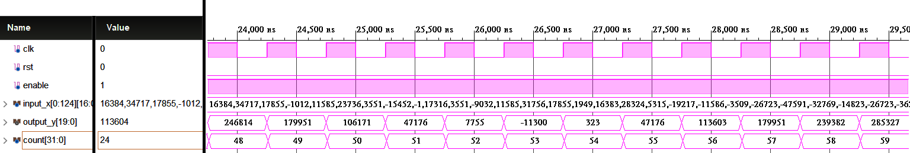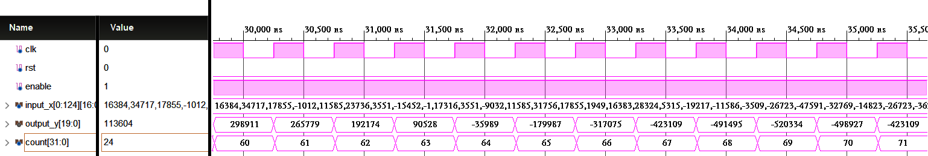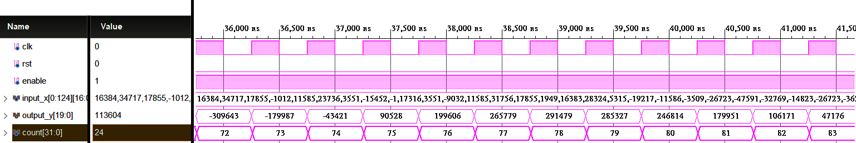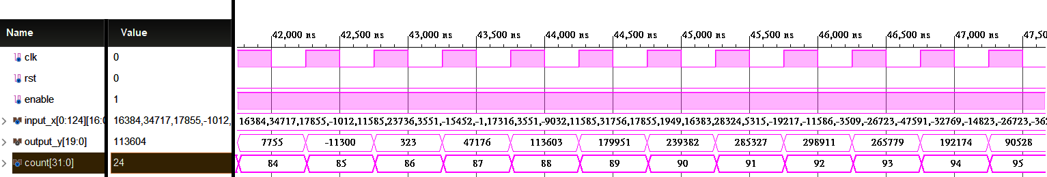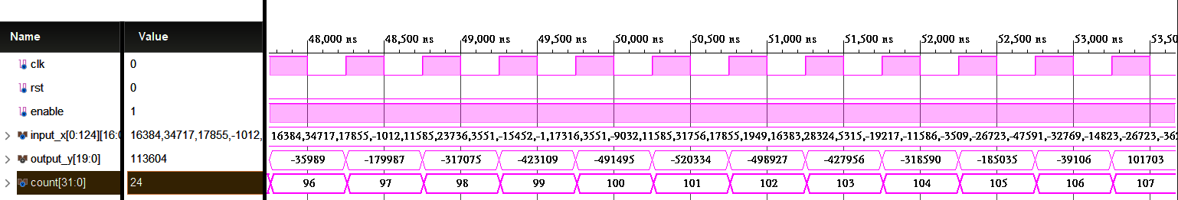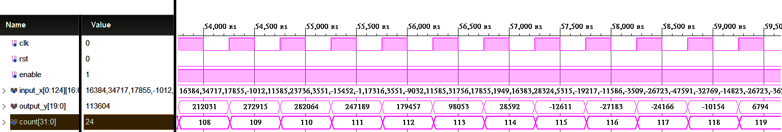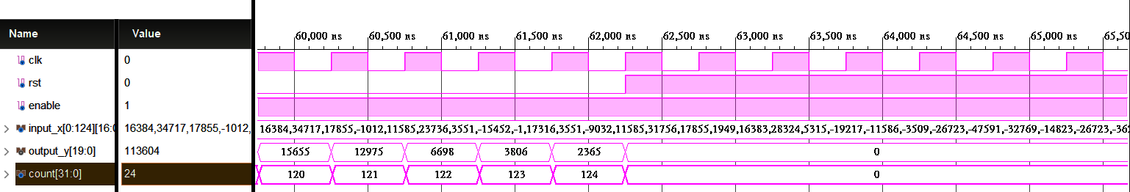

## post-route simulation

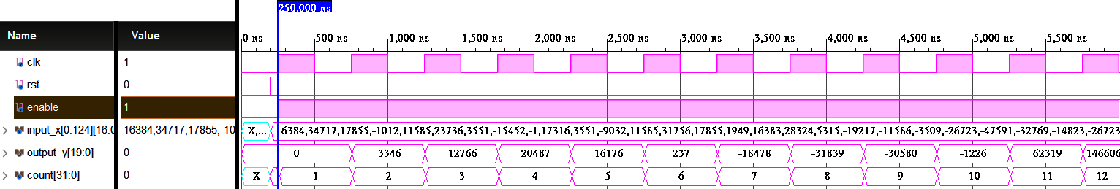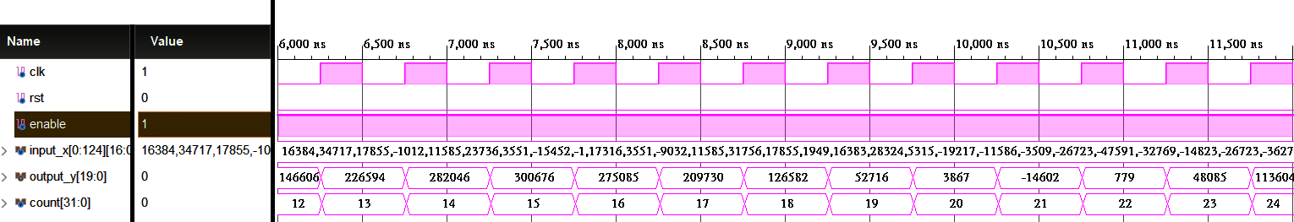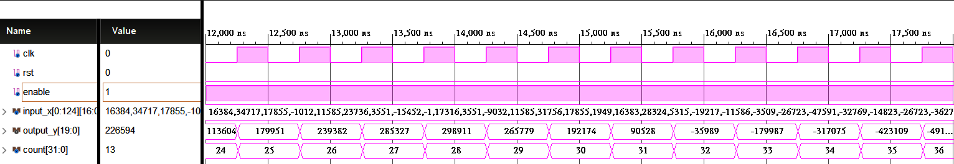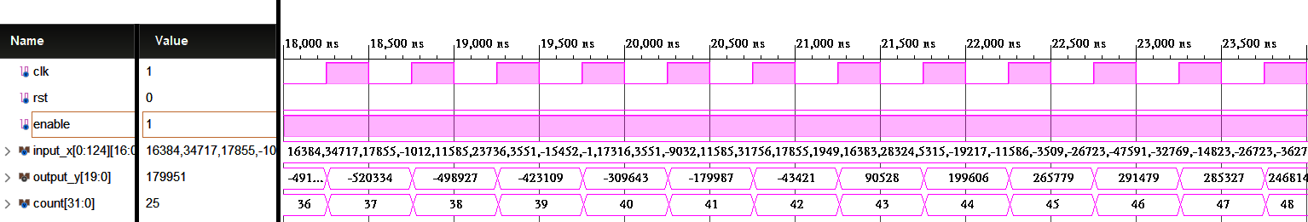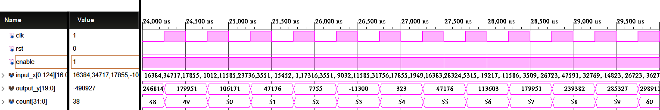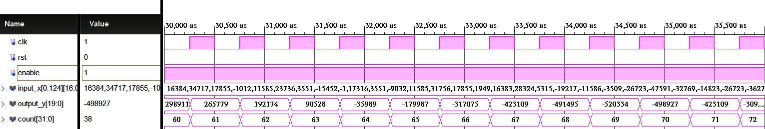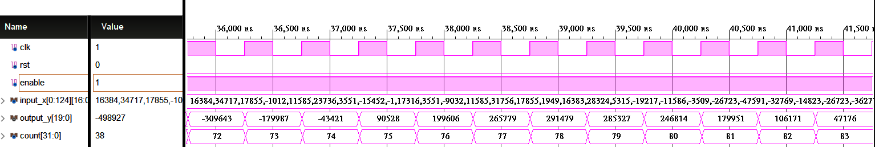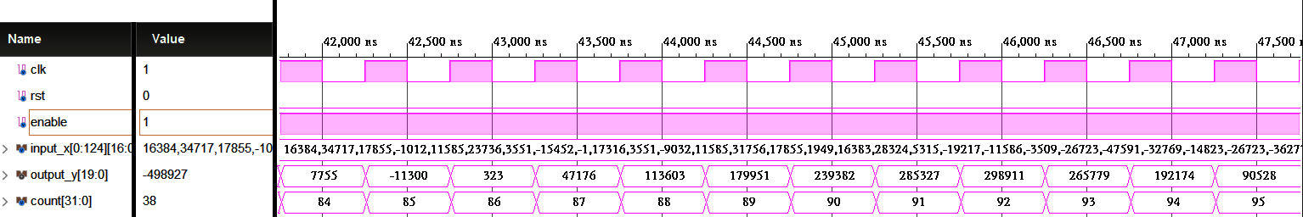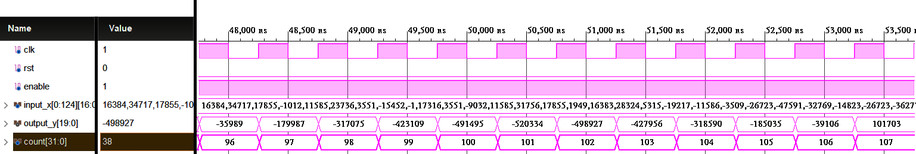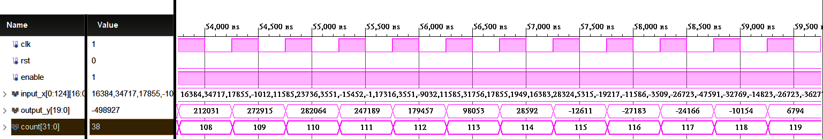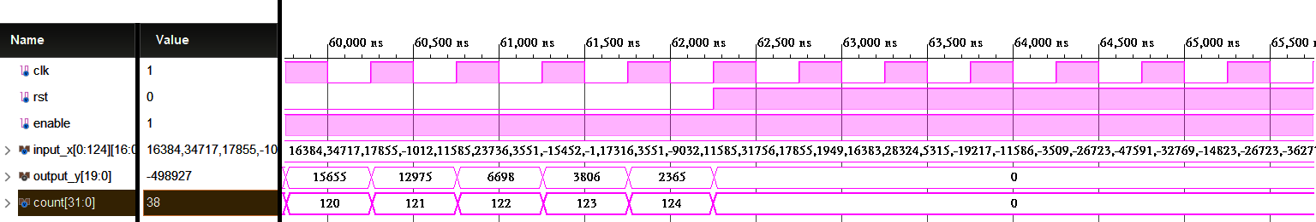

## Show the errors of hardware outputs and Matlab floating-point results of direct from FIR by Matlab figures.

Average error (log2): -12.9371

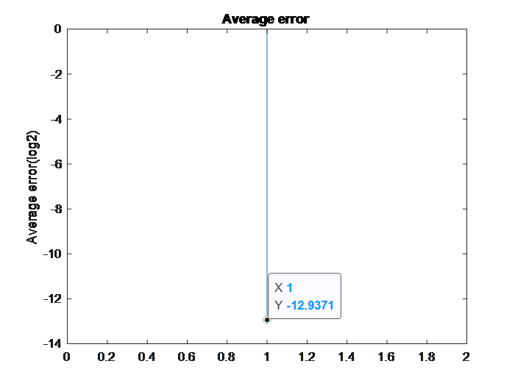

## Behavior simulation

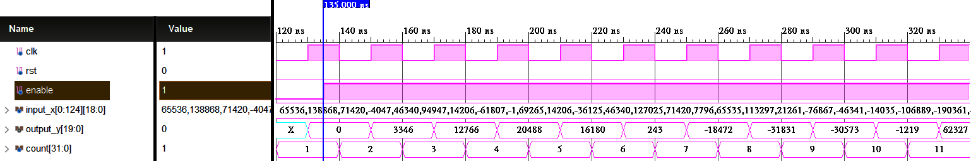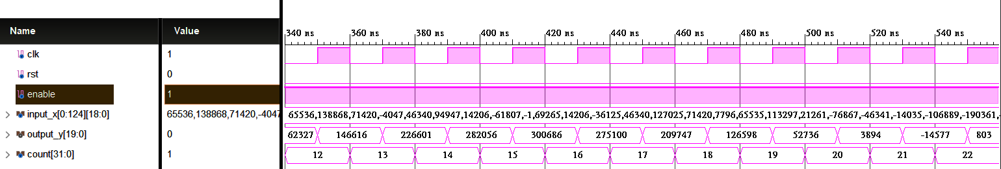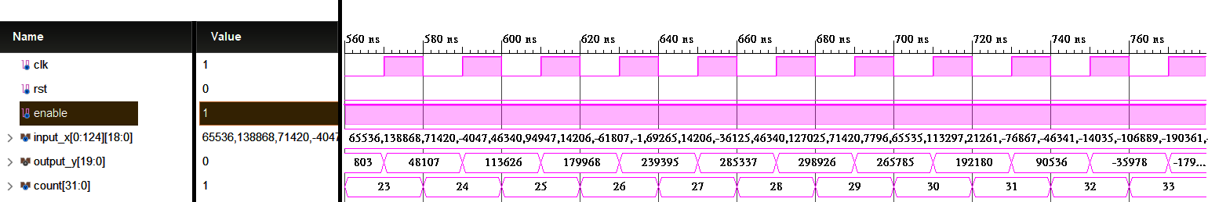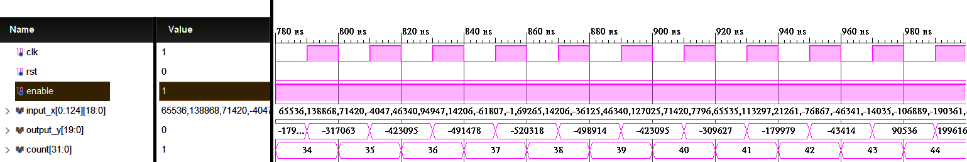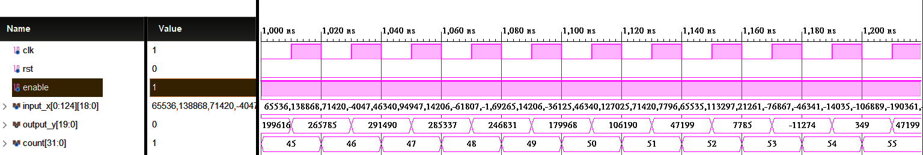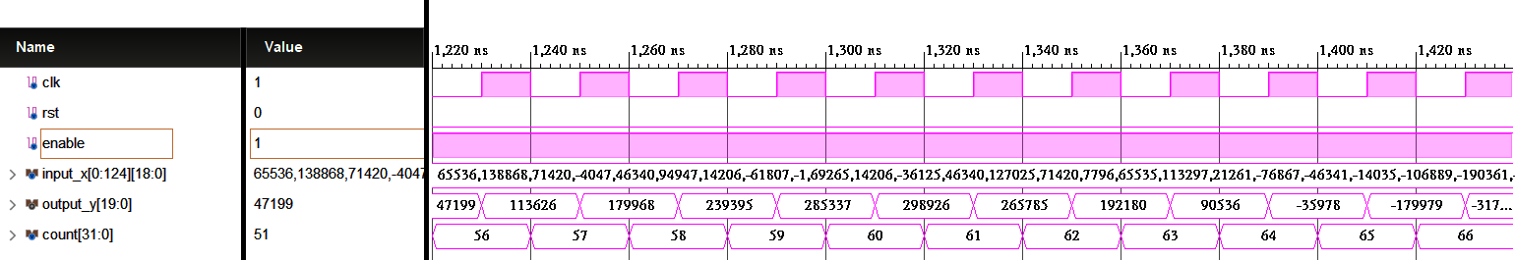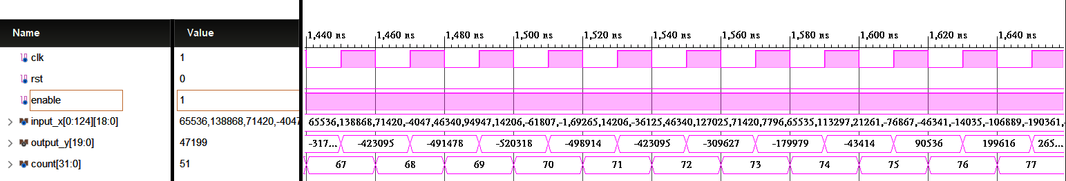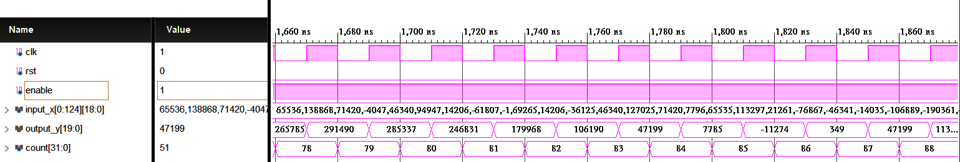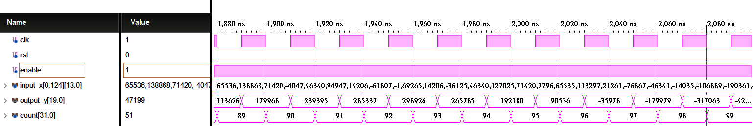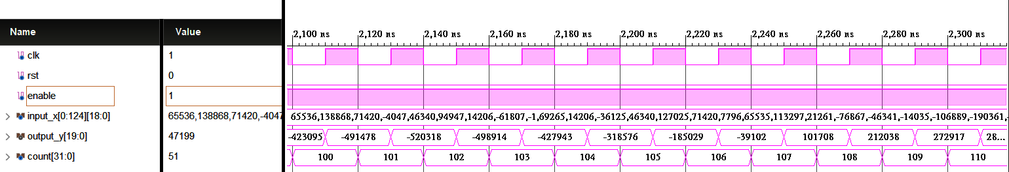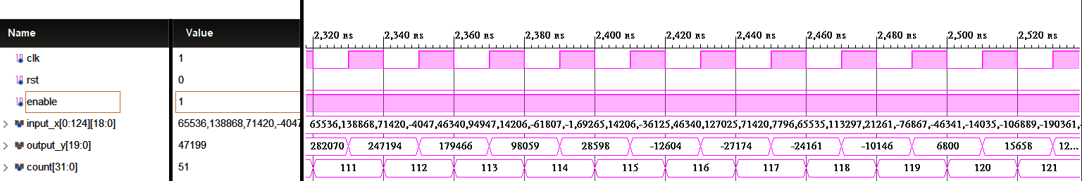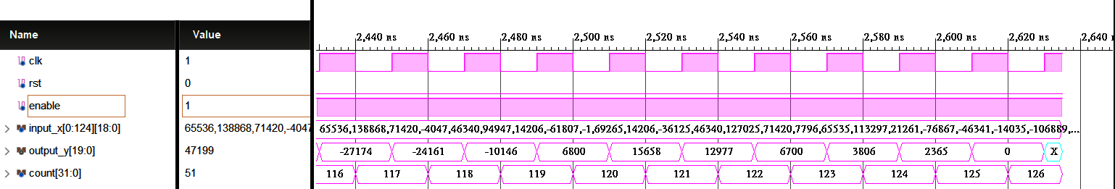

## post-route simulation

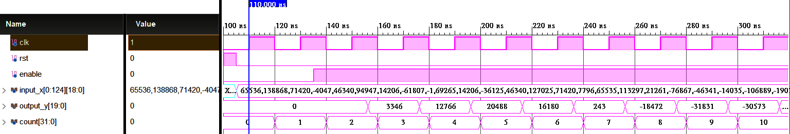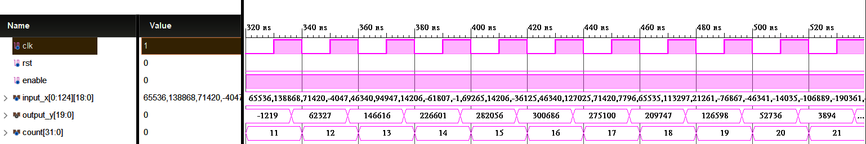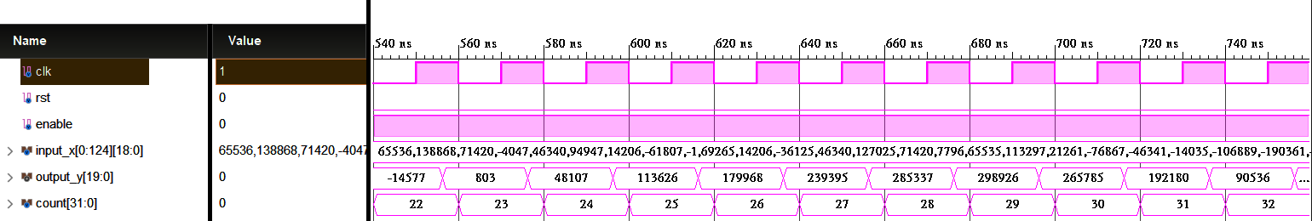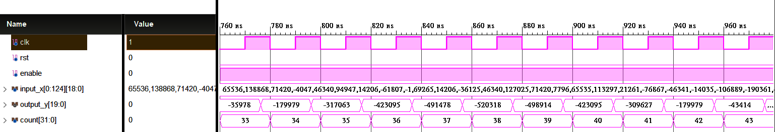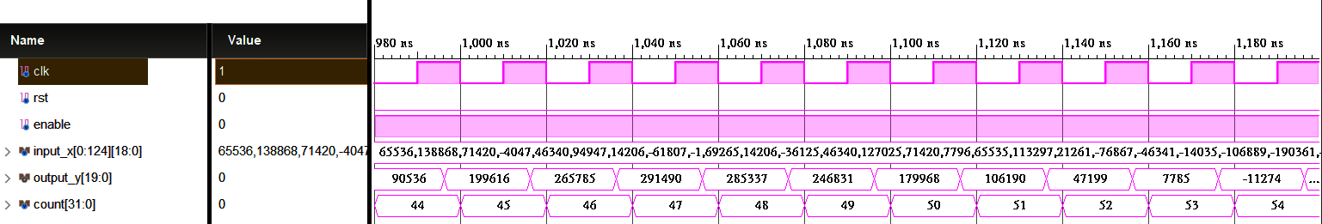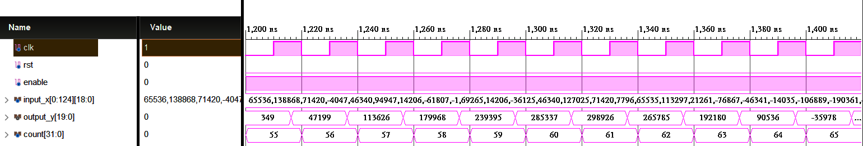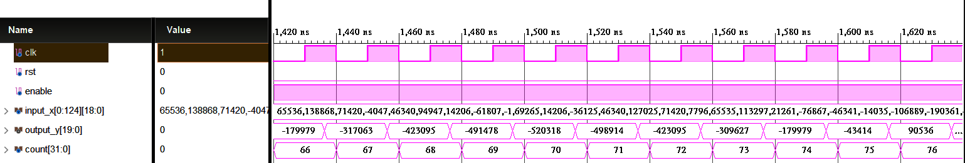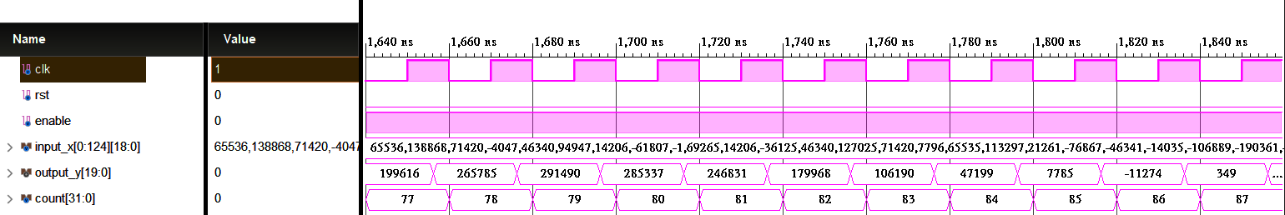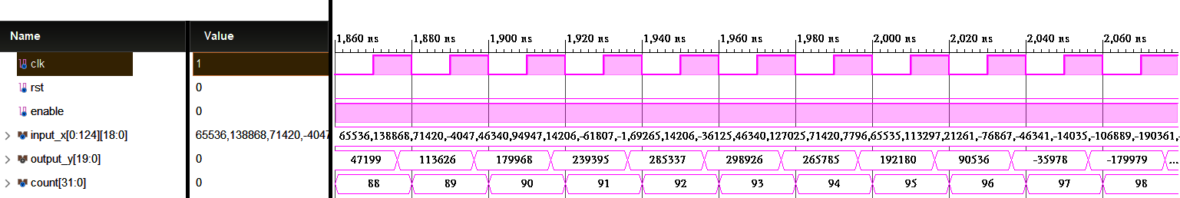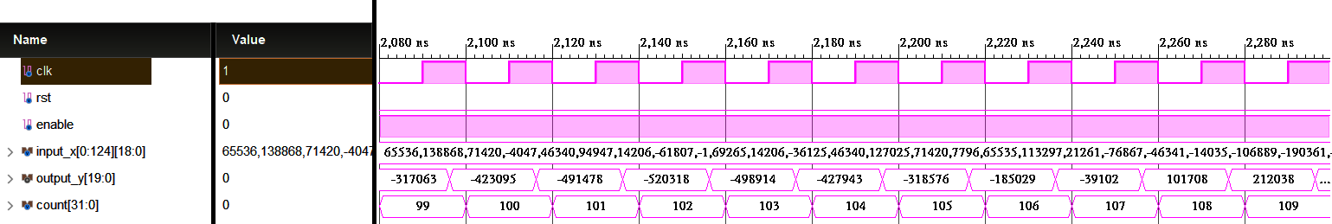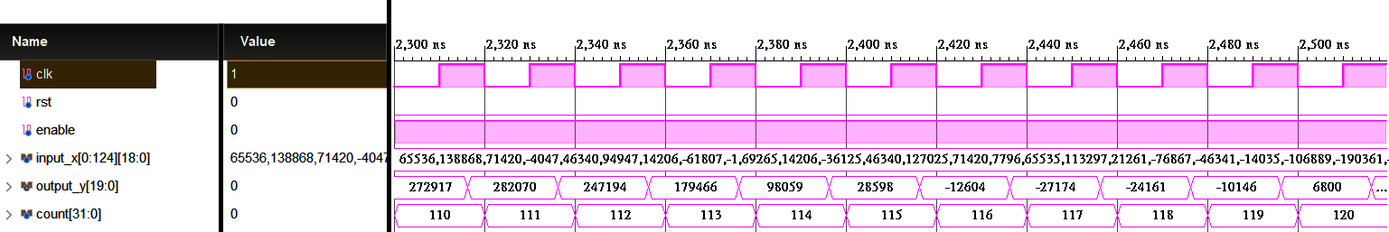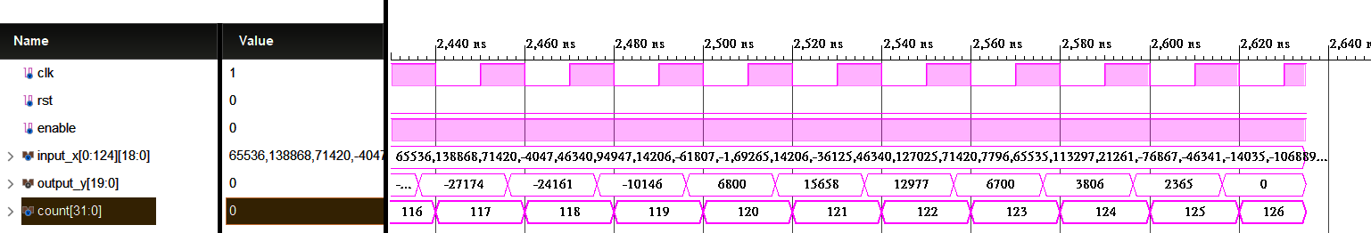

## Show the errors of hardware outputs and Matlab floating-point results of direct from FIR by Matlab figures.

Average error (log2): -14.7189

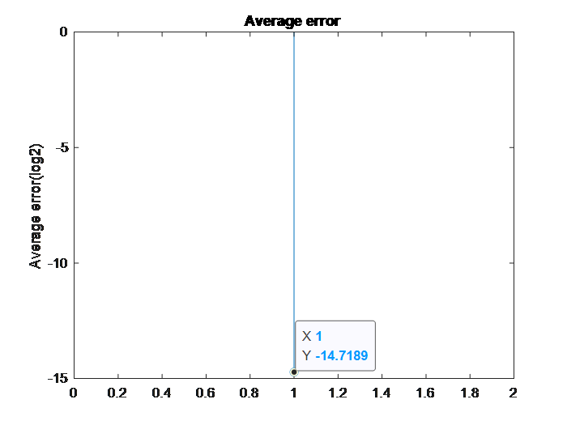

# Direct Form

# 

**output_y**

**S2.17**

**S1.18**

**input_x**

**S1.15**

**S1.15**

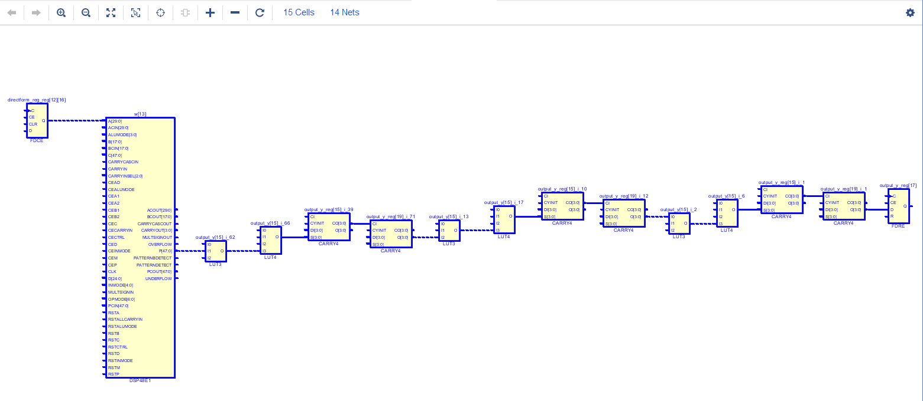

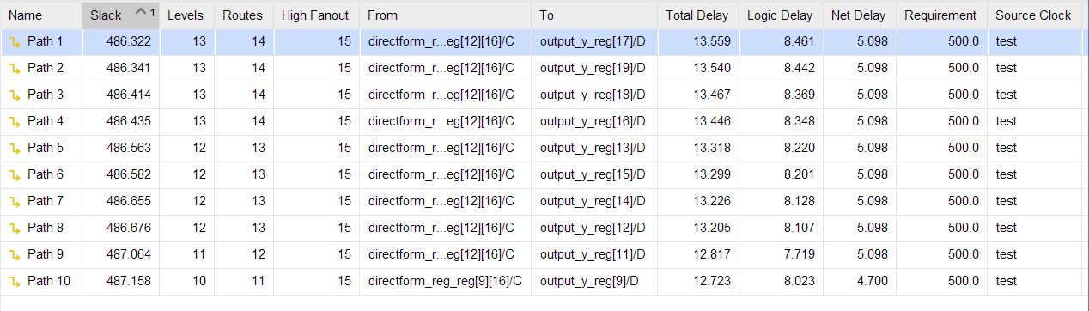

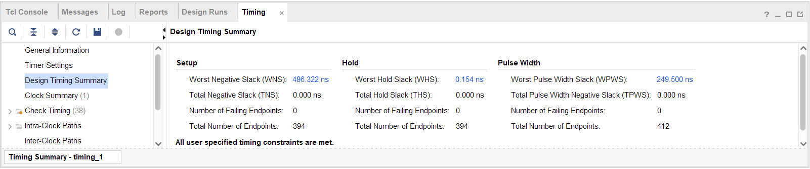

# Transposed Form



**output_y**

**input_x**

**S2.17**

**S1.20**

**S1.16**

**S1.17**

