**Lab. 4 Interpolator_2**

班級:通訊碩一 學號:110523064 姓名:徐巧庭 指導教授: 蔡佩芸 教授

# The time-domain impulse response of interpolator

## Word-length of input.



## Word-length of 𝜇.



## Word-length of multiplier (by 𝜇).



## Word-length of adder



## Final architecture of the piece-wise parabolic interpolator

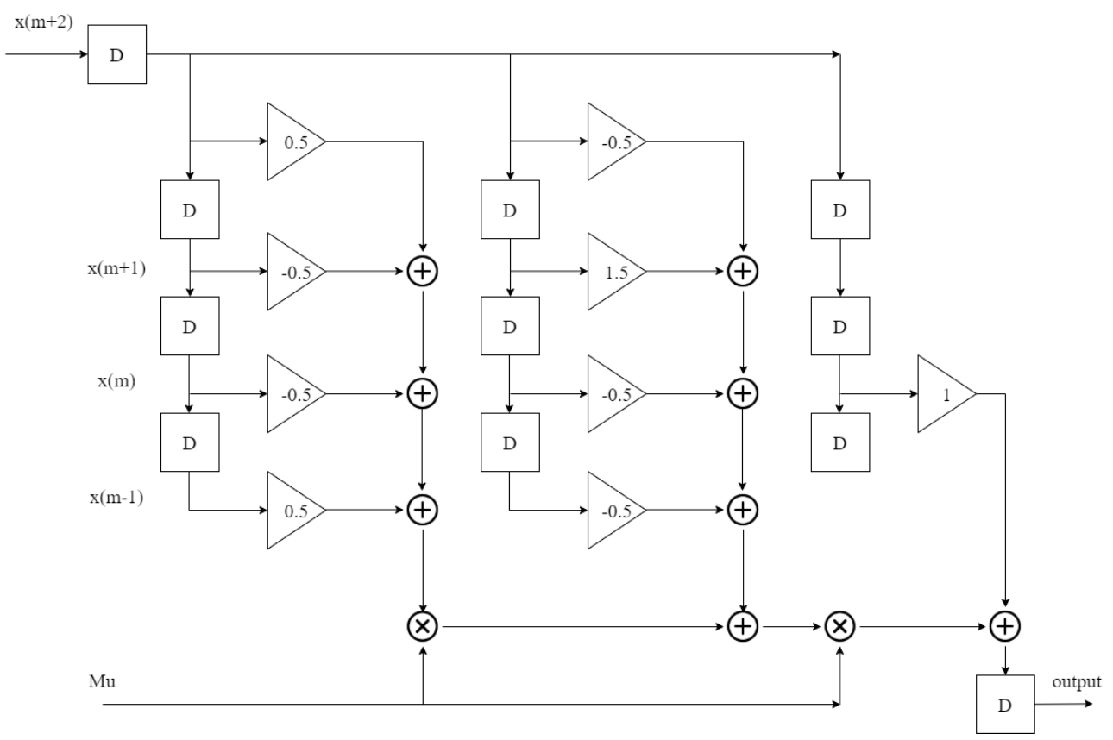

S1.11

S1.11

S1.11

S1.11

## Behavior simulation result.

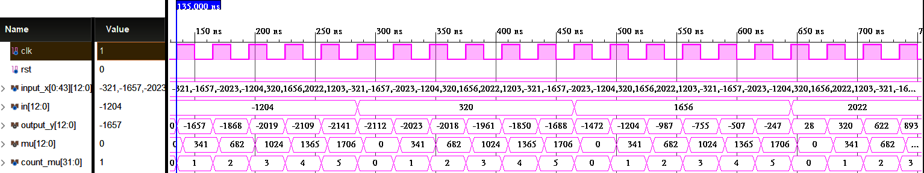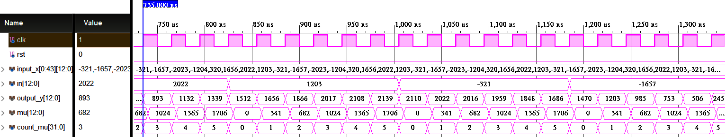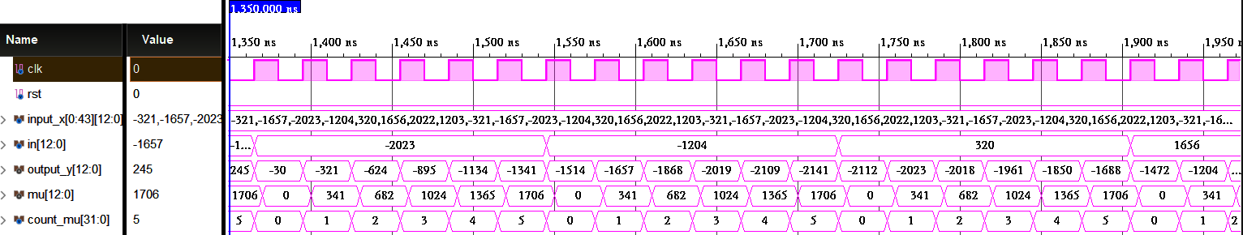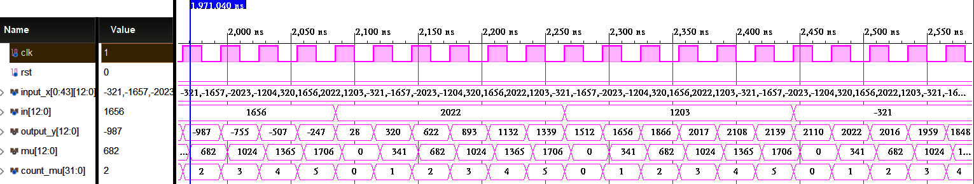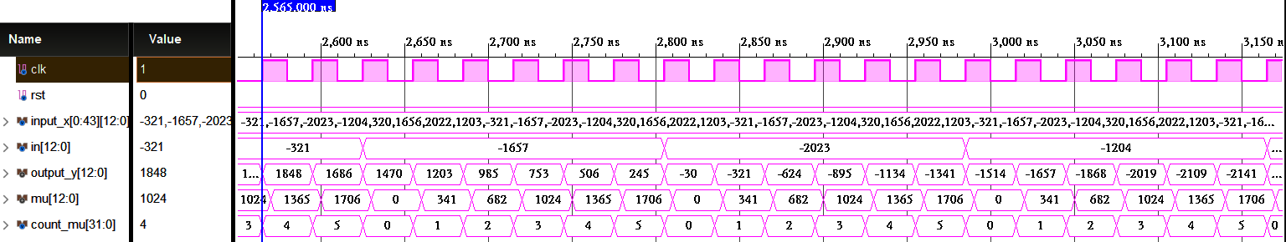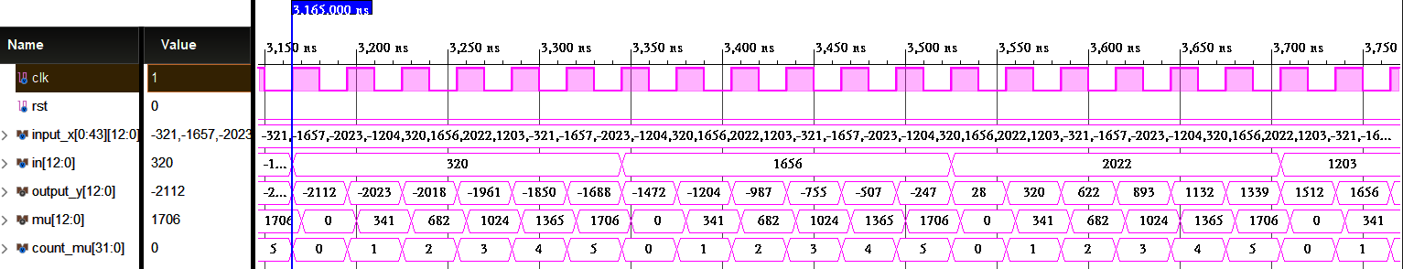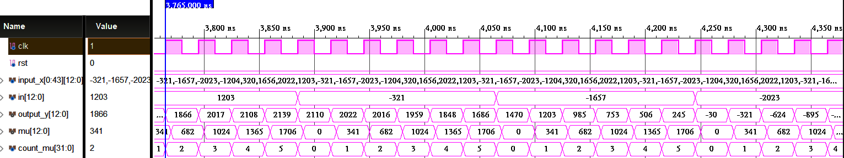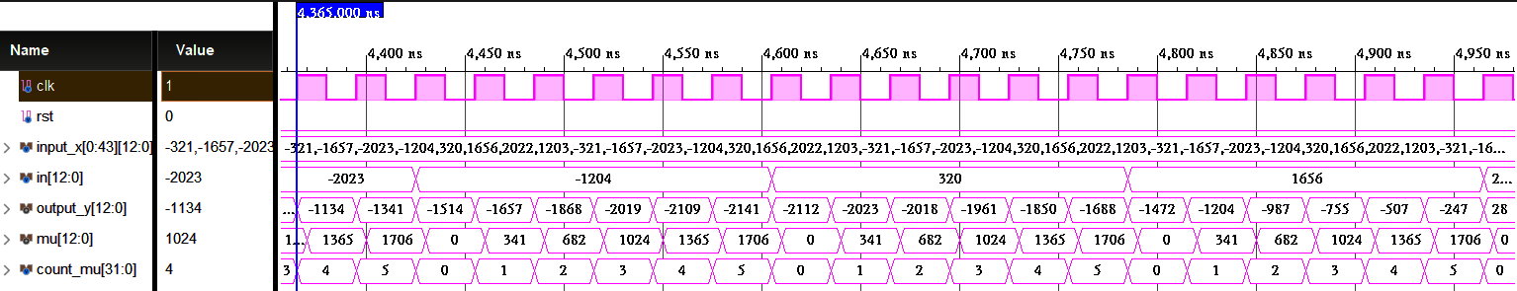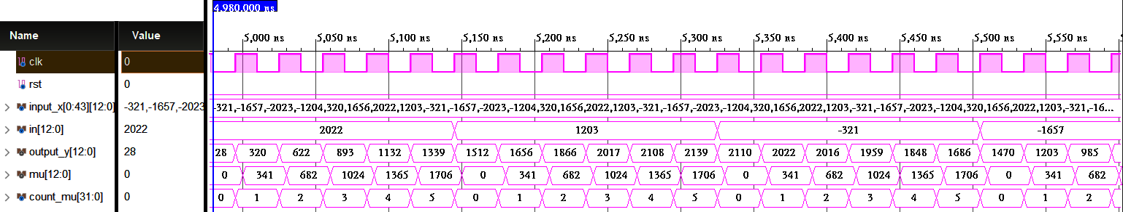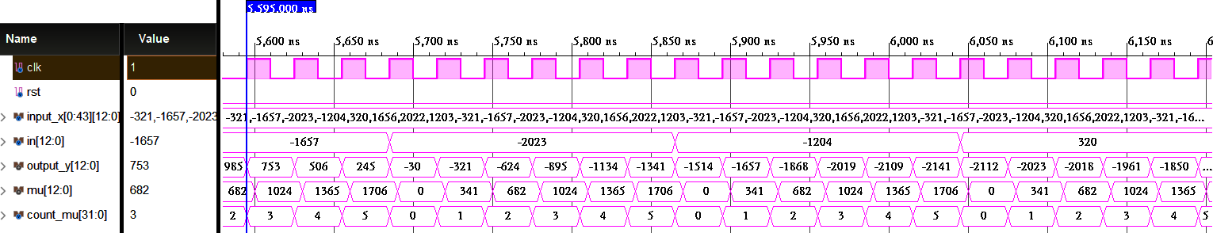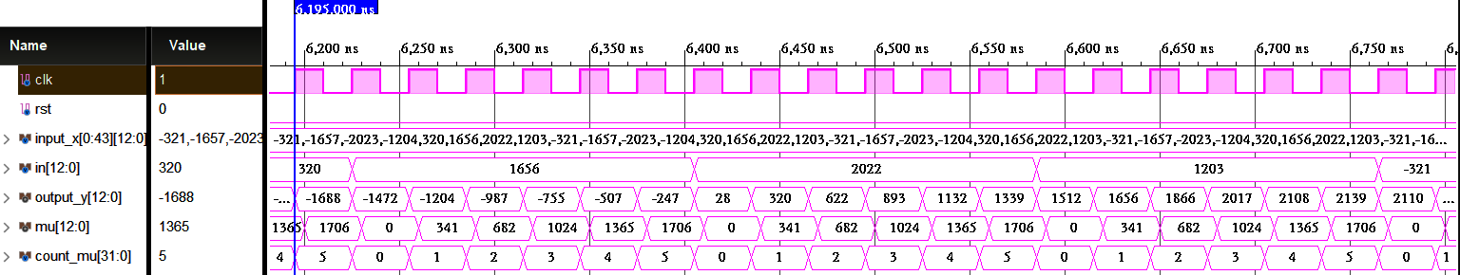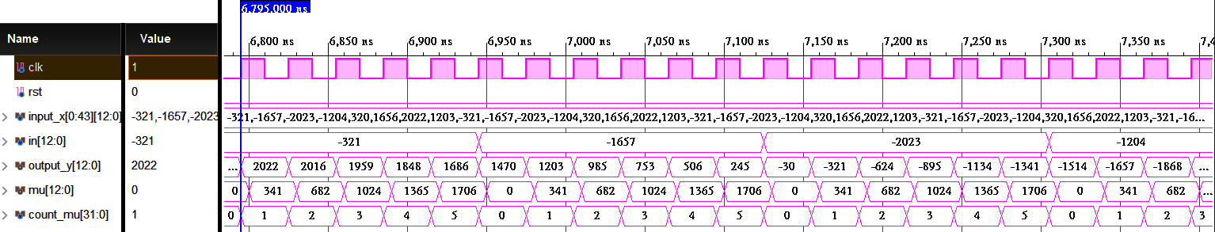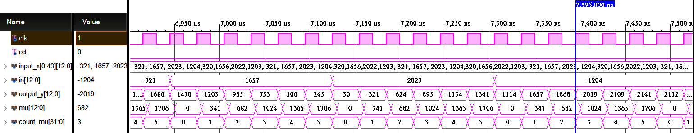

## Post-route simulation results.

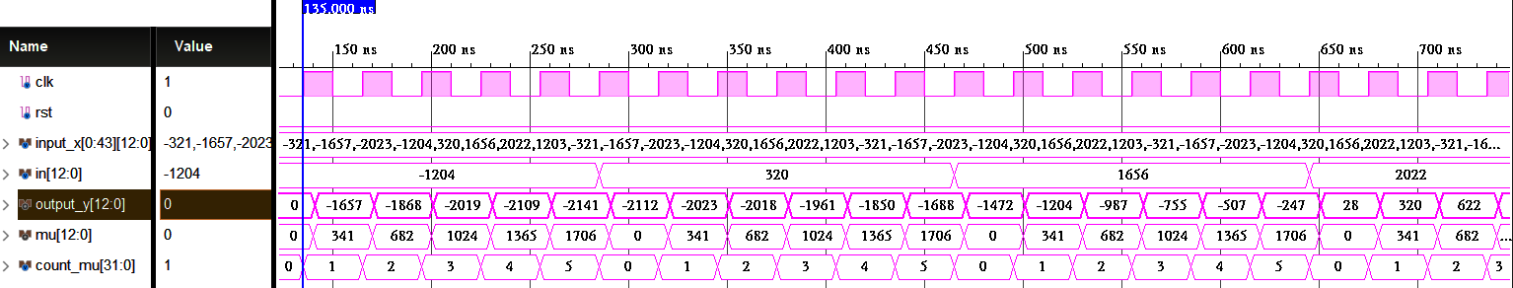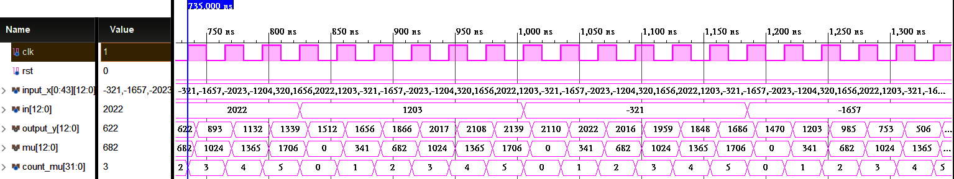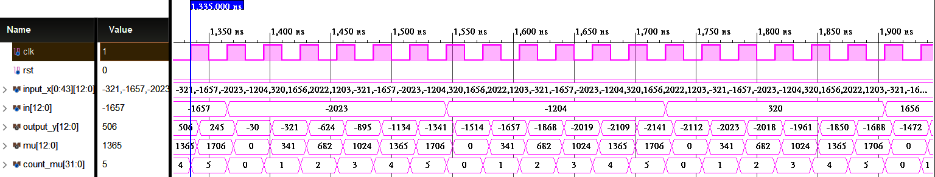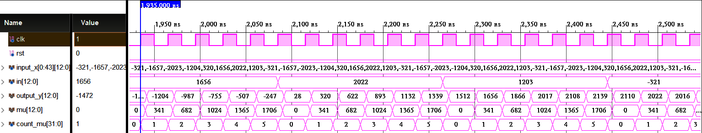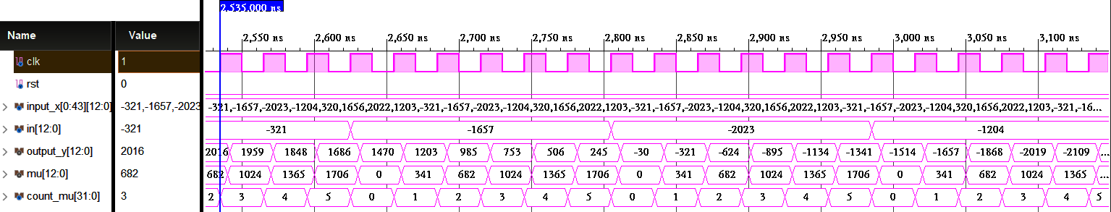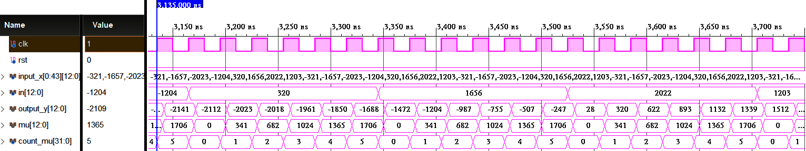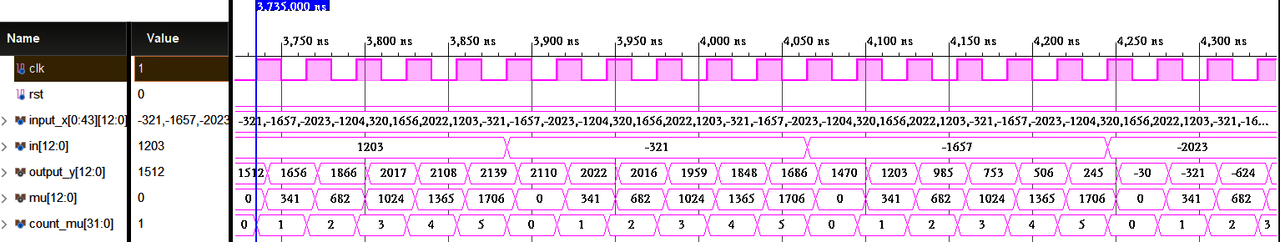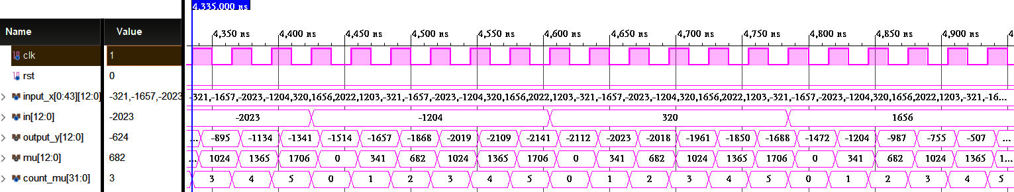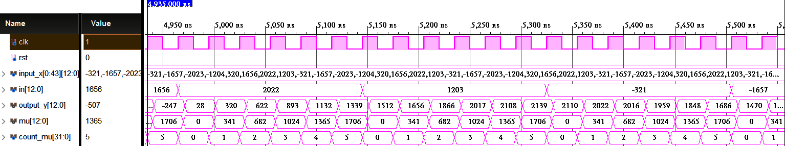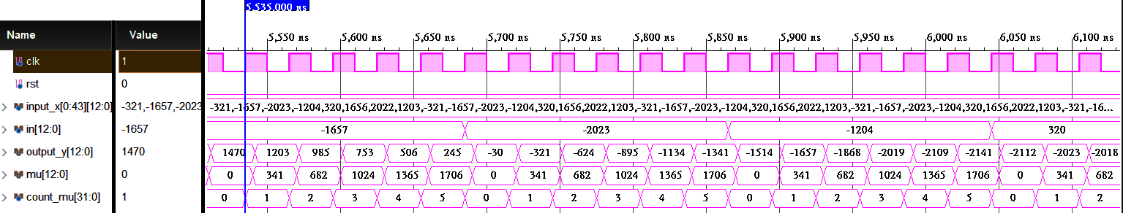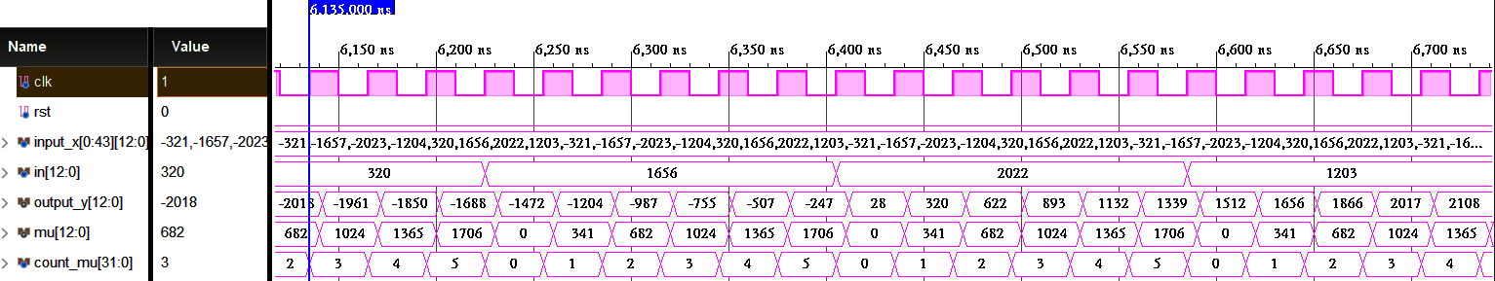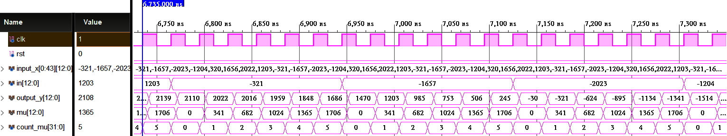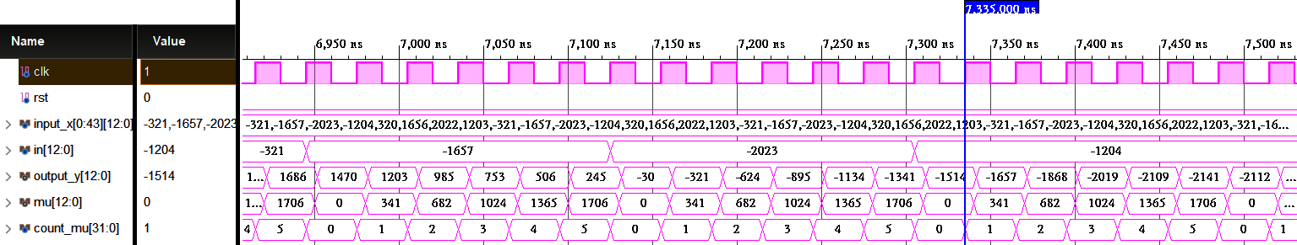

## The error between the Verilog outputs and Matlab floating-point outputs.

RMSE (log2): -10.8853



## Timing report.

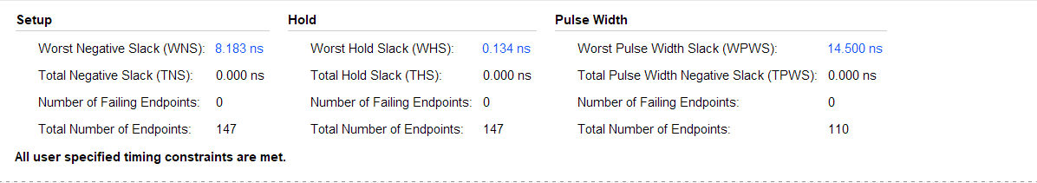

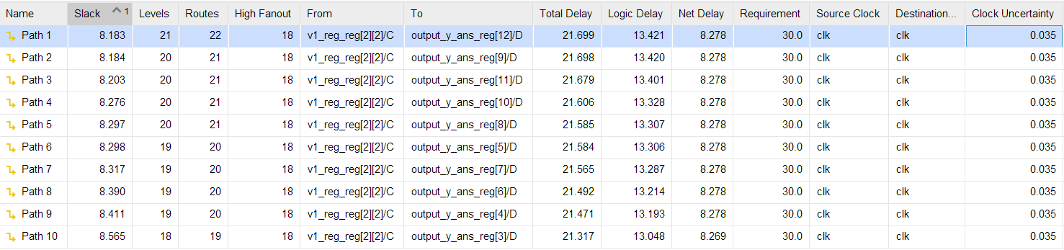

## Critical path

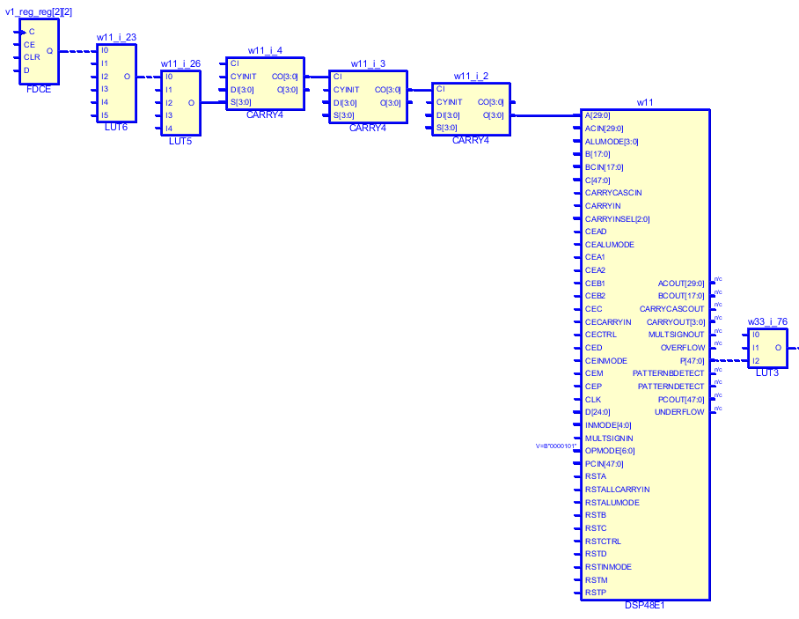

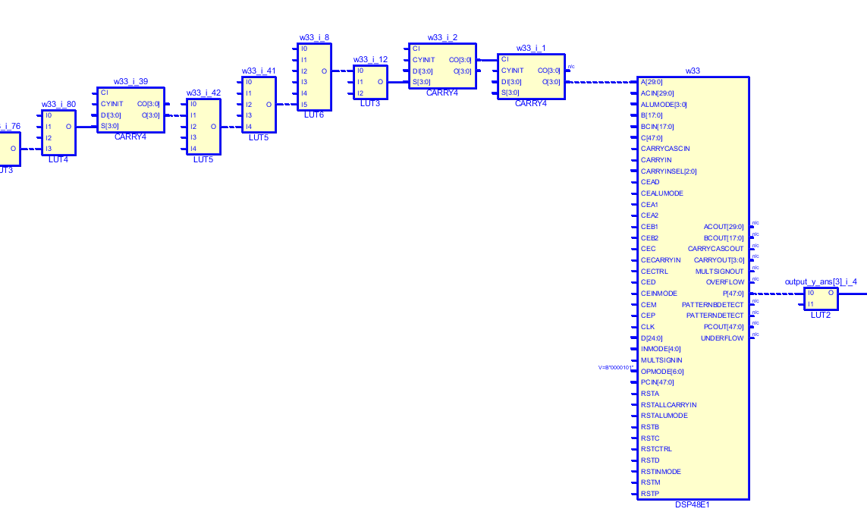

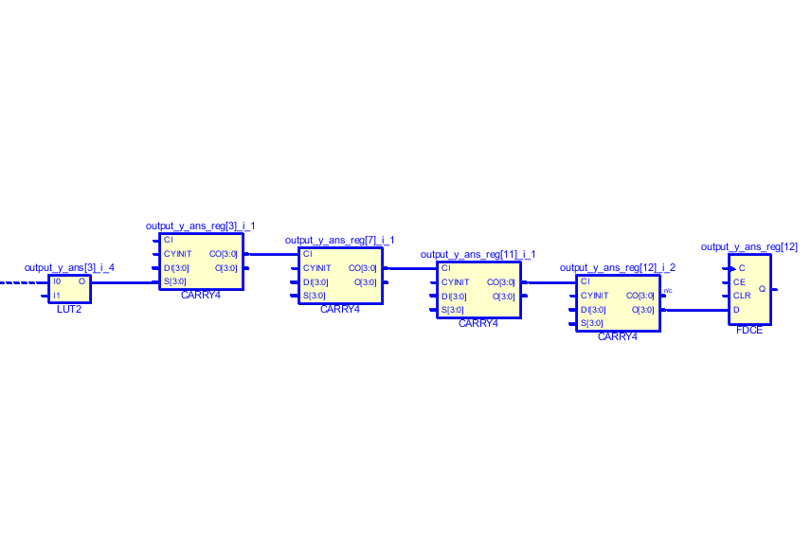



**v0_reg[0]**

**v0_reg[1]**

**v0_reg[2]**

**v1_eg[0]**

**v1_reg[1]**

**v1_reg[2]**

**v2_reg[0]**

**v2_reg[1]**

**v2_reg[2]**

**Reg[3]**

**w11**

**w33**

**v0_out**

**v1_out**

**v2_out**

**Output_y_ans**

