**Lab. 5 CORDIC_2**

班級:通訊碩一 學號:110523064 姓名:徐巧庭 指導教授: 蔡佩芸 教授

## Behavior simulation result

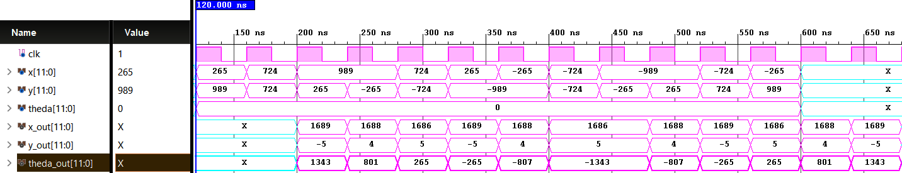

## Post-route simulation results

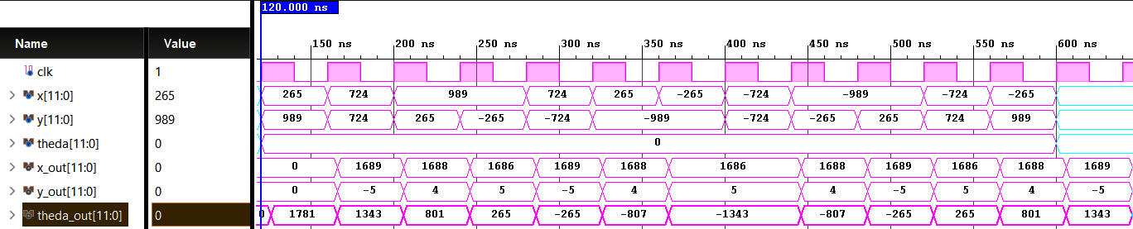

Average error of theda out (log2): -13.077



## Timing report

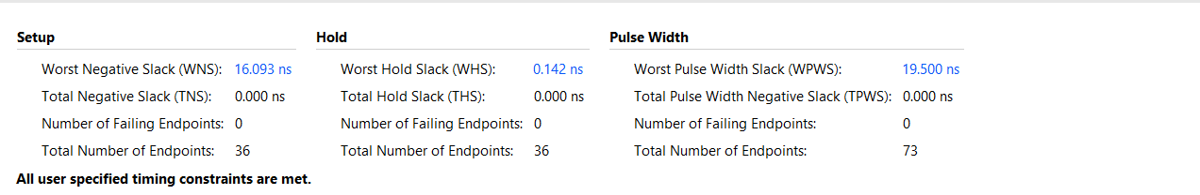

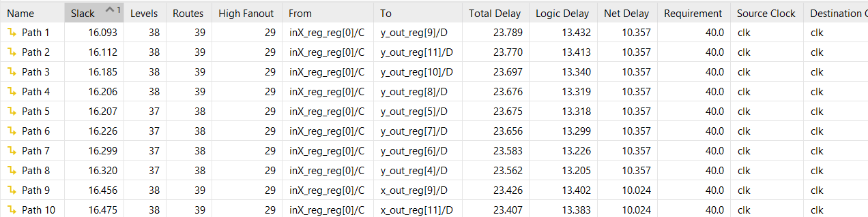

## Critical path

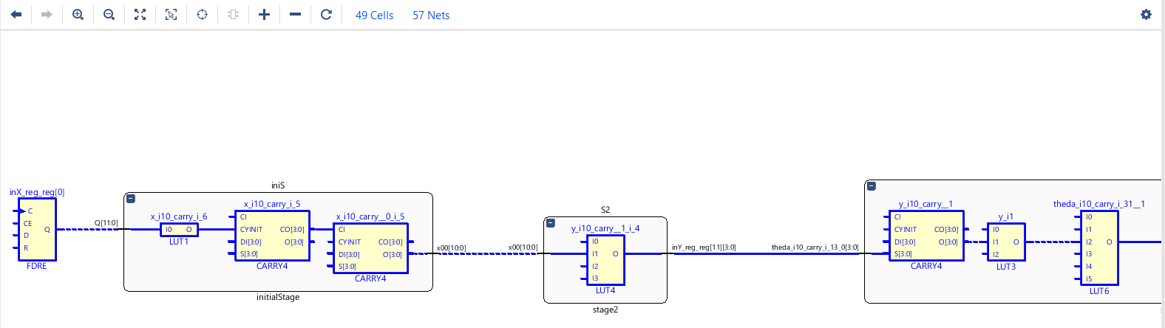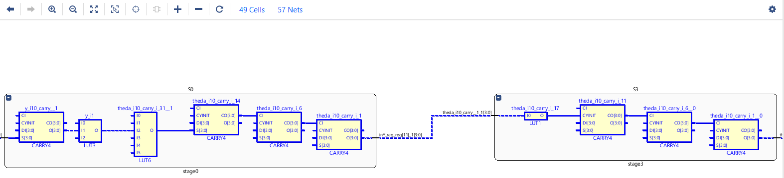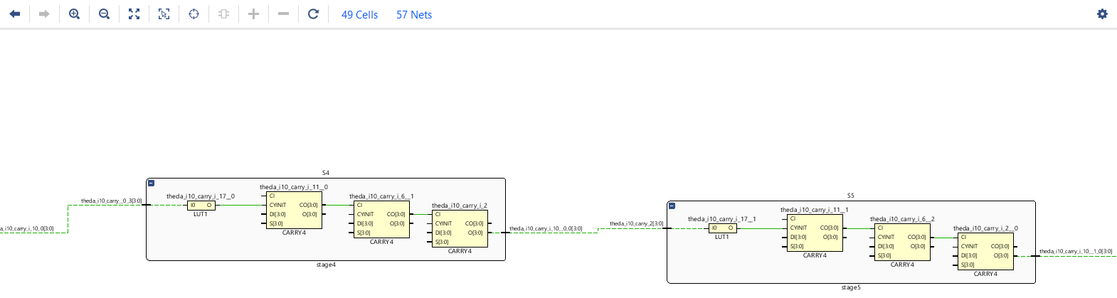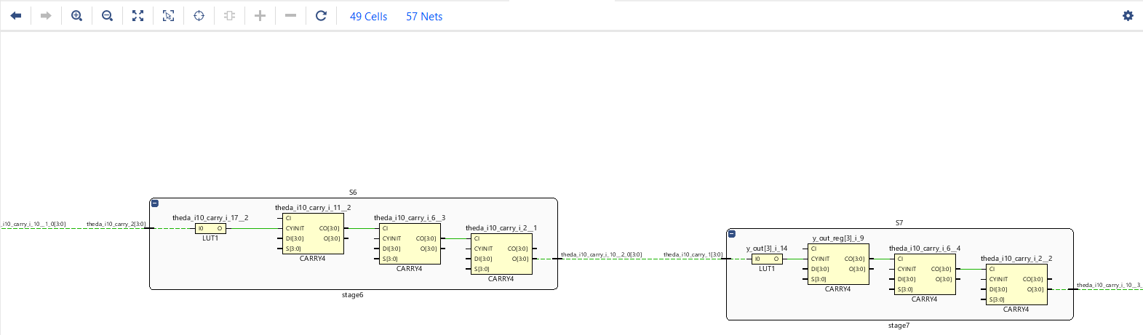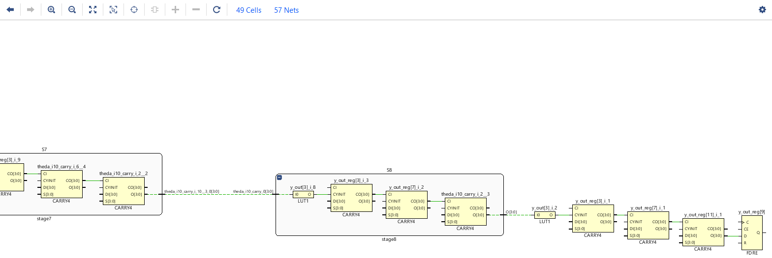

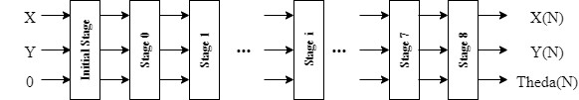

**S1.10**

**S1.10**

**S1.10**

**S1.10**

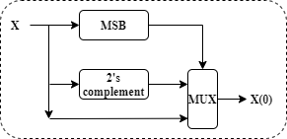 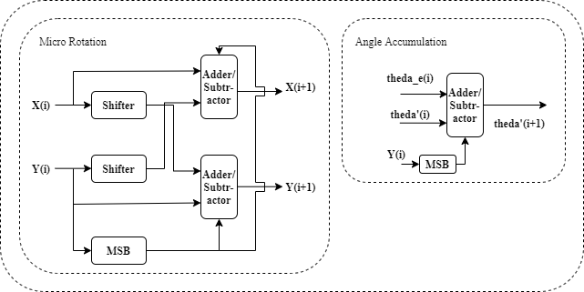

## Behavior simulation result

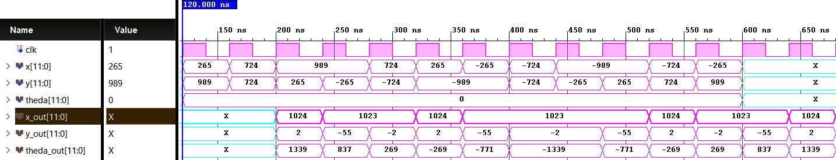

## Post-route simulation results

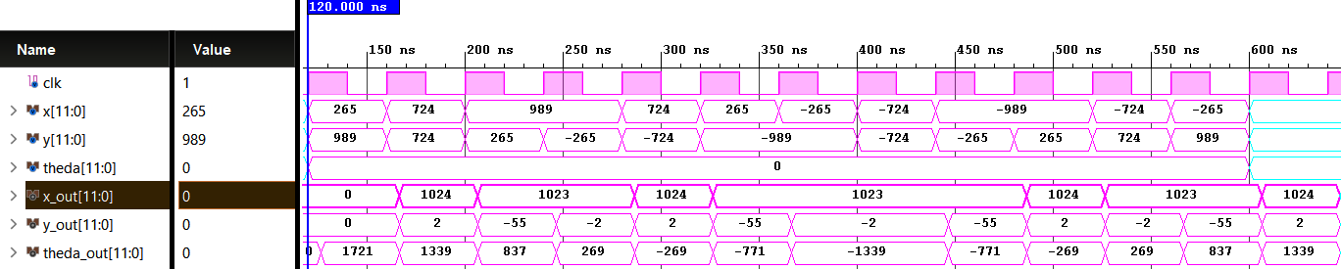

Average error of scaling out (log2): -7.998



## Timing report

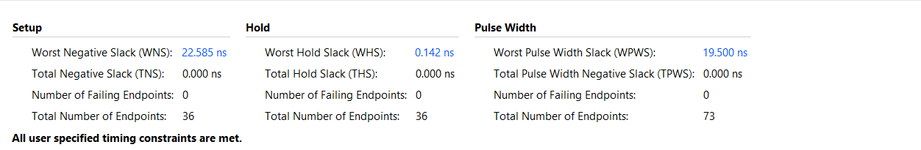

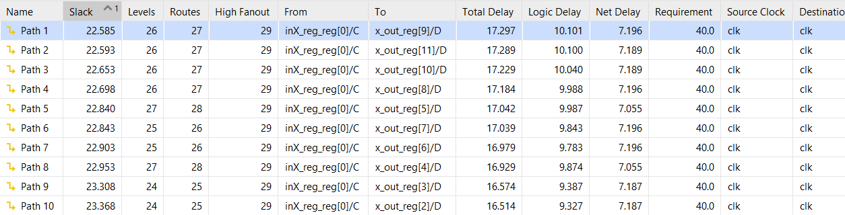

## Critical path

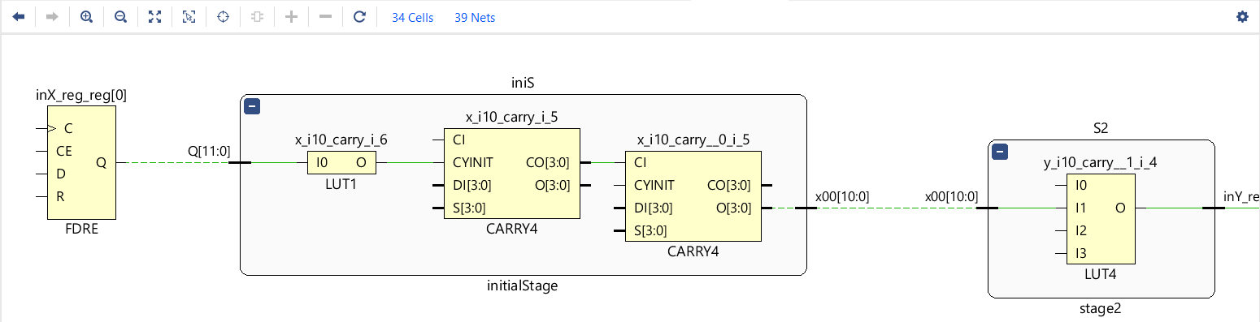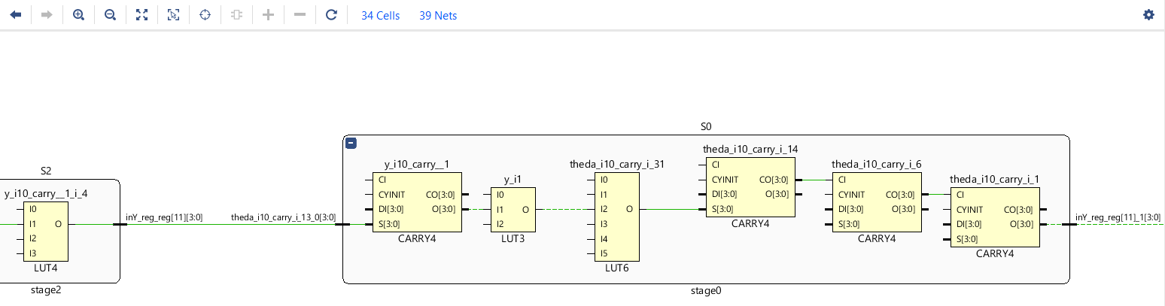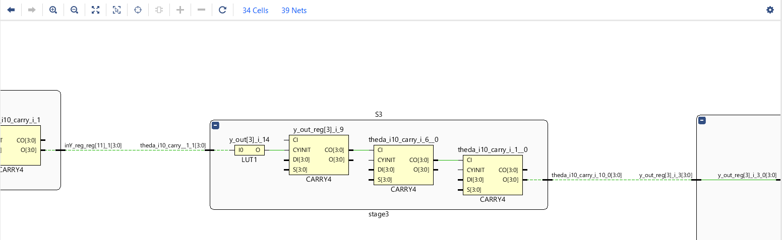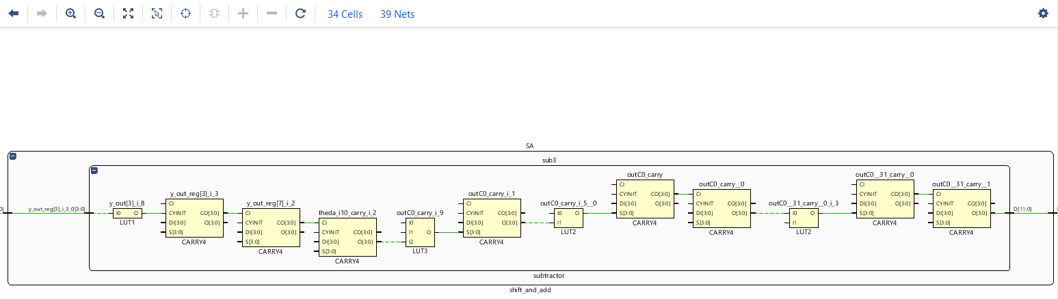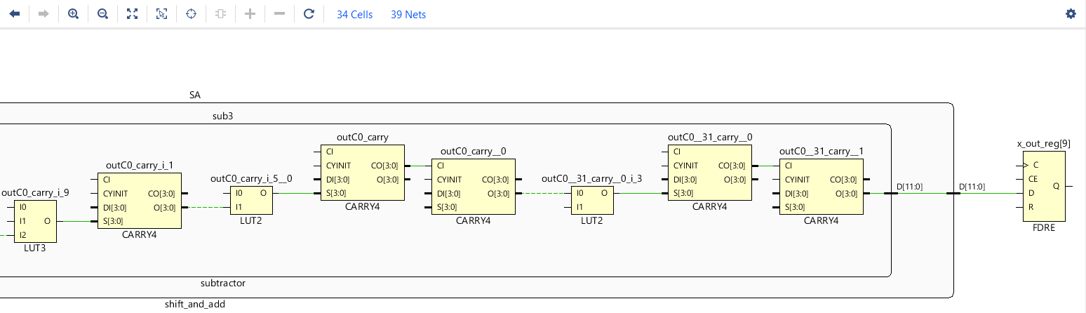

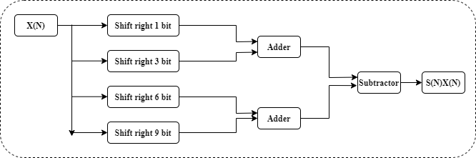

**S1.10**

**S1.10**

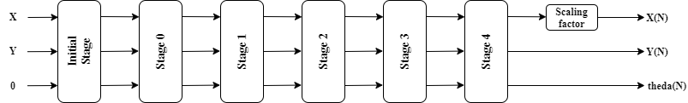

**S1.10**

**S1.10**

**S1.10**

**S1.10**

 

## Measurement results of Q8

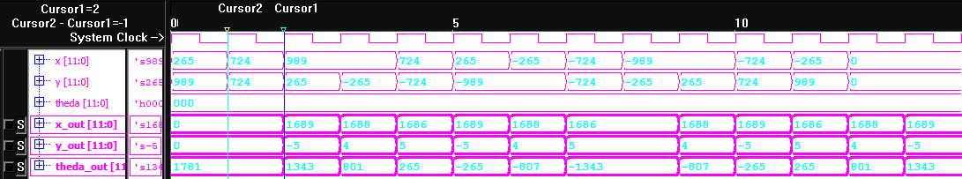



## Measurement results of Q10

