**Lab. 6 Fast Fourier Transform (FFT)_2**

班級:通訊碩一 學號:110523064 姓名:徐巧庭 指導教授: 蔡佩芸 教授

## The real-part and imaginary-part of 𝑥0~𝑥31



## The real-part and imaginary-part of X0~X31



## The real-part and imaginary-part of Y0~Y31



## The difference between X and 𝑌



## Behavior simulation result

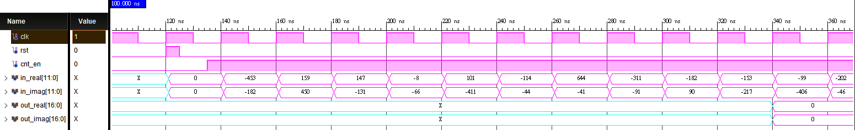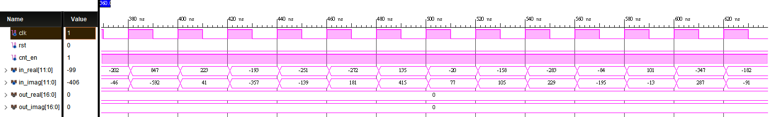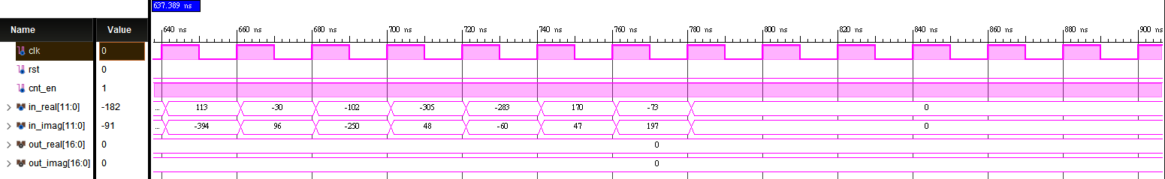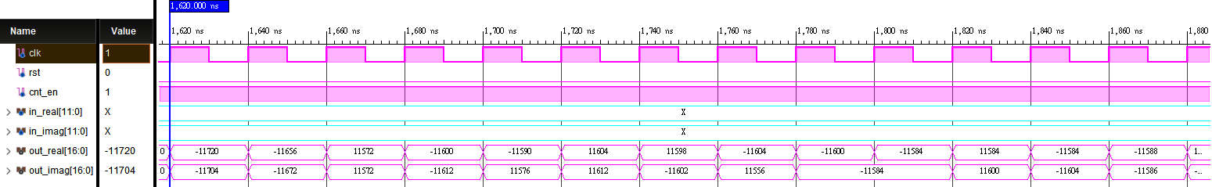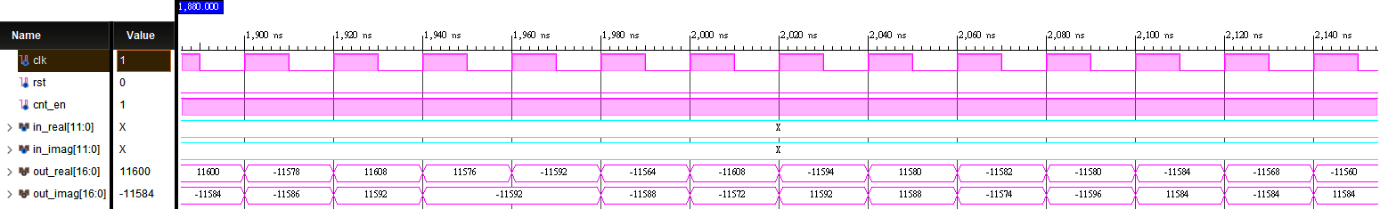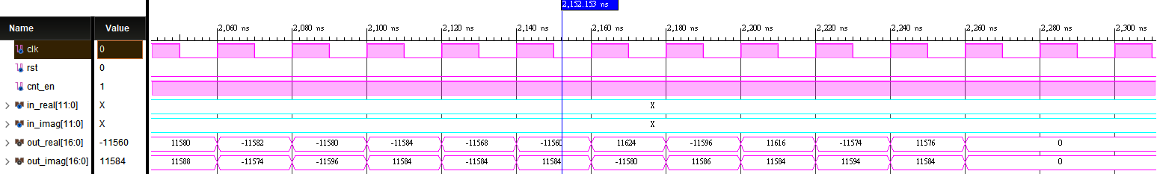

## Post-route simulation results

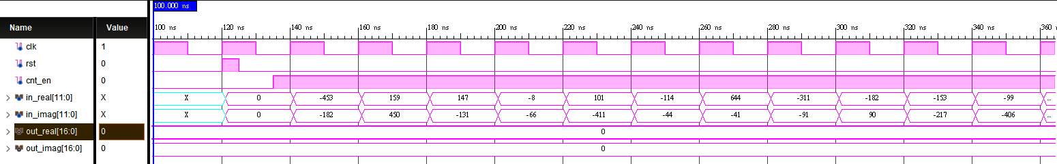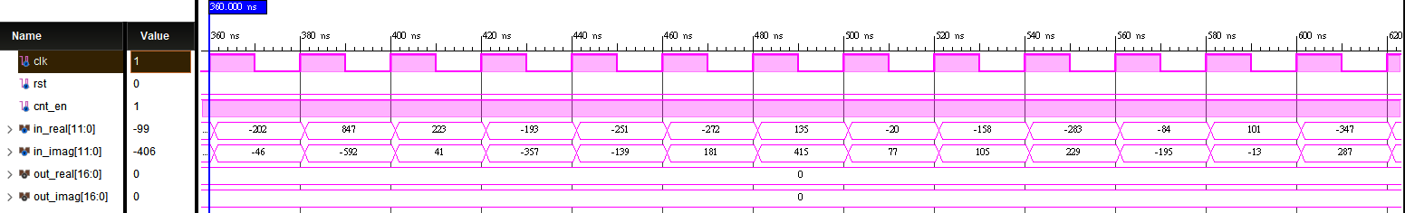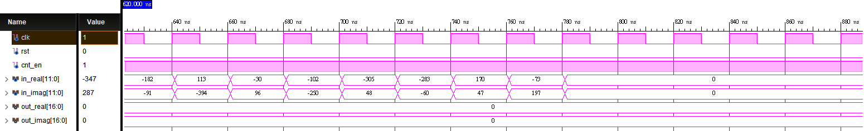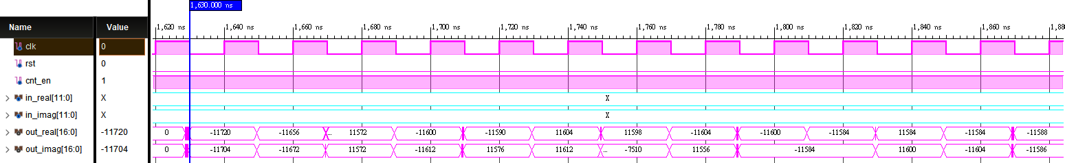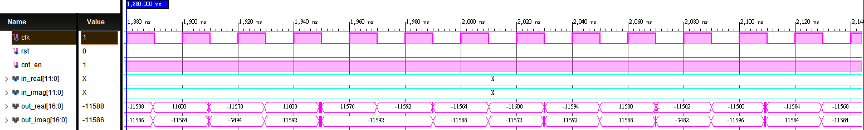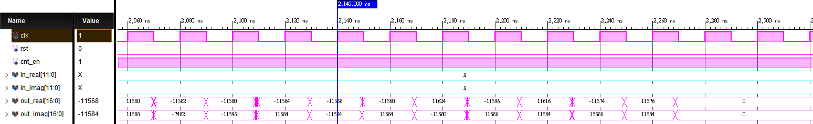

## Compare the outputs after bit-reverse reordering with the Matlab results.





## Timing report

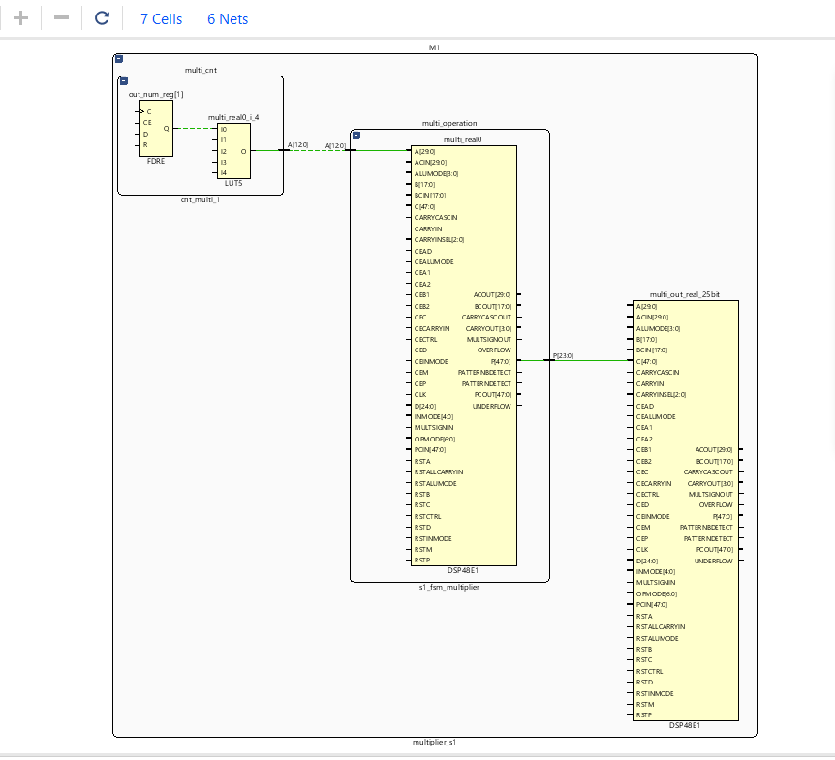

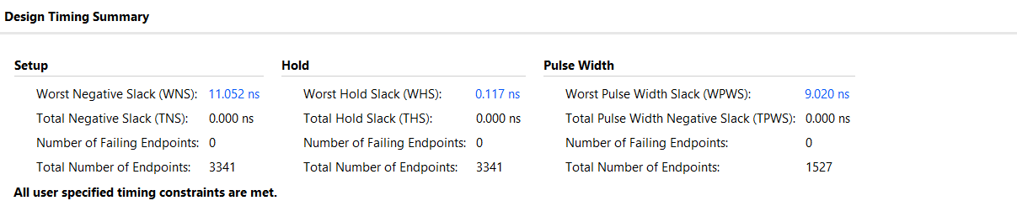

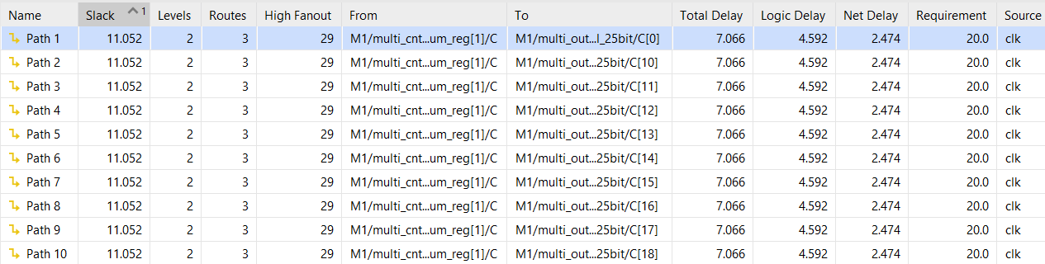

## The measurement results

