選擇BayesNet Cross-validation 正確率：92.6667

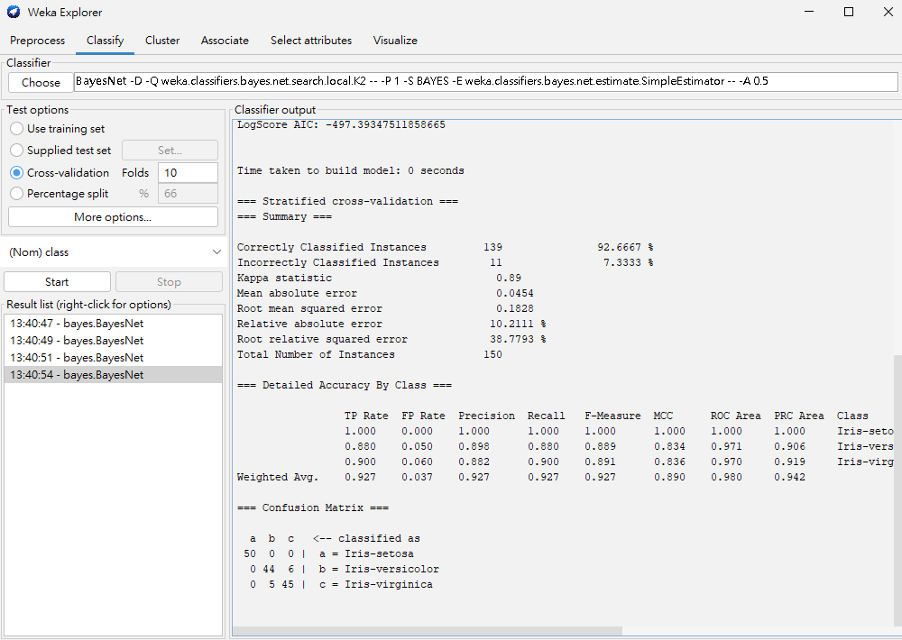

Use training set 正確率為94.6667

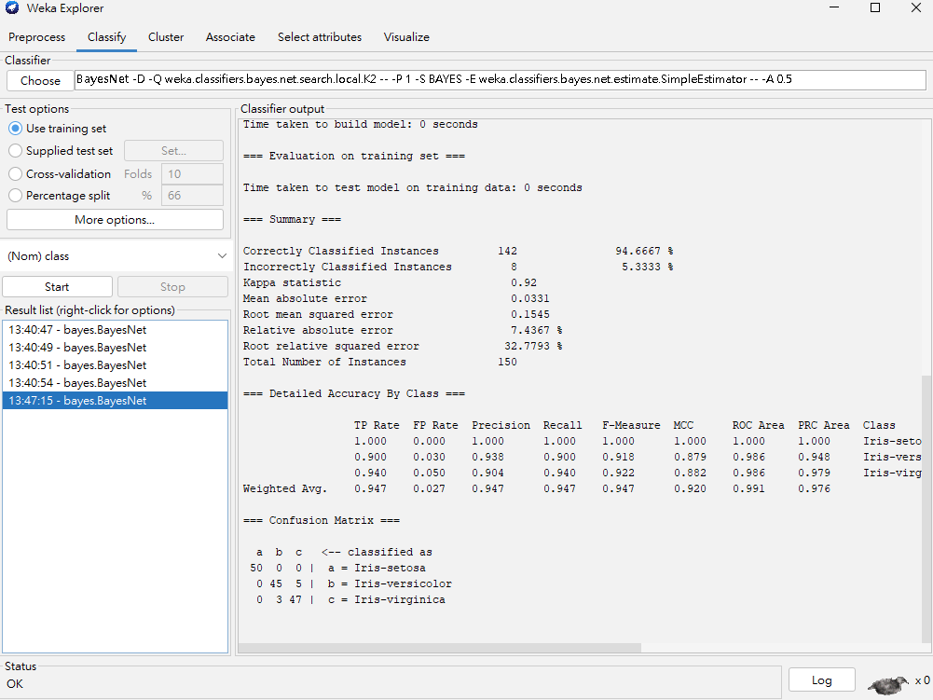選擇Percentage split：66% 正確率94.1176%

