Appendix A
List of the items present in the initial, larger, 27-item pool.
Dimension | Item Name | Example picture | Description | Reference
Figurative thinking (metaphor comprehension) | MetaphorNoun | 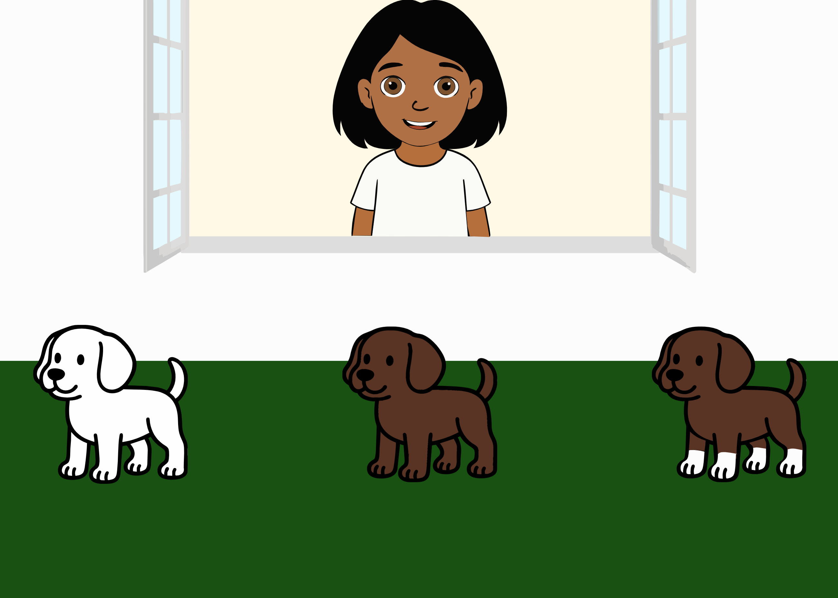 | Ella says: “Oh look, a dog with socks! Which one is it?”. The ambiguity of the literal message is integrated with information from the context (the three different dogs, one white, one brown and one having white paws), about the world (socks are worn on the feet) and about the speaker’s communicative intention (the utterances Ella would have uttered if she had wanted to refer to each one of the alternatives). | Pouscoulous and Tomasello (2020)
Figurative thinking (metaphor comprehension) | MetaphorAdjective | 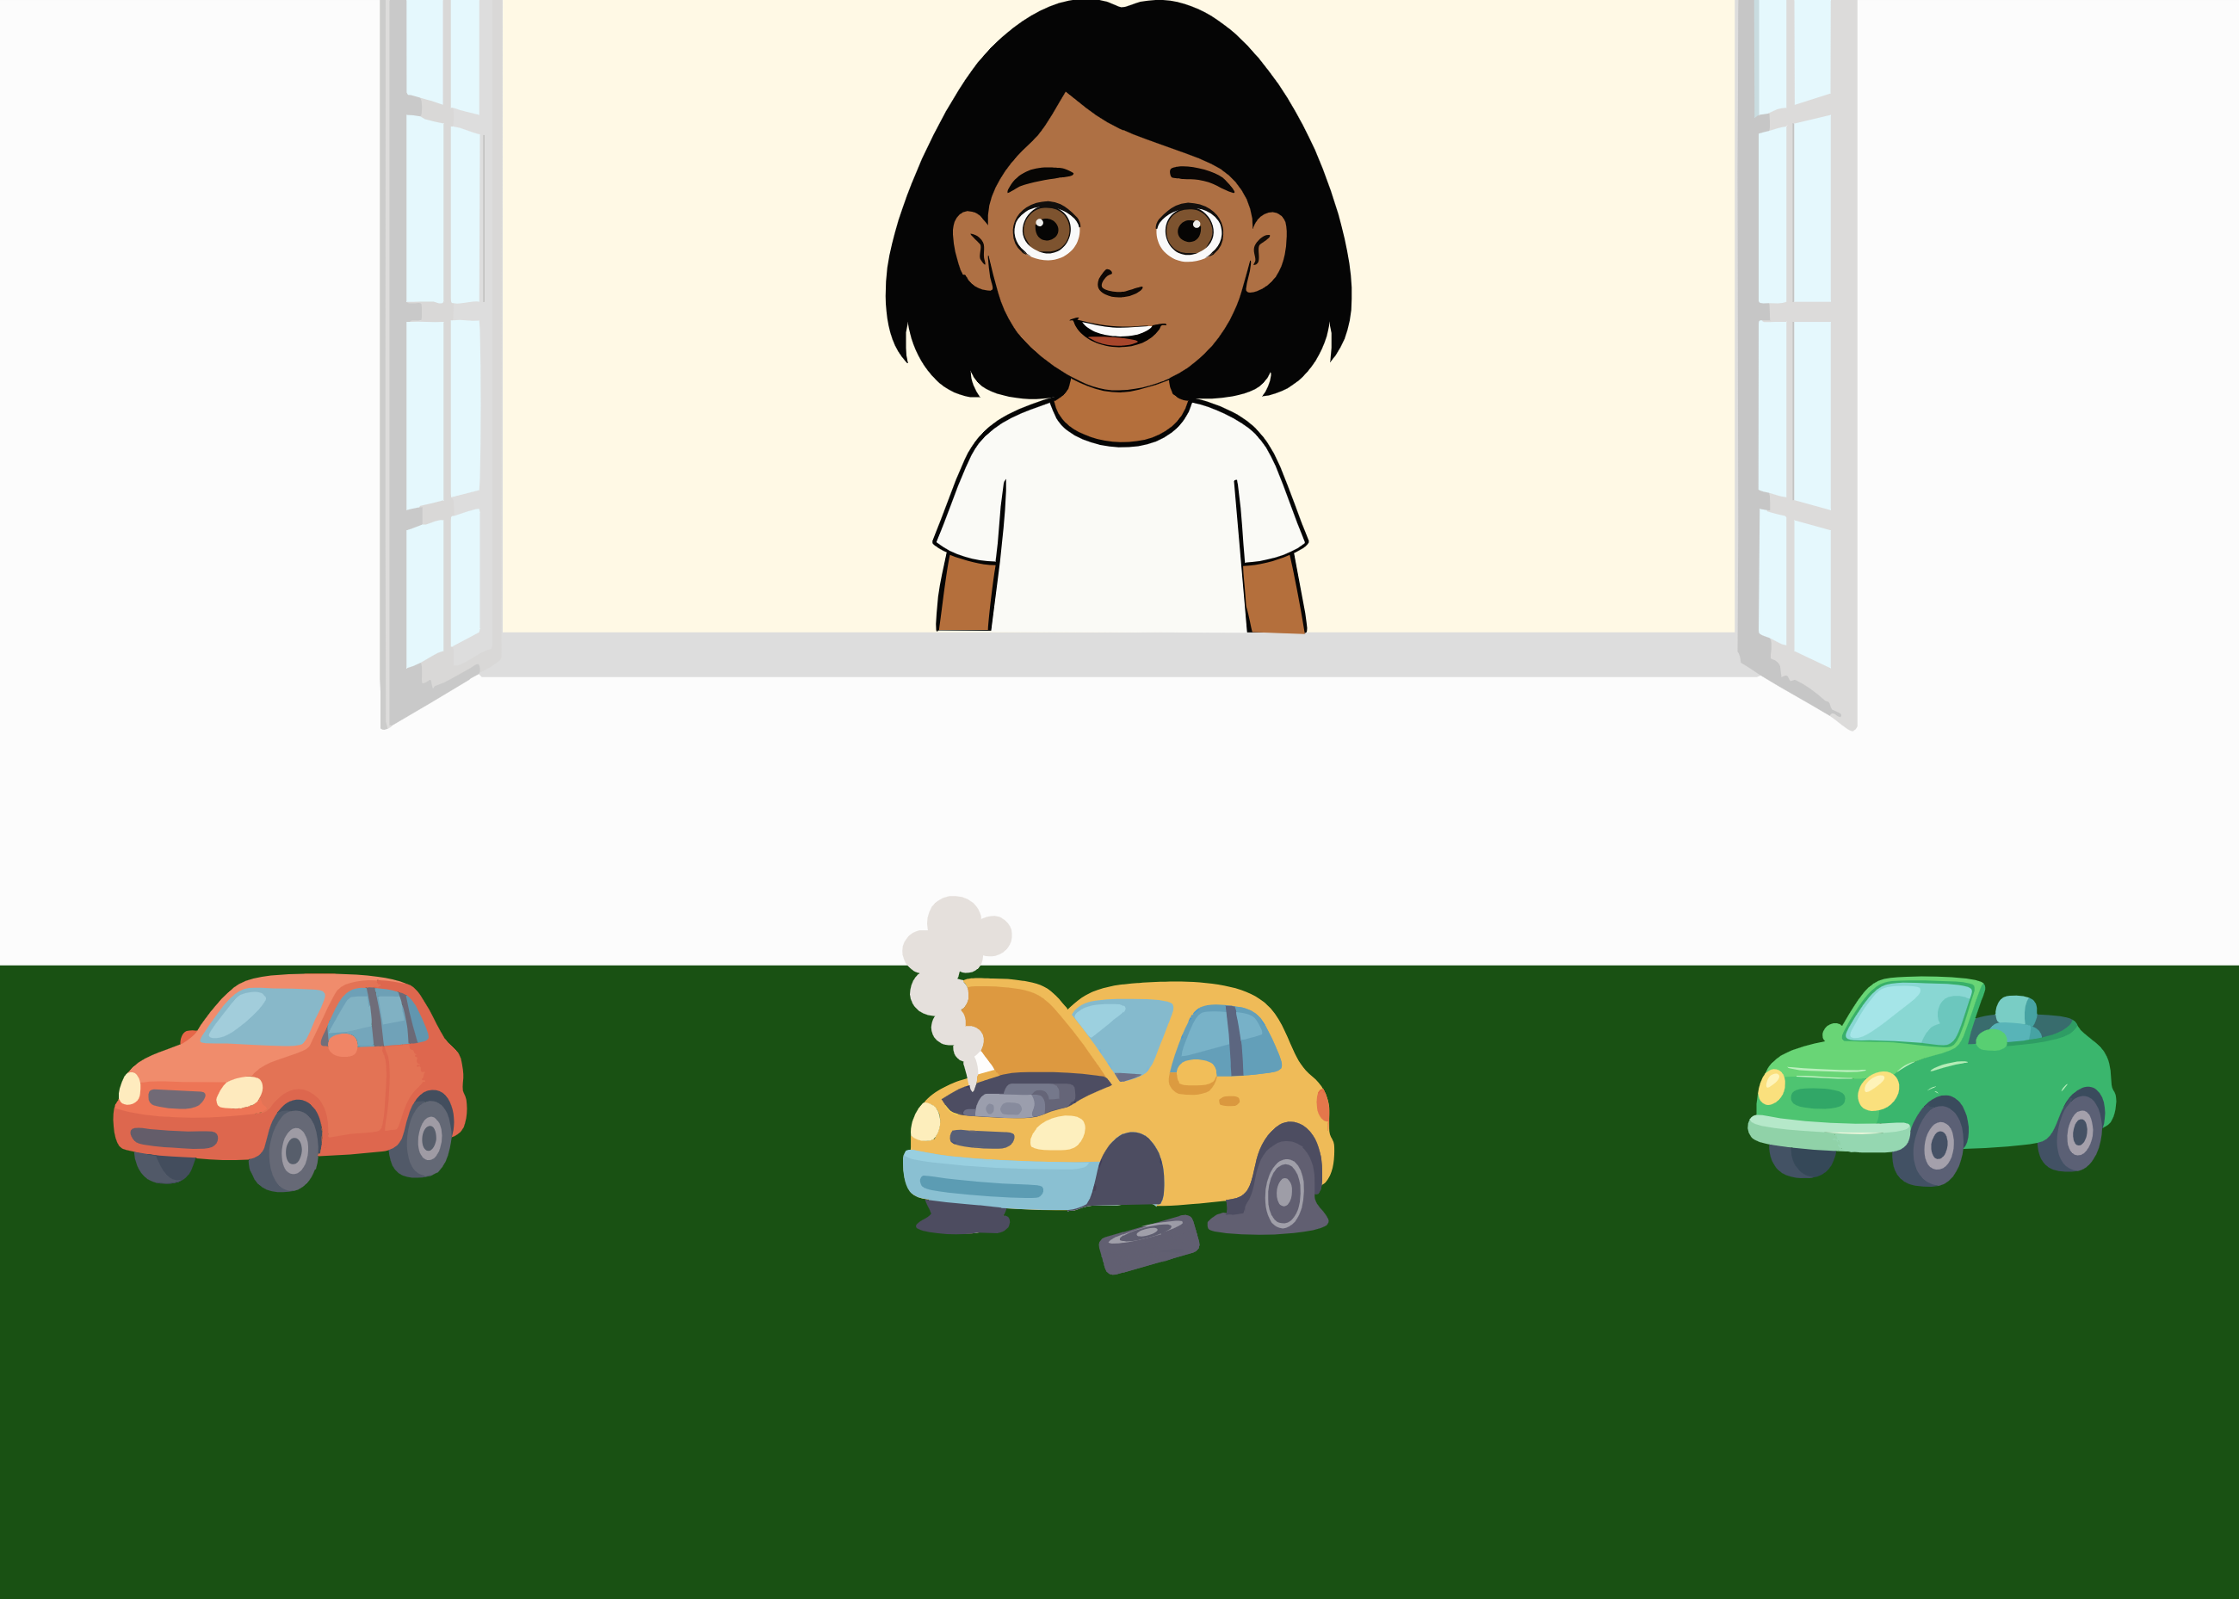 | Ella says: “Oh look, the car is sick! Which one is it?”. The ambiguity of the literal message is integrated with information from the context (the three different cars, namely a normal car, a broken one and a convertible one), the world (one who is sick is usually in poor physical conditions) and about the speaker’s communicative intention (the utterances Ella would have uttered if she had wanted to refer to each one of the alternatives). | Pouscoulous and Tomasello (2020)
Figurative thinking (metaphor comprehension) | MetaphorVerb | 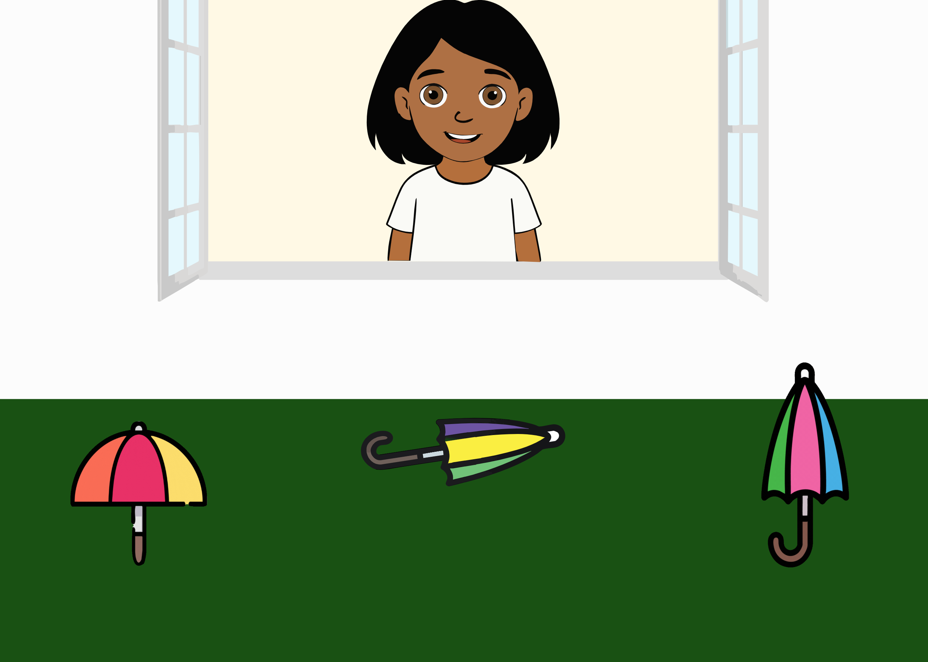 | Ella says: “Look, an umbrella that’s sleeping! Which one is it?”. The ambiguity of the literal message is integrated with information from the context (the three different umbrellas, namely one twirling, one laying on the ground and one opening and closing), the world (one who sleeps is usually laying down) and about the speaker’s communicative intention (the utterances Ella would have uttered if she had wanted to refer to each one of the alternatives). | Pouscoulous and Tomasello (2020)
Implicature understanding (Conversational Implicature) | ConvImp1 | 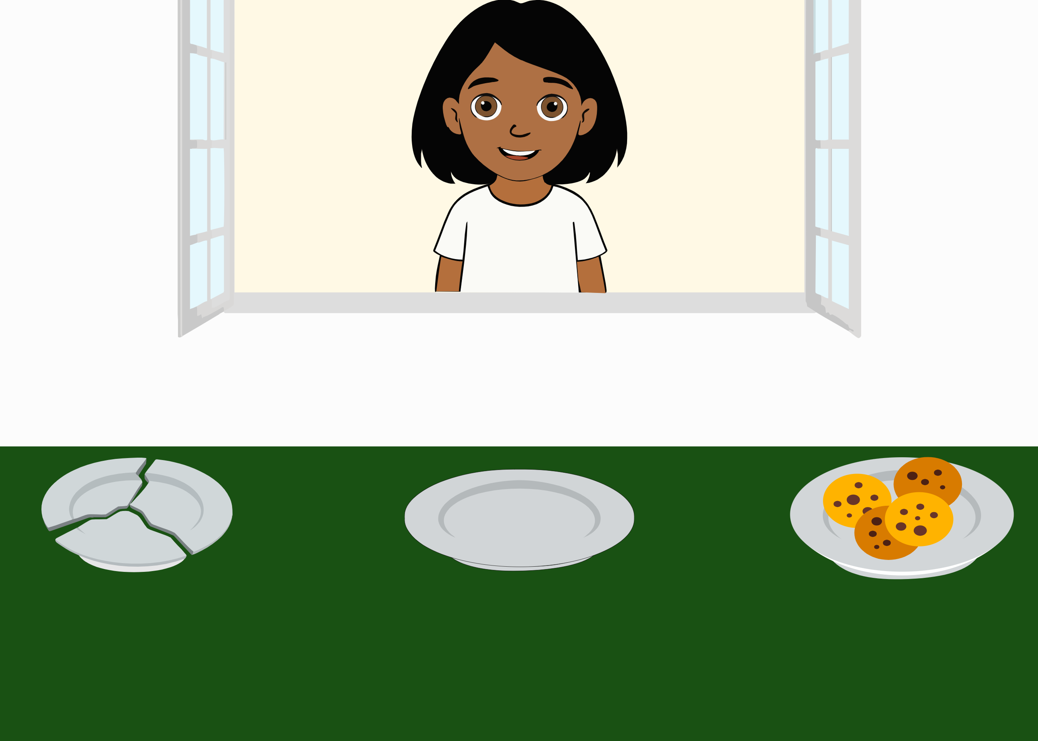 | Ella says: “Now I’m really hungry and I want to eat. Can you give me my plate?”. The ambiguity of the literal message (there is no indication as to which one is her plate) is integrated with information from the context (the three different plates, one broken, one empty and one with cookies), about the world (i.e., if one is hungry, they likely want to eat; a broken plate is not useful) and about the speaker’s communicative intention (the utterances Ella would have uttered if she had wanted to refer to each one of the alternatives). | Grice (1975)
Implicature understanding (Conversational Implicature) | ConvImp2 | 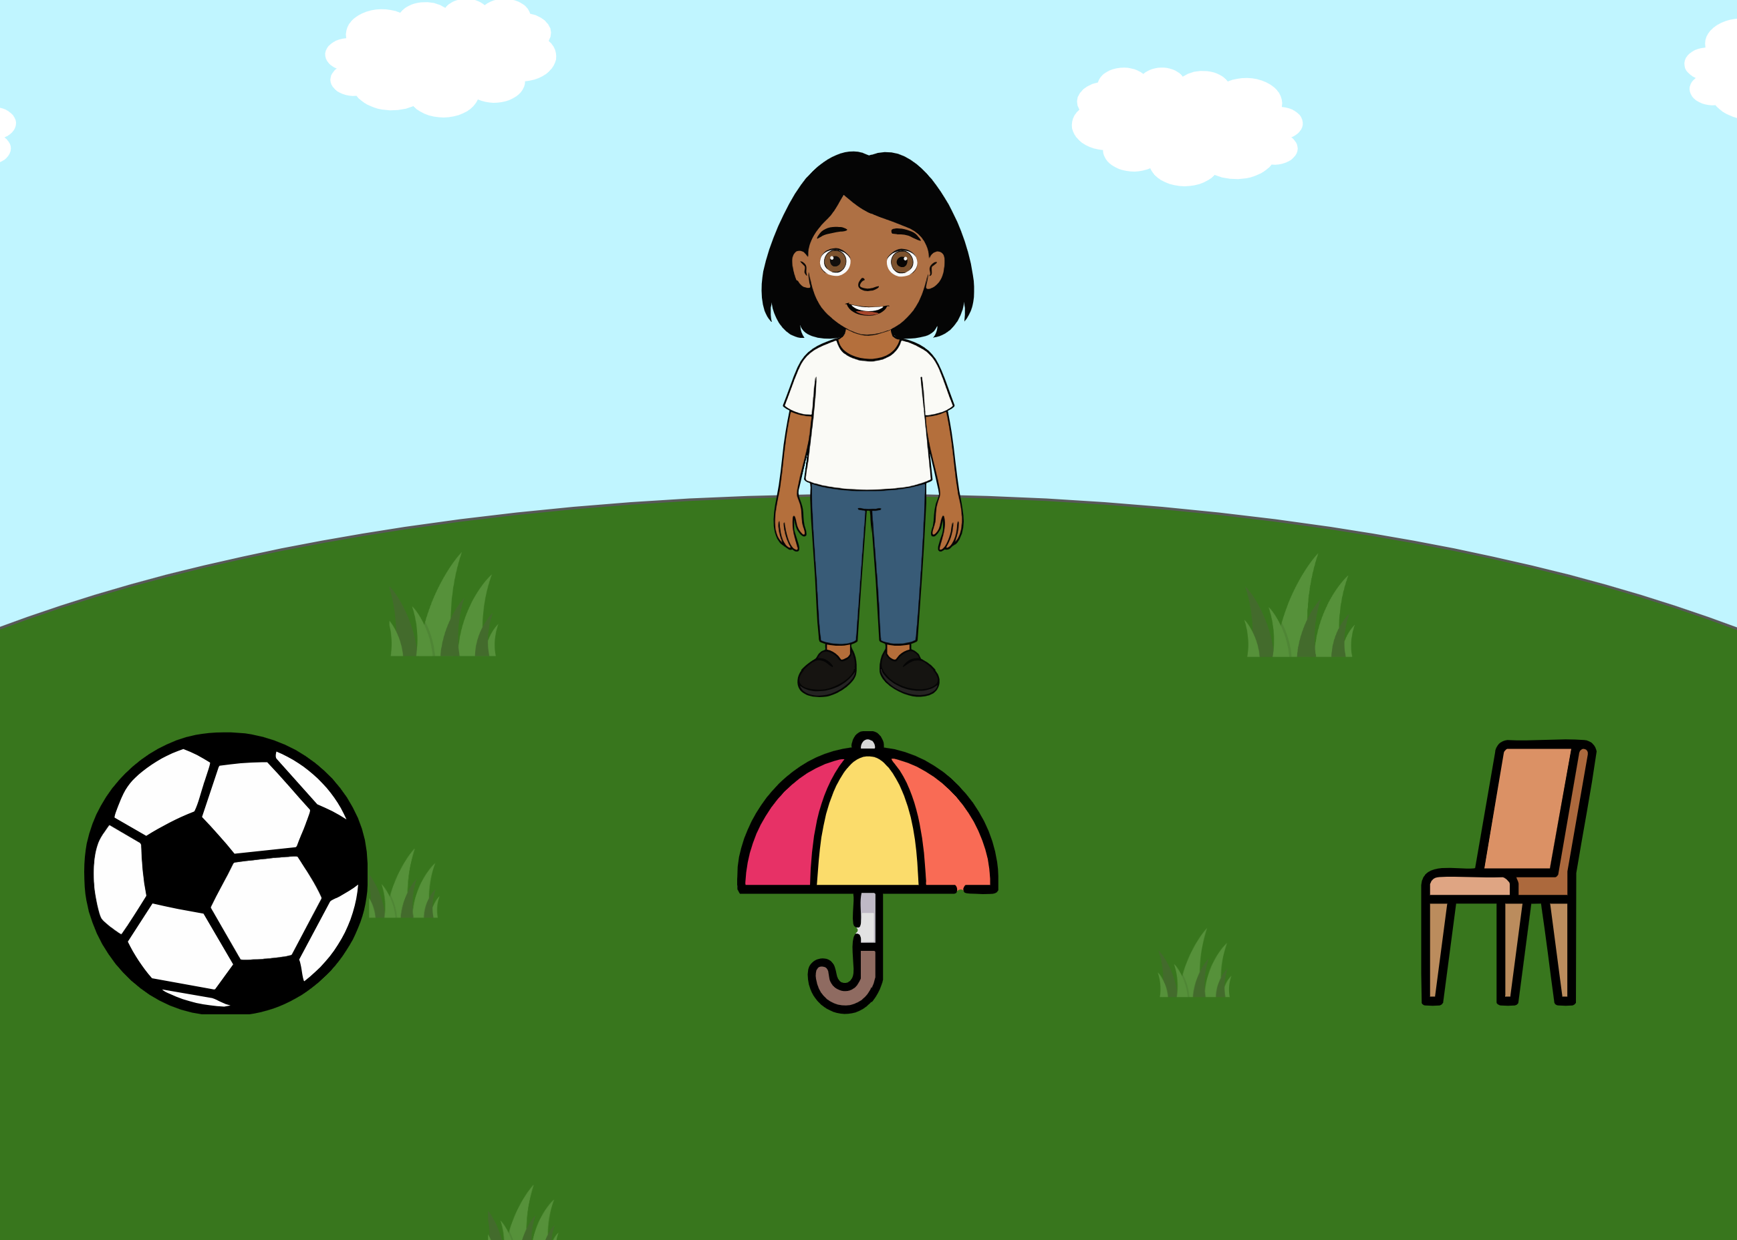 | Ella says: “Oh, it looks like it’s about to rain … Mmh, could you pass it to me?”. The ambiguity of the literal message (with a pronoun potentially referring to any of the alternatives) is integrated with information from the context (the three objects), about the world (the utility of each object in case of rain) and about the speaker’s communicative intention (the utterances Ella would have uttered if she had wanted to refer to each one of the alternatives). | Grice (1975)
Implicature understanding (Ad-Hoc Implicature) | AdHocColor | 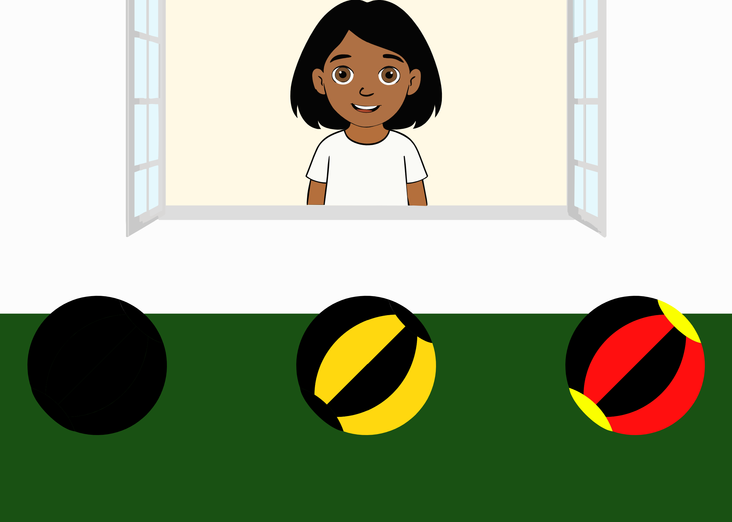 | Ella says: “I want the black ball. Where is it?”. The ambiguity of the literal message (the adjective “black” is not false for all three balls) is integrated with information from the context (the three different balls with different degrees of black) and inferences about the speaker’s communicative intention (the utterances she would have uttered if she had wanted to refer to each one of the alternatives). | Bohn, Tessler, Kordt, Hausmann, and Frank (2023)
Implicature understanding (Ad-Hoc Implicature) | AdHocNumber1 | 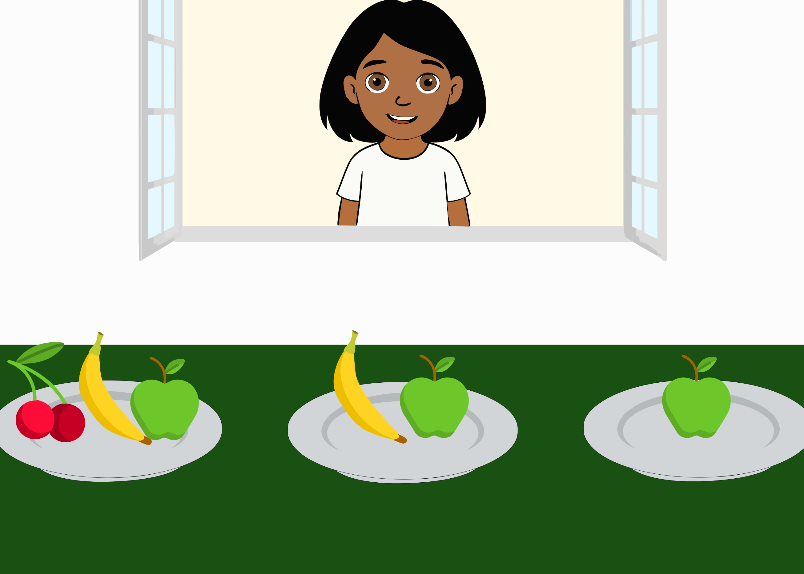 | Ella asks: “Look, the plate with the apple. Can you click on it?”. The ambiguity of the literal message is integrated with information from the context (the three different plates, one having fruit and an apple, one an apple and a banana, one only an apple) and inferences about the speaker’s communicative intention (the utterances she would have uttered if she had wanted to refer to each one of the alternatives). | Bohn, Tessler, et al. (2023)
Implicature understanding (Ad-Hoc/ Scalar Implicature) | AdHocNumber | 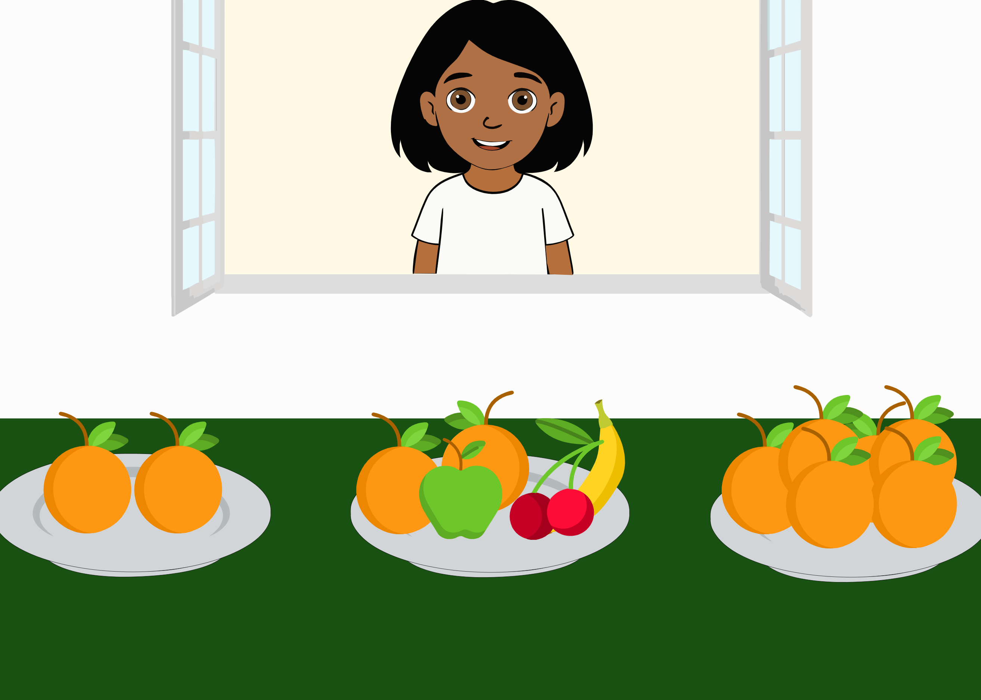 | Ella asks: “There is a plate with a few oranges. Can you click on it?”. The ambiguity of the literal message is integrated with information from the context (the three different plates, one containing two oranges, one with fruit and two oranges, one with a lot of oranges) and inferences about the speaker’s communicative intention (the utterances she would have uttered if she had wanted to refer to each one of the alternatives). | Bohn, Tessler, et al. (2023), Grice (1975)
Implicature understanding (Typicality implicature) | TypImp1 | 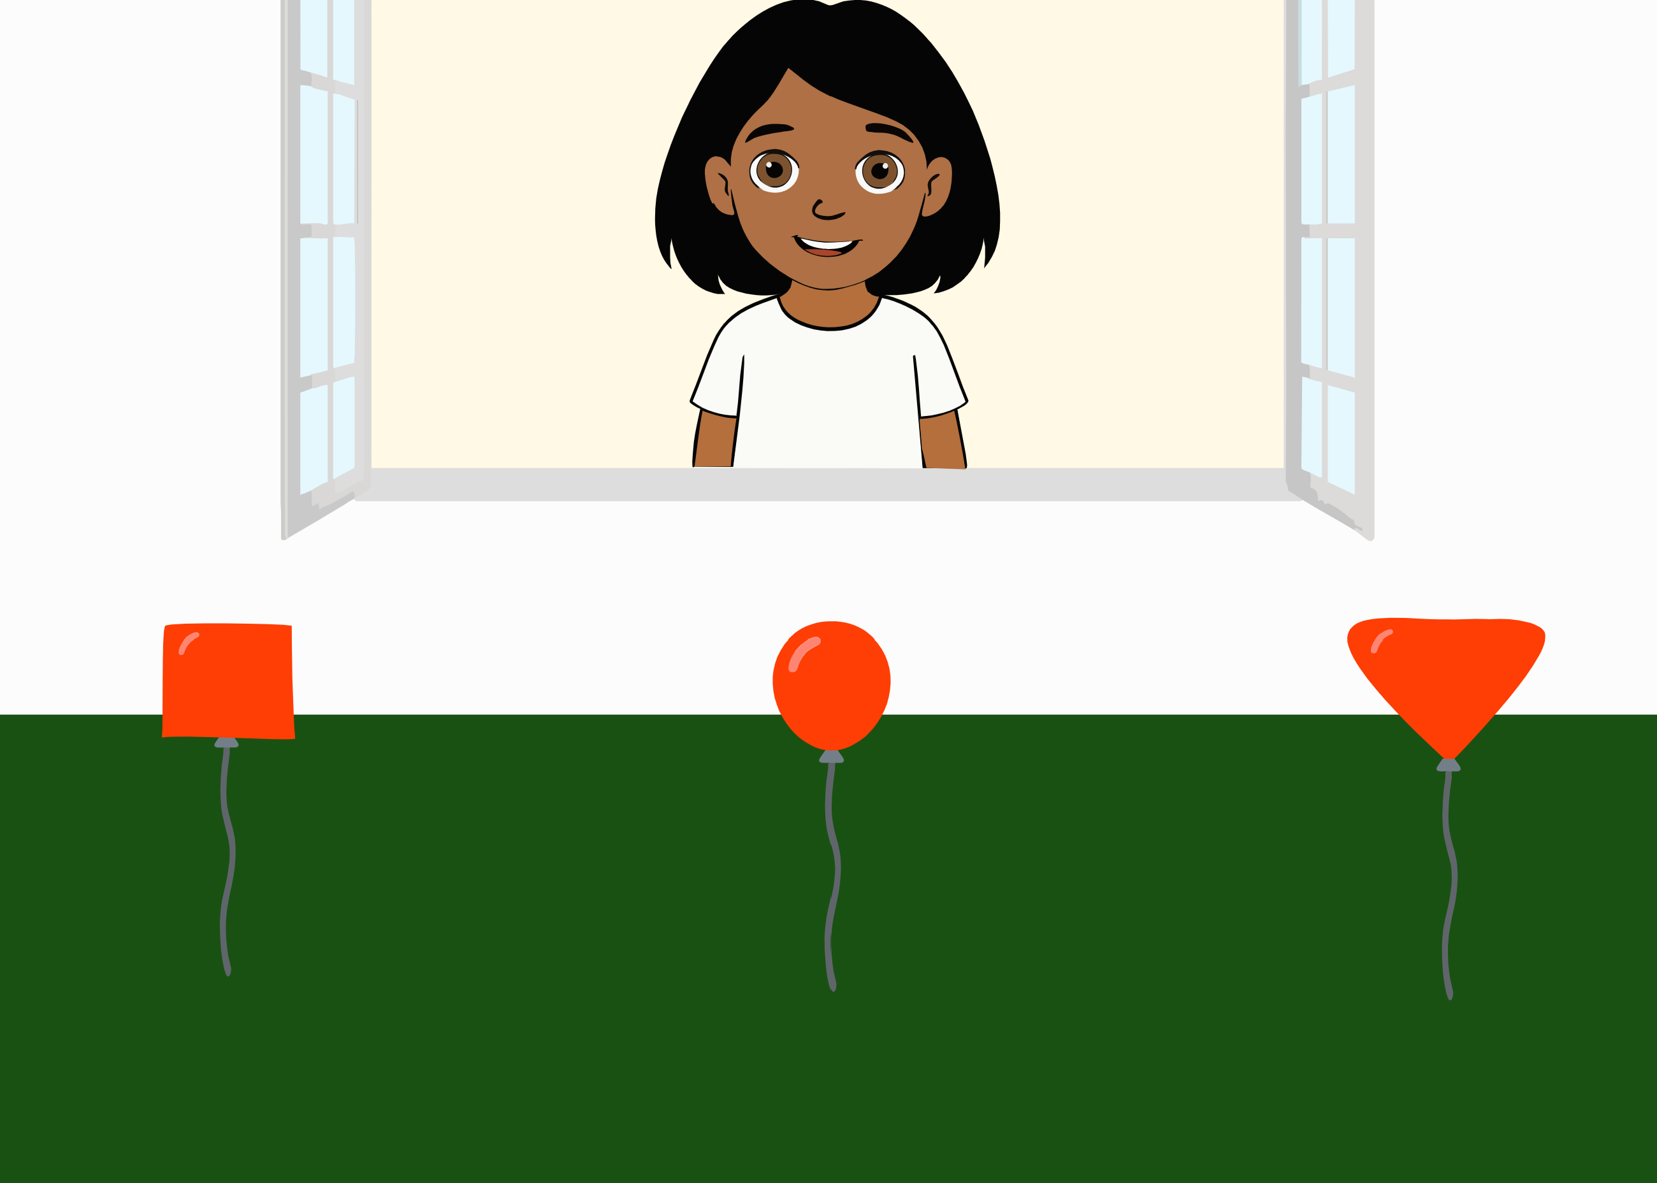 | Ella asks: “Now I need the balloon. Can you find it?”. The ambiguity of the literal message is integrated with information from the context (the three different balloons, a typical one, a square-shaped and a triangle-shaped one), about the world (typical balloons are round-shaped) and inferences about the speaker’s communicative intention (the utterances she would have uttered if she had wanted to refer to each one of the alternatives). | Franchin, Porrini, & Surian (2023)
Implicature understanding (Typicality implicature) | TypImp2 | 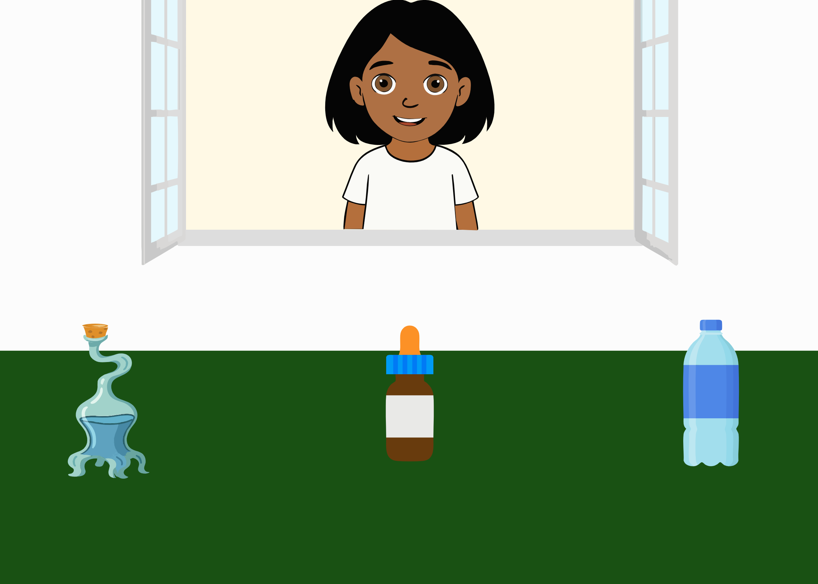 | Ella asks: “Now I need the bottle. Where is it?”. The ambiguity of the literal message is integrated with information from the context (the three different bottles, a typical one, a weird one and a medicine bottle), about the world (typical bottles look like the one on the right) and inferences about the speaker’s communicative intention (the utterances she would have uttered if she had wanted to refer to each one of the alternatives). | Franchin et al. (2023)
Implicature understanding (Scalar implicature) | ScalarImplicature | 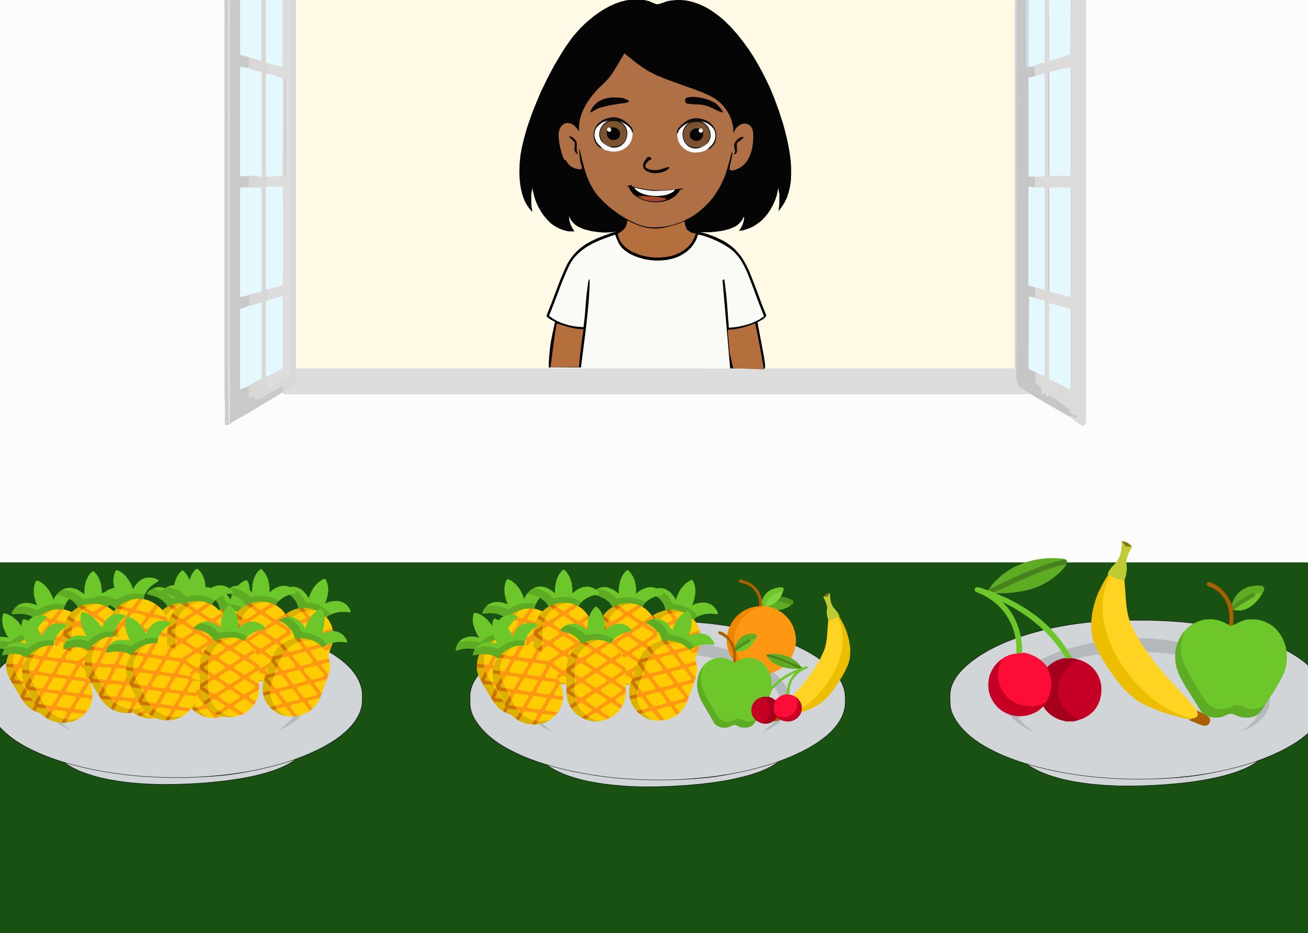 | Ella says: “On my plate some of the fruits are pineapples. Can you click on it?”. The ambiguity of the literal message (the quantifier “some” is true for two of the options) is integrated with information from the context (the three different plates, one containing only pineapples, one with fruit and pineapples, one with different fruit) and inferences about the speaker’s communicative intention (the utterances she would have uttered if she had wanted to refer to each one of the alternatives). | Grice (1975)
Mutual exclusivity (in nouns) | MutexNoun | 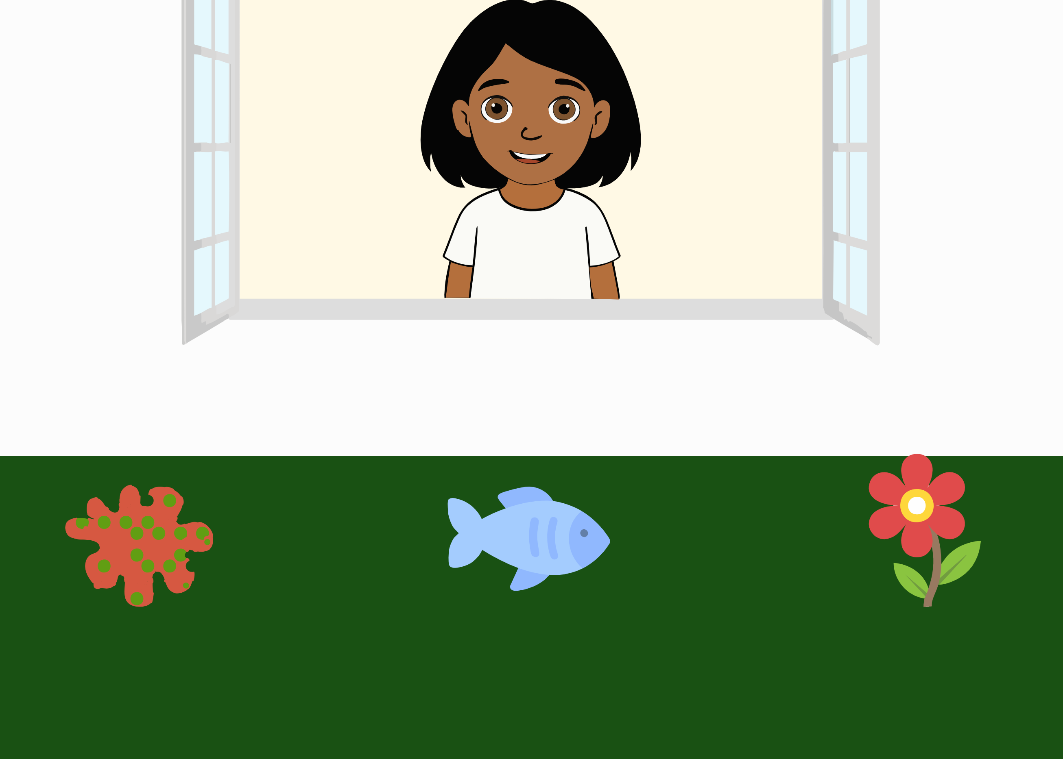 | Ella asks “Look, there’s a palvi. Can you click on the palvi?”. The ambiguity of the literal message (where the target word is novel) is integrated with information from the context (the three objects, namely a novel one, a fish and a flower) and inferences about the speaker’s communicative intention (the utterances she would have uttered if she had wanted to refer to each one of the alternatives). | Bohn, Tessler, et al., (2023); Markman & Wachtel, (1988)
Mutual exclusivity (in adjectives) | MutexAdj | 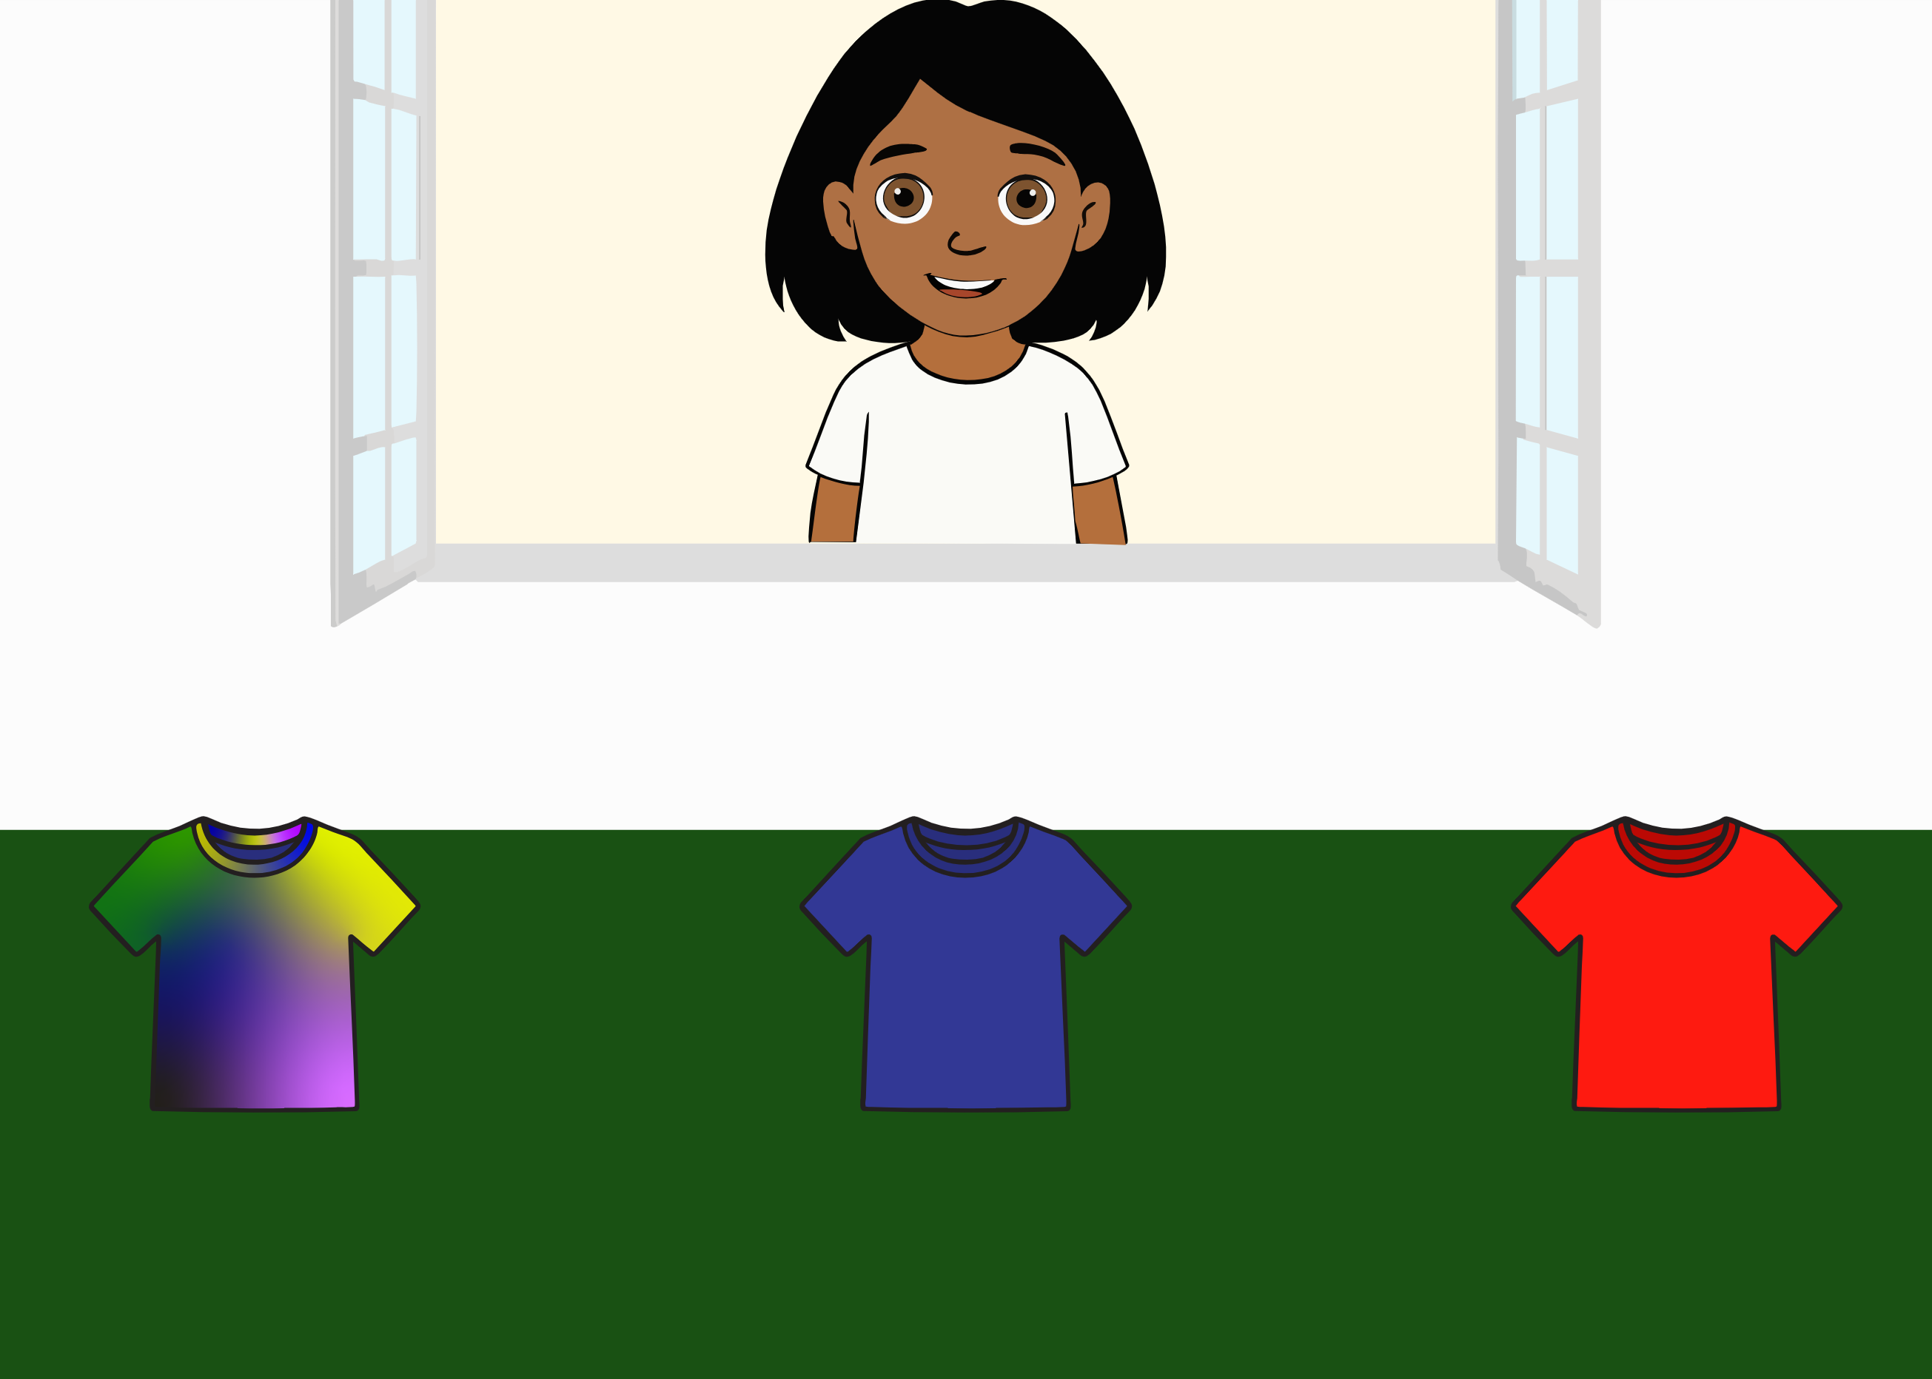 | Ella says: “Now I really want the sherlig T-Shirt! Where is it?”. The ambiguity of the literal message (where the target word is novel) is integrated with information from the context (the three t-shirts, one with a novel pattern, a red and a blue one) and inferences about the speaker’s communicative intention (the utterances she would have uttered if she had wanted to refer to each one of the alternatives). | Markman and Wachtel (1988), Diesendruck, Hall, and Graham (2006), Diesendruck (2005), Yoshida and Hanania (2013)
Mutual exclusivity (in verbs) | MutexVerb | 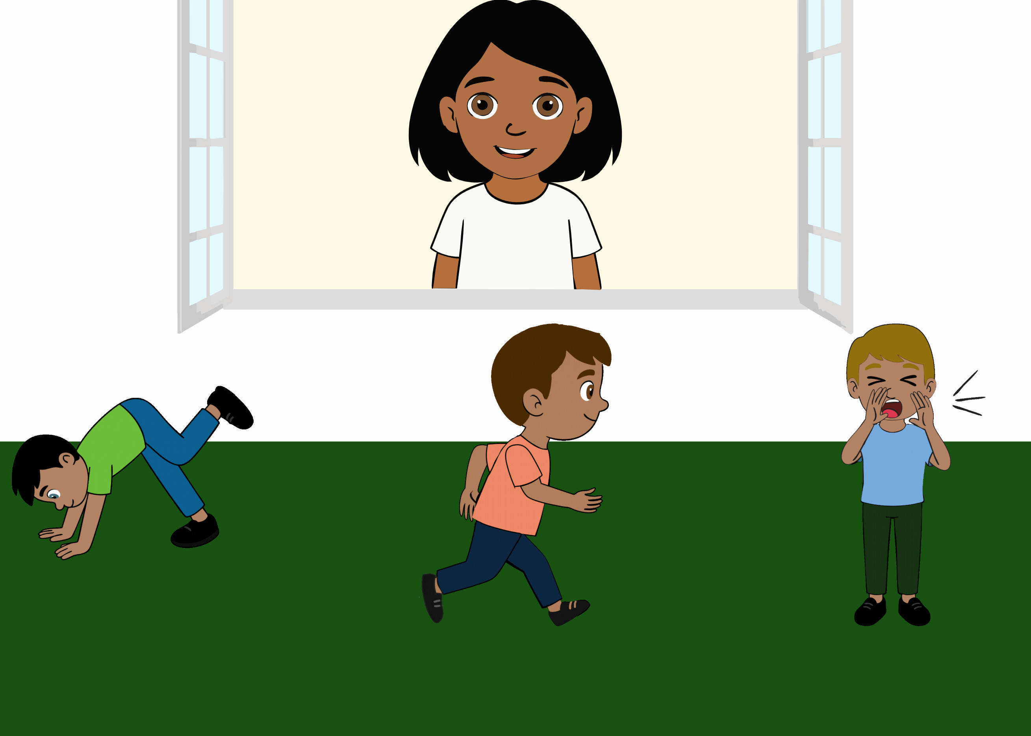 | Ella says: “Oh look! My friend is warfling! Can you tap on him?”. The ambiguity of the literal message (where the target word is novel) is integrated with information from the context (the three actions, where the boy either performs a novel action, is running, or is screaming) and inferences about the speaker’s communicative intention (the utterances she would have uttered if she had wanted to refer to each one of the alternatives). | Merriman, Marazita, & Jarvis (1993)
Indirect request | IndirectRequest | 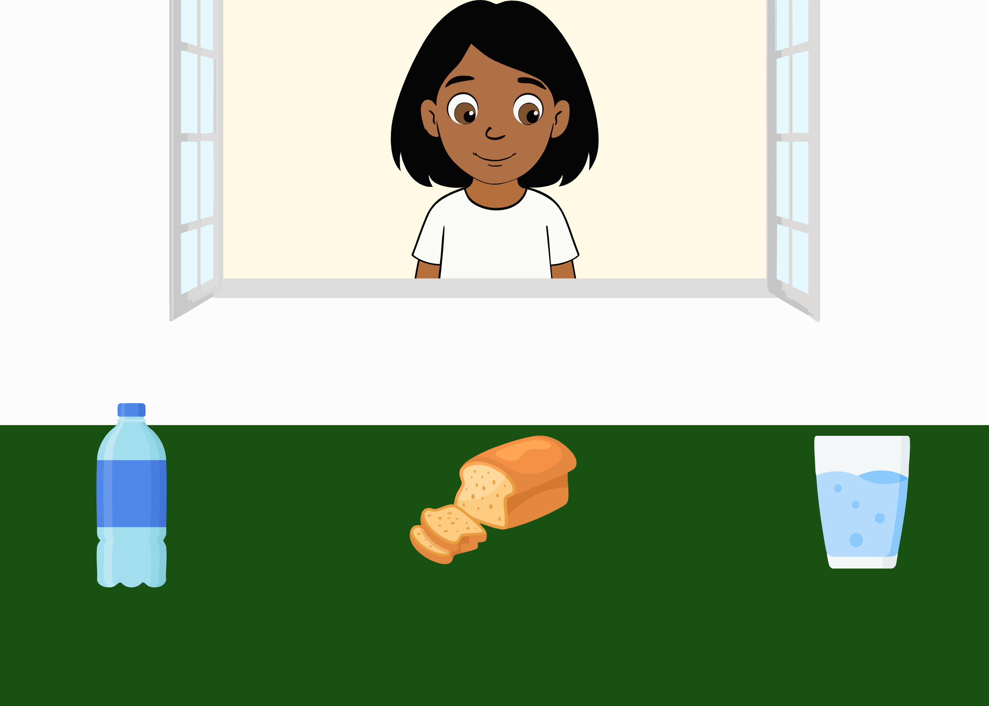 | Ella looks in front of her and says “Mmh, now I’m thirsty…” and looks at the glass of water. The ambiguity of the literal message (where there is no clear request being made) is integrated with information from the context (the three options, namely a bottle, loaf of bread and a glass of water), the world (if one is thirsty, they will likely want to drink) and inferences about the speaker’s communicative intention (the utterances she would have uttered if she had wanted to refer to each one of the alternatives, and the attention of the speaker). | This item was not developed based on a specific paradigm but builds on literature about indirect requests and integration of gaze cues (Çetinçelik, Rowland, & Snijders, 2021; Clark, 1979; Macdonald & Tatler, 2013; Nappa, Wessel, McEldoon, Gleitman, & Trueswell, 2009).
Discourse-based inferences (Speaker’s Informativeness) | Informativeness1 | 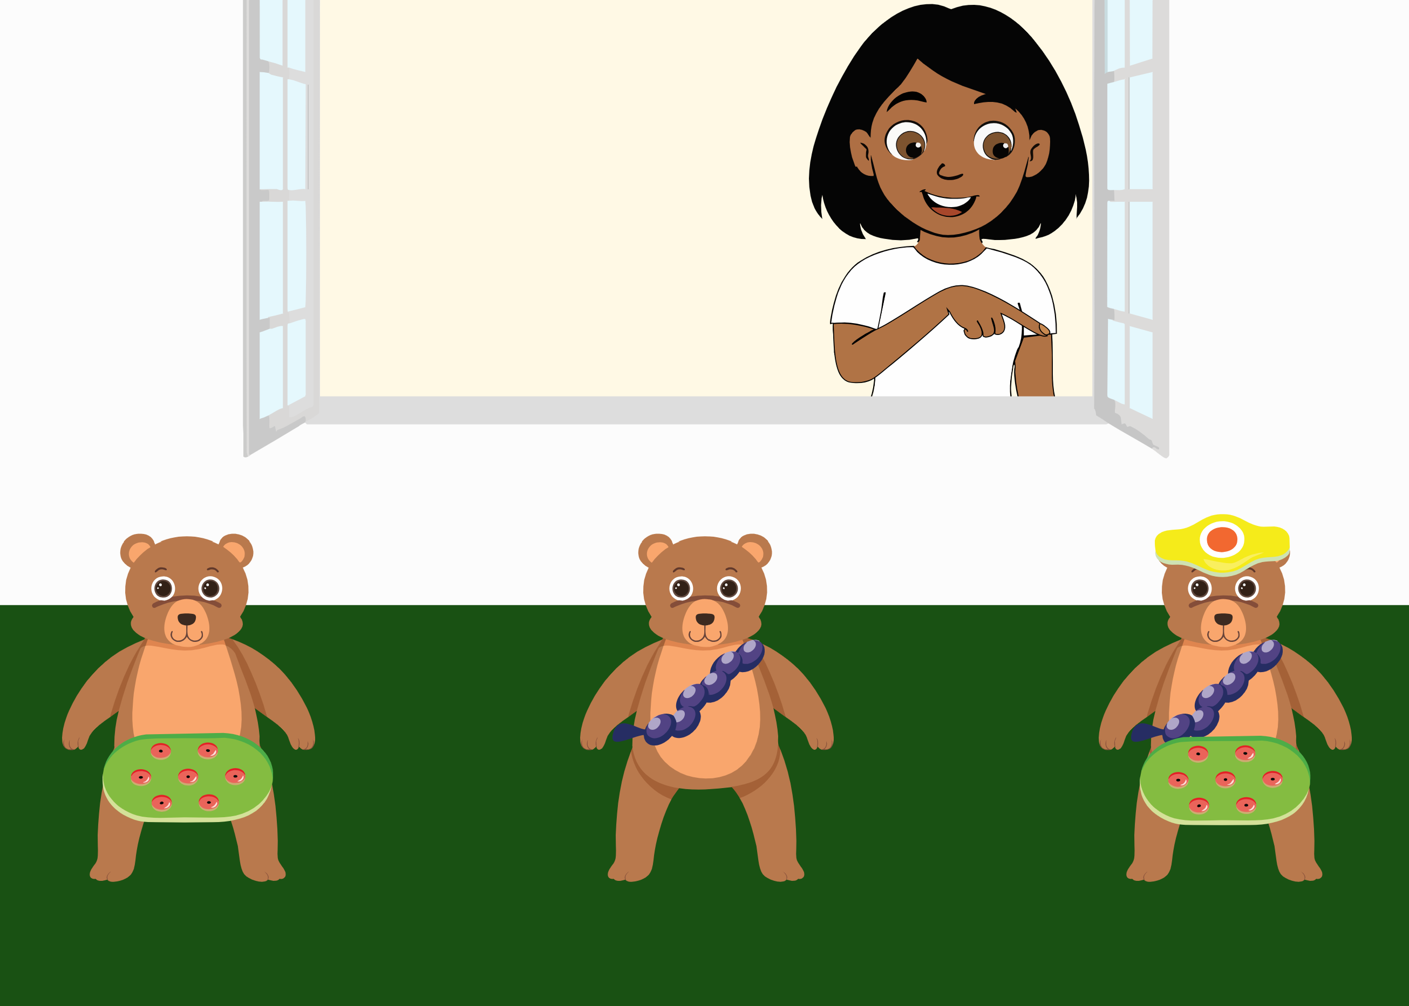 | Ella looks at each one of the three bears: One wearing novel object A, one wearing novel object B and one wearing novel object A, B and C. She does not say anything when looking at the first two, but when looking at the last one (with objects A, B and C), she says “Oh look, a bear with a Sörel! I love the bear with the Sörel!”. The scenario changes and three bears appear, each one with only one novel object on them (either A, B or C). Ella asks “Can you click on the bear with the Sörel?”. The ambiguity of the literal message (where the target word is novel) is integrated with information from the context (the previous discourse, where Ella only expressed interest when the bear was wearing object C) and inferences about the speaker’s communicative intention (the utterances she would have uttered if she had wanted to refer to each one of the alternatives). | Bohn, Tessler, et al., (2023)
Discourse-based inferences (Speaker’s Informativeness) | Informativeness2 | 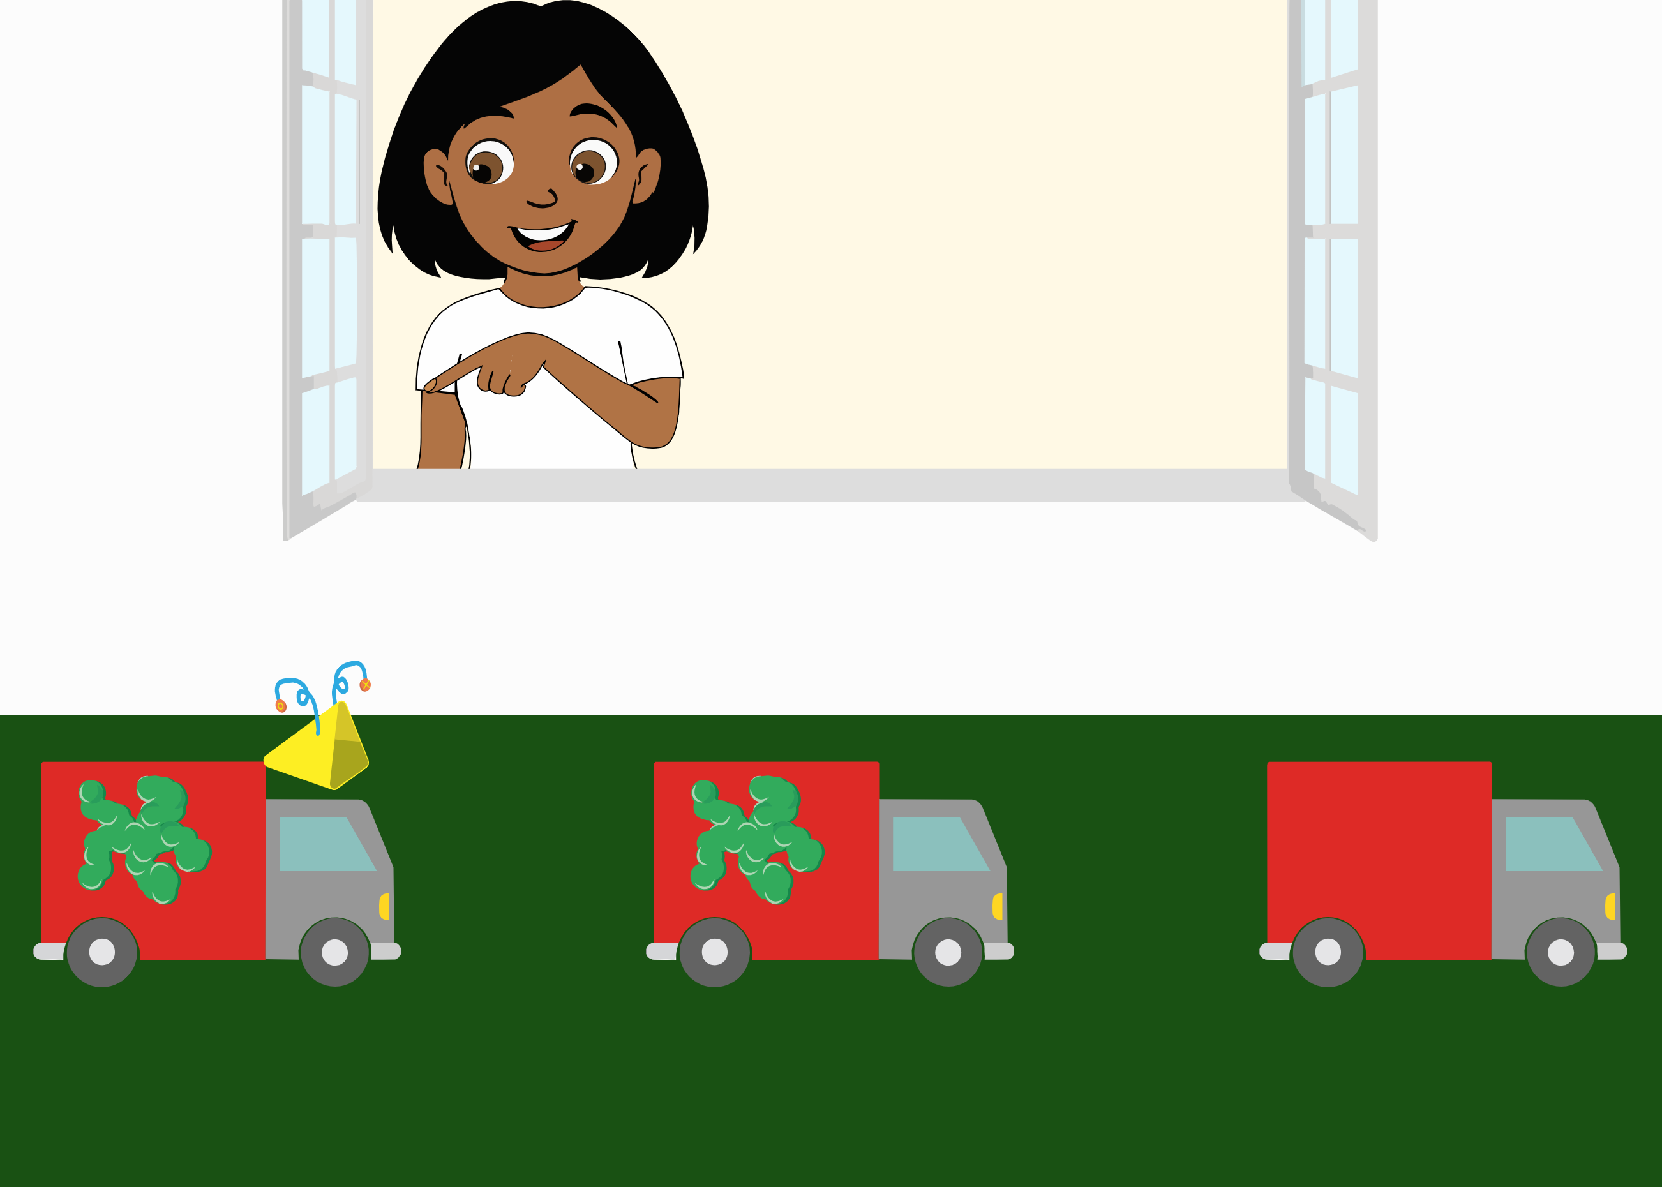 | Ella looks at each one of the three trucks: one with object A and B, one with object B, one without any specific object. She does not say anything when looking at the empty truck and at the truck with object B, but when looking at the truck with objects A and B, she says “Oh look, a truck with a Tikon! I love the truck with the Tikon!”. The scenario changes and three trucks appear, each one either with object A, B or no novel object on them. Ella asks “Can you click on the truck with the Tikon?”. The ambiguity of the literal message (where the target word is novel) is integrated with information from the context (the previous discourse, where Ella only expressed interest when the truck had object A) and inferences about the speaker’s communicative intention (the utterances she would have uttered if she had wanted to refer to each one of the alternatives). | Bohn, Tessler, et al. (2023)
Discourse-based inferences (Discourse Continuity) | DiscCont | 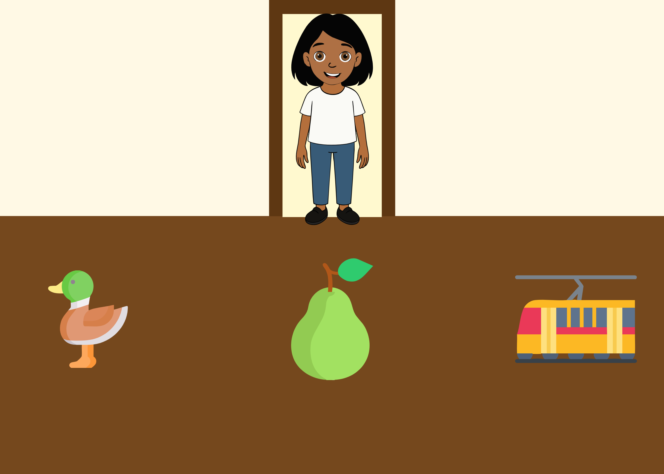 | Ella says she has to collect some things from her room. In five exposure trials, Ella always asks for a different fruit. In the sixth trial, Ella asks “Can you give it to me?”. The ambiguity of the pronoun is integrated with information from the context (the previous discourse, where Ella only requested fruit items) and inferences about the speaker’s communicative intention (the utterances she would have uttered if she had wanted to refer to each one of the alternatives). | Bohn, Tessler, et al. (2023)
Discourse-based inferences (Speaker’s Preference) | SpeakPref | 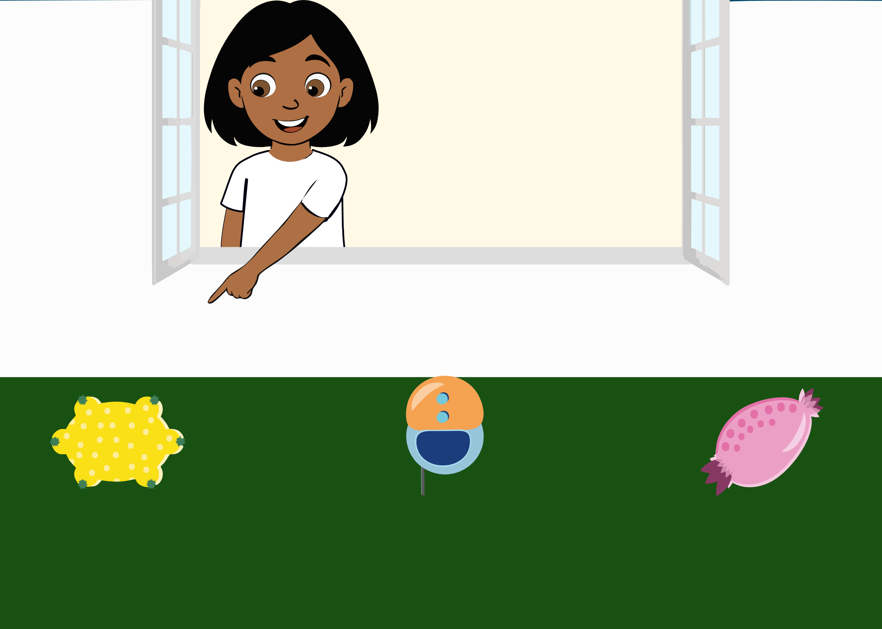 | Ella looks at the first object and affirms: “I really do not like this one!”; She looks at the second and affirms: “This one is fine”; She looks at the third one and affirms: “I really like this one!”; She leaves and when she comes back, she enthusiastically says: “Oh the Blicket is still here! Can you click on the Blicket?”. The ambiguity of the literal message (containing a novel word) is integrated with information from the context (the previous discourse, where Ella only expressed excitement for the last object) and inferences about the speaker’s communicative intention (the utterances she would have uttered if she had wanted to refer to each one of the alternatives). | Bohn, Tessler, et al. (2023)
Discourse-based inferences (Discourse Novelty) | DiscNovelty | 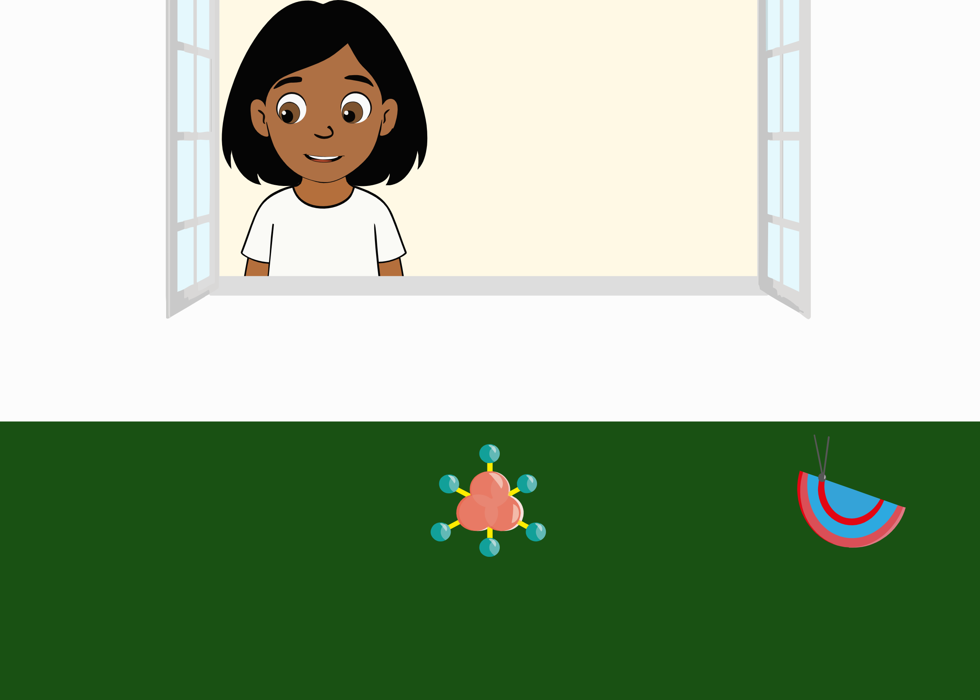 | Ella looks at the first two objects, and, when looking for the third, she finds nothing and says: “Oh, there is nothing here”. She leaves; While she is not at the window, a third object appears. Ella comes back and says “Oh, there is a Pesgon! So nice, a Pesgon! Can you give it to me?”. The ambiguity of the novel word is integrated with information from the context (the previous discourse, where Ella did not express interest for the first two objects, and noticed the absence of a third one) and inferences about the speaker’s communicative intention (the utterances she would have uttered if she had wanted to refer to each one of the alternatives). | Akhtar, Carpenter, & Tomasello, (1996); Bohn, Tessler, et al. (2023)
Communicative gesture comprehension | Gesture1 | 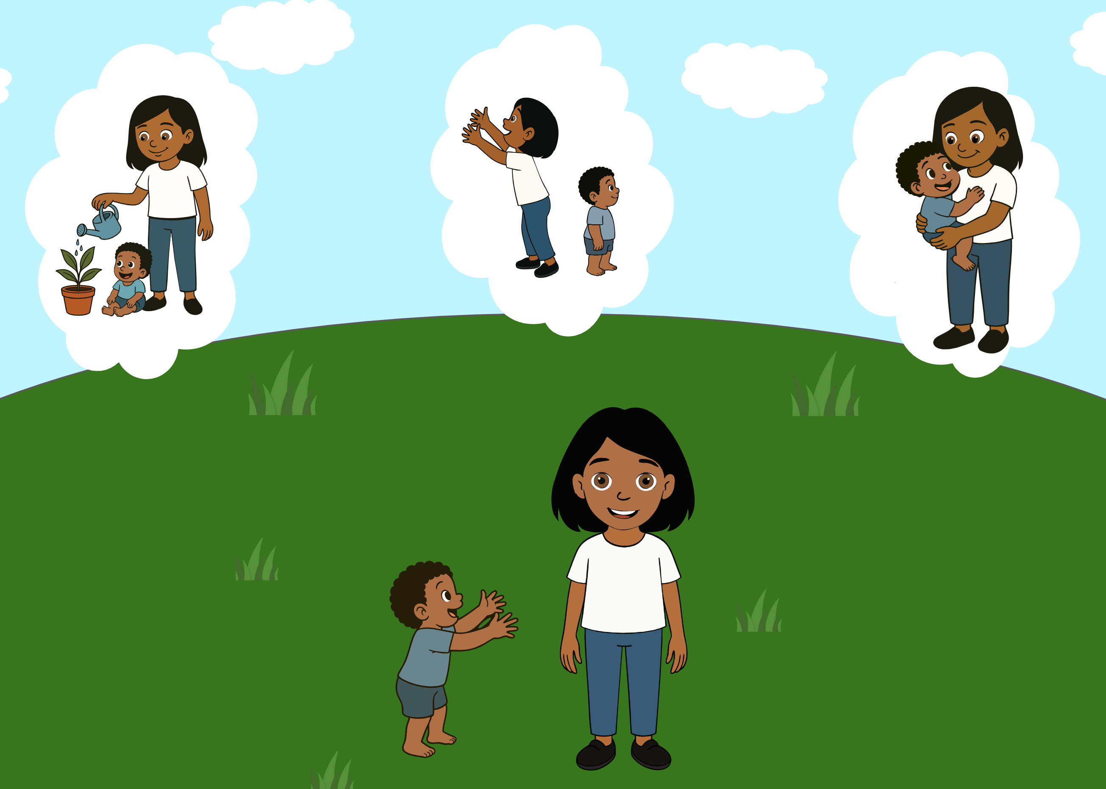 | Ella looks at her brother stretching his arms towards her and asks “What should I do?”. The ambiguity of the paralinguistic message (the brother’s gesture) is integrated with information from the context (the three alternatives, namely Ella watering a plant, Ella imitating the brother, Ella picking up the brother), about the world (children stretch out their arms when they want to be picked up) and inferences about the speaker’s communicative intention (the gestures the brother would have made if he had wanted Ella to do each one of the alternative actions). | Bucciarelli, Colle, & Bara (2003)
Communicative gesture comprehension | Gesture2 | 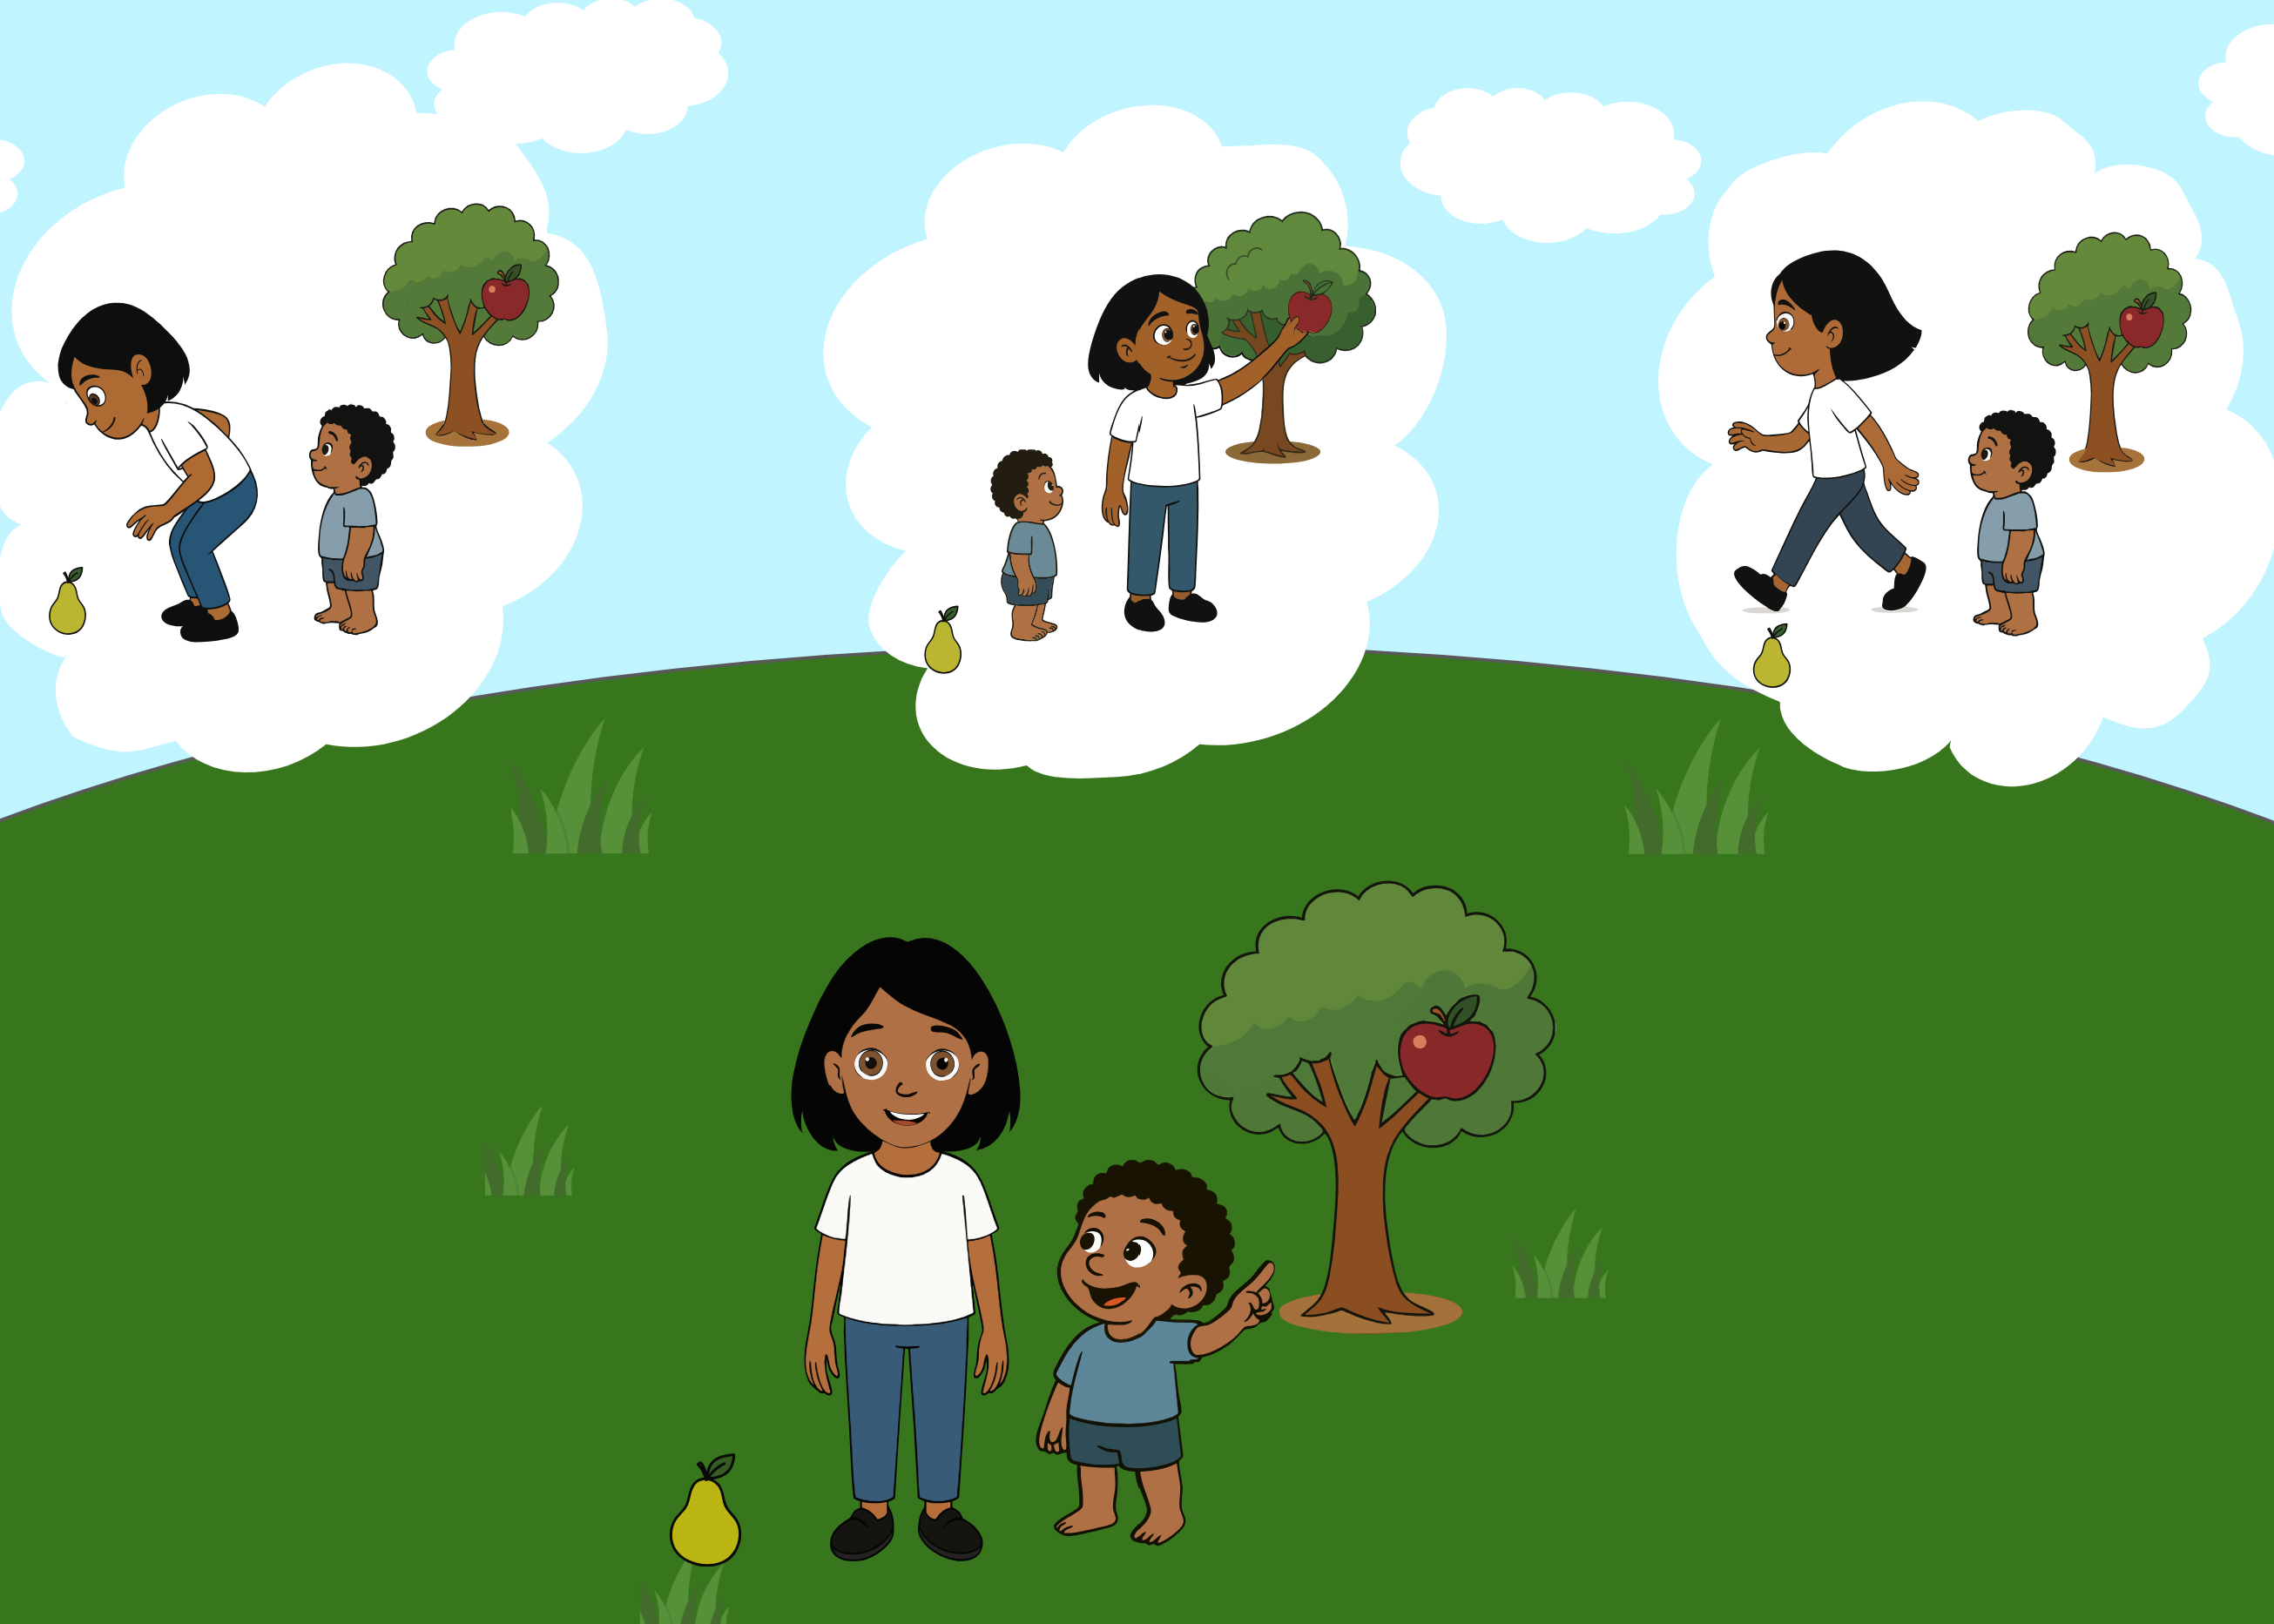 | Ella looks at her brother pointing to the apple on the tree and asks “What should I do?”. The ambiguity of the paralinguistic message (the brother’s pointing gesture while looking at Ella) is integrated with information from the context (the three alternatives, namely Ella picking up the pear from the ground, Ella picking up the apple from the tree, Ella leaving), about the world (pointing directs attention towards something specific) and inferences about the speaker’s communicative intention (the gestures the brother would have made if he had wanted Ella to do each one of the alternative actions, and the brother’s gaze). | Bucciarelli et al. (2003).
Communicative gesture comprehension | Gesture3 | 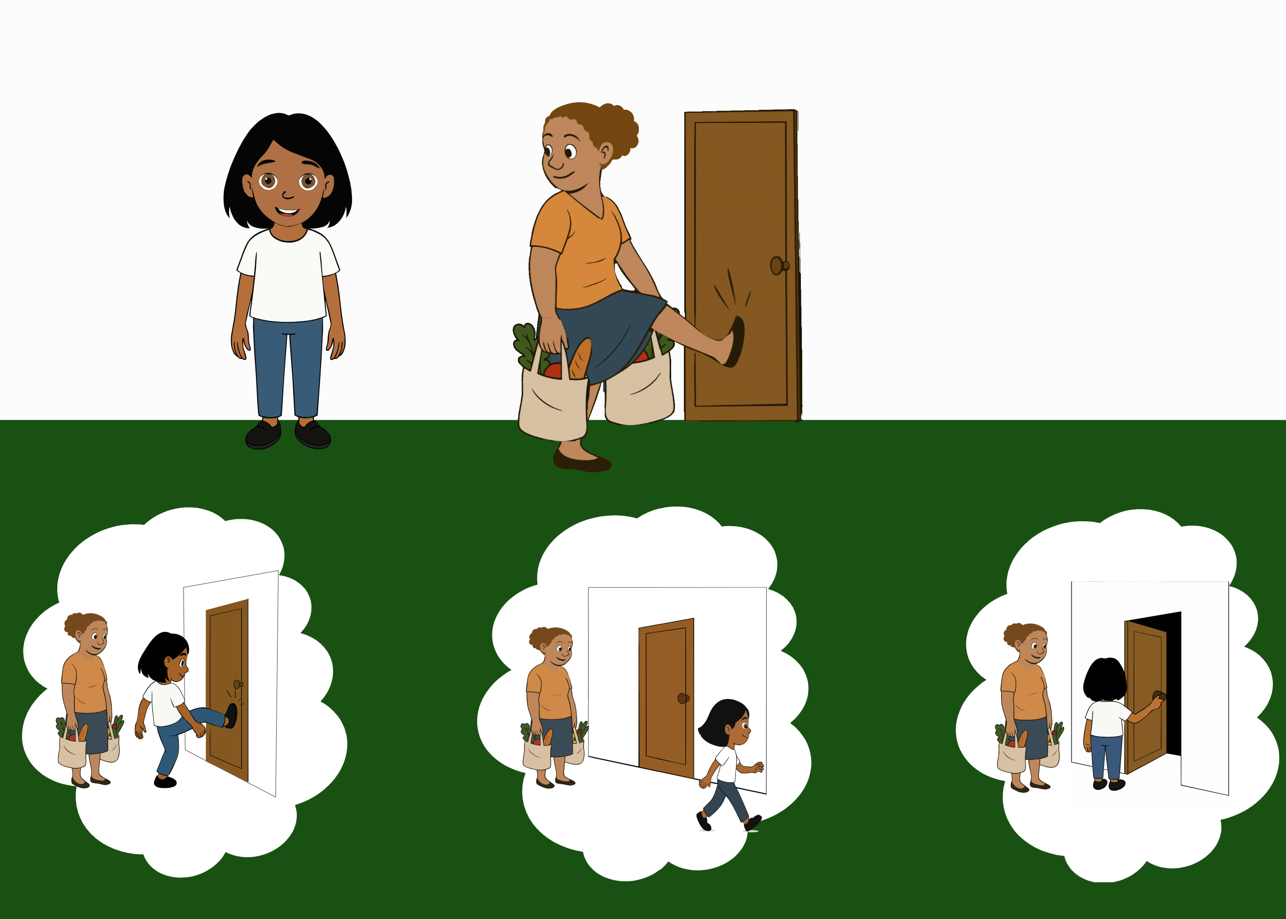 | Ella looks at her mother kicking the door and asks “What should I do?”. The ambiguity of the paralinguistic message (the mother kicking the door while looking at Ella) is integrated with information from the context (the three alternatives, namely Ella kicking the door, Ella leaving, Ella opening the door), about the world (someone carrying heavy bags cannot open the door) and inferences about the speaker’s communicative intention (the gestures the mother would have made if she had wanted Ella to do each one of the alternative actions, and her gaze towards Ella). | Bucciarelli et al. (2003).
Emotional prosody understanding | EmotPros | 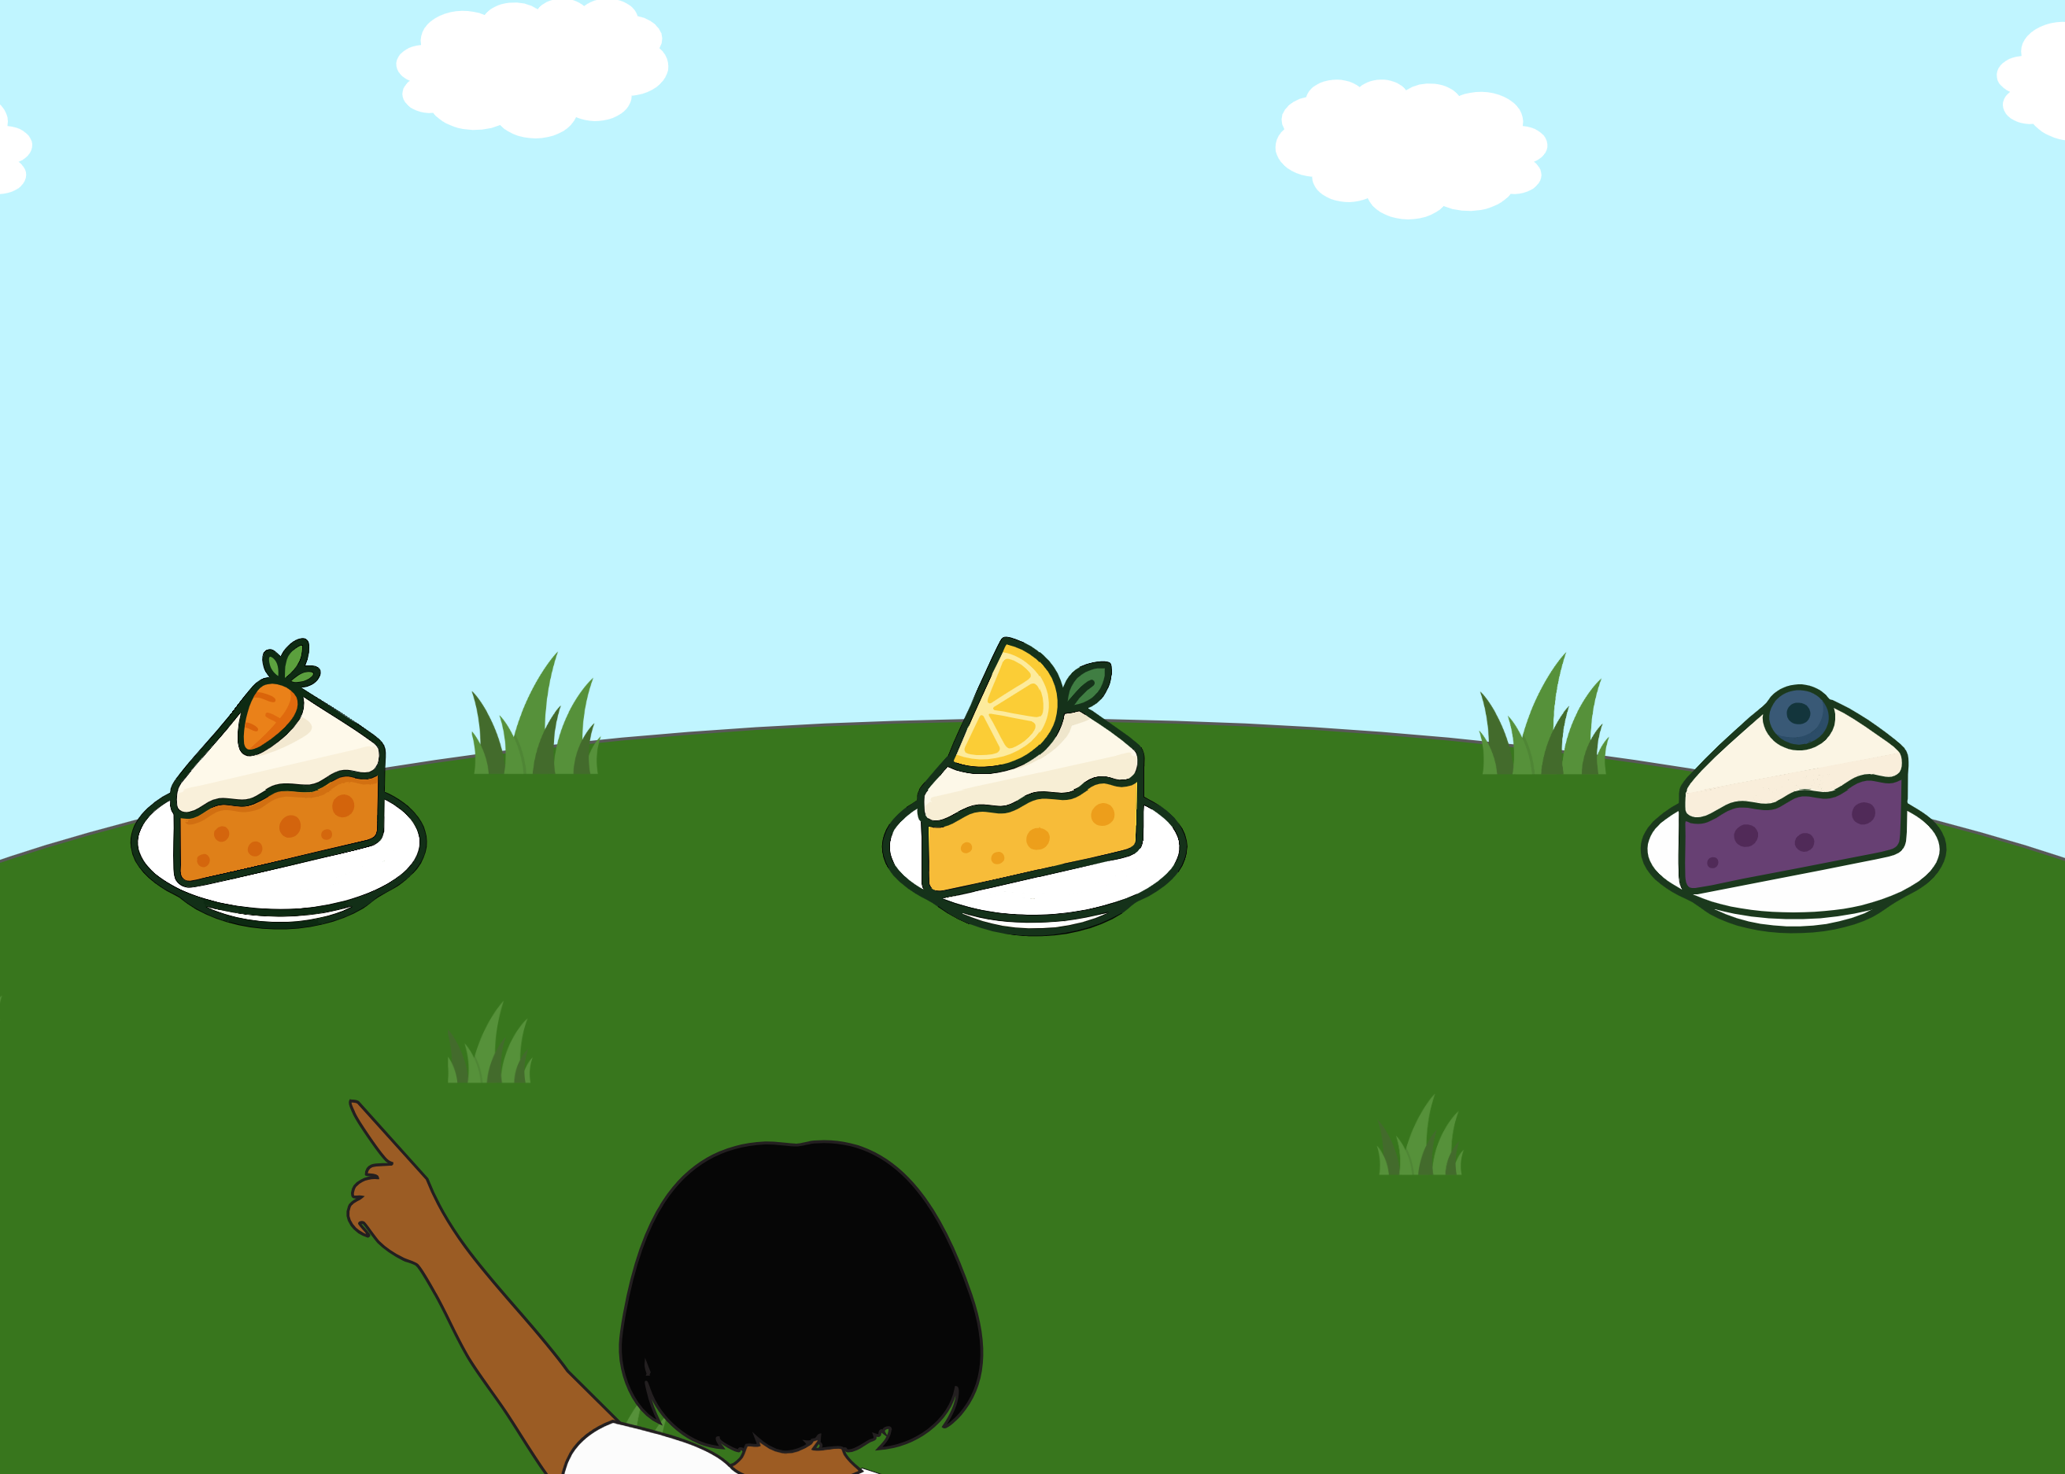 | Ella looks at each piece of cake and says “Oh, cake!”. In the first case, she has an enthusiastic intonation; in the second she has a neutral tone; in the third one she sounds disgusted. Then she turns and asks “Which one is my favorite cake?”. The ambiguity of the literal message (where no preference for a single cake is expressed) is integrated with information from the context (the three alternatives), about the world (one usually expresses enthusiasm for things they find pleasant) and inferences about the speaker’s communicative intention (the intonation Ella would have used if she had wanted to refer to a bad, good or normal cake). | Floyd et al. (2025).
Conversational perspective taking (Listener’s perspective) | ConvPerspTakingLIST1 | 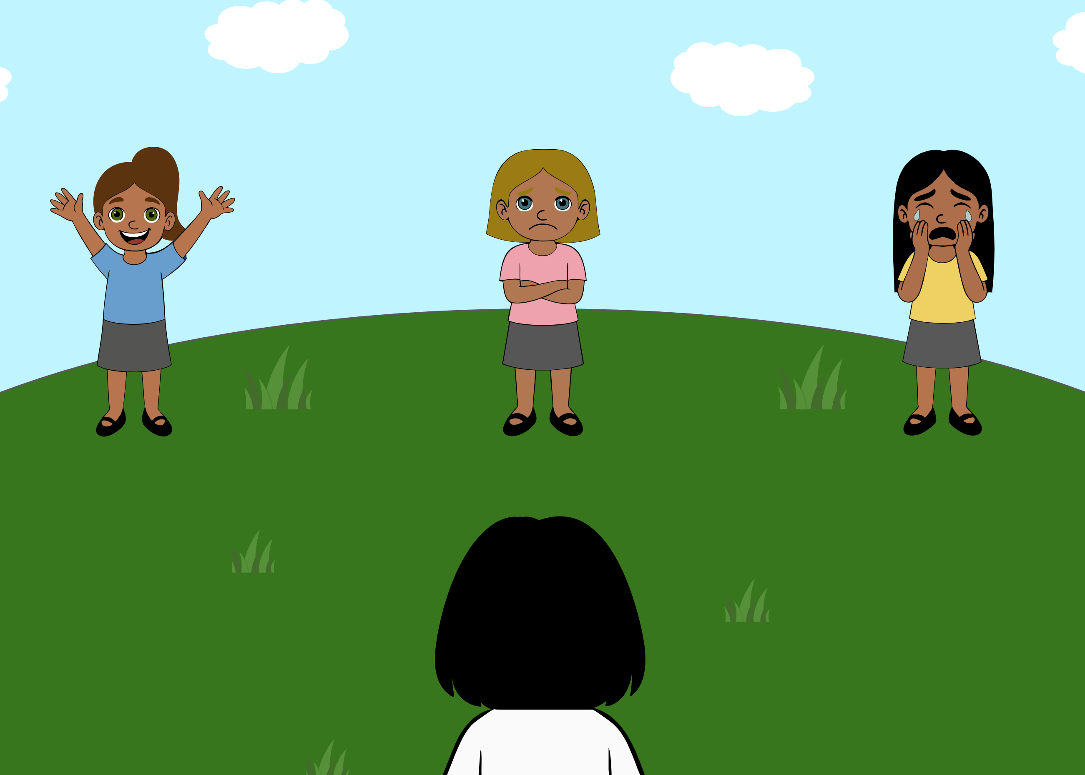 | There are three girls. Ella says: “Anna, you’re invited to my birthday!”. One girl becomes happy, one becomes very sad and one starts crying. Then she turns and asks “Can you click on Anna?”. The ambiguity of the literal message (there is no indication as to who is Anna) is integrated with information from the context (the three girls, one being happy, one sad and one crying), about the world and about the listener (if one is invited to a birthday party, they might be happy about it rather than sad). | Bernard and Deleau (2007), Le Sourn-Bissaoui, Caillies, Bernard, Deleau, and Brulé (2012).
Conversational perspective taking (Listener’s perspective) | ConvPerspTakingLIST2 | 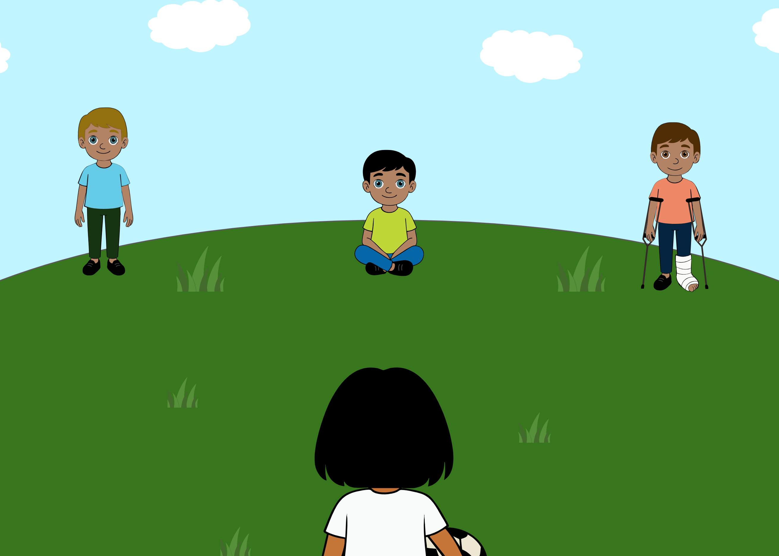 | Ella holds a ball and says: “It’s a shame you cannot play with us, Tommi!”. Then she turns and asks “Can you click on Tommi?”. The ambiguity of the literal message (there is no indication as to who is Tommi) is integrated with information from the context (the three boys, one standing, one sitting and one with a cast on the foot), about the world and about the listener (someone who has a cast, cannot play football; If Ella had wanted to refer to the other boys, she would have not used the verb “cannot”, as none of them is unable to play). | Bernard and Deleau (2007), Le Sourn-Bissaoui et al. (2012).
Conversational perspective taking (Speaker’s perspective) | ConvPerspTakingSPEAK | 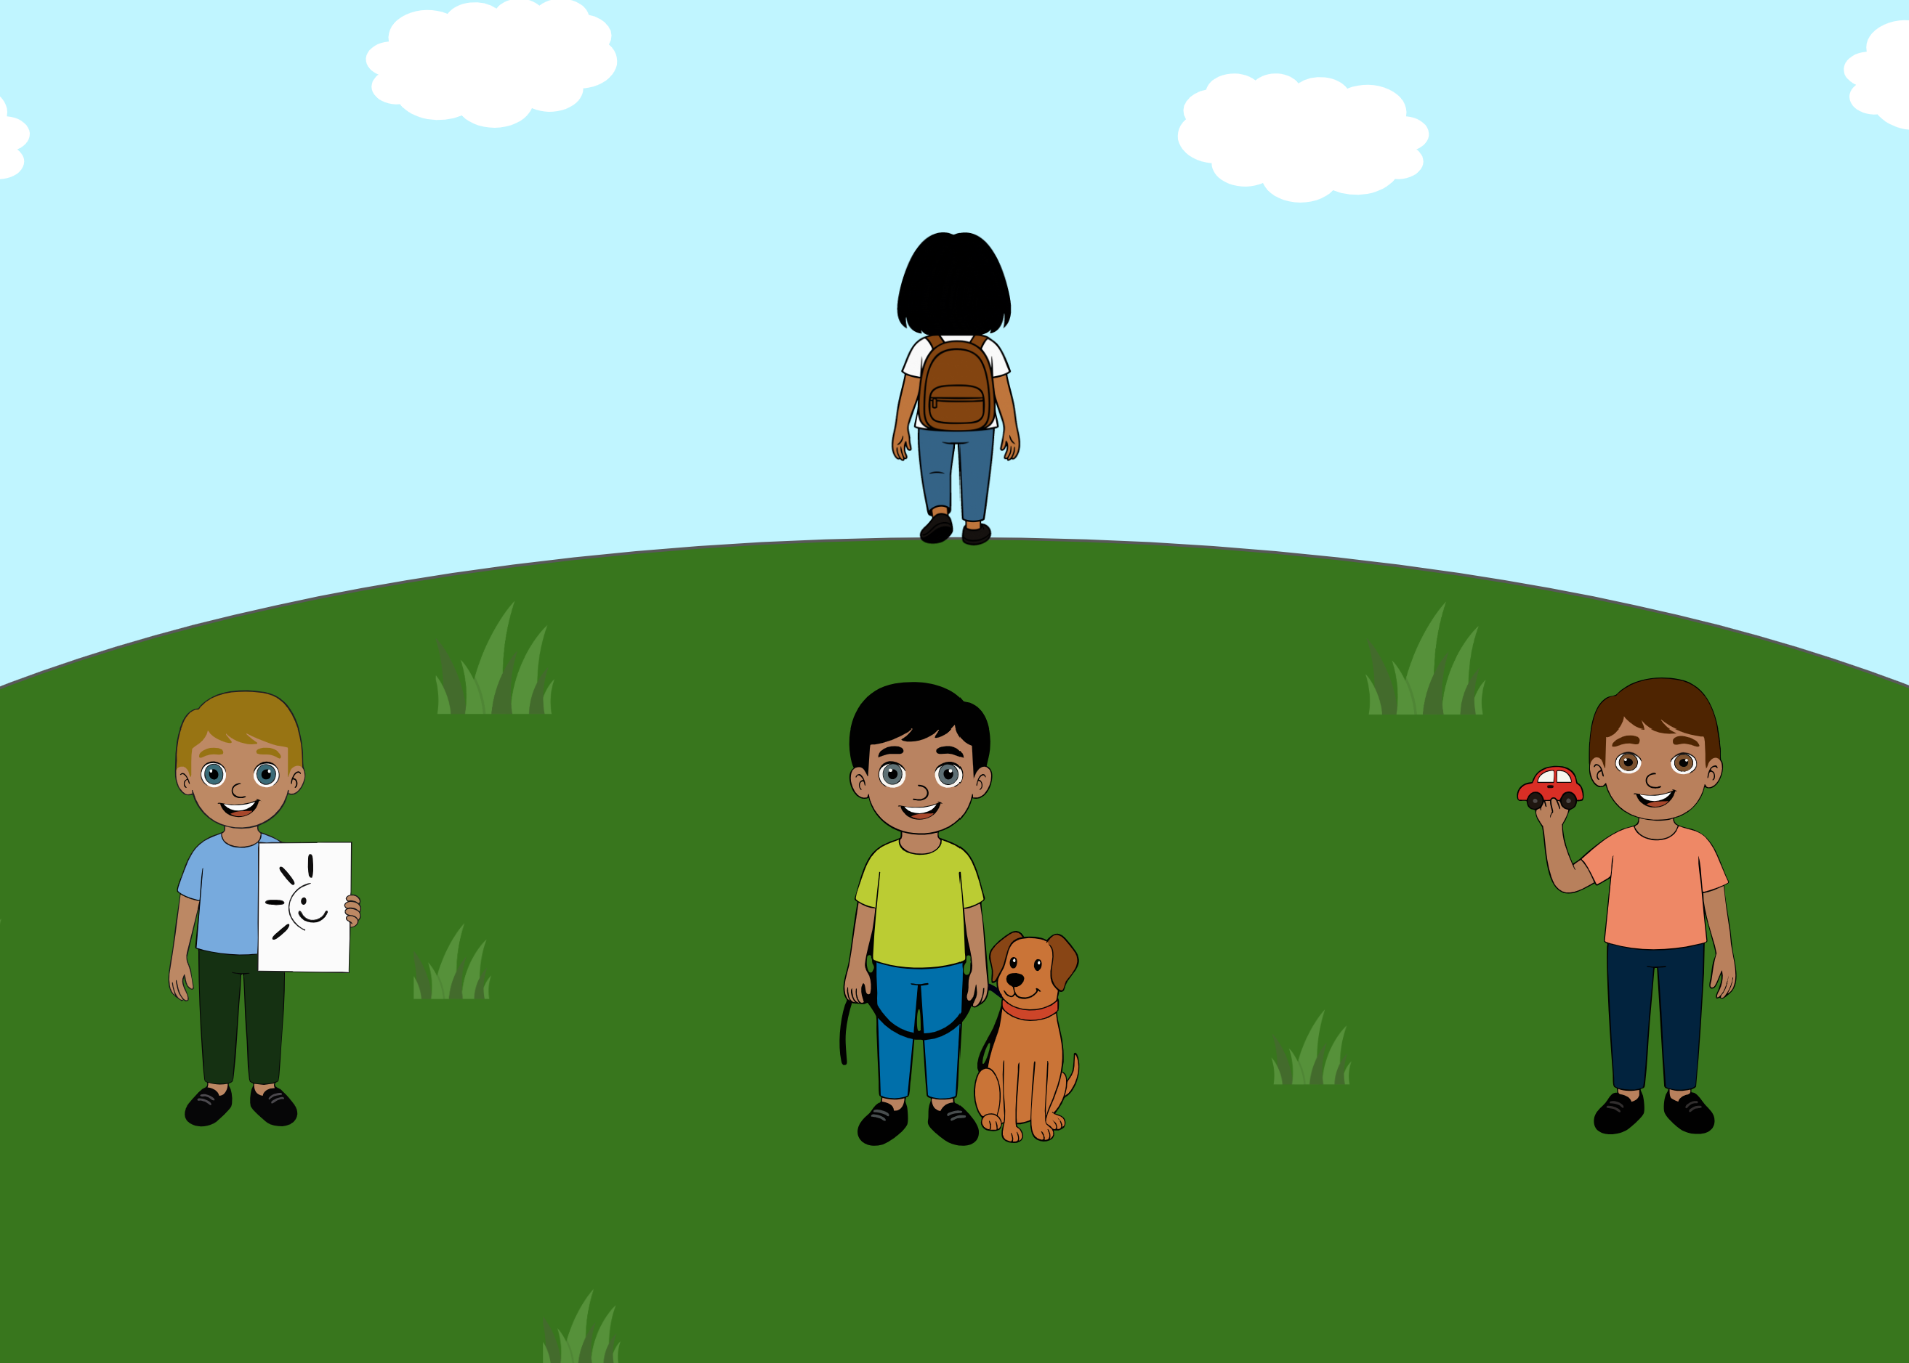 | A voice says: “Ella, can I borrow your pencil?”. Ella turns and asks “Who said that?”. The ambiguity of the literal message (there is no indication as to who said the sentence) is integrated with information from the context (the three boys, one holding a drawing, one with a dog and one holding a car), about the world (pencils are used on paper) and about the listener (if one needs a pencil, they likely want to draw something). | Bernard and Deleau (2007), Le Sourn-Bissaoui et al. (2012).

