Trend in fisheries

WGEEL

27 September 2021

This section presents and describes data from commercial, recreational and non-commercial fisheries, aquaculture production and restocking of eel. Data can be reported by eel life stage (glass, yellow, silver), habitat type (freshwater, tidal, marine) and by eel management unit (EMU) where possible. Historical series for which these details are not available are reported by country. The current database structure will allow aggregation by country or region if necessary. The landings data presented are those reported to the WGEEL, either through responses to the 2021 Data call, in Country Reports, or integrated by the WGEEL during data calls.

Care should also be taken with the interpretation of the landings as indicators of the stock, since the catch statistics now reflect the status of reduced activity as well as of stock levels. In summary, reported commercial landings are declining, a long-term continuing trend, from a level of around 10,000 t in the 1960s, reported commercial landings have now dropped to xxx tonnes (glass eel + yellow eel + silver eel) in 2020.

# Key numbers

### Glass eel landings

Glass eel commercial fisheries within the EU in 2020 = 59.33 t countries where data were reported: ES,PT,FR,GB Glass eel commercial fisheries within the EU in 2021 = 51.77 t countries where data were reported: ES,FR,PT Mean glass eel commercial fisheries for the previous 5 years ( 2015 - 2019 ) within the EU = 58.516 t

### Yellow and Silver com eels landings

## `summarise()` has grouped output by 'eel_cou_code'. You can override using the `.groups` argument.

Yellow and Silver eel commercial fisheries within the EU (Y, S, YS) in 2019 = 2642.2 t. Number of countries reporting: 22 Yellow and Silver eel commercial fisheries within the EU (Y, S, YS) in 2020 = 2135 t. Number of countries reporting: 19 Mean Yellow and Silver eel commercial fisheries for the previous 5 years ( 2014 - 2018 ) within the EU = 2776.968 t. Reconstructed Yellow and Silver eel commercial fisheries within the EU (Y, S, YS) in 2019 = 2652.68 t. Reconstructed Yellow and Silver eel commercial fisheries within the EU (Y, S, YS) in 2020 = 2342.18 t. Mean Reconstructed Yellow and Silver eel commercial fisheries for the previous 5 years ( 2014 - 2018 ) within the EU = 2777.01 t.

### Glass eel recreational landings

Glass eel recreational fisheries within the EU in 2020 = 0.66 t countries where data were reported: ES,FR Glass eel recreational fisheries within the EU in 2021 = t countries where data were reported: Mean glass eel recreational fisheries for the previous 5 years ( 2015 - 2019 ) within the EU = 1.63 t.

### Yellow and Silver eel recreational landings

Yellow and Silver eel recreational fisheries within the EU (Y, S, YS) in 2019 = 490.51 t. Number of countries reporting: 10 Yellow and Silver eel recreational fisheries within the EU (Y, S, YS) in 2020 = 274 t. Number of countries reporting: 9 Mean Yellow and Silver eel recreational fisheries for the previous 5 years ( 2014 - 2018 ) within the EU = 532.86 t.

### Aquaculture

Eel aquaculture within the EU in 2019 = 5276.57 t countries where data were reported: NL,SE,MA,GR,PT,ES,DK,IT,DE Mean aquaculture for the previous 5 years ( 2015 - 2019 ) within the EU = 5724.97 t

### Release

Number of glass eels (G, QG) released in 2019 = 48.83 millions , Number of countries reporting: 12 Number of yellow eels (Y) released in 2018 = 0.86 millions , Number of countries reporting: 4 Number of silver eels (S) released in 2020 = 0.43 millions , Number of countries reporting: 6

# Figures

## Commercial fisheries landings

#### Glass eel

Glass eel landings show a sharp decline since 1980 from 2 000 tonnes to around 40–60 tonnes since 2009 onwards. In 2019, the raw (uncorrected) landings data for glass eels is XXX (Annex XXX Table XXX for raw data and Table XXX for raw and corrected data).

## `summarise()` has grouped output by 'eel_cou_code'. You can override using the `.groups` argument.

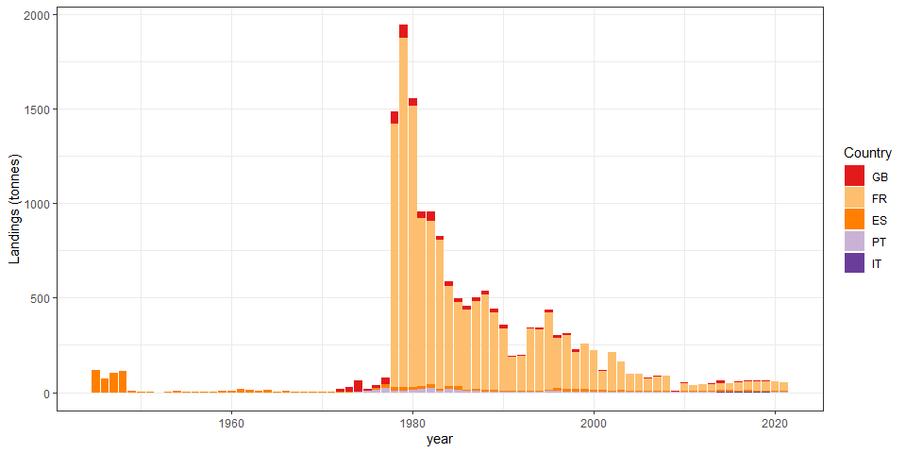

Figure 1: Time-series of reported commercial glass eel fishery landings (tonnes), by country. United King-dom (GB), France (FR), Spain (ES), Portugal (PT) and Italy (IT) are included combining information from the Data call 2020 and the WGEEL database.

## `summarise()` has grouped output by 'eel_cou_code'. You can override using the `.groups` argument.

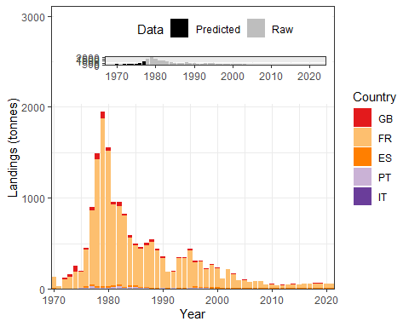

Figure 2: Time-series of reported or reconstructed commercial glass eel fishery landings (tonnes), 1970-2020, by country. United Kingdom (GB), France (FR), Spain (ES), Portugal (PT) and Italy (IT) combining information from the Data call 2020 and the WGEEL database, and a reconstruction of the non-reported countries/years combinations (see text). The inset box shows the proportion of data reconstructed per year.

#### Yellow and silver eel

Figure 3 presents data but for yellow and silver eels aggregated coming from 20 countries, and Figure 4 presents the time-series including reconstructed data to fill the gaps. The proportion of “corrected” landing was as high as 50% in the 1950s, but rather low since the mid-1980s. Annex 8 Table 3 presents the raw data for yellow and silver eel combined, Annex 8 Table 4 presents the raw and corrected data for yellow and silver eel landings data. The total landings of yellow and silver eels decrease from 18,000–20,000 tonnes in the 1950s to 2,000–3,000 tonnes since 2009. In XXCY-1XX, the amount was XXX for yellow and silver landings, combined.

## `summarise()` has grouped output by 'eel_cou_code'. You can override using the `.groups` argument.

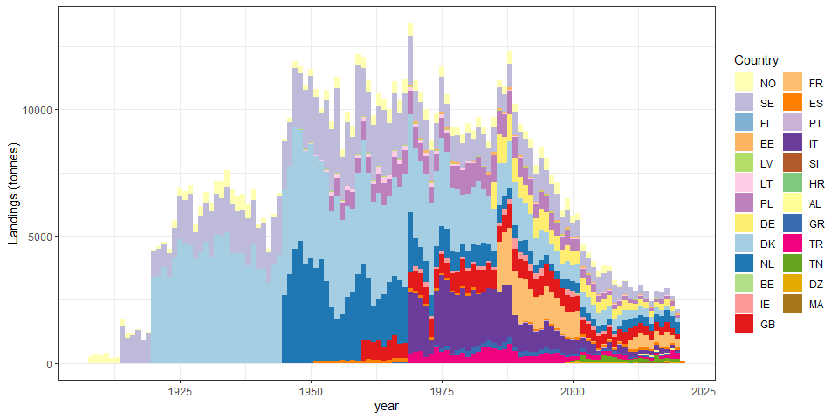

Figure 3: Time-series of reported commercial yellow (Y), silver (S) and yellow-silver (YS) eel fishery landings (tonnes) 1908?2018, by country, Norway (NO), Sweden (SE), Finland (FI), Estonia (EE), Latvia (LV), Lithuania (LT), Poland (PL), Ger-many (DE), Denmark (DK), Netherlands (NL), Ireland (IE), United Kingdom (GB), France (FR), Spain (ES), Portugal (PT), Italy (IT), Slovenia (SI), Croatia (HR), Greece (GR), Turkey (TR) and Tunisia (TN), combining information from the Data call and the WGEEL database.

## `summarise()` has grouped output by 'eel_cou_code'. You can override using the `.groups` argument.

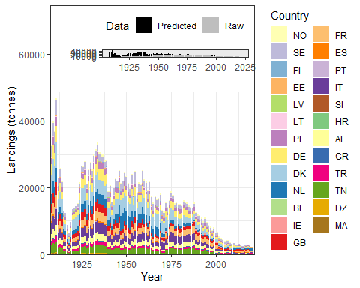

Figure 4: Time-series of reported or reconstructed commercial yellow and silver eel fishery landings (tonnes), by country, Norway (NO), Sweden (SE), Finland (FI), Estonia (EE), Latvia (LV), Lithuania (LT), Poland (PL), Germany (DE), Denmark (DK), Netherlands (NL), Ireland (IE), United Kingdom (GB), France (FR), Spain (ES), Portugal (PT), Italy (IT), Croatia (HR), Slovenia (SI), Greece (GR), Turkey (TR) and Tunisia (TN) combining information from the Data call, the WGEEL database and a reconstruction of the non-reported countries/years combinations. Inset box shows the proportion of reconstructed landings, per year.

## Recreational fisheries

## `summarise()` has grouped output by 'eel_cou_code'. You can override using the `.groups` argument.

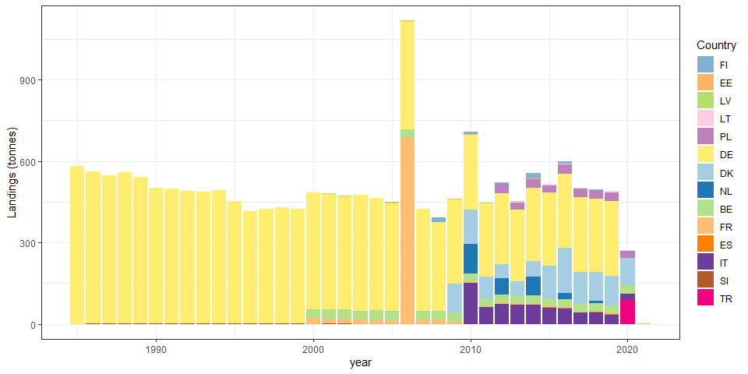

Figure 5: Time-series of reported or reconstructed commercial yellow and silver eel fishery landings (tonnes), by country, Norway (NO), Sweden (SE), Finland (FI), Estonia (EE), Latvia (LV), Lithuania (LT), Poland (PL), Germany (DE), Denmark (DK), Netherlands (NL), Ireland (IE), United Kingdom (GB), France (FR), Spain (ES), Portugal (PT), Italy (IT), Croatia (HR), Slovenia (SI), Greece (GR), Turkey (TR) and Tunisia (TN) combining information from the Data call.

## `summarise()` has grouped output by 'eel_cou_code'. You can override using the `.groups` argument.

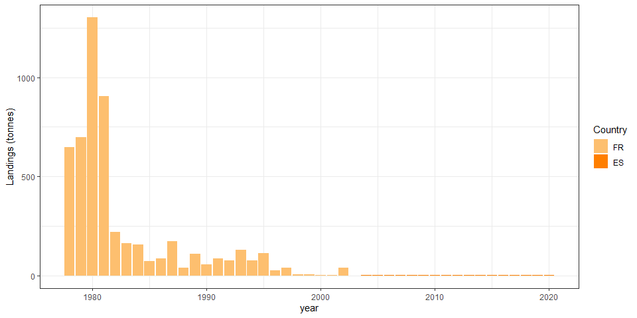

## Release

## `summarise()` has grouped output by 'eel_cou_code'. You can override using the `.groups` argument.

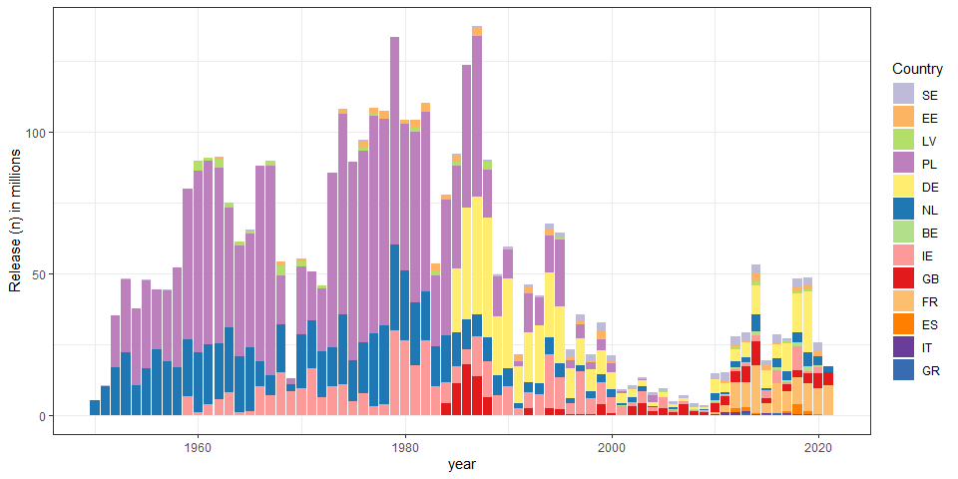

Figure 7: Reported releases of glass eel (in millions) per country, Sweden (SE), Estonia (EE), Latvia (LV), Poland (PL), Germany (DE), Netherlands (NL), Belgium (BE), Ireland (IE), United Kingdom (GB), France (FR), Spain (ES), Italy (IT) and Greece (GR).

## `summarise()` has grouped output by 'eel_cou_code'. You can override using the `.groups` argument.

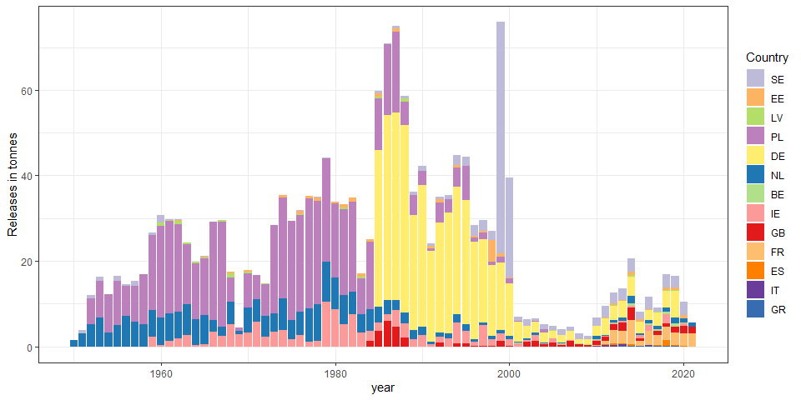

Figure X: Reported releases of glass eel (in tonnes) per country Estonia (EE), Latvia (LV), Poland (PL), Germany (DE), Netherlands (NL), Belgium (BE), Ireland (IE), United Kingdom (GB), France (FR), Spain (ES), Italy (IT) and Greece (GR).

## `summarise()` has grouped output by 'eel_cou_code'. You can override using the `.groups` argument.

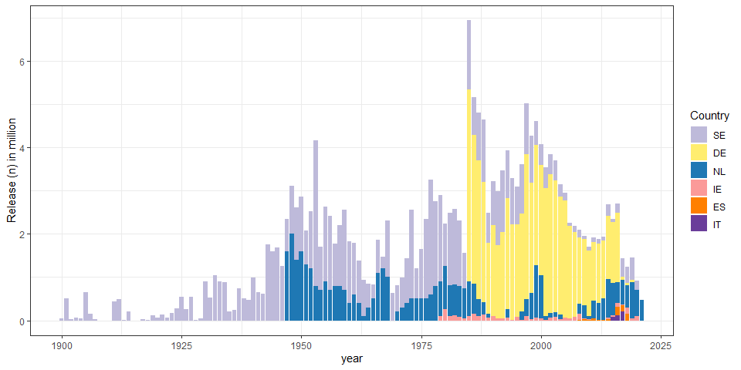

Figure 8:Reported releases of yellow eel (in millions) per country, Germany (DE), Netherlands (NL), Ireland (IE), Spain (ES) and Italy (IT).

## `summarise()` has grouped output by 'eel_cou_code'. You can override using the `.groups` argument.

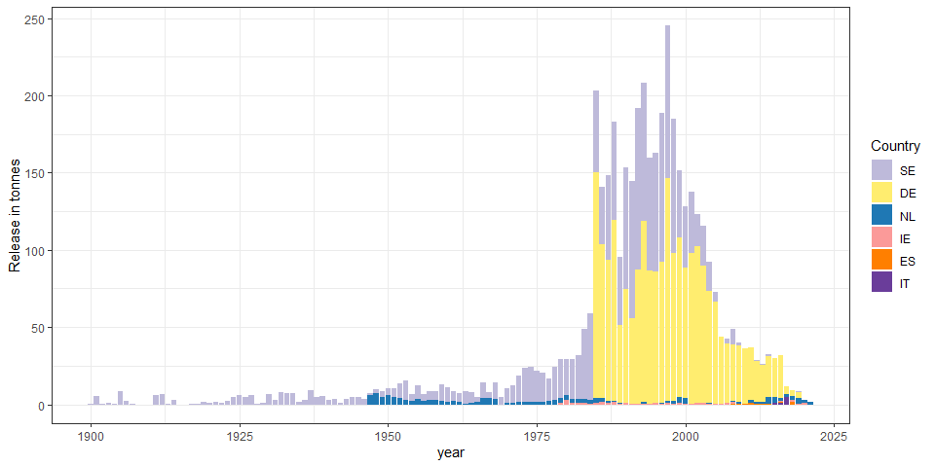

Figure x:Reported releases of yellow eel (in tonnes) per country: Sweden (SE) Germany (DE), Netherlands (NL), Ireland (IE), Spain (ES) and Italy (IT).

## `summarise()` has grouped output by 'eel_cou_code'. You can override using the `.groups` argument.

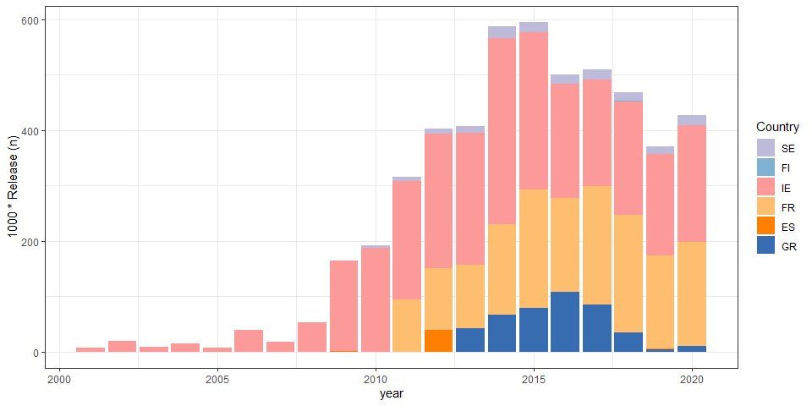

Figure 9: Reported releases of silver eel (in thousands) per country, Sweden (SE), Finland (FI), Ireland (IE), France (FR), Spain (ES), and Greece (GR).

## `summarise()` has grouped output by 'eel_cou_code'. You can override using the `.groups` argument.

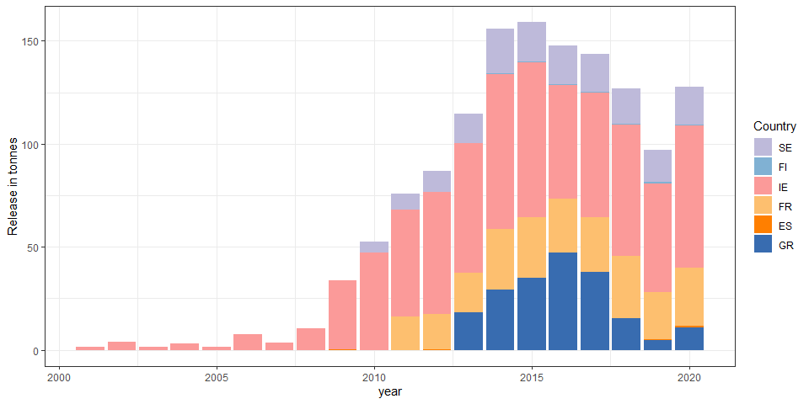

Figure x: Reported releases of silver eel (in tonnes) per country, Sweden (SE), Finland (FI), Ireland (IE), France (FR), Spain (ES), and Greece (GR).

## `summarise()` has grouped output by 'eel_cou_code'. You can override using the `.groups` argument.

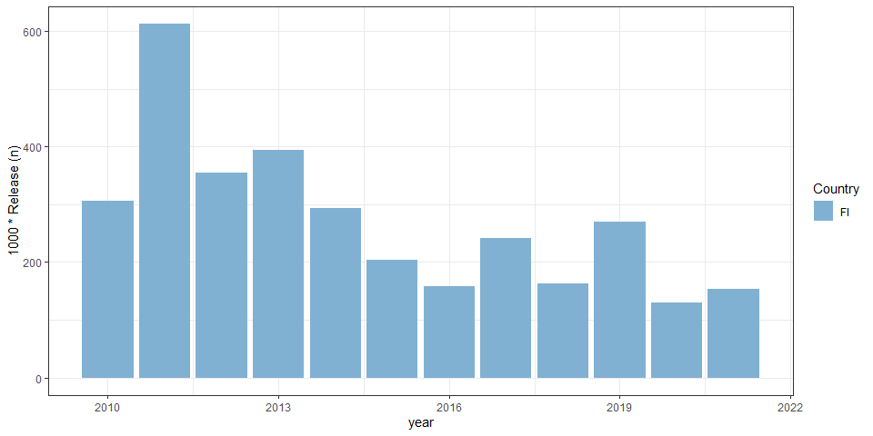

Figure 10: Reported releases of Quarantined glass eel (in thousands) per country, Sweden (SE) and Finland (FI).

## `summarise()` has grouped output by 'eel_cou_code'. You can override using the `.groups` argument.

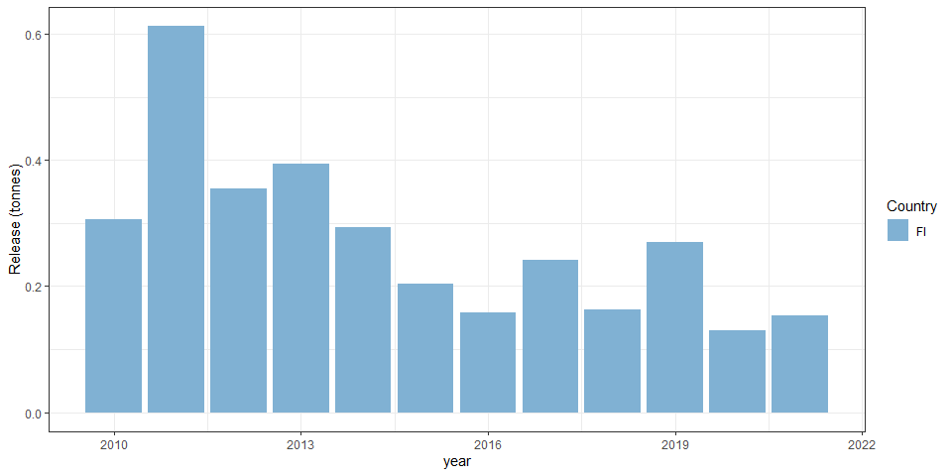

Figure x: Reported releases of Quarantined glass eel (in tonnes) per country, Sweden (SE) and Finland (FI).

## `summarise()` has grouped output by 'eel_cou_code'. You can override using the `.groups` argument.

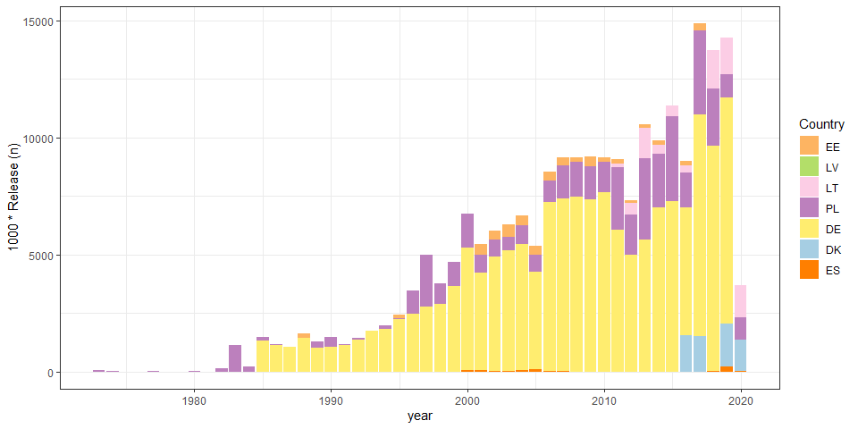

Figure 11: Reported releases of ongrown glass eel (in thousands) per country, Estonia (EE), Latvia (LV), Lithuania (LT), Poland (PL), Germany (DE), Denmark (DK) and Spain (ES).

## `summarise()` has grouped output by 'eel_cou_code'. You can override using the `.groups` argument.

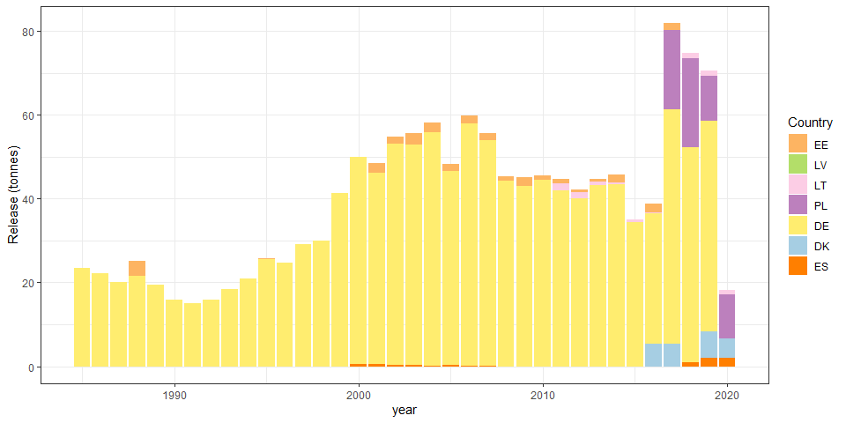

Figure x: Reported releases of ongrown glass eel (in tonnes) per country, Estonia (EE), Latvia (LV), Lithuania (LT), Poland (PL), Germany (DE), Denmark (DK) and Spain (ES).

## `summarise()` has grouped output by 'eel_cou_code'. You can override using the `.groups` argument.

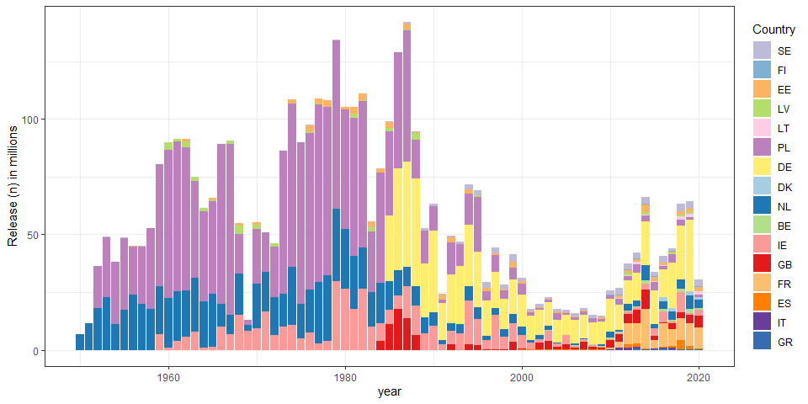

Figure 12: Reported releases of all stages (Y, YS, OG, S, QG) (in millions) per country, Sweden (SE), Finland (FI), Estonia (EE), Latvia (LV), Lithuania (LT), Poland (PL), Germany (DE), Denmark (DK), Netherlands (NL), Belgium (BE), Ireland (IE), United Kingdom (GB), France (FR), Spain (ES), Italy (IT) and Greece (GR)..

## `summarise()` has grouped output by 'eel_cou_code'. You can override using the `.groups` argument.

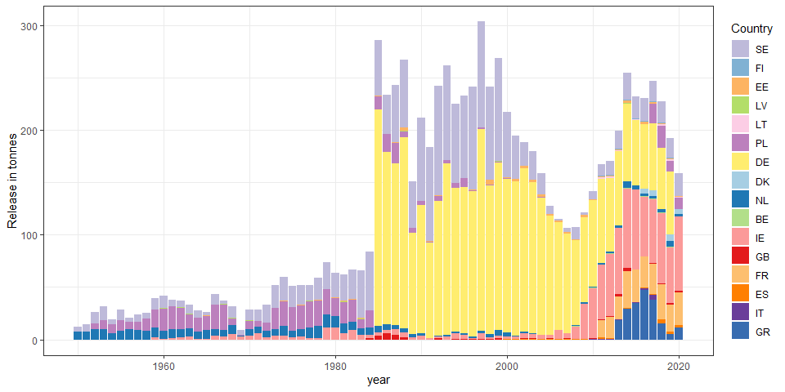 ## Other landings

## `summarise()` has grouped output by 'eel_cou_code'. You can override using the `.groups` argument.

## Error in `[.data.frame`(table, , c(1, 2:8)): undefined columns selected

## Error in `[.data.frame`(table, , c(1, 9:ncol(table))): undefined columns selected

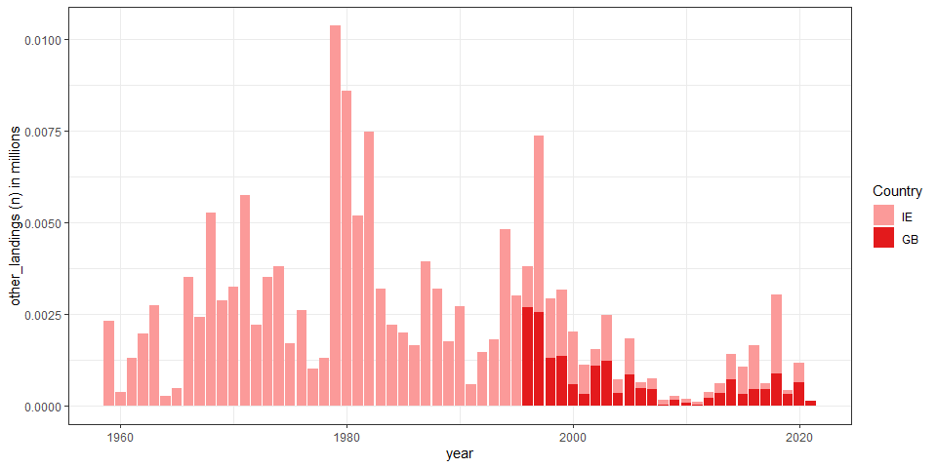

Figure 7: Reported other_landingss of glass eel (in millions) per country, Sweden (SE), Estonia (EE), Latvia (LV), Poland (PL), Germany (DE), Netherlands (NL), Belgium (BE), Ireland (IE), United Kingdom (GB), France (FR), Spain (ES), Italy (IT) and Greece (GR).

## `summarise()` has grouped output by 'eel_cou_code'. You can override using the `.groups` argument.

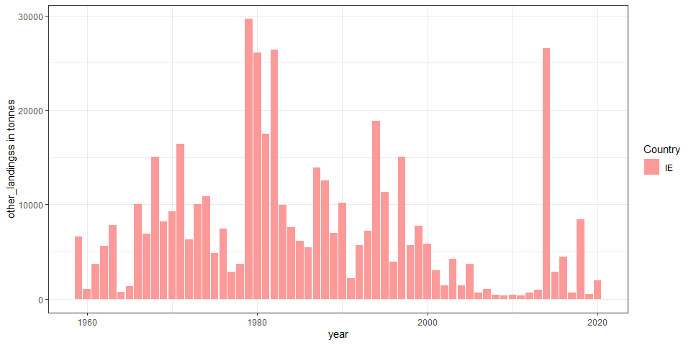

Figure X: Reported other_landingss of glass eel (in tonnes) per country Estonia (EE), Latvia (LV), Poland (PL), Germany (DE), Netherlands (NL), Belgium (BE), Ireland (IE), United Kingdom (GB), France (FR), Spain (ES), Italy (IT) and Greece (GR).

## `summarise()` has grouped output by 'eel_cou_code'. You can override using the `.groups` argument.

## Error in rowSums(table[, -1], na.rm = T): 'x' must be an array of at least two dimensions

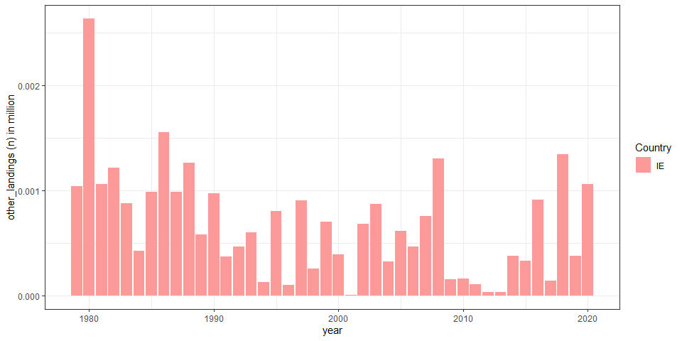

Figure 8:Reported other_landingss of yellow eel (in millions; OG and Y) per country, Germany (DE), Netherlands (NL), Ireland (IE), Spain (ES) and Italy (IT).

## `summarise()` has grouped output by 'eel_cou_code'. You can override using the `.groups` argument.

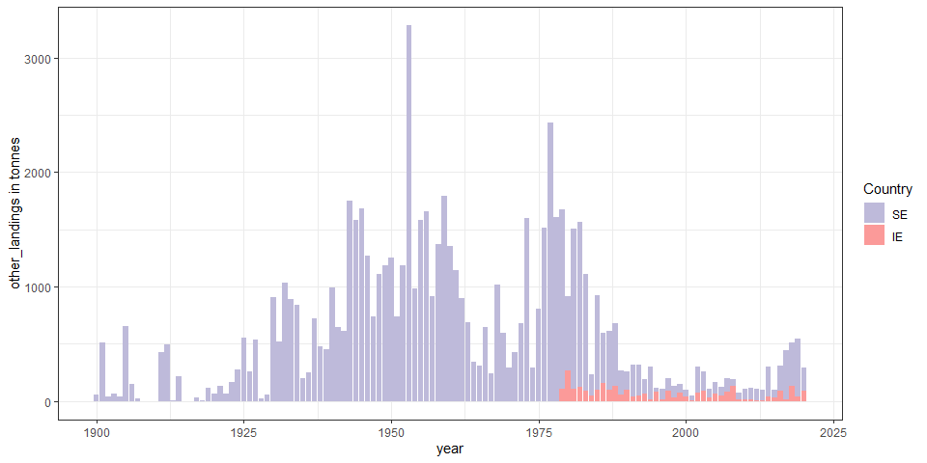

Figure x:Reported other_landingss of yellow eel (OG +Y) (in tonnes) per country: Sweden (SE) Germany (DE), Netherlands (NL), Ireland (IE), Spain (ES) and Italy (IT).

## `summarise()` has grouped output by 'eel_cou_code'. You can override using the `.groups` argument.

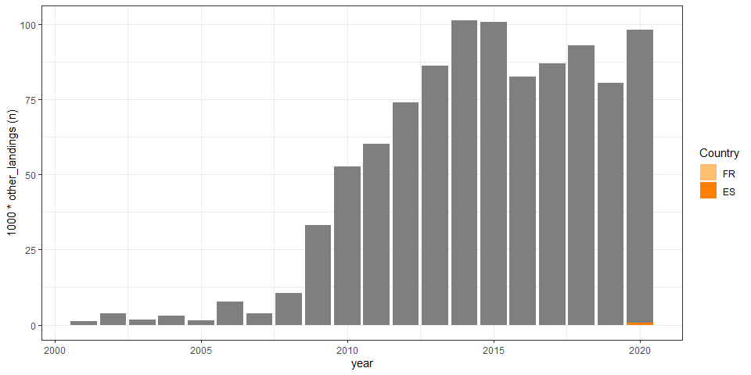

Figure 9: Reported other_landingss of silver eel (in thousands) per country, Sweden (SE), Finland (FI), Ireland (IE), France (FR), Spain (ES), and Greece (GR).

## `summarise()` has grouped output by 'eel_cou_code'. You can override using the `.groups` argument.

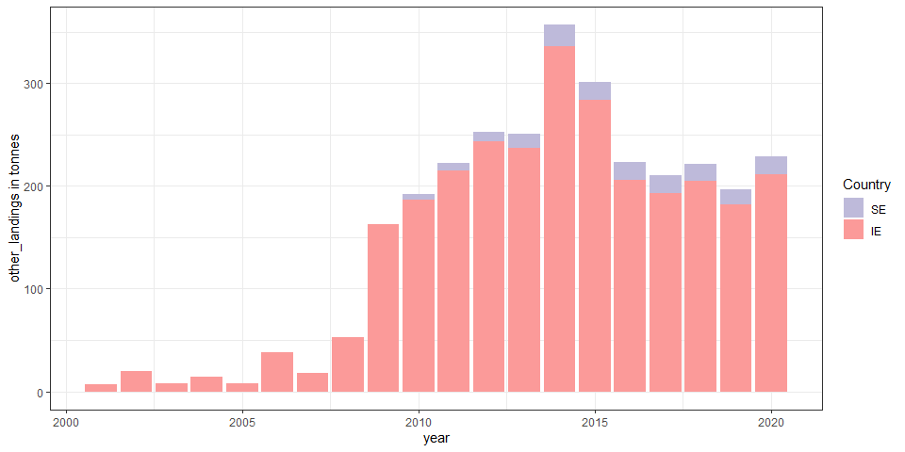

Figure x: Reported other_landingss of silver eel (in tonnes) per country, Sweden (SE), Finland (FI), Ireland (IE), France (FR), Spain (ES), and Greece (GR).

## `summarise()` has grouped output by 'eel_cou_code'. You can override using the `.groups` argument.

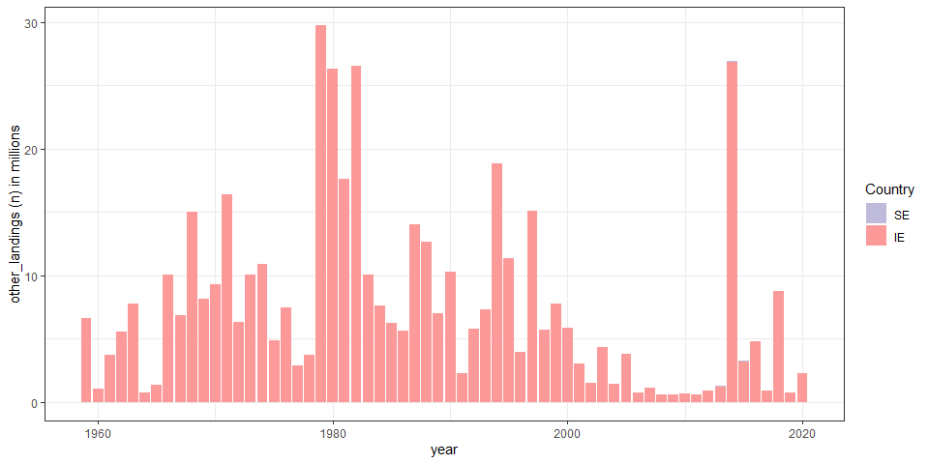

Figure 12: Reported other_landingss of all stages (Y, YS, S) (in millions) per country, Sweden (SE), Finland (FI), Estonia (EE), Latvia (LV), Lithuania (LT), Poland (PL), Germany (DE), Denmark (DK), Netherlands (NL), Belgium (BE), Ireland (IE), United Kingdom (GB), France (FR), Spain (ES), Italy (IT) and Greece (GR)..

## `summarise()` has grouped output by 'eel_cou_code'. You can override using the `.groups` argument.

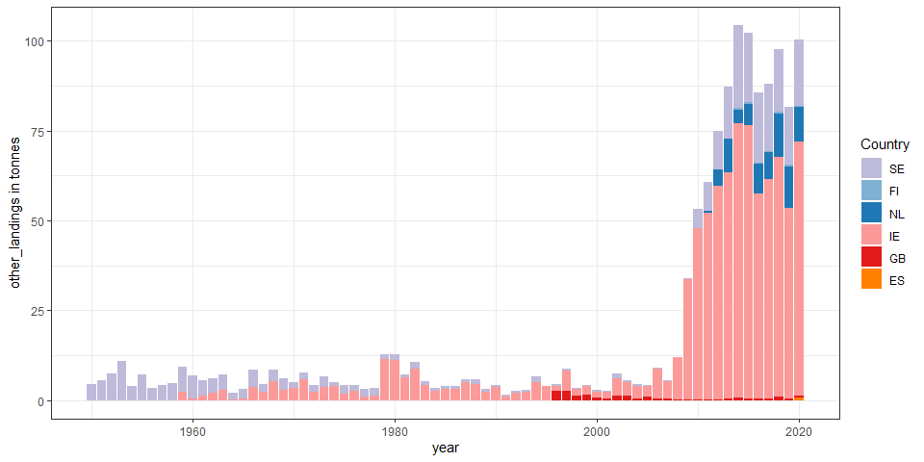 ## Aquaculture

## `summarise()` has grouped output by 'eel_cou_code'. You can override using the `.groups` argument.

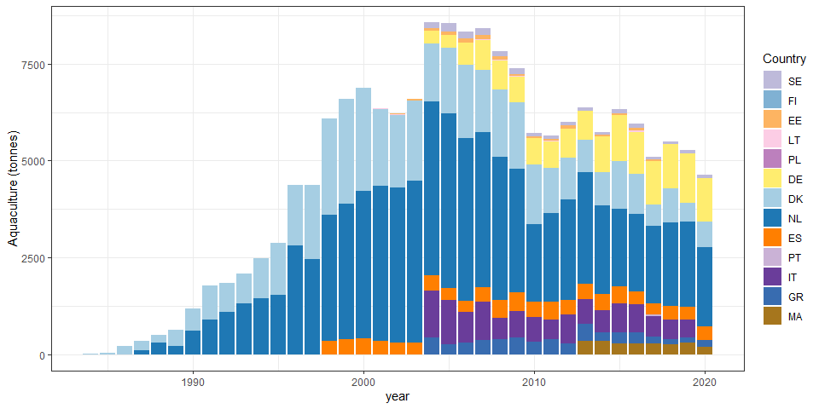

Figure 13: Reported aquaculture production of European eel in Europe from 1984 onwards, in tonnes, in Sweden (SE), Finland (FI), Estonia (EE), Lithuania (LT), Poland (PL), Germany (DE), Denmark (DK), Netherlands (NL), Ireland (IE), Spain (ES), Portugal (PT), Italy (IT) and Greece (GR).

# tables

Table 1: Glass eel commercial fisheries landings (in tonnes) from 1984 to 2021, reported by countries: GB United Kingdom, FR France, ES Spain, PT Portugal, IT Italy.

|  |  |  |  |  |  |  |
| --- | --- | --- | --- | --- | --- | --- |
| Year | GB | FR | ES | PT | IT | sum |
| 1945 |  |  | 119.246 |  |  | 119.246 |
| 1946 |  |  | 71.931 |  |  | 71.931 |
| 1947 |  |  | 100.09 |  |  | 100.09 |
| 1948 |  |  | 110.624 |  |  | 110.624 |
| 1949 |  |  | 9.319 |  |  | 9.319 |
| 1950 |  |  | 3.828 |  |  | 3.828 |
| 1951 |  |  | 2.093 |  |  | 2.093 |
| 1953 |  |  | 2.535 |  |  | 2.535 |
| 1954 |  |  | 5.91 |  |  | 5.91 |
| 1955 |  |  | 0.906 |  |  | 0.906 |
| 1956 |  |  | 0.884 |  |  | 0.884 |
| 1957 |  |  | 2.833 |  |  | 2.833 |
| 1958 |  |  | 0.402 |  |  | 0.402 |
| 1959 |  |  | 6.637 |  |  | 6.637 |
| 1960 |  |  | 9.453 |  |  | 9.453 |
| 1961 |  |  | 16.731 |  |  | 16.731 |
| 1962 |  |  | 11.088 |  |  | 11.088 |
| 1963 |  |  | 7.997 |  |  | 7.997 |
| 1964 |  |  | 11 |  |  | 11 |
| 1965 |  |  | 4 |  |  | 4 |
| 1966 |  |  | 6 |  |  | 6 |
| 1967 |  |  | 5 |  |  | 5 |
| 1968 |  |  | 4 |  |  | 4 |
| 1969 |  |  | 4 |  |  | 4 |
| 1970 |  |  | 5 |  |  | 5 |
| 1971 |  |  | 1 |  |  | 1 |
| 1972 | 16.7 |  | 1 |  |  | 17.7 |
| 1973 | 28.2 |  | 1 |  |  | 29.2 |
| 1974 | 57.5 |  | 2 | 1.596 |  | 61.096 |
| 1975 | 10.5 |  | 2.6 | 5.578 |  | 18.678 |
| 1976 | 13.1 |  | 11.6 | 12.548 |  | 37.248 |
| 1977 | 38.6 |  | 17.5 | 22.637 |  | 78.737 |
| 1978 | 61.2 | 1393 | 21.6 | 7.344 |  | 1483.144 |
| 1979 | 67 | 1850 | 17.3 | 8.758 |  | 1943.058 |
| 1980 | 40.1 | 1491 | 15.4 | 10.11 |  | 1556.61 |
| 1981 | 36.9 | 890 | 13 | 18.05 |  | 957.95 |
| 1982 | 48 | 866 | 19.309 | 22.235 |  | 955.544 |
| 1983 | 16.9 | 791 | 10.34 | 6.74 |  | 824.98 |
| 1984 | 25 | 528 | 16.387 | 16.064 |  | 585.451 |
| 1985 | 20 | 444 | 18.28 | 14.843 |  | 497.123 |
| 1986 | 19 | 423 | 6.402 | 7 |  | 455.402 |
| 1987 | 21.3 | 461 | 9.384 | 9.51 |  | 501.194 |
| 1988 | 21.4 | 504 | 9.855 | 2.571 |  | 537.826 |
| 1989 | 20.6 | 410 | 9.872 | 2.834 |  | 443.306 |
| 1990 | 20.9 | 325 | 5.283 | 4.485 |  | 355.668 |
| 1991 | 1.1 | 179 | 6.822 | 2.8 |  | 189.722 |
| 1992 | 5 | 183 | 3.665 | 4.471 |  | 196.136 |
| 1993 | 5.73 | 329 | 5.248 | 3.626 |  | 343.604 |
| 1994 | 9.5 | 329 | 2.371 | 2.9 |  | 343.771 |
| 1995 | 11.9 | 413 | 4.9 | 5.3 |  | 435.1 |
| 1996 | 18.8 | 262 | 14.545 | 8.7 |  | 304.045 |
| 1997 | 8.7 | 287 | 11.978 | 4.44 |  | 312.118 |
| 1998 | 11.2 | 195 | 14.119 | 4.46 |  | 224.779 |
| 1999 |  | 242 | 13.869 | 3.6 |  | 259.469 |
| 2000 |  | 206 | 10.987 | 3 |  | 219.987 |
| 2001 | 0.809 | 101 | 12.044 | 1.149 |  | 115.002 |
| 2002 | 0.521 | 202 | 8.577 | 0.804 |  | 211.902 |
| 2003 | 1.715 | 151 | 9.974 | 1.45 |  | 164.139 |
| 2004 | 0.97 | 89 | 5.12 | 0.814 |  | 95.904 |
| 2005 | 1.704 | 89 | 6.425 | 1.174 |  | 98.303 |
| 2006 | 1.274 | 67 | 4.143 | 2.736 |  | 75.153 |
| 2007 | 2.074 | 77 | 5.241 | 0.905 |  | 85.22 |
| 2008 | 0.817 | 79 | 5.148 | 0.75 |  | 85.715 |
| 2009 | 0.291 |  | 3.655 | 1.35 |  | 5.296 |
| 2010 | 1.324 | 41.018 | 6.466 | 2.36 |  | 51.168 |
| 2011 | 2.239 | 31.258 | 5.206 | 1.085 |  | 39.788 |
| 2012 | 2.773 | 34.296 | 5.326 | 0.808 |  | 43.203 |
| 2013 | 5.907 | 33.616 | 7.155 | 1.081 |  | 47.759 |
| 2014 | 11.772 | 35.341 | 11.28 | 1.176 | 0.425 | 59.994 |
| 2015 | 2.696 | 36.094 | 8.763 | 1.284 | 0.159 | 48.996 |
| 2016 | 4.04 | 46.371 | 6.668 | 0.409 | 0.06 | 57.548 |
| 2017 | 3.53 | 43.191 | 11.09 | 2.178 | 0.146 | 60.135 |
| 2018 | 4.66 | 53.405 | 4.501 | 1.048 | 0.243 | 63.857 |
| 2019 | 6.95 | 50.009 | 4.245 | 0.587 | 0.243 | 62.034 |
| 2020 | 3.417 | 48.738 | 6.28 | 0.891 |  | 59.326 |
| 2021 |  | 46.071 | 4.459 | 1.236 |  | 51.766 |

Table 2a: Commercial fisheries landings (in tonnes) for yellow eel and silver eel from 1908 to 2021 (part 1), reported by countries: NO Norway, SE Sweden, FI Finland, EE Estonia, LV Latvia, LT Lithuania, PL Poland, DE Germany, DK Denmark, NL Netherlands, BE Belgium (to be continued for other countries in next table).

|  |  |  |  |  |  |  |  |  |  |  |  |
| --- | --- | --- | --- | --- | --- | --- | --- | --- | --- | --- | --- |
| Year | NO | SE | FI | EE | LV | LT | PL | DE | DK | NL | BE |
| 1908 | 268.145 |  |  |  |  |  |  |  |  |  |  |
| 1909 | 326.558 |  |  |  |  |  |  |  |  |  |  |
| 1910 | 303.064 |  |  |  |  |  |  |  |  |  |  |
| 1911 | 383.821 |  |  |  |  |  |  |  |  |  |  |
| 1912 | 187.325 |  |  |  |  |  |  |  |  |  |  |
| 1913 | 212.749 |  |  |  |  |  |  |  |  |  |  |
| 1914 | 282 | 1460.605 |  |  |  |  |  |  |  |  |  |
| 1915 | 143 | 996.92 |  |  |  |  |  |  |  |  |  |
| 1916 | 117 | 1078.247 |  |  |  |  |  |  |  |  |  |
| 1917 | 44 | 1283.643 |  |  |  |  |  |  |  |  |  |
| 1918 | 35 | 884.351 |  |  |  |  |  |  |  |  |  |
| 1919 | 64 | 1145.353 |  |  |  |  |  |  |  |  |  |
| 1920 | 80 | 969.609 |  |  |  |  |  |  | 3413 |  |  |
| 1921 | 79 | 1072.376 |  |  |  |  |  |  | 3443 |  |  |
| 1922 | 94 | 925.85 |  |  |  |  |  |  | 3760 |  |  |
| 1923 | 140 | 947.739 |  |  |  |  |  |  | 3396 |  |  |
| 1924 | 290 | 1201.069 |  |  |  |  |  |  | 4130 |  |  |
| 1925 | 325 | 1714.229 |  |  |  |  |  |  | 4880 |  |  |
| 1926 | 341 | 1707.254 |  |  |  |  |  |  | 4726 |  |  |
| 1927 | 354 | 2011.481 |  |  |  |  |  |  | 4648 |  |  |
| 1928 | 325 | 1040.056 |  |  |  |  |  |  | 4117 |  |  |
| 1929 | 425 | 1393.667 |  |  |  |  |  |  | 4375 |  |  |
| 1930 | 450 | 1528.797 |  |  |  |  |  |  | 4773 |  |  |
| 1931 | 329 | 1794.757 |  |  |  |  |  |  | 4195 |  |  |
| 1932 | 518 | 1588.748 |  |  |  |  |  |  | 5088 |  |  |
| 1933 | 694 | 1493.965 |  |  |  |  |  |  | 5014 |  |  |
| 1934 | 674 | 1768.74 |  |  |  |  |  |  | 5171 |  |  |
| 1935 | 564 | 1950.935 |  |  |  |  |  |  | 4316 |  |  |
| 1936 | 631 | 1654.478 |  |  |  |  |  |  | 4332 |  |  |
| 1937 | 603 | 1725.109 |  |  |  |  |  |  | 4329 |  |  |
| 1938 | 526 | 1870.504 |  |  |  |  |  |  | 3849 |  |  |
| 1939 | 434 | 1774.362 |  |  |  |  |  |  | 4662 |  |  |
| 1940 | 143 | 1625.714 |  |  |  |  |  |  | 3709 |  |  |
| 1941 | 174 | 1821.767 |  |  |  |  |  |  | 3717 |  |  |
| 1942 | 131 | 1226.46 |  |  |  |  |  |  | 3140 |  |  |
| 1943 | 136 | 1827.842 |  |  |  |  |  |  | 3917 |  |  |
| 1944 | 150 | 2319.761 |  |  |  |  |  |  | 4245 |  |  |
| 1945 | 102 | 1906.104 |  |  |  |  |  |  | 4169 | 2668 |  |
| 1946 | 167 | 1744.632 |  |  |  |  |  |  | 4269 | 3492 |  |
| 1947 | 268 | 2346.809 |  |  | 10 | 8 |  |  | 4784 | 4502 |  |
| 1948 | 293 | 2211.86 |  |  | 10 | 14 |  |  | 4386 | 4799 |  |
| 1949 | 214 | 2329 |  |  | 50 | 21 |  |  | 4492 | 3873 |  |
| 1950 | 282 | 2628 |  |  | 10 | 29 |  |  | 4500 | 4152 |  |
| 1951 | 312 | 2311 |  |  | 10 | 32 |  |  | 4400 | 3661 |  |
| 1952 | 178 | 1848 |  |  | 10 | 39 |  |  | 3900 | 3978 |  |
| 1953 | 371 | 2756 |  |  | 20 | 80 |  |  | 4300 | 3157 |  |
| 1954 | 327 | 2459 |  |  | 20 | 147 | 609 |  | 3800 | 2085 |  |
| 1955 | 451 | 3338 |  |  | 40 | 163 | 732 |  | 4800 | 1651 |  |
| 1956 | 293 | 1702 |  |  | 20 | 131 | 656 |  | 3700 | 1817 |  |
| 1957 | 430 | 2494 |  |  | 20 | 168 | 616 |  | 3600 | 2509 |  |
| 1958 | 437 | 2024 |  |  | 20 | 149 | 635 |  | 3300 | 2674 |  |
| 1959 | 409 | 3522 |  |  | 24 | 155 | 566 |  | 4000 | 3413 |  |
| 1960 | 430 | 1905 |  |  | 37 | 165 | 733 |  | 4937 | 2999 |  |
| 1961 | 449 | 2387 |  |  | 43 | 139 | 640 |  | 4110 | 2452 |  |
| 1962 | 356 | 2171 |  |  | 41 | 155 | 663 |  | 4122 | 1443 |  |
| 1963 | 503 | 2334 |  |  | 56 | 260 | 762 |  | 4166 | 1618 |  |
| 1964 | 440 | 2612 |  | 3 | 37 | 225 | 884 |  | 3505 | 2068 |  |
| 1965 | 523 | 2051 |  | 0.3 | 35 | 125 | 682 |  | 3402 | 2268 |  |
| 1966 | 510 | 2219 |  | 1.9 | 33 | 238 | 804 |  | 3901 | 2339 |  |
| 1967 | 491 | 1835 |  | 2.7 | 39 | 153 | 906 |  | 3679 | 2524 |  |
| 1968 | 569 | 2052 |  | 2.9 | 28 | 165 | 943 |  | 4476 | 2209 |  |
| 1969 | 522 | 1922 |  | 49 | 36 | 134 | 935 |  | 3878 | 2389 |  |
| 1970 | 422 | 1209 |  | 61.5 | 29 | 118 | 847 |  | 3558 | 1111 |  |
| 1971 | 415 | 1391 |  | 59.5 | 29 | 124 | 722 |  | 3378 | 853 |  |
| 1972 | 422 | 1204 |  | 73.4 | 25 | 126 | 696 |  | 3429 | 857 |  |
| 1973 | 409 | 1212 |  | 69 | 27 | 120 | 644.707 |  | 3656 | 823 |  |
| 1974 | 368 | 1034 |  | 51.1 | 20 | 86 | 691.129 |  | 2977 | 840 |  |
| 1975 | 407 | 1391 |  | 82.1 | 19 | 114 | 809.665 |  | 3485 | 1000 |  |
| 1976 | 386 | 935 |  | 71.6 | 24 | 88 | 760.519 |  | 3054 | 1172 |  |
| 1977 | 352 | 989 |  | 65.8 | 16 | 68 | 867.806 |  | 2502 | 783 |  |
| 1978 | 347 | 1076 |  | 63.2 | 18 | 70 | 910.375 |  | 2492 | 719 |  |
| 1979 | 374 | 954 |  | 28.5 | 21 | 57 | 978.932 |  | 1904 | 530 |  |
| 1980 | 387 | 1112 |  | 25.7 | 9 | 45 | 1214.035 |  | 2288 | 664 |  |
| 1981 | 369 | 887 |  | 21.9 | 10 | 27 | 943.503 |  | 2227 | 722 |  |
| 1982 | 385 | 1161 |  | 13.9 | 12 | 28 | 911.289 |  | 2541 | 842 |  |
| 1983 | 324 | 1212 |  | 28.84 | 9 | 23 | 867.978 |  | 2119 | 937 |  |
| 1984 | 310 | 963 |  | 72.2 | 12 | 27 | 819.414 |  | 1871 | 691 |  |
| 1985 | 352 | 1029 |  | 75.1 | 18 | 29 | 1022.467 | 1096.653 | 1630 | 679 |  |
| 1986 | 272 | 827.689 |  | 61.1 | 19 | 32 | 920.661 | 1118.657 | 1672 | 721 |  |
| 1987 | 282 | 699.389 |  | 66.7 | 25 | 20 | 886.569 | 1031.004 | 1279 | 538 |  |
| 1988 | 513 | 932.679 |  | 109.7 | 15 | 23 | 943.271 | 1018.002 | 1878 | 425 |  |
| 1989 | 313 | 901.969 |  | 54.8 | 13 | 21 | 812.85 | 963.611 | 1696 | 526 |  |
| 1990 | 336 | 916.204 |  | 61.3 | 13 | 19 | 768.095 | 829.743 | 1675 | 472 |  |
| 1991 | 323 | 1058.467 |  | 52.4 | 14 | 16 | 669.686 | 724.738 | 1465 | 573 |  |
| 1992 | 372 | 1152.483 |  | 39.4 | 17 | 12 | 638.191 | 761.654 | 1451 | 548 |  |
| 1993 | 340 | 1119.366 |  | 59.2 | 19 | 10 | 567.994 | 790.061 | 1080 | 293 |  |
| 1994 | 472 | 1261.954 |  | 46.9 | 19 | 12 | 635.126 | 833.051 | 1200 | 330 |  |
| 1995 | 454 | 948.031 |  | 45.4 | 38 | 9.4 | 641.863 | 777.853 | 892 | 354 |  |
| 1996 | 353 | 1053.309 |  | 55.1 | 24 | 8.6 | 628.986 | 602.967 | 751.5 | 300 |  |
| 1997 | 467 | 1064.963 |  | 59.1 | 25 | 10.7 | 525.997 | 616.185 | 797 | 285 |  |
| 1998 | 331 | 646.377 |  | 44.2 | 30 | 17.1 | 544.371 | 566.948 | 597 | 323 |  |
| 1999 | 447 | 701.611 |  | 64.8 | 26 | 17.9 | 599.12 | 645.112 | 717 | 356.962 |  |
| 2000 | 281 | 530.879 |  | 67 | 13.669 | 21.986 | 443.649 | 591.233 | 628 | 370.11 | 2.879 |
| 2001 | 304 | 643.153 |  | 67 | 17.404 | 22.968 | 434.509 | 569.024 | 707 | 439.494 | 2.879 |
| 2002 | 311 | 591.366 |  | 49.9 | 9.58 | 25.609 | 372.911 | 543.918 | 614 | 370.235 | 2.879 |
| 2003 | 240 | 565.089 |  | 48.6 | 10.347 | 23.532 | 365.522 | 497.903 | 648 | 309.765 | 2.879 |
| 2004 | 237 | 583.18 |  | 39.2 | 11.337 | 32.001 | 337.199 | 475.279 | 546 | 310.153 | 2.879 |
| 2005 | 249 | 675.817 |  | 30.7 | 10.267 | 44.563 | 219.91 | 454.761 | 534 | 255.176 | 2.879 |
| 2006 | 293 | 732.285 |  | 33.4 | 7.88 | 31.604 | 184.448 | 472.196 | 596 | 240.327 |  |
| 2007 | 194 | 702.458 |  | 31.1 | 9.561 | 29.769 | 180.7 | 423.634 | 537 | 196.963 |  |
| 2008 | 211 | 671.354 | 1 | 30.6 | 12.86 | 26.989 | 159.7 | 406.098 | 466 | 147.63 |  |
| 2009 | 69 | 514.079 | 1.8 | 22.1 | 4.873 | 17.246 | 160.6 | 374.585 | 467 | 108.029 |  |
| 2010 | 32 | 525.123 | 2.3 | 18.9 | 8.915 | 37.562 | 173.2 | 367.055 | 422 | 445.011 |  |
| 2011 | 0 | 450.431 | 1.549 | 16.2 | 5.993 | 22.613 | 118.8 | 278.884 | 370 | 370.593 |  |
| 2012 | 0 | 339.986 | 1.539 | 17.7 | 6.264 | 15.791 | 119.3 | 245.371 | 317 | 351.733 |  |
| 2013 | 0 | 374.384 | 1.307 | 17.4 | 4.698 | 28.423 | 137.4 | 264.843 | 356 | 318.852 |  |
| 2014 | 0 | 324.234 | 1.021 | 16.7 | 4.405 | 15.409 | 116.8 | 232.92 | 346 | 320.271 |  |
| 2015 | 0 | 246.486 | 0.609 | 14.15 | 5.19 | 11.774 | 102.423 | 226.127 | 282 | 292.978 |  |
| 2016 | 3 | 279.532 | 1.326 | 15.215 | 4.159 | 28.4 | 138.393 | 206.828 | 265 | 312.479 |  |
| 2017 | 10.898 | 244.978 | 1.081 | 15.686 | 8.645 | 24.287 | 172.618 | 241.698 | 257.267 | 421.255 | 0 |
| 2018 | 3.403 | 250.993 | 1.095 | 18.319 | 5.784 | 20.279 | 146.49 | 226.936 | 181.806 | 476.864 |  |
| 2019 | 4 | 188.198 | 0.394 | 21.731 | 6.088 | 4.62 | 167.535 | 209.122 | 183.257 | 483.972 |  |
| 2020 | 4 | 194.431 | 0.202 | 38.8 | 6.676 | 6.841 | 103.632 |  | 182.2 | 475.462 |  |
| 2021 |  |  |  |  |  |  |  |  |  |  |  |

Table 2b: Commercial fisheries landings (in tonnes) for yellow eel and silver eel from 1908 to 2021 (part 2), reported by countries and all countries: IE Ireland, GB United Kingdom, FR France, ES Spain, PT Portugal, IT Italy, Sl Sovenia, HR Croatia, GR Greece, sum .

|  |  |  |  |  |  |  |  |  |  |  |  |  |  |  |  |
| --- | --- | --- | --- | --- | --- | --- | --- | --- | --- | --- | --- | --- | --- | --- | --- |
| Year | IE | GB | FR | ES | PT | IT | SI | HR | AL | GR | TR | TN | DZ | MA | sum |
| 1908 |  |  |  |  |  |  |  |  |  |  |  |  |  |  | 268.145 |
| 1909 |  |  |  |  |  |  |  |  |  |  |  |  |  |  | 326.558 |
| 1910 |  |  |  |  |  |  |  |  |  |  |  |  |  |  | 303.064 |
| 1911 |  |  |  |  |  |  |  |  |  |  |  |  |  |  | 383.821 |
| 1912 |  |  |  |  |  |  |  |  |  |  |  |  |  |  | 187.325 |
| 1913 |  |  |  |  |  |  |  |  |  |  |  |  |  |  | 212.749 |
| 1914 |  |  |  |  |  |  |  |  |  |  |  |  |  |  | 1742.605 |
| 1915 |  |  |  |  |  |  |  |  |  |  |  |  |  |  | 1139.92 |
| 1916 |  |  |  |  |  |  |  |  |  |  |  |  |  |  | 1195.247 |
| 1917 |  |  |  |  |  |  |  |  |  |  |  |  |  |  | 1327.643 |
| 1918 |  |  |  |  |  |  |  |  |  |  |  |  |  |  | 919.351 |
| 1919 |  |  |  |  |  |  |  |  |  |  |  |  |  |  | 1209.353 |
| 1920 |  |  |  |  |  |  |  |  |  |  |  |  |  |  | 4462.609 |
| 1921 |  |  |  |  |  |  |  |  |  |  |  |  |  |  | 4594.376 |
| 1922 |  |  |  |  |  |  |  |  |  |  |  |  |  |  | 4779.85 |
| 1923 |  |  |  |  |  |  |  |  |  |  |  |  |  |  | 4483.739 |
| 1924 |  |  |  |  |  |  |  |  |  |  |  |  |  |  | 5621.069 |
| 1925 |  |  |  |  |  |  |  |  |  |  |  |  |  |  | 6919.229 |
| 1926 |  |  |  |  |  |  |  |  |  |  |  |  |  |  | 6774.254 |
| 1927 |  |  |  |  |  |  |  |  |  |  |  |  |  |  | 7013.481 |
| 1928 |  |  |  |  |  |  |  |  |  |  |  |  |  |  | 5482.056 |
| 1929 |  |  |  |  |  |  |  |  |  |  |  |  |  |  | 6193.667 |
| 1930 |  |  |  |  |  |  |  |  |  |  |  |  |  |  | 6751.797 |
| 1931 |  |  |  |  |  |  |  |  |  |  |  |  |  |  | 6318.757 |
| 1932 |  |  |  |  |  |  |  |  |  |  |  |  |  |  | 7194.748 |
| 1933 |  |  |  |  |  |  |  |  |  |  |  |  |  |  | 7201.965 |
| 1934 |  |  |  |  |  |  |  |  |  |  |  |  |  |  | 7613.74 |
| 1935 |  |  |  |  |  |  |  |  |  |  |  |  |  |  | 6830.935 |
| 1936 |  |  |  |  |  |  |  |  |  |  |  |  |  |  | 6617.478 |
| 1937 |  |  |  |  |  |  |  |  |  |  |  |  |  |  | 6657.109 |
| 1938 |  |  |  |  |  |  |  |  |  |  |  |  |  |  | 6245.504 |
| 1939 |  |  |  |  |  |  |  |  |  |  |  |  |  |  | 6870.362 |
| 1940 |  |  |  |  |  |  |  |  |  |  |  |  |  |  | 5477.714 |
| 1941 |  |  |  |  |  |  |  |  |  |  |  |  |  |  | 5712.767 |
| 1942 |  |  |  |  |  |  |  |  |  |  |  |  |  |  | 4497.46 |
| 1943 |  |  |  |  |  |  |  |  |  |  |  |  |  |  | 5880.842 |
| 1944 |  |  |  |  |  |  |  |  |  |  |  |  |  |  | 6714.761 |
| 1945 |  |  |  |  |  |  |  |  |  |  |  |  |  |  | 8845.104 |
| 1946 |  |  |  |  |  |  |  |  |  |  |  |  |  |  | 9672.632 |
| 1947 |  |  |  |  |  |  |  |  |  |  |  |  |  |  | 11918.809 |
| 1948 |  |  |  |  |  |  |  |  |  |  |  |  |  |  | 11713.86 |
| 1949 |  |  |  |  |  |  |  |  |  |  |  |  |  |  | 10979 |
| 1950 |  |  |  |  |  |  |  |  |  |  |  |  |  |  | 11601 |
| 1951 |  |  |  | 90 |  |  |  |  |  |  |  |  |  |  | 10816 |
| 1952 |  |  |  | 102.2 |  |  |  |  |  |  |  |  |  |  | 10055.2 |
| 1953 |  |  |  | 80.2 |  |  |  |  |  |  |  |  |  |  | 10764.2 |
| 1954 |  |  |  | 97.7 |  |  |  |  |  |  |  |  |  |  | 9544.7 |
| 1955 |  |  |  | 102.9 |  |  |  |  |  |  |  |  |  |  | 11277.9 |
| 1956 |  |  |  | 106.12 |  |  |  |  |  |  |  |  |  |  | 8425.12 |
| 1957 |  |  |  | 80 |  |  |  |  |  |  |  |  |  |  | 9917 |
| 1958 |  |  |  | 115 |  |  |  |  |  |  |  |  |  |  | 9354 |
| 1959 |  |  |  | 100 |  |  |  |  |  |  |  |  |  |  | 12189 |
| 1960 |  | 771.655 |  | 98 |  |  |  |  |  |  |  |  |  |  | 12075.655 |
| 1961 |  | 768.37 |  | 153.837 |  |  |  |  |  |  |  |  |  |  | 11142.207 |
| 1962 |  | 696.1 |  | 114.941 |  |  |  |  |  |  |  |  |  |  | 9762.041 |
| 1963 |  | 787.819 |  | 136.853 |  |  |  |  |  |  |  |  |  |  | 10623.672 |
| 1964 |  | 548.918 |  | 91.5 |  |  |  |  |  |  |  |  |  |  | 10414.418 |
| 1965 |  | 783.816 |  | 130.444 |  |  |  |  |  |  |  |  |  |  | 10000.56 |
| 1966 |  | 881.045 |  | 191.518 |  |  |  |  |  | 14.9 |  |  |  |  | 11133.363 |
| 1967 |  | 568.717 |  | 163.826 |  |  |  |  |  | 19 |  |  |  |  | 10381.243 |
| 1968 |  | 585.615 |  | 175.601 |  |  |  |  |  | 4.904 |  |  |  |  | 11211.02 |
| 1969 |  | 605.628 |  | 136.356 |  | 2469 |  |  |  | 2.932 | 342 |  |  |  | 13420.916 |
| 1970 | 200 | 752.141 |  | 119.396 |  | 2300 |  |  |  | 0 | 441 |  |  |  | 11168.037 |
| 1971 | 200 | 842.231 |  | 107.37 |  | 2113 |  |  |  | 0 | 460 |  |  |  | 10694.101 |
| 1972 | 200 | 632.599 |  | 119.414 |  | 1997 |  |  |  | 4.307 | 220 |  |  |  | 10005.72 |
| 1973 | 91 | 723.24 |  | 100.198 |  | 588 |  |  |  | 15.496 | 315 |  |  |  | 8793.641 |
| 1974 | 67 | 765.03 |  | 93.403 |  | 2122 |  |  |  | 129.768 | 588 |  |  |  | 9832.43 |
| 1975 | 79 | 762.162 |  | 78.002 |  | 2886 |  |  |  | 133.776 | 448 |  |  |  | 11694.705 |
| 1976 | 150 | 621.718 |  | 82.729 |  | 2596 |  |  |  | 158.741 | 499 |  |  |  | 10599.307 |
| 1977 | 108 | 690.508 |  | 79.867 |  | 2390 |  |  |  | 89.214 | 282 |  |  |  | 9283.195 |
| 1978 | 76 | 823.576 |  | 67.034 |  | 2172 |  |  |  | 225.269 | 283 |  |  |  | 9342.454 |
| 1979 | 110 | 1045.034 |  | 96.823 |  | 2354 |  |  |  | 185.479 | 396 |  |  |  | 9034.768 |
| 1980 | 75 | 912.167 |  | 89.797 |  | 2198 |  |  |  | 226.933 | 224 |  |  |  | 9470.632 |
| 1981 | 94 | 907.102 |  | 97.706 |  | 2270 |  |  |  | 250.648 | 374 |  |  |  | 9200.859 |
| 1982 | 144 | 942.547 |  | 19.871 |  | 2025 | 0.795 |  |  | 255.244 | 424 |  |  |  | 9705.646 |
| 1983 | 117 | 866.413 |  | 18.394 |  | 2013 | 0.67 |  |  | 200.757 | 588 |  |  |  | 9325.052 |
| 1984 | 88 | 973.392 |  | 10.972 |  | 2050 | 1.154 |  |  | 285.437 | 616 |  |  |  | 8790.569 |
| 1985 | 87 | 750.036 |  | 16.504 |  | 2135 | 2.456 |  |  | 189.569 | 583 |  |  |  | 9694.785 |
| 1986 | 87 | 650.76 | 1944 | 13.448 |  | 2134 | 2.705 |  |  | 151.55 | 517 |  |  |  | 11144.57 |
| 1987 | 230 | 684.122 | 2062 | 21.225 |  | 2265 | 1.595 |  |  | 266.306 | 543 |  |  |  | 10900.91 |
| 1988 | 215 | 933.554 | 2265 | 13.913 |  | 2027 | 1.535 |  |  | 268.088 | 756 |  |  |  | 12337.742 |
| 1989 | 400 | 874.679 | 1746 | 5.308 | 13.532 | 1243 | 1.303 |  |  | 155.618 | 472 |  |  |  | 10213.67 |
| 1990 | 256 | 783.908 | 1778 | 8.696 | 13 | 1088 | 1.943 |  |  | 194.214 | 230 |  |  |  | 9444.103 |
| 1991 | 245 | 736.922 | 1645 | 49.818 | 23.486 | 1097 | 1.399 |  |  | 209.4 | 262 |  |  |  | 9166.316 |
| 1992 | 234 | 715.355 | 1321 | 54.285 | 29.665 | 1084 | 0.061 |  |  | 184.846 | 245 |  |  |  | 8859.94 |
| 1993 | 260 | 670.679 | 1280 | 66.481 | 33.943 | 782 | 0.066 |  |  | 181.902 | 261 |  |  |  | 7814.692 |
| 1994 | 300 | 777.838 | 1280 | 50.741 | 26.553 | 771 | 0.718 |  |  | 200.505 | 329 |  |  |  | 8546.386 |
| 1995 |  | 899.576 | 1280 | 69.401 | 23.706 | 1047 | 0.01 |  |  | 201.386 | 390 |  |  |  | 8071.626 |
| 1996 |  | 805.237 | 1280 | 61.732 | 25.566 | 953 | 0.012 |  |  | 151.339 | 342 |  |  |  | 7396.348 |
| 1997 |  | 730.722 | 1223 | 61.452 | 24.707 | 727 | 0.002 |  |  | 136.506 | 400 |  |  |  | 7154.334 |
| 1998 |  | 693.373 | 1150 | 43.592 | 23.277 | 666 | 0.003 |  |  | 87.585 | 300 |  |  |  | 6063.826 |
| 1999 | 250 | 667.772 | 1005 | 48.298 | 23.143 | 634 |  |  |  | 80.72 | 200 |  | 20.386 |  | 6504.824 |
| 2000 | 250 | 587.224 | 1008.842 | 55.321 | 21.772 | 588 | 0.004 |  |  | 88.068 | 176 | 52.825 | 17.216 |  | 5795.677 |
| 2001 | 98 | 582.715 | 1024.128 | 130.156 | 15.003 | 520 | 0.019 |  |  | 93.428 | 122 | 93.251 | 44.495 |  | 5930.626 |
| 2002 | 123 | 551.139 | 30.392 | 105.596 | 26.863 | 415 | 0.009 |  |  | 136.333 | 147 | 250.669 | 25.393 |  | 4702.792 |
| 2003 | 111 | 552.333 | 21.425 | 95.634 | 10.63 | 446 |  |  |  | 76.503 | 158 | 137.046 | 25.203 |  | 4345.411 |
| 2004 | 136 | 471.689 | 12.512 | 85.253 | 8.848 | 379 |  |  |  | 58.056 | 165 | 95.436 | 29 |  | 4015.022 |
| 2005 | 101 | 476.057 | 7.774 | 87.96 | 7.022 | 75 | 0.002 |  |  | 116.128 | 176 | 106.693 | 7.594 |  | 3638.303 |
| 2006 | 133 | 382.804 | 14.976 | 115.583 | 10.131 | 56 | 0.014 |  |  | 77.097 | 162 | 288.404 | 2.652 |  | 3833.801 |
| 2007 | 114 | 450.155 | 26.136 | 82.073 | 10.512 | 277 | 0.009 |  |  | 89.653 | 179 | 256.772 | 14.6 |  | 3805.095 |
| 2008 | 108.323 | 399.372 | 31.398 | 65.611 | 6.954 | 56 | 0.031 |  |  | 71.068 | 171 | 193.739 | 13.95 |  | 3250.677 |
| 2009 | 0 | 460.347 | 42.044 | 89.225 | 8.169 | 329.924 | 0.002 |  |  | 78.468 | 158 | 140.585 | 14.2 |  | 3060.276 |
| 2010 | 0 | 460.635 | 20.2 | 104.557 | 11.031 | 265.052 | 0.003 |  |  | 58.632 | 182 | 113.532 | 3.4 |  | 3251.108 |
| 2011 | 0 | 455.857 | 368 | 93.598 | 5.866 | 189.68 | 0 |  |  | 83.229 | 28.3 | 122.017 |  |  | 2981.61 |
| 2012 | 0 | 415.06 | 472.581 | 121.551 | 3.814 | 182.427 | 0 |  |  | 55.207 | 38 | 140.724 | 0.4 |  | 2844.448 |
| 2013 | 0 | 426.512 | 504.054 | 132.721 | 2.736 | 172.213 | 0.001 |  | 46.98 | 37.96 | 48.2 | 179.912 | 3 | 23 | 3080.596 |
| 2014 | 0 | 405.936 | 434.359 | 130.384 | 3.348 | 184.612 | 0 | 0.516 | 43.01 | 58.271 | 56 | 136.75 | 6 | 23 | 2859.946 |
| 2015 | 0 | 340.972 | 356.891 | 91.977 | 2.885 | 170.254 | 0 | 0.149 | 49.99 | 60.238 | 71 | 95.2 | 3 | 4 | 2428.293 |
| 2016 | 0 | 347.178 | 442.602 | 115.058 | 2.435 | 205.028 | 0 | 0.595 | 40.97 | 60.889 | 75 | 298.993 | 2 | 7 | 2852.08 |
| 2017 | 0 | 321.775 | 434.105 | 98.174 | 1.539 | 213.82 |  | 0.559 | 47.02 | 48.316 | 81 | 148.65 | 10.6 | 2 | 2805.971 |
| 2018 | 0 | 366.913 | 617.355 | 92.899 | 3.572 | 123.513 |  | 0.61 | 59.95 | 42.797 | 111 | 153.012 | 32.962 | 2 | 2938.552 |
| 2019 | 0 | 295.628 | 309.638 | 64.055 | 1.894 | 126.628 |  | 0.562 | 70 | 20.439 | 330 | 129.252 | 25.19 |  | 2642.203 |
| 2020 | 0 | 182.247 | 330.283 | 96.958 | 3.157 | 89.466 |  |  |  | 27.871 | 232.75 | 140.371 | 18 |  | 2133.347 |
| 2021 | 0 |  | 18.485 | 52.904 |  |  |  |  |  |  |  |  |  |  | 71.389 |

Table 3a: Recreational fisheries landings (in tonnes) for yellow eel and silver eel from 1980 to 2021 (part 1), reported by countries: NO Norway, SE Sweden, FI Finland, EE Estonia, LV Latvia, LT Lithuania, PL Poland, DE Germany, DK Denmark,NL Netherlands, BE Belgium (to be continued for other countries in next table).

|  |  |  |  |  |  |  |  |  |  |  |  |
| --- | --- | --- | --- | --- | --- | --- | --- | --- | --- | --- | --- |
| Year | FI | EE | LV | LT | PL | DE | DK | NL | BE | FR | ES |
| 1980 |  |  |  |  |  |  |  |  |  |  |  |
| 1981 |  |  |  |  |  |  |  |  |  |  |  |
| 1982 |  |  |  |  |  |  |  |  |  |  |  |
| 1983 |  |  |  |  |  |  |  |  |  |  |  |
| 1984 |  |  |  |  |  |  |  |  |  |  |  |
| 1985 |  |  |  |  |  | 581.602 |  |  |  |  |  |
| 1986 |  |  |  |  |  | 562.815 |  |  |  |  |  |
| 1987 |  |  |  |  |  | 546.318 |  |  |  |  |  |
| 1988 |  |  |  |  |  | 558.477 |  |  |  |  |  |
| 1989 |  |  |  |  |  | 542.533 |  |  |  |  |  |
| 1990 |  |  |  |  |  | 501.281 |  |  |  |  |  |
| 1991 |  |  |  |  |  | 498.119 |  |  |  |  |  |
| 1992 |  |  |  |  |  | 488.506 |  |  |  |  |  |
| 1993 |  |  |  |  |  | 485.559 |  |  |  |  |  |
| 1994 |  |  |  |  |  | 492.858 |  |  |  |  |  |
| 1995 |  |  |  |  |  | 452.21 |  |  |  |  |  |
| 1996 |  |  |  |  |  | 416.32 |  |  |  |  |  |
| 1997 |  |  |  |  |  | 423.748 |  |  |  |  |  |
| 1998 |  |  |  |  |  | 430.477 |  |  |  |  |  |
| 1999 |  |  |  |  |  | 424.756 |  |  |  |  |  |
| 2000 |  |  | 1.663 |  |  | 428.91 |  |  | 33.6 | 20.91 |  |
| 2001 |  |  | 1.241 |  |  | 425.86 |  |  | 33.6 | 19.893 |  |
| 2002 |  |  | 1.133 |  |  | 417.336 |  |  | 33.6 | 19.043 |  |
| 2003 |  |  | 0.418 |  |  | 427.86 |  |  | 33.6 | 14.702 |  |
| 2004 |  |  | 0.655 |  |  | 413.941 |  |  | 33.6 | 16.813 |  |
| 2005 |  | 1.692 | 2.612 |  |  | 398.097 |  |  | 33.6 | 12.933 |  |
| 2006 |  | 1.024 | 0.326 |  |  | 399.088 |  |  | 33.6 | 683.894 |  |
| 2007 |  | 0.958 | 0.34 |  |  | 375.39 |  |  | 33.6 | 14.646 |  |
| 2008 | 17 | 1.061 | 0.183 |  |  | 326.352 |  |  | 33.6 | 14.858 |  |
| 2009 |  | 1.393 | 0.69 |  |  | 309.824 | 108 |  | 33.6 | 7.134 |  |
| 2010 | 10 | 1.104 | 0.348 |  |  | 276.669 | 125.5 | 111 | 30 | 4.89 |  |
| 2011 |  | 0.98 | 0.383 |  |  | 271.796 | 79.5 |  | 30 | 3.209 |  |
| 2012 | 5 | 0.612 | 0.415 | 1.4 | 32.4 | 262.586 | 52.3 | 59 | 30 | 4.587 |  |
| 2013 |  | 0.589 | 0.738 | 3 | 26.7 | 265.222 | 50.3 |  | 30 | 4.664 | 1.029 |
| 2014 | 20 | 0.536 | 0.503 | 1.8 | 29.5 | 270.144 | 57 | 70 | 30 | 4.299 | 1.028 |
| 2015 |  | 0.744 | 0.45 | 5 | 26.5 | 270.48 | 118.3 |  | 29.523 | 3.541 | 0.993 |
| 2016 | 8 | 0.634 | 0.17 | 1.638 | 34.216 | 274.614 | 164.3 | 24 | 29.523 | 3.144 | 0.814 |
| 2017 |  | 0.579 | 0.45 | 2.973 | 30.851 | 275.515 | 117.1 |  | 29.523 | 2.873 | 0.103 |
| 2018 | 2 | 0.565 | 0.166 | 0.587 | 30 | 271.054 | 105 | 10 | 29.723 | 2.547 | 0.876 |
| 2019 |  | 0.615 | 0.258 | 6.038 | 30.4 | 275.981 | 110 |  | 29.723 | 1.67 | 2.162 |
| 2020 |  | 1.092 | 0.519 | 1.158 | 27.7 |  | 98.9 |  | 29.723 | 1.032 |  |
| 2021 |  |  |  |  |  |  |  |  |  | 0.182 |  |

Table 3b: Recreational fisheries landings (in tonnes) for yellow eel and silver eel from 1980 to 2021 (part 2), reported by countries and all countries: IE Ireland, GB United Kingdom, FR France, ES Spain, PT Portugal, IT Italy, Sl Sovenia, HR Croatia, GR Greece, sum .

|  |  |  |  |  |
| --- | --- | --- | --- | --- |
| Year | IT | SI | TR | sum |
| 1980 |  | 0 |  | 0 |
| 1981 |  | 0 |  | 0 |
| 1982 |  | 0 |  | 0 |
| 1983 |  | 0 |  | 0 |
| 1984 |  | 0 |  | 0 |
| 1985 |  | 0 |  | 581.602 |
| 1986 |  | 0.07 |  | 562.885 |
| 1987 |  | 0.14 |  | 546.458 |
| 1988 |  | 0.134 |  | 558.611 |
| 1989 |  | 0.11 |  | 542.643 |
| 1990 |  | 0.06 |  | 501.341 |
| 1991 |  | 0.058 |  | 498.177 |
| 1992 |  | 0.092 |  | 488.598 |
| 1993 |  | 0.078 |  | 485.637 |
| 1994 |  | 0.036 |  | 492.894 |
| 1995 |  | 0.029 |  | 452.239 |
| 1996 |  | 0.143 |  | 416.463 |
| 1997 |  | 0.207 |  | 423.955 |
| 1998 |  | 0.088 |  | 430.565 |
| 1999 |  | 0.023 |  | 424.779 |
| 2000 |  | 0.004 |  | 485.087 |
| 2001 |  | 0.02 |  | 480.614 |
| 2002 |  | 0.033 |  | 471.145 |
| 2003 |  | 0.004 |  | 476.584 |
| 2004 |  | 0.006 |  | 465.015 |
| 2005 |  | 0 |  | 448.934 |
| 2006 |  | 0.004 |  | 1117.936 |
| 2007 |  | 0 |  | 424.934 |
| 2008 |  | 0 |  | 393.054 |
| 2009 |  | 0 |  | 460.641 |
| 2010 | 149.504 | 0 |  | 709.015 |
| 2011 | 60.623 | 0 |  | 446.491 |
| 2012 | 73.623 | 0 |  | 521.923 |
| 2013 | 69.653 | 0 |  | 451.895 |
| 2014 | 69.816 | 0 |  | 554.626 |
| 2015 | 60.195 | 0 |  | 515.726 |
| 2016 | 56.84 | 0 |  | 597.893 |
| 2017 | 41.26 |  |  | 501.227 |
| 2018 | 42.3 |  |  | 494.818 |
| 2019 | 33.66 |  |  | 490.507 |
| 2020 | 24.531 |  | 87.25 | 271.905 |
| 2021 |  |  |  | 0.182 |

Table 4: Raw recreational landings (tonnes) for glass eels ( 1978 - 2020 ) for ES,FR.

|  |  |  |  |
| --- | --- | --- | --- |
| Year | FR | ES | sum |
| 1978 | 647 |  | 647 |
| 1979 | 697 |  | 697 |
| 1980 | 1303 |  | 1303 |
| 1981 | 904 |  | 904 |
| 1982 | 219 |  | 219 |
| 1983 | 161 |  | 161 |
| 1984 | 156 |  | 156 |
| 1985 | 71 |  | 71 |
| 1986 | 87 |  | 87 |
| 1987 | 172 |  | 172 |
| 1988 | 40 |  | 40 |
| 1989 | 110 |  | 110 |
| 1990 | 54 |  | 54 |
| 1991 | 87 |  | 87 |
| 1992 | 77 |  | 77 |
| 1993 | 130 |  | 130 |
| 1994 | 74 |  | 74 |
| 1995 | 113 |  | 113 |
| 1996 | 25 |  | 25 |
| 1997 | 39 |  | 39 |
| 1998 | 6 |  | 6 |
| 1999 | 6 |  | 6 |
| 2000 | 2 |  | 2 |
| 2001 | 1 |  | 1 |
| 2002 | 37 |  | 37 |
| 2004 |  | 0.858 | 0.858 |
| 2005 | 0 | 1.181 | 1.181 |
| 2006 | 1 | 1.656 | 2.656 |
| 2007 | 0 | 1.339 | 1.339 |
| 2008 | 0 | 1.563 | 1.563 |
| 2009 | 0 | 0.439 | 0.439 |
| 2010 | 0 | 0.821 | 0.821 |
| 2011 | 0 | 0.389 | 0.389 |
| 2012 | 0 | 1.104 | 1.104 |
| 2013 | 0 | 1.555 | 1.555 |
| 2014 | 0 | 2.414 | 2.414 |
| 2015 | 0 | 2.316 | 2.316 |
| 2016 | 0 | 1.73 | 1.73 |
| 2017 | 0 | 1.511 | 1.511 |
| 2018 | 0 | 1.725 | 1.725 |
| 2019 | 0 | 0.865 | 0.865 |
| 2020 | 0 | 0.662 | 0.662 |

Table 5a: Release of glass eel in millions from 1950 to 2021), reported by countries SE Sweden, EE Estonia, LV Latvia, PL Poland, DE Germany, NL Netherlands, BE Belgium(to be continued for other countries in next table).

|  |  |  |  |  |  |  |  |
| --- | --- | --- | --- | --- | --- | --- | --- |
| Year | SE | EE | LV | PL | DE | NL | BE |
| 1950 |  |  |  |  |  | 5.1 |  |
| 1951 | 0.107 |  |  |  |  | 10.2 |  |
| 1952 | 0.147 |  |  | 18 |  | 16.9 |  |
| 1953 | 0.164 |  |  | 26 |  | 21.9 |  |
| 1954 |  |  |  | 27 |  | 10.5 |  |
| 1955 | 0.174 |  |  | 31 |  | 16.5 |  |
| 1956 | 0.07 | 0.2 |  | 21 |  | 23.1 |  |
| 1957 | 0.197 |  |  | 25 |  | 19 |  |
| 1958 | 0.011 |  |  | 35 |  | 16.9 |  |
| 1959 | 0.1 |  |  | 53 |  | 20.1 |  |
| 1960 | 0.259 | 0.06 | 3.189 | 64 |  | 21.1 |  |
| 1961 | 0.007 |  | 1 | 65 |  | 21 |  |
| 1962 | 0.021 | 0.9 | 2.644 | 62 |  | 19.8 |  |
| 1963 |  |  | 1.901 | 42 |  | 23.2 |  |
| 1964 | 0.004 | 0.2 | 1.302 | 39 |  | 20 |  |
| 1965 | 0.041 | 0.7 | 0.693 | 40 |  | 22.5 |  |
| 1966 |  |  |  | 69 |  | 8.9 |  |
| 1967 |  |  | 1.768 | 74 |  | 6.9 |  |
| 1968 |  | 1.4 | 3.57 | 17 |  | 17 |  |
| 1969 |  |  |  | 2 |  | 2.7 |  |
| 1970 | 0.002 | 1 | 1.797 | 24 |  | 19 |  |
| 1971 |  |  |  | 17 |  | 17 |  |
| 1972 | 0.001 | 0.1 | 1.134 | 22 |  | 16.1 |  |
| 1973 | 0.01 |  |  | 61.922 |  | 13.6 |  |
| 1974 |  | 1.8 |  | 70.989 |  | 24.4 |  |
| 1975 |  |  |  | 69.977 |  | 14.4 |  |
| 1976 | 0.184 | 2.6 | 0.851 | 67.95 |  | 18 |  |
| 1977 |  | 2.1 | 0.52 | 76.977 |  | 25.8 |  |
| 1978 | 0.284 | 2.7 |  | 73.012 |  | 27.7 |  |
| 1979 | 0.23 |  |  | 73.027 |  | 30.6 |  |
| 1980 | 0.138 | 1.3 |  | 51.784 |  | 24.8 |  |
| 1981 |  | 2.7 | 1.8 | 60.036 |  | 22.3 |  |
| 1982 | 0.02 | 3 | 0.29 | 63.173 |  | 17.2 |  |
| 1983 |  | 2.5 | 1.927 | 25.103 |  | 14.1 |  |
| 1984 |  | 1.8 |  | 47.6 |  | 16.6 |  |
| 1985 | 0.633 | 2.4 | 1.481 | 36.278 | 22.561 | 11.8 |  |
| 1986 | 0.08 |  |  | 50.213 | 39.544 | 10.5 |  |
| 1987 | 0.648 | 2.5 | 0.26 | 56.891 | 41.38 | 7.9 |  |
| 1988 | 0.637 |  | 2.906 | 16.66 | 42.445 | 8.4 |  |
| 1989 | 0.914 |  |  | 13.962 | 20.951 | 6.8 |  |
| 1990 | 1.089 |  |  | 10.174 | 31.92 | 6.1 |  |
| 1991 | 0.586 | 2 |  | 1.67 | 13.156 | 1.9 |  |
| 1992 | 0.681 | 2.5 |  | 13.798 | 17.464 | 3.5 |  |
| 1993 | 0.987 |  |  | 9.743 | 20.545 | 3.8 |  |
| 1994 | 2.347 | 1.9 |  | 13.117 | 22.822 | 6.2 |  |
| 1995 | 2.022 |  | 0.572 | 23.721 | 19.915 | 4.8 |  |
| 1996 | 2.517 | 1.4 |  | 2.766 | 10.726 | 1.8 |  |
| 1997 | 2.505 | 0.9 |  | 5.106 | 9.453 | 2.3 |  |
| 1998 | 2.154 | 0.5 |  | 2.496 | 7.851 | 2.5 |  |
| 1999 | 3.246 | 2.3 | 0.294 | 3.982 | 8.5 | 2.9 |  |
| 2000 | 1.574 | 1.1 |  | 3.116 | 6.065 | 2.8 |  |
| 2001 | 0.908 |  |  | 0.701 | 3.338 | 0.9 | 0.162 |
| 2002 | 1.393 |  | 0.251 |  | 2.858 | 1.6 |  |
| 2003 | 0.702 |  |  | 0.506 | 1.994 | 1.6 | 0.324 |
| 2004 | 1.118 |  | 0.06 | 2.25 | 1.643 | 0.3 |  |
| 2005 | 1.037 |  | 0.12 |  | 1.869 | 0.1 |  |
| 2006 | 1.314 |  | 0.003 |  | 1.084 | 0.582 | 0.33 |
| 2007 | 0.959 |  | 0.015 |  | 1.001 | 0.216 |  |
| 2008 | 1.377 |  |  |  | 0.51 | 0 | 0.351 |
| 2009 | 0.76 |  |  |  | 0.789 | 0.3 | 0.456 |
| 2010 | 1.937 |  |  |  | 5.009 | 2.714 | 0.429 |
| 2011 | 2.624 | 0.68 | 0.304 |  | 3.403 | 0.529 | 0.48 |
| 2012 | 2.566 | 0.91 | 1.03 |  | 4.033 | 2.287 | 0.618 |
| 2013 | 2.658 | 0.89 |  |  | 5.08 | 1.895 | 0.432 |
| 2014 | 2.953 | 3 | 1.386 |  | 10.449 | 5.698 | 1.62 |
| 2015 | 1.866 | 1.87 |  |  | 6.116 | 0.863 |  |
| 2016 | 2.871 | 0.9 |  |  | 5.027 | 3.042 | 1.155 |
| 2017 | 0.947 |  | 1.03 |  | 9.879 | 3.044 | 0.727 |
| 2018 | 3.109 | 1.424 | 0.715 |  | 13.545 | 3.577 | 1.59 |
| 2019 | 2.872 | 1.58 | 0.69 |  | 21.512 | 4.677 | 2.028 |
| 2020 | 3.091 | 2.029 | 0 |  |  | 2.93 | 0.9 |
| 2021 |  |  |  |  |  | 2.39 | 0 |

Table 5b: Release of glass eel in millions from 1950 to 2021), reported by countries: IE Ireland, GB United Kingdom, FR France, ES Spain, IT Italy, GR Greece.

|  |  |  |  |  |  |  |  |
| --- | --- | --- | --- | --- | --- | --- | --- |
| Year | IE | GB | FR | ES | IT | GR | sum |
| 1950 |  |  |  |  |  |  | 5.1 |
| 1951 |  |  |  |  |  |  | 10.307 |
| 1952 |  |  |  |  |  |  | 35.047 |
| 1953 |  |  |  |  |  |  | 48.064 |
| 1954 |  |  |  |  |  |  | 37.5 |
| 1955 |  |  |  |  |  |  | 47.674 |
| 1956 |  |  |  |  |  |  | 44.37 |
| 1957 |  |  |  |  |  |  | 44.197 |
| 1958 |  |  |  |  |  |  | 51.911 |
| 1959 | 6.586 |  |  |  |  |  | 79.786 |
| 1960 | 1.02 |  |  |  |  |  | 89.628 |
| 1961 | 3.711 |  |  |  |  |  | 90.718 |
| 1962 | 5.566 |  |  |  |  |  | 90.931 |
| 1963 | 7.791 |  |  |  |  |  | 74.892 |
| 1964 | 0.743 |  |  |  |  |  | 61.249 |
| 1965 | 1.3 |  |  |  |  |  | 65.234 |
| 1966 | 10.017 |  |  |  |  |  | 87.917 |
| 1967 | 6.866 |  |  |  |  |  | 89.534 |
| 1968 | 15.029 |  |  |  |  |  | 53.999 |
| 1969 | 8.163 |  |  |  |  |  | 12.863 |
| 1970 | 9.277 |  |  |  |  |  | 55.076 |
| 1971 | 16.42 |  |  |  |  |  | 50.42 |
| 1972 | 6.309 |  |  |  |  |  | 45.644 |
| 1973 | 10.017 |  |  |  |  |  | 85.549 |
| 1974 | 10.854 |  |  |  |  |  | 108.043 |
| 1975 | 4.823 |  |  |  |  |  | 89.2 |
| 1976 | 7.42 |  |  |  |  |  | 97.005 |
| 1977 | 2.857 |  |  |  |  |  | 108.254 |
| 1978 | 3.714 |  |  |  |  |  | 107.41 |
| 1979 | 29.637 |  |  |  |  |  | 133.494 |
| 1980 | 26.079 |  |  |  |  |  | 104.101 |
| 1981 | 17.473 |  |  |  |  |  | 104.309 |
| 1982 | 26.407 |  |  |  |  |  | 110.09 |
| 1983 | 9.926 |  |  |  |  |  | 53.556 |
| 1984 | 7.573 | 4 |  |  |  |  | 77.573 |
| 1985 | 6.136 | 11 |  |  |  |  | 92.289 |
| 1986 | 5.445 | 17.8 |  |  |  |  | 123.582 |
| 1987 | 13.888 | 13.7 |  |  |  |  | 137.167 |
| 1988 | 12.546 | 6.3 |  |  |  |  | 89.894 |
| 1989 | 6.949 | 0 |  |  |  |  | 49.576 |
| 1990 | 10.177 | 0 |  |  |  |  | 59.46 |
| 1991 | 2.185 | 0 |  |  |  |  | 21.497 |
| 1992 | 5.693 | 2.4 |  |  |  |  | 46.036 |
| 1993 | 7.209 | 0 |  |  |  |  | 42.284 |
| 1994 | 18.86 | 2.3 |  |  |  |  | 67.546 |
| 1995 | 11.291 | 2.1 |  |  |  |  | 64.421 |
| 1996 | 3.918 | 0.1 |  |  |  |  | 23.227 |
| 1997 | 15.003 | 0.2 |  |  |  |  | 35.467 |
| 1998 | 5.698 | 0.052 |  |  |  |  | 21.251 |
| 1999 | 7.708 | 3.6 |  |  |  |  | 32.53 |
| 2000 | 5.792 | 0.45 |  |  |  |  | 20.897 |
| 2001 | 3.03 | 0 |  |  |  |  | 9.039 |
| 2002 | 1.412 | 3 |  |  |  |  | 10.514 |
| 2003 | 4.224 | 3.9 |  |  |  |  | 13.25 |
| 2004 | 1.396 | 1.2 |  |  |  |  | 7.967 |
| 2005 | 3.71 | 2.4 |  |  |  |  | 9.236 |
| 2006 | 0.616 | 1 |  |  |  |  | 4.929 |
| 2007 | 1.027 | 3.6 |  |  |  |  | 6.818 |
| 2008 | 0.418 | 1.3 |  |  |  |  | 3.956 |
| 2009 | 0.375 | 0.719 |  |  | 0 |  | 3.399 |
| 2010 | 0.444 | 3.149 | 0.627 |  | 0.3 |  | 14.609 |
| 2011 | 0.318 | 3.255 | 2.35 | 0.014 | 0.9 |  | 14.857 |
| 2012 | 0.647 | 3.968 | 9.258 | 1.338 | 0.9 |  | 27.555 |
| 2013 | 0.972 | 5.763 | 8.775 | 1.259 | 0.9 | 0.419 | 29.043 |
| 2014 | 2.166 | 8.297 | 17.037 | 0.245 |  | 0.204 | 53.055 |
| 2015 | 2.885 | 1.864 | 3.464 | 0.045 | 0.366 | 0.017 | 19.356 |
| 2016 | 4.462 | 0.053 | 10.347 | 0.003 | 0.21 | 0.471 | 28.541 |
| 2017 | 0.685 | 2.481 | 6.986 | 0.767 | 0.437 | 0.149 | 27.132 |
| 2018 | 8.407 | 2.313 | 9.498 | 3.762 |  | 0.094 | 48.034 |
| 2019 | 0.476 | 3.758 | 9.703 | 1.22 |  | 0.046 | 48.562 |
| 2020 | 1.956 | 5.142 | 9.174 | 0.34 |  |  | 25.562 |
| 2021 |  | 4.611 | 10.252 |  |  |  | 17.253 |

Table 6: Releases for yellow eel from 1900 to 2021 in millions, reported by countries DE Germany, NL Netherlands, IE Ireland, ES Spain, IT Italy.

|  |  |  |  |  |  |  |  |
| --- | --- | --- | --- | --- | --- | --- | --- |
| Year | SE | DE | NL | IE | ES | IT | sum |
| 1900 | 0.053 |  |  |  |  |  | 0.053 |
| 1901 | 0.51 |  |  |  |  |  | 0.51 |
| 1902 | 0.034 |  |  |  |  |  | 0.034 |
| 1903 | 0.065 |  |  |  |  |  | 0.065 |
| 1904 | 0.041 |  |  |  |  |  | 0.041 |
| 1905 | 0.652 |  |  |  |  |  | 0.652 |
| 1906 | 0.15 |  |  |  |  |  | 0.15 |
| 1907 | 0.021 |  |  |  |  |  | 0.021 |
| 1909 | 0 |  |  |  |  |  | 0 |
| 1911 | 0.43 |  |  |  |  |  | 0.43 |
| 1912 | 0.49 |  |  |  |  |  | 0.49 |
| 1913 | 0.004 |  |  |  |  |  | 0.004 |
| 1914 | 0.212 |  |  |  |  |  | 0.212 |
| 1917 | 0.03 |  |  |  |  |  | 0.03 |
| 1918 | 0.004 |  |  |  |  |  | 0.004 |
| 1919 | 0.113 |  |  |  |  |  | 0.113 |
| 1920 | 0.062 |  |  |  |  |  | 0.062 |
| 1921 | 0.128 |  |  |  |  |  | 0.128 |
| 1922 | 0.06 |  |  |  |  |  | 0.06 |
| 1923 | 0.166 |  |  |  |  |  | 0.166 |
| 1924 | 0.275 |  |  |  |  |  | 0.275 |
| 1925 | 0.551 |  |  |  |  |  | 0.551 |
| 1926 | 0.258 |  |  |  |  |  | 0.258 |
| 1927 | 0.536 |  |  |  |  |  | 0.536 |
| 1928 | 0.017 |  |  |  |  |  | 0.017 |
| 1929 | 0.052 |  |  |  |  |  | 0.052 |
| 1930 | 0.903 |  |  |  |  |  | 0.903 |
| 1931 | 0.53 |  |  |  |  |  | 0.53 |
| 1932 | 1.037 |  |  |  |  |  | 1.037 |
| 1933 | 0.897 |  |  |  |  |  | 0.897 |
| 1934 | 0.876 |  |  |  |  |  | 0.876 |
| 1935 | 0.198 |  |  |  |  |  | 0.198 |
| 1936 | 0.249 |  |  |  |  |  | 0.249 |
| 1937 | 0.736 |  |  |  |  |  | 0.736 |
| 1938 | 0.505 |  |  |  |  |  | 0.505 |
| 1939 | 0.471 |  |  |  |  |  | 0.471 |
| 1940 | 0.99 |  |  |  |  |  | 0.99 |
| 1941 | 0.655 |  |  |  |  |  | 0.655 |
| 1942 | 0.608 |  |  |  |  |  | 0.608 |
| 1943 | 1.758 |  |  |  |  |  | 1.758 |
| 1944 | 1.589 |  |  |  |  |  | 1.589 |
| 1945 | 1.693 |  |  |  |  |  | 1.693 |
| 1946 | 1.266 |  |  |  |  |  | 1.266 |
| 1947 | 0.743 |  | 1.6 |  |  |  | 2.343 |
| 1948 | 1.122 |  | 2 |  |  |  | 3.122 |
| 1949 | 1.213 |  | 1.4 |  |  |  | 2.613 |
| 1950 | 1.271 |  | 1.6 |  |  |  | 2.871 |
| 1951 | 0.772 |  | 1.3 |  |  |  | 2.072 |
| 1952 | 1.317 |  | 1.2 |  |  |  | 2.517 |
| 1953 | 3.368 |  | 0.8 |  |  |  | 4.168 |
| 1954 | 0.998 |  | 0.7 |  |  |  | 1.698 |
| 1955 | 1.731 |  | 0.9 |  |  |  | 2.631 |
| 1956 | 1.72 |  | 0.7 |  |  |  | 2.42 |
| 1957 | 0.968 |  | 0.8 |  |  |  | 1.768 |
| 1958 | 1.402 |  | 0.8 |  |  |  | 2.202 |
| 1959 | 1.856 |  | 0.7 |  |  |  | 2.556 |
| 1960 | 1.423 |  | 0.4 |  |  |  | 1.823 |
| 1961 | 1.186 |  | 0.6 |  |  |  | 1.786 |
| 1962 | 0.979 |  | 0.4 |  |  |  | 1.379 |
| 1963 | 0.843 |  | 0.1 |  |  |  | 0.943 |
| 1964 | 0.542 |  | 0.3 |  |  |  | 0.842 |
| 1965 | 0.329 |  | 0.5 |  |  |  | 0.829 |
| 1966 | 0.761 |  | 1.1 |  |  |  | 1.861 |
| 1967 | 0.279 |  | 1.2 |  |  |  | 1.479 |
| 1968 | 1.306 |  | 1 |  |  |  | 2.306 |
| 1969 | 0.632 |  | 0 |  |  |  | 0.632 |
| 1970 | 0.608 |  | 0.2 |  |  |  | 0.808 |
| 1971 | 0.683 |  | 0.3 |  |  |  | 0.983 |
| 1972 | 1.03 |  | 0.4 |  |  |  | 1.43 |
| 1973 | 2.064 |  | 0.5 |  |  |  | 2.564 |
| 1974 | 0.705 |  | 0.5 |  |  |  | 1.205 |
| 1975 | 1.159 |  | 0.5 |  |  |  | 1.659 |
| 1976 | 1.851 |  | 0.5 |  |  |  | 2.351 |
| 1977 | 2.652 |  | 0.6 |  |  |  | 3.252 |
| 1978 | 1.965 |  | 0.8 |  |  |  | 2.765 |
| 1979 | 2.003 |  | 0.8 | 0.105 |  |  | 2.908 |
| 1980 | 0.976 |  | 1 | 0.265 |  |  | 2.241 |
| 1981 | 1.677 |  | 0.7 | 0.107 |  |  | 2.484 |
| 1982 | 1.762 |  | 0.7 | 0.122 |  |  | 2.584 |
| 1983 | 1.519 |  | 0.7 | 0.088 |  |  | 2.307 |
| 1984 | 0.811 |  | 0.7 | 0.042 |  |  | 1.553 |
| 1985 | 1.599 | 4.449 | 0.8 | 0.099 |  |  | 6.947 |
| 1986 | 0.862 | 3.441 | 0.7 | 0.156 |  |  | 5.159 |
| 1987 | 1.095 | 3.213 | 0.4 | 0.099 |  |  | 4.807 |
| 1988 | 1.436 | 2.783 | 0.3 | 0.127 |  |  | 4.646 |
| 1989 | 0.685 | 1.642 | 0.1 | 0.058 |  |  | 2.485 |
| 1990 | 1.019 | 2.098 | 0 | 0.098 |  |  | 3.215 |
| 1991 | 1.251 | 1.696 | 0 | 0.037 |  |  | 2.984 |
| 1992 | 1.422 | 2.002 | 0 | 0.047 |  |  | 3.471 |
| 1993 | 1.116 | 2.565 | 0.2 | 0.061 |  |  | 3.942 |
| 1994 | 1.078 | 2.202 | 0 | 0.013 |  |  | 3.293 |
| 1995 | 0.876 | 2.148 | 0 | 0.08 |  |  | 3.104 |
| 1996 | 1.154 | 2.259 | 0.2 | 0.01 |  |  | 3.623 |
| 1997 | 1.183 | 3.35 | 0.4 | 0.091 |  |  | 5.024 |
| 1998 | 1.075 | 2.568 | 0.6 | 0.026 |  |  | 4.269 |
| 1999 | 0.552 | 2.786 | 1.2 | 0.071 |  |  | 4.609 |
| 2000 | 0.486 | 2.551 | 1 | 0.039 |  |  | 4.076 |
| 2001 | 0.483 | 2.959 | 0.1 | 0 |  |  | 3.542 |
| 2002 | 0.47 | 3.207 | 0.1 | 0.068 |  |  | 3.845 |
| 2003 | 0.461 | 3.056 | 0.1 | 0.088 |  |  | 3.705 |
| 2004 | 0.284 | 2.733 | 0.1 | 0.032 |  |  | 3.149 |
| 2005 | 0.174 | 2.712 | 0 | 0.066 |  |  | 2.952 |
| 2006 | 0.074 | 2.14 | 0 | 0.047 |  |  | 2.261 |
| 2007 | 0.153 | 1.963 | 0 | 0.076 |  |  | 2.192 |
| 2008 | 0.174 | 1.544 | 0.23 | 0.131 | 0.016 |  | 2.095 |
| 2009 | 0.071 | 1.544 | 0.3 | 0.015 | 0.03 |  | 1.96 |
| 2010 | 0.09 | 1.524 | 0.062 | 0.016 | 0.013 |  | 1.705 |
| 2011 | 0.107 | 1.359 | 0.408 | 0.011 | 0.039 |  | 1.924 |
| 2012 | 0.1 | 1.386 | 0.392 | 0.003 | 0 |  | 1.881 |
| 2013 | 0.093 | 1.333 | 0.506 | 0.003 | 0.004 |  | 1.939 |
| 2014 | 0.261 | 1.457 | 0.903 | 0.038 | 0.021 |  | 2.68 |
| 2015 | 0.068 | 1.412 | 0.742 | 0.033 |  | 0.085 | 2.34 |
| 2016 | 0.217 | 1.596 | 0.49 | 0.092 | 0.183 | 0.122 | 2.7 |
| 2017 | 0.429 | 0.076 | 0.574 | 0.014 | 0.15 | 0.2 | 1.443 |
| 2018 | 0.374 | 0.055 | 0.517 | 0.135 | 0.156 |  | 1.237 |
| 2019 | 0.507 | 0.054 | 0.851 | 0.038 |  |  | 1.45 |
| 2020 | 0.203 |  | 0.619 | 0.092 |  |  | 0.914 |
| 2021 |  |  | 0.472 |  |  |  | 0.472 |

Table 7: Releases for silver eel from 2001 to 2020 in millions, reported by countries SE Sweden, FI Finland, IE Ireland, Fr France, ES Spain, GR Greece.

|  |  |  |  |  |  |  |  |
| --- | --- | --- | --- | --- | --- | --- | --- |
| Year | SE | FI | IE | FR | ES | GR | sum |
| 2001 |  |  | 0.006 |  |  |  | 0.006 |
| 2002 |  |  | 0.02 |  |  |  | 0.02 |
| 2003 |  |  | 0.008 |  |  |  | 0.008 |
| 2004 |  |  | 0.015 |  |  |  | 0.015 |
| 2005 |  |  | 0.007 |  |  |  | 0.007 |
| 2006 |  |  | 0.038 |  |  |  | 0.038 |
| 2007 |  |  | 0.018 |  |  |  | 0.018 |
| 2008 |  |  | 0.052 |  |  |  | 0.052 |
| 2009 |  |  | 0.163 |  | 0.001 |  | 0.164 |
| 2010 | 0.005 |  | 0.187 |  |  |  | 0.192 |
| 2011 | 0.008 |  | 0.215 | 0.094 |  |  | 0.317 |
| 2012 | 0.01 |  | 0.243 | 0.111 | 0.039 |  | 0.403 |
| 2013 | 0.013 |  | 0.238 | 0.116 |  | 0.042 | 0.409 |
| 2014 | 0.021 | 0 | 0.336 | 0.164 |  | 0.067 | 0.588 |
| 2015 | 0.018 | 0 | 0.284 | 0.214 |  | 0.079 | 0.595 |
| 2016 | 0.017 | 0 | 0.206 | 0.17 |  | 0.108 | 0.501 |
| 2017 | 0.017 | 0 | 0.193 | 0.213 |  | 0.086 | 0.509 |
| 2018 | 0.016 | 0 | 0.205 | 0.212 |  | 0.035 | 0.468 |
| 2019 | 0.015 | 0 | 0.182 | 0.169 | 0.001 | 0.004 | 0.371 |
| 2020 | 0.018 | 0 | 0.211 | 0.187 | 0.001 | 0.01 | 0.427 |

Table 8: Releases for quarantined glass eel from 2010 to 2021 in millions, reported by countries SE Sweden, FI Finland.

|  |  |
| --- | --- |
| Year | FI |
| 2010 | 0.31 |
| 2011 | 0.61 |
| 2012 | 0.35 |
| 2013 | 0.39 |
| 2014 | 0.29 |
| 2015 | 0.2 |
| 2016 | 0.16 |
| 2017 | 0.24 |
| 2018 | 0.16 |
| 2019 | 0.27 |
| 2020 | 0.13 |
| 2021 | 0.15 |

Table 9: Releases for ongrown glass eel from 1973 to 2020 in millions, reported by countries: EE Estonia, LV Latvia, LT Lithuania, PL Poland, DE Germany, DK Denmark, ES Spain.

|  |  |  |  |  |  |  |  |
| --- | --- | --- | --- | --- | --- | --- | --- |
| Year | EE | LV | LT | PL | DE | DK | ES |
| 1973 |  |  |  | 0.06 |  |  |  |
| 1974 |  |  |  | 0.01 |  |  |  |
| 1977 |  |  |  | 0.01 |  |  |  |
| 1980 |  |  |  | 0 |  |  |  |
| 1982 |  |  |  | 0.14 |  |  |  |
| 1983 |  |  |  | 1.13 |  |  |  |
| 1984 |  |  |  | 0.2 |  |  |  |
| 1985 |  |  |  | 0.14 | 1.33 |  |  |
| 1986 |  |  |  | 0.05 | 1.12 |  |  |
| 1987 |  |  |  | 0 | 1.03 |  |  |
| 1988 | 0.18 |  |  | 0.01 | 1.42 |  |  |
| 1989 |  |  |  | 0.25 | 1.02 |  |  |
| 1990 |  |  |  | 0.44 | 1.04 |  |  |
| 1991 |  |  |  | 0.03 | 1.12 |  |  |
| 1992 |  |  |  | 0.06 | 1.37 |  |  |
| 1993 |  |  |  | 0 | 1.74 |  |  |
| 1994 |  |  |  | 0.14 | 1.82 |  |  |
| 1995 | 0.15 |  |  | 0.04 | 2.23 |  |  |
| 1996 |  |  |  | 1.02 | 2.46 |  |  |
| 1997 |  |  |  | 2.21 | 2.79 |  |  |
| 1998 |  |  |  | 0.85 | 2.9 |  |  |
| 1999 |  |  |  | 1.02 | 3.66 |  |  |
| 2000 |  |  |  | 1.43 | 5.26 |  | 0.04 |
| 2001 | 0.44 |  |  | 0.75 | 4.19 |  | 0.05 |
| 2002 | 0.36 |  |  | 0.75 | 4.88 |  | 0.02 |
| 2003 | 0.54 |  |  | 0.56 | 5.15 |  | 0.03 |
| 2004 | 0.44 |  |  | 0.81 | 5.38 |  | 0.06 |
| 2005 | 0.37 |  |  | 0.74 | 4.14 |  | 0.11 |
| 2006 | 0.38 |  |  | 0.92 | 7.25 |  | 0 |
| 2007 | 0.33 |  |  | 1.39 | 7.39 |  | 0.02 |
| 2008 | 0.19 |  |  | 1.52 | 7.45 |  |  |
| 2009 | 0.42 |  |  | 1.4 | 7.36 |  |  |
| 2010 | 0.21 |  |  | 1.29 | 7.66 |  |  |
| 2011 | 0.2 |  | 0.15 | 2.67 | 6.06 |  |  |
| 2012 | 0.12 |  | 0.49 | 1.75 | 4.98 |  |  |
| 2013 | 0.13 |  | 1.3 | 3.48 | 5.65 |  |  |
| 2014 | 0.19 |  | 0.38 | 2.29 | 7.01 |  |  |
| 2015 |  |  | 0.45 | 3.63 | 7.29 |  |  |
| 2016 | 0.22 |  | 0.27 | 1.51 | 5.49 | 1.53 |  |
| 2017 | 0.31 |  | 0 | 3.58 | 9.47 | 1.52 |  |
| 2018 |  | 0 | 1.65 | 2.44 | 9.65 |  | 0.01 |
| 2019 |  |  | 1.59 | 0.98 | 9.68 | 1.81 | 0.22 |
| 2020 |  |  | 1.37 | 0.95 |  | 1.34 | 0.03 |

Table 10a: Aquaculture for all stages in tonnes from 1984 to 2020 reported by countries: SE Sweden, FI Finland, EE Estonia, LT Lithuania, PL Poland, DE Germany, DK Denmark.(to be continued for other countries in next table)

|  |  |  |  |  |  |  |  |
| --- | --- | --- | --- | --- | --- | --- | --- |
| Year | SE | FI | EE | LT | PL | DE | DK |
| 1984 |  |  |  |  |  |  | 18 |
| 1985 |  |  |  |  |  |  | 40 |
| 1986 |  |  |  |  |  |  | 200 |
| 1987 |  |  |  |  |  |  | 240 |
| 1988 |  |  |  |  |  |  | 195 |
| 1989 |  |  |  |  |  |  | 430 |
| 1990 |  |  |  |  |  |  | 586 |
| 1991 |  |  |  |  |  |  | 866 |
| 1992 |  |  |  |  |  |  | 748 |
| 1993 |  |  |  |  |  |  | 782 |
| 1994 |  |  |  |  |  |  | 1034 |
| 1995 |  |  |  |  |  |  | 1324 |
| 1996 |  |  |  |  |  |  | 1568 |
| 1997 |  |  |  |  |  |  | 1913 |
| 1998 |  |  |  | 2 |  |  | 2483 |
| 1999 |  |  |  | 2 |  |  | 2718 |
| 2000 |  |  |  | 1 |  |  | 2674 |
| 2001 |  |  |  | 5 |  |  | 2000 |
| 2002 |  |  | 20 | 17 |  |  | 1880 |
| 2003 |  |  | 40 | 20 |  |  | 2050 |
| 2004 | 158 |  | 50 | 9 |  | 328 | 1500 |
| 2005 | 222 |  | 80 | 8 |  | 329 | 1700 |
| 2006 | 191 |  | 100 | 12 |  | 567 | 1900 |
| 2007 | 175 |  | 100 | 13 |  | 774 | 1617 |
| 2008 | 124.4 |  | 90 | 10.6 |  | 749.4 | 1740 |
| 2009 | 142.6 |  | 60 | 12 |  | 667 | 1707 |
| 2010 | 92.8 |  | 40 | 8.3 |  | 681 | 1537 |
| 2011 | 91.4 |  | 50 | 12.6 |  | 692 | 1156 |
| 2012 | 93.4 |  | 70 | 3.5 |  | 744 | 1093 |
| 2013 | 91.7 | 0 |  | 3.45 |  | 758 | 824 |
| 2014 | 64.4 | 0.5 | 55.65 | 7.15 |  | 926 | 842 |
| 2015 | 104.3 | 0.5 | 52.45 | 0.2 | 0.6 | 1176 | 1234 |
| 2016 | 117.1 | 0 | 60.91 | 36.4 | 0.98 | 1099 | 1033 |
| 2017 | 75 | 0 | 50 |  | 2.81 | 1111 | 549.61 |
| 2018 | 64.6 |  |  |  | 3.09 | 1132 | 893.94 |
| 2019 | 81 |  |  |  |  | 1286 | 490.26 |
| 2020 | 73.9 |  |  |  |  | 1125.4 | 659 |

Table 10b: Aquaculture for all stages in tonnes from 1984 to 2020 reported by countries: NL Netherlands, IE Ireland, ES Spain, PT Portugal, IT Italy, GR Greece.

|  |  |  |  |  |  |  |  |
| --- | --- | --- | --- | --- | --- | --- | --- |
| Year | NL | ES | PT | IT | GR | MA | sum |
| 1984 |  |  |  |  |  |  | 18 |
| 1985 |  |  |  |  |  |  | 40 |
| 1986 |  |  |  |  |  |  | 200 |
| 1987 | 100 |  |  |  |  |  | 340 |
| 1988 | 300 |  |  |  |  |  | 495 |
| 1989 | 200 |  |  |  |  |  | 630 |
| 1990 | 600 |  |  |  |  |  | 1186 |
| 1991 | 900 |  |  |  |  |  | 1766 |
| 1992 | 1100 |  |  |  |  |  | 1848 |
| 1993 | 1300 |  |  |  |  |  | 2082 |
| 1994 | 1450 |  |  |  |  |  | 2484 |
| 1995 | 1540 |  |  |  |  |  | 2864 |
| 1996 | 2800 |  |  |  |  |  | 4368 |
| 1997 | 2450 |  |  |  |  |  | 4363 |
| 1998 | 3250 | 347.1 |  |  |  |  | 6082.1 |
| 1999 | 3500 | 383.09 |  |  |  |  | 6603.09 |
| 2000 | 3800 | 411.08 |  |  |  |  | 6886.08 |
| 2001 | 4000 | 339.07 |  |  |  |  | 6344.07 |
| 2002 | 4000 | 295.06 |  |  |  |  | 6212.06 |
| 2003 | 4200 | 292.05 |  |  |  |  | 6602.05 |
| 2004 | 4500 | 377.04 |  | 1220 | 429 |  | 8571.04 |
| 2005 | 4500 | 321.03 |  | 1131 | 261 |  | 8552.03 |
| 2006 | 4200 | 275.02 |  | 807 | 290 |  | 8342.02 |
| 2007 | 4000 | 369.01 |  | 1000 | 365 |  | 8413.01 |
| 2008 | 3700 | 460 |  | 550.74 | 396 |  | 7821.14 |
| 2009 | 3200 | 493 |  | 677.4 | 428 |  | 7387 |
| 2010 | 2000 | 392 | 0.28 | 647.19 | 320 |  | 5718.57 |
| 2011 | 2300 | 468 | 0.56 | 509.3 | 377.05 |  | 5656.91 |
| 2012 | 2600 | 373 | 0.89 | 736.98 | 281 |  | 5995.77 |
| 2013 | 2900 | 393 | 1 | 642.14 | 432 | 340 | 6385.29 |
| 2014 | 2300 | 406 | 0.92 | 571.9 | 220 | 350 | 5744.52 |
| 2015 | 2000 | 454 | 0.89 | 750 | 270.86 | 280 | 6323.8 |
| 2016 | 2000 | 330 | 2 | 710.1 | 289.46 | 282 | 5960.95 |
| 2017 | 2005 | 292.26 | 33 | 528.6 | 184.26 | 274 | 5105.54 |
| 2018 | 2155 | 346.17 | 0.46 | 509.35 | 128 | 257.41 | 5490.02 |
| 2019 | 2200 | 318.91 | 0.77 | 464.04 | 146.42 | 289.17 | 5276.57 |
| 2020 | 2065 | 338.05 |  |  | 184.41 | 183.03 | 4628.79 |

Table 5a: other_landings of glass eel in millions from 1959 to 2021), reported by countries SE Sweden, EE Estonia, LV Latvia, PL Poland, DE Germany, NL Netherlands, BE Belgium(to be continued for other countries in next table).

|  |  |  |  |  |  |  |  |
| --- | --- | --- | --- | --- | --- | --- | --- |
| Year | SE | EE | LV | PL | DE | NL | BE |
| 1950 |  |  |  |  |  | 5.1 |  |
| 1951 | 0.107 |  |  |  |  | 10.2 |  |
| 1952 | 0.147 |  |  | 18 |  | 16.9 |  |
| 1953 | 0.164 |  |  | 26 |  | 21.9 |  |
| 1954 |  |  |  | 27 |  | 10.5 |  |
| 1955 | 0.174 |  |  | 31 |  | 16.5 |  |
| 1956 | 0.07 | 0.2 |  | 21 |  | 23.1 |  |
| 1957 | 0.197 |  |  | 25 |  | 19 |  |
| 1958 | 0.011 |  |  | 35 |  | 16.9 |  |
| 1959 | 0.1 |  |  | 53 |  | 20.1 |  |
| 1960 | 0.259 | 0.06 | 3.189 | 64 |  | 21.1 |  |
| 1961 | 0.007 |  | 1 | 65 |  | 21 |  |
| 1962 | 0.021 | 0.9 | 2.644 | 62 |  | 19.8 |  |
| 1963 |  |  | 1.901 | 42 |  | 23.2 |  |
| 1964 | 0.004 | 0.2 | 1.302 | 39 |  | 20 |  |
| 1965 | 0.041 | 0.7 | 0.693 | 40 |  | 22.5 |  |
| 1966 |  |  |  | 69 |  | 8.9 |  |
| 1967 |  |  | 1.768 | 74 |  | 6.9 |  |
| 1968 |  | 1.4 | 3.57 | 17 |  | 17 |  |
| 1969 |  |  |  | 2 |  | 2.7 |  |
| 1970 | 0.002 | 1 | 1.797 | 24 |  | 19 |  |
| 1971 |  |  |  | 17 |  | 17 |  |
| 1972 | 0.001 | 0.1 | 1.134 | 22 |  | 16.1 |  |
| 1973 | 0.01 |  |  | 61.922 |  | 13.6 |  |
| 1974 |  | 1.8 |  | 70.989 |  | 24.4 |  |
| 1975 |  |  |  | 69.977 |  | 14.4 |  |
| 1976 | 0.184 | 2.6 | 0.851 | 67.95 |  | 18 |  |
| 1977 |  | 2.1 | 0.52 | 76.977 |  | 25.8 |  |
| 1978 | 0.284 | 2.7 |  | 73.012 |  | 27.7 |  |
| 1979 | 0.23 |  |  | 73.027 |  | 30.6 |  |
| 1980 | 0.138 | 1.3 |  | 51.784 |  | 24.8 |  |
| 1981 |  | 2.7 | 1.8 | 60.036 |  | 22.3 |  |
| 1982 | 0.02 | 3 | 0.29 | 63.173 |  | 17.2 |  |
| 1983 |  | 2.5 | 1.927 | 25.103 |  | 14.1 |  |
| 1984 |  | 1.8 |  | 47.6 |  | 16.6 |  |
| 1985 | 0.633 | 2.4 | 1.481 | 36.278 | 22.561 | 11.8 |  |
| 1986 | 0.08 |  |  | 50.213 | 39.544 | 10.5 |  |
| 1987 | 0.648 | 2.5 | 0.26 | 56.891 | 41.38 | 7.9 |  |
| 1988 | 0.637 |  | 2.906 | 16.66 | 42.445 | 8.4 |  |
| 1989 | 0.914 |  |  | 13.962 | 20.951 | 6.8 |  |
| 1990 | 1.089 |  |  | 10.174 | 31.92 | 6.1 |  |
| 1991 | 0.586 | 2 |  | 1.67 | 13.156 | 1.9 |  |
| 1992 | 0.681 | 2.5 |  | 13.798 | 17.464 | 3.5 |  |
| 1993 | 0.987 |  |  | 9.743 | 20.545 | 3.8 |  |
| 1994 | 2.347 | 1.9 |  | 13.117 | 22.822 | 6.2 |  |
| 1995 | 2.022 |  | 0.572 | 23.721 | 19.915 | 4.8 |  |
| 1996 | 2.517 | 1.4 |  | 2.766 | 10.726 | 1.8 |  |
| 1997 | 2.505 | 0.9 |  | 5.106 | 9.453 | 2.3 |  |
| 1998 | 2.154 | 0.5 |  | 2.496 | 7.851 | 2.5 |  |
| 1999 | 3.246 | 2.3 | 0.294 | 3.982 | 8.5 | 2.9 |  |
| 2000 | 1.574 | 1.1 |  | 3.116 | 6.065 | 2.8 |  |
| 2001 | 0.908 |  |  | 0.701 | 3.338 | 0.9 | 0.162 |
| 2002 | 1.393 |  | 0.251 |  | 2.858 | 1.6 |  |
| 2003 | 0.702 |  |  | 0.506 | 1.994 | 1.6 | 0.324 |
| 2004 | 1.118 |  | 0.06 | 2.25 | 1.643 | 0.3 |  |
| 2005 | 1.037 |  | 0.12 |  | 1.869 | 0.1 |  |
| 2006 | 1.314 |  | 0.003 |  | 1.084 | 0.582 | 0.33 |
| 2007 | 0.959 |  | 0.015 |  | 1.001 | 0.216 |  |
| 2008 | 1.377 |  |  |  | 0.51 | 0 | 0.351 |
| 2009 | 0.76 |  |  |  | 0.789 | 0.3 | 0.456 |
| 2010 | 1.937 |  |  |  | 5.009 | 2.714 | 0.429 |
| 2011 | 2.624 | 0.68 | 0.304 |  | 3.403 | 0.529 | 0.48 |
| 2012 | 2.566 | 0.91 | 1.03 |  | 4.033 | 2.287 | 0.618 |
| 2013 | 2.658 | 0.89 |  |  | 5.08 | 1.895 | 0.432 |
| 2014 | 2.953 | 3 | 1.386 |  | 10.449 | 5.698 | 1.62 |
| 2015 | 1.866 | 1.87 |  |  | 6.116 | 0.863 |  |
| 2016 | 2.871 | 0.9 |  |  | 5.027 | 3.042 | 1.155 |
| 2017 | 0.947 |  | 1.03 |  | 9.879 | 3.044 | 0.727 |
| 2018 | 3.109 | 1.424 | 0.715 |  | 13.545 | 3.577 | 1.59 |
| 2019 | 2.872 | 1.58 | 0.69 |  | 21.512 | 4.677 | 2.028 |
| 2020 | 3.091 | 2.029 | 0 |  |  | 2.93 | 0.9 |
| 2021 |  |  |  |  |  | 2.39 | 0 |

Table 5b: other_landings of glass eel in millions from 1959 to 2021), reported by countries: IE Ireland, GB United Kingdom, FR France, ES Spain, IT Italy, GR Greece.

|  |  |  |  |  |  |  |  |
| --- | --- | --- | --- | --- | --- | --- | --- |
| Year | IE | GB | FR | ES | IT | GR | sum |
| 1950 |  |  |  |  |  |  | 5.1 |
| 1951 |  |  |  |  |  |  | 10.307 |
| 1952 |  |  |  |  |  |  | 35.047 |
| 1953 |  |  |  |  |  |  | 48.064 |
| 1954 |  |  |  |  |  |  | 37.5 |
| 1955 |  |  |  |  |  |  | 47.674 |
| 1956 |  |  |  |  |  |  | 44.37 |
| 1957 |  |  |  |  |  |  | 44.197 |
| 1958 |  |  |  |  |  |  | 51.911 |
| 1959 | 6.586 |  |  |  |  |  | 79.786 |
| 1960 | 1.02 |  |  |  |  |  | 89.628 |
| 1961 | 3.711 |  |  |  |  |  | 90.718 |
| 1962 | 5.566 |  |  |  |  |  | 90.931 |
| 1963 | 7.791 |  |  |  |  |  | 74.892 |
| 1964 | 0.743 |  |  |  |  |  | 61.249 |
| 1965 | 1.3 |  |  |  |  |  | 65.234 |
| 1966 | 10.017 |  |  |  |  |  | 87.917 |
| 1967 | 6.866 |  |  |  |  |  | 89.534 |
| 1968 | 15.029 |  |  |  |  |  | 53.999 |
| 1969 | 8.163 |  |  |  |  |  | 12.863 |
| 1970 | 9.277 |  |  |  |  |  | 55.076 |
| 1971 | 16.42 |  |  |  |  |  | 50.42 |
| 1972 | 6.309 |  |  |  |  |  | 45.644 |
| 1973 | 10.017 |  |  |  |  |  | 85.549 |
| 1974 | 10.854 |  |  |  |  |  | 108.043 |
| 1975 | 4.823 |  |  |  |  |  | 89.2 |
| 1976 | 7.42 |  |  |  |  |  | 97.005 |
| 1977 | 2.857 |  |  |  |  |  | 108.254 |
| 1978 | 3.714 |  |  |  |  |  | 107.41 |
| 1979 | 29.637 |  |  |  |  |  | 133.494 |
| 1980 | 26.079 |  |  |  |  |  | 104.101 |
| 1981 | 17.473 |  |  |  |  |  | 104.309 |
| 1982 | 26.407 |  |  |  |  |  | 110.09 |
| 1983 | 9.926 |  |  |  |  |  | 53.556 |
| 1984 | 7.573 | 4 |  |  |  |  | 77.573 |
| 1985 | 6.136 | 11 |  |  |  |  | 92.289 |
| 1986 | 5.445 | 17.8 |  |  |  |  | 123.582 |
| 1987 | 13.888 | 13.7 |  |  |  |  | 137.167 |
| 1988 | 12.546 | 6.3 |  |  |  |  | 89.894 |
| 1989 | 6.949 | 0 |  |  |  |  | 49.576 |
| 1990 | 10.177 | 0 |  |  |  |  | 59.46 |
| 1991 | 2.185 | 0 |  |  |  |  | 21.497 |
| 1992 | 5.693 | 2.4 |  |  |  |  | 46.036 |
| 1993 | 7.209 | 0 |  |  |  |  | 42.284 |
| 1994 | 18.86 | 2.3 |  |  |  |  | 67.546 |
| 1995 | 11.291 | 2.1 |  |  |  |  | 64.421 |
| 1996 | 3.918 | 0.1 |  |  |  |  | 23.227 |
| 1997 | 15.003 | 0.2 |  |  |  |  | 35.467 |
| 1998 | 5.698 | 0.052 |  |  |  |  | 21.251 |
| 1999 | 7.708 | 3.6 |  |  |  |  | 32.53 |
| 2000 | 5.792 | 0.45 |  |  |  |  | 20.897 |
| 2001 | 3.03 | 0 |  |  |  |  | 9.039 |
| 2002 | 1.412 | 3 |  |  |  |  | 10.514 |
| 2003 | 4.224 | 3.9 |  |  |  |  | 13.25 |
| 2004 | 1.396 | 1.2 |  |  |  |  | 7.967 |
| 2005 | 3.71 | 2.4 |  |  |  |  | 9.236 |
| 2006 | 0.616 | 1 |  |  |  |  | 4.929 |
| 2007 | 1.027 | 3.6 |  |  |  |  | 6.818 |
| 2008 | 0.418 | 1.3 |  |  |  |  | 3.956 |
| 2009 | 0.375 | 0.719 |  |  | 0 |  | 3.399 |
| 2010 | 0.444 | 3.149 | 0.627 |  | 0.3 |  | 14.609 |
| 2011 | 0.318 | 3.255 | 2.35 | 0.014 | 0.9 |  | 14.857 |
| 2012 | 0.647 | 3.968 | 9.258 | 1.338 | 0.9 |  | 27.555 |
| 2013 | 0.972 | 5.763 | 8.775 | 1.259 | 0.9 | 0.419 | 29.043 |
| 2014 | 2.166 | 8.297 | 17.037 | 0.245 |  | 0.204 | 53.055 |
| 2015 | 2.885 | 1.864 | 3.464 | 0.045 | 0.366 | 0.017 | 19.356 |
| 2016 | 4.462 | 0.053 | 10.347 | 0.003 | 0.21 | 0.471 | 28.541 |
| 2017 | 0.685 | 2.481 | 6.986 | 0.767 | 0.437 | 0.149 | 27.132 |
| 2018 | 8.407 | 2.313 | 9.498 | 3.762 |  | 0.094 | 48.034 |
| 2019 | 0.476 | 3.758 | 9.703 | 1.22 |  | 0.046 | 48.562 |
| 2020 | 1.956 | 5.142 | 9.174 | 0.34 |  |  | 25.562 |
| 2021 |  | 4.611 | 10.252 |  |  |  | 17.253 |

Table 6: other_landingss for yellow eel from 1979 to 2020 in millions, reported by countries DE Germany, NL Netherlands, IE Ireland, ES Spain, IT Italy.

|  |  |
| --- | --- |
| Year | IE |
| 1979 | 0.001 |
| 1980 | 0.003 |
| 1981 | 0.001 |
| 1982 | 0.001 |
| 1983 | 0.001 |
| 1984 | 0 |
| 1985 | 0.001 |
| 1986 | 0.002 |
| 1987 | 0.001 |
| 1988 | 0.001 |
| 1989 | 0.001 |
| 1990 | 0.001 |
| 1991 | 0 |
| 1992 | 0 |
| 1993 | 0.001 |
| 1994 | 0 |
| 1995 | 0.001 |
| 1996 | 0 |
| 1997 | 0.001 |
| 1998 | 0 |
| 1999 | 0.001 |
| 2000 | 0 |
| 2001 | 0 |
| 2002 | 0.001 |
| 2003 | 0.001 |
| 2004 | 0 |
| 2005 | 0.001 |
| 2006 | 0 |
| 2007 | 0.001 |
| 2008 | 0.001 |
| 2009 | 0 |
| 2010 | 0 |
| 2011 | 0 |
| 2012 | 0 |
| 2013 | 0 |
| 2014 | 0 |
| 2015 | 0 |
| 2016 | 0.001 |
| 2017 | 0 |
| 2018 | 0.001 |
| 2019 | 0 |
| 2020 | 0.001 |

Table 7: other_landingss for silver eel from 2001 to 2020 in millions, reported by countries SE Sweden, FI Finland, IE Ireland, Fr France, ES Spain, GR Greece.

|  |  |  |  |  |  |  |
| --- | --- | --- | --- | --- | --- | --- |
| Year | SE | FI | NL | IE | ES | sum |
| 2001 |  |  |  | 0.001 |  | 0.001 |
| 2002 |  |  |  | 0.004 |  | 0.004 |
| 2003 |  |  |  | 0.002 |  | 0.002 |
| 2004 |  |  |  | 0.003 |  | 0.003 |
| 2005 |  |  |  | 0.002 |  | 0.002 |
| 2006 |  |  |  | 0.008 |  | 0.008 |
| 2007 |  |  |  | 0.004 |  | 0.004 |
| 2008 |  |  |  | 0.01 |  | 0.01 |
| 2009 |  |  |  | 0.033 |  | 0.033 |
| 2010 | 0.005 |  |  | 0.047 |  | 0.052 |
| 2011 | 0.008 |  | 0.001 | 0.052 |  | 0.061 |
| 2012 | 0.01 |  | 0.005 | 0.059 |  | 0.074 |
| 2013 | 0.014 |  | 0.009 | 0.063 |  | 0.086 |
| 2014 | 0.022 | 0 | 0.004 | 0.075 |  | 0.101 |
| 2015 | 0.019 | 0.001 | 0.006 | 0.075 |  | 0.101 |
| 2016 | 0.019 | 0 | 0.008 | 0.055 |  | 0.082 |
| 2017 | 0.018 | 0 | 0.007 | 0.061 |  | 0.086 |
| 2018 | 0.017 | 0.001 | 0.012 | 0.063 |  | 0.093 |
| 2019 | 0.016 | 0.001 | 0.012 | 0.053 |  | 0.082 |
| 2020 | 0.018 | 0 | 0.009 | 0.069 | 0.001 | 0.097 |

## Error in file(file, ifelse(append, "a", "w")): cannot open the connection

## Error in file(file, ifelse(append, "a", "w")): cannot open the connection

## Error in file(file, ifelse(append, "a", "w")): cannot open the connection

## Error in file(file, ifelse(append, "a", "w")): cannot open the connection

## Error in file(file, ifelse(append, "a", "w")): cannot open the connection

## Error in file(file, ifelse(append, "a", "w")): cannot open the connection

## Error in file(file, ifelse(append, "a", "w")): cannot open the connection

## Error in file(file, ifelse(append, "a", "w")): cannot open the connection

## Error in file(file, ifelse(append, "a", "w")): cannot open the connection

## Error in file(file, ifelse(append, "a", "w")): cannot open the connection

## Error in png_dev(..., res = dpi, units = "in"): unable to start png() device

## Error in png_dev(..., res = dpi, units = "in"): unable to start png() device

## Error in png_dev(..., res = dpi, units = "in"): unable to start png() device

## Error in png_dev(..., res = dpi, units = "in"): unable to start png() device

## Error in png_dev(..., res = dpi, units = "in"): unable to start png() device

## Error in png_dev(..., res = dpi, units = "in"): unable to start png() device

## Error in png_dev(..., res = dpi, units = "in"): unable to start png() device

## Error in png_dev(..., res = dpi, units = "in"): unable to start png() device

## Error in png_dev(..., res = dpi, units = "in"): unable to start png() device

## Error in png_dev(..., res = dpi, units = "in"): unable to start png() device

## Error in png_dev(..., res = dpi, units = "in"): unable to start png() device

## Error in png_dev(..., res = dpi, units = "in"): unable to start png() device

## Error in png_dev(..., res = dpi, units = "in"): unable to start png() device

## Error in png_dev(..., res = dpi, units = "in"): unable to start png() device