COMP9321 Assignment-3
Zid: z5467129 Name: Chang Chiayi
- Challenges
Regression
For the regression, there are many difficult parts, such as the fact that property prices are highly volatile, with a range of prices from hundreds of thousands to tens of millions of dollars, which is high variance data. High variance may make it difficult for the model to capture the pattern of housing prices, and it is prone to over- or under-simulation. To solve the housing price problem, I use logarithmic transformation for the housing price column to make the distribution of values closer to the normal distribution. At the same time, it reduces the impact of extreme values on model training. After the prediction is done, expm1() is used to reduce it to the actual price. Moreover, there are too many features to consider in the price forecast, but much of the information given is 0, which makes the prediction inaccurate. In addition, I also found that some data labelled HOUSE is correct, but the bedroom and bathroom values are all 0, it is very likely that there is no correct information in the registration.
To effectively improve the forecasting results, in addition to removing and supplementing our data, future improvements can include using external sources like CoreLogic’s suburb reports or ABS demographic statistics to better reflect local market dynamics.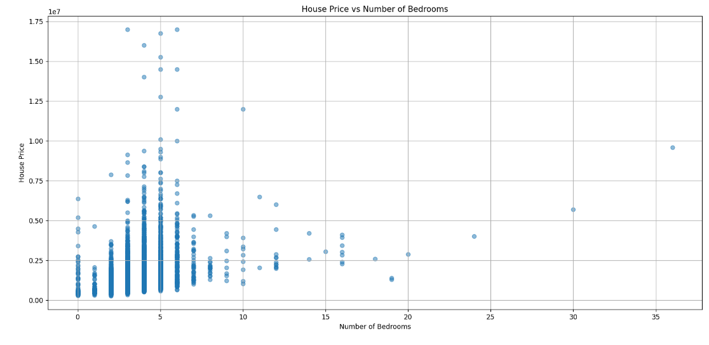
Classification
For the classification, the most difficult part is that the imbalance of the category might result in lower predictive power for minority categories. As you can see in our histogram, the “house” category is overrepresented, with other categories accounting for less than half of the total. Models will tend to always predict ‘House’, resulting in overall performance that seems high but is useless for a small number of categories. To handle the imbalance, I used the weighted F1-score as the evaluation metric and XGBoost Classifier, which performs better under imbalance.
Perhaps the introduction of more sub-categories of data or the introduction of regional property type distribution data might help to make the forecasts more accurate and usable.
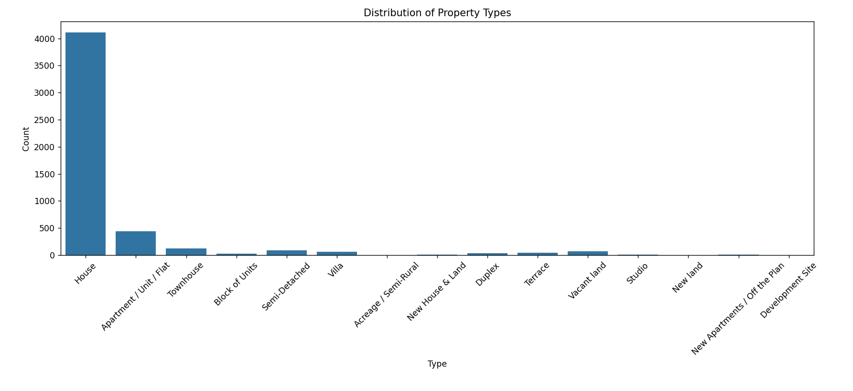
- Incorporating Temporal Features
In the pre-processing stage, I convert the date_sold field to the time feature year_sold, month_sold, season, day_of_week, weekend, quarter.
As we can see from the line graph below, property prices are different from year to year, so it's clear that time of year has an impact on property prices. For example, between 2021 and 2022, prices reached its peak and fell sharply at the end of the year, possibly due to the impact of Covid. 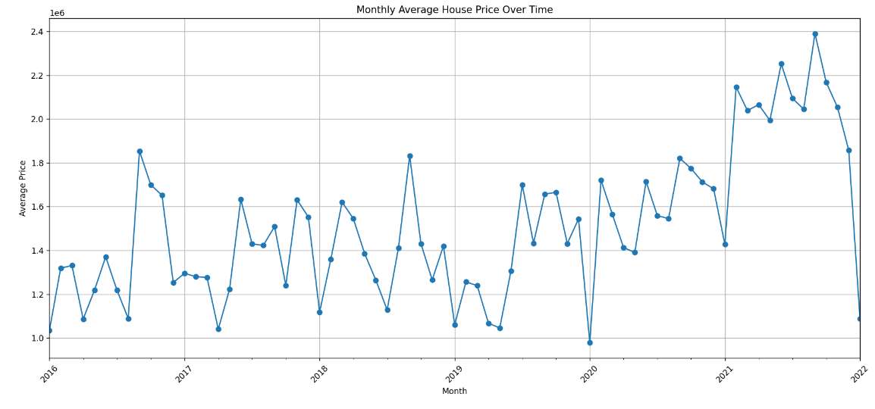
At the same time, I also calculated the average price of houses in different seasons and found that the price of rooms in spring is the highest (about 1.75e6 AUD) and the lowest in autumn (about 1.5e6 AUD). Not only the year, but also the price in each season is affected by the market trend and seasonal pattern.
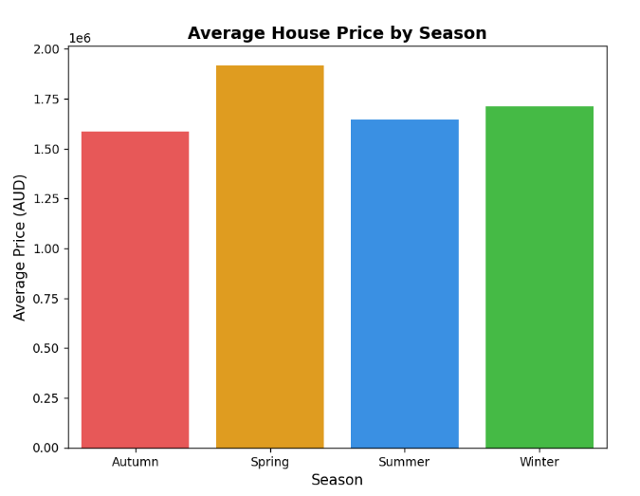
For integrating date-related features, I believe there are several ways to compare rolling averages over the past three or six months, such as average prices or use the Lag features which is the average price or number of sales for the previous month in the same suburb.
- Evaluation Metrics
Regression
I think MAE is chosen as the assessment indicator because it is not sensitive to extreme values. As the change in housing prices varies greatly across districts, it is a high variance data.
Classification
I think the reason for choosing F1 Score is because when the data is unbalanced, due to the unbalance of type categories in the data, for example, House appears very much, F1 can take care of both precision and recall, preventing the prediction of only large categories. When using weighted F1, it can balance the contribution of each type.
In terms of model selection, I tried to use three different models, LightGBM, RandomForest, and XGBoost. Firstly, the LightGBM model this model have warning, and the F1score is only 0.87, so I gave up use it , and then I switched to the RandomForest model, which is more stable but not easy to control the over-simulation, but even after adjusting the parameter, it could not reach the standard required by the teacher, so I switched to the third method, which is also the one that I chose in the end, which has higher accuracy and can handle a large number of features. It has higher accuracy, can handle a large number of features, and has some tolerance for missing values and anomalies, which makes it the best of the bunch. Basically, its MAE stays below 310000, and its F1 score reaches 0.89 or above. Although it has the disadvantage of high randomness, I have tried to use random_state=42 and n_job=1 to reduce the variation.

