COMP9334 Capacity Planning of Computer Systems and Networks
Assignment Part B
Student name: Chiayi Chang zid:Z5467129
Question B1
(a) Derive the conditional probability that there are 4 customers in the call centre at time (t+∆t) given that there are 5 customers in the call centre at time t. You should express the conditional probability in terms of µ, ν and ∆t.
Answer:
There are some situation that might lead to 5 customers becoming 4 customers:
1.If one operator finishes and leaves
One operator’s mean service time is 1/μ, so the service rate is 1/(1/μ) which is μ. In this question, we have 2 operators. The possibility of finishing the service is μ*∆t of each of them, so the total possibility is 2*μ*∆t.
2. if one customer decides to hang up (only happen in 2 or 3 queue position)
The possible hanging up the phone at slot 2 and 3 is the same which is ν*∆t, and there are two positions in the queue that can hang up the phone. Therefore, the total possibility is 2ν*∆t.
Therefore, the conditional probability is
P(N(t+∆t) = 4∣ N(t)=5 ) = 2*μ*∆t +2ν*∆t = (2μ+2ν) ∆t
(b) Formulate a continuous-time Markov chain for the call centre. Your formulation should include the definition of the states and the transition rates between states. The transition rates should be expressed in terms λ, µ and ν.
Answer:
There are six states in the system
State 0: there are no courses in the system
State 1: there is one call in the operator
State 2: there are two calls in the operator
State 3: there are two calls in the operator and one waiting in slot 1
State 4: there are two calls in the operator and two waiting in slot 1 and slot2
State 5: there are two calls in the operator and two waiting in slot 1, slot2 and slot3
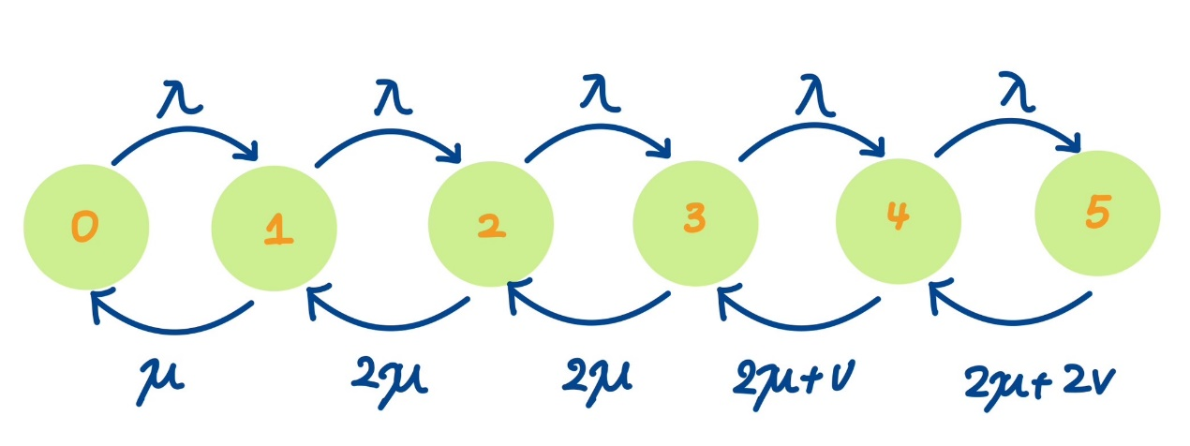
(c) Write down the balance equations for the continuous-time Markov chain that you have formulated.
Answer:
λ *P0 = µ*P1
(µ + λ) *P1= λ*P0 + 2*µ*P2
(2*µ + λ) *P2 = λ*P1 + 2*µ*P3
(2*µ + λ) *P3 = λ*P2 + (2*µ + v) *P4
(2*µ + v + λ) *P4 = λ*P3 + (2*µ + 2v) *P5
(2*µ + 2v) *P5 = λ*P4
P0 + P1 + P2 + P3 + P4 + P5 =1
(d) Assuming λ = 4.3 and µ = 2.9 and ν = 0.8
(i) Compute the steady state probabilities of the states of the continuous-time Markov chain that you have formulated in Part 3.
Answer:
The possibility of the states is (Round five decimal places):
P0 = 0.19097
P1 = 0.28316
P2 = 0.20993
P3 = 0.15563
P4 = 0.10140
P5 = 0.05892
Specific calculation methods are as follows
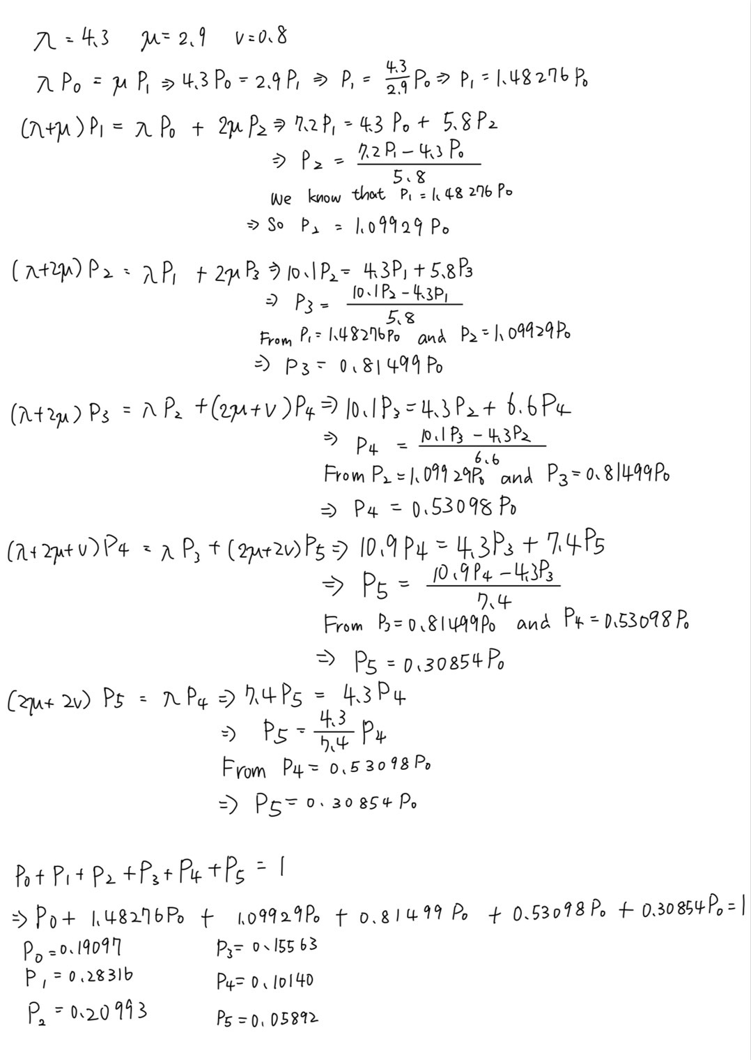
(ii) Compute the probability that an arriving request will be rejected.
Answer:
The probability of requesting will be rejected means that the whole system is full, which is the state5. Therefore, the answer is P5 = 0.05892.
(iii) Compute the throughput of the call centre.
Answer:
According to the characteristics of the continuous time Markov chain, the throughput can be calculated by the total rate of service completed in each state of the system which is
0*P0​+ μ*P1 ​+ 2μ*(P2​+P3​+P4​+P5​)
= 2.9*0.28316 + 2*2.9*(0.20993+0.15563+0.10140+0.05892)
= 0.821164 + 3.050104
= 3.871268
(iv) Compute the mean response time of the call centre.
Answer:
From the little’s law, we know that the mean response time can be solved by using average customers to divide the throughput
L is the average customer
$$L=\sum_{i=0}^{5}{ip_{i}}$$
L = 0*P0​ + 1*P1 ​+ 2*P2​ + 3*P3​ + 4*P4 ​+ 5*P5​
L = 1*0.28316 + 2*0.20993 + 3*0.15563 + 4 *0.10140 + 5 *0.05892
L = 1.87011
So, the mean response time might be 1.87011/3.871268 = 0.483074 hr.

Question B2
(a) The system described above can be modelled by a continuous-time Markov chain whose state is a 4-tuple (n1, n2, q1, q2) where
• n1 = number of Type 1 requests in the processing units,
• n2 = number of Type 2 requests in the processing units,
• q1 = number of requests in the Type 1 queueing slot, and
• q2 = number of requests in the Type 2 queueing slot.
Note that not all values of n1, n2, q1 and q2 result in a valid state of the system. For example:
• The 4-tuple (0, 0, 0, 0) is a valid state and it represents the state where all the processing units and queues are empty.
• The 4-tuple (1, 1, 0, 1) is a valid state and it represents the state of the system at time t3 in Figure 2.
• The 4-tuple (3, 0, 1, 0) is an invalid state because you cannot have an idle processing unit while there is a request in the Type 1 queue.
• The 4-tuple state (3, 0, 0, 2) is an invalid state because there is only 1 queueing slot. Your task is to list all valid states for this Markov chain.
Answer:
From the question, we know that there are 4 processing units, 1slot only for Type1 and 1 slot only for type 2.
There are some Rules we should follows:
N1: 0 ≤ n1 ​≤ 4
N2: 0 ≤ n2 ​≤ 2
Q1: q1​ = 0 or 1
Q2: q2 = 0 or 1
There are only 4 processing units so n1 ​+ 2*n2​ ≤ 4
And also, when q1 = 1, n1 + n2 = 4
when q2 = 1, n1 + n2 >= 3
Following the rules we get the result:
Effective Status | Processing unit | Slot
- (0,0,0,0) | 0 user | 0 waiting
- (1,0,0,0) | 1Type1 is using | 0 waiting
- (2,0,0,0) | 2 Type1 is using | 0 waiting
- (3,0,0,0) | 3 Type1 is using | 0 waiting
- (4,0,0,0) | 4 Type1 is using | 0 waiting
- (3,0,0,1) | 3 Type1 is using | 1 Type2 is waiting
- (4,0,0,1) | 4 Type1 is using | 1 Type2 is waiting
- (4,0,1,0) | 4 Type1 is using | 1 Type1 is waiting
- (4,0,1,1) | 4 Type1 is using | 1 Type1 and 1 Type2 is waiting
- (0,1,0,0) | 1 Type2 is using | 0 waiting
- (1,1,0,0) | 1 Type1 and 1 Type2 is using | 0 waiting
- (2,1,0,0) | 2 Type1 and 1 Type2 is using | 0 waiting
- (1,1,0,1) | 1 Type1 and 1 Type2 is using | 1 Type2 is waiting
- (2,1,0,1) | 2 Type1 and 1 Type2 is using | 1 Type2 is waiting
- (2,1,1,0) | 2 Type1 and 1 Type2 is using | 1 Type1 is waiting
- (2,1,1,1) | 2 Type1 and 1 Type2 is using | 1 Type1 and 1 Type2 is waiting
- (0,2,0,) | 2 Type2 is using | 0 waiting
- (0,2,0,1) | 2 Type2 is using | 1 Type2 is waiting
- (0,2,1,0) | 2 Type2 is using | 1 Type1 is waiting
- (0,2,1,1) | 2 Type2 is using | 1 Type1 and 1 Type2 is waiting

(b) Your task for this part is to draw the part of the state transition diagram around the state (2, 1, 0, 1). The requirements are that your drawing must include:
• The state (2, 1, 0, 1);
• All states that can transition into (2, 1, 0, 1) as well as the arcs from these states into (2, 1, 0, 1);
• All state that the state (2, 1, 0, 1) can transition out of as well as the arcs from (2, 1, 0, 1) into these states;
• The state transition rate of the arcs that you have included. You can express the transition rates in terms of λ1, λ2, µ1 and µ2.
Answer:
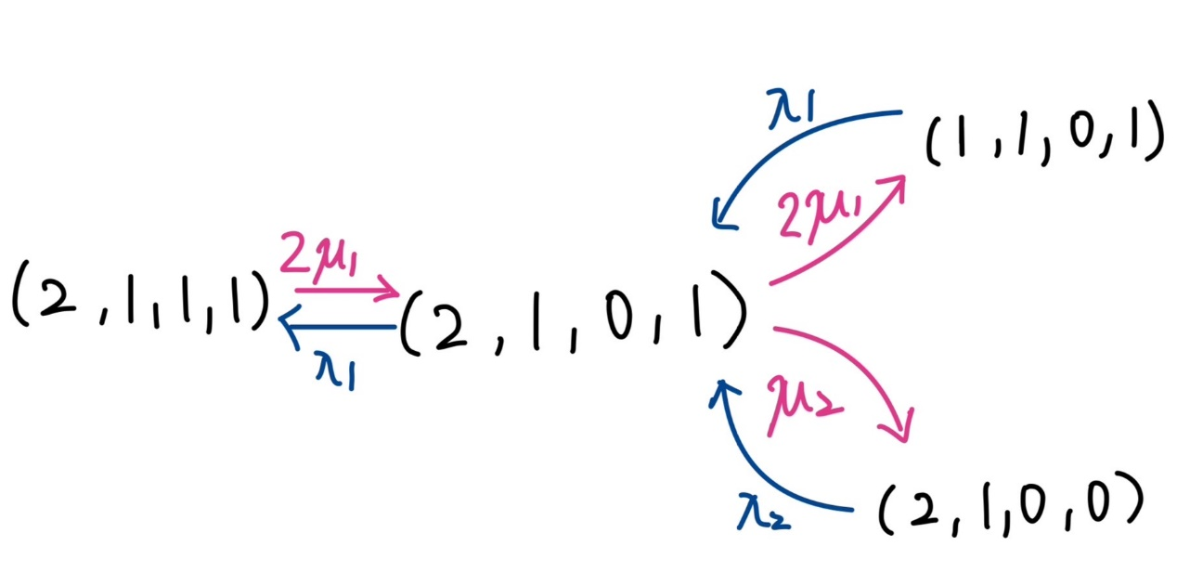
(c) Let P(n1, n2, q1, q2) denotes the steady state probability of the state (n1, n2, q1, q2). For example, for the state (1, 1, 0, 1), the steady state probability in this state is denoted by P(1, 1, 0, 1).
You should express your answer in terms of the appropriate P(n1, n2, q1, q2). For example, you may claim that the required probability is given by P(0, 0, 0, 0) + P(0, 1, 0, 0) and explain why; note that this example is to show you what your answer may look like and the example is definitely not the correct answer.
Answer:
What is the probability that an arriving Type 1 request will be rejected?
Type 1 request will be rejected is equal to Type1 is full.
P(Type 1 request will be rejected)=P(4,0,1,0)+(4,0,1,1)+P(2,1,1,0)+P(0,2,1,0)+P(2,1,1,1)+P(0,2,1,1)

(d) This question is similar to Part (c). What is the probability that an arriving Type 2 request will be rejected?
Answer:
Type 2 request will be rejected is equal to Type2 is full.
P(Type 2 request will be rejected) = P(3,0,0,1)+P(4,0,0,1) +P(1,1,0,1)+P(2,1,0,1)+P(0,2,0,1)+P(2,1,1,1)+P(4,0,1,1)+P(0,2,1,1)

