Interactive Visualization with Plotly

Chia-Yu Wei

2023-12-15

## Learn about ‘plotly’

# install.packages('plotly')  
library(ggplot2)  
library(plotly)

##   
## 載入套件：'plotly'

## 下列物件被遮斷自 'package:ggplot2':  
##   
## last_plot

## 下列物件被遮斷自 'package:stats':  
##   
## filter

## 下列物件被遮斷自 'package:graphics':  
##   
## layout

pl <- ggplot(mtcars, aes(mpg, wt)) + geom_point()  
print(pl)

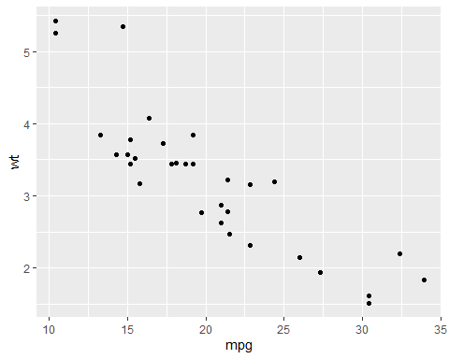

### We can use plotly to interact with the data and graph.

It’s a really cool tool.

gpl <- ggplotly(pl)  
print(gpl)

### We can find the documentation example graph and code from the [link](https://plotly.com/ggplot2/)

#https://plot.ly/ggplot2/