Chapter 4
This chapter presents the results of the analysis of the nutritional status and dietary patterns of adolescent girls in rural and urban areas. The findings are organized into four main sections based on the specific objectives: sociodemographic status, prevalence of malnutrition, dietary intake, and factors affecting dietary habits.
4.1 Specific Objective 1: Sociodemographic Status
The sociodemographic characteristics of the respondents are presented in the following figures.
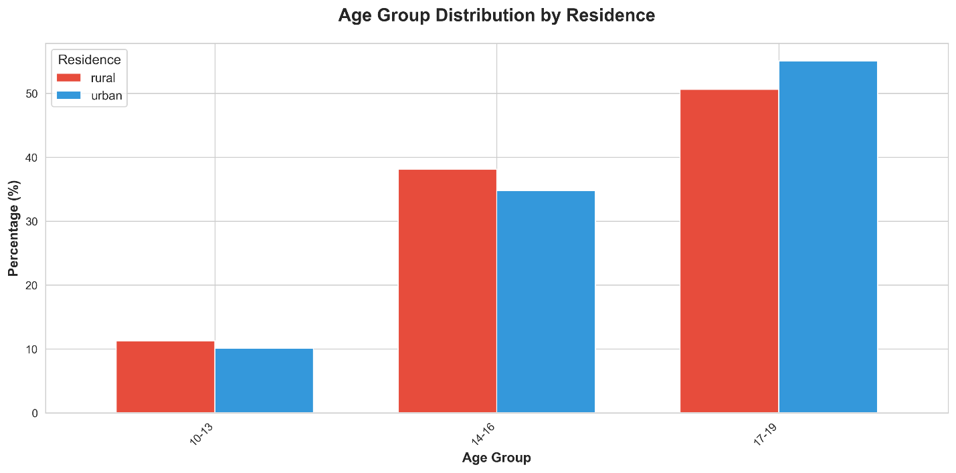
Figure 1: Age Distribution of Respondents
The age distribution shows that most of the respondents were in the 17-19 years age group (53.1%), followed by 14-16 years (36.2%). A similar trend was observed in both urban (55.1%) and rural (50.6%) areas.
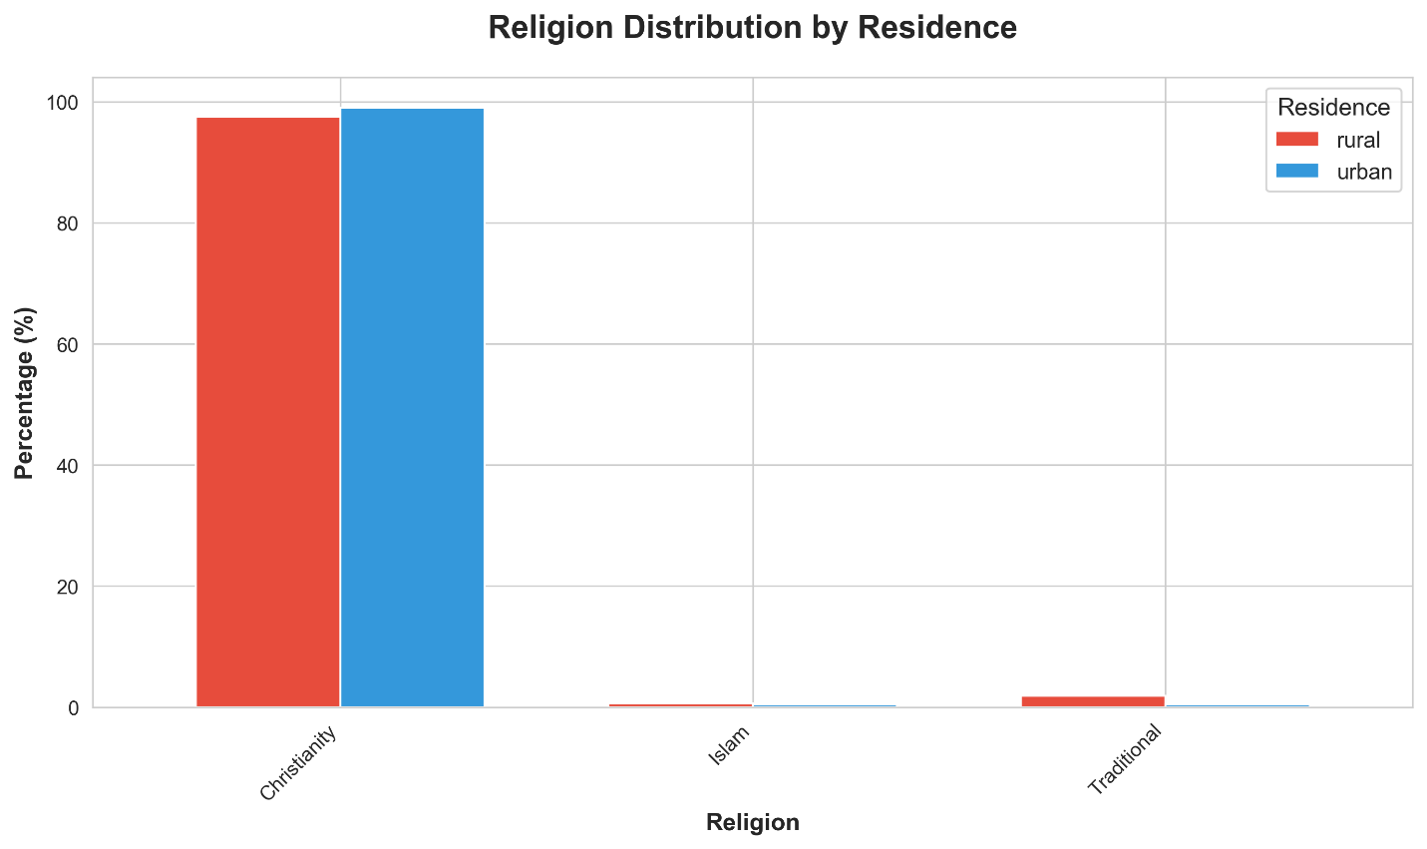
Figure 2: Religious Distribution
Most of the respondents were Christians (98.4%), with very few practicing Traditional religion (1.1%) or Islam (0.5%). This distribution was consistent across both urban and rural settings.

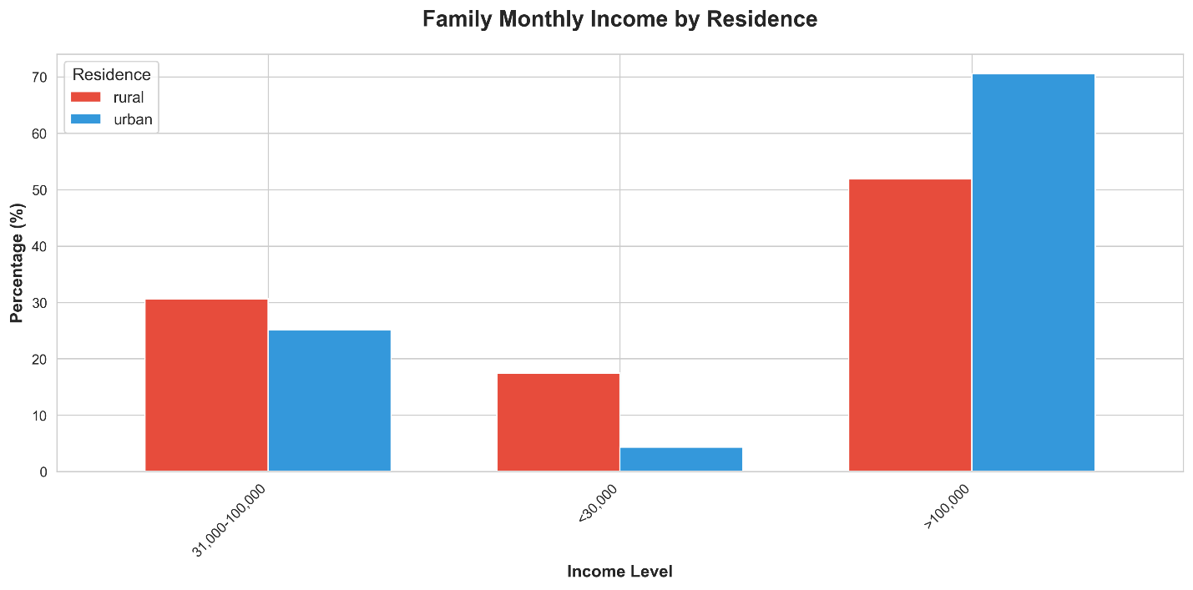Figure 3: Family Monthly Income
There was a notable difference in the monthly family income. Overall, 62.4% of families earned above 100,000 Naira. However, this was higher in urban areas (70.5%) compared to rural areas (51.9%), indicating a higher economic status among urban families.
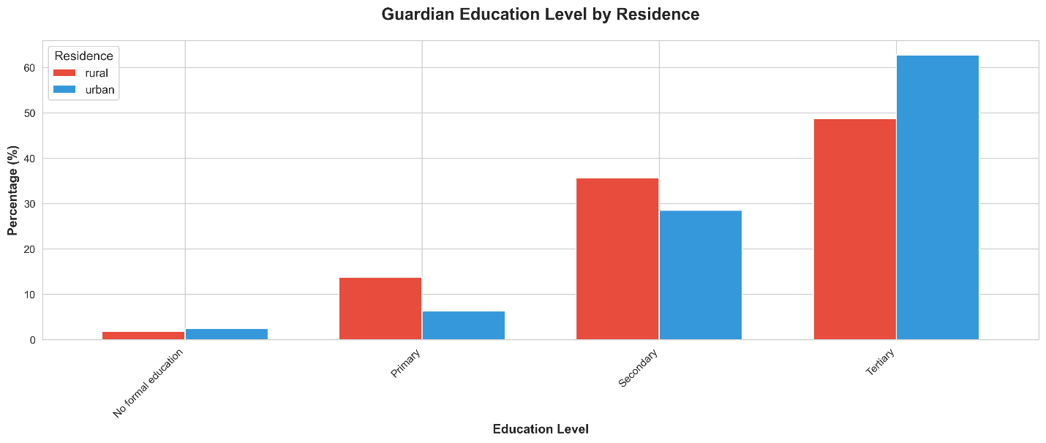Figure 4: Guardian Education Level
Regarding guardian education, 56.7% of guardians had tertiary education. This was more prevalent in urban areas (62.8%) compared to rural areas (48.8%), suggesting higher educational attainment among urban guardians.
4.2 Specific Objective 2: Prevalence of Malnutrition
The anthropometric status of adolescents was assessed to determine the prevalence of malnutrition.
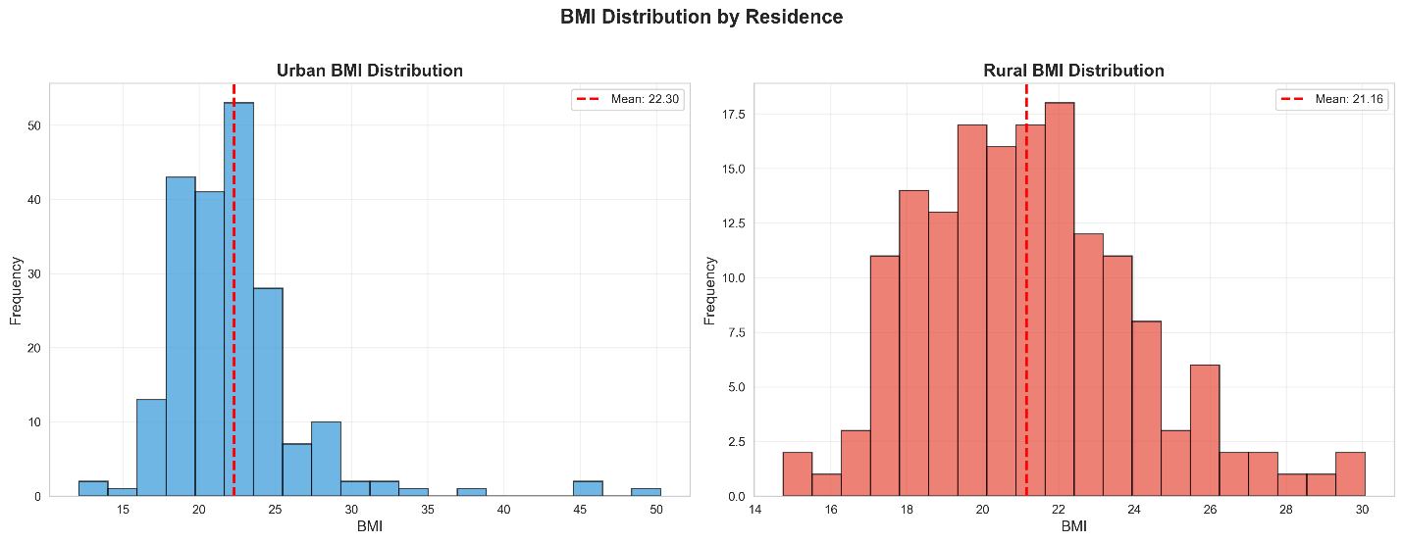Figure 5: BMI Distribution
The distribution of Body Mass Index (BMI) shows the spread of nutritional status among the girls. The mean BMI for the urban population was significantly higher (22.30 kg/m²) compared to the rural population (21.16 kg/m²).
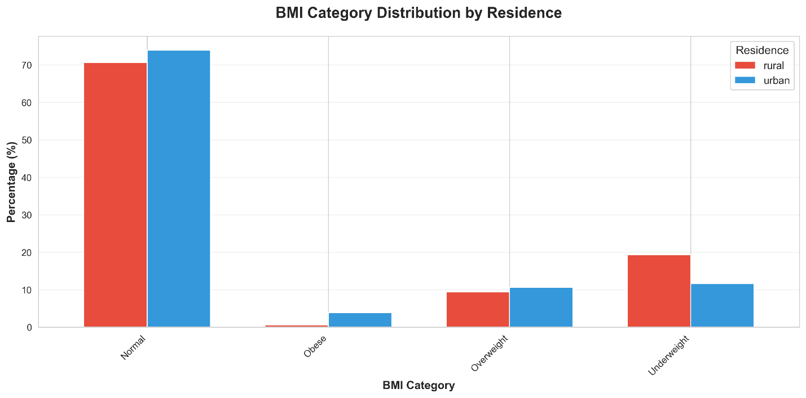Figure 6: BMI Categories
The classification of BMI into categories reveals the prevalence of underweight, normal weight, overweight, and obesity. The chart indicates a higher tendency towards overweight and obesity in the urban area, while the rural area has a higher proportion of normal weight and underweight individuals.

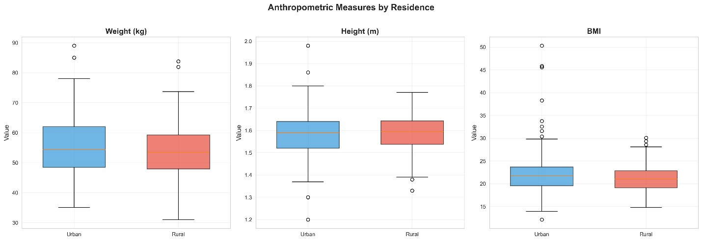Figure 7: Anthropometric Measurements (Boxplots)
The boxplots provide a comparative view of weight, height, and BMI. While height was similar between the two groups (Urban: 1.58m, Rural: 1.59m), weight and BMI showed greater variation, with urban girls generally having higher values.
4.3 Specific Objective 3: Dietary Intake
Dietary intake was assessed using dietary diversity scores and food group consumption patterns.
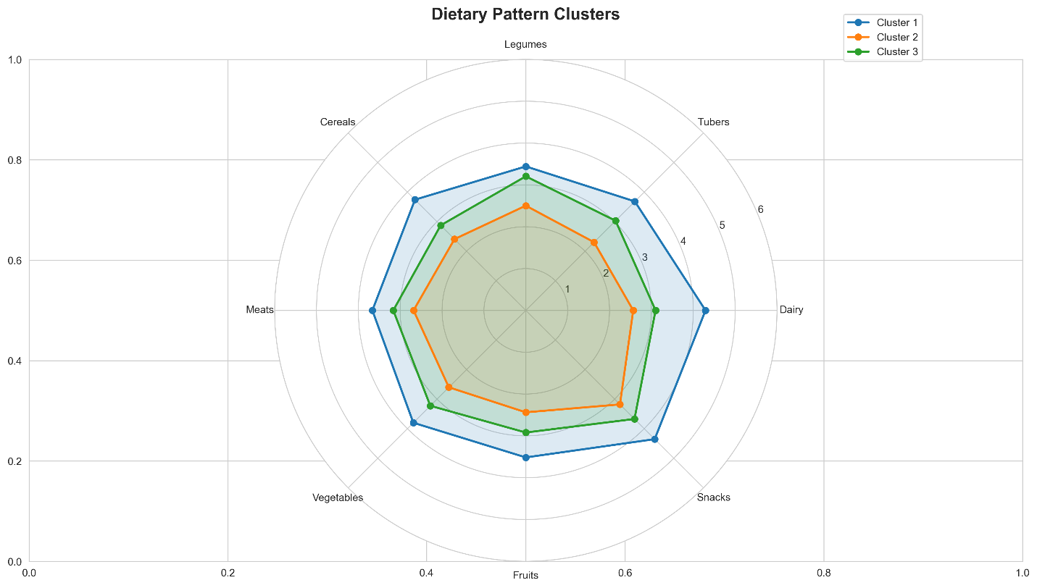Figure 8: Dietary Patterns (Cluster Profiles)
Cluster analysis identified three distinct dietary patterns among the population:
1. Cluster 1 "Modern/Affluent Diet" (17.3%): Characterized by high consumption of all food groups, particularly Snacks (4.35), Dairy (4.29), and Fruits. This cluster is predominantly Urban (80.6%), reflecting a diet rich in variety but also high in processed foods.
2. Cluster 2 "Limited Diet" (21.7%): Characterized by the lowest consumption frequency across all food groups. This cluster is predominantly Rural (59.0%), indicating potential food insecurity or limited access to diverse foods.
3. Cluster 3 "Average/Mixed Diet" (61.0%): The largest group with moderate consumption of all food groups. It is balanced but slightly more Urban (56.6%).

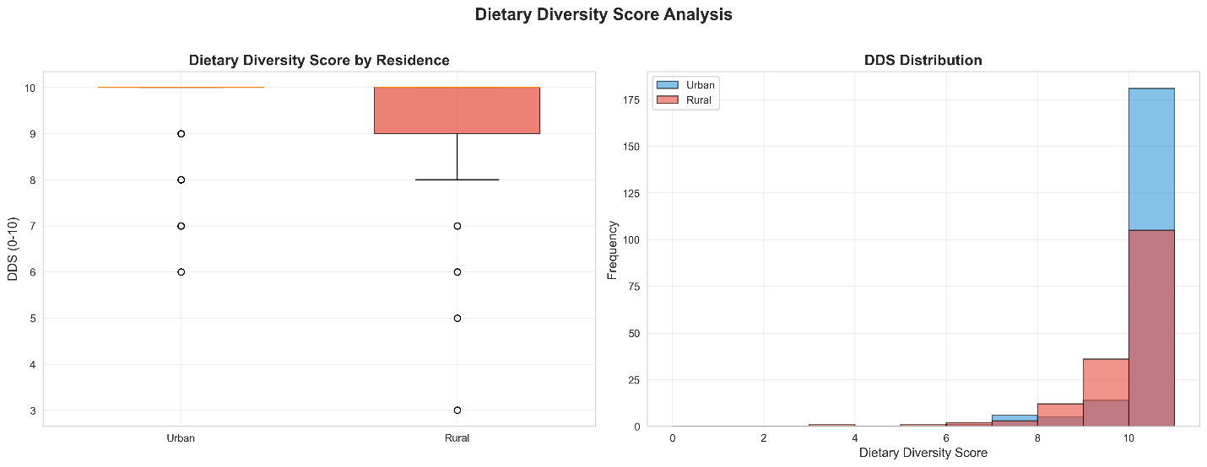Figure 9: Dietary Diversity Score Analysis
The Dietary Diversity Score (DDS) analysis highlights the variety of foods consumed. Urban girls had a higher mean DDS compared to rural girls, indicating a more diverse diet.
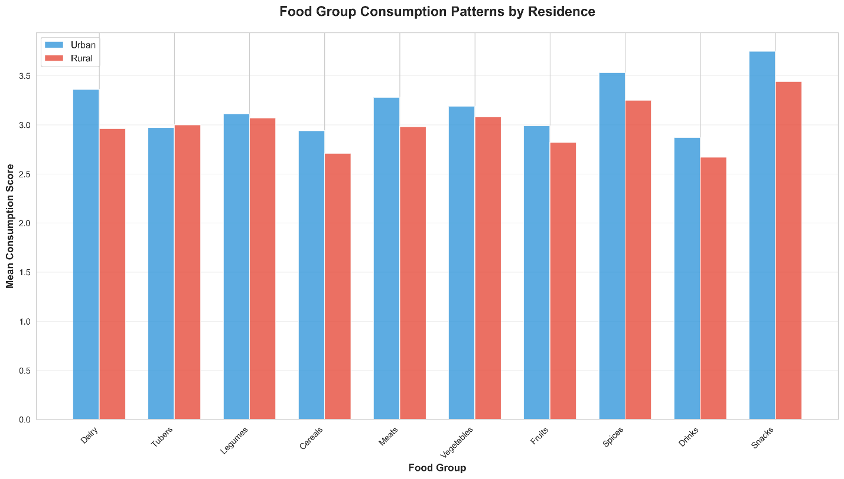Figure 10: Food Group Consumption
Consumption of specific food groups varies. Urban girls had higher mean consumption scores for Snacks (3.75 vs 3.44) and Dairy (3.36 vs 2.96), while rural girls had slightly higher consumption of Tubers (3.00 vs 2.97).
4.4 Specific Objective 4: Factors Affecting Dietary Habits
Various factors influencing dietary habits were identified, along with specific eating behaviors.

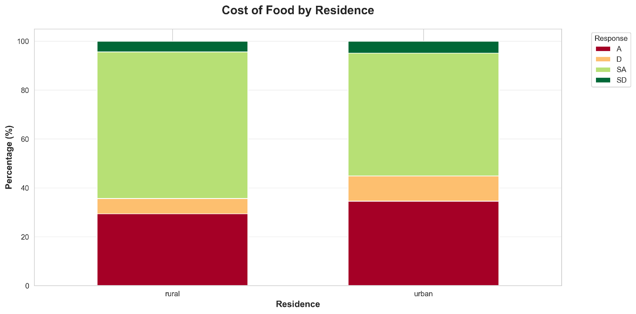Figure 11: Influence of Cost of Food
Cost of food was a major factor, with 54.0% of respondents strongly agreeing that it affects their choices. This was more pronounced in rural areas (60.0% strongly agree) compared to urban areas (49.3%).

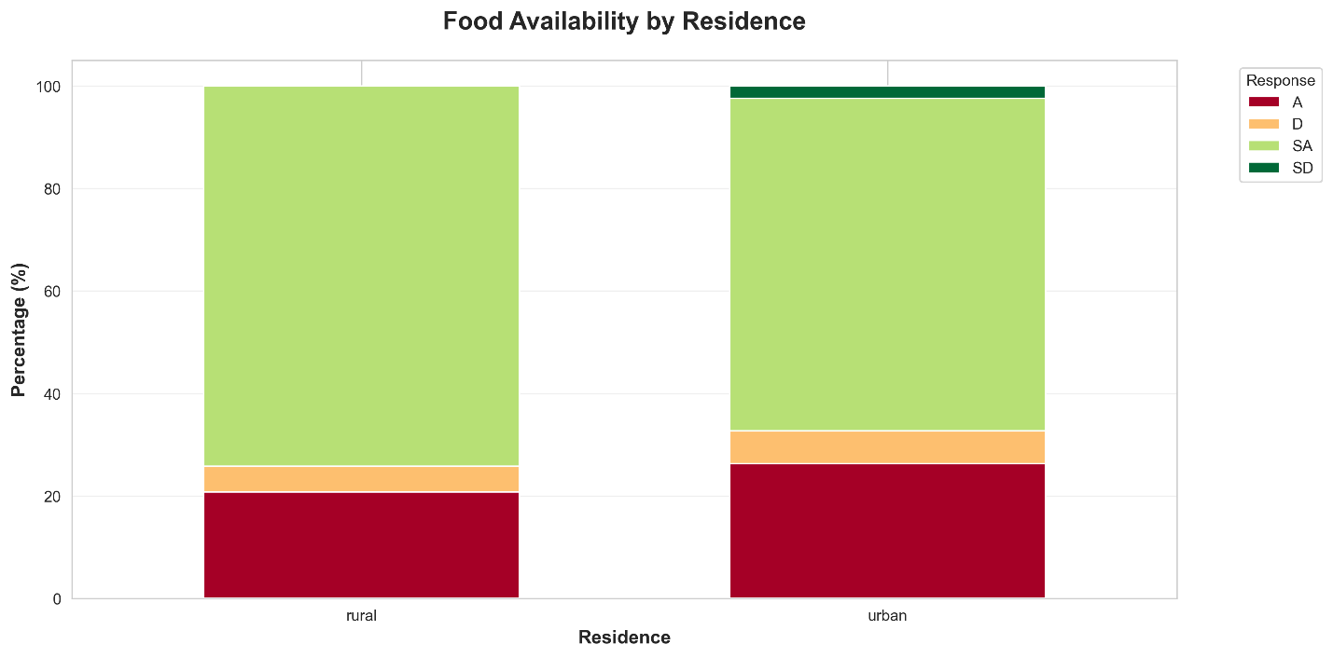Figure 12: Influence of Food Availability
Food availability also played a significant role, with 68.4% strongly agreeing. Rural respondents (73.8%) felt this more strongly than urban respondents (64.3%).

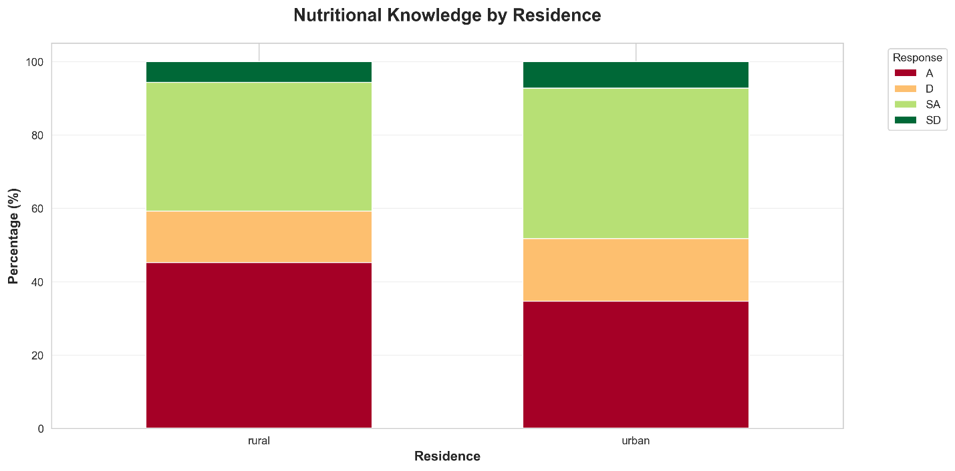Figure 13: Influence of Nutritional Knowledge
Nutritional knowledge influenced choices, with 38.7% agreeing and 37.9% strongly agreeing. The distribution was relatively similar across both groups.

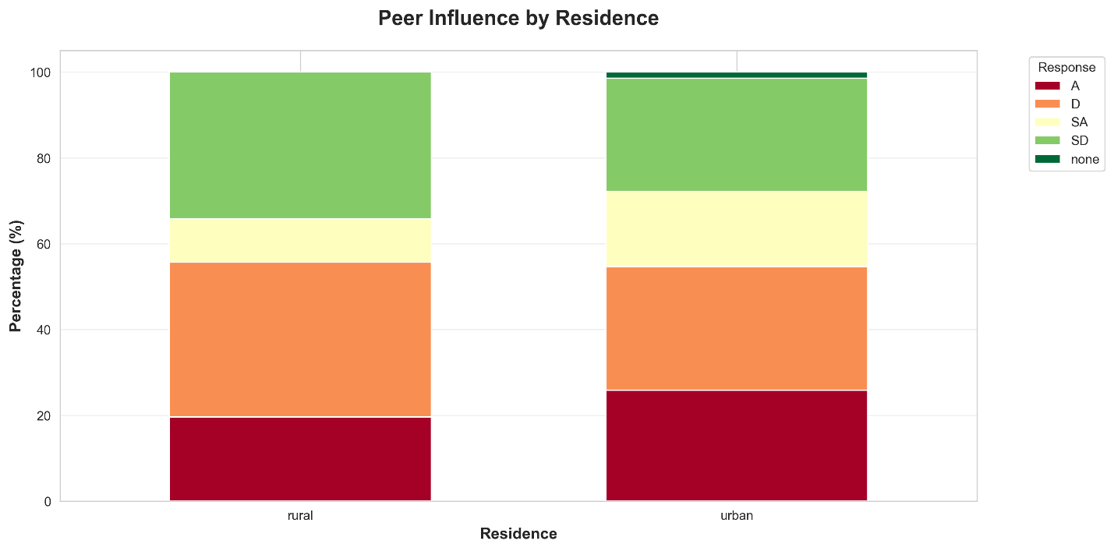Figure 14: Peer Influence
Peer influence showed mixed results. A significant portion disagreed (31.6%) or strongly disagreed (29.4%) that peers influenced their diet, though 22.9% agreed.

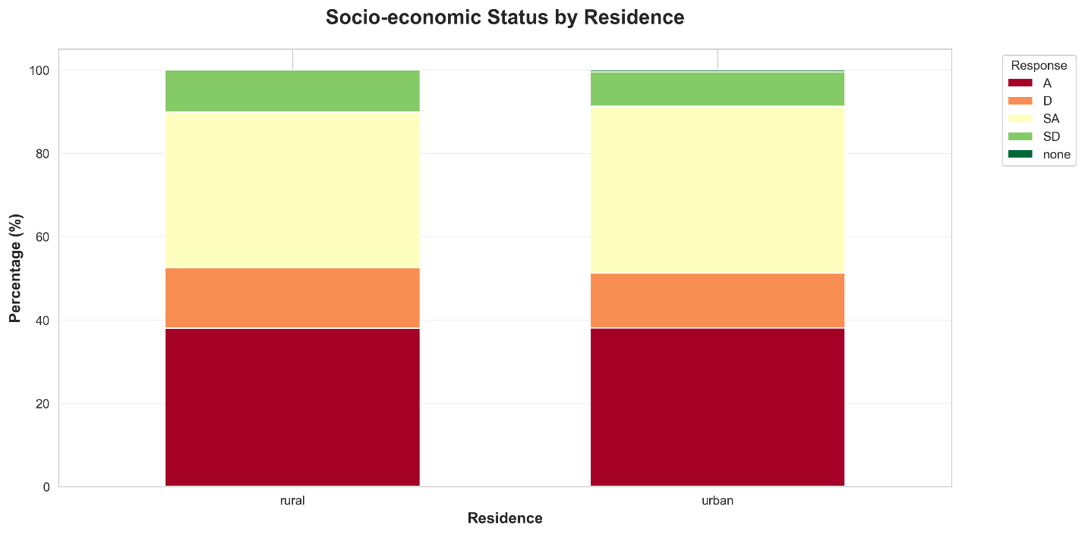Figure 15: Influence of Socio-Economic Status
Socio-economic status was acknowledged as a factor, with 38.4% strongly agreeing and 37.6% agreeing that it affects their dietary habits.

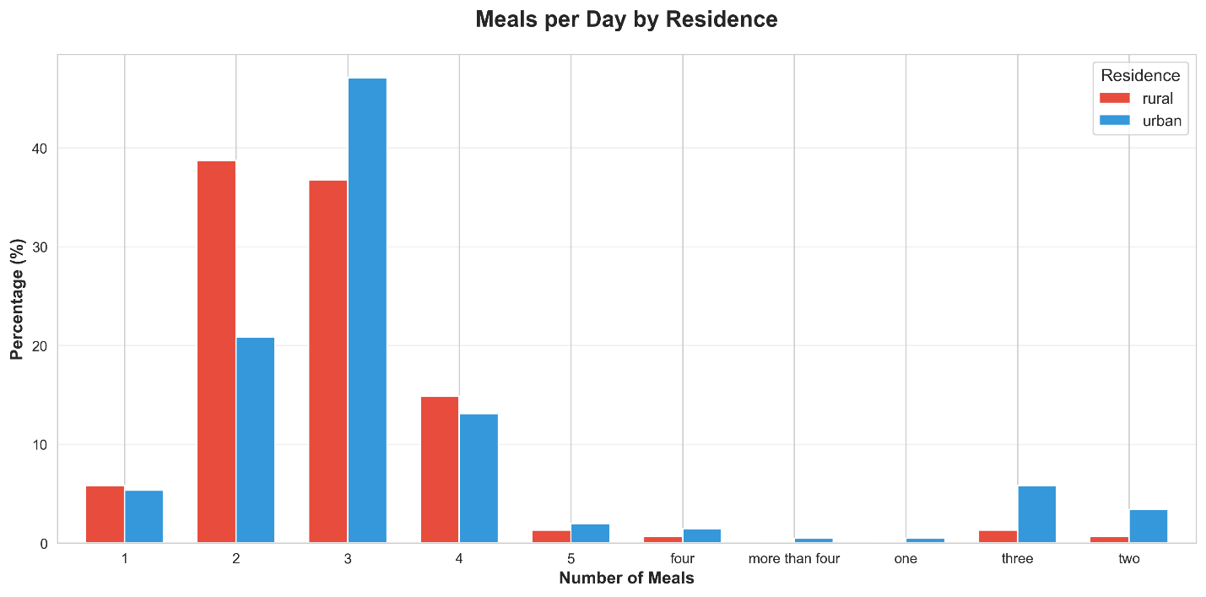Figure 16: Meals Per Day
Regarding meal frequency, 42.0% of girls consumed 3 meals per day. This practice was more common in urban areas (46.9%) than in rural areas (35.6%).

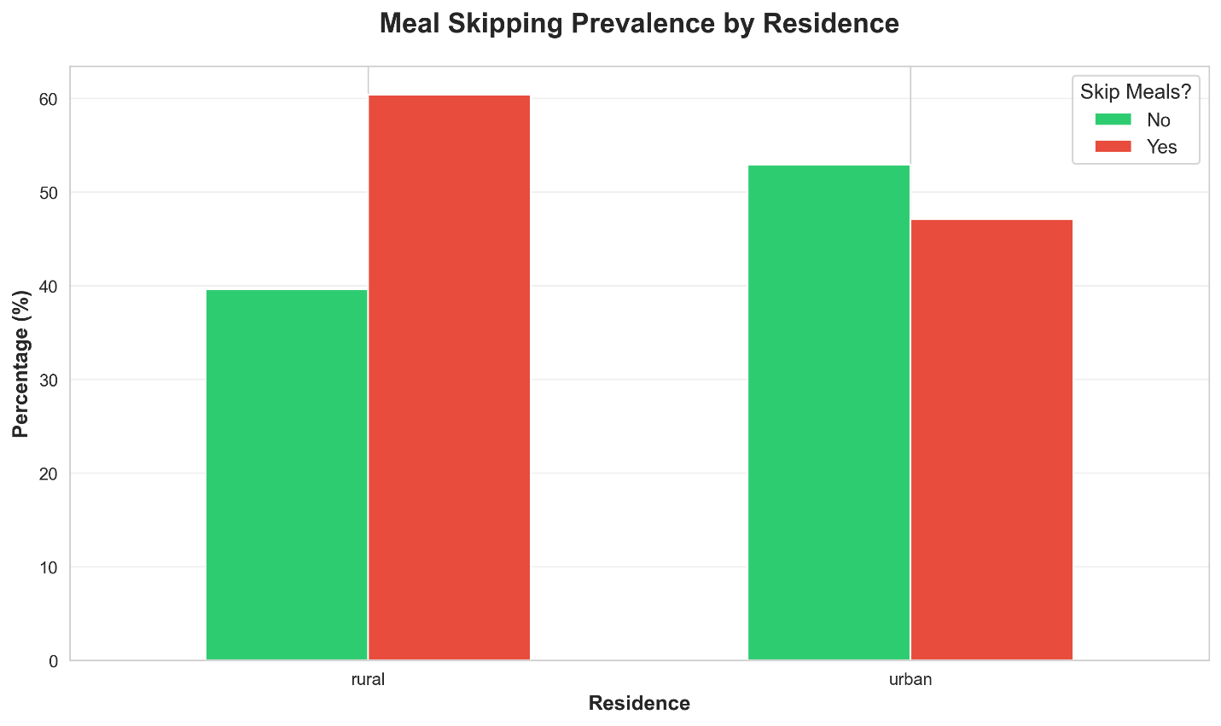Figure 17: Meal Skipping
Meal skipping was prevalent, with 51.8% of respondents reporting that they skip meals. This was higher in rural areas (58.1%) compared to urban areas (46.9%).

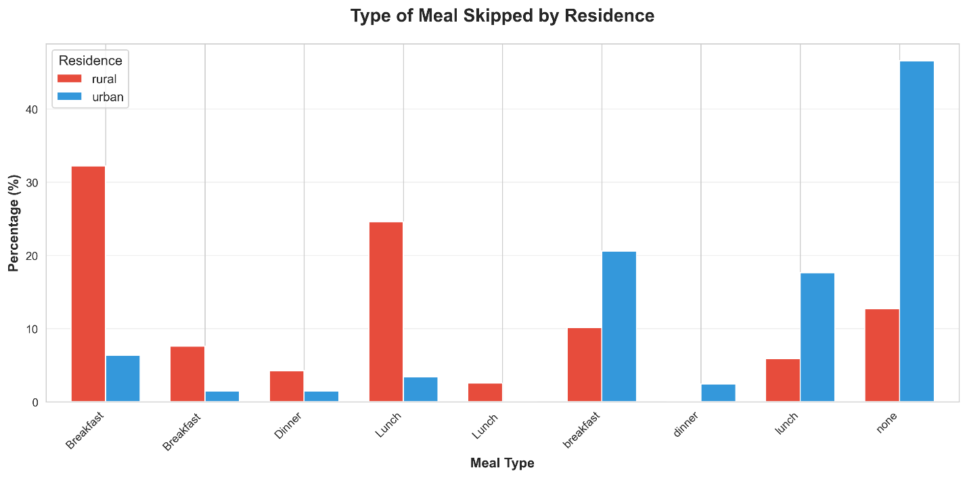Figure 18: Meal Type Skipped
Breakfast was the most frequently skipped meal.

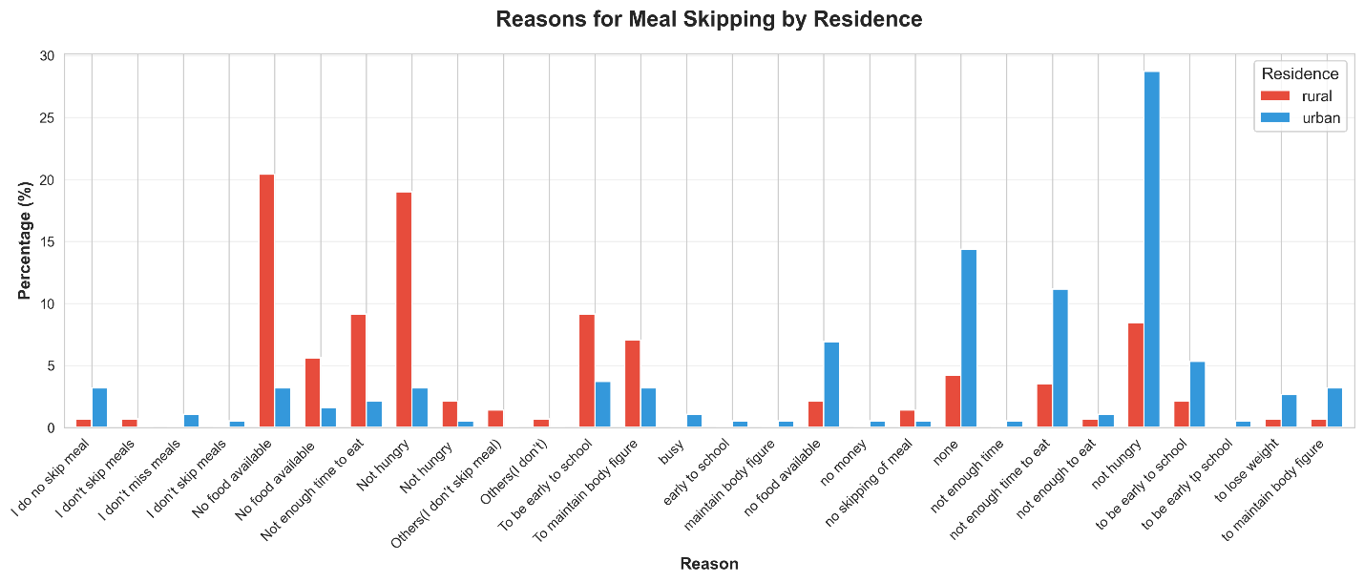Figure 19: Reasons for Skipping Meals
The primary reasons for skipping meals were "Not hungry" (18.0%) and "No food available" (9.5%). In rural areas, "No food available" was a more significant reason (18.1%) compared to urban areas (2.9%).

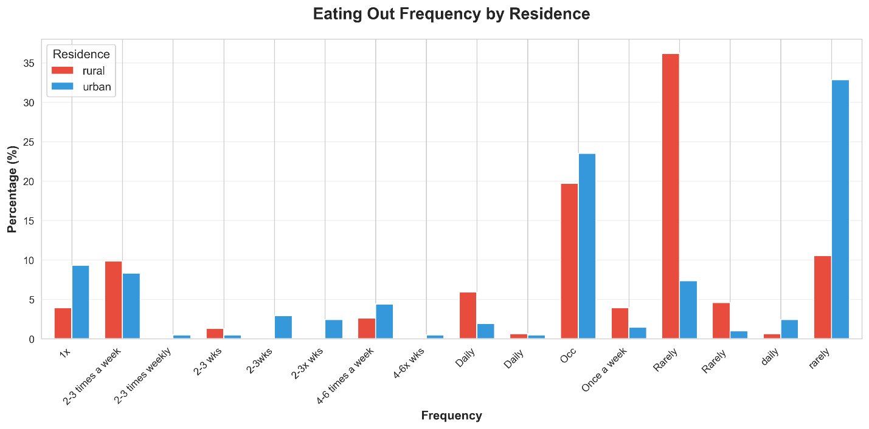Figure 20: Frequency of Eating Out
Eating out was relatively infrequent, with 22.6% doing so "rarely". However, urban girls ate out more frequently than rural girls.

Figure 21: Snack Preference
Most respondents (80.4%) stated they did not prefer snacks over main meals. However, 17.4% did prefer snacks, with a slightly higher percentage in urban areas (19.8%) compared to rural areas (14.4%).

