|  |
| --- |
|  |
| The Documentation |
| [Type the document subtitle] |
|  |
| **[Your Name]** |
| **[Pick the date]** |

[Type the abstract of the document here. The abstract is typically a short summary of the contents of the document. Type the abstract of the document here. The abstract is typically a short summary of the contents of the document.]

Table of Contents

[To update the table of contents, right click the message below and select Update Field (F9 on PC, ⌥⌘U on Mac).]

**No table of contents entries found.**

1. Pages
   1. Page Tree

Ramen  
 Log in  
 Forgot password  
 Main Home  
MASTERS  
 Customers  
 Customer New  
 Contact  
 Contact New  
 Vehicle  
 New Details  
 New Bare Rental Rates  
 New Manned Rental Rates  
 New Fluids  
 New Wheels & Tires  
 New Telematics  
 New Filters  
 New Documents  
 Employee  
 New Details  
 New Qualifications  
 New Labor Rates  
 New SalesPerson  
 New Driver Information  
 New Documents  
 Supplier  
 Supplier New  
 Service  
 Service New  
 Company  
 New Details  
 New Outbound Mail  
 New Logo  
 Country  
CRANE  
 Jobs  
 Jobs_Info  
 Jobs_Site/Maps  
 Jobs_Resources  
 Jobs_Lift  
 Jobs_Permits  
 Jobs_Notes  
 Resource Calendar  
 Service Agreement  
 Terms and conditions  
 Proposal note  
CRM  
 Prospect  
 New Prospect  
 Opportunity  
 New Opportunity  
 Engineering  
 New Inspection  
 Quote  
 New Quote  
 Add Vehicle  
 Add Service  
 Add Items Notes  
 quote Preview/PDF  
 Tracing  
 Tracing History  
 New Tracing Notes  
 Schedule  
 New Task  
FLEET  
 Fleet_Fuel  
 New Fuel Entry  
 Fleet_Work_Order  
 W/O Entry Open  
 W/O Status Completed  
 Fleet_Issues  
 New Issue Entry  
 Fleet_Service_Reminders  
 New Service Reminder Entry  
 Fleet_Renewal_Reminders  
 New Renewal Reminder Entry  
 Fleet_Documents  
 Fleet_comments  
INVENTORY  
 Items  
 Add New Item  
 Stock Adjusment  
 Stock Transfer  
 Purchase  
 Order Stock  
 Receive Stock  
 View Receive History  
 View Items On Order  
 Locations  
 Material Requisition

* 1. Ramen
     1. User Interface

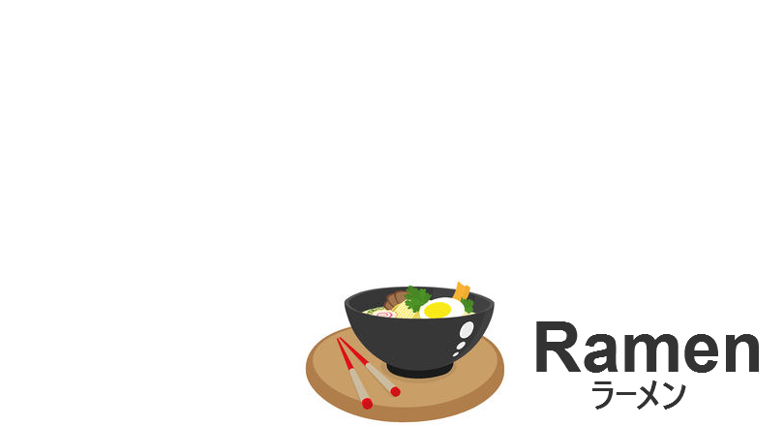

* 1. Log in
     1. User Interface

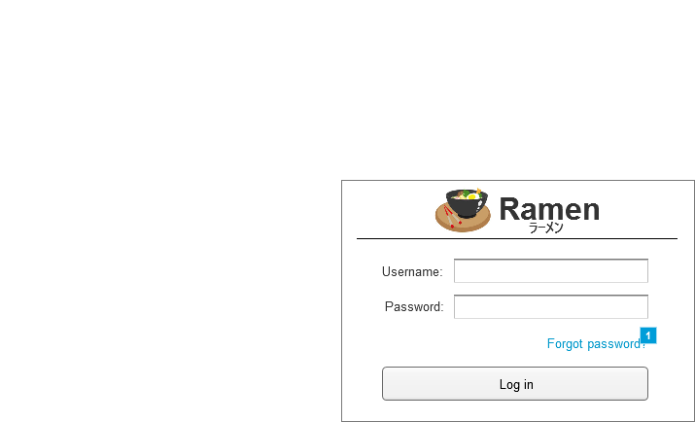

* + 1. Widget Table

|  |  |
| --- | --- |
| Footnote | Interactions |
| 1 | OnClick:  Case 1:  Open Forgot password in Current Window |

* 1. Forgot password
     1. User Interface

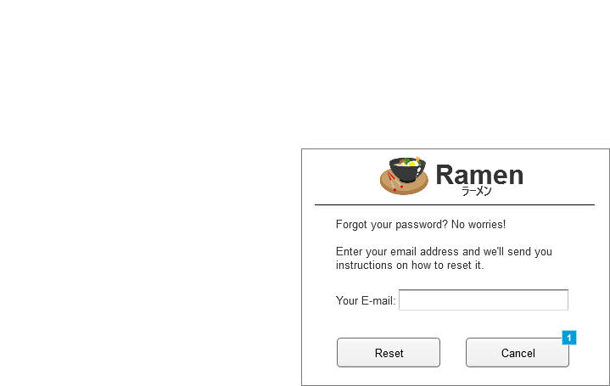

* + 1. Widget Table

|  |  |
| --- | --- |
| Footnote | Interactions |
| 1 | OnClick:  Case 1:  Open Log in in Current Window |

* 1. Main Home
     1. User Interface



* 1. Customers
     1. User Interface

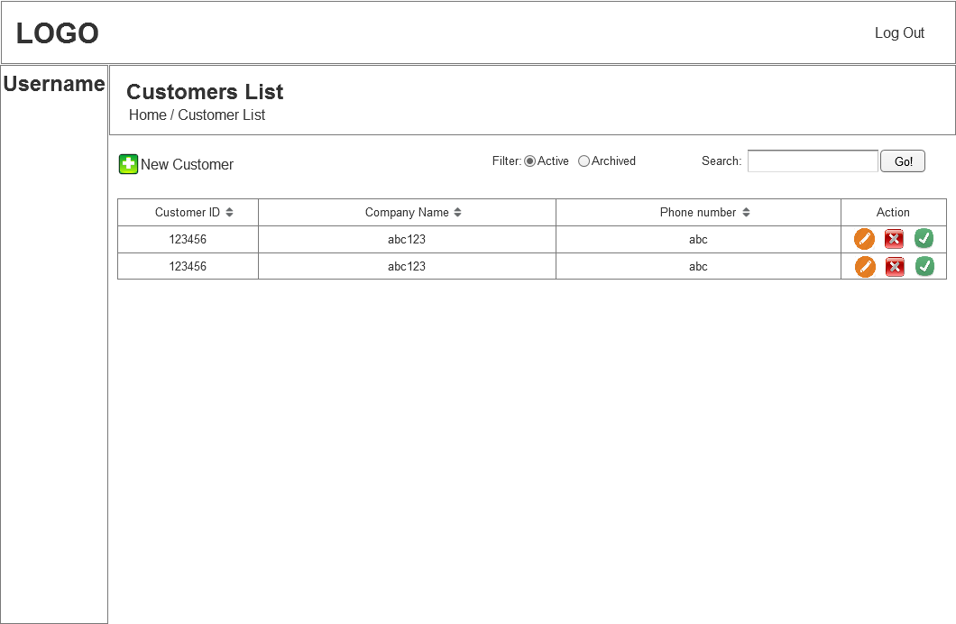

* 1. Customer New
     1. User Interface

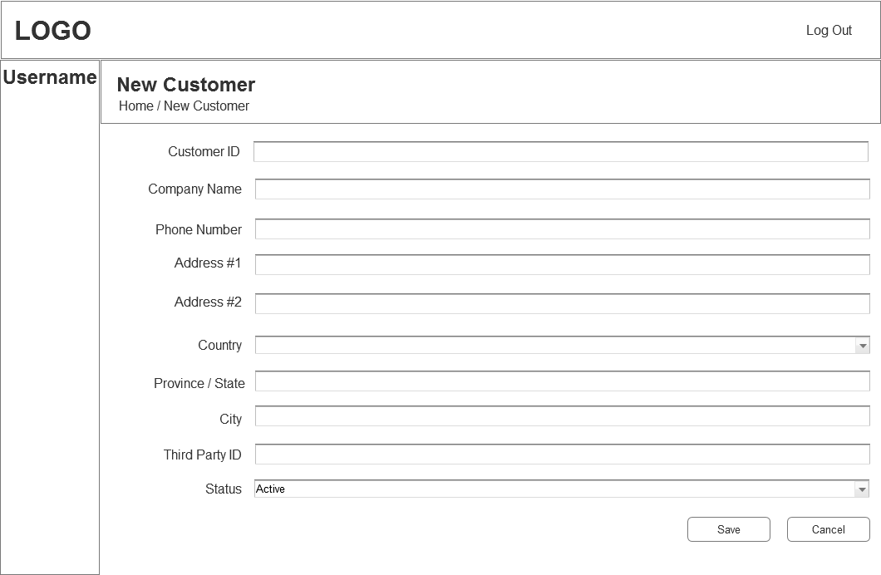

* 1. Contact
     1. User Interface

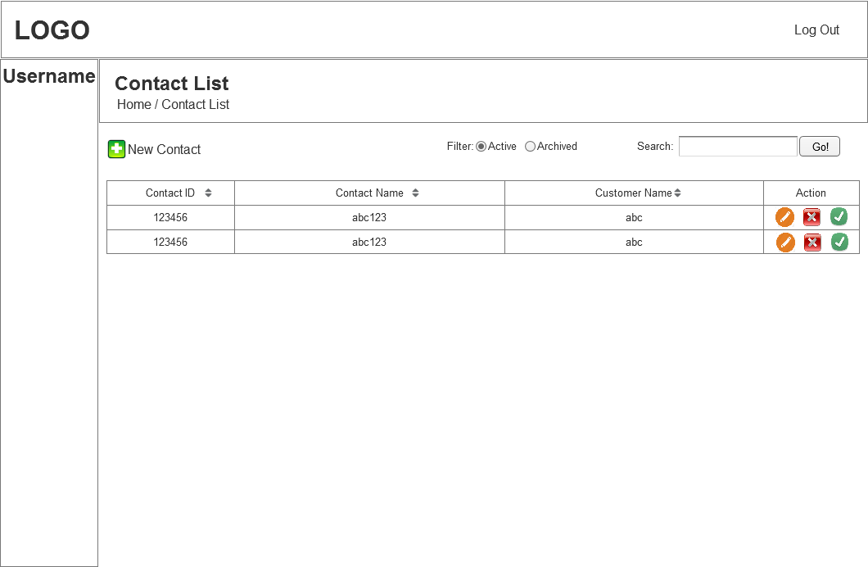

* 1. Contact New
     1. User Interface

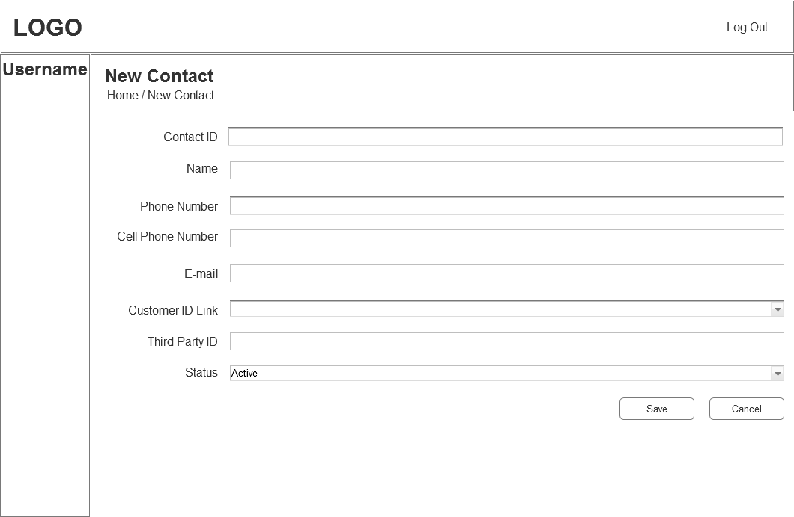

* 1. Vehicle
     1. User Interface

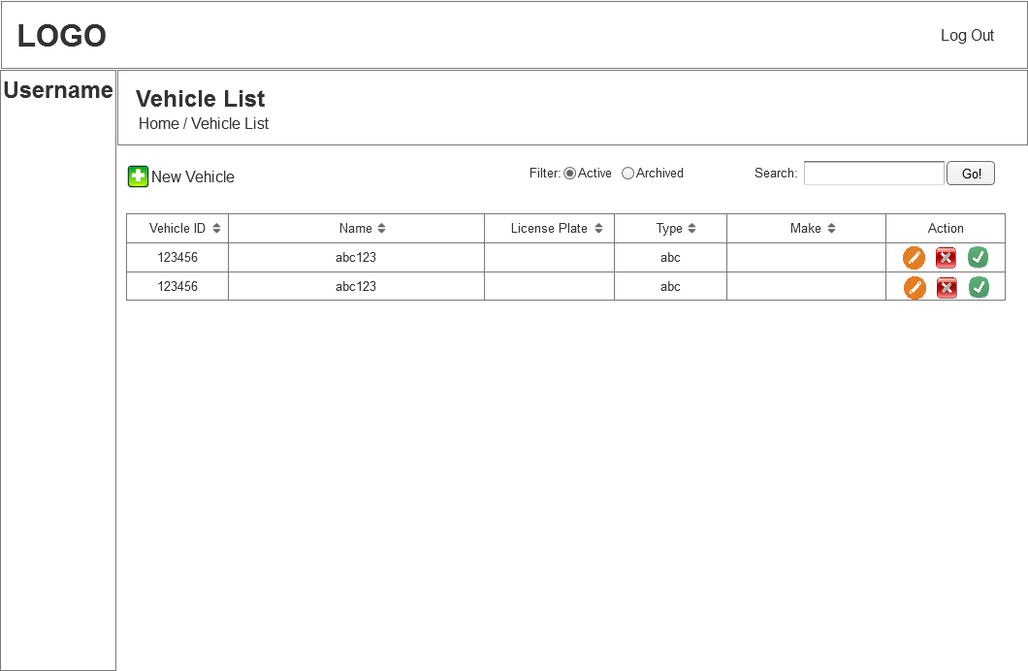

* 1. New Details
     1. User Interface

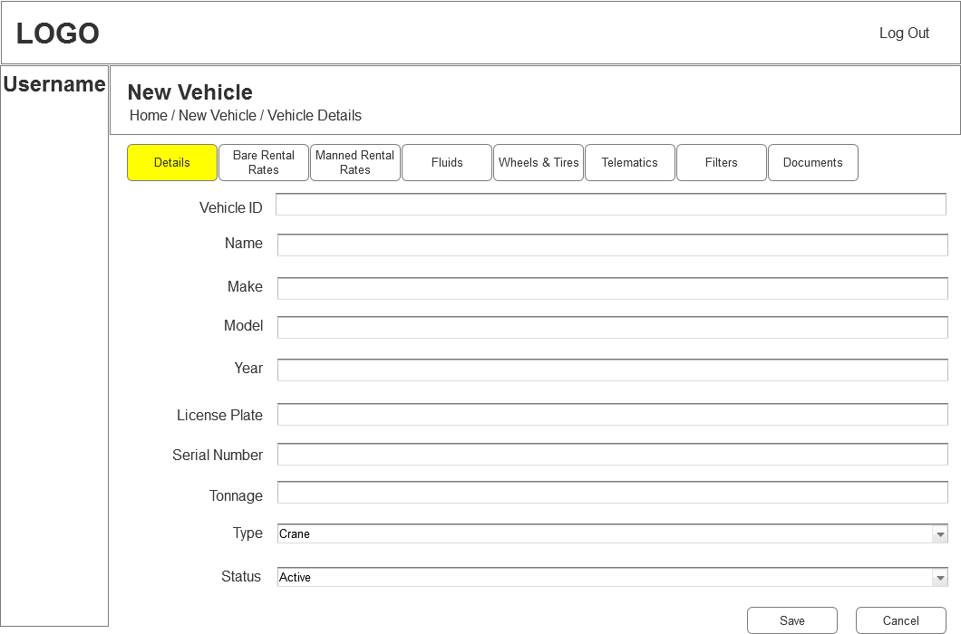

* 1. New Bare Rental Rates
     1. User Interface

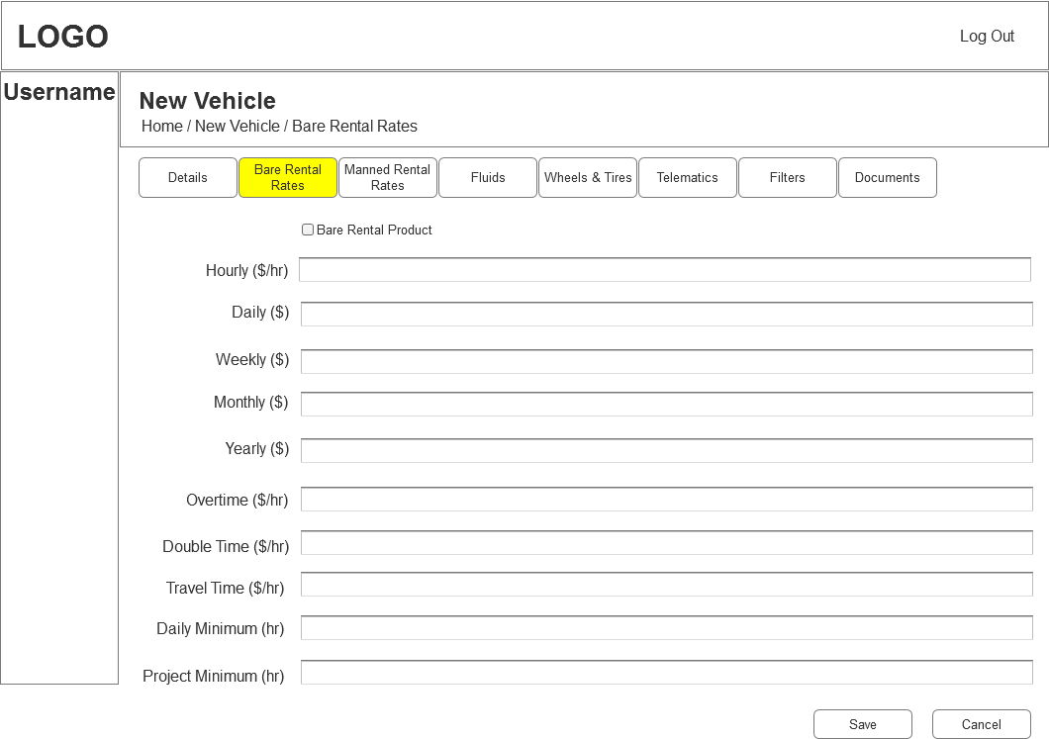

* 1. New Manned Rental Rates
     1. User Interface

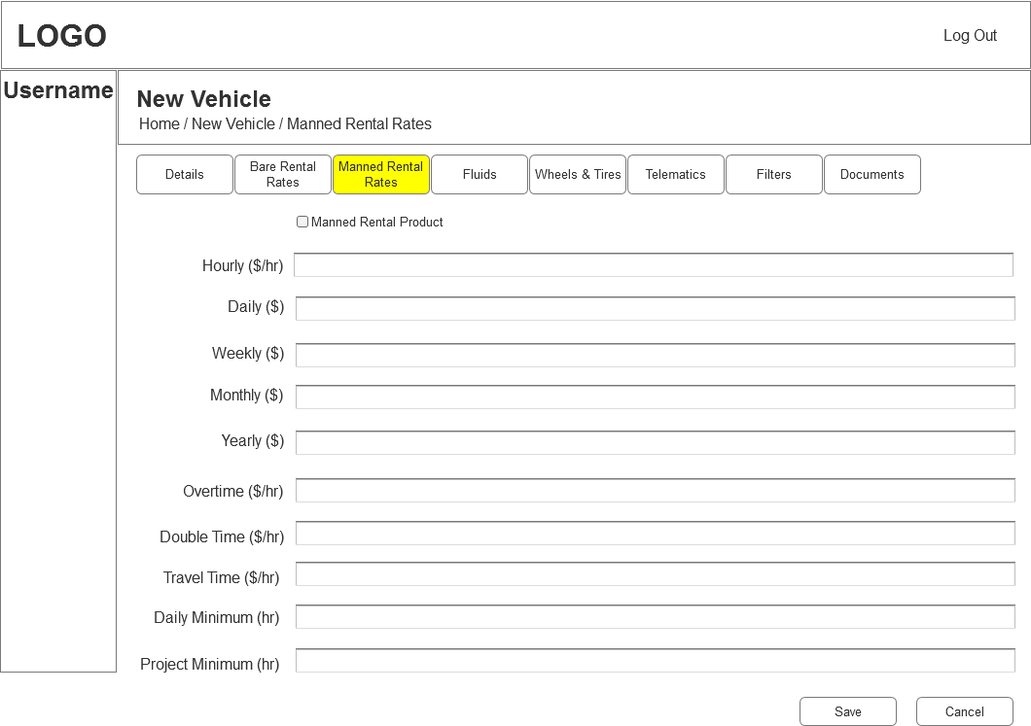

* 1. New Fluids
     1. User Interface

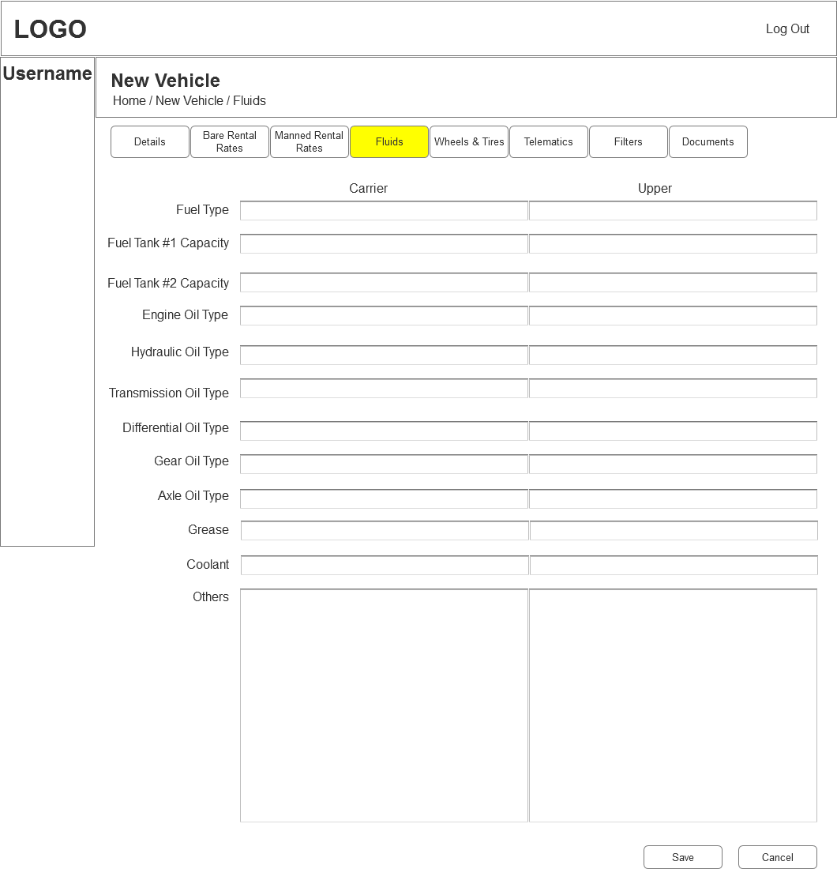

* 1. New Wheels & Tires
     1. User Interface

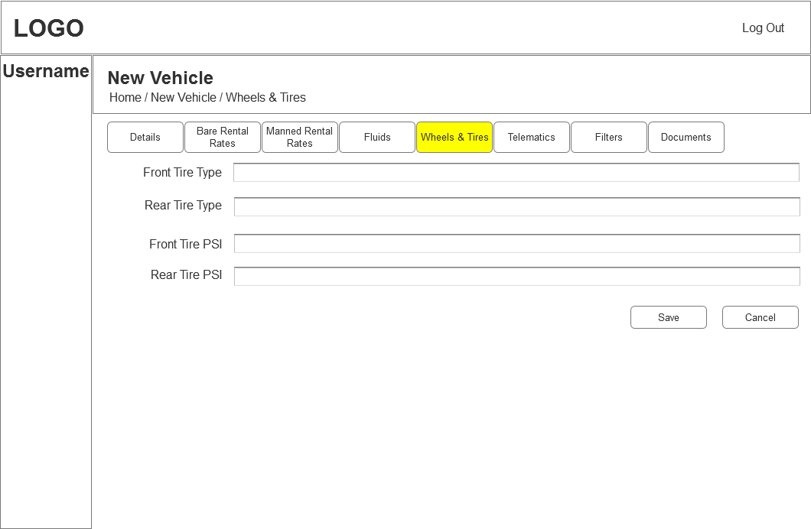

* 1. New Telematics
     1. User Interface

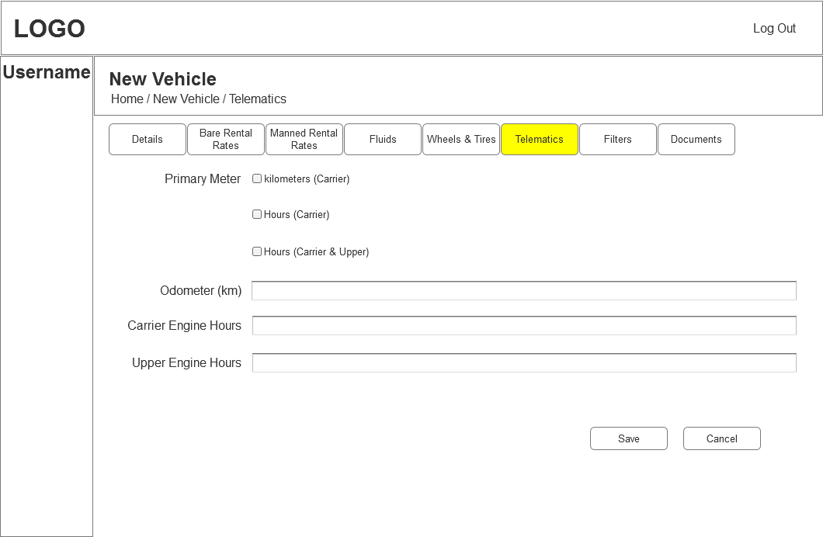

* 1. New Filters
     1. User Interface

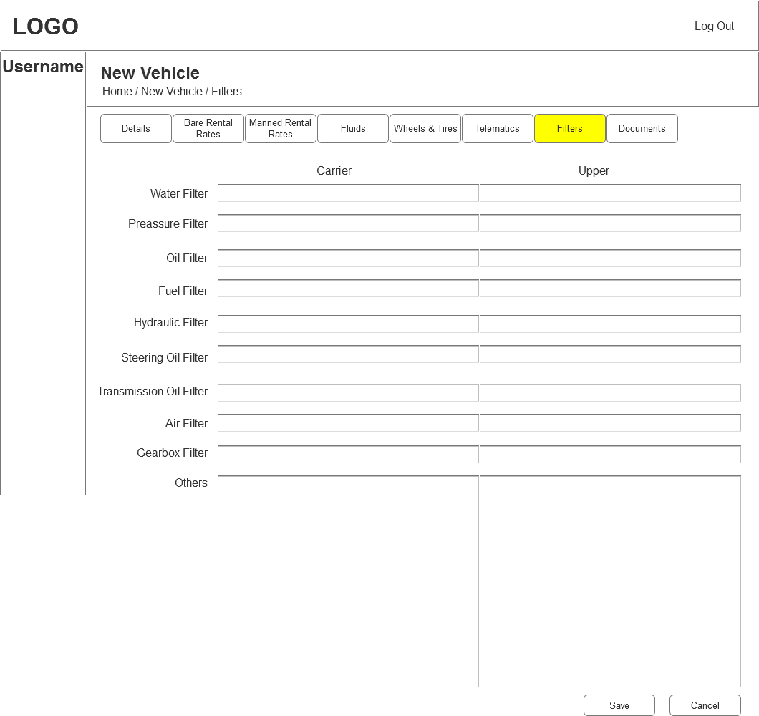

* 1. New Documents
     1. User Interface

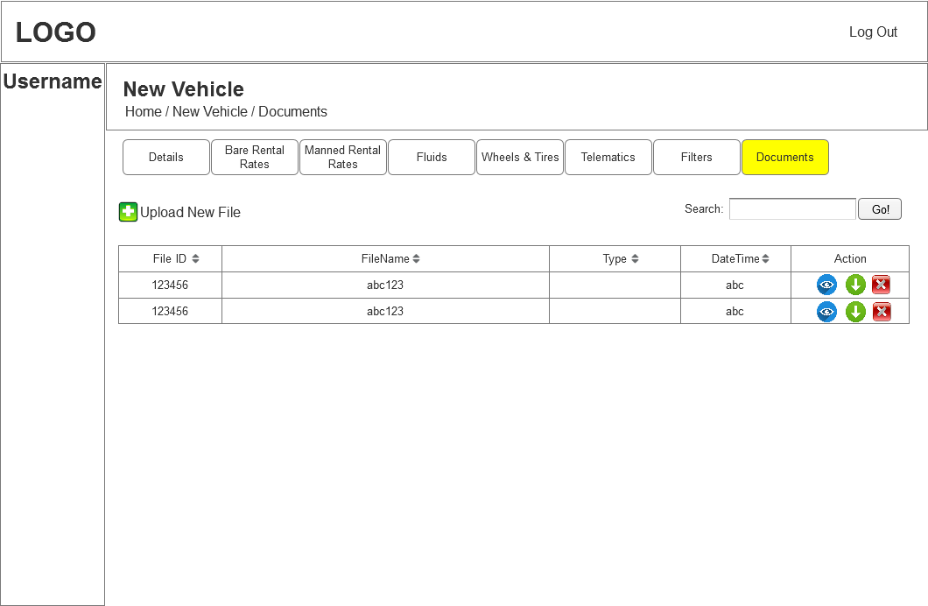

* 1. Employee
     1. User Interface

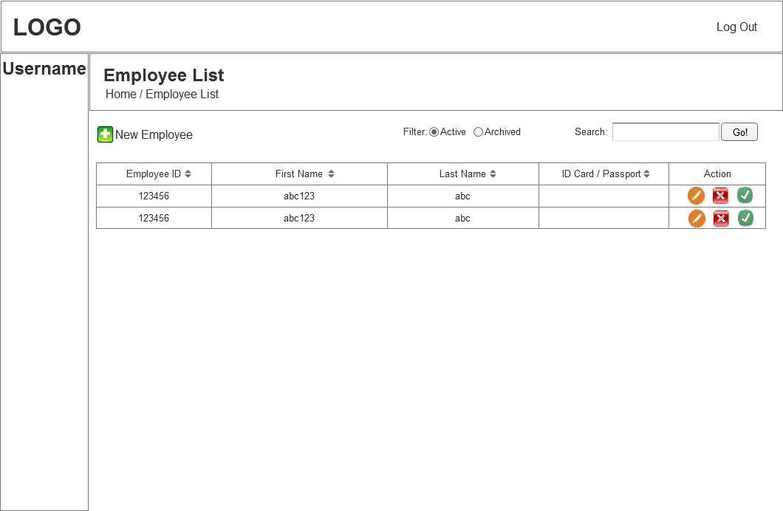

* 1. New Details
     1. User Interface

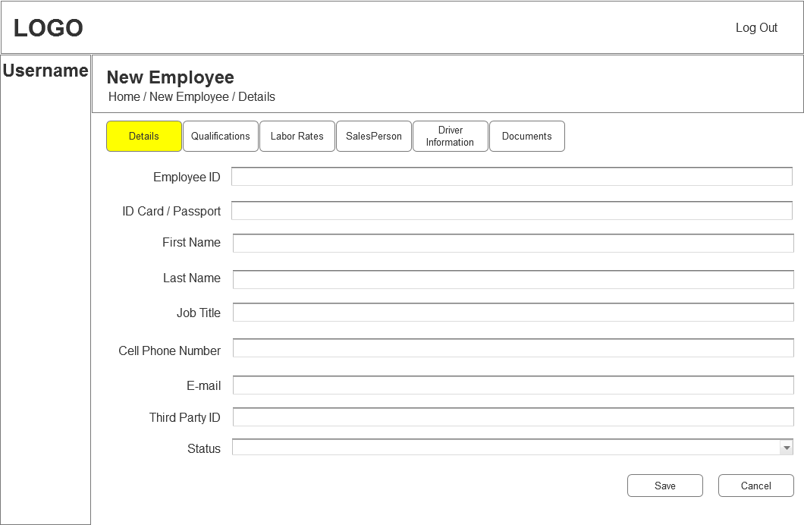

* 1. New Qualifications
     1. User Interface

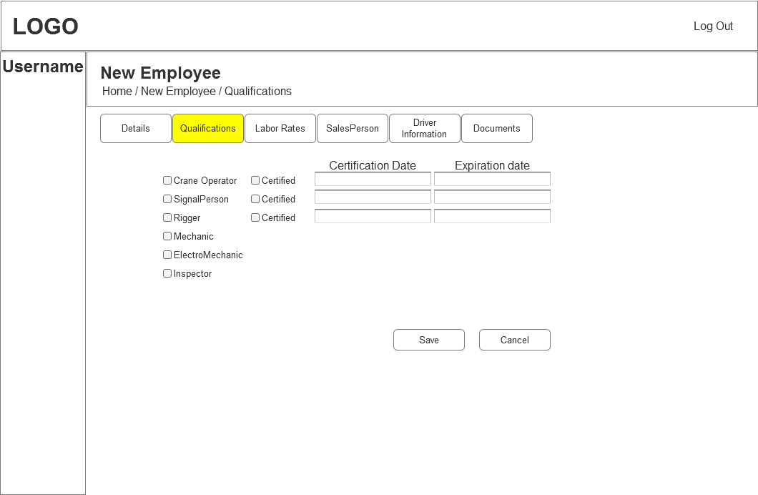

* 1. New Labor Rates
     1. User Interface

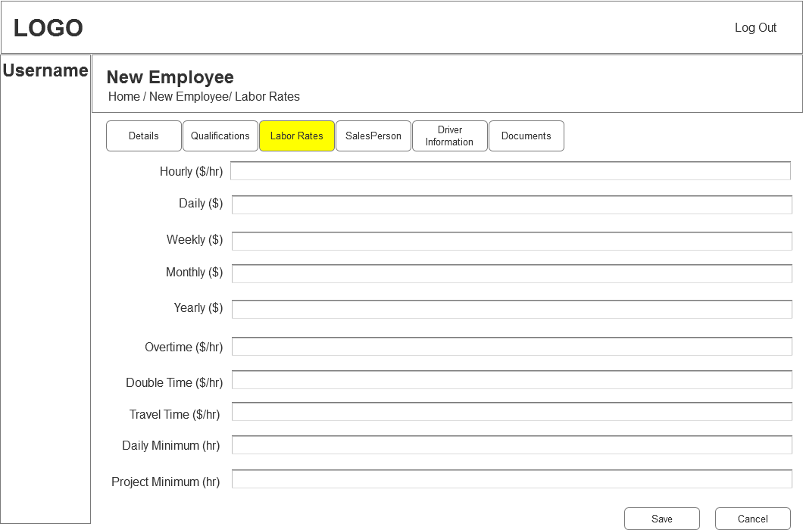

* 1. New SalesPerson
     1. User Interface

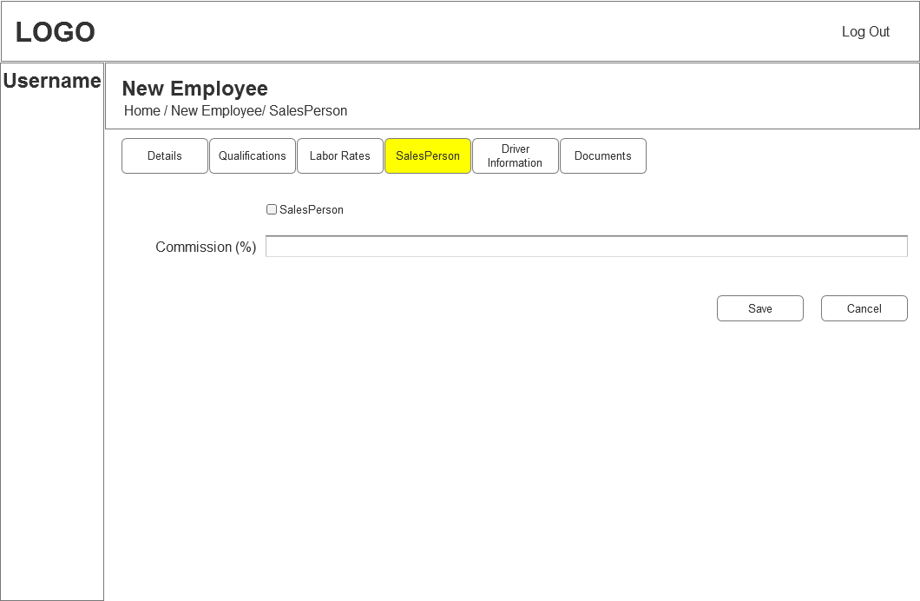

* 1. New Driver Information
     1. User Interface

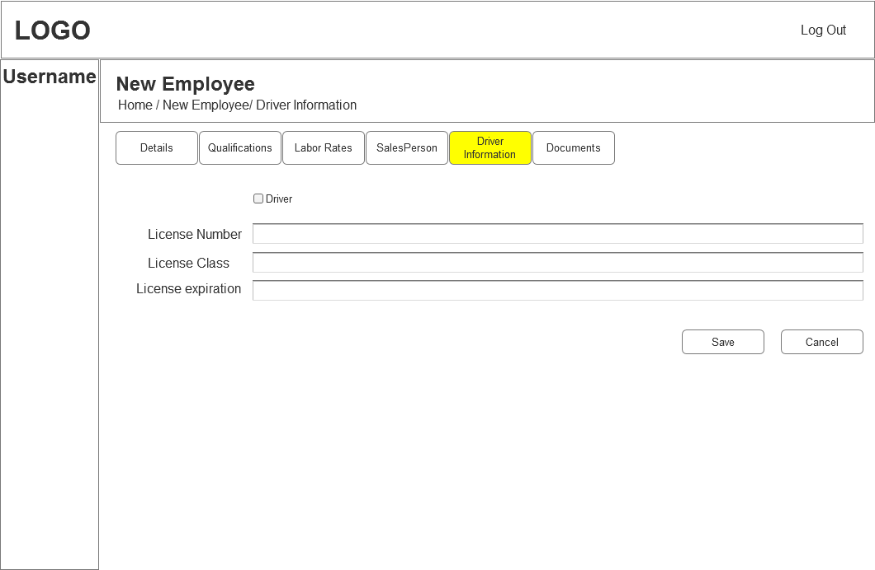

* 1. New Documents
     1. User Interface

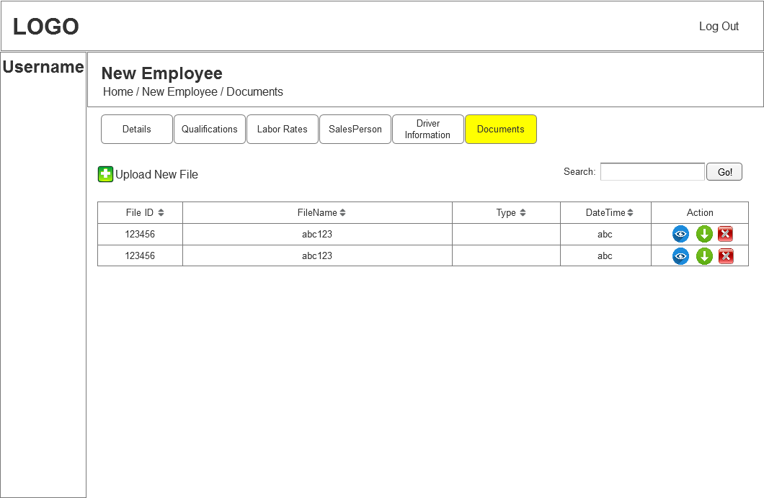

* 1. Supplier
     1. User Interface

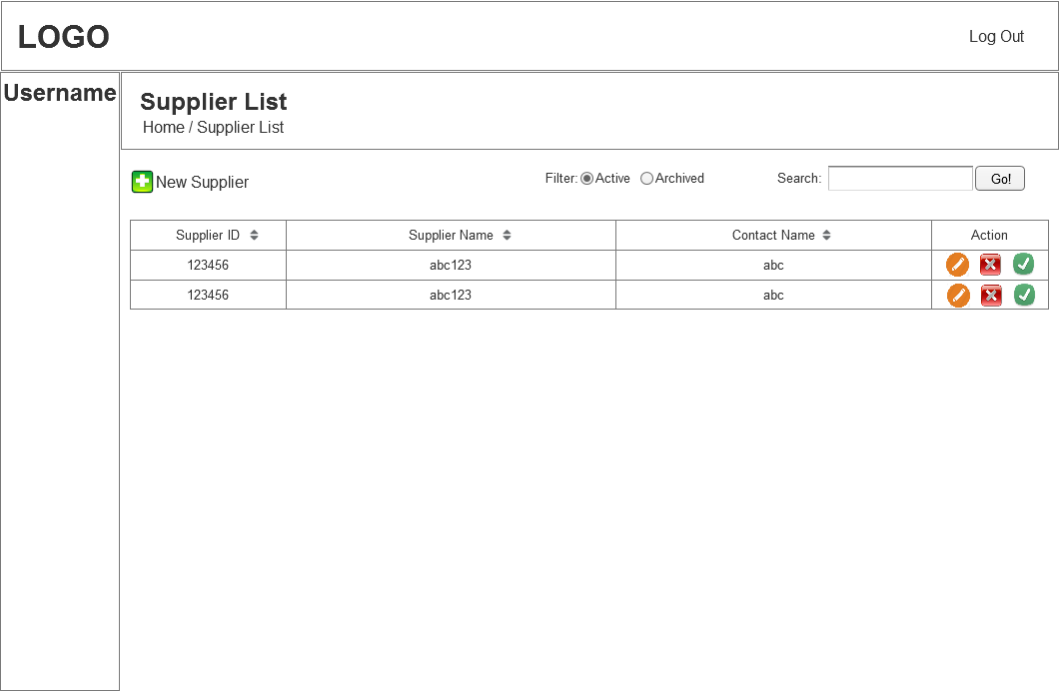

* 1. Supplier New
     1. User Interface

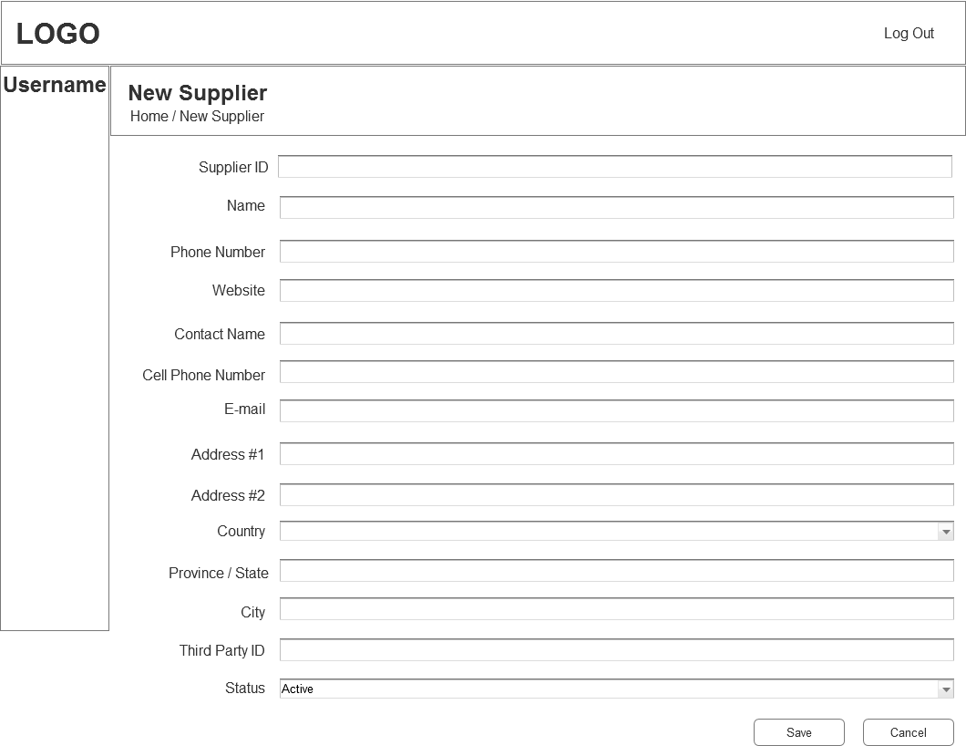

* 1. Service
     1. User Interface

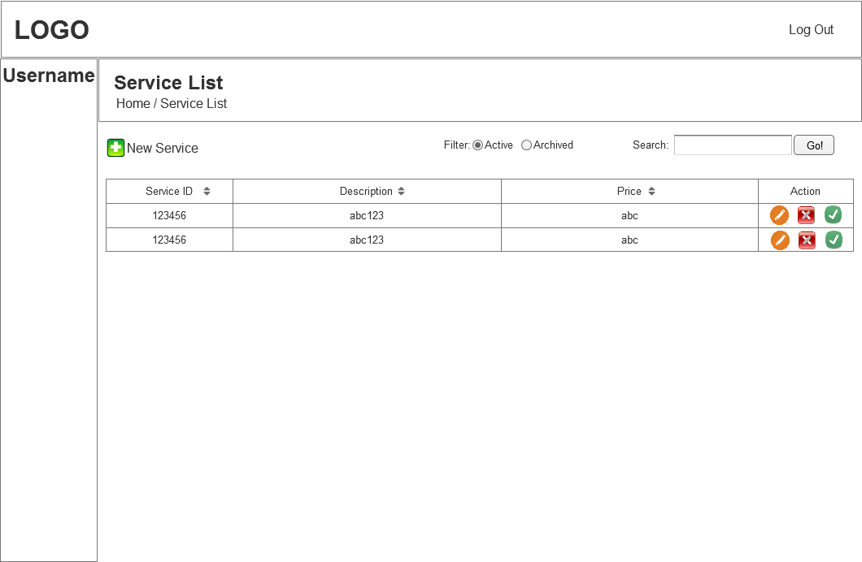

* 1. Service New
     1. User Interface

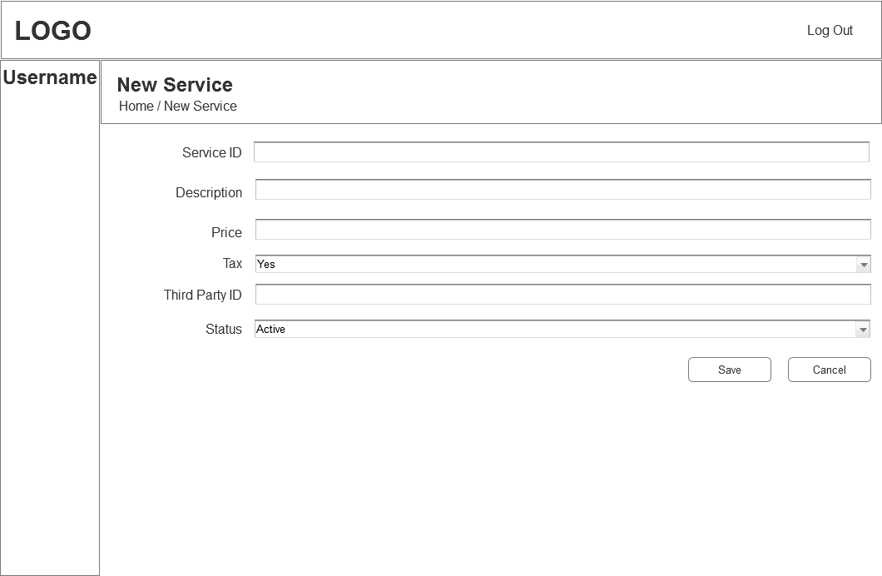

* 1. Company
     1. User Interface



* 1. New Details
     1. User Interface

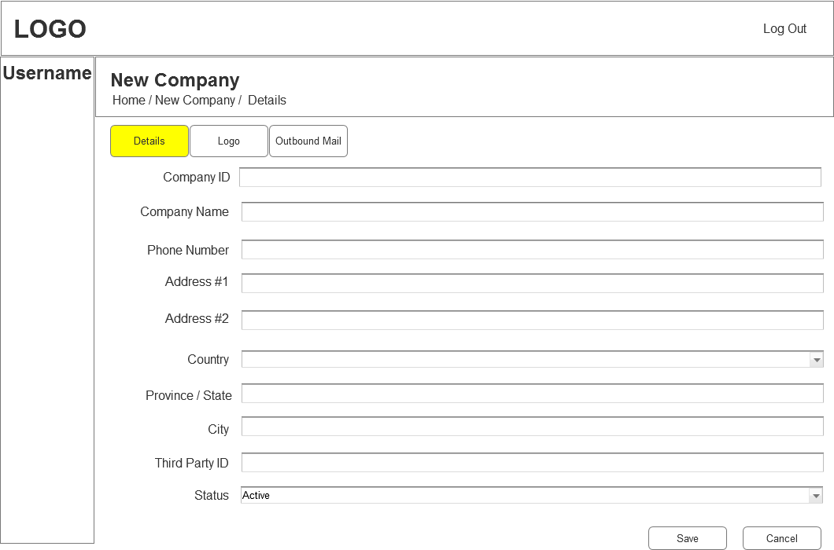

* 1. New Outbound Mail
     1. User Interface

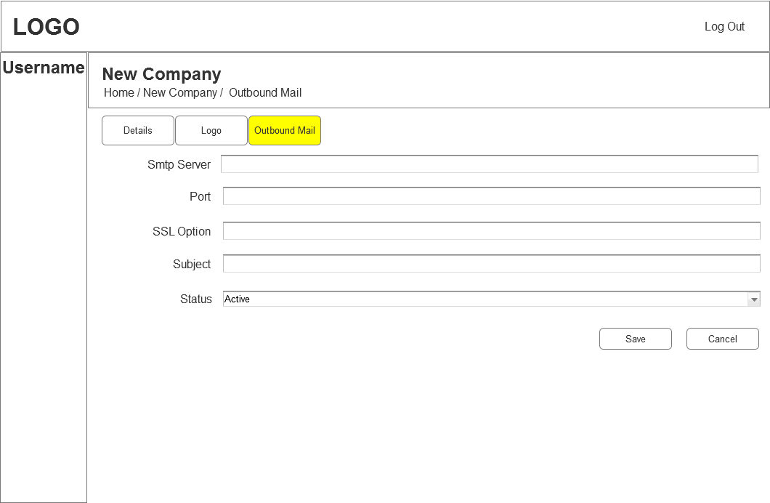

* 1. New Logo
     1. User Interface

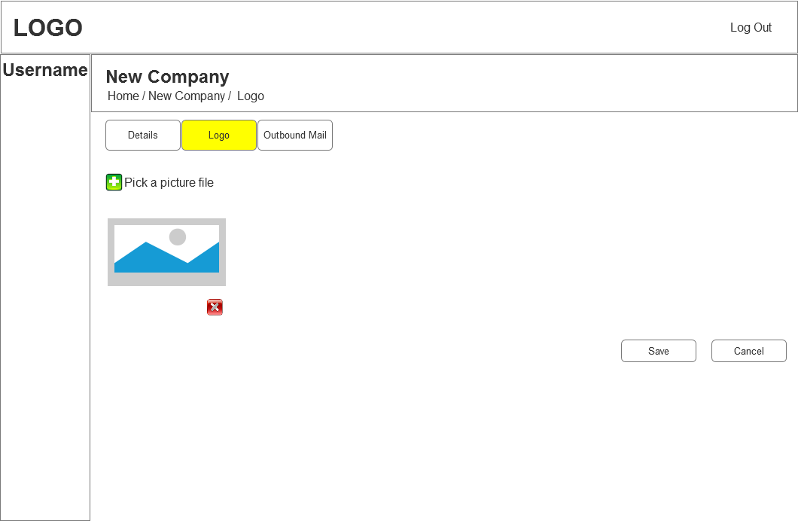

* 1. Country
  2. Jobs
     1. User Interface

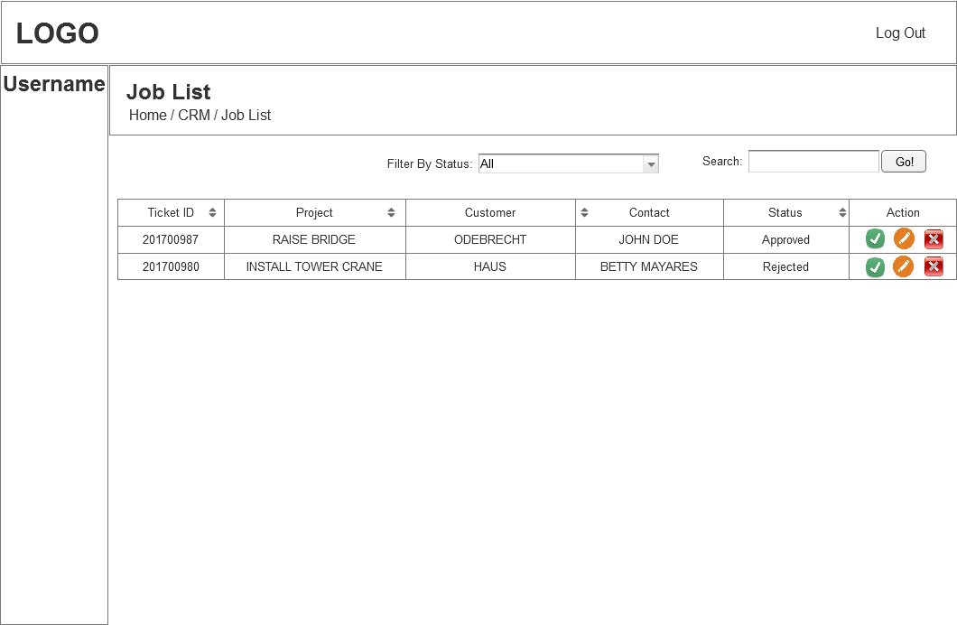

* 1. Jobs_Info
     1. User Interface

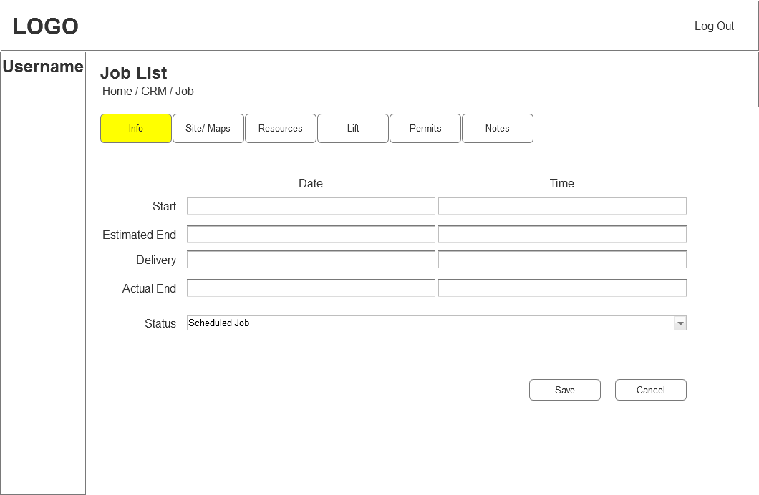

* 1. Jobs_Site/Maps
     1. User Interface

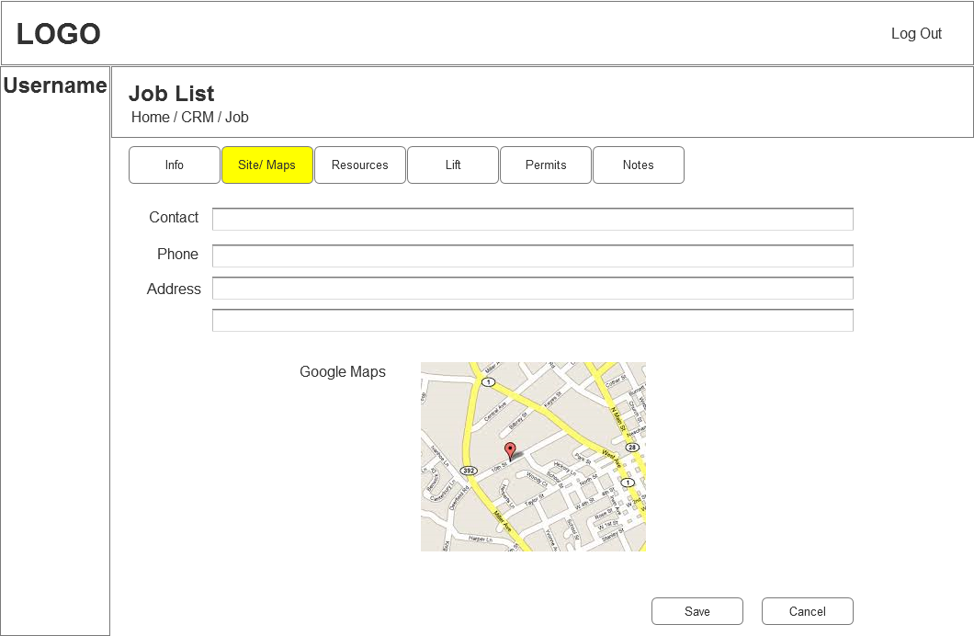

* 1. Jobs_Resources
     1. User Interface

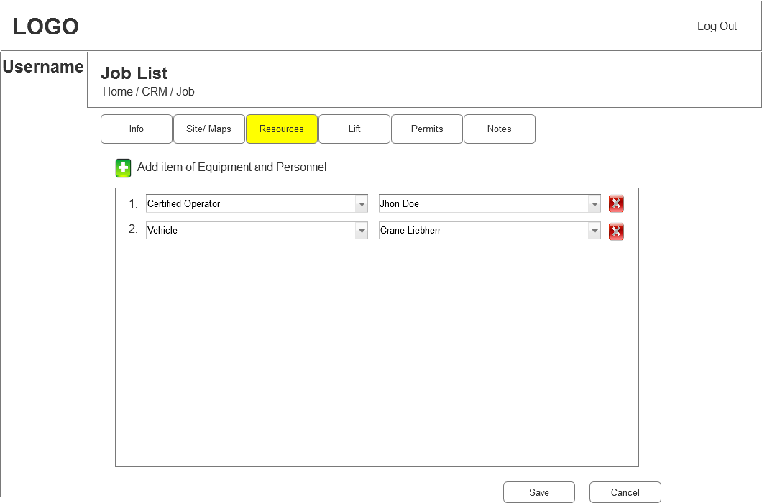

* 1. Jobs_Lift
     1. User Interface

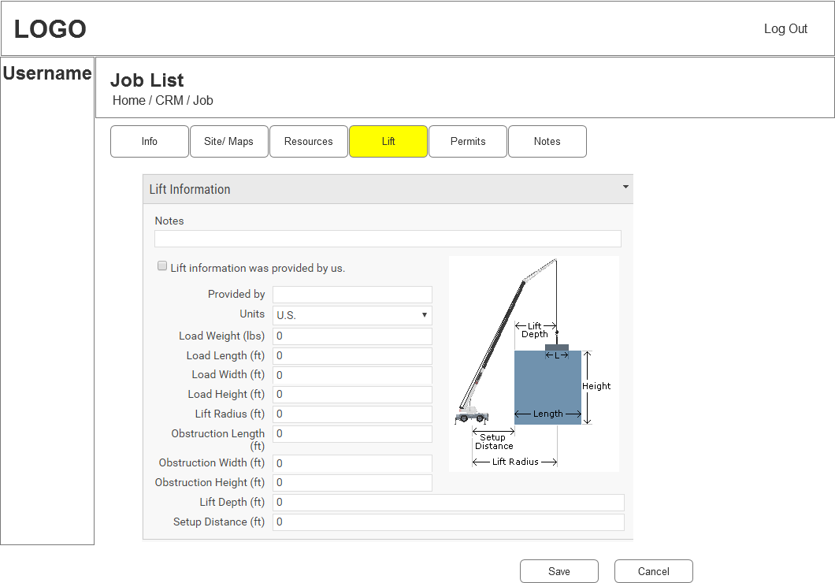

* 1. Jobs_Permits
     1. User Interface

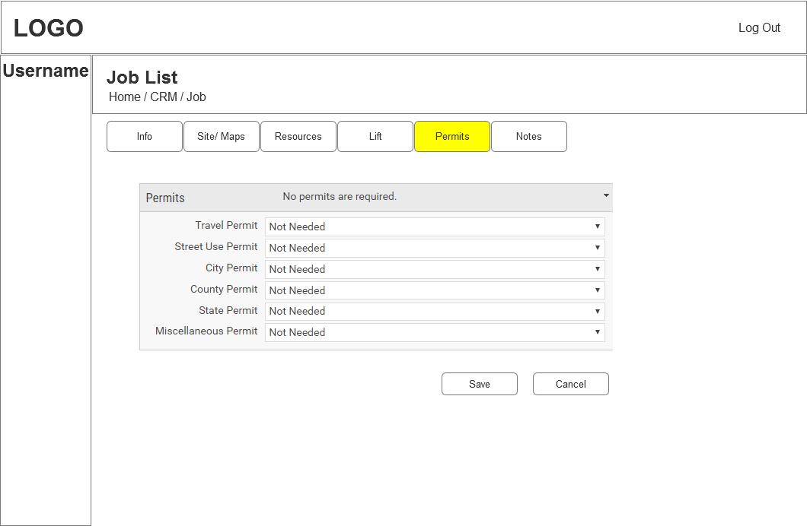

* 1. Jobs_Notes
     1. User Interface

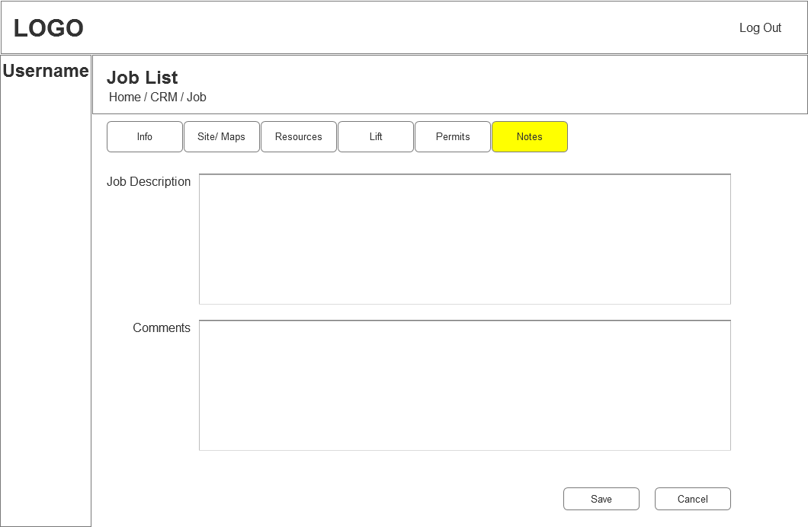

* 1. Resource Calendar
     1. User Interface

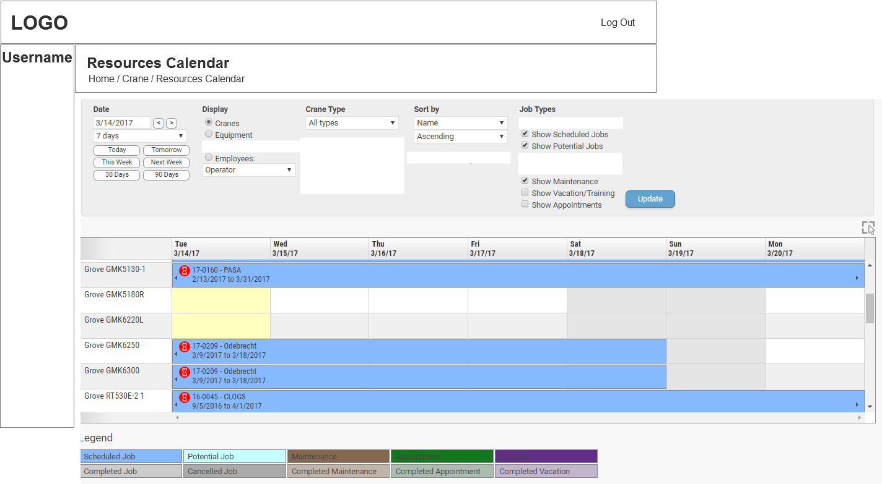

* 1. Service Agreement
     1. User Interface

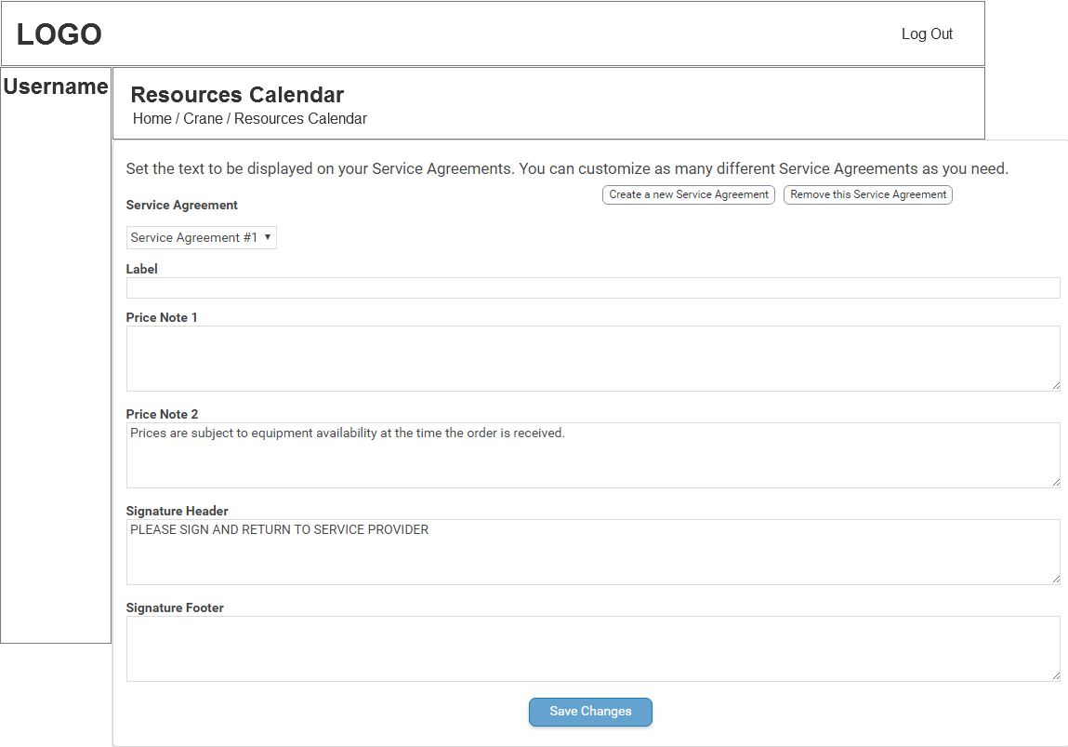

* 1. Terms and conditions
     1. User Interface

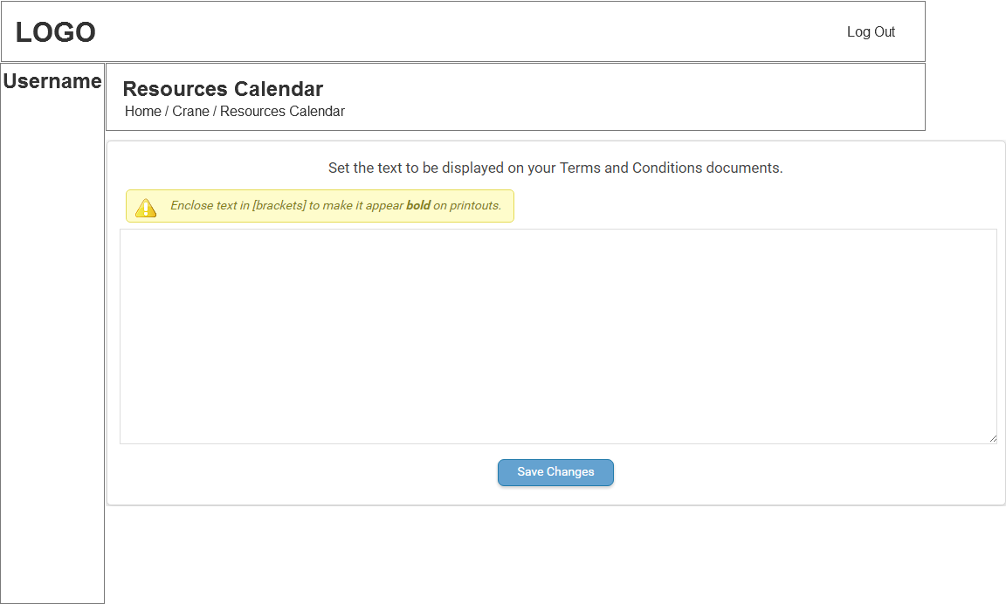

* 1. Proposal note
     1. User Interface

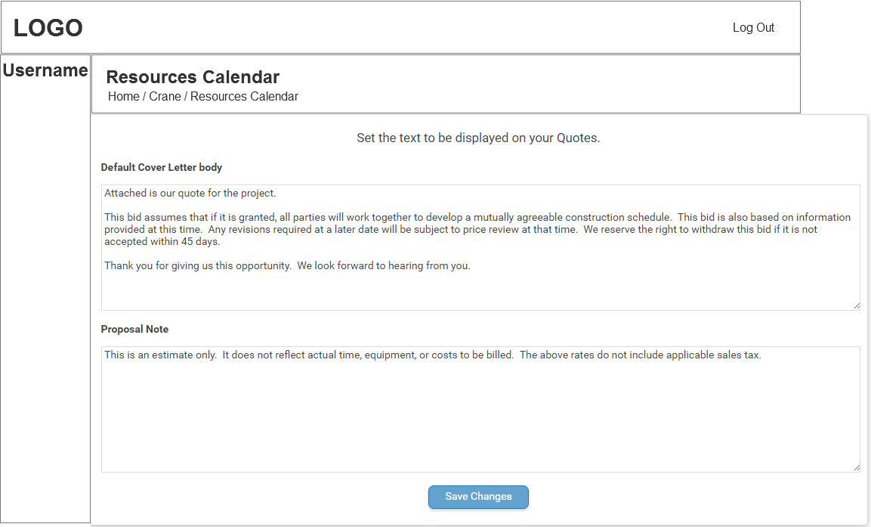

* 1. Prospect
     1. User Interface

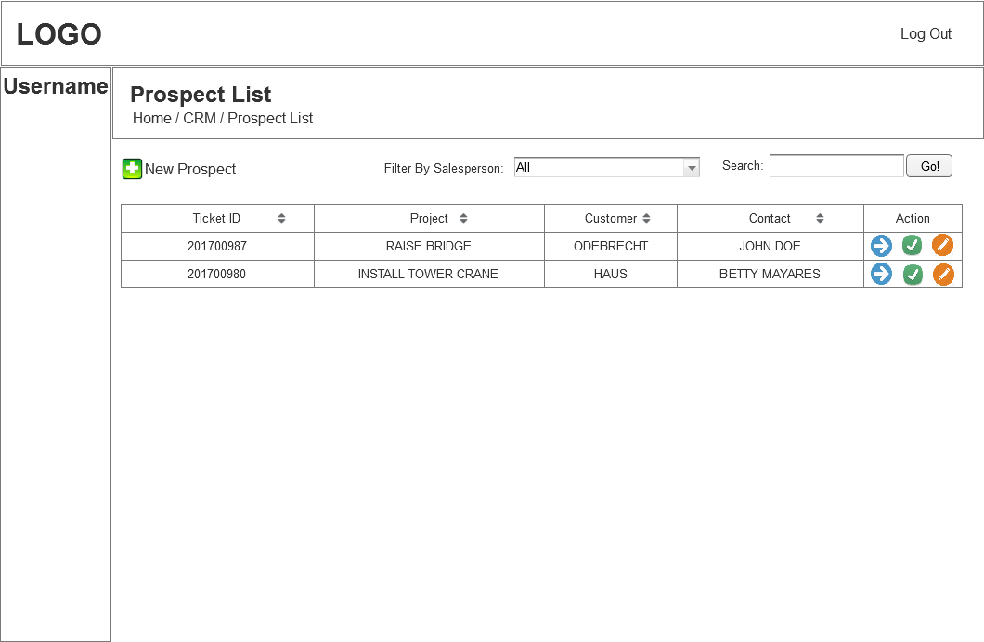

* 1. New Prospect
     1. User Interface

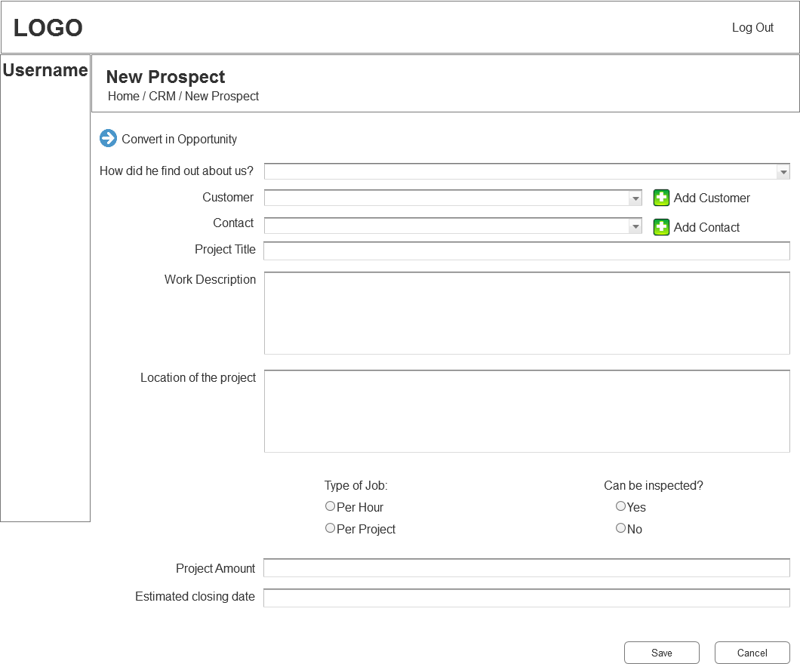

* 1. Opportunity
     1. User Interface

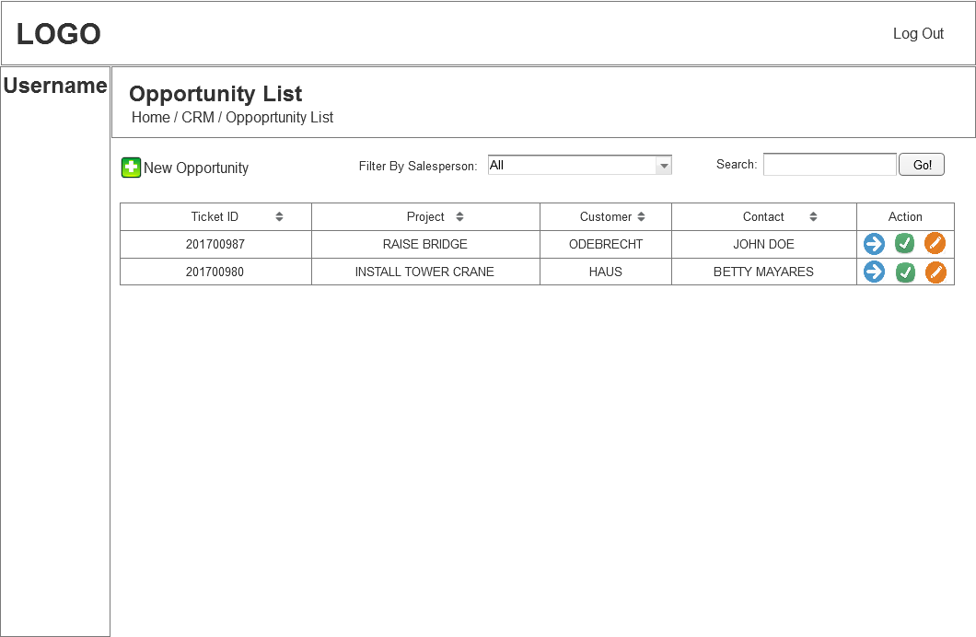

* 1. New Opportunity
     1. User Interface

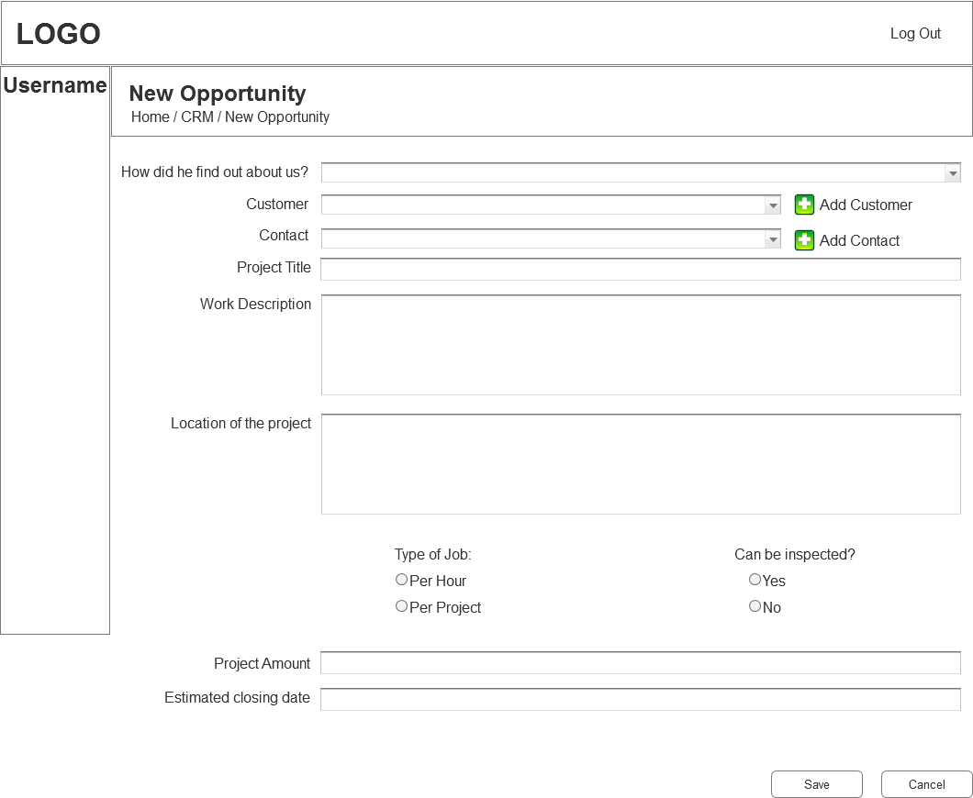

* 1. Engineering
     1. User Interface

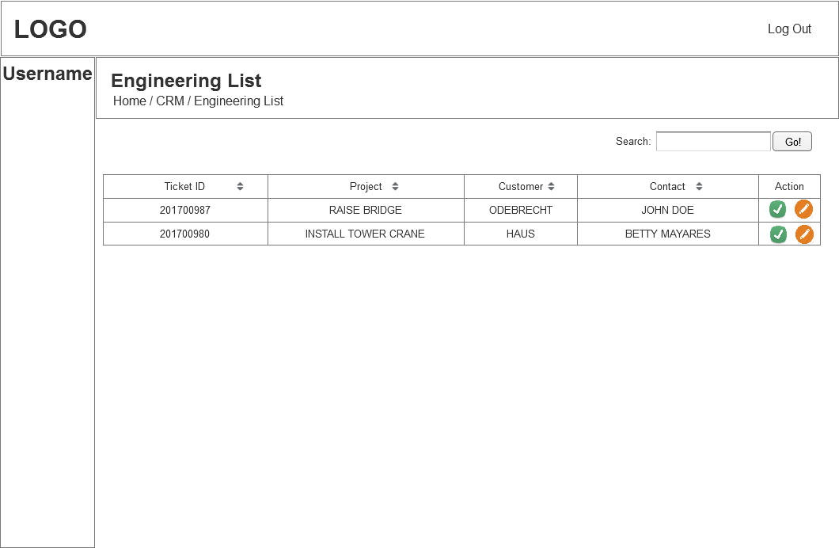

* 1. New Inspection
     1. User Interface

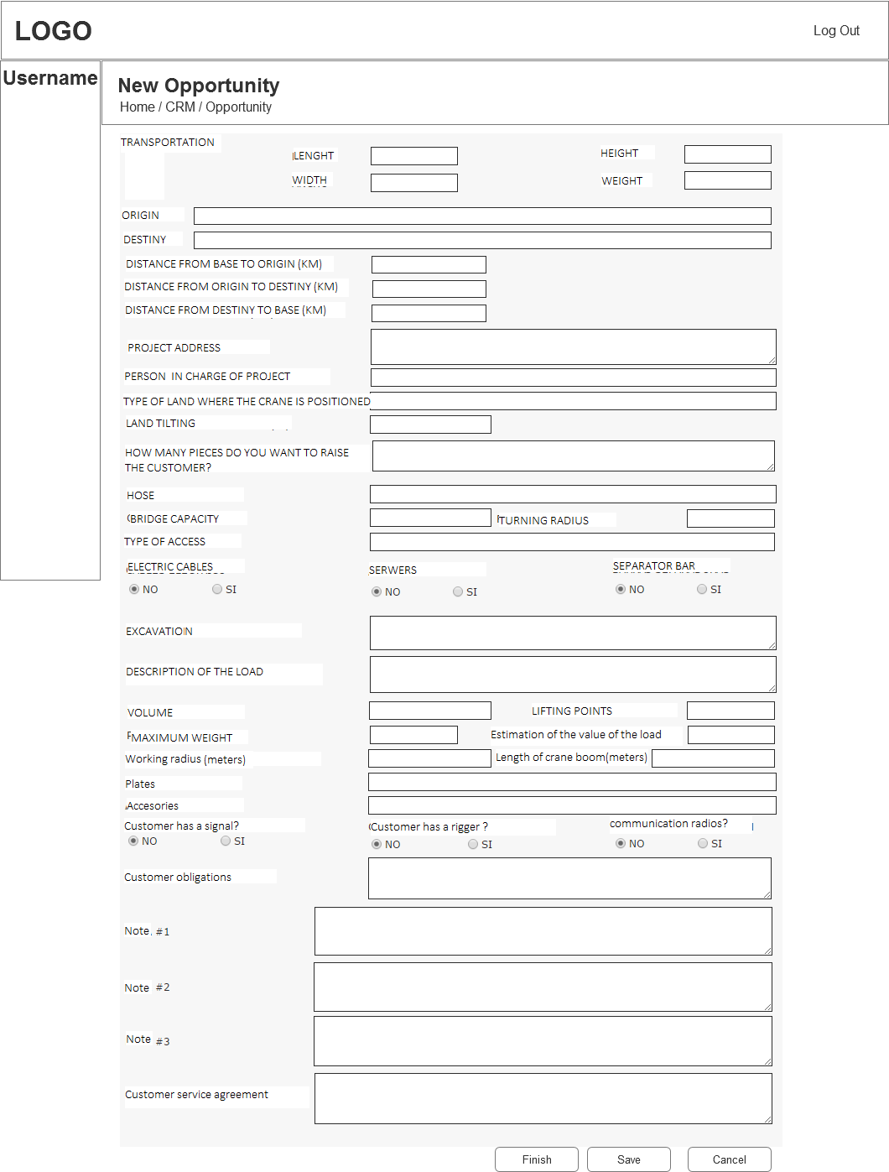

* 1. Quote
     1. User Interface

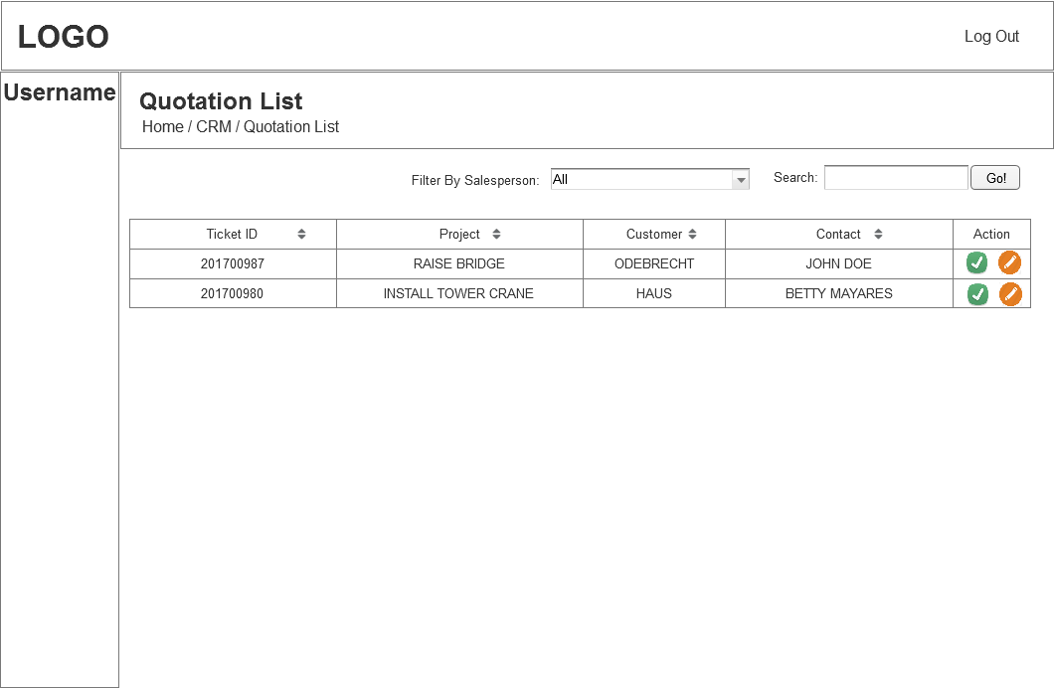

* 1. New Quote
     1. User Interface

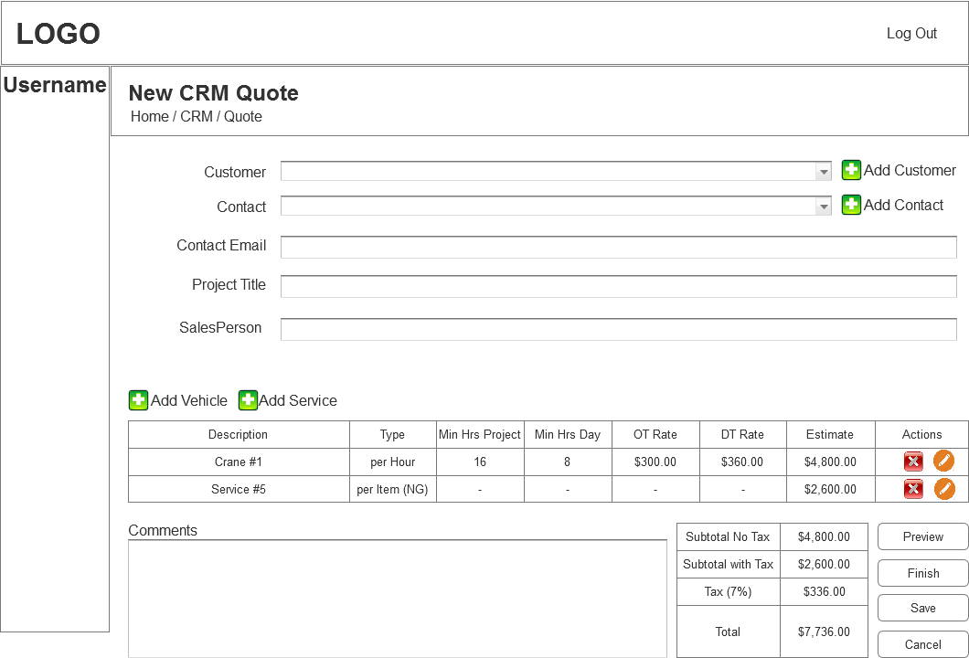

* 1. Add Vehicle
     1. User Interface

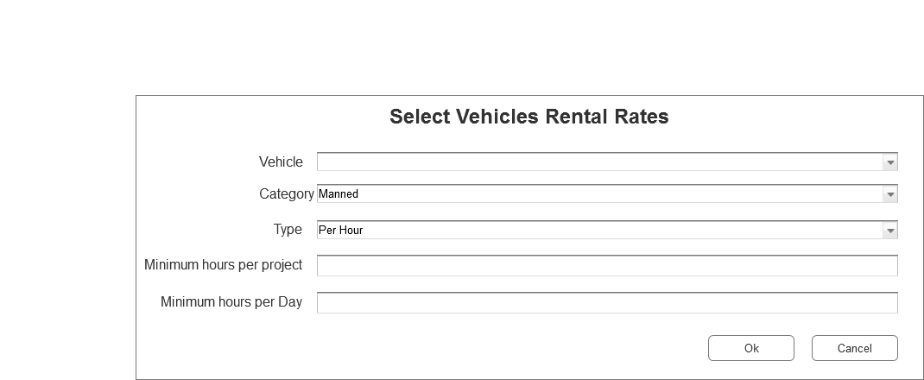

* 1. Add Service
     1. User Interface

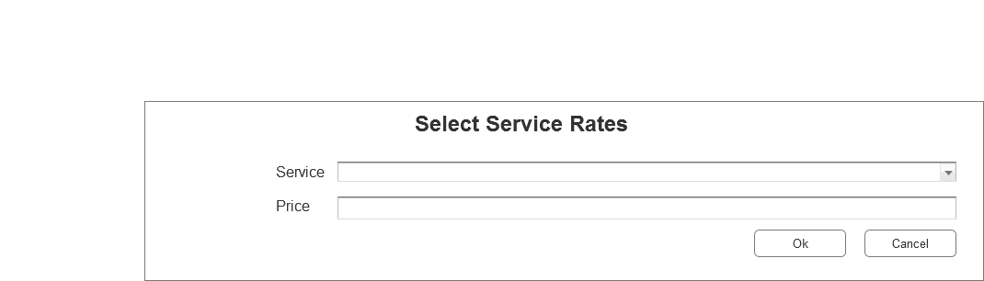

* 1. Add Items Notes
     1. User Interface

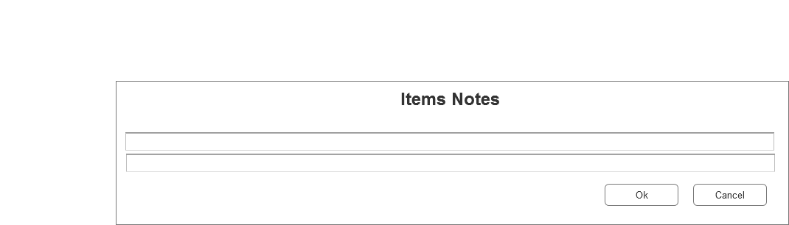

* 1. quote Preview/PDF
     1. User Interface

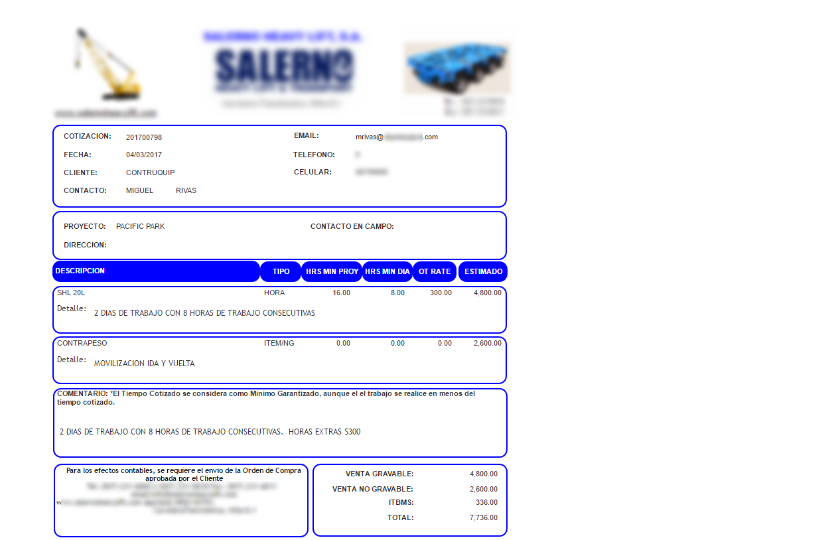

* 1. Tracing
     1. User Interface

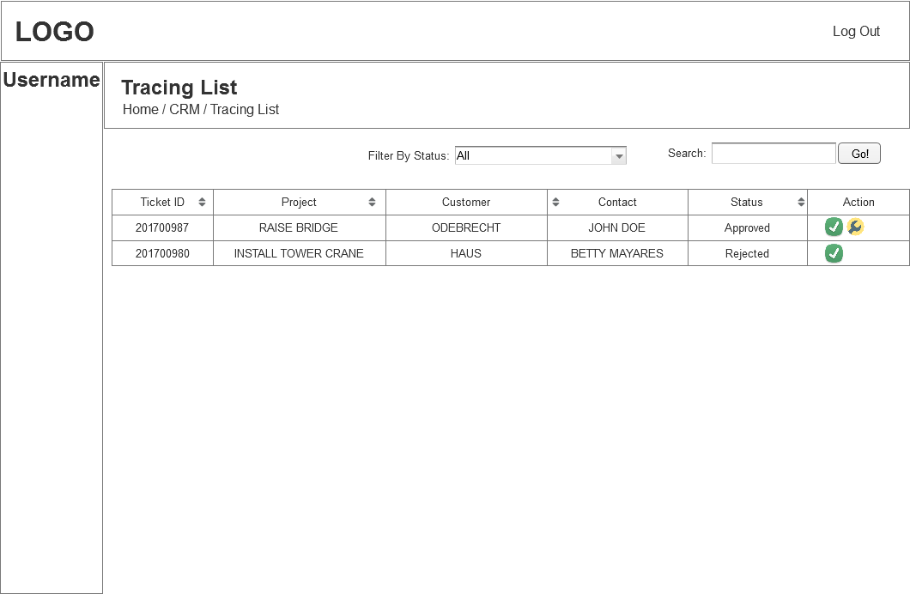

* 1. Tracing History
     1. User Interface

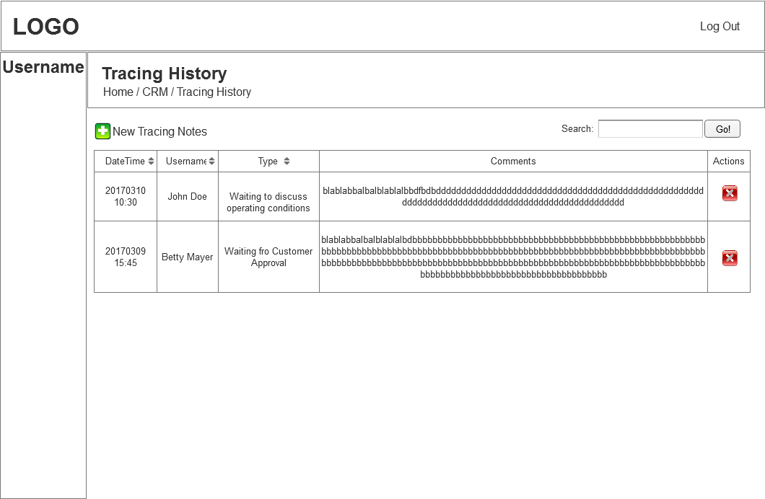

* 1. New Tracing Notes
     1. User Interface

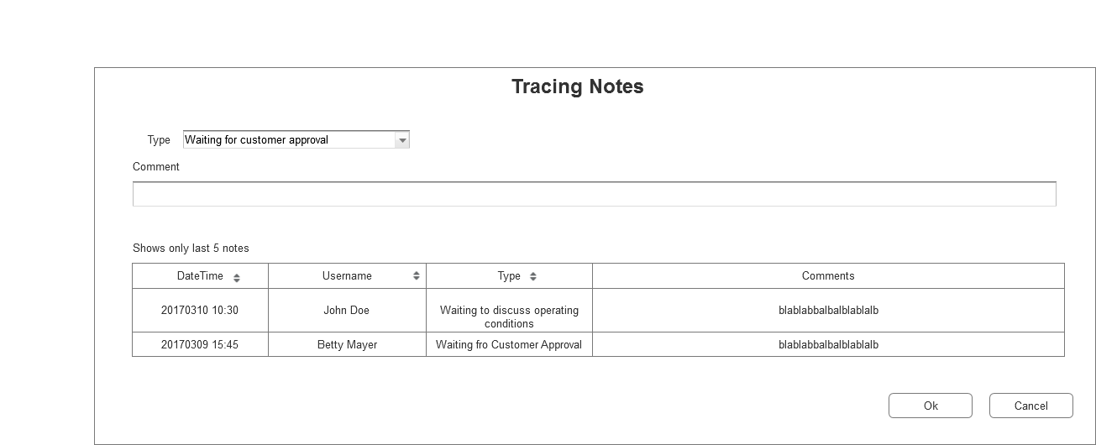

* 1. Schedule
     1. User Interface

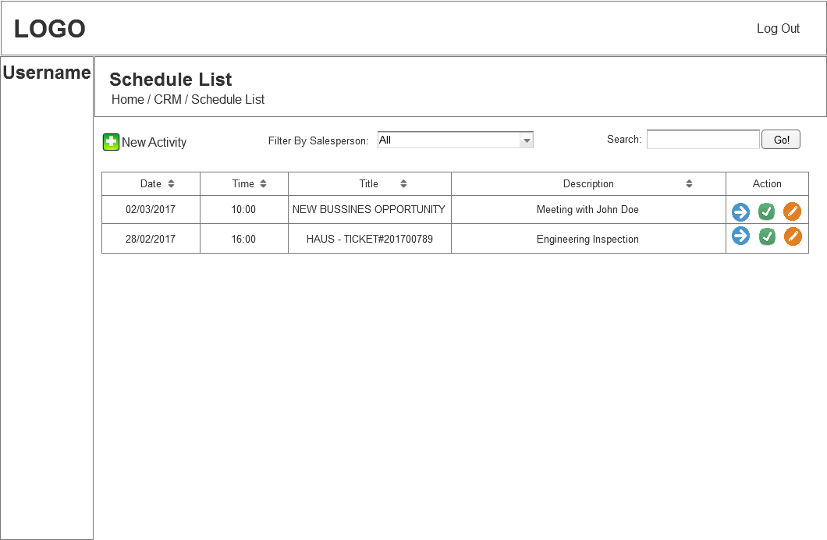

* 1. New Task
     1. User Interface

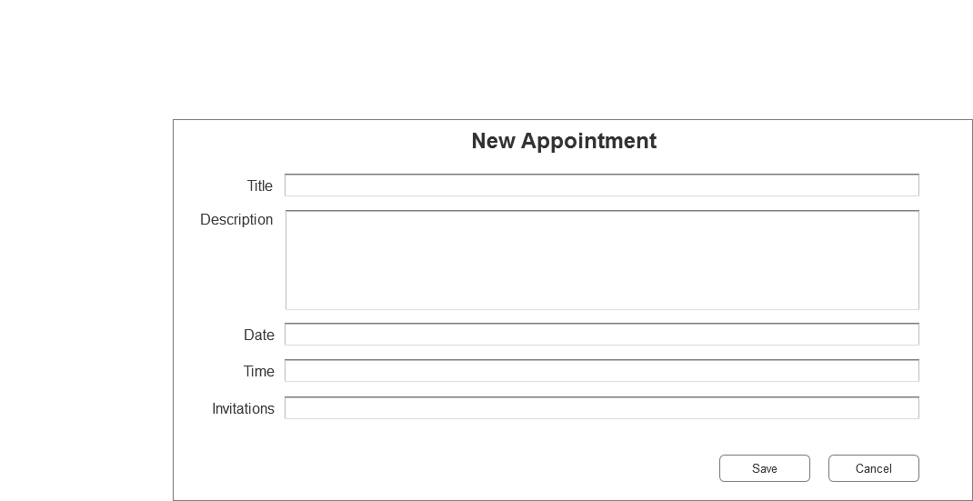

* 1. Fleet_Fuel
     1. User Interface

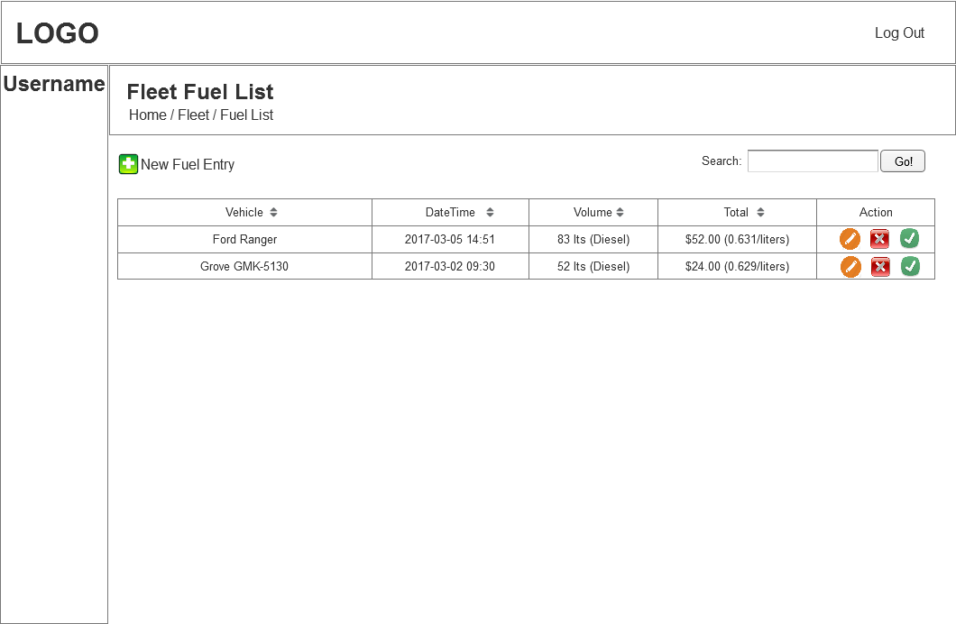

* 1. New Fuel Entry
     1. User Interface

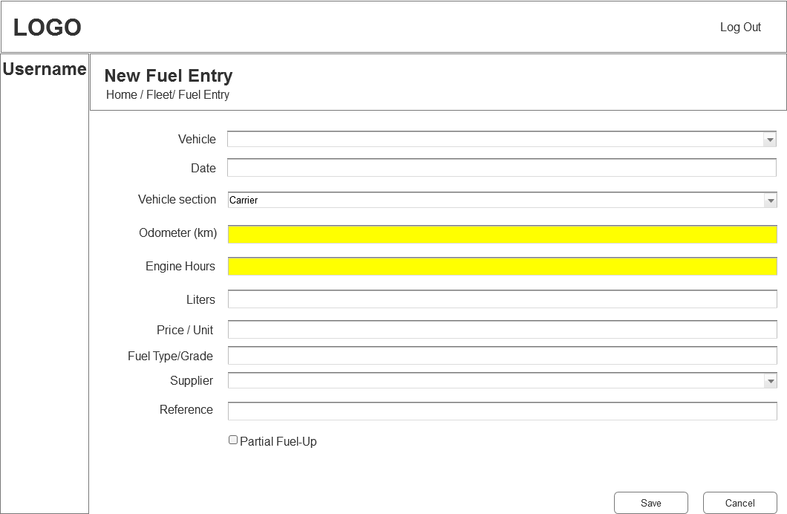

* 1. Fleet_Work_Order
     1. User Interface

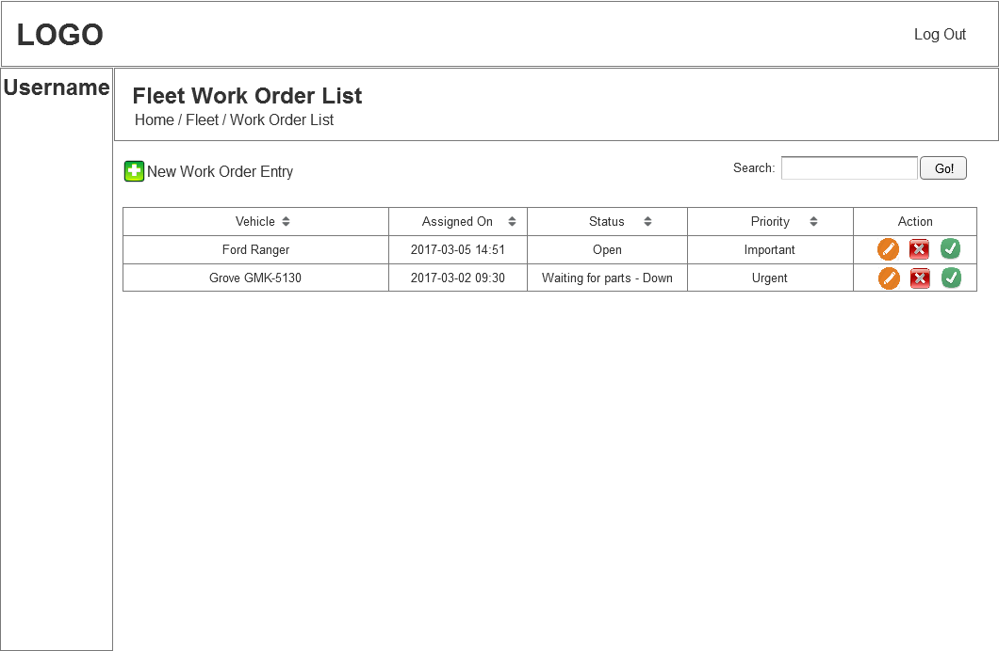

* 1. W/O Entry Open
     1. User Interface

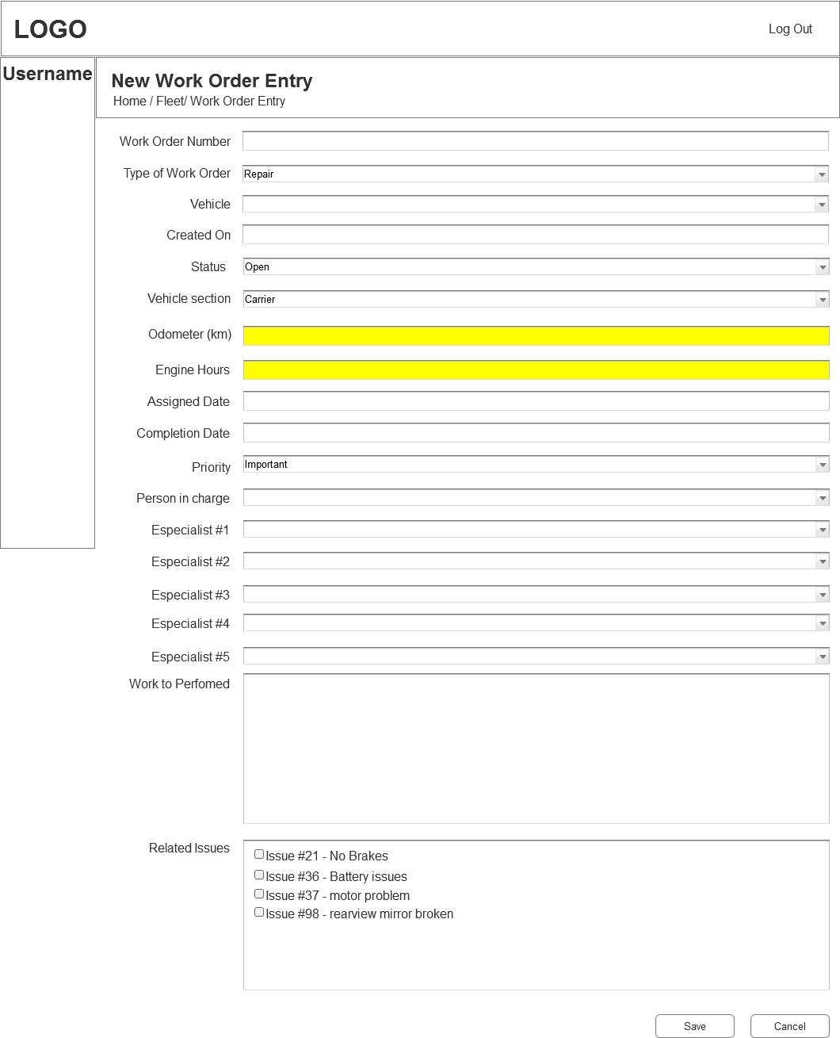

* 1. W/O Status Completed
     1. User Interface

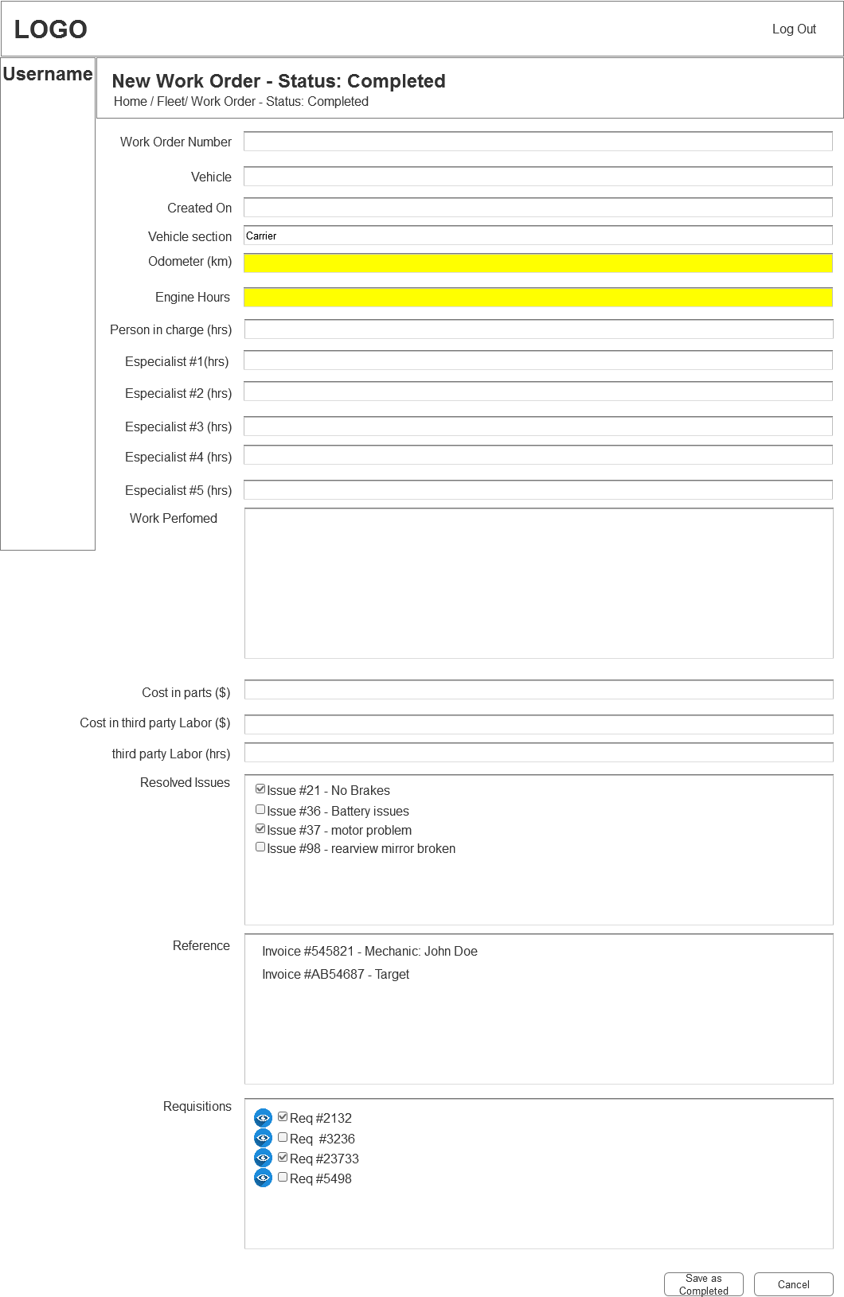

* 1. Fleet_Issues
     1. User Interface

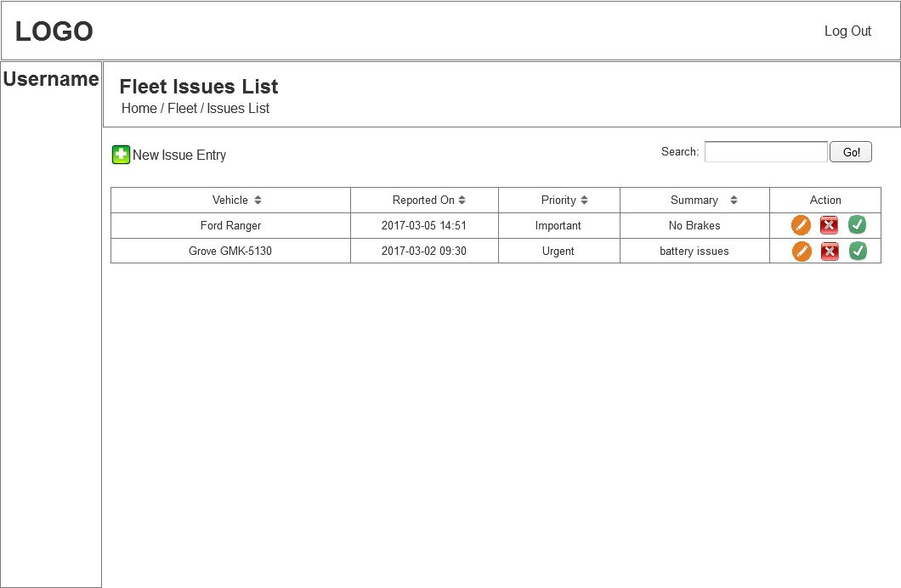

* 1. New Issue Entry
     1. User Interface

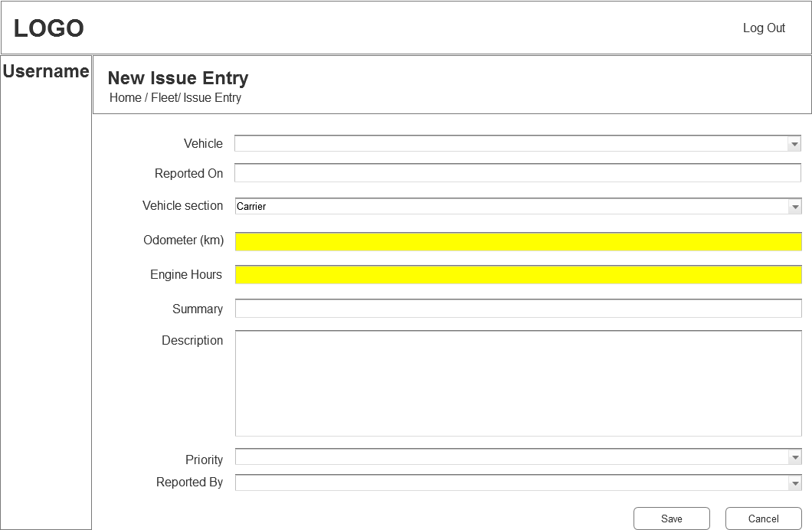

* 1. Fleet_Service_Reminders
     1. User Interface

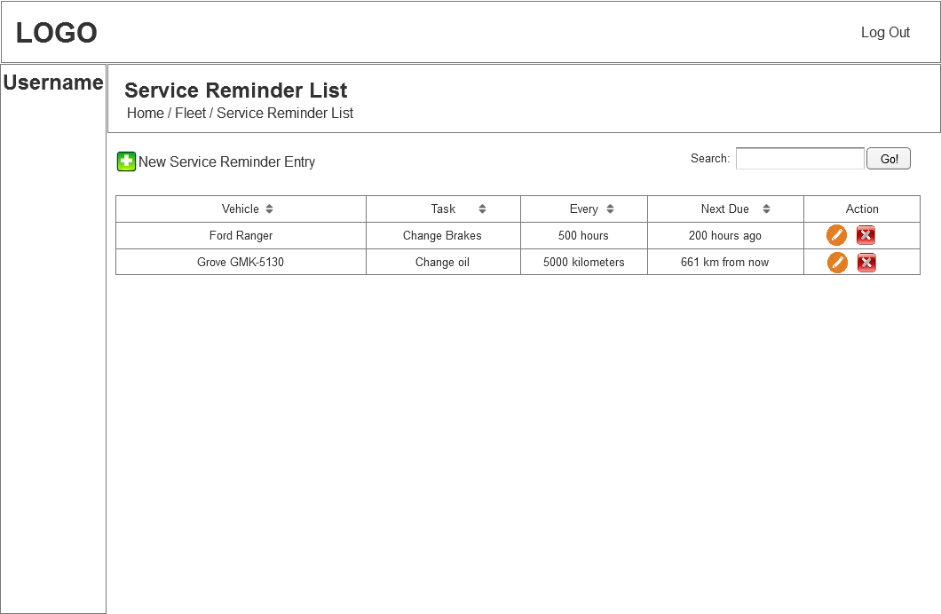

* 1. New Service Reminder Entry
     1. User Interface

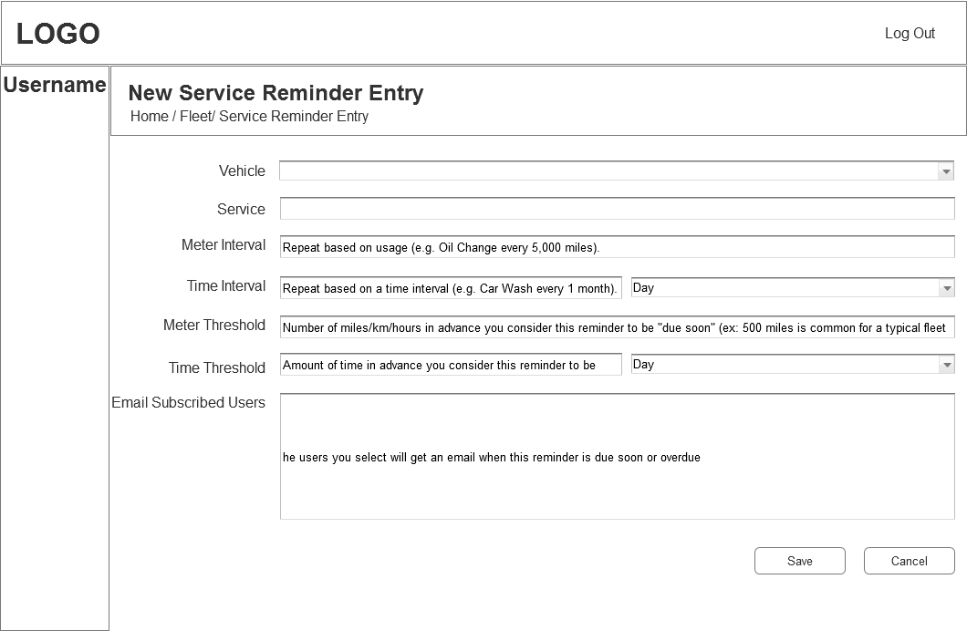

* 1. Fleet_Renewal_Reminders
     1. User Interface

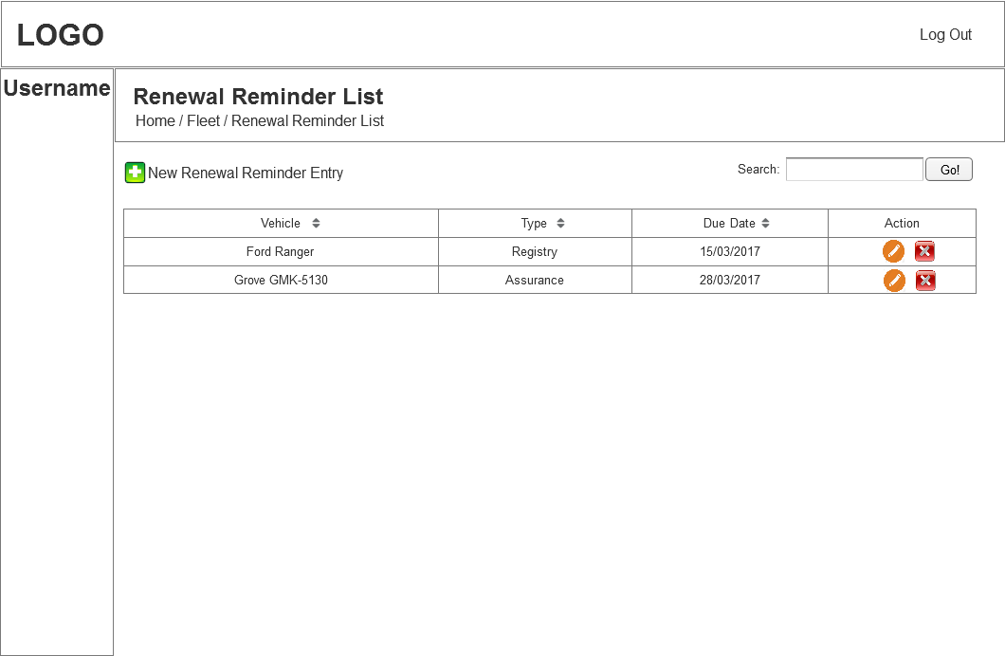

* 1. New Renewal Reminder Entry
     1. User Interface

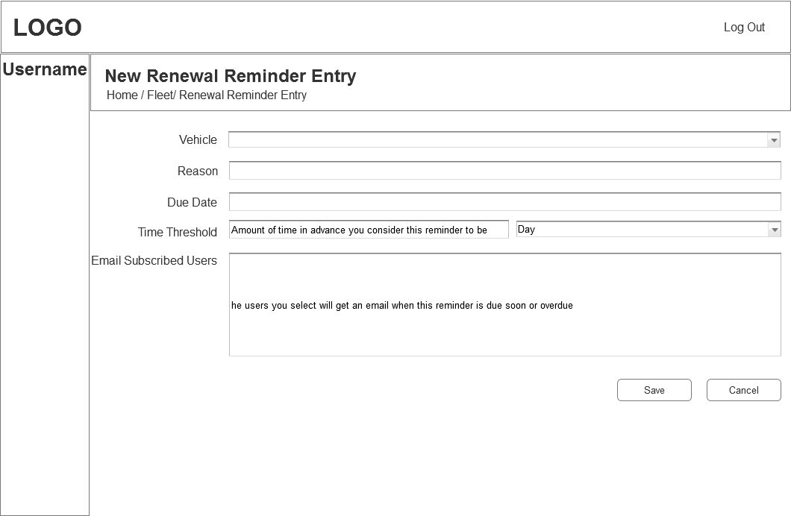

* 1. Fleet_Documents
     1. User Interface

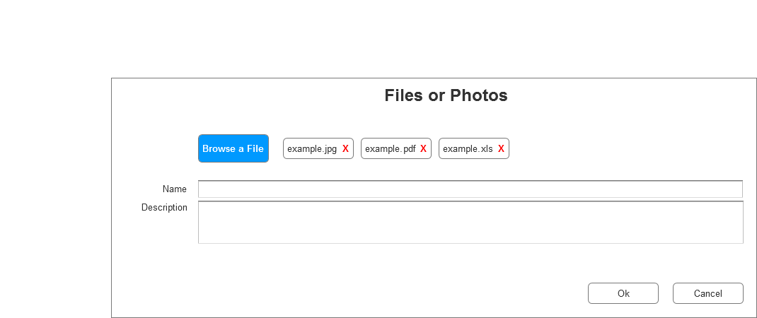

* 1. Fleet_comments
     1. User Interface

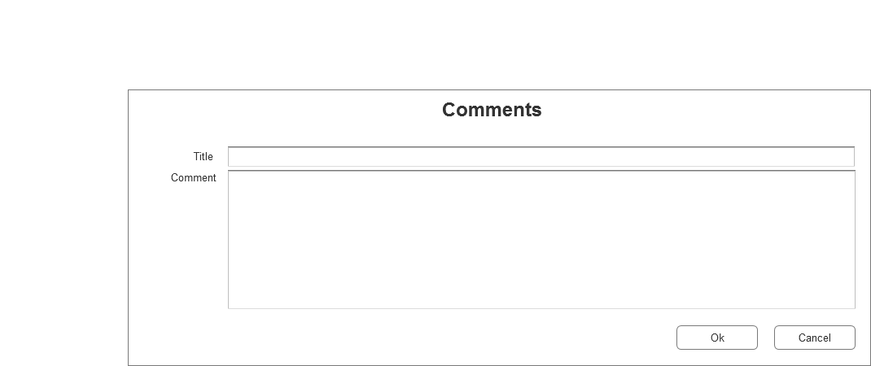

* 1. Items
     1. User Interface

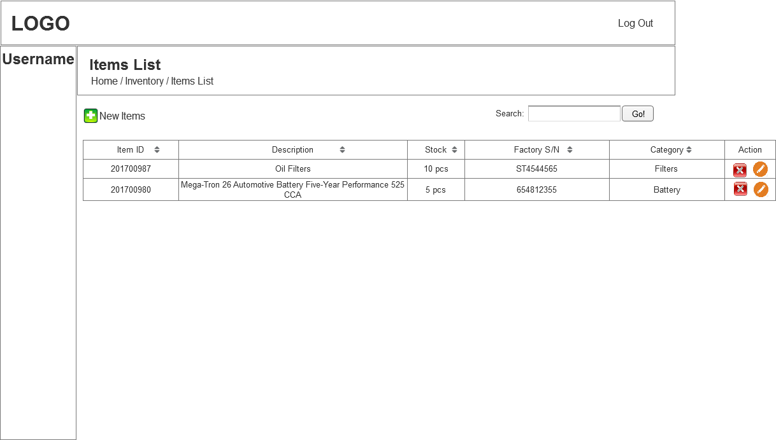

* 1. Add New Item
     1. User Interface

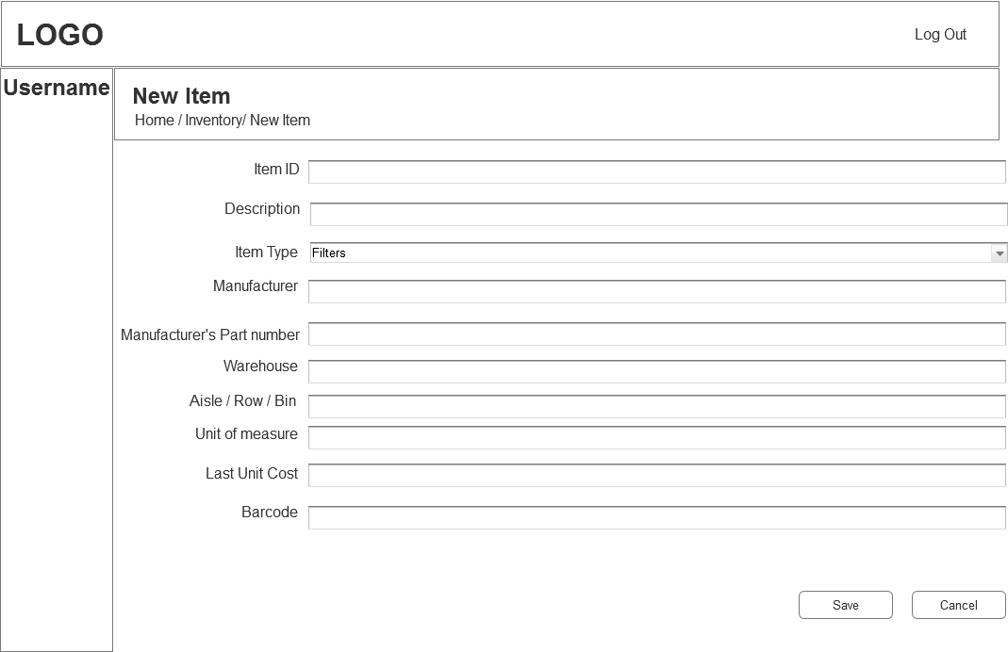

* 1. Stock Adjusment
     1. User Interface

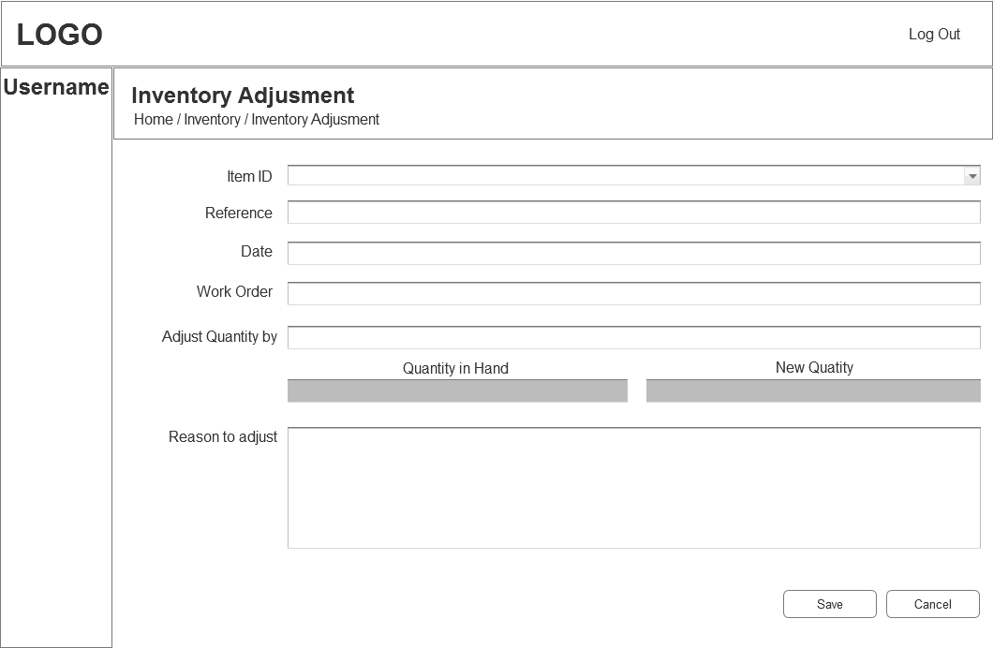

* 1. Stock Transfer
     1. User Interface

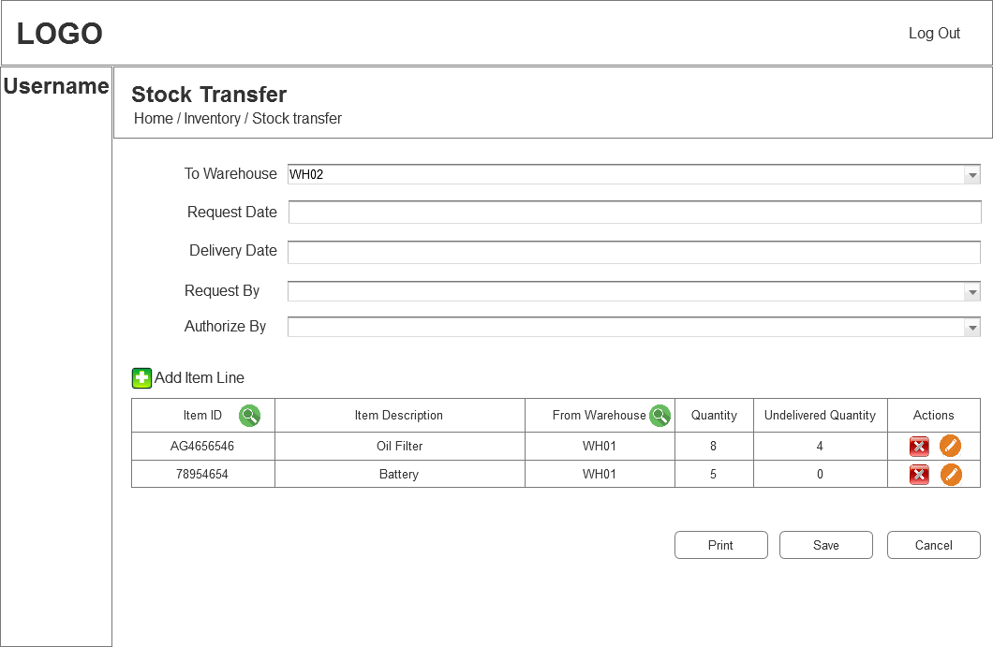

* 1. Purchase
  2. Order Stock
     1. User Interface

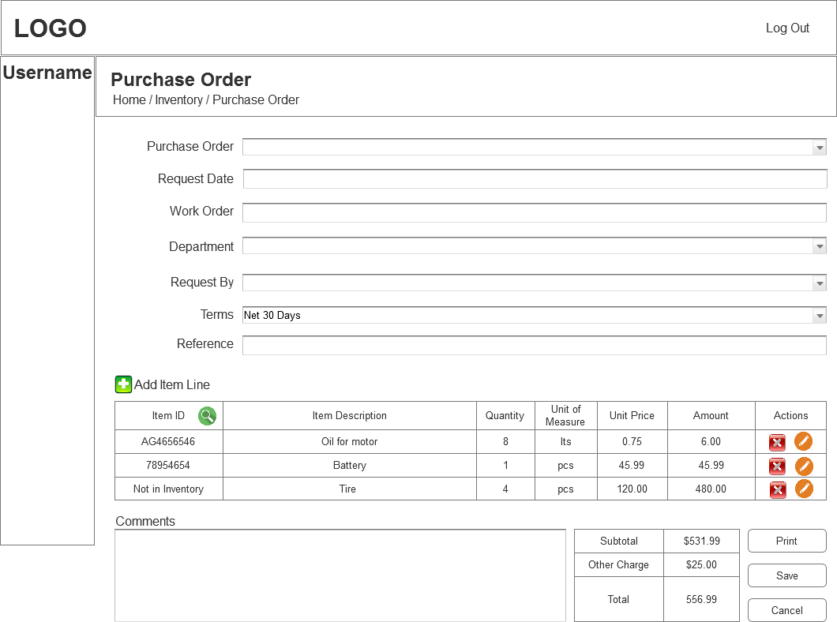

* 1. Receive Stock
  2. View Receive History
  3. View Items On Order
  4. Locations
  5. Material Requisition
     1. User Interface

