EE 444

Embedded Systems Design

Lab 3: MSP430: ADC12_A

*2/23/2017*

**Chic J O’Dell**

Does your solution work the way it’s supposed to work? □YES □NO1

1If your answer is NO, please explain in your report.

Instructor/TA comments and grading

# Objective and Background

use ADC12_A to sample various internal and external signals, and  
use the board’s LCD to display the results.

# Equipment

* CrossStudio for MSP430
* TI MSP-EXP430F5438 Experimenter Board
* Oscilloscope

# Procedure

Using SMCLK set to 16 MHz (in the same manner as in the past three labs) as an input to the ADC12_A. The ADC is then used to measure the internal temperature sensor located on the MSP silicon dye. To accomplish this the control registers for the ADC_12 were set as follows.

* REFCTL0: Enable the reference modual and make that reference available externally to the ADC
* ADCCTL0: Turn on the ADC, enable multiple sample conversion, set sample hold time to be sufficient for the temp sensors sample time (greater than 30 us).
* ADCCTL1: Set sample hold time to pulse mode, select SMCLK as an input, set the conversion sequence mode to “sequence of channels”.
* ADC12MCTLx: selecting the input for the ADC measurement as the internal temp sensor, set the reference voltage to Vref+ and Vref-, and for ADC12MCTL7 setting the end of sequence bit.
* *Provide a short description of how you did what you did in this lab, especially if there were different ways of doing it.*
* *Don’t copy the lab assignment’s procedure. Instead, give a summary of the steps you took to design and implement what you created in lab, in your own words.*
* *Make sure you mention all the wonderful things you did that were not specifically mentioned in the assignment.*

# Results

* *What happened?*
* *Did it work as expected?*
* *If not, why?*
* *If it did work, how could you make it better?*

# 5. Discussion and Questions

* *Answer the questions that were asked in the assignment (sometimes it might be more practical to include them in the previous section).*

# 6. Conclusion

* *What was the point of this lab?*
* *What did you learn from this lab?*

# 7. Attachments

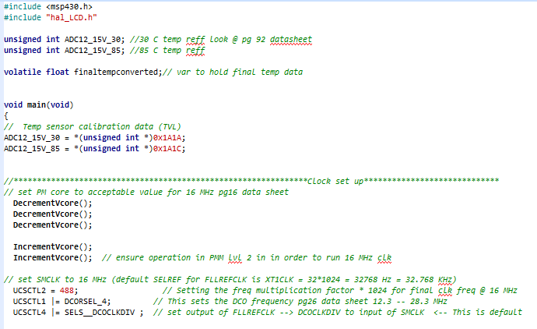

Figure : SMCLK set to 16 MHz.

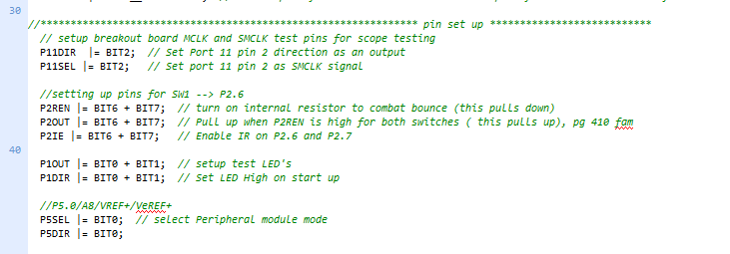

Figure : Pin setup for SMCLK breakout, Port 2 IR, SW LED toggle, Vreff Breakout

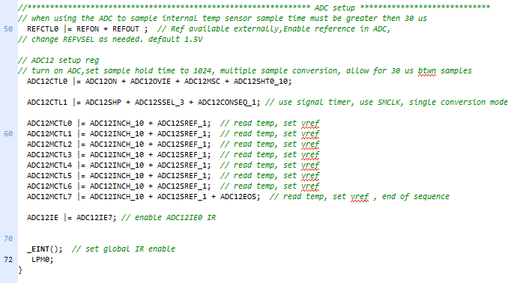

Figure : Setup ADC_12 and enter main LPM0

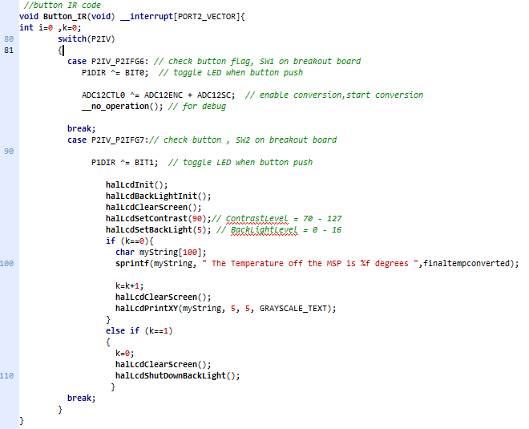

Figure : Port 2 interrupt service routine.

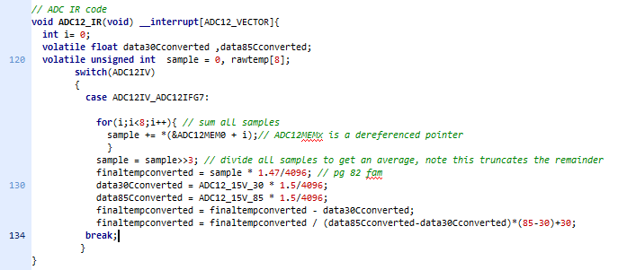

Figure : ADC_12 interrupt.