EE 444

MSP430-UART communication and interrupt mechanism

Lab 4: *MSP430: Digital I/O*

*3/10/2017*

**Chic J O’Dell**

Does your solution work the way it’s supposed to work? □YES □NO1

1If your answer is NO, please explain in your report.

Instructor/TA comments and grading

# Objective and Background

This lab is to introduce the USCI modal, specifically UART functionality. Using the MSP430 breakout board we will connect to a PC via serial connection in order to communicate ADC12 data, as well as echo back input chars and keep track of the number of chars entered.

# Equipment

* CrossStudio for MSP430
* TI MSP-EXP430F5438 Experimenter Board
* Oscilloscope

# Procedure

Beginning the lab SMCLK is set to 17 MHz. To accomplish this as in previous labs the proper core voltage and UCS settings are programed to the MSP. Port 11 pin 1 is set as an output of SMCLK in order to check its output is as desired.

In order for the UART to function the control registers are set as seen in the attached code, a synapsis of this is as follows. UART registers are set to facilitate communication from MSP to PC as seen in the Tera Term serial setup window as seen in Figure 1.

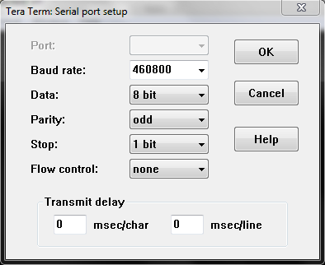

Figure : Tera Term Serial port setup for MSP430 UART transmission.

To accomplish this setup most UART CTL register settings are left at default with the exception of UCA1CTL0 parity enable setting (parity is odd by default). These settings are very important as your PC serial port will not preform without exact knowledge of the transmission protocol settings. UCA1CTL1 is set such that SMCLK is used for the UART modal and the software reset is enabled.

# 4. Results

* *What happened?*
* *Did it work as expected?*
* *If not, why?*
* *If it did work, how could you make it better?*

# 5. Discussion and Questions

* *Answer the questions that were asked in the assignment (sometimes it might be more practical to include them in the previous section).*

# 6. Conclusion

* *What was the point of this lab?*
* *What did you learn from this lab?*

# 7. Attachments

* *Additional oscilloscope printouts, code, etc.*