# Application of Electromagnetic principles in Modern Weapon systems

Physics investigatory project (2022-2023)

**%name%**

**%class% – %section%**

# Index

1. Aim
2. Introduction
3. Basics
4. Design
5. Advantages
6. Disadvantages
7. Conclusion
8. Bibliography

# Aim

The aim of this investigatory project is to study the applications of Electromagnetic principles in Modern Weapon systems by investigating the **Rail gun** a high velocity projectile launching weapon.

# Introduction

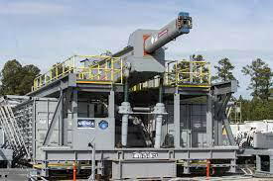

A prototype rail gun.

A **railgun** or **rail gun** is a linear motor device. It uses electromagnetic force to launch high velocity projectiles. The projectile normally does not contain explosives, instead relying on the projectile's high speed, mass, and kinetic energy to inflict damage. The railgun uses a pair of parallel conductors (rails), along which a sliding armature is accelerated by the electromagnetic effects of a current that flows down one rail, into the armature and then back along the other rail.

While explosive-powered military guns cannot readily achieve a muzzle velocity of more than ≈2 km/s (Mach 5.9), railguns can readily exceed 3 km/s (Mach 8.8). For a similar projectile, the range of railguns may exceed that of conventional guns. The destructive force of a projectile depends upon its kinetic energy (the projectile's mass multiplied by its velocity squared) at the point of impact. Because of the potentially higher velocity of a railgun-launched projectile, its force may be much greater than conventionally launched projectiles of the same mass. The absence of explosive propellants or warheads to store and handle, as well as the low cost of projectiles compared to conventional weaponry, are also advantageous.

# Basics

The railgun in its simplest form differs from a traditional electric motor in that no use is made of additional field windings (or permanent magnets). This basic configuration is formed by a single loop of current and thus requires high currents (e.g., of order one million amperes) to produce sufficient accelerations (and muzzle velocities). A relatively common variant of this configuration is the *augmented railgun* in which the driving current is channelled through additional pairs of parallel conductors, arranged to increase ('augment') the magnetic field experienced by the moving armature. These arrangements reduce the current required for a given acceleration. In electric motor terminology, augmented railguns are usually series-wound configurations. Some railguns also use strong neodymium magnets with the field perpendicular to the current flow to increase the force on the projectile.

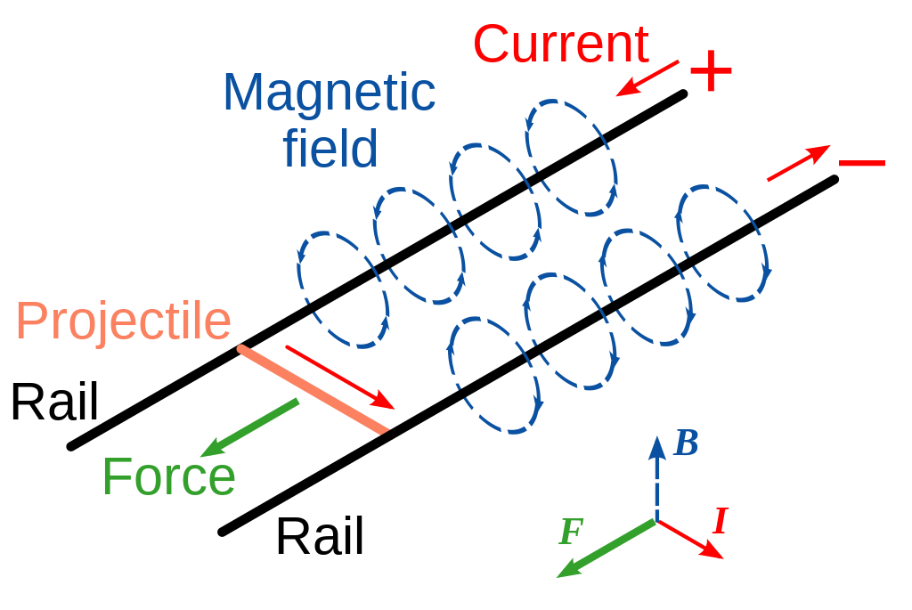

The armature may be an integral part of the projectile, but it may also be configured to accelerate a separate, electrically isolated or non-conducting projectile. Solid, metallic sliding conductors are often the preferred form of railgun armature but plasma or 'hybrid' armatures can also be used. A plasma armature is formed by an arc of ionised gas that is used to push a solid, non-conducting payload in a similar manner to the propellant gas pressure in a conventional gun. A hybrid armature uses a pair of plasma contacts to interface a metallic armature to the gun rails. Solid armatures may also 'transition' into hybrid armatures, typically after a particular velocity threshold is exceeded. The high current required to power a railgun can be provided by various power supply technologies, such as capacitors, pulse generators and disc generators.

For potential military applications, railguns are usually of interest because they can achieve much greater muzzle velocities than guns powered by conventional chemical propellants. Increased muzzle velocities with better aerodynamically streamlined projectiles can convey the benefits of increased firing ranges while, in terms of target effects, increased terminal velocities can allow the use of kinetic energy rounds incorporating hit-to-kill guidance, as replacements for explosive shells. Therefore, typical military railgun designs aim for muzzle velocities in the range of 2,000–3,500 m/s (4,500–7,800 mph; 7,200–12,600 km/h) with muzzle energies of 5–50 megajoules (MJ). For comparison, 50 MJ is equivalent to the kinetic energy of a school bus weighing 5 metric tons, traveling at 509 km/h (316 mph; 141 m/s). For single loop railguns, these mission requirements require launch currents of a few million amperes, so a typical railgun power supply might be designed to deliver a launch current of 5 MA for a few milliseconds. As the magnetic field strengths required for such launches will typically be approximately 10 tesla (100 kilogauss), most contemporary railgun designs are effectively air-cored, i.e., they do not use ferromagnetic materials such as iron to enhance the magnetic flux. However, if the barrel is made of a magnetically permeable material, the magnetic field strength increases because the increase in permeability (*μ* = *μ*0\**μ*r, where *μ* is the effective permeability, *μ*0 is the permeability constant and *μ*r is the relative permeability of the barrel) This increases the force on the projectile.

Railgun velocities generally fall within the range of those achievable by two-stage light-gas guns; however, the latter are generally only considered being suitable for laboratory use, while railguns are judged to offer some potential prospects for development as military weapons. A light gas gun, the Combustion Light Gas Gun in a 155 mm prototype form was projected to achieve 2500 m/s with a 70 caliber barrel. In some hypervelocity research projects, projectiles are 'pre-injected' into railguns, to avoid the need for a standing start, and both two-stage light-gas guns and conventional powder guns have been used for this role. In principle, if railgun power supply technology can be developed to provide safe, compact, reliable, combat survivable, and lightweight units, then the total system volume and mass needed to accommodate such a power supply and its primary fuel can become less than the required total volume and mass for a mission equivalent quantity of conventional propellants and explosive ammunition. Arguably such technology has been matured with the introduction of the Electromagnetic Aircraft Launch System (EMALS) (albeit that railguns require much higher system powers, because roughly similar energies must be delivered in a few milliseconds, as opposed to a few seconds). Such a development would then convey a further military advantage in that the elimination of explosives from any military weapons platform will decrease its vulnerability to enemy fire.

# Design

**Theory**

A railgun consists of two parallel metal rails (hence the name). At one end, these rails are connected to an electrical power supply, to form the breech end of the gun. Then, if a conductive projectile is inserted between the rails (e.g. by insertion into the breach), it completes the circuit. Electrons flow from the negative terminal of the power supply up the negative rail, across the projectile, and down the positive rail, back to the power supply.

This current makes the railgun behave as an electromagnet, creating a magnetic field inside the loop formed by the length of the rails up to the position of the armature. In accordance with the right-hand rule, the magnetic field circulates around each conductor. Since the current is in the opposite direction along each rail, the net magnetic field between the rails (**B**) is directed at right angles to the plane formed by the central axes of the rails and the armature. In combination to all with the current (**I**) in the armature, this produces a Lorentz force which accelerates the projectile along the rails, always out of the loop (regardless of supply polarity) and away from the power supply, toward the muzzle end of the rails. There are also Lorentz forces acting on the rails and attempting to push them apart, but since the rails are mounted firmly, they cannot move.

By definition, if a current of one ampere flows in a pair of ideal infinitely long parallel conductors that are separated by a distance of one meter, then the magnitude of the force on each meter of those conductors will be exactly 0.2 micro-newtons. Furthermore, in general, the force will be proportional to the square of the magnitude of the current and inversely proportional to the distance between the conductors. It also follows that, for railguns with projectile masses of a few kg and barrel lengths of a few m, very large currents will be required to accelerate projectiles to velocities of the order of 1000 m/s.

A very large power supply, providing on the order of one million amperes of current, will create a tremendous force on the projectile, accelerating it to a speed of many kilometres per second (km/s). Although these speeds are possible, the heat generated from the propulsion of the object is enough to erode the rails rapidly. Under high-use conditions, current railguns would require frequent replacement of the rails, or to use a heat-resistant material that would be conductive enough to produce the same effect. At this time it is generally acknowledged that it will take major breakthroughs in materials science and related disciplines to produce high-powered railguns capable of firing more than a few shots from a single set of rails. The barrel must withstand these conditions for up to several rounds per minute for thousands of shots without failure or significant degradation. These parameters are well beyond the state of the art in materials science.

**Electromagnetic analysis**

This section presents some elementary analysis of the fundamental theoretical electromagnetic principles that govern the mechanics of railguns.

If a railgun were to provide a uniform magnetic field of strength ***B*** oriented at right angles to both the armature and the bore axis, then,

With an armature current ***I*** and an armature length ***l*** , the force ***F*** accelerating the projectile would be given by the formula:



Here the force, current and field are all treated as vectors, so the above vector cross product gives a force directed along the bore axis, acting on the current in the armature, as a consequence of the magnetic field.

In most simple railguns, the magnetic field ***B*** is only provided by the current flowing in the rails, i.e. behind the armature. It follows that the magnetic field will neither be constant nor spatially uniform. Hence, in practice, the force must be calculated after making due allowances for the spatial variation of the magnetic field over the volume of the armature.

To illustrate the principals involved, it can be useful to consider the rails and the armature as thin wires or "filaments". With this approximation, the magnitude of the force vector can be determined from a form of the Biot–Savart law and a result of the Lorentz force. The force can be derived mathematically in terms of the permeability constant (${}_{}μ_{°}$), the radius of the rails (which are assumed to be circular in cross section) ($rr$), the distance between the central axes of the rails ($dd$) and the current ($ΙΙ$) as described below.

First, it can be shown from the Biot–Savart law that at one end of a semi-infinite current-carrying wire, the magnetic field at a given perpendicular distance ($ss$) from the end of the wire is given by

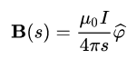

Note this is if the wire runs from the location of the armature e.g. from x = 0 back to $xx= -∞$ and $s$  is measured relative to the axis of the wire.

So, if the armature connects the ends of two such semi-infinite wires separated by a distance, $d$ , a fairly good approximation assuming the length of the wires is much larger than $d$ , the total field from both wires at any point on the armature is:



Where $s$    is the perpendicular distance from the point on the armature to the axis of one of the wires.

Note that $dss\hat{φ }$ between the rails is $\hat{}\hat{z }$ assuming the rails are lying in the xy plane and run from x = 0 back to $x= -∞$  as suggested above.

Next, to evaluate the force on the armature, the above expression for the magnetic field on the armature can be used in conjunction with the Lorentz Force Law,

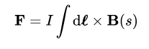

To give the force as

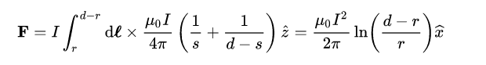

This shows that the force will be proportional to the product of $μ_{°}$  and the square of the current, $I$ $iiiii$ . Because the value of *μ*0 is small (4*π*×10−7 H/m) it follows that powerful railguns need large driving currents.

The above formula is based on the assumption that the distance ($l$ $l$) between the point where the force (***F***) is measured and the beginning of the rails is greater than the separation of the rails ($d$ $.d$) by a factor of about 3 or 4 ($l>3d$ $.$). Some other simplifying assumptions have also been made; to describe the force more accurately, the geometry of the rails and the projectile must be considered.

With most practical railgun geometries, it is not easy to produce an electromagnetic expression for the railgun force that is both simple and reasonably accurate. For a more workable simple model, a useful alternative is to use a lumped circuit model, to describe the relationship between the driving current and the railgun force.

In these models the railgun is modelled on an electrical circuit and the driving force can be determined from the energy flow in the circuit. The voltage across the railgun breech is given by

C:\Users\Sachin\Desktop\Capture.PNG

So the total power flowing into the railgun is then simply the product $VI$ $α$. This power represents an energy flow into three main forms: kinetic energy in the projectile and armature, energy stored in the magnetic field, **B** and energy lost via electrical resistance heating of the rails (and armature).

As the projectile travels along the barrel, the distance from the breech to the armature increases. Hence the resistance and inductance of the barrel also increase. For a simple model, the barrel resistance and inductance can be assumed to vary as linear functions of the projectile position, **x**, so these quantities are modelled as



Where $R^{'}$ is the resistance per unit length and $L^{'}$ is the inductance per unit length, or the inductance gradient. It follows that



Where $dx/dt$ is the all-important projectile velocity, $v$ . Then



Now, if the driving current is held constant, the $dI/dT$ term will be zero. Resistive losses now correspond to a power flow ${ I}^{2}R^{'}x$, while the power flow $I^{2}L^{'}v$ represents the electromagnetic work done.

This simple model predicts that exactly half of the electromagnetic work will be used to store energy in the magnetic field along the barrel, $L^{'}xI^{2}/2$, as the length of the current loop increases.

The other half of the electromagnetic work represents the more useful power flow - into the kinetic energy of the projectile. Since power can be expressed as force times speed, this shows the force on the railgun armature is given by

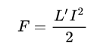

This equation also shows that high accelerations will require very high currents. For an ideal square bore single-turn railgun, the value of $L^{'}$ would be about 0.6 microHenries per meter (μH/m) but most practical railgun barrels exhibit lower values of $L^{'}$ than this. Maximizing the inductance gradient is but one of the challenges faced by the designers of railgun barrels.

Since the lumped circuit model describes the railgun force in terms of fairly normal circuit equations, it becomes possible to specify a simple time domain model of a railgun. Ignoring friction and air drag, the projectile acceleration is given by

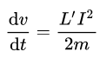

Where *m* is the projectile mass. The motion along the barrel is given by



And the above voltage and current terms can be placed into appropriate circuit equations to determine the time variation of current and voltage.

It can also be noted that the textbook formula for the high frequency inductance per unit length of a pair of parallel round wires, of radius r and axial separation d is:

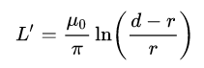

So the lumped parameter model also predicts the force for this case as:

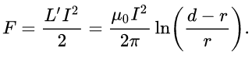

With practical railgun geometries, much more accurate two or three dimensional models of the rail and armature current distributions (and the associated forces) can be computed, e.g., by using finite element methods to solve formulations based on either the scalar magnetic potential or the magnetic vector potential.

# Advantages

* Higher muzzle velocity than conventional guns allowing for more heavier and sophisticated payloads to be fired.
* Increased range and high accuracy than conventional guns and explosives.
* They cover a much larger area of attack.
* The cost per shot is far less than missiles and turrets.
* As there is no need of explosives to operate it improves the on board safety of personnel.
* They are not subjected to line of sight problems like with laser guided weapons.
* Less moving parts contribute to a mechanically simple and reliable weapon.

# Disadvantages

* As the weapon uses electricity to accelerate the projectile it requires high voltage energy at a massive scale.
* The weapon itself is very time-consuming to manufacture and implement in existing military installations.
* It is not very economical as a single one of these rail guns takes over $400 million to develop.
* It is not easily portable compared to that of a turret or a missile launcher.
* Due to its special nature requires personnel with a specific skill set to operate.
* The gun is not very durable as the rails wear out due to high velocity projectiles very quick and takes a lot of time and labour to replace with a new one.
* The rail gun fails to shoot multiple shots in a short period of time. It takes around 10 – 25 minutes between each shot.
* Due to its extreme physical nature payloads in the gun have to be made with strict constrains. The U.S. Navy's RFP Navy SBIR 2012.1 – Topic N121-102 for developing such a projectile gives a good overview of just how challenging railgun projectile development is:

The projectile must fit within the mass (< 2 kg), diameter (< 40 mm outer diameter), and volume (200 cm3) constraints of the projectile and do so without altering the center of gravity. It should also be able to survive accelerations of at least 20,000 g (threshold) / 40,000 g (objective) in all axes, high electromagnetic fields (E > 5,000 V/m, B > 2 T), and surface temperatures of >800 deg C. The projectile should be able to operate in the presence of any plasma that may form in the bore or at the muzzle exit and must also be radiation hardened owing to exo-atmospheric flight. Total power consumption must be less than 8 watts (threshold)/5 watts (objective) and the battery life must be at least 5 minutes (from initial launch) to enable operation during the entire engagement. In order to be affordable, the production cost per projectile must be as low as possible, with a goal of less than $1,000 per unit.

# Conclusion

The rail gun is an interesting application of electromagnetic principles. It is very amazing to see simple principle like a solenoid being able to accelerate objects to incredible velocities. Precisely timed electromagnets and high voltage transformers all work together in symphony to create the weapons of tomorrow while showing us the significance of physics and its principle’s significance in the course of one’s life and human future.

# Bibliography

Major reference:

<https://en.wikipedia.org/wiki/Railgun>

Other references:

<https://www.forbes.com/sites/lorenthompson/2017/07/19/navys-hypervelocity-railgun-could-be-a-gamechanger-if-congress-funds-it>

<https://www.electropages.com/blog/2020/01/four-things-know-about-railguns>

<https://cove.army.gov.au/article/future-battlefield-what-impact-will-railguns-have>