Physics Investigatory project (2022-23)

Topic :-

To find the refractive indices of (a) water (b) oil using a plane mirror, an equiconvex lens and an adjustable object needle.

Name - %name%

Class – %class%

Sec - %section%

INDEX:-

S.no Topics

1 INTRODUCTION

2 OBJECTIVE / AIM

3 APPARATUS / MATERIAL REQUIRED

4 DIAGRAM

5 THEORY

6 PROCEDURE

7 OBSERVATIONS

8 CALCULATIONS

9 RESULTS

10 PRECAUTIONS

11 SOURCES OF ERRORS

12 BIBLIOGRAPHY

AIM:-

To find the refractive indices of (a) water (b) oil using a plane mirror, an equiconvex lens and an adjustable object needle.

INTRODUCTION:-

In optics, the refractive index or index of refraction n of a material is a dimensionless number that describes how light propagates through that medium. It is defined as

n=c/v

Where cis the speed of light in vacuum and vis the phase velocity of light in the

medium. For example, the refractive index of water is 1.333; meaning that light travels

1.333 times faster in a vacuum than it does in water.

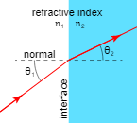

REFRACTION OF A LIGHT:-

When a light ray is incident on the surface separating two media, the direction of the ray changes. This phenomenon is known as the [Reraction](https://www.vedantu.com/physics/refraction)of light. The speed of light is maximum in the [vacuum](https://www.vedantu.com/physics/vacuum). In any medium, light travels with less speed. Due to this, the direction of light changes at the interface of two different media. The frequency of the incident light remains constant but the speed and wavelength change. When a light ray enters a denser medium, it bends closer to the normal whereas for a lighter medium, the ray shifts away from the normal.

APPARATUS:-

* CONCAVE
* PLANE MIRROR
* WATER
* OIL
* CLAMP STAND
* AN OPTICAL NEEDLE
* PLUMB LINE
* KNITTING NEEDLE
* HALF METER SCALE
* GLASS SLAB
* SPHEROMETER

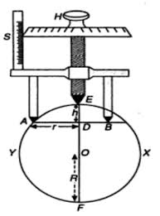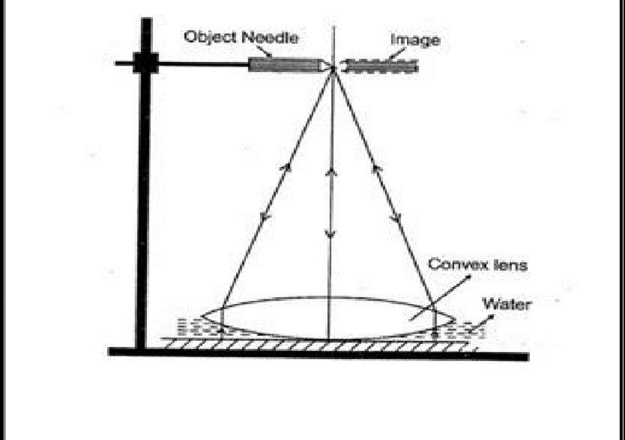DIAGRAM:-

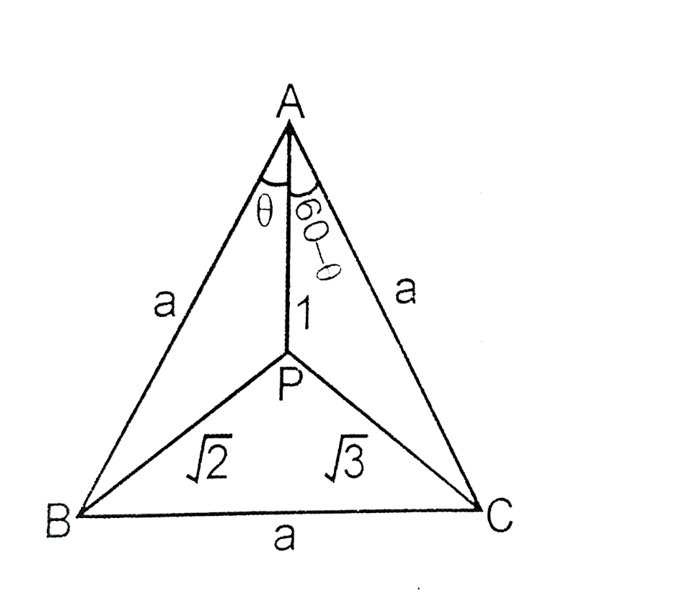



THEORY:-

1. If f7 and f2 be the focal length of the glass convex

lens and liquid lens and f be the focal length of their

combination then: -

1/f=1/f1+1/f2 (or) f2= Ff2/f1-F

2. Liquid lens formed a Plano-concave Lens with RI=R and R2= ∞ then by using lens make’s formula.

1/f2=(n-1)[1/R1-1/R2]

=(n-1)[1/R1-1/∞ ]

=(n-1)[1/R-0]

1/f2=n-1/R

n= R/f2+1

3.The radius of the lower surface of the convex lens is given by :

R= l^2/6h+h/2

Here,l is the average distance between the legs of the spherometer and h is the difference in the reading of the spherometer when placed first on the convex lens and then on plane mirror.

procedure:-



1. For focal length of convex lens:-

1. Find the rough focal length of the convex lens.

2. Place a plane mirror on the horizontal base of the

iron stand and then a convex lens on the plane mirror.

3. Hold the needle in the clamp stand and adjust its

position on the stand such that there is no parallax

between tip of the needle and its image.

4. Measure distance between tip and upper surface of

the lens by using a plumb line and half meter scale. Also

measure the distance between tip of needle and upper

surface of the mirror. Take the mean of the two

readings. This means distance will be equal to the focal

length of the convex lens (f1).

1. For focal length of the combination:-

5.Put a few drops of the water on the plane mirror and

put the convex lens over it with its same face above as

before. The water spreads in a form of layer and acts like a Plano-concave lens.

6. Repeat the steps 3 and 4 to determine the equivalent

focal length of the combination.

7. Record the observation.

8. Repeat the steps 5, 6, 7 for other transparent liquid(oil).

(c) Forradius of curvature of convex lens surface:-

9.Determine the pitch and the least count of the spherometer.

10. Remove the convex lens and dry it completely. Put

the spherometer on this lens surface.

11. All the three legs of the spherometer should be placed symmetrically on the lens and adjust the central screw tip to touch the surface of the lens.

12. Remove the spherometer from the surface of the lens

and place on the plane mirror surface and record the reading.

13. Repeat the steps 10 and 11 three times.

14. Obtain the impressions of the three legs of the spherometer on a paper and mark them and their average distance.

L=l1+l2+l3/3

Observation :-

Pitch of the spherometer= 1 cm

Least count of the spherometer = 0.01 cm

Distance between the legs:

(1)AB = 3cm

(2)BC = 3cm

(3)CA = 3cm

Table for calculation of ‘h’:-



| S.no | Initial reding of the C.S. on the convex lens  (a) | No.of complete reactions  (n | Final reading of the C.S n the glass slab | Additional C.S div.moved | h=n x pitch+m x  L.c | Mean  “h”(cm) |
| --- | --- | --- | --- | --- | --- | --- |
| 1 | 62 | 0 | 6.5 | 55.5 | 0.555 | 0.5775 |
| 2 | 64 | 0 | 4 | 60 | 0.6 |  |

To measure focal length ‘f’ of convex lens:-

|  |  | Distance of needle tip from |  |  |  |
| --- | --- | --- | --- | --- | --- |
| Area between lens and plane mirror | S.no | Tip of the upper surface of the convex lens (cm) X1 | Upper surface of the plane mirror (cm) X2 | Mean  X=x1+x2/2 | Focal length  (cm) |
| Without liquid | 1 | 30.5 | 31 | 30.75 | f1=33.85 |
| 2 | 36.7 | 37.2 | 36.95 |
| With water | 1 | 31.4 | 31.8 | 31.6 | f2=34.7 |
| 2 | 37.5 | 38.1 | 37.8 |
| With oil | 1 | 9.4 | 9.6 | 9.5 | f3=10 |
| 2 | 10.4 | 10.6 | 10.5 |

Calculations :-

Mean distance between two legs

l=AB+BC+CA/3=3cm

Mean of h =(0.555+0.6)/2=0.5775cm

To find the radius of curvature of the convex lens :

R=l^2/6h+h/2=2.8861cm

Measurement of refractive indices of water and oil

1. With water between the convex lens and the plane mirror:

 μ1=1+R/f2=1+2.8861/34.7=1.0831

1. With oil between the convex lens and the plane mirror:

 μ2=1+R/f3=1+2.8861/10=1.2886



Result:-

* The refractive index of water is  μ1 = 1.0831
* The refractive index of oil is  μ2 = 1.2886

Precautions :-

1.The plane mirror should be clean and fully shining surface.

2. The liquid taken should be transparent.

3. The parallax should be removed tip to tip.

4. The eye should be at a distance about 30 cm from the needle while removing the parallax.

5. Only few drops of liquid should be taken so that its

layer should be thick.

6. The legs of the spherometer should be vertical.

7. The centre leg of the spherometer should turn in one

direction only.

Sources of error :-

* Liquid may not be quite transparent.

* The parallax may not be fully removed.

* The spherometer legs should be placed symmetrical on the surface of the convex lens.

* The tip of the central screw should not just touch the surface of lens or mirror.

Bibliography:-

# Help from internet

# Help from teachers

# NCERT physics lab manual

# [www.google.com](http://www.google.com)

# [www.wikipedia.com](http://www.wikipedia.com)