The microservice architecture is a software design approach that decomposes an application into small independent services that communicate over well-defined APIs. Since each service can be developed and maintained by autonomous teams, it is the most scalable method for software development.

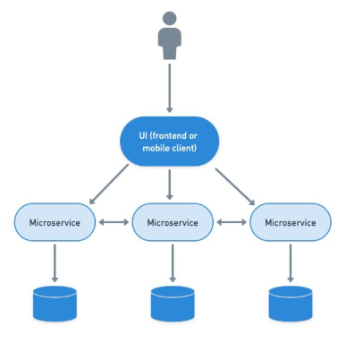

* A microservice is responsible for a single capability.
* A microservice is individually deployable.
* A microservice consists of one or more processes.
* A microservice owns its own data store.
* A microservice is replaceable.

In Bucstop, under MicroServices there are two cs files named MicroClient, which houses the get method for the games and deserializes them from Json. The other being GameInfo.cs which is the class that holds the game’s attributes. The meat and potatoes of the games are in wwwroot/js.

In the MicroServices project, under controllers, there is a file named microController.cs. In this file is the game’s information that was gotten from an HTTP call to route /Micro.