Documentation
Daniel Enns
2025-11-21
Table of contents

This document…
is a detailed explanation of the data and model generating process for the paper “Urban land use and related infrastructure limit ecological status of freshwater invertebrates”. It describes the procedures of how to delineate watersheds, how to build a stream network for routing and how the variables were quantified. Futher, details about an initial explorative data analysis, analysis of spatial autocorrelation, as well as data cleaning and feature engineering are described. Finally, model construction, which includes task and learner setup and model tuning and tuning evaluation are explained.

Methods

0.1 Library
The following packages are needed for the analysis:
# general
library(readxl)
library(tidyverse)
library(dtplyr)
library(data.table)
library(cowplot)
# Saptial analysis
library(geodata)
library(stars)
library(sf)
library(spdep)
library(nngeo)
library(sfnetworks)
library(tidygraph)
library(whitebox)
library(osmextract)
library(httr2)
library(tmap)
library(units)
# modeling
library(mlr3verse)
library(mlr3spatiotempcv)
library(ranger)
library(iml)
library(pdp)
library(doParallel)
library(parallelMap)

0.2 Combining Spatial Data

0.2.1 Point features
For the spatial analysis all necessary shape and raster files are projected into EPSG 25832.
The freshwater invertebrate sampling sites, as well as the data on WWTPs, stormwater overflows (SOs) and barriers can readily be loaded into R. Sampling sites located on large Rivers (e.g. Rhine, Main, Weser) were excluded, due to incomplete catchment data.
# load and filter invertebrate sampling sites
mzb <- read_delim("./MZB.csv", delim = ";") %>%
bind_cols(mzb, stream_net[st_nearest_feature(mzb, stream_net),]) %>%
select(-geom) %>%
filter(!GEWKZ %in% c("2", "238", "24", "41", "4", "44", "239152", "23932", "2396", "23988", "24779892"))
Highway and railroad networks can be read in from OpenStreetMap pbf files via the osmextract package. These can be intersected with the stream network to create point features. In the osm highway and railroad networks, each lane / track is represented as an individual line feature, so that multiple crossings are present in locations with high lane / track density.
# Extract highway and railroad networks
transport_net <- oe_read("./hessen-latest.osm.pbf", extra_tags = "railway") %>%
filter(highway == "motorway" | railway == "rail") %>%
st_transform(st_crs(stream_net))
# Intersect with stream network
crossings <- st_intersection(stream_net, transport_net) %>%
st_cast("POINT")

0.2.2 Watershed delineation
In order to delineate upstream watersheds for each bio sampling site the SRTM GL1 30m (OpenTopography 2013) digital elevation model will be used to extract flow accumulation and pointer grids, from which the watersheds are calculated. However, the delineation algorithms struggles in regions with low profiles (namely the Rhine basin), creating an inaccurate stream raster and watersheds. To improve accuracy, the existing stream network is burned into the DEM following these steps in QGIS:
- Reproject raster network to stream CRS (EPSG: 25832)
- dissolve the stream network
- Run the Grass r.carve algorithm with a stream width of 60 m, depth of 3 m and with no flat areas in direction of stream flow allowed (Note: the algorithm does not work on latitude-longitude CRS, see r.carve GRASS GIS manual)
The algorithm will take some time to run (approximately 1 hour and 18 minutes with an Intel core i7, 16 GB RAM). Finally, watersheds can be extracted using the whitebox package (Wu and Brown 2025), following the instructions from Gannon, 2024.
# Breach and fill pits in raster
wbt_breach_depressions_least_cost(
dem = "./SRTMGL1_30m_2px_burned.tif",
output = "./srtm_breach.tif",
dist = 7,
fill = T
)
# Create flow accumulation & pointer grids
wbt_d8_flow_accumulation(
input = "./srtm_breach.tif",
output = "./D8FA.tif"
)
wbt_d8_pointer(
dem = "./srtm_breach.tif",
output = "./D8pointer.tif"
)
# Extract streams
wbt_extract_streams(
flow_accum = "./D8FA.tif",
output = "./stream_raster.tif",
threshold = 700
)
# Snap points to stream raster
wbt_jenson_snap_pour_points(
pour_pts = "./MZB.shp",
streams = "./stream_raster.tif",
output = "./MZB_snap.shp",
snap_dist = 300
)
# Delineate watersheds
wbt_watershed(
d8_pntr = "./D8pointer.tif",
pour_pts = "./MZB_snap.shp",
output = "./watersheds.tif"
)
Figure 1 demonstrates the structure of the watersheds, which were build consecutively between multiple pour points.
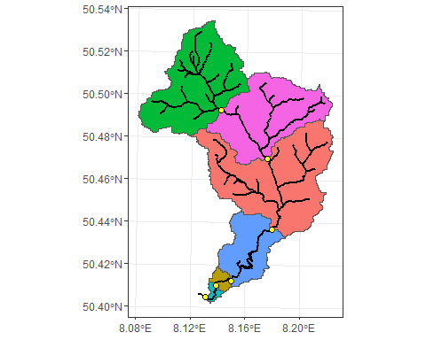
Figure 1: Example watershed. Each watershed is build consecutively between specified pourpoints.
The created watershed raster can be read in and converted to polygon features, which subsequently be used to intersect the CORINE Land Cover polygons. The area of each intersection can be calculated using the st_area() function.
# Read in Watersheds and convert to polygon
ws_poly <- read_stars("./watersheds.tif") %>%
st_as_sf(as_points = F, merge = T)
# Create dataframe with land cover areas
landcover_ws <- st_intersection(landcover, ws_poly) %>%
mutate(area = st_area(.)) %>% st_drop_geometry() %>%
as.data.frame() %>% filter(!is.na(type))
# Summarize land cover types in each watershed
landcover_sum <- landcover_ws %>% group_by(watersheds.tif, type) %>%
summarize(area = sum(area)) %>%
pivot_wider(names_from = type, values_from = area)
# Combine watersheds with summarized land cover
watersheds_lc <- left_join(ws_poly, landcover_sum, by = "watersheds.tif")

0.2.3 Network building
The Hessian stream network is a collection of 100 m long line segments, each containing a stream ID and a segment ID. The stream ID is designed in such a way, that it consecutively builds upon the ID of a previous stream segment, adding numbers to it whenever the stream splits in upstream direction. The segment number increases towards the source of a stream (Fig. 2). Each 100 m segment already contains information on the in-stream and surrounding habitat structural quality (1 - pristine to 7 - completly altered).
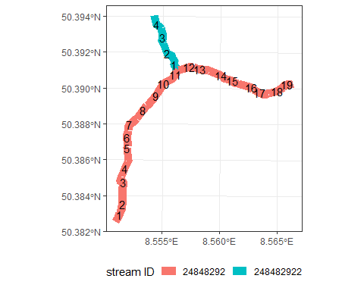
Figure 2: Example of stream- and segment ID system. The segment number increases in the direction of the source. The stream ID of smaller confluence resembels always that of the bigger stream, in which it flows into, plus additional numbers.
The sfnetwork package (van der Meer et al. 2024) provides many useful functions for network analysis and routing operations, where the main function as_sfnetwork() builds a network by connecting aligning nodes. An initial build reveals that many stream segments visually seem connected, but are separated from their nearest node or edge by a few meters. Thus, to build a useful network for routing the precision of the stream network sf object needs to be lowered (for more information see Details on st_set_precision() and st_as_binary() help page). To what precision to round depends, in general, on the maximum distance of dangling nodes and if the network can be build by connecting nodes with edges, or just by connecting nodes. The precision will be set to 70 meters (be aware of the object CRS units!).
In the resulting network, the right streams are connected (Fig. 3) and it can be used for routing operations. Performance of routing can be greatly increased by simplifying the network and removing pseudo-nodes (more info here).
# Lower precision to 70 meters
str_net_70m <- st_set_precision(stream_net, set_units(70, "m"))
# Create sf_network object, simplify and smooth pseudo-nodes
network <- as_sfnetwork(str_net_70m) %>% convert(to_spatial_simple) %>%
convert(to_spatial_smooth)
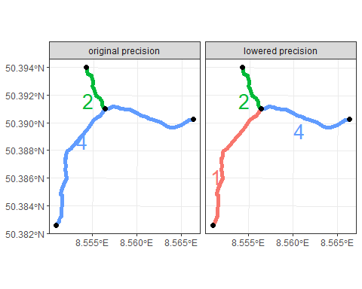
Figure 3: Example for how precision changes the connectedness of the network. The numbers indicate from which node a stream originates.
Sampling sites and point stressors can be blend in as nodes into the created network.
# Blend in sampling sites, wastewater treatment plants and dams
network_blend <- st_network_blend(network, mzb) %>% st_network_blend(.,wwtp) %>%
st_network_blend(.,dams)

0.3 Spatial Data quantification
For the quantification of point- and polygon features and their attributes I wrote two custom functions, st_shift() and upstream_summarize(). The first function is required within the latter and shifts a set of point geometries a proportional distance towards another specified point. The upstream_summarize() function builds a sub-network from a given point to all its vertices (stream sources) and extracts the node data, from which it counts the number of specified nodes and sums up specified attribute values. Further, it can calculate the minimal, maximal, or average network distance between the start point and a set of nodes specified by their IDs with the IDs argument. If no such nodes are present in the sub-network, inf or NaN values are returned. Additionally the Shreve stream magnitude, defined as the sum of sources upstream from a specified node, can be calculated. The function can sum up attribute values of provided polygons the following way: First, the set of nodes present in the sub-network are shifted towards their centroid by 0.1% of their length, to avoid including adjacent polygons. Then, it creates a filtering mask by selecting all polygons which are touched by the shifted nodes and fills in ‘holes’ in the set of polygons. By setting a threshold, the mask can be shrunken to avoid selecting adjacent polygons. This mask is finally used to select all polygons present in the sub-network, from which their specified attributes are summarized. The function contains the following set of arguments:
- net : The complete network with blended in points of interest
- start : Row number of node from which to rout upstream
- node_cols : Names of attribute columns to summarize, present in nodes
- IDs : ID columns for sets of nodes, which should be unique in each set
- area : sf object with only polygon geometries
- area_cols : names of attribute columns to summarize, present in area
- dist : Either 'min', 'max', 'mean', or 'all'. Calculates distances between start and nodes, specified by IDs.
- threshold : Value (in polygon CRS units) by which the polygon mask should be shrunken.
- Shreve : logical, should Shreve stream magnitude be calculated?
Before this function can be used, the points from which the function should rout must be extracted as nodes from the network and their row name must be saved as a new column.
# Extract nodes of invertebrate sampling sites and add row names
mzb_nodes <- st_as_sf(network_blend, "nodes") %>% filter(!is.na(ID_SITE)) %>%
mutate(ID_NODE = row.names(nodes)[with(nodes, !is.na(ID_SITE))])
upstream_summarize() can be used in combination with rowwise() and mutate() to perform the action over multiple points. Depending on the number of nodes within the entire network, this task can take quite a lot of time. Luckily this task can be parallelized to save a lot of time.
# Set up cluster
num_cores <- (detectCores()-1)
num_cores %>% makeCluster() %>% registerDoParallel()
# Split data into chunks
data_chunks <- mzb_nodes %>%
split(., ceiling(seq_along(row_number(.)) / (length(row_number(.)) %/% num_cores)))
# Apply upstream_summarize parallel and row-wise over all sampling site nodes
mzb_data_complete <- foreach(chunk = data_chunks, .combine = rbind, .packages = c("dplyr", "dtplyr","sf","sfnetworks","tidygraph","nngeo")) %dopar% {
chunk %>% rowwise() %>%
mutate(upstream_summarize(
net = network_blend,
start = ID_NODE,
node_cols = c("population_equivalents", "dam_discharge"),
IDs = c("ID_WWTP", "ID_DAMS"),
area = watersheds_lc,
area_cols = c("Agriculture", "Urban", "semi-Natural"),
dist = T,
threshold = 30)
)
}

0.4 Data analysis and handling

0.4.1 EDA
Before modeling it is good practice to get a sens of the target and explanatory variables. Here, multiple models should perform two different tasks, regression and multi-class classification. The respective target variables are the multi metric index (MMI) and the resulting ecological quality class (EQC). The MMI is a summarization of multiple core metrics, compared to reference conditions (for more details see (Hering et al. 2006)). It ranges from zero to one, representing bad to good condition respectively.
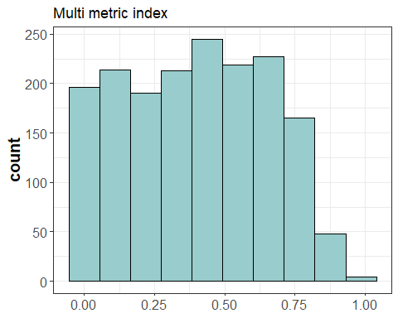
Figure 4: Histogram of the site averaged multi metric index.
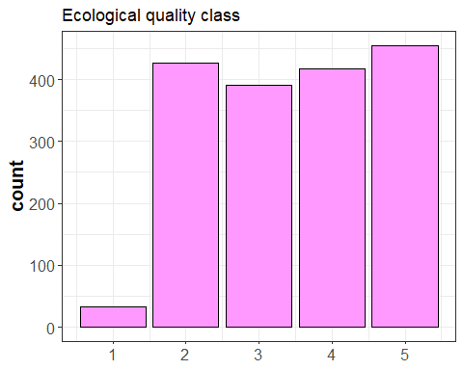
Figure 5: Histogram of the site averaged ecological quality class.
From the EQC histogram (Fig. 5) a strong class imbalance is observable. Since the classes are ordered categorical, the minority could be merged with an adjacent class. Although that would mean a loss of information, most practitioners are trying to achieve a “good or better” status for which a combination of the top two classes is legitimate.
Some covariates follow the same method of quantification and are therefore auto correlated by default. Sites at bigger reaches will have more point stressors in the upstream watershed compared to sites further upstream, therefore the different stressor covariates are automatically correlated. The correlation can be displayed in a correlation plot (Fig. 6).
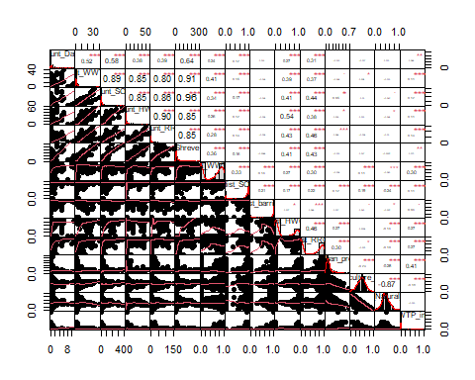
Figure 6: Correlation plot of covariates.
Tree ensemble learning algorithms are robust to autocorrelated covariates when it comes to overall model performance, but it is good to keep in mind that these relations between variables exist.

0.4.2 Spatial autocorrelation
Toblers first law states that “everything is related to everything else, but near things are more related than distant things”. This degree can be quantified by the Moranes Index, which can be calculated with distance-based weight matrix for points.
# K-nearest neighbours
suppressPackageStartupMessages(require(deldir))
data_nb_knn <- knn2nb(knearneigh(mzb_data_complete, k = 1))
# Distance neighbours
dsts <- unlist(nbdists(data_nb_knn, mzb_data_complete))
summary(dsts)
max_1nn <- max(dsts)
data_nb_dst <- dnearneigh(mzb_data_complete, d1 = 0, d2 = 0.75*max_1nn)
data_lw <- nb2listw(data_nb_dst, style = "W", zero.policy = T)
# Moran statistics
moran.test(mzb_data_complete$MMI_mean, data_lw, alternative = "greater")
moran.plot(mzb_data_complete$MMI_mean, data_lw)
Min. 1st Qu. Median Mean 3rd Qu. Max.
1.0 332.7 840.2 1197.1 1663.7 8718.0
Moran I test under randomisation
data: data_all$MMI_mean
weights: data_lw
n reduced by no-neighbour observations
Moran I statistic standard deviate = 39.571, p-value < 2.2e-16
alternative hypothesis: greater
sample estimates:
Moran I statistic Expectation Variance
0.4357911968 -0.0005844535 0.0001216123
The index shows a significant deviation from the expectation, signifying strong spatial autocorrelation. This can also be visualized with a Moranes plot (Fig. 7).
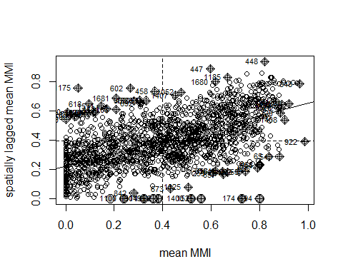
Figure 7: Moranes plot for the site averaged multi metric index.
Consequently, the spatial heterogenity should be kept in mind for model tuning and cross validation (Schratz et al. 2019).

0.4.3 Data cleaning and feature engineering
Tree ensemble learning algorithms can handle covariates of different types and are robust to auto-correlated covariates. Nevertheless, it is good practice to clean and modify desired features before modeling. For each sampling site, land use types in the upstream watershed were calculated as proportions to the total watershed area.
Distance variables where transformed into relative inverse distances:
$$dist_{inverse}=1−x/\left(x_{max}+5m\right)$$
Where $x$ is the distance to the closest point stressor in meters and $x_{max}$ is the maximal distance to the closest point stressor in meters.
The Wastewater impact was calculated as the cumulative number of population equivalents from all WWTPs upstream of a sampling site, divided by the Shreve stream magnitude of the sampling site.
The set of variables, used in the consecutive section were:
Table 1: Variables used for modelling
Variable | Description | Average | Range
count_Dam | count of Dams upstream | 0.48 | 0-11
count_WWTP | count of wastewater treatment plants upstream | 3.1 | 0-40
count_SO | count of stormwater overflows upstream | 30.86 | 0-401
count_ HWC | count of higway crossings upstream | 3.97 | 0-58
count_RRC | count of railroad crossings upstream | 9.36 | 0-153
dist_barrier | distance to nearest hydrological barrier upstream | 0.91 | 0-1
dist_WWTP | distance to nearest wastewater treatment plant upstream | 0.48 | 0-1
dist_SO | distance to nearest stormwater overflow upstream | 0.84 | 0-1
dist_HWC | distance to nearest highway crossing upstream | 0.29 | 0-1
dist_RRC | distance to nearest railroad crossing upstream | 0.4 | 0-1
prop_agri | proportion of agricultural area in upstream catchment | 0.4 | 0-0.99
prop_urb | proportion of urban area in upstream catchment | 0.1 | 0-0.68
prop_nat | proportion of semi-natural area in upstream catchment | 0.45 | 0-1
WWTP_imp | wastewater impact | 0.02 | 0-1
HQ | habitat quality
ST | stream type
Shreve | Shreve stream magnitude | 32.25 | 1-295

0.5 Modeling
To understand how the site averaged MMI and the averaged EQC are influenced by the variables in table 1, the relationships are modelled using ML algorithms. Since the MMI is a numeric and the EQC is a categorical variable, the tasks at hand are regression and classification respectively. The mlr3 package (Lang, Schratz, and Becker 2025) offers an extensive framework for model building, tuning, interpretation, etc.

0.5.1 Set-up tasks and learners
The regression and classification tasks are set-up by dropping the respective unnecessary target from the data and specify which features are coordinates for the spatial resampling technique mentioned later on. Then, the tasks are partitioned into training and test sets, with a default ratio of 67% to 33% respectively, using the same splits.
# seed
set.seed(1234)
# create task
tsk_reg <- data4model_fin %>% select(-EQC_mean) %>% as_task_regr_st(target = "MMI_mean", coordinate_names = c("X", "Y"))
tsk_classif <- data4model_fin %>% select(-MMI_mean) %>% as_task_classif_st(target = "EQC_mean", coordinate_names = c("X", "Y"))
# create partition
splits_reg <- partition(tsk_reg)
tsk_reg_train <- tsk_reg$clone()$filter(splits_reg$train)
tsk_reg_test <- tsk_reg$clone()$filter(splits_reg$test)
tsk_classif_train <- tsk_classif$clone()$filter(splits_reg$train)
tsk_classif_test <- tsk_classif$clone()$filter(splits_reg$test)
Data preprocessing, feature selection and modelling will be done using a graph learner (Fig. 8), a construct where data flows from one operator to another, potentially branching into different paths. This allows to examine how preprocessing methods, feature selection and choice of model algorithm influences the final model performance. The first branch in the graph is a division between performing a pca on scaled and standardized data, only scaling the data or performing no operation. The output is then one-hot encoded, turning categorical features into numerical ones, so that they can be used in the subsequent models. The second branch divides the paths into performing a feature selection based on feature importance, or to perform no operation. The final branch is the division between the model algorithms used, namely xgboost and random forest (ranger).
# regression
# create and plot graph learner
graph <- as_learner(
po("branch", c("nop", "scale", "pca"), id = "branch_1") %>>%
gunion(list(
po("nop"),
po("scale"),
po("pca", scale. = T, rank. = to_tune(p_int(1, 10, depends = branch_1.selection == "pca")))
)) %>>%
po("unbranch", id = "unbranch_1") %>>%
po("encode", method = "one-hot") %>>%
po("branch", c("nop", "filter"), id = "branch_2") %>>%
gunion(list(
po("nop", id = "nop_2"),
po("filter", filter = flt("importance", learner = lrn("regr.xgboost")), filter.nfeat = to_tune(p_int(1, tsk_reg$ncol, depends = branch_2.selection == "filter")))
)) %>>%
po("unbranch", id = "unbranch_2") %>>%
po("branch", c("xgboost", "ranger"), id = "branch_3") %>>%
gunion(list(
lrn("regr.xgboost"),
lrn("regr.ranger")
)) %>>%
po("unbranch", id = "unbranch_3")
)
# set additional params
graph$param_set$set_values(
branch_1.selection = to_tune(c("nop", "scale", "pca")),
branch_2.selection = to_tune(c("nop", "filter")),
branch_3.selection = to_tune(c("xgboost", "ranger")),
regr.xgboost.eta = to_tune(p_dbl(1e-04, 1, logscale = T, depends = branch_3.selection == "xgboost")),
regr.xgboost.nrounds = to_tune(p_int(1, 5000, depends = branch_3.selection == "xgboost")),
regr.xgboost.max_depth = to_tune(p_int(1, 20, depends = branch_3.selection == "xgboost")),
regr.xgboost.colsample_bytree = to_tune(p_dbl(0.1, 1, depends = branch_3.selection == "xgboost")),
regr.xgboost.colsample_bylevel = to_tune(p_dbl(0.1, 1, depends = branch_3.selection == "xgboost")),
regr.xgboost.lambda = to_tune(p_dbl(0.001, 1000, logscale = T, depends = branch_3.selection == "xgboost")),
regr.xgboost.alpha = to_tune(p_dbl(0.001, 1000, logscale = T, depends = branch_3.selection == "xgboost")),
regr.xgboost.subsample = to_tune(p_dbl(0.1, 1, depends = branch_3.selection == "xgboost")),
regr.ranger.mtry.ratio = to_tune(p_dbl(0, 1, depends = branch_3.selection == "ranger")),
regr.ranger.replace = to_tune(p_lgl(depends = branch_3.selection == "ranger")),
regr.ranger.sample.fraction = to_tune(p_dbl(0.1, 1, depends = branch_3.selection == "ranger")),
regr.ranger.num.trees = to_tune(p_int(1, 2000, depends = branch_3.selection == "ranger"))
)
# classification
graph_classif <- as_learner(
po("branch", c("nop", "scale", "pca"), id = "branch_1") %>>%
gunion(list(
po("nop"),
po("scale"),
po("pca", scale. = T, rank. = to_tune(p_int(1, 10, depends = branch_1.selection == "pca")))
)) %>>%
po("unbranch", id = "unbranch_1") %>>%
po("encode", method = "one-hot") %>>%
po("branch", c("nop", "filter"), id = "branch_2") %>>%
gunion(list(
po("nop", id = "nop_2"),
po("filter", filter = flt("importance", learner = lrn("classif.xgboost")), filter.nfeat = to_tune(p_int(1, tsk_classif$ncol, depends = branch_2.selection == "filter")))
)) %>>%
po("unbranch", id = "unbranch_2") %>>%
po("branch", c("xgboost", "ranger"), id = "branch_3") %>>%
gunion(list(
lrn("classif.xgboost"),
lrn("classif.ranger")
)) %>>%
po("unbranch", id = "unbranch_3")
)
graph_classif$param_set$set_values(
branch_1.selection = to_tune(c("nop", "scale", "pca")),
branch_2.selection = to_tune(c("nop", "filter")),
branch_3.selection = to_tune(c("xgboost", "ranger")),
classif.xgboost.eta = to_tune(p_dbl(1e-04, 1, logscale = T, depends = branch_3.selection == "xgboost")),
classif.xgboost.nrounds = to_tune(p_int(1, 5000, depends = branch_3.selection == "xgboost")),
classif.xgboost.max_depth = to_tune(p_int(1, 20, depends = branch_3.selection == "xgboost")),
classif.xgboost.colsample_bytree = to_tune(p_dbl(0.1, 1, depends = branch_3.selection == "xgboost")),
classif.xgboost.colsample_bylevel = to_tune(p_dbl(0.1, 1, depends = branch_3.selection == "xgboost")),
classif.xgboost.lambda = to_tune(p_dbl(0.001, 1000, logscale = T, depends = branch_3.selection == "xgboost")),
classif.xgboost.alpha = to_tune(p_dbl(0.001, 1000, logscale = T, depends = branch_3.selection == "xgboost")),
classif.xgboost.subsample = to_tune(p_dbl(0.1, 1, depends = branch_3.selection == "xgboost")),
classif.ranger.mtry.ratio = to_tune(p_dbl(0, 1, depends = branch_3.selection == "ranger")),
classif.ranger.replace = to_tune(p_lgl(depends = branch_3.selection == "ranger")),
classif.ranger.sample.fraction = to_tune(p_dbl(0.1, 1, depends = branch_3.selection == "ranger")),
classif.ranger.num.trees = to_tune(p_int(1, 2000, depends = branch_3.selection == "ranger"))
)
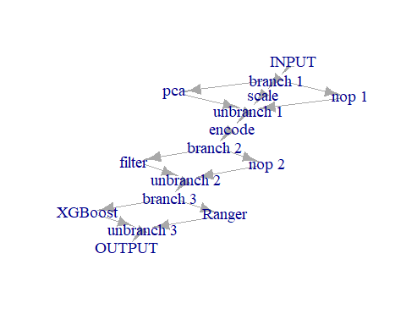
Figure 8: Graph learner used for modeling.

0.5.2 Tuning and tuning evaluation
The graph learner can be tuned to find an optimal hyperparameter constellation. Hyperparameters can be e.g. the number of principal components or features to keep, internal parameters which control model building and performance, but also the choice of which path to follow in the graph. The performance of each model, resulting out of one hyperparameter constellation, is measured by the root mean squared error (rmse) and the explained variance for the regression model and by classification accuracy for the classification model. To get a robust performance estimation, a 10 fold k-nearest neighbour cross validation based on coordinates is used. The algorithm used to find the ‘best’ hyperparameter constellation is a random search with 500 evaluation iterations. It consecutively builds models with random hyperparameter constellations, evaluates them via the selected resampling method on the train data and stores the performance and constellation in an archive.
# setup tuning
# regression
instance <- ti(
task = tsk_reg_train,
learner = graph,
resampling = rsmp("spcv_coords", folds = 10),
measure = msrs(c("regr.rsq", "regr.rmse")),
terminator = trm("evals", n_evals = 500)
)
# classification
instance_classif <- ti(
task = tsk_classif_train,
learner = graph_classif,
resampling = rsmp("spcv_coords", folds = 10),
measure = msr("classif.acc"),
terminator = trm("evals", n_evals = 500)
)
tuner <- tnr("random_search")
# tuning process
# regression
future::plan("multisession", workers = detectCores()-1)
tuner$optimize(instance)
# classification
future::plan("multisession", workers = detectCores()-1)
tuner$optimize(instance_classif)
The tuning exhaustion can be visualized by plotting the sorted measures (root mean squared error and classification accuracy) against the evaluation steps (Fig. 9). Both curves inflection point is situated at around 200 iterations and is surpassed after 500 evaluation rounds, where no great improvements in RMSE and Accuracy is observed.
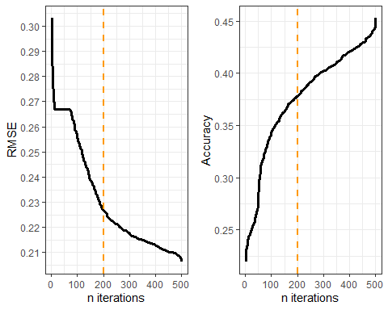
Figure 9: Tuning exhaustion plot shows the performance measuere against the number of tuning iterations
Since the optimization of the regression model uses two performance measures simultaneously, the relation of both rmse and explained variance to each other can be visualized via a pareto front plot for each hyperparameter constellation (fig. 10). The most optimal constellation maximizes the explained variance and minimizes the rmse.
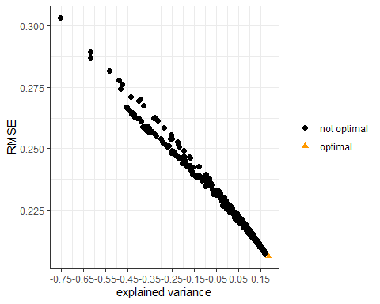
Figure 10: Pareto front plot shows the relation of two performance measures which were tuned simultaneously
The performance of the path selection for the graph learner is visualized in figure 11. The lowest rmse results from selecting no data preprocessing, selecting no filtering as well as selecting a XGBoost algorithm, whereas the highest classification accuracy results from selecting feature scaling, selecting no filtering and selecting the random forest algorithm. The optimal set of hyperparameters is presented in table 2.
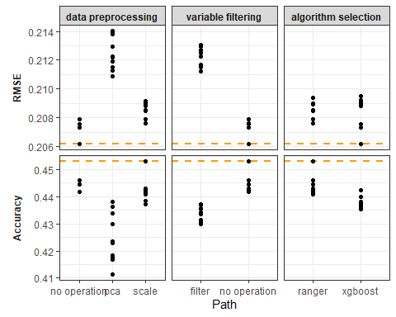
Figure 11: Path selection plot shows how the selected path influences the model performance for the top 10 performing tuning iterations
Table 2: Optimal set of hyper parameters
Model | Hyperparameter | Value
Regression | xgboost.alpha | -2.990768
Regression | xgboost.eta | -3.074318
Regression | xgboost.lambda | 4.878687
Regression | xgboost.max_depth | 5
Regression | xgboost.nrounds | 272
Regression | xgboost.subsample | 0.7369354
Regression | xgboost.colsample_bylevel | 0.3088645
Regression | xgboost.colsample_bytree | 0.6463654
Classification | ranger.mtry.ratio | 0.7950264
Classification | ranger.num.trees | 279
Classification | ranger.replace | TRUE
Classification | ranger.sample.fraction | 0.1824466
Finally the model can be trained on the training data, using the optimal hyperparameter configuration, and then be evaluated on the test data to get an unbiased performance measure. We can compare the model performances against a baseline model, which in this case would just be the average for the regression and the majority class for the classification model. Model results are easily interpretable by inspecting feature importance ranking and partial dependence plots (for more info see here).
# evaluate RMSE and explained variance
xgb_tuned <- graph
xgb_tuned$param_set$values = instance$archive$learner_param_vals(uhash = "dd69e4d8-0237-4e3e-8ccd-dbec49be2fa0")
xgb_tuned$train(tsk_reg_train)
prediction <- xgb_tuned$predict(tsk_reg_test)
prediction$score(msrs(c("regr.rsq", "regr.rmse")))
# compare to baseline
reg_baseline <- lrn("regr.featureless")$train(tsk_reg_test)
prediction_baseline <- reg_baseline$predict(tsk_reg_test)
prediction_baseline$score(msrs(c("regr.rsq", "regr.rmse")))
# evaluate Accuracy
ranger_tuned <- graph_classif
ranger_tuned$param_set$values = instance_classif$archive$learner_param_vals(uhash = "0fbd7e51-5420-42e6-9543-f7231006db55")
ranger_tuned$train(tsk_classif_train)
prediction_classif <- ranger_tuned$predict(tsk_classif_test)
prediction_classif$score(msr("classif.acc"))
prediction_classif$confusion
# compare to baseline
classif_baseline <- lrn("classif.featureless")$train(tsk_classif_train)
prediction_cl_baseline <- classif_baseline$predict(tsk_classif_test)
prediction_cl_baseline$score(msr("classif.acc"))
The results of model performances, as well as feature importance and partial dependence are available at the respective paper.

Data availability
Data on WFD invertebrate sampling and the Hessian stream network were kindly provided by the Hessian state office for nature, environment and geology (HLNUG). Data on wastewater treatment plants, stormwater overflows are available for download from the WRRL-viewer. Further, data on hydrological barriers are available from the Amber Barrier Atlas. OpenStreetMap data can be downloaded as pbf files at geofabrik. CORINE land cover shapefiles and rasters are available at Copernicus Land Monitoring Service. The SRTM GL1 30m digital elevation model can be downloaded from OpenTopography.

References
Hering, Daniel, Christian K. Feld, Otto Moog, and Thomas Ofenböck. 2006. “Cook Book for the Development of a Multimetric Index for Biological Condition of Aquatic Ecosystems: Experiences from the European AQEM and STAR Projects and Related Initiatives.” In, 311–24. Springer Netherlands. https://doi.org/10.1007/978-1-4020-5493-8_22.
Lang, Michel, Patrick Schratz, and Marc Becker. 2025. Mlr3verse: Easily Install and Load the ’Mlr3’ Package Family. https://mlr3verse.mlr-org.com.
OpenTopography. 2013. “Shuttle Radar Topography Mission (SRTM) Global.” https://doi.org/10.5069/G9445JDF.
Schratz, Patrick, Jannes Muenchow, Eugenia Iturritxa, Jakob Richter, and Alexander Brenning. 2019. “Hyperparameter Tuning and Performance Assessment of Statistical and Machine-Learning Algorithms Using Spatial Data.” Ecological Modelling 406 (August): 109–20. https://doi.org/10.1016/j.ecolmodel.2019.06.002.
van der Meer, Lucas, Lorena Abad, Andrea Gilardi, and Robin Lovelace. 2024. Sfnetworks: Tidy Geospatial Networks. https://luukvdmeer.github.io/sfnetworks/.
Wu, Qiusheng, and Andrew Brown. 2025. ’Whitebox’: ’WhiteboxTools’ r Frontend. https://CRAN.R-project.org/package=whitebox.

