CUSTOMER SEGMENTATION &
SALES PERFORMANCE ANALYSIS
ApexPlanet Internship — Task 3 | Deep-Dive Analysis & Interactive Dashboarding
Prepared using the uploaded cleaned sales workbook and the Power BI dashboard structure shared in this conversation.

Executive Summary
The analysis covers 1,000 sales records from 01 Jan 2025 to 01 Jan 2026. Recorded sales total 139,399,439.65 workbook units across 992 distinct order IDs and 947 distinct customer IDs. Average order value is 140,523.63 and overall revenue per distinct customer is 147,201.10. The 36–45 age group contributes the highest recorded revenue (31,533,245.71), while Electronics is the leading category (50,778,581.70).
Currency note: the workbook does not specify a currency code or symbol. Values are therefore reported in workbook units. If the Power BI report displays $, confirm that this is the correct source currency before submission.

1. Business Objective and Problem
Objective: answer the business question, “Which customer segments contribute most to sales, and how can the business use customer, product, location and time-based insights to improve performance?”
The project defines five core KPIs, performs a customer age-group segmentation deep-dive, and uses a Power BI report to let stakeholders explore revenue by segment, product, category, city and month.

2. Dataset Overview
The cleaned Excel workbook contains 1,000 rows and 17 columns. It includes order and customer identifiers, order date, age, gender, city, product, category, quantity, unit price, total sales, calculated sales, sales difference, sales year/month and customer age group.
Attribute | Verified result
Rows / columns | 1,000 / 17
Date coverage | 01 Jan 2025 – 01 Jan 2026
Distinct orders | 992
Distinct customers | 947
Missing cells | 0
Exact duplicate rows | 0
Non-zero Sales_Difference rows | 0

3. Data Preparation and Validation
- Imported the cleaned Excel workbook into Power BI using Get Data → Excel Workbook → Transform Data.
- Checked data types: identifiers as text, Order_Date as date, Age and Quantity as whole numbers, and sales/price fields as numeric.
- Workbook-level validation found 0 missing cells and 0 exact duplicate rows.
- All 1,000 rows have Sales_Difference equal to zero; Calculated_Sales matches Total_Sales in the supplied validation field.
- There are 8 repeated Order_ID rows beyond the first occurrence. These should not be removed automatically because an order may contain multiple records.
- 13 records use City = 'Unknown', representing 1,540,617.54 in sales.
Important segmentation caveat: 47 customer IDs appear in more than one Customer_Age_Group. This means segment-level distinct customer counts can overlap and may sum to more than the overall distinct customer count. Before treating segment customer counts or revenue-per-customer comparisons as definitive, resolve each customer's age/age group to one consistent value (for example, using a verified customer master record or a documented rule).
The final date in the workbook is 01 Jan 2026. The 2026-01 period contains only 5 rows and 809,389.99 in sales (0.6% of total revenue). Treat this as a partial month, not a full-month decline.

4. Core KPIs
KPI | Definition / formula | Verified value | Business rationale
Total Revenue | SUM(Total_Sales) | 139,399,439.65 | Measures the overall value of recorded sales.
Total Orders | DISTINCTCOUNT(Order_ID) | 992 | Measures unique order volume; avoids counting multiple rows in one order as separate orders.
Average Order Value | Total Revenue ÷ Total Orders | 140,523.63 | Shows average revenue per unique order.
Total Customers | DISTINCTCOUNT(Customer_ID) | 947 | Measures the number of unique customers represented.
Revenue per Customer | Total Revenue ÷ Total Customers | 147,201.10 | Measures overall revenue per distinct customer.
DAX measures (assuming the imported table is named Sales):
Total Revenue = SUM(Sales[Total_Sales])
Total Orders = DISTINCTCOUNT(Sales[Order_ID])
Average Order Value = DIVIDE([Total Revenue], [Total Orders], 0)
Total Customers = DISTINCTCOUNT(Sales[Customer_ID])
Revenue per Customer = DIVIDE([Total Revenue], [Total Customers], 0)

5. Deep-Dive: Customer Segmentation
Customers are segmented using the supplied Customer_Age_Group field. Revenue is summed within each group to compare the contribution of the age bands.
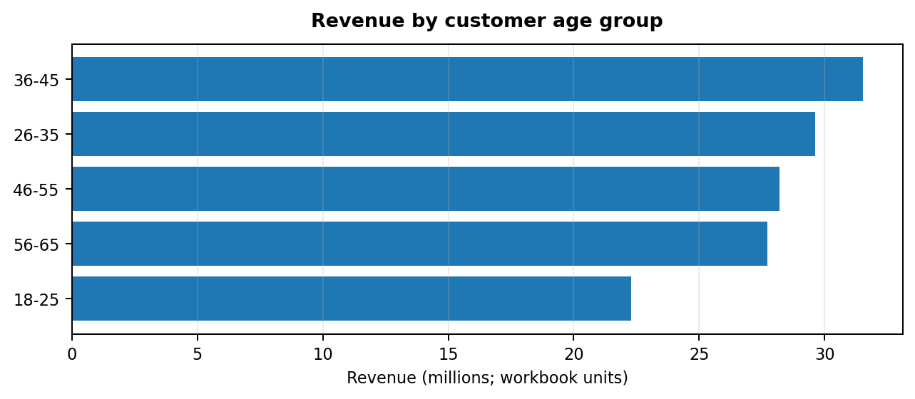
Age group | Revenue | Share of total revenue | Distinct customers in group
36-45 | 31,533,245.71 | 22.6% | 222
26-35 | 29,632,336.96 | 21.3% | 217
46-55 | 28,216,508.63 | 20.2% | 202
56-65 | 27,733,251.41 | 19.9% | 196
18-25 | 22,284,096.94 | 16.0% | 158
The 36–45 segment has the highest recorded revenue at 31,533,245.71 (22.6% of total revenue). The next highest is 26-35 at 29,632,336.96. These are revenue comparisons, not proof of profitability or customer lifetime value.

6. Product, Category and Geographic Analysis
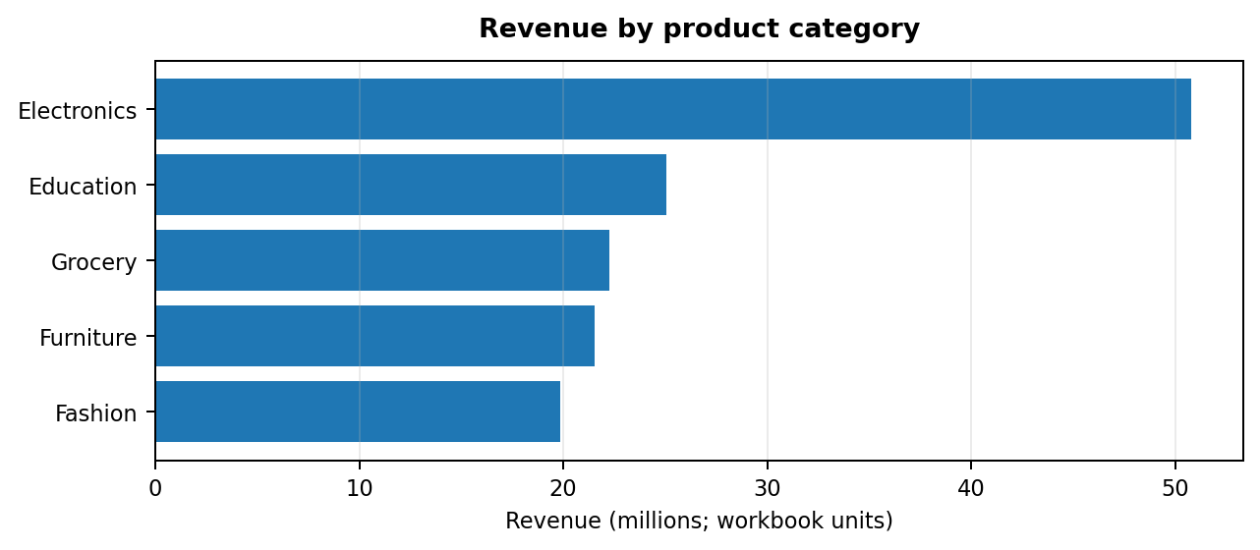
Electronics is the largest category at 50,778,581.70 (36.4% of total revenue).
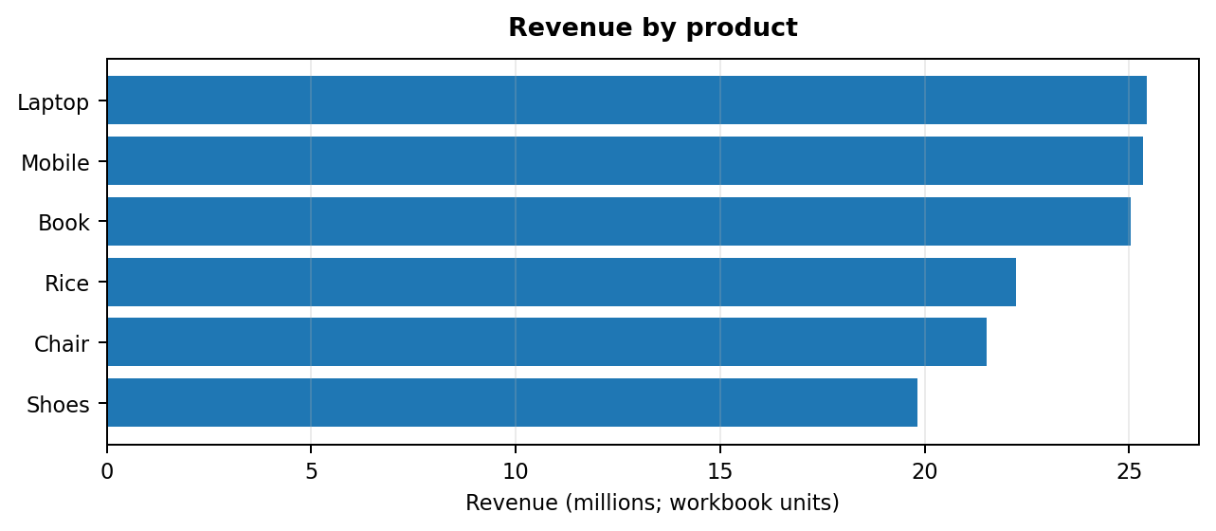
The highest-revenue product is Laptop at 25,443,008.51; the next products are Mobile and Book.
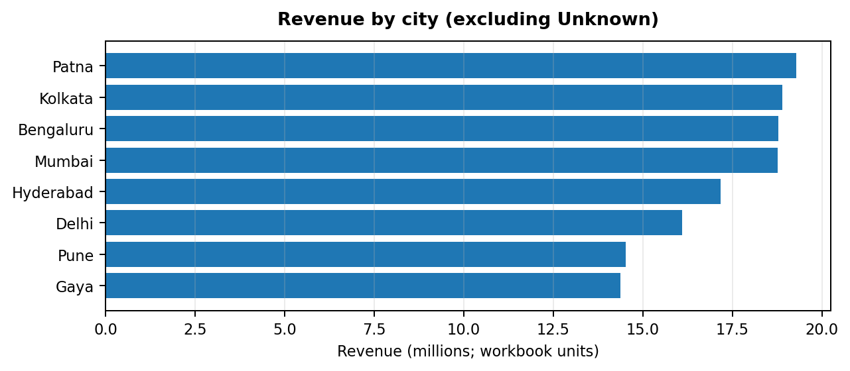
Among named cities, Patna has the highest revenue at 19,285,966.89. City = Unknown accounts for 1,540,617.54 and should be reviewed if geographic decisions are important.

7. Monthly Sales Trend
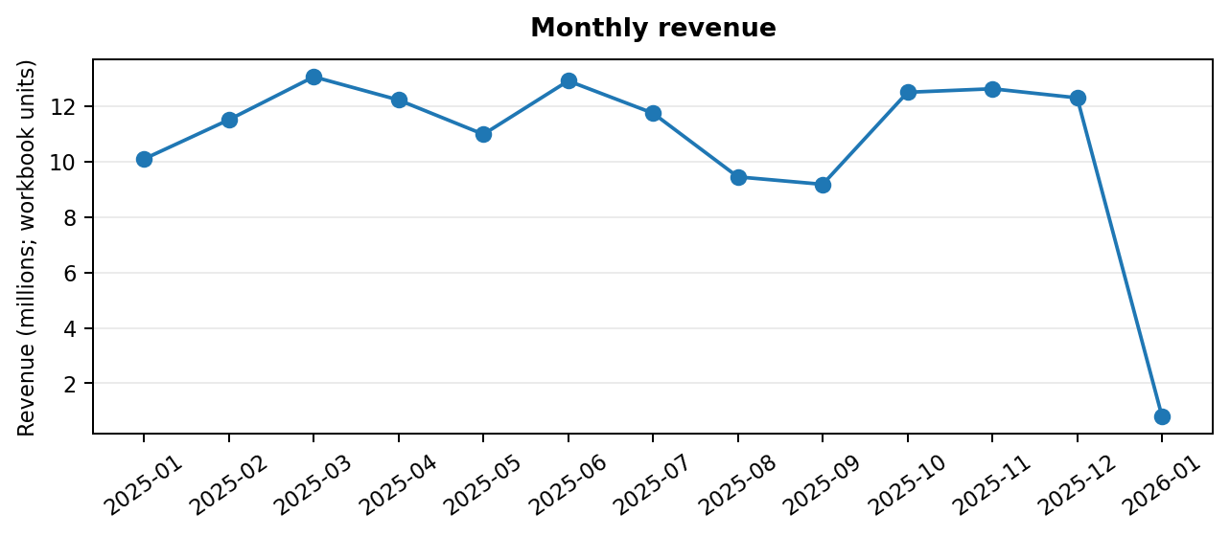
Within the complete 2025 calendar months present, 2025-03 has the highest monthly revenue (13,059,899.94). January 2026 is incomplete and should not be compared directly with full months.

8. Power BI Dashboard and Interactivity
The Power BI report shared for review includes five KPI cards and visuals for monthly revenue, product revenue, customer counts by age group, revenue per customer by age group, category revenue, revenue by age group and city revenue. The planned slicers are City, Category, Gender, Customer Age Group and Date.
Before submission, test each slicer in Power BI Desktop and confirm that all intended visuals and KPI cards respond. Also verify the currency format, date sorting, and the January 2026 partial-period treatment. A report file's visual structure alone does not prove that every interaction works.

9. Key Findings
- Total recorded sales are 139,399,439.65 workbook units across 992 distinct orders and 947 distinct customers.
- Average order value is 140,523.63 workbook units.
- The 36–45 age group leads age-segment revenue at 31,533,245.71.
- Electronics leads category revenue at 50,778,581.70.
- Laptop is the highest-revenue product at 25,443,008.51.
- Patna is the highest-revenue named city at 19,285,966.89.
- January 2026 is a partial month with only 5 rows, so its low total is not evidence of a full-month sales collapse.

10. Business Recommendations
- Investigate the needs and purchasing patterns of the 36–45 age segment, then test targeted campaigns; do not assume higher revenue means higher profit.
- Review the Electronics category's product mix, stock availability and margin before making inventory or promotion decisions.
- Compare product-level sales with gross margin, returns and stock costs before prioritizing products.
- Use the city results to guide further market research, while resolving Unknown city records before geographic allocation decisions.
- Use complete comparable periods for month-over-month reporting; exclude or clearly label partial January 2026.
- Resolve inconsistent age-group assignments for 47 customer IDs before publishing segment-level customer counts or revenue-per-customer rankings.

11. Conclusion
The analysis provides a structured view of sales performance across customer age groups, products, categories, cities and time. The Power BI dashboard brings the five core KPIs and deep-dive visuals together for interactive exploration. The strongest initial revenue signals are the 36–45 age group and Electronics category. Data-quality caveats—especially inconsistent customer age-group assignments, Unknown city values, and the partial January 2026 period—should be addressed before using the results for high-impact business decisions.

12. Submission Checklist
- Save the final Power BI report as a .pbix file.
- Validate slicer interactions and KPI calculations in Power BI Desktop.
- Export the report as PDF and add dashboard screenshots.
- Publish the report to an authorized Power BI workspace and add the accessible report link (if permitted).
- Upload the report, PBIX file and README to the GitHub repository, subject to dataset-sharing permissions.
- Record a 5–7 minute LinkedIn demonstration covering KPIs, filters, key findings and recommendations.
Prepared from the supplied apexplanet_cleaned_sales.xlsx workbook. Values are calculated from the workbook's Total_Sales field. The workbook does not identify a currency code; confirm the correct currency before final publication.

