**Day-3 Excercise**

**M.Chidanand -19001218**

1. Design a Stopwatch  
Design a class called Stopwatch. The job of this class is to simulate a stopwatch. It should  
provide two methods: Start and Stop. We call the start method first, and the stop method next.  
Then we ask the stopwatch about the duration between start and stop. Duration should be a  
value in Time Span. Display the duration on the console.  
We should also be able to use a stopwatch multiple times. So we may start and stop it and then  
start and stop it again. Make sure the duration value each time is calculated properly.  
We should not be able to start a stopwatch twice in a row (because that may overwrite the initial  
start time). So the class should throw an Invalid Operation Exception if its started twice.

Ans:

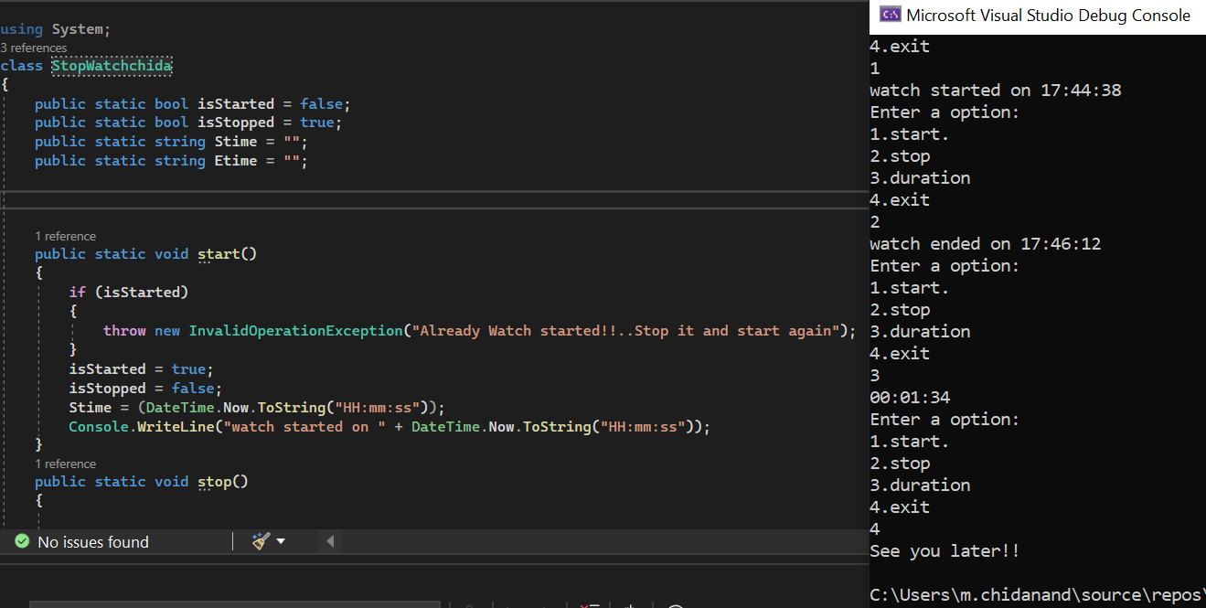

2.

Design a Stack Overflow Post. Design a class called Post. This class models a Stack Overflow post. It should have properties for title, description and the date/time it was created. We should be able to up-vote or down-vote a post. We should also be able to see the current vote value. In the main method, create a post, up-vote and down-vote it a few times and then display the current vote value. In this exercise, you will learn that a Stack Overflow post should provide methods for up-voting and down-voting. You should not give the ability to set the Vote property from the outside, because otherwise, you may accidentally change the votes of a class to 0 or to a random number. And this is how we create bugs in our programs. The class should always protect its state and hide its implementation detail.

