M.chidanand

Day-2 Exercise

1.Write a program to concatenate two string variables?

Ans:

string a = "Hi ";

string b = "This is";

string c = " Chidanand";

Console.WriteLine(string.Concat(a,b,c));

2. Explain any 5 methods of strings with example?

**Concat:** A concat method in C# helps combine or concatenate several strings. It returns a combined string.

**Upper():**

A upper Method is used to convert string into uppercase. It returns a string

**Copy():**

ACopy() method is used to create a new instance of String with the same value as a specified String. It is a static method of String class. Its return type is string.

**Join():**

A Join() methods is used to concatenate the elements of an array, using the specified separator between each element. It returns a modified string.

**Replace():**

Replace() method is used to get a new string in which all occurrences of a specified Unicode character in this string are replaced with another specified Unicode character.

.

3 Explain String Interpolation with an example?

Single interpolation is a method of concatenating, formatting, and manipulating strings

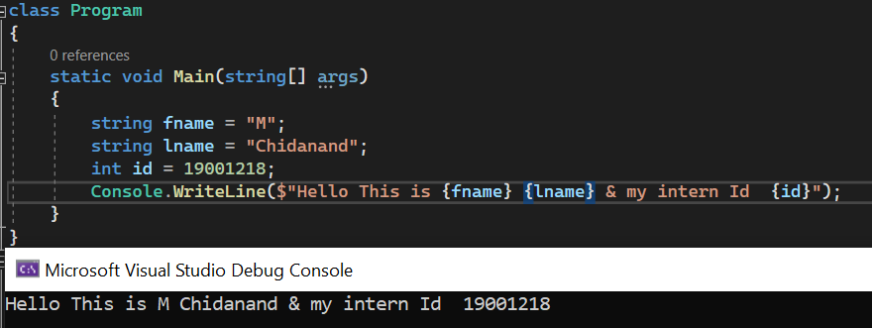

4 How do you assign a string value which has double quotes within it?

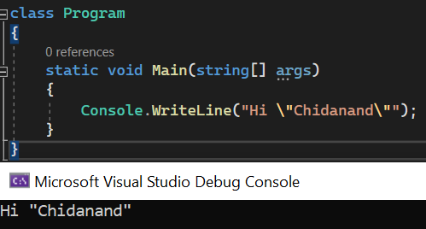

5 Write a program to find the number of times a substring appears in a given string?

Ans:

class Program

{

static void Main(string[] args)

{

string a=Console.ReadLine();

String b =Console.ReadLine();

int Count = 0;

for (int i = 0; i <= (a.Length - b.Length); i++)

{

String result = a.Substring(i, b.Length);

if (result.Equals(b))

{

Count += 1;

}

}

Console.WriteLine("repetative is "+Count);

}

}

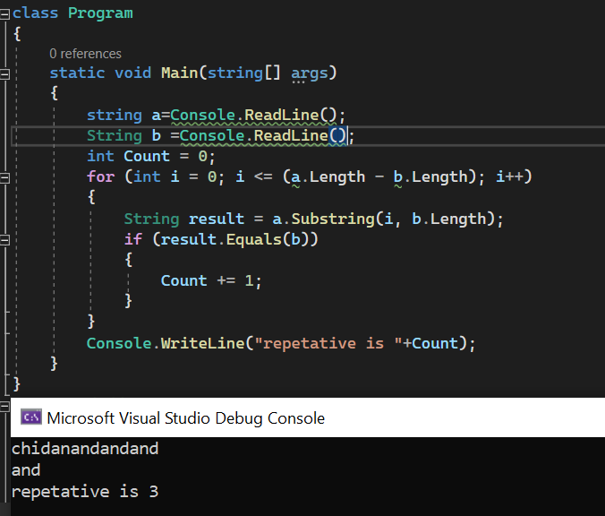  
6 Create a string array of 10 elements and print all the elements in the even index?

string[] a = { "zero","one", "two", "three", "four", "five", "six", "seven", "eight", "nine","ten" };

for (int i = 0; i < a.Length; i++)

{

//condtion given is print only even numbers

if (i % 2 == 0)

Console.WriteLine(a[i]);

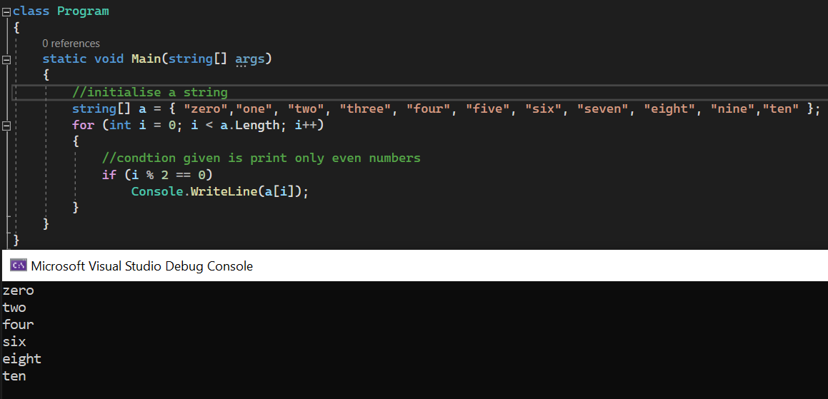

7 Create a array of elements and loop through it using the foreach loop?

Ans:

class Program

{

static void Main(string[] args)

{

string[] arr = { "My","Name","is","chidanand" };

foreach (string i in arr)

{

Console.WriteLine(i);

}

}

}

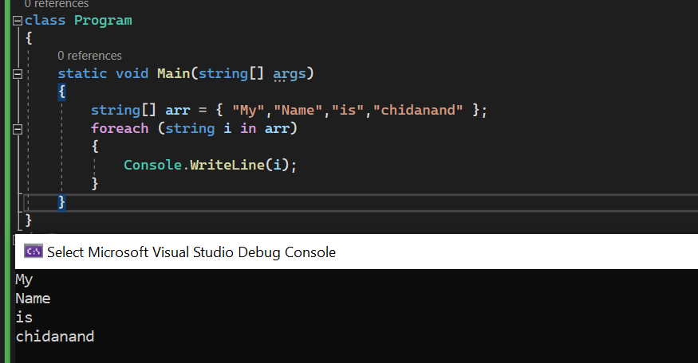  
8 What is a multidimensional array?

The multidimensional array is also known as rectangular arrays in C#. It can be two dimensional or three dimensional. The data is stored in tabular form (row * column) which is also known as matrix.

9 Create a 2D array and loop through it and display the value at index [1,2]?

Ans:

int rowSize = 3;

int colSize = 3;

int[,] arr = new int[rowSize, colSize];

for (int i = 0; i < rowSize; i++)

{

for (int j = 0; j < colSize; j++)

{

arr[i, j] = Convert.ToInt32(Console.ReadLine());

}

}

Console.Write("element at position arr[1,2] is: "+ arr[1, 2]);

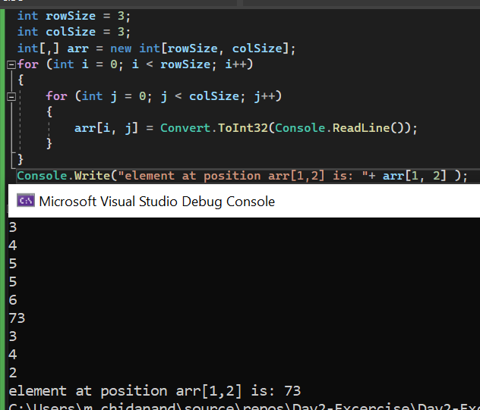

10 What is Enums and how will you use it?

Enum in C# is also known as enumeration. It is used to store a set of named constants such as season, days, month, size etc. The enum constants are also known as enumerators. Enum in C# can be declared within or outside class.

Eg:

class Function

{

enum a

{

Jan,

Feb,

Mar=3,

Apr,

May,

Jun,

Jul

}

static void Main(string[] args)

{

int month = (int)a.May;

Console.WriteLine(month);

}

}

11 C# File class belongs to which namespace?

Ans: The C# file class belongs to System.io

12 Write a program to create a file and write the string value inside it?

Ans:

StreamWriter chidanand = new StreamWriter("C:\\Users\\m.chidanand\\OneDrive - Dedalus S.p.A\\Documents\\Visual Studio 2022\\temp.txt");

string[] chida = { "Monday", "tuesday", "wednesday", "thursday" ,"friday"};

foreach(string i in chida)

{

chidanand.WriteLine(i);

}

chidanand.Close();

13 Explain any three methods of File class with an example?

Ans:

Create():

File.Create("C:\\Users\\m.chidanand\\OneDrive - Dedalus S.p.A\\Documents\\Visual Studio 2022\\temp1.txt");

Exists()-

Console.WriteLine(File.Exists("C:\\Users\\m.chidanand\\OneDrive - Dedalus S.p.A\\Documents\\Visual Studio 2022\\temp1.txt"));

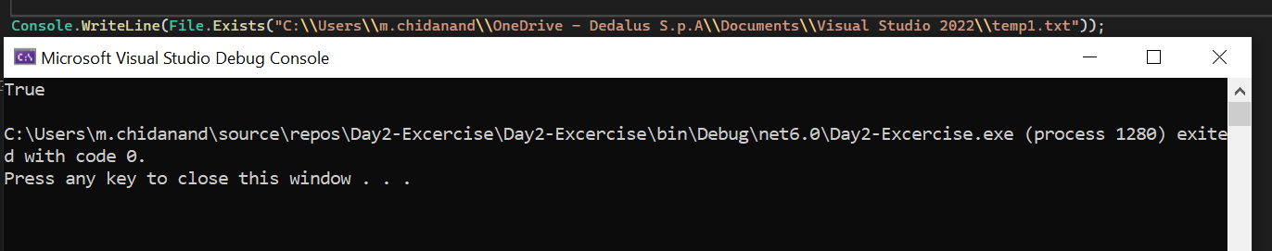

Delete()-

File.Delete("C:\\Users\\m.chidanand\\OneDrive - Dedalus S.p.A\\Documents\\Visual Studio 2022\\temp1.txt");

14 How do you handle exceptions in C#? Explain with an example?

Ans:

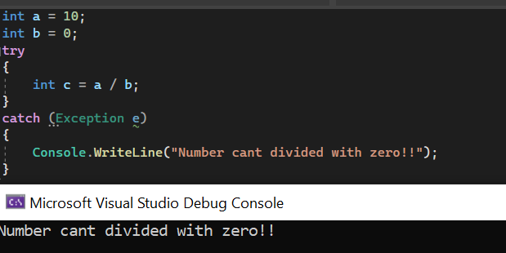

15 What is the use of finally in C# exceptions?

Ans:

By using a finally block, you can clean up any resources that are allocated in a try block, and you can run code even if an exception occurs in the try block.

16.What is the purpose of throw keyword? Explain with an example?

throw can also be used in a catch block to re-throw an exception handled in a catch block

