Overview of SK BUFF

sk_buff in linux represents a packet. It consists of three segments.
- sk_buff structure which is also referred to as a sk_buffer header.
- Linear data block containing data
- NonLinear data portion represented by struct skb_shared_info.

sk_buff contains linear and non-linear data. Linear data are represented by the data field of the sk_buff. Normally we allocate one page of linear data only for segments that can be accommodated in s a single page. In the case where the total segment length is more than one page, we have two options.
- First is to have a linear data of length which can accommodate the entire segment.
- Have a page data area for the rest of the packet.

Cloning SKBUFF – Separate copy of sk_buff structure but sharing the same data blocks.
Copy SKBUFF – Duplicate the sk_buff with a separate copy of the data.

The length of the sk_buff has three fields which is confusing.
- Len – Total length of the segment.
- data_len – This field is used only when we have non-linear data associated with the sk_buff. This field indicates the portion of the total packet length that is contained as paged data, which means the linear data length will be skb->len – skb->data_len.

This part is the linear data. Its length can be found by len – data_len. So len = 700 – 400 = 300.
Len : 300

Total packet length
Len : 700

This part of the data is the paged data. Its length is given by data_len.
data_len : 400

It must be understood that once paged data starts to be used on an SKB, this puts a specific restriction on all future SKB data area operations. In particular, it is no longer possible to do skb_put() operations.
We will now mention that there are actually two length variables assosciated with an SKB, len and data_len. The latter only comes into play when there is paged data in the SKB. skb->data_len tells how many bytes of paged data there are in the SKB. From this we can derive a few more things:
- The existence of paged data in an SKB is indicated by skb->data_len being non-zero. This is codified in the helper routine skb_is_nonlinear() so that it the function you should use to test this.
- The amount of non-paged data at skb->data can be calculated as skb->len - skb->data_len. Again, there is a helper routine already defined for this called skb_headlen() so please use that.

There are three pointers associated with the sk_buff that deals with managing the data.
- Head – This field points to the start of the linear data area.
- Data – This field points to the start of the data residing in the linear-data area. The data residing in the linear-data area may not be always start from the start of the linear-data area pointed to by head.
- Tail – This field points to the last byte of the data residing in the linear-data area.
- End – This field points to the end of the linear-data area and is different from tail. The end of the data residing in the linear-data area, so we have a tail. With this field we make sure that we dont use more than what is available.

SKB_SHARED_INFO

There is a structure called skb_shared_info at the end of the data buffer that keeps additional information about the data block.

This structure contains information about the non-linear data area for the sk_buff. By non-linear area, it means that the data contained by sk_buff are just more than that can be accommodated in the linear data area. The data contained in the non-linear data area is a continuation of the data from the offset pointed to by end field of the sk_buff. The total length of the sk_buff is stored in len field and the length of the non-linear (paged) data is stored in data_len field of sk_buff. The paged data area is possible only if the DMA allows scatter-gather operations on physically non-contiguous and scattered pages.
The skb_shared_info structure is used by the fragmented skbuffs. It has a meaning when the data_len field in the skbuff. header is different from zero.

This field counts the data not in the linear part of the skbuff. The dataref field counts the number of references to the fragmented part of the skbuff, so that a writer knows if it is necessary to copy it. The nr_frags field keeps the number of pages in which this skbuff is fragmented. This kind of fragmentation is done for interfaces supporting scatter and gather. This feature is described in the netdevice structure by the NETIF_F_SG flag. (3com 3c59x , 3com typhoon, Intel e100, ... ) When an skbuff is to be allocated, if the mss is larger than a page then if the interface supports scatter and gather a linear skbuff of a single page is allocated with alloc_skb and then the other pages are allocated and added to the frags array

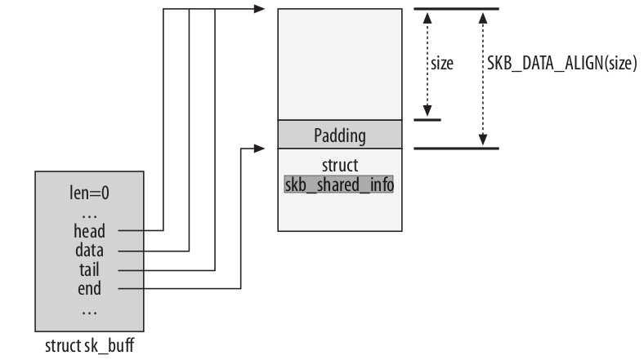

There is no field inside the sk_buff structure pointing at the skb_shared_info data structure. To access this structure, functions need to use the skb_shinfo macro, which simply returns the end pointer.
In order to increment the number of fragments, the macro can be used as follows
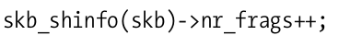

This structure can be used to increase the size of the buffer by adding memory areas that can be located anywhere, not necessarily adjacent to one another.

Another representation of skb_shared_info

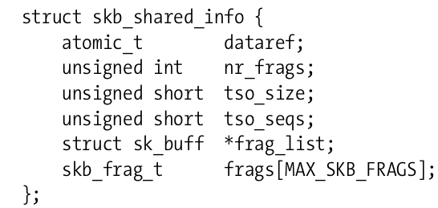

DataRef – Number of users of the data block
nr_flags, frag_list, frags – Used to handle IP fragements
- nr_flags – Keeps track of number paged fragments for the sk_buff. It is an indication of number of elements in the frags[] array containing paged data for sk_buff.
- Frags – this is an array of fragments containing the paged data for the sk_buff. The paged data are represented by the skb_frag_struct. The length of the data contained in the paged area is the sum of the number of bytes contained in each page fragemtn and is stored in the data_len field of the sk_buff structure. .
skb_is_nonlinear – Routine used to check whether the buffer is fragmented.
skb_linearize – Routine used to collapse the fragments into a flat single buffer.

