Table : Worker

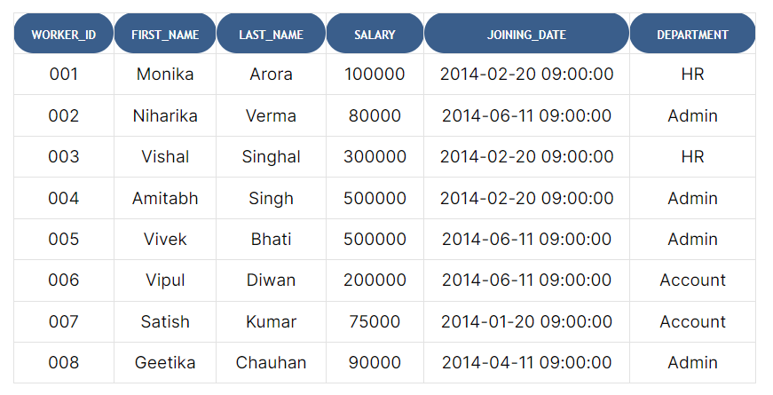

Table : Bonus

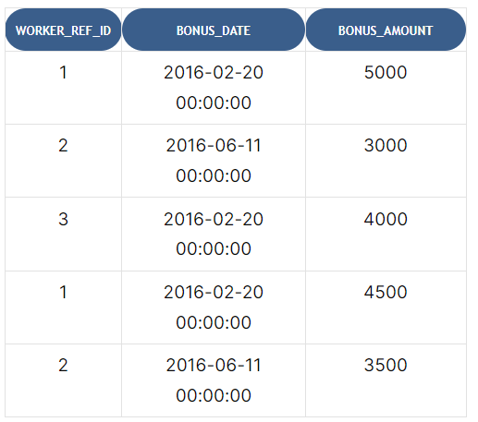

Table : Title

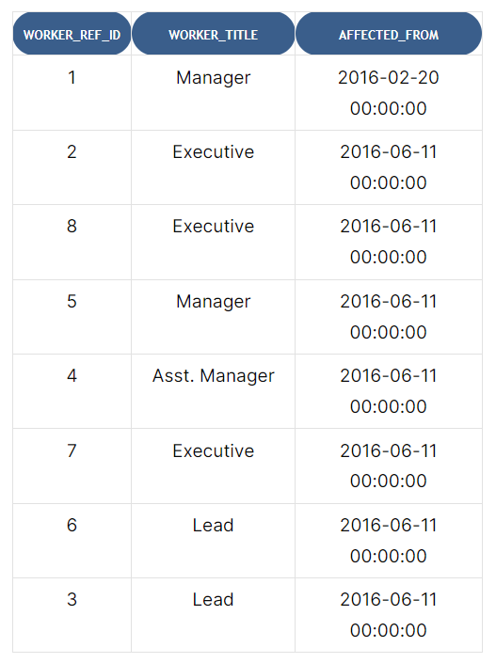

Q1. Write an SQL query to fetch “FIRST_NAME” from the Worker table using the alias name <WORKER_NAME>.

Ans – Select FIRST_NAME as ‘WORKER_NAME’ From Worker

----------------------------------------------------------------------------------------------

#### Q2. Write an SQL query to fetch unique values of DEPARTMENT from the Worker table.

#### Ans – Select Distinct DEPARTMENT From Worker

#### ---------------------------------------------------------------------------------------------

#### Q3. Write an SQL query to print all Worker details from the Worker table order by FIRST_NAME Ascending.

#### Ans – Select * from Worker Order by FIRST_NAME Asc

--------------------------------------------------------------------------------------------------------------------------------------

#### Q4. Write an SQL query to print all Worker details from the Worker table order by FIRST_NAME Ascending and DEPARTMENT Descending.

#### Select * from Worker Order by FIRST_NAME Asc , DEPARTMENT Desc

#### -----------------------------------------------------------------------------------------

Q5. Write an SQL query to print details for Workers with the first names “Vipul” and “Satish” from the Worker table

Select * from Worker Where FIRST_NAME in (‘Vipul’ , ‘Satish’)

------------------------------------------------------------------------------------------

#### Q5. Write an SQL query to print details of Workers with DEPARTMENT name as “Admin”.

Select * from Worker Where DEPARTMENT = ‘Admin’

----------------------------------------------------------------------------------------

#### Q6. Write an SQL query to print details of the Workers whose FIRST_NAME contains ‘a’.

Select * from Worker Where FIRST_NAME like ‘%a%’

----------------------------------------------------------------------------------------------------------------------------

#### Q7. Write an SQL query to print details of the Workers whose FIRST_NAME ends with ‘h’ and contains six alphabets.

#### Select * from Worker Where FIRST_NAME Like ‘_____h’

#### ---------------------------------------------------------------------------------------

#### Q8. Write an SQL query to print details of the Workers whose SALARY lies between 100000 and 500000.

Select * from Worker Where SALARY Between 100000 and 500000

----------------------------------------------------------------------------------------------

#### Q9. Write an SQL query to fetch the count of employees working in the department ‘Admin’.

Select Count (*) from Worker where DEPARTMENT = ‘Admin’

------------------------------------------------------------------------------------------------------------------------------------

#### Q10. Write an SQL query to print details of the Workers whose FIRST_NAME ends with ‘a’.

Select * from Worker Where FIRST_NAME like ‘%a’

#### ----------------------------------------------------------------------------------------