**DISASTER RECOVERY TESTING**

**DR Architecture**



Azure Services Tested for DR

1. Azure Storage Account
2. Azure SQL Database
3. Azure Synapse Restoration
4. Azure Data Lake
5. Azure Data Factory
6. Azure Databricks
7. Azure Key Vault

# **Azure Storage Account**

Description: The Name of Storage Account used for Testing is: edmtestscbsa01 in Azure Sponsorship Account.

The Storage has been failed over to SouthEast Asia Region to East Asia Region of Azure to Perform a Failover and FailBack.

We Also Tested the Replication Status before Failover and FailBack.

Master Script Execution for Storage Account Failover.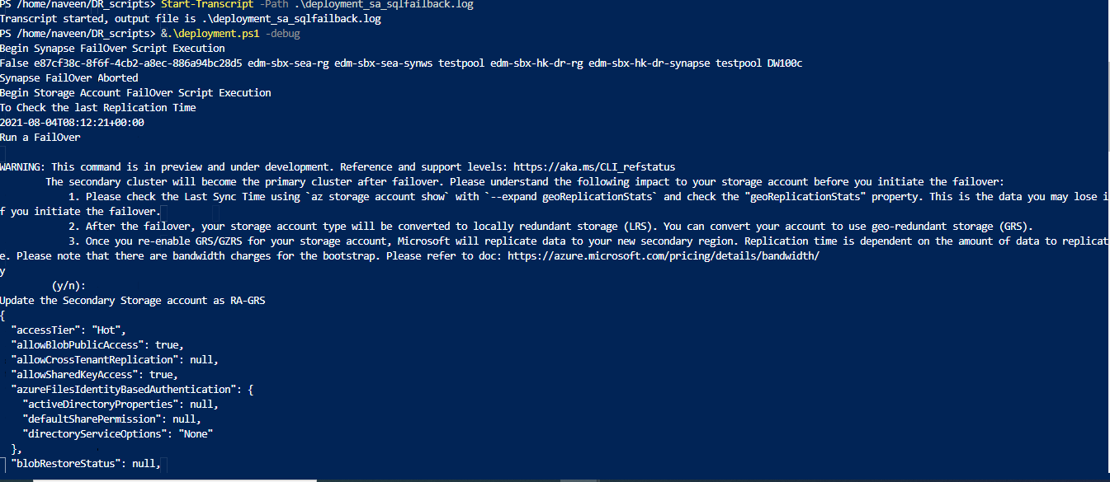

The Geo-Failover took approximately 12 Min during our Testing. After the Failover, Reinitiate the Storage Account to use RA-GRS.

**Note:**

1. Incurs a one-time egress charge.
2. Migrating from LRS to GRS is not supported if the storage account contains blobs in the archive tier.
3. If you performed an [account failover](https://docs.microsoft.com/en-us/azure/storage/common/storage-disaster-recovery-guidance) for your (RA-)GRS or (RA-)GZRS account, the account is locally redundant (LRS) in the new primary region after the failover
4. Account level Storage Replica can also be done to Other Azure Data Centers based on the Requirement.

# **Azure SQL Database-DR**

## Description: The Name of SQL Database used for Testing is: edmsbxseasqldb_Copy

in Azure Sponsorship Account at Southeast Asia Region and another replica created in East Asia Region.

Both these Databases has been placed in Failover Groups and failover and Failback has been tested between the Databases across two Regions.

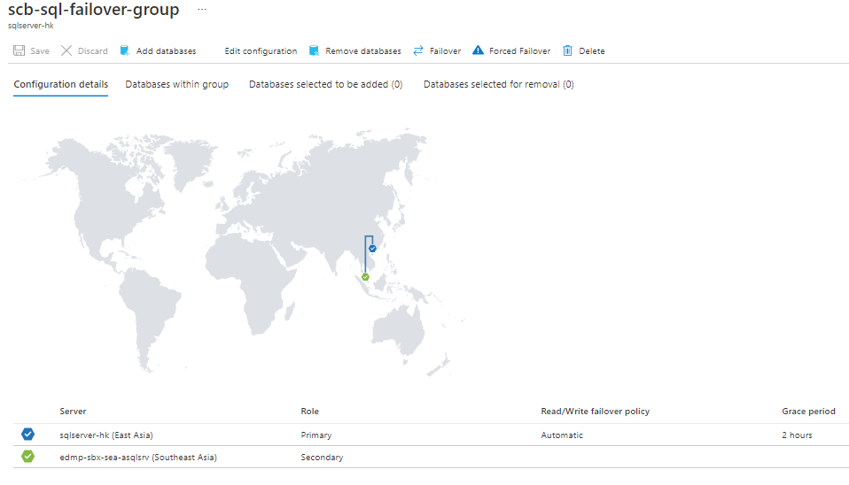

**It took less than One Minute to perform the Failover in our Testing.**

**Example Script for Failover Testing:**

**Fail over to the secondary server:**

# Set variables

$resourceGroupName = "<Resource-Group-Name>

"$serverName = "<Primary-Server-Name>

"$failoverGroupName = "<Failover-Group-Name>"# Failover to secondary serverWrite-host "Failing over failover group to the secondary..."

Switch-AzSqlDatabaseFailoverGroup ` -ResourceGroupName $resourceGroupName ` -ServerName $drServerName ` -FailoverGroupName $failoverGroupName

Write-host "Failed failover group to successfully to" $drServerName

**Revert failover group back to the primary server**

# Set variables

$resourceGroupName = "<Resource-Group-Name>"

$serverName = "<Primary-Server-Name>

"$failoverGroupName = "<Failover-Group-Name>"# Revert failover to primary serverWrite-host "Failing over failover group to the primary...."

Switch-AzSqlDatabaseFailoverGroup ` -ResourceGroupName $resourceGroupName ` -ServerName $serverName ` -FailoverGroupName $failoverGroupName

Write-host "Failed failover group successfully to back to" $serverName

# **Azure Synapse**

## Description: The Name of the Azure Synapse in Testing is: “edm-sbx-sea-synws”.

## The Azure Synapse Workspace in East Asia Region is: “edm-sbx-ea-001-synws”

## Command for Creating Restoration Point:

## New-AzSynapseSqlPoolRestorePoint -WorkspaceName "edm-sbx-sea-synws" -Name "scbdemodb001" -RestorePointLabel "28June1130am"

## Restore from Restoration Point

Note: Testing has been 128GB Size of Database

To create Snapshot in took approximately 1-2 Min.

Restoration Started at 4:54pm in a blank workspace with No Data.

The Restoration Completed at: 05:03pm (8 Min) for 128GB.

## Delete the Restoration Point



**DR Failover & failback Scripts for Azure Storage Account, Azure SQL Server, Databricks, and Azure Synapse.**

This consists of master scripts(deployment.ps1) and Individual service scripts (sql.ps1, synapse.ps1, databricks.ps1) that are triggered by the Master Scripts. Failover can be configured by parameterizing the parameters. json.



Pre-Created Services are pre-provisioned during Infrastructure setup in East Asia Region.

Added the Log Files and Screenshot for reference.

# **Azure Data Lake**

Azure Data Lake Storage are Storage Accounts with Hierarchy Namespace Enabled (Storage Gen2 Storage Accounts). Manual (Customer Managed) FailOver is not supported. The Storages in Southeast Asia are RA-GRS Replication Enabled which would replicate the Data Asynchronously to the paired Region (East Asia Region).

The Failover for this Storage Account is either Microsoft Managed or customer need to deploy preview version of Azure Data Lake Storage to perform Failover. A sample Screenshot for Data Lake in Southeast Asia Region is shared below:

# **Azure Data Factory**

Data Factory is provisioned using IAC Code in the below Link for the East Asia Region.

[Datafactory - Repos (azure.com)](https://dev.azure.com/Standard-Chartered-Banks/ACAI-SCB_EDM_Cloud_Platform/_git/EDM-Platform?path=%2FEDM-Devops%2Fcommon-library%2FTerraformModules%2FDatafactory)

Jenkins pipeline Log attached



**Configuring the Data Factory**

**Deployment.log**



**Errors during Data Factory Configuration**

# **Azure DataBricks**

DataBricks will be provisioned using IAC Code in the below Link for the East Asia Region.

[Databricks - Repos (azure.com)](https://dev.azure.com/Standard-Chartered-Banks/ACAI-SCB_EDM_Cloud_Platform/_git/EDM-Platform?path=%2FEDM-Devops%2Fcommon-library%2FTerraformModules%2FDatabricks)

Jenkins pipeline log attached



Provisioning of Interactive Cluster



Logs: Migrating All Notebooks



Deploy Files to DBFS



**Azure KeyVault**

This is Microsoft Managed and below are the details:

[Azure Key Vault availability and redundancy - Azure Key Vault | Microsoft Docs](https://docs.microsoft.com/en-us/azure/key-vault/general/disaster-recovery-guidance)

**DevOps Code for provisioning pre-created services in East Asia Region. This contains Jenkins files to deploy Infrastructure, Deploy Notebooks, deploy files to databricks DBFS, and Configure Data factory Resources.**



**Frequently Asked Questions (FAQs)**

**Q1) List of services will be pre created and what is the cost if it incurs any?**

**A**: The Services that would be pre-created in East Asia Region would include Azure Data Factory, Azure Databricks, Azure Synapse, Azure Log Analytics.

The Charges incurred with pre-created services would be very negligible.

Q2) **How the pre created scripts will be created – Is it via terraform code, any other scripting language or manually?**

**A**: The Pre-created Services in the East Asia Region are created using Terraform.

Q3) **List of Services will be created during DR initiation and what kind of scripts they will use for creating the services (terraform code, any other scripting language or manually)?**

**A**: During DR Initiation, The DR Scripts are invoked which create and configure the pre-created services to enable a successful failover. The DR Scripts are, developed in powershell, for the Successful failover for Azure Storage Account, SQL Server, Azure Synapse SQL pool.

The Test Execution Results as part of DR Initiation are provided above.

For Databricks, an Interactive Cluster is provisioned using Terraform Code as part of DR Initiation.

Q4) **How the integration of all the services will happen after individual service setup completed – Is it via script, manual activity etc?**

**A**: After the Individual Service Setup in East Asia Region is completed, ARM Templates are deployed to configure and deploy Factory pipelines, Linked Services, Data sets and Triggers in the Data factory in East Asia Region. To enable successful connection to other services, Data factory Managed Identity are role assigned to data lake, Storage account, Databricks etc.

Q5) **How to apply application specific infrastructure configuration – Manual / automated (if automated then script)?**

**A**: Such Configurations are handled by the Jenkins Jobs. Automated Pipelines are used that configure the services for application specific infrastructure configurations. These include configuring the Data factory resources, Deploying the Databricks Files in DBFS, Notebooks etc. The test deployment for the application specific Configuration logs are shared above.

Q6) **How the back up and restoration will be enable in DR (manual / automated) (if automated then script)?**

**A**: Backups for Storage Account and Data Lake are Managed by Azure due to RA-GRS Data Replication. For SQL Servers, Failover groups are pre-created during Southeast region setup which with Asynchronous Data replication between the SQL Servers in southeast and East Asia Region.

Azure Synapse have restore Points for SQL Pools frequently created (Managed by Azure and Custom DR Scripts) which is used Restore the SQL Pools in the East Asia Region.

Databricks resources such as Notebooks and files are backed up the Version Control Repositories. The Deployment Logs are Shared above.

Data Factory in SouthEast Asia Region have ARM Templates for the published Resources in the adf_publish branch in git Repository. These ARM Templates are deployed in East Asia Region using the Jenkins Job. The Deployment Logs are shared above.

Q7) **How the Infrastructure setup DR script will run and what all input parameters it will require as global parameter for DR initiation?**

**A**: Infrastructure DR setup is performed using Terraform and PowerShell scripts. The Parameters for the Terraform Scripts are maintained in config tfvars. The Terraform Scripts create pre-created Services required in East Asia Region. In a scenario when Southeast Asia Region is down, The DR Scripts perform the Failover of the Services. These Scripts are parameterized in parameters. json and not hardcoded. The Terraform and DR Failover Scripts and DR Failover Testing is performed and evidence/Snapshots/ Execution logs are shared above.