Flowchart 1: Customer, System and Admin flow
E-Cycle Trace · EVS Assignment (BCS508): Environmental problem E-Waste Disposal
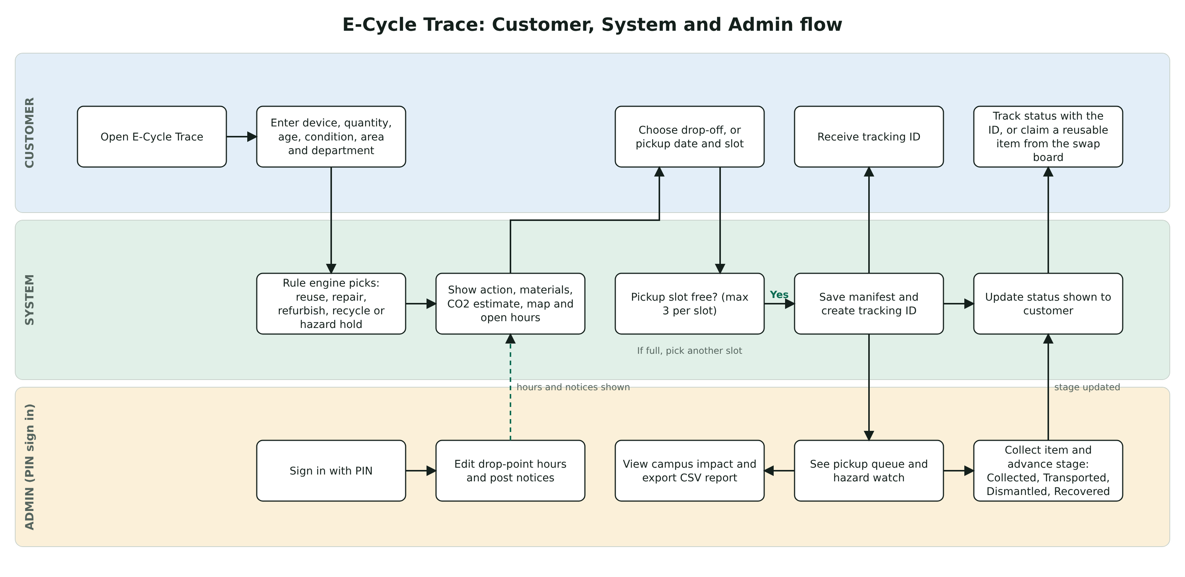
How a customer logs an item, how the system decides and books it, and how the admin tracks it to recovery.

Flowchart 2: Input, Processing, Output
E-Cycle Trace · EVS Assignment (BCS508): Environmental problem E-Waste Disposal
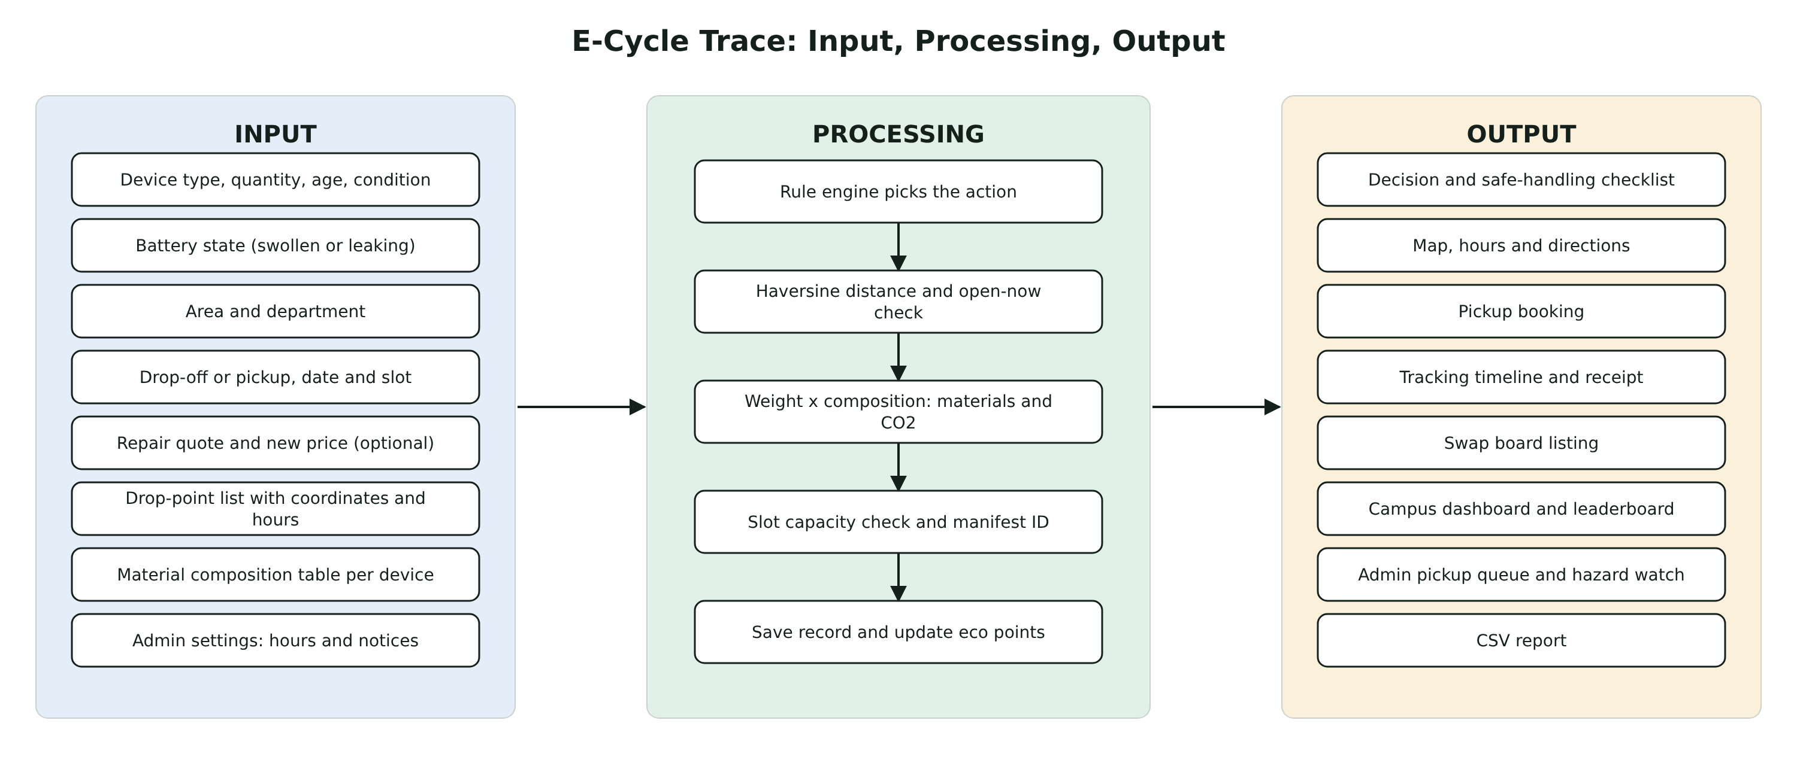
The data going into E-Cycle Trace, what the system does with it, and what it produces.

