Dataset Understanding & Data Cleaning Report

Netflix Dataset

Dataset Understanding
The Netflix dataset contains information about movies and TV shows available on the platform. Key attributes include title, type (Movie/TV Show), director, cast, country, date added, release year, rating, duration, and genre.
The dataset is mainly used to analyze:
- Content distribution (Movies vs TV Shows)
- Popular genres and ratings
- Country-wise content production
- Trends in content release over time

Data Cleaning Process
To prepare the dataset for analysis, the following cleaning steps were performed:
- Handled Missing Values:
Columns such as director, cast, and country had missing values. These were filled with “Unknown” or left blank where appropriate.
- Removed Duplicates:
Duplicate records were identified and removed to ensure accurate analysis.
- Standardized Text Fields:
Inconsistent formatting in columns like country, rating, and type was corrected for uniformity.
- Date Formatting:
The “date_added” column was converted into proper date format to enable time-based analysis (year, month, quarter).
- Split Columns:
Duration was separated into numeric values and units (minutes/seasons) for better analysis.
- Data Type Correction:
Ensured numeric fields (like release year) were correctly formatted as integers.

EDA
Metric | Date Added | Release Year | Movies | TV_Show
Count | 8797 | 8807 | 6131 | 2676
Mean | 5/17/2019 | 2014.18 | 99.56 | 1.76
Mode | 1/1/2020 | 2018 | 90 | 1
Max | 9/25/2021 | 2021 | 312 | 17
Min | 1/1/2008 | 1925 | 3 | 1
Standard Deviation | 568.27164 | 8.81931 | 51.51915 | 1.19162

Key Findings (Summary)
- The dataset contains 8,807 titles, with ~6,131 Movies (≈70%) and ~2,676 TV Shows (≈30%), showing a movie-dominated catalog.
- Content is relatively recent, with an average release year of 2014, but ranging from 1925 to 2021, indicating a mix of old and modern content.
- Content addition peaked around 2020, with the most common “Date Added” being Jan 1, 2020, showing strong catalog expansion in recent years.
- Movies dominate duration variability, with values ranging from 3 to 312 minutes, showing wide diversity in movie lengths.
- TV Shows are more consistent, mostly around 1–2 seasons on average, with a maximum of 17 seasons, indicating a few long-running series.
- Overall, Netflix content shows rapid modern growth, strong movie dominance, and high variation in movie duration, while TV shows remain relatively standardized.

Visualizations:
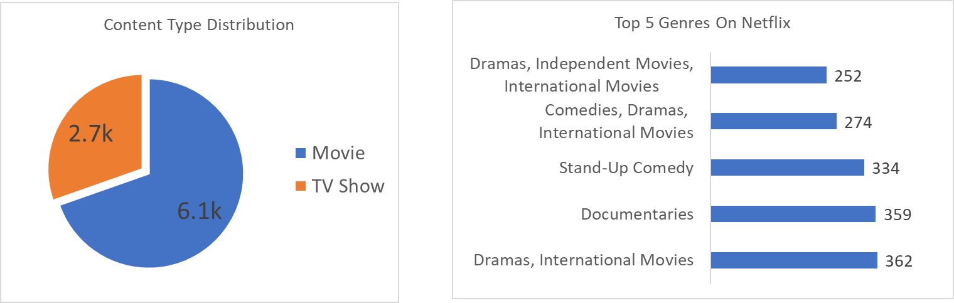
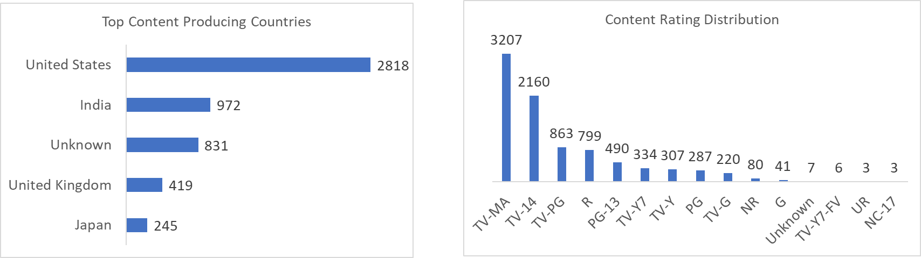
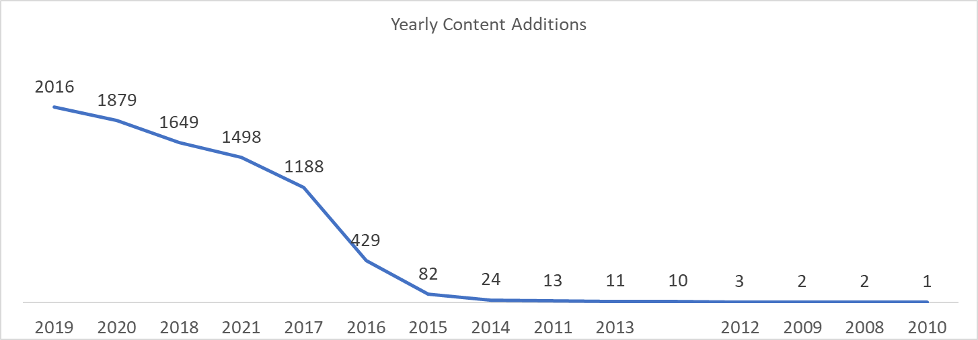

Insights:

Content Distribution
- Movies account for approximately 69% of the catalog (6.1K titles), while TV Shows represent 31% (2.7K titles).
- This reflects Netflix's stronger focus on movie content compared to television series.

Content Trends
- Content additions grew rapidly between 2016 and 2019, reaching a peak of over 2,000 titles in 2019.
- The trend indicates a significant expansion of Netflix's content library during this period.

Regional Performance
- The United States leads content production with 2,818 titles, significantly outperforming other countries.
- India ranks second with 972 titles, followed by the United Kingdom and Japan.
- The distribution demonstrates Netflix's strong global reach while maintaining a dominant presence in the U.S. market.

Genre & Rating Insights
- Dramas, International Movies is the most common genre category, followed by Documentaries, Stand-Up Comedy, and Comedies, Dramas, International Movies.
- TV-MA is the most frequent content rating with 3,207 titles, indicating a strong focus on mature audiences.
- Family-oriented ratings such as TV-G, TV-Y, and TV-Y7 make up a smaller portion of the catalog compared to adult-oriented content.

