Netflix Dashboard Summary

Data Cleaning Challenges
- Missing values in key columns such as Director, Cast, Country, Date Added, and Rating.
- Inconsistent country naming formats (e.g., “United States, United Kingdom” vs “United Kingdom, United States”).
- Date fields required standardization into a uniform format.
- Mixed duration units (minutes and seasons) complicated numerical analysis.
- Duplicate records were identified and removed where necessary.
The dataset was successfully cleaned and standardized, with key data quality issues addressed to ensure consistent, accurate, and reliable analysis
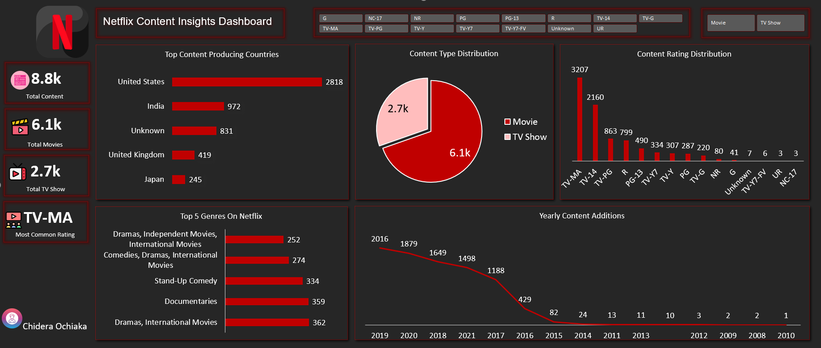

Executive Summary
The dashboard provides an overview of Netflix's content library, highlighting content distribution, genre popularity, content ratings, content-producing countries, and content addition trends. Netflix's catalog is dominated by movies, with the United States serving as the largest content-producing country.

Key KPIs
- Total Content: 8.8K
- Total Movies: 6.1K
- Total TV Shows: 2.7K
- Most Common Rating: TV-MA
Overall, Netflix maintains a diverse content portfolio with a strong emphasis on movies, mature-rated programming, and internationally produced content.

Key Insights

Content Distribution
- Movies account for approximately 69% of the catalog (6.1K titles), while TV Shows represent 31% (2.7K titles).
- This reflects Netflix's stronger focus on movie content compared to television series.

Content Trends
- Content additions grew rapidly between 2016 and 2019, reaching a peak of over 2,000 titles in 2019.
- The trend indicates a significant expansion of Netflix's content library during this period.

Regional Performance
- The United States leads content production with 2,818 titles, significantly outperforming other countries.
- India ranks second with 972 titles, followed by the United Kingdom and Japan.
- The distribution demonstrates Netflix's strong global reach while maintaining a dominant presence in the U.S. market.

Genre & Rating Insights
- Dramas, International Movies is the most common genre category, followed by Documentaries, Stand-Up Comedy, and Comedies, Dramas, International Movies.
- TV-MA is the most frequent content rating with 3,207 titles, indicating a strong focus on mature audiences.
- Family-oriented ratings such as TV-G, TV-Y, and TV-Y7 make up a smaller portion of the catalog compared to adult-oriented content.

Conclusion
Netflix's content library is heavily movie-focused, with substantial contributions from the United States and growing international representation. The platform experienced significant content growth between 2016 and 2019, while mature-rated and drama-focused content remain the dominant categories. These insights highlight Netflix's strategy of offering a broad and diverse catalog tailored primarily toward adult audiences.

