Online Retail Store Dashboard Summary

Data Cleaning Challenges
During the data cleaning process, several data quality challenges were identified:
- Missing values in the Customer ID and Description fields.
- Negative quantities indicating returned or cancelled transactions.
- Negative unit prices requiring validation and investigation.
- Duplicate transaction records that could lead to inaccurate reporting.
- Inconsistent data formats across certain fields.
- Cancelled invoices (Invoice Numbers beginning with "C") mixed with completed sales transactions.
The dataset was successfully cleaned and transformed into an analysis-ready format. Key data quality issues such as missing values, duplicates, cancelled orders, and inconsistent records were addressed to improve the accuracy and reliability of the dashboard insights.
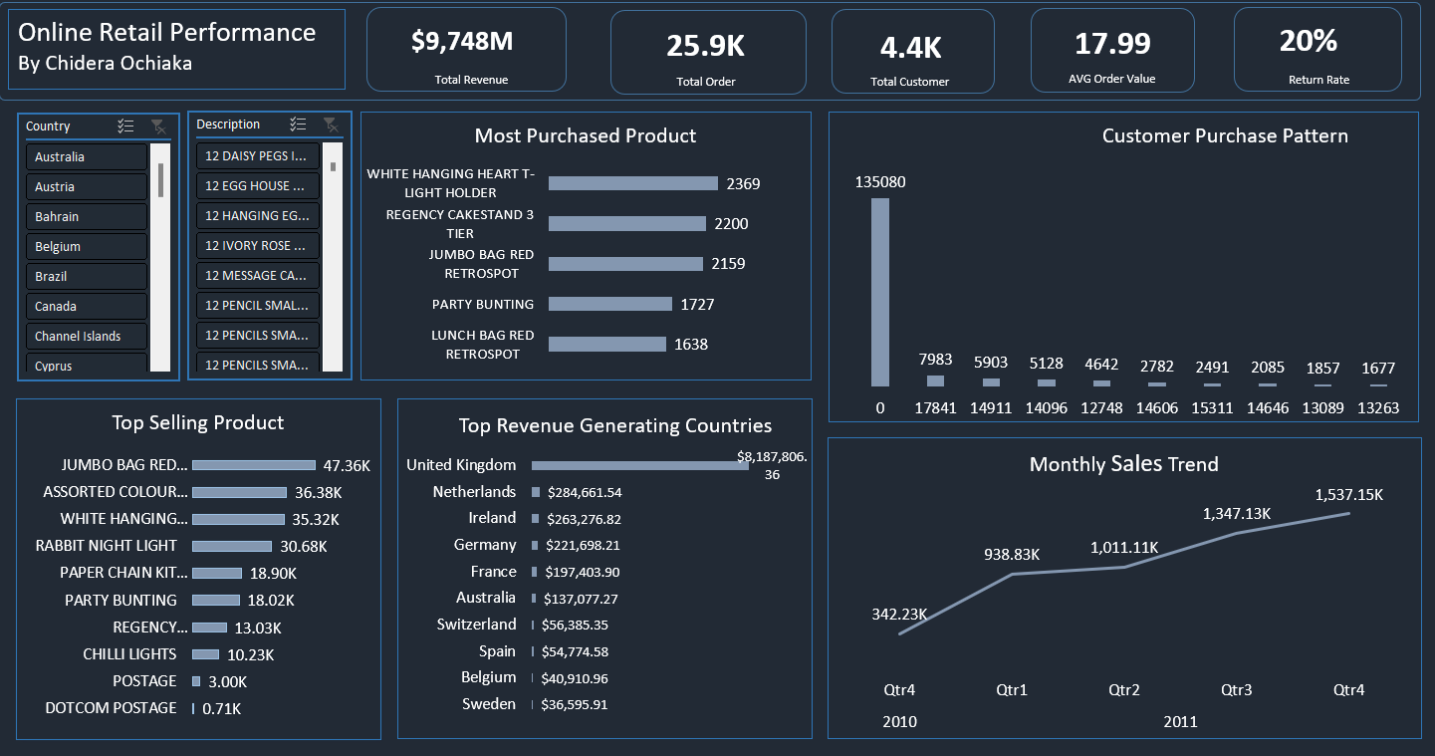

Executive Summary
The dashboard provides an overview of revenue, customers, products, sales trends, and regional performance. The business shows strong revenue growth across multiple countries, with the United Kingdom as the main revenue driver.

Key KPIs
- Total Revenue: $9.75M
- Total Orders: 25.9K
- Total Customers: 4.4K
- Average Order Value: $17.99
- Return Rate: 20%
Overall, the business shows strong sales performance and customer engagement, though the 20% return rate highlights potential issues in product satisfaction or order quality.

Key Insights

Product Performance
- JUMBO BAG RED RETROSPOT was the top-selling product by quantity.
- WHITE HANGING HEART T-LIGHT HOLDER was the most frequently purchased item.
- Decorative home and gift products dominated sales.
- A small group of products generated a large share of total revenue, showing a concentrated demand pattern.

Sales Trends
- Revenue showed steady growth across the period.
- Quarterly sales rose from about $342K in late 2010 to over $1.5M by late 2011.
- This indicates sustained demand and positive sales momentum.

Regional Performance
- The United Kingdom accounted for over $8M in revenue, dominating overall sales.
- Other key markets included the Netherlands, Ireland, Germany, and France.
- Heavy reliance on the UK market presents both strength and concentration risk.

Customer Activity

Customer behavior is highly concentrated, with a small group driving a large share of purchases.
- Repeat customers contribute significantly to revenue, indicating strong retention.
- With over 4,000 customers, there is opportunity for deeper segmentation and targeted marketing.

Recommendations
- Increase inventory and promotional efforts for high-demand products such as JUMBO BAG RED RETROSPOT and WHITE HANGING HEART T-LIGHT HOLDER.
- Develop customer retention programs to encourage repeat purchases from high-value customers.
- Expand marketing and sales initiatives in non-UK markets to reduce reliance on a single country.
- Investigate the 20% return rate to identify common causes of returns and implement corrective actions.
- Use customer purchasing patterns to create personalized marketing campaigns and cross-selling opportunities.

Conclusion
The dashboard highlights a business experiencing strong revenue growth, driven by popular product lines, a loyal customer base, and dominant performance in the United Kingdom market. While sales trends are highly positive, reducing returns and expanding international market penetration could further improve profitability and long-term business sustainability.

