International Trade Relations Database (ITReD)

Group 6 Project Report

by
Bryce Shifflett, Chidera C. Nnadiekwe, Jacob Pham, Iago T. Nonaka, Carlos R. Coronel, Michael Brennan, Jonathan Hebert, Abdul Mutaal, Isaac Humphries, Jacob Atkinson, Parker Ryan

CSC 4402 – Database Management Systems
Instructor: Prof. Jianhua Chen

May 1, 2026

Abstract
International trade among nations is an important indicator of the global economy. It boosts economic growth, reduces poverty, fosters efficiency, lowers costs of production through economies of sales, and facilitates access to goods and services. Ultimately, international trade aims to improve standards of living. The vast information regarding international trades is scattered over many materials and online resources and requires time and effort to synthesize collectively. Hence, designing and creating a relational database will make it easy, efficient, and convenient to access this information. In designing the International Trade Relations Database (ITReD), we considered the following relations for the logical schema: Regions (continent/trading bloc grouping), Countries, Product Categories, Products, Trade Agreements, Agreement Members, Tariffs, Trade Flows, Exchange Rates, and Sanctions. We have also included an E-R diagram for effective visualization of entities relationships and created Views for top bilateral trade relationships, trade balance per country per year, as well as tariff impact. Some analytical queries we have included are (1) Which country trades the most, (2) Trade balance for every country in a particular year, and (3) Product most impacted by tariffs greater than 10%, amongst others. To implement this database, we used VS Code editor for code development, Draw.io for E-R diagram, GitHub for version control, and Warp/VS Code Terminal as command interface.

Table of Contents
Abstract 2
1. Introduction 3
1.1 Motivation 4
1.2 Prospective Users of ITReD 4
2. Database Design 4
2.1 User Requirement, Business Rules, and Assumptions 4
2.2 E-R Diagram 5
2.3 Table Schemas and Functional Dependencies 6
2.3.1 REGIONS 6
2.3.2 COUNTRIES 6
2.3.3 PRODUCT_CATEGORIES 6
2.3.5 TRADE_AGREEMENTS 7
2.3.6 AGREEMENT_MEMBERS 7
2.3.7 TARIFFS 7
2.3.8 TRADE_FLOWS 8
2.3.9 EXCHANGE_RATES 8
2.3.10 SANCTIONS 8
Database Implementation 9

Introduction
The International Trade Relations Database (ITReD) is a relational database system designed to capture, store, and enable easy and efficient querying of global trade data. The database covers bilateral trade flows between countries, the products traded (classified using the Harmonized System), the tariff rates applied, trade agreements governing those rates, currency exchange rates, and economic sanctions between nations. International trade is a cornerstone of economic development. Nations specialize in the goods and services they can produce most efficiently, and exchange these with trading partners to maximize collective welfare. Tracking and analyzing this data requires consolidating information from sources such as UN Comtrade, the World Trade Organization (WTO), the World Bank, and the International Monetary Fund (IMF). The ITReD provides a single, structured repository to perform these analyses quickly and reproducibly.

Motivation
Despite the importance of trade data, it is currently scattered across different online portals and sources in inconsistent formats. Researchers, policy analysts, and government officials must manually combine data from multiple sources before any analysis can begin. The ITReD addresses this gap by providing a single relational database with consistent schemas, enforced referential integrity, and pre-built analytical Views.

Prospective Users of ITReD
- Economists and trade policy analysts who need to quickly compare tariffs across countries.
- Government trade agencies tracking bilateral agreements and sanction compliance.
- Academic researchers studying the impact of trade agreements on trade volumes.
- Businesses and import/export strategists analyzing market access conditions.
- Journalists and data journalists covering global commerce.

Database Design

User Requirement, Business Rules, and Assumptions
Business Rules:
- Each trade flow is uniquely identified by the combination of (exporter, importer, product, year). No duplicate flows are allowed.
- A country cannot impose sanctions on itself (enforced via CHECK constraint no_self_sanction).
- A country cannot trade with itself (enforced via CHECK constraint no_self_trade).
- All tariff rates (MFN and applied) are stored as percentage values between 0 and 100.
- Agreement membership status is restricted to: active, suspended, withdrawn, or observer.
- Agreement type is restricted to: Free Trade Agreement (FTA), Custom Union (CU).
- Economic Integration Agreement (EIA), Preferential Trade Agreement (PTA), World.
- Trade Organization (WTO), or OTHER.
Assumptions:
- Trade values are recorded as FOB (Free On Board) values in USD, excluding transportation and insurance costs.
- GDP and population figures are World Bank 2023 estimates.
- WTO membership dates and statuses are sourced from WTO.org.
- Product codes follow the 6-digit Harmonized System (HS) classification standard.
- Exchange rates represent units of local currency per 1 USD (annual average).
- A NULL product_id in the SANCTIONS table represents an all-goods sanction.

E-R Diagram
The ITReD E-R diagram was hand-drawn using the free version Draw.io and captures all ten entities along with their relationships as shown in Figure 1. The diagram is reproduced in textual form as shown below. Additionally, a full Mermaid source file is included in Appendix A.
Key entities and relationships:
- REGIONS groups COUNTRIES (one-to-many): each country belongs to exactly one geographic/economic region.
- COUNTRIES participate in AGREEMENT_MEMBERS (many-to-many bridge to TRADE_AGREEMENTS).
- COUNTRIES exports and imports in TRADE_FLOWS (two foreign keys to COUNTRIES, plus PRODUCTS).
- TARIFFS links importing countries, exporting countries, products, and optionally a TRADE_AGREEMENT.
- EXCHANGE_RATES records annual currency rates per country.
- SANCTIONS links two countries (imposing and target) and optionally a product.
- PRODUCT_CATEGORIES classifies PRODUCTS via HS section numbers.
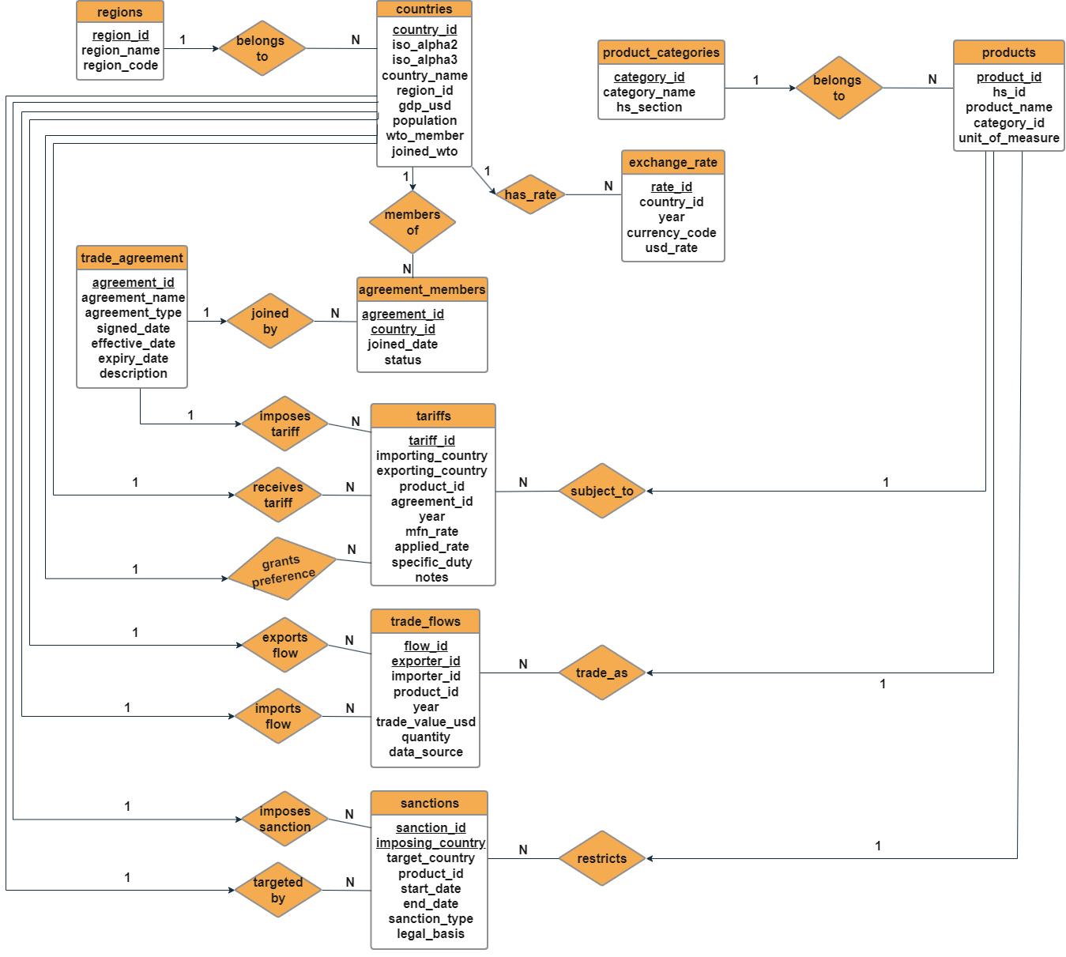
Figure 1. E-R Diagram of ITReD showing the 10 entities, their attributes and cardinalities.

Table Schemas and Functional Dependencies
All 10 tables are designed to satisfy Boyce-Codd Normal Form (BCNF). The schemas, primary keys, foreign keys, and primary functional dependencies are described below.

REGIONS
Attributes: region_id (PK), region_name, region_code
Functional Dependencies: The arrow means “maps to”
- region_id → region_name, region_code
- region_name → region_id, region_code
- region_code → region_id, region_name
Normal Form: BCNF (every determinant is a superkey)

COUNTRIES
Attributes: country_id (PK), iso_alpha2, iso_alpha3, country_name, region_id (FK → REGIONS), gdp_usd, population, wto_member, and joined_wto.
Functional Dependencies:
- country_id → iso_alpha2, iso_alpha3, country_name, region_id, gdp_usd, population, wto_member, joined_wto.
- iso_alpha2 → country_id (unique alternate key)
- iso_alpha3 → country_id (unique alternate key)
- country_name → country_id (unique alternate key)
Normal Form: BCNF

PRODUCT_CATEGORIES
Attributes: category_id (PK), category_name, and hs_section.
Functional Dependencies:
- category_id → category_name, hs_section
- hs_section → category_id, category_name
Normal Form: BCNF

PRODUCTS
Attributes: product_id (PK), hs_code, product_name, category_id (FK → PRODUCT_CATEGORIES), and unit_of_measure.
Functional Dependencies:
- product_id → hs_code, product_name, category_id, unit_of_measure
- hs_code → product_id (unique alternate key)
Normal Form: BCNF

TRADE_AGREEMENTS
Attributes: agreement_id (PK), agreement_name, agreement_type, signed_date, effective_date, expiry_date, and description.
Functional Dependencies:
- agreement_id → agreement_name, agreement_type, signed_date, effective_date, expiry_date, description
Normal Form: BCNF

AGREEMENT_MEMBERS
Attributes: agreement_id (PK, FK → TRADE_AGREEMENTS), country_id (PK, FK → COUNTRIES), joined_date, and status.
Functional Dependencies:
- (agreement_id, country_id) → joined_date, status
Normal Form: BCNF (composite PK is the only superkey)

TARIFFS
Attributes: tariff_id (PK), importing_country (FK → COUNTRIES), exporting_country (FK → COUNTRIES), product_id (FK → PRODUCTS), year, mfn_rate, applied_rate, specific_duty, agreement_id (FK → TRADE_AGREEMENTS), and notes.
Functional Dependencies:
- tariff_id → all other attributes
- (importing_country, exporting_country, product_id, year) → tariff_id (UNIQUE constraint)
Normal Form: BCNF

TRADE_FLOWS
Attributes: flow_id (PK), exporter_id (FK → COUNTRIES), importer_id (FK → COUNTRIES), product_id (FK → PRODUCTS), year, trade_value_usd, quantity, and data_source.
Functional Dependencies:
- flow_id → all other attributes
- (exporter_id, importer_id, product_id, year) → flow_id (UNIQUE constraint)
Normal Form: BCNF

EXCHANGE_RATES
Attributes: rate_id (PK), country_id (FK → COUNTRIES), year, currency_code, and usd_rate
Functional Dependencies:
- rate_id → country_id, year, currency_code, usd_rate
- (country_id, year) → currency_code, usd_rate (UNIQUE constraint)
Normal Form: BCNF

SANCTIONS
Attributes: sanction_id (PK), imposing_country (FK → COUNTRIES), target_country (FK → COUNTRIES), product_id (FK → PRODUCTS, nullable), start_date, end_date, sanction_type, and legal_basis.
Functional Dependencies:
- sanction_id → imposing_country, target_country, product_id, start_date, end_date, sanction_type, legal_basis
Normal Form: BCNF

Database Implementation
The ITReD was implemented using MySQL 9.5. Development was conducted in Visual Studio Code with the Warp/VS code terminal. Version control was managed through GitHub. The Draw.io was used to hand-construct and refine the E-R diagram.

Implementation Stacks and Platform
Table 1. List of stacks and/or tools used to implement ITReD
Stack/tool | Component
MySQL 9.5 | Database design
VS Code | Code Editor
Warp/VS Code Terminal | Terminal
Draw.io | E-R Diagram
GitHub | Version Control
Data Sources | UN Comtrade, WTO.org, World Bank, IMF, ISO 3166-1

Data Definition

CREATE TABLE Statements
The following CREATE TABLE statements define the ITReD schema.
CREATE TABLE regions (
region_id INT AUTO_INCREMENT PRIMARY KEY,
region_name VARCHAR(100) NOT NULL UNIQUE,
region_code CHAR(4) NOT NULL UNIQUE
);

CREATE TABLE countries (
country_id INT AUTO_INCREMENT PRIMARY KEY,
iso_alpha2 CHAR(2) NOT NULL UNIQUE,
iso_alpha3 CHAR(3) NOT NULL UNIQUE,
country_name VARCHAR(100) NOT NULL UNIQUE,
region_id INT NOT NULL,
gdp_usd DECIMAL(20,2),
population BIGINT,
wto_member BOOLEAN DEFAULT TRUE,
joined_wto DATE,
FOREIGN KEY (region_id) REFERENCES regions(region_id)
);

CREATE TABLE product_categories (
category_id INT AUTO_INCREMENT PRIMARY KEY,
category_name VARCHAR(150) NOT NULL UNIQUE,
hs_section SMALLINT NOT NULL UNIQUE
);

CREATE TABLE products (
product_id INT AUTO_INCREMENT PRIMARY KEY,
hs_code CHAR(6) NOT NULL UNIQUE,
product_name VARCHAR(200) NOT NULL,
category_id INT NOT NULL,
unit_of_measure VARCHAR(30) DEFAULT ‘kg’,
FOREIGN KEY (category_id) REFERENCES product_categories(category_id)
);

CREATE TABLE trade_agreements (
agreement_id INT AUTO_INCREMENT PRIMARY KEY,
agreement_name VARCHAR(200) NOT NULL UNIQUE,
agreement_type ENUM('FTA', 'CU', 'EIA', 'PTA', 'WTO', 'OTHER') NOT NULL,
signed_date DATE,
effective_date DATE,
expiry_date DATE,
description TEXT
);

CREATE TABLE agreement_members (
agreement_id INT NOT NULL,
country_id INT NOT NULL,
joined_date DATE,
status ENUM ('active', 'suspended', 'withdrawn', 'observer') DEFAULT 'active',
PRIMARY KEY (agreement_id, country_id),
FOREIGN KEY (agreement_id) REFERENCES trade_agreements(agreement_id) ON DELETE CASCADE,
FOREIGN KEY (country_id) REFERENCES countries(country_id) ON DELETE CASCADE
);

CREATE TABLE tariffs (
tariff_id INT AUTO_INCREMENT PRIMARY KEY,
importing_country INT NOT NULL,
exporting_country INT NOT NULL,
product_id INT NOT NULL,
year SMALLINT NOT NULL,
mfn_rate DECIMAL(7, 4),
applied_rate DECIMAL(7, 4),
specific_duty DECIMAL(12, 4),
agreement_id INT NULL,
notes TEXT,
UNIQUE (
importing_country,
exporting_country,
product_id,
year
),
FOREIGN KEY (agreement_id) REFERENCES trade_agreements(agreement_id),
FOREIGN KEY (importing_country) REFERENCES countries(country_id),
FOREIGN KEY (exporting_country) REFERENCES countries(country_id),
FOREIGN KEY (product_id) REFERENCES products(product_id)
);

CREATE TABLE trade_flows (
flow_id INT AUTO_INCREMENT PRIMARY KEY,
exporter_id INT NOT NULL,
importer_id INT NOT NULL,
product_id INT NOT NULL,
year SMALLINT NOT NULL,
trade_value_usd DECIMAL(20, 2) NOT NULL, -- FOB value in USD
quantity DECIMAL(20, 4), -- in product's unit_of_measure
data_source VARCHAR(100) DEFAULT 'UN Comtrade',
CONSTRAINT no_self_trade CHECK (exporter_id <> importer_id),
UNIQUE (exporter_id, importer_id, product_id, year),
FOREIGN KEY (exporter_id) REFERENCES countries(country_id),
FOREIGN KEY (importer_id) REFERENCES countries(country_id),
FOREIGN KEY (product_id) REFERENCES products(product_id)
);

CREATE TABLE exchange_rates (
rate_id INT AUTO_INCREMENT PRIMARY KEY,
country_id INT NOT NULL,
year SMALLINT NOT NULL,
currency_code CHAR(3) NOT NULL,
usd_rate DECIMAL(18, 6) NOT NULL,
UNIQUE (country_id, year),
FOREIGN KEY (country_id) REFERENCES countries(country_id)
);

CREATE TABLE sanctions (
sanction_id INT AUTO_INCREMENT PRIMARY KEY,
imposing_country INT NOT NULL,
target_country INT NOT NULL,
product_id INT,
start_date DATE NOT NULL,
end_date DATE,
sanction_type VARCHAR(80),
legal_basis TEXT,
CONSTRAINT no_self_sanction CHECK (imposing_country <> target_country),
FOREIGN KEY (imposing_country) REFERENCES countries(country_id),
FOREIGN KEY (target_country) REFERENCES countries(country_id),
FOREIGN KEY (product_id) REFERENCES products(product_id)
);

Sample INSERT Statements
The following shows two INSERT statements for each of the tables.
REGIONS:
INSERT INTO regions (region_name, region_code) VALUES
('North America', 'NOAM'),
('Latin America & Caribbean', 'LACB');

COUNTRIES:
INSERT INTO countries (iso_alpha2, iso_alpha3, country_name, region_id, gdp_usd, population, wto_member, joined_wto) VALUES
('US', 'USA', 'United States', 1, 25462700000000.00, 331000000, TRUE, '1995-01-01'),
('CA', 'CAN', 'Canada', 1, 2139840000000.00, 38000000, TRUE, '1995-01-01');

PRODUCT CATEGORIES:
INSERT INTO product_categories (category_name, hs_section) VALUES
('Live Animals & Animal Products', 1),
('Vegetable Products', 2);

PRODUCTS:
INSERT INTO products (hs_code, product_name, category_id, unit_of_measure) VALUES
('010121', 'Live horses, purebred breeding animals', 1, 'units'),
('020110', 'Carcasses and half-carcasses of bovine animals, fresh or chilled', 1, 'kg');

TRADE AGREEMENTS:
INSERT INTO trade_agreements (agreement_name, agreement_type, signed_date, effective_date, expiry_date, description) VALUES
('World Trade Organization', 'WTO', '1994-04-15', '1995-01-01', NULL, 'Multilateral rules-based trading system covering goods, services and IP.'),
('USMCA – United States-Mexico-Canada Agreement', 'FTA', '2018-11-30', '2020-07-01', NULL,
'Successor to NAFTA; governs trade among the US, Canada and Mexico.');

AGREEMENT MEMBERS:
INSERT INTO agreement_members (agreement_id, country_id, joined_date, status) VALUES
(1, 1, '1995-01-01', 'active'), -- US
(1, 2, '1995-01-01', 'active'); -- Canada

TARIFFS:
INSERT INTO tariffs (importing_country, exporting_country, product_id, year, mfn_rate, applied_rate, specific_duty, agreement_id, notes) VALUES
(1, 70, 14, 2023, 0.0000, 0.0000, 0.1052, NULL, 'US MFN rate on crude petroleum is zero; specific duty applies'),
(1, 46, 31, 2023, 0.0000, 7.5000, NULL, NULL, 'Section 301 tariff surcharge applied on top of MFN zero rate');

TRADE FLOWS:
INSERT INTO trade_flows (exporter_id, importer_id, product_id, year, trade_value_usd, quantity, data_source) VALUES
(1, 46, 8, 2022, 14000000000.00, 31600000000.00, 'UN Comtrade'),
(1, 2, 38, 2022, 38000000000.00, 1500000.00, 'UN Comtrade');

EXCHANGE RATES:
INSERT INTO exchange_rates (country_id, year, currency_code, usd_rate) VALUES
(1, 2022, 'USD', 1.000000), -- US Dollar
(2, 2022, 'CAD', 1.301400); -- Canadian Dollar

SANCTIONS:
INSERT INTO sanctions (imposing_country, target_country, product_id, start_date, end_date, sanction_type, legal_basis) VALUES
(1, 74, NULL, '2018-11-05', NULL, 'import ban; export ban; asset freeze', 'Executive Order 13846; IEEPA; Iran Sanctions Act — reimposed after JCPOA withdrawal'),
-- US sanctions on Russia (post-Ukraine invasion)
(1, 36, NULL, '2022-03-01', NULL, 'export ban; asset freeze; financial sanctions', 'Export Administration Regulations (EAR) Entity List; E.O. 14024; CAATSA');

Table Content (SELECT *)
After inserting all data, the following table shows the records from all the. Tables with more than 10 rows show only the first 10 records.
- REGIONS — SELECT * FROM regions LIMIT 10; We have 10 regions.
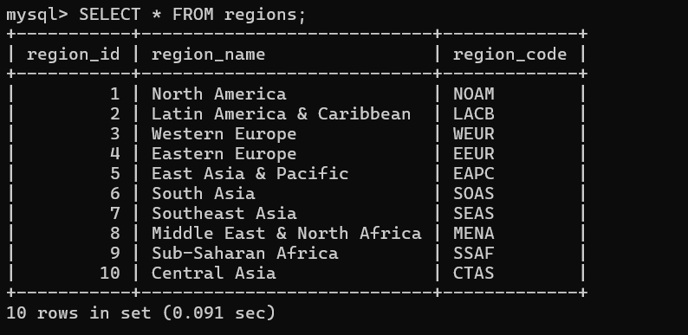
- COUNTRIES — SELECT * FROM countries LIMIT 10; We have 101 countries.
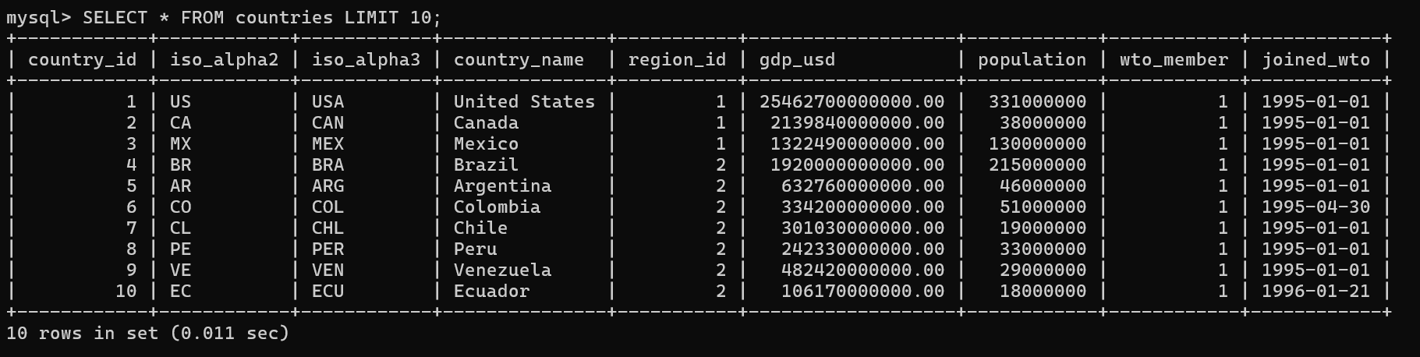
- PRODUCT CATEGORIES — SELECT * FROM product_categories LIMIT 10; We have 21 product categories.
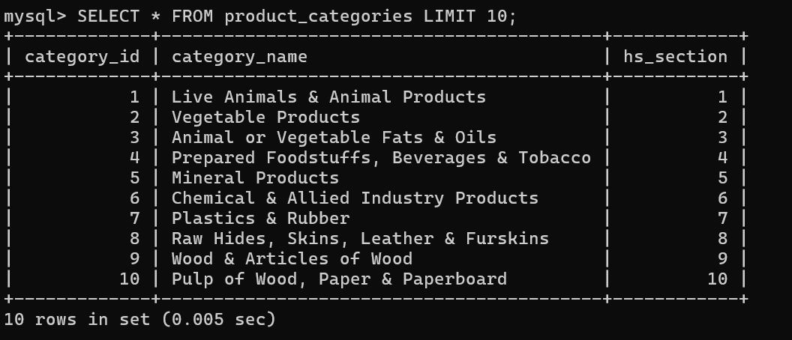
- PRODUCTS — SELECT * FROM products LIMIT 10; We have 50 products.
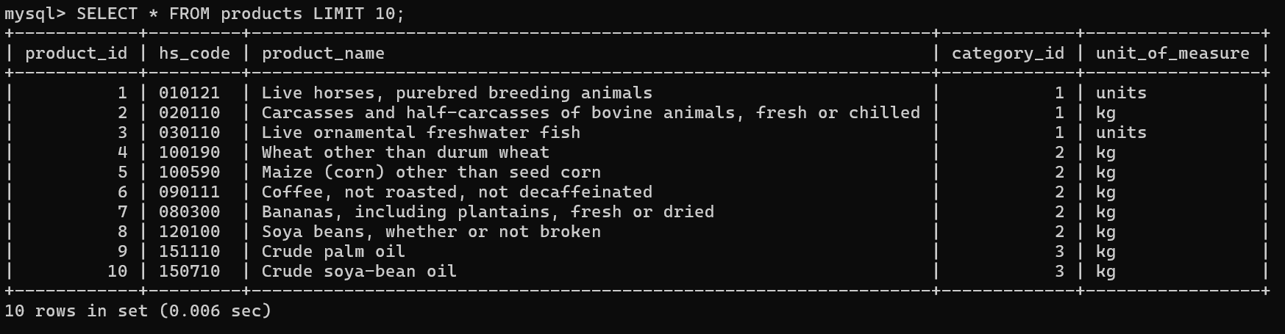
- TRADE AGREEMENTS — SELECT * FROM trade_agreements LIMIT 10; We have 15 trade agreements.
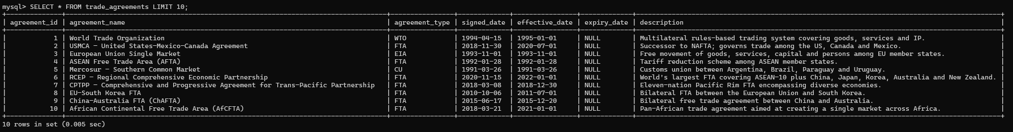
- AGREEMENT MEMBERSHIP — SELECT * FROM agreement_members LIMIT 10; We have 123 agreement members.
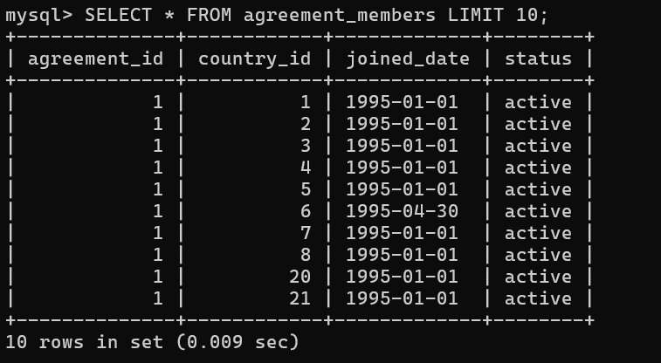
- TARIFFS — SELECT * FROM tariffs LIMIT 10; We have 29 tariffs.
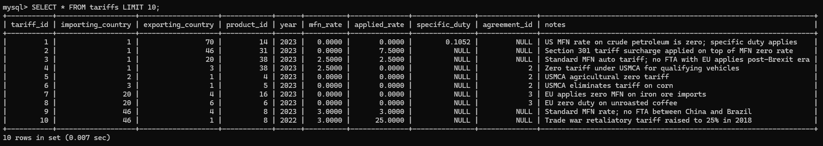
- TRADE FLOWS — SELECT * FROM trade_flows LIMIT 10; We have 50 trade flows.
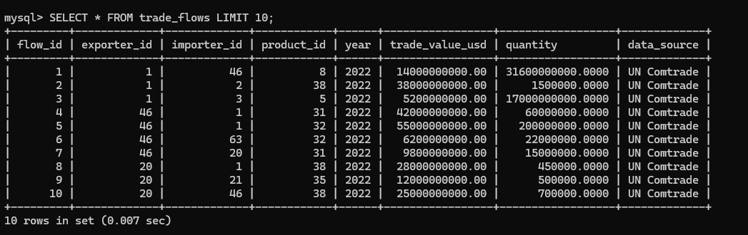
- EXCHANGE RATES — SELECT * FROM exchange_rates LIMIT 10; We have 51 exchange rates.
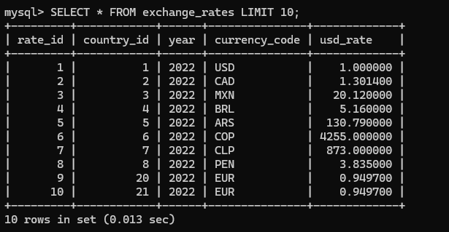
- SANCTIONS — SELECT * FROM sanctions LIMIT 10; We have 14 sanctions.
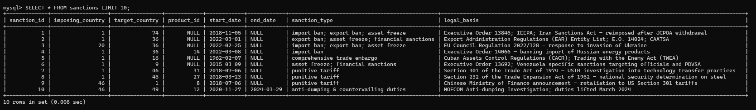

Data Manipulation

Analytical “SELECT” queries
The following are the 10 analytical SELECT queries supported by ITReD designed to demonstrate a range of SQL techniques including multi-table joins, subqueries, GROUP BY with aggregation functions, etc.
Query 1: Which country pairs trade the most? (Top 10 bilateral, 2022)
English: Retrieve the top 10 pairs of countries by total two-way trade value in 2022, expressed in billions of USD.
SELECT
country_a,
country_b,
year,
ROUND(total_two_way_usd / 1e9, 1) AS total_billion_usd
FROM vw_bilateral_trade
WHERE year = 2022
ORDER BY total_two_way_usd DESC
LIMIT 10;

Result Screenshot
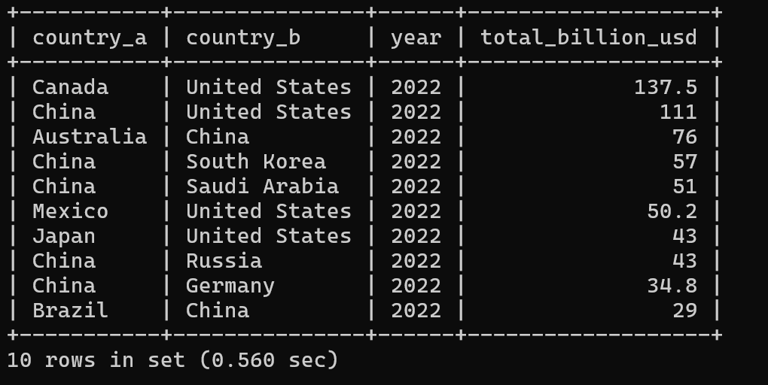
Query 2: Trade balance for every country (2022)
English: For each country, compute total exports, total imports, and the net trade balance in 2022, labeling each as a surplus or deficit country.
SELECT
country_name,
ROUND(exports_usd / 1e9, 1) AS exports_bn,
ROUND(ABS(imports_neg_usd) / 1e9, 1) AS imports_bn,
ROUND(trade_balance_usd / 1e9, 1) AS balance_bn,
CASE WHEN trade_balance_usd > 0
THEN 'Surplus' ELSE 'Deficit' END AS status
FROM vw_trade_balance
WHERE year = 2022
ORDER BY trade_balance_usd DESC;

Result Screenshot
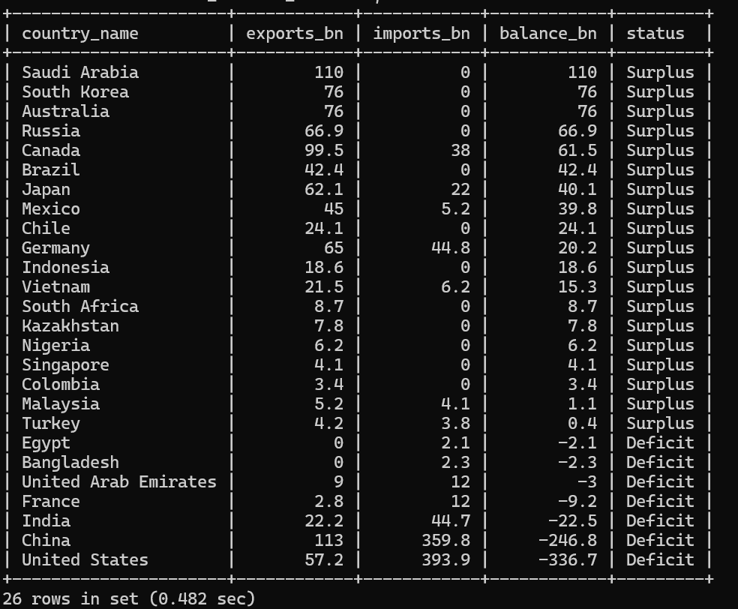
Query 3: Products most affected by tariffs greater than 10%
English: List all tariff records where the applied rate exceeds 10%, along with the associated product, product category, importer, exporter, and the corresponding trade flow value.
SELECT
p.hs_code, p.product_name, pc.category_name,
i.country_name AS importer, e.country_name AS exporter,
t.applied_rate AS tariff_pct,
ROUND(tf.trade_value_usd / 1e9, 2) AS flow_bn_usd
FROM tariffs t
JOIN products p ON p.product_id = t.product_id
JOIN product_categories pc ON pc.category_id = p.category_id
JOIN countries i ON i.country_id = t.importing_country
JOIN countries e ON e.country_id = t.exporting_country
LEFT JOIN trade_flows tf ON tf.exporter_id = t.exporting_country
AND tf.importer_id = t.importing_country
AND tf.product_id = t.product_id
AND tf.year = t.year
WHERE t.applied_rate > 10
ORDER BY t.applied_rate DESC, tf.trade_value_usd DESC;

Result Screenshot
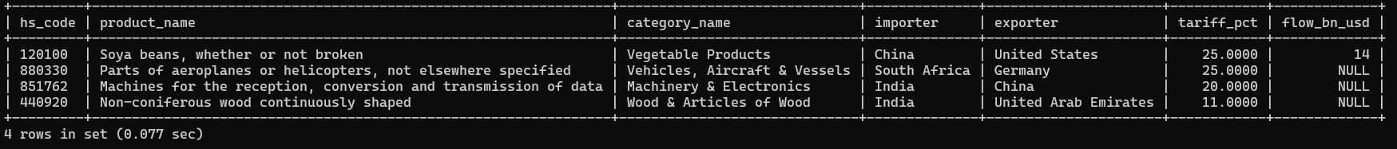
Query 4: Preference margin by trade agreement
English: For each trade agreement, compute the average and maximum preference margin (MFN rate minus applied rate), number of tariff lines, and list of importing countries.
SELECT
agreement_name,
COUNT(*) AS tariff_lines,
ROUND(AVG(preference_margin), 2) AS avg_margin_pct,
ROUND(MAX(preference_margin), 2) AS max_margin_pct,
GROUP_CONCAT(DISTINCT importer
ORDER BY importer SEPARATOR ', ') AS importers
FROM vw_tariff_preference
WHERE agreement_name IS NOT NULL
GROUP BY agreement_name
ORDER BY avg_margin_pct DESC;
Result Screenshot
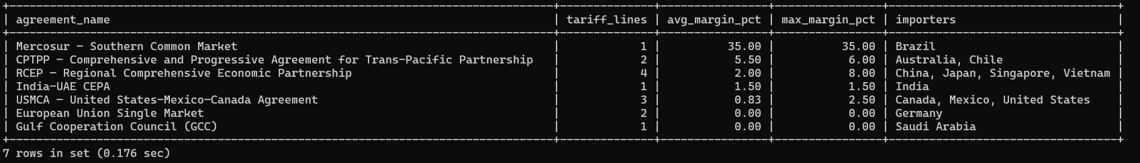
Query 5: Top exported products globally (2022)
English: Rank the top 10 products by total global trade value in 2022, counting how many nations export and import each product.
SELECT
p.hs_code, p.product_name, pc.category_name,
COUNT(DISTINCT tf.exporter_id) AS exporting_nations,
COUNT(DISTINCT tf.importer_id) AS importing_nations,
ROUND(SUM(tf.trade_value_usd)/1e9,1) AS global_flow_bn_usd
FROM trade_flows tf
JOIN products p ON p.product_id = tf.product_id
JOIN product_categories pc ON pc.category_id = p.category_id
WHERE tf.year = 2022
GROUP BY p.hs_code, p.product_name, pc.category_name
ORDER BY global_flow_bn_usd DESC
LIMIT 10;

Result Screenshot
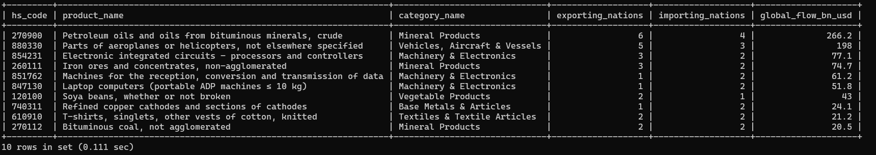
Query 6: Impact of sanctions on remaining trade flows
English: For each sanction record, show the imposing country, target country, affected product, sanction type, and the trade value in the year the sanction began.
SELECT
imp.country_name AS imposing, tgt.country_name AS target,
p.product_name, s.start_date, s.sanction_type,
ROUND(SUM(tf.trade_value_usd)/1e9, 2) AS remaining_flow_bn_usd
FROM sanctions s
JOIN countries imp ON imp.country_id = s.imposing_country
JOIN countries tgt ON tgt.country_id = s.target_country
LEFT JOIN products p ON p.product_id = s.product_id
LEFT JOIN trade_flows tf
ON (tf.exporter_id = s.target_country
AND tf.importer_id = s.imposing_country
OR tf.exporter_id = s.imposing_country
AND tf.importer_id = s.target_country)
AND (s.product_id IS NULL OR tf.product_id = s.product_id)
AND tf.year = EXTRACT(YEAR FROM s.start_date)
GROUP BY imp.country_name, tgt.country_name,
p.product_name, s.start_date, s.sanction_type
ORDER BY s.start_date;

Result Screenshot
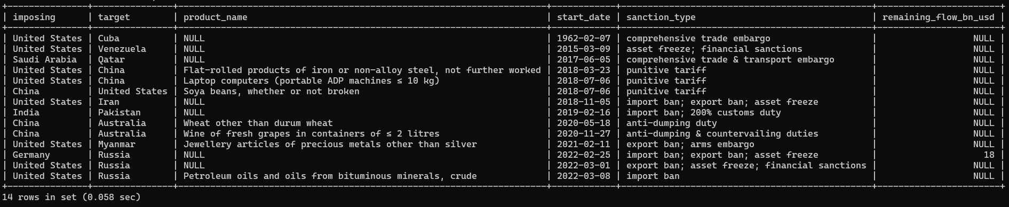
Query 7: Regional trade intensity (intra-region vs cross-region)
English: For 2022, compute total trade flows and their percentage of global trade by exporter region and importer region pair, using a window function for percentage calculation.
SELECT
er.region_name AS exporter_region,
ir.region_name AS importer_region,
ROUND(SUM(tf.trade_value_usd)/1e9, 1) AS flow_bn_usd,
ROUND(100.0 * SUM(tf.trade_value_usd) /
SUM(SUM(tf.trade_value_usd)) OVER (), 1) AS pct_of_total
FROM trade_flows tf
JOIN countries e ON e.country_id = tf.exporter_id
JOIN countries i ON i.country_id = tf.importer_id
JOIN regions er ON er.region_id = e.region_id
JOIN regions ir ON ir.region_id = i.region_id
WHERE tf.year = 2022
GROUP BY er.region_name, ir.region_name
ORDER BY flow_bn_usd DESC;

Result Screenshot
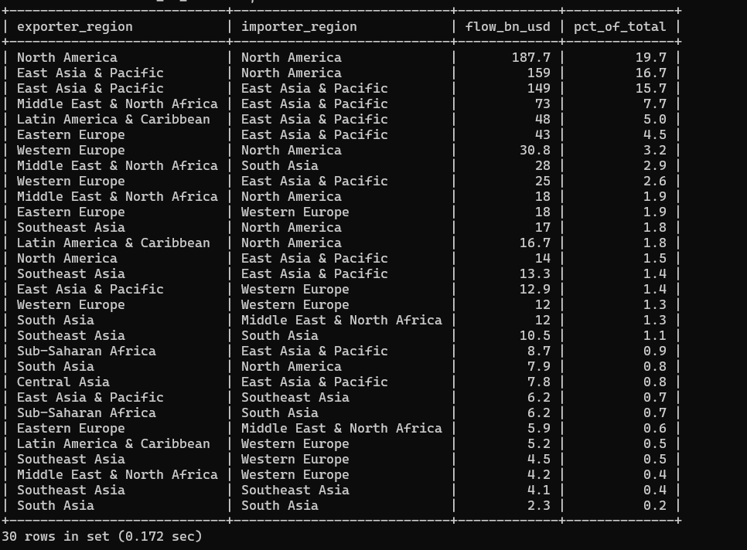
Query 8: Countries most dependent on a single export product (CTE)
English: Using a Common Table Expression, identify countries where one product accounts for more than 30% of total exports in 2022, ranked by concentration.
WITH country_totals AS (
SELECT exporter_id, year, SUM(trade_value_usd) AS total_exports
FROM trade_flows GROUP BY exporter_id, year
),
country_product AS (
SELECT exporter_id, product_id, year,
SUM(trade_value_usd) AS product_exports
FROM trade_flows GROUP BY exporter_id, product_id, year
)
SELECT
c.country_name, p.product_name, cp.year,
ROUND(cp.product_exports / ct.total_exports * 100, 1)
AS export_concentration_pct
FROM country_product cp
JOIN country_totals ct
ON ct.exporter_id = cp.exporter_id AND ct.year = cp.year
JOIN countries c ON c.country_id = cp.exporter_id
JOIN products p ON p.product_id = cp.product_id
WHERE cp.year = 2022
AND cp.product_exports / ct.total_exports > 0.30
ORDER BY export_concentration_pct DESC LIMIT 10;
Result Screenshot
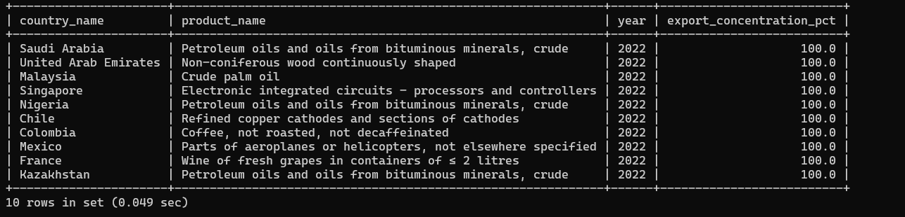
Query 9: Exchange-rate adjusted trade value
English: For the top 10 trade flows by value in 2022, show the equivalent trade value in both the exporter's and importer's local currency using exchange rates.
SELECT
e.country_name AS exporter, i.country_name AS importer,
p.product_name, tf.trade_value_usd,
xr_e.currency_code AS exporter_currency,
ROUND(tf.trade_value_usd * xr_e.usd_rate, 0)
AS value_in_exporter_currency,
xr_i.currency_code AS importer_currency,
ROUND(tf.trade_value_usd * xr_i.usd_rate, 0)
AS value_in_importer_currency
FROM trade_flows tf
JOIN countries e ON e.country_id = tf.exporter_id
JOIN countries i ON i.country_id = tf.importer_id
JOIN products p ON p.product_id = tf.product_id
LEFT JOIN exchange_rates xr_e
ON xr_e.country_id = tf.exporter_id AND xr_e.year = tf.year
LEFT JOIN exchange_rates xr_i
ON xr_i.country_id = tf.importer_id AND xr_i.year = tf.year
WHERE tf.year = 2022
ORDER BY tf.trade_value_usd DESC LIMIT 10;

Result Screenshot
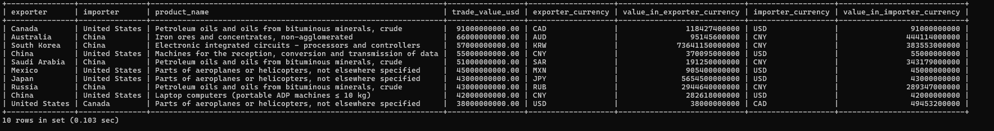
Query 10: Compute mean applied tariff each country imposes in 2023
SELECT c.country_name AS importer,
ROUND(AVG(t.applied_rate),2) AS avg_applied_tariff_pct,
COUNT(*) AS tariff_lines
FROM tariffs t
JOIN countries c ON c.country_id = t.importing_country
WHERE t.year = 2023
GROUP BY c.country_name
ORDER BY avg_applied_tariff_pct DESC;

Result Screenshot
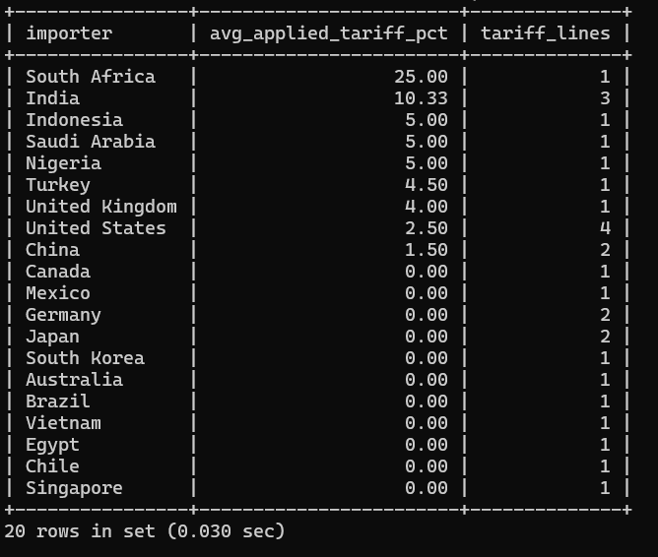

UPDATE Statements
The following UPDATE Statements demonstrate data manipulation capabilities of the ITReD.
Update 1: Revise GDP for United States (World Bank revised estimate):
UPDATE countries
SET gdp_usd = 26950000000000.00
WHERE iso_alpha3 = 'USA';

Update 2: Apply 10% tariff reduction to all products under USMCA (agreement_id = 1) in 2023:
UPDATE tariffs
SET applied_rate = ROUND(applied_rate * 0.90, 4)
WHERE agreement_id = 1 AND year = 2023;

Update 3: Mark a sanction as ended:
UPDATE sanctions
SET end_date = '2023-12-31'
WHERE imposing_country = 1 AND target_country = 37
AND start_date = '2022-02-28';

Update 4: Update exchange rate for Euro (Germany) for 2023:
UPDATE exchange_rates
SET usd_rate = 0.9250, currency_code = 'EUR'
WHERE country_id = (SELECT country_id FROM countries
WHERE iso_alpha3 = 'DEU')
AND year = 2023;

Update 5: Correct a trade flow quantity:
UPDATE trade_flows
SET quantity = 1250000.0000, data_source = 'WTO Verified'
WHERE exporter_id = 1 AND importer_id = 48
AND product_id = 12 AND year = 2022;

Web-Based GUI Implementation
The project included a fully functional browser-based GUI that allows users to explore the International Trade Relations Database interactively, without writing any SQL. The interface provides an interactive world map as the primary navigation element; clicking a country retrieves its trade flows, annual trade balance, and active or historical sanctions from the MySQL database in real time.

Implementation Platform and Software Packages
Table 2 shows the different technologies used to develop the different layers of the web-based GUI of ITReD.
Table 2. Platforms and packages for the development of the web-based GUI.
Layer | Technology | Version
Frontend framework | React | 19.2.4
Build tool | Vite | 8.0.4
HTTP client | Axios | 1.15.0
Map rendering | react-simple-maps | 3.0.0
Backend runtime | Node.js | ≥ 18
Backend framework | Express | 5.2.1
Database driver | mysql2 | 3.22.1
Database | MySQL Community Server | 8.x
Environment config | dotenv | 17.4.2

The frontend development server runs on port 5173 and the REST API server runs on port 3001. Cross-Origin Resource Sharing (CORS) is enabled at the backend so the browser can reach the API freely during development.

Architecture Overview
The application follows a classic three-tier architecture as shown in the screenshot be:
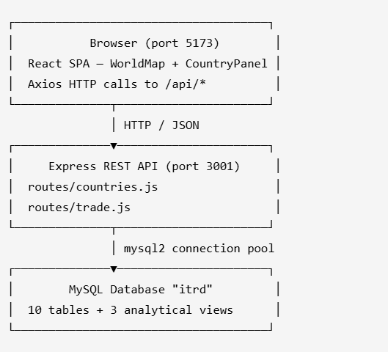
The frontend never connects to MySQL directly. All database access is mediated through the Express API, which validates parameters, executes parameterized SQL queries, and returns JSON to the browser.

Frontend–Backend Integration
API Service Layer:
All HTTP calls are centralized in a single file (frontend/src/services/api.js) so that components never construct URLs themselves:
import axios from 'axios';

const api = axios.create({ baseURL: 'http://localhost:3001/api' });

export const getCountries = () => api.get('/countries');
export const getCountryTrade = (iso3) => api.get(`/countries/${iso3}/trade`);
export const getCountryBalance = (iso3) => api.get(`/countries/${iso3}/balance`);
export const getCountrySanctions = (iso3) => api.get(`/countries/${iso3}/sanctions`);
export const getTradeFlows = (year) => api.get(`/trade/flows?year=${year}`);
export const getBilateral = (year) => api.get(`/trade/bilateral?year=${year}`);

Database Connection Pool (Backend)
The backend uses a connection pool to avoid opening a new MySQL connection for every request:
// backend/db/connection.js
import mysql from 'mysql2/promise';
import dotenv from 'dotenv';
dotenv.config();

const pool = mysql.createPool({
host: process.env.DB_HOST,
user: process.env.DB_USER,
password: process.env.DB_PASSWORD,
database: process.env.DB_NAME,
waitForConnections: true,
connectionLimit: 10,
});

export default pool;

Country Selection → Data Load Flow
When a user clicks a country on the map, CountryPanel.jsx fires three parallel API calls using Promise.all, so all three tabs populate simultaneously:
// frontend/src/components/CountryPanel.jsx (excerpt)
useEffect(() => {
if (!country) return;
setLoading(true);

Promise.all([
getCountryTrade(country.iso_alpha3),
getCountryBalance(country.iso_alpha3),
getCountrySanctions(country.iso_alpha3),
]).then(([tradeRes, balanceRes, sanctionsRes]) => {
setTrade(tradeRes.data);
setBalance(balanceRes.data);
setSanctions(sanctionsRes.data);
setLoading(false);
});
}, [country]);
This pattern ensures the UI never blocks on a single slow query.

GUI Walkthrough

View 1 — Main Page (Interactive World Map)
The landing page fills the entire viewport with a dark-themed, zoomable world map rendered by react-simple-maps. The right-side panel is empty on load, prompting the user to select a country.
Color coding:
- Blue — country is present in the ITRD database (101 countries)
- Gray — country not in the database
Users can scroll to zoom or drag to pan. Clicking any blue country turns it yellow and loads its data in the right panel.
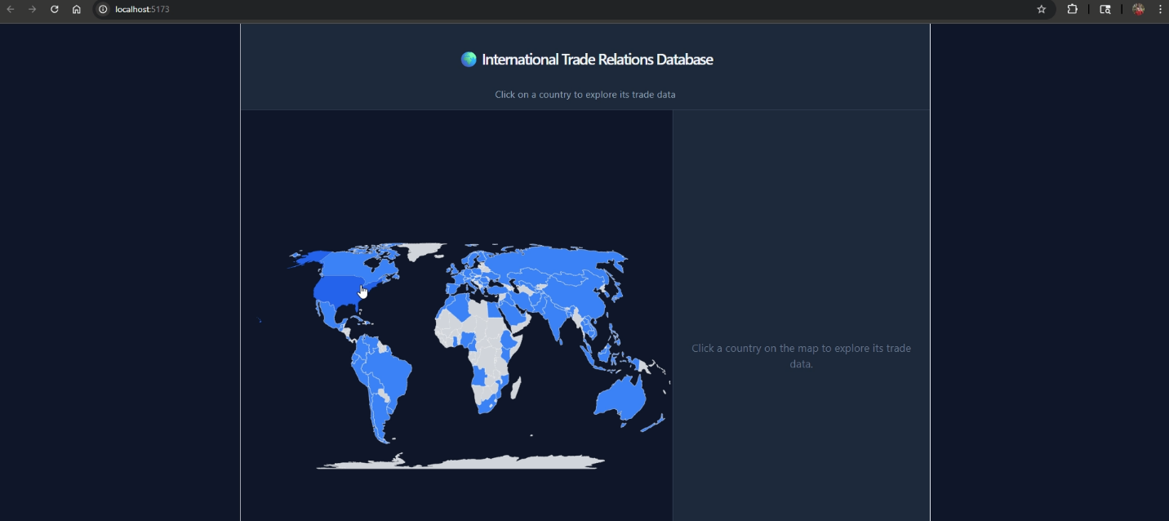
Backend query triggered on load (GET /api/countries):
SELECT c.country_id, c.country_name, c.iso_alpha2, c.iso_alpha3,
c.gdp_usd, c.population, c.wto_member, c.joined_wto,
r.region_name
FROM countries c
JOIN regions r ON c.region_id = r.region_id
ORDER BY c.country_name;
This query runs once when the React app mounts. The resulting list of ISO-alpha3 codes is used to paint countries blue on the map, and the full country metadata (GDP, population, region, WTO status) is cached in memory so the detail panel can populate without an extra request.

View 2 — Trade Tab
Clicking a country e.g., the United States, highlights it yellow on the map and opens the right panel. The panel header displays the country name, region, GDP, population, and WTO membership drawn from the cached country list. Below the header, the Trade tab (selected by default) lists all bilateral trade flows in which the country participates, either as exporter or importer, sorted by trade value descending.
Panel header fields: country name · region · GDP · population · WTO membership status
Table columns: Exporter | Importer | Product | Year | Value (B$)
The example below shows the top flows for the United States in 2022: Canada exporting crude petroleum oils ($91B),Chinaexportingdata-transmissionmachines($55 B), and Mexico exporting aircraft parts ($45 B), all into the United States.
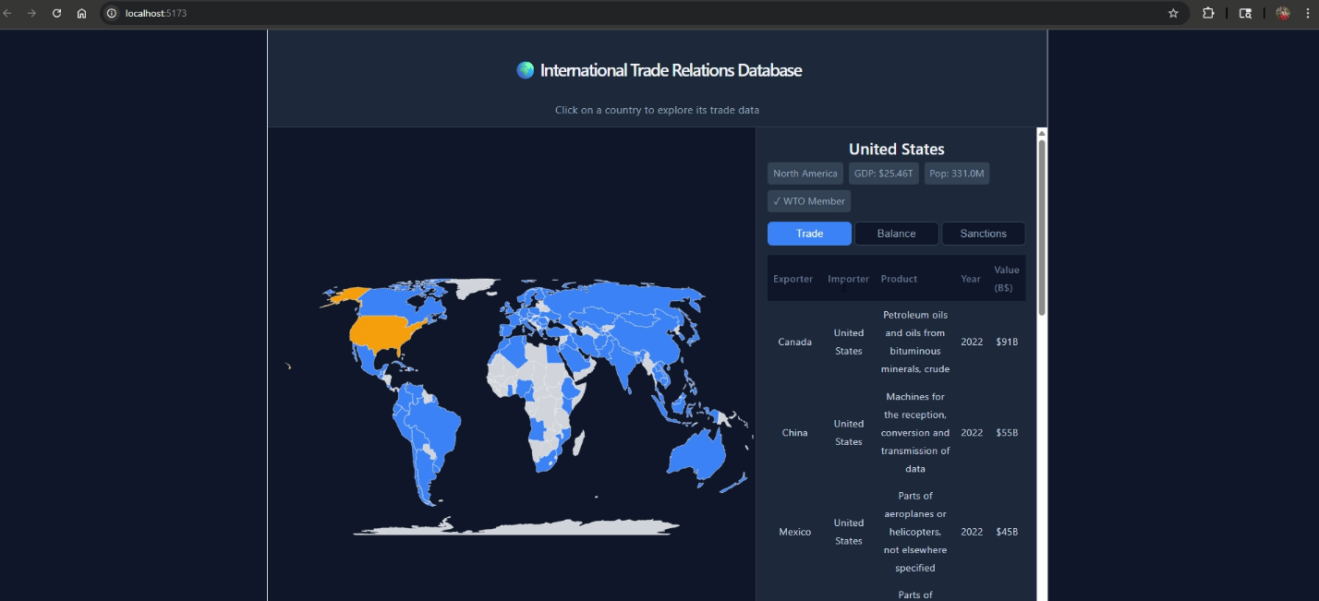
Backend query (GET /api/countries/:iso3/trade):
SELECT ce.country_name AS exporter,
ce.iso_alpha3 AS exporter_iso3,
ci.country_name AS importer,
ci.iso_alpha3 AS importer_iso3,
p.product_name,
p.hs_code,
tf.year,
ROUND(tf.trade_value_usd / 1e9, 3) AS trade_value_bn_usd
FROM trade_flows tf
JOIN countries ce ON tf.exporter_id = ce.country_id
JOIN countries ci ON tf.importer_id = ci.country_id
JOIN products p ON tf.product_id = p.product_id
WHERE ce.iso_alpha3 = ?
OR ci.iso_alpha3 = ?
ORDER BY tf.trade_value_usd DESC;
The ? placeholder is filled with the ISO-alpha3 code of the selected country (e.g., 'USA'). Using a parameterized query prevents SQL injection.

View 3 — Balance Tab
The Balance tab shows the net annual trade balance (exports minus imports) for the selected country, powered by the pre-built database view vw_trade_balance. Deficit rows are highlighted red with a ▼ indicator; surplus rows would appear green with a ▲ indicator.
Table columns: Year | Exports (B$)∣Imports(B$) | Balance (B$)
For the United States in 2022, the panel shows exports of $57.28Bagainstimportsof$393.98 B, resulting in a trade deficit of ▼ $336.78 B, displayed in red.
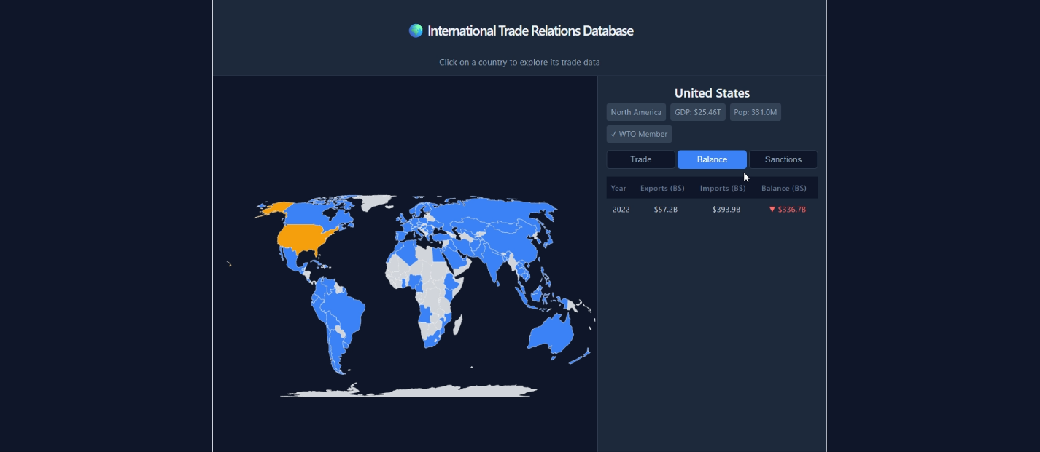
Backend query (GET /api/countries/:iso3/balance):
-- The vw_trade_balance view definition:
CREATE VIEW vw_trade_balance AS
SELECT c.iso_alpha3,
c.country_name,
tf.year,
SUM(CASE WHEN tf.exporter_id = c.country_id
THEN tf.trade_value_usd ELSE 0 END) AS exports_usd,
SUM(CASE WHEN tf.importer_id = c.country_id
THEN tf.trade_value_usd ELSE 0 END) AS imports_usd,
SUM(CASE WHEN tf.exporter_id = c.country_id
THEN tf.trade_value_usd
ELSE -tf.trade_value_usd END) AS trade_balance_usd
FROM countries c
JOIN trade_flows tf ON tf.exporter_id = c.country_id
OR tf.importer_id = c.country_id
GROUP BY c.country_id, tf.year;

-- Query used by the endpoint:
SELECT year, exports_usd, imports_usd, trade_balance_usd
FROM vw_trade_balance
WHERE iso_alpha3 = ?
ORDER BY year DESC;

View 4 — Sanctions Tab
The Sanctions tab lists every economic sanction involving the selected country, whether it is the imposing party or the target. All rows for the United States shown here have "Active" in the End column, meaning no end date has been recorded, indicating the measures are currently in force.
Table columns: Imposing | Target | Type | Start | End
The United States example shows six active measures: an import ban on Russia (2022-03-08), a package of export ban, asset freeze, and financial sanctions also against Russia (2022-03-01), an export ban and arms embargo against Myanmar (2021-02-11), a combined import/export ban and asset freeze against Iran (2018-11-05), a punitive tariff against China (2018-07-06), and a reciprocal punitive tariff imposed by China on the United States (2018-07-06).
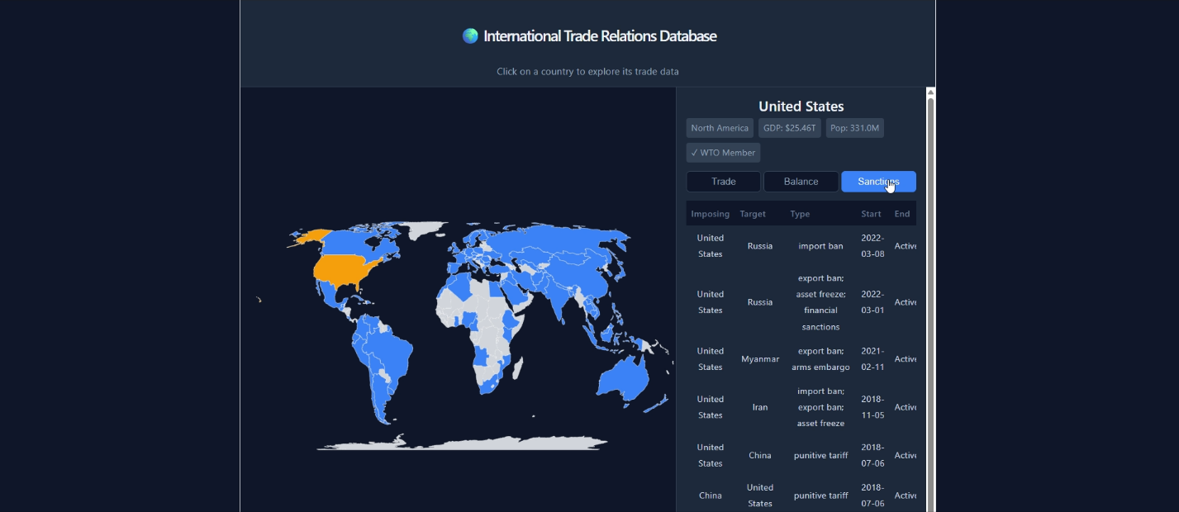
Backend query (GET /api/countries/:iso3/sanctions):
SELECT ci.country_name AS imposing_country,
ct.country_name AS target_country,
p.product_name,
s.start_date,
s.end_date,
s.sanction_type,
s.legal_basis
FROM sanctions s
JOIN countries ci ON s.imposing_country = ci.country_id
JOIN countries ct ON s.target_country = ct.country_id
LEFT JOIN products p ON s.product_id = p.product_id
WHERE ci.iso_alpha3 = ?
OR ct.iso_alpha3 = ?
ORDER BY s.start_date DESC;
A LEFT JOIN is used on products because product_id is nullable in sanctions — a NULL value means the sanction applies to all goods traded between the two countries, not a specific product category.

Request–Response Data Flow (Summary)
The sequence below summarizes what happens from a mouse click to data appearing on screen:
1. User clicks country on WorldMap
↓
2. WorldMap calls onCountryClick(countryObject)
↓
3. App passes selected country to CountryPanel via props
↓
4. CountryPanel's useEffect fires Promise.all([
GET /api/countries/{iso3}/trade,
GET /api/countries/{iso3}/balance,
GET /api/countries/{iso3}/sanctions
])
↓
5. Express router receives each request, extracts :iso3 param
↓
6. mysql2 pool runs parameterized SQL against itrd database
↓
7. Results serialized to JSON, sent back as HTTP 200
↓
8. Axios resolves all three promises simultaneously
↓
9. React state updated → component re-renders with data
↓
10. User sees country header + three populated tabs
Total round-trip time is dominated by MySQL query execution; typical response times on a local setup are under 50 ms per endpoint.

Design Decisions
Decision | Rationale
Single-page application (no routing) | The entire experience fits in one view; adding a router would add complexity without benefit for this scope.
Parallel API calls with Promise.all | All three-tab datasets are independent; fetching sequentially would triple perceived load time.
Parameterized SQL queries only | Prevents SQL injection at the application layer, in addition to the database-level constraints.
Analytical views in the database (vw_trade_balance, vw_bilateral_trade) | Keeps complex aggregation logic in SQL where it belongs and makes the Express route code trivially simple.
ISO-alpha3 as the URL key | Human-readable, stable, and matches the GeoJSON property used by react-simple-maps, avoiding a separate lookup step.
Dark color scheme | Reduces eye strain during long data exploration sessions and provides strong contrast for the map color coding (blue/yellow/gray).

Conclusions and Future Directions
The International Trade Relations Database (ITReD) successfully demonstrates the application of relational database design principles to a real-world domain of significant economic importance. The ITReD provides a normalized, well-constrained schema that captures the multidimensional nature of global trade, spanning countries, products, tariffs, agreements, exchange rates, and sanctions in a single queryable system.

Summary of Achievements
- Designed and implemented a 10-table relational database in BCNF, with all functional dependencies properly identified and enforced.
- Modeled 100 countries across 10 global regions using real-world GDP, population, and WTO membership data.
- Created 10 analytical SELECT queries demonstrating multi-table joins, subqueries, GROUP BY, aggregate functions, and window functions.
- Implemented 3 analytical views (vw_bilateral_trade, vw_trade_balance, vw_tariff_preference) for reusable business intelligence.
- Enforced referential integrity and domain constraints via PRIMARY KEY, FOREIGN KEY, UNIQUE, CHECK, and ENUM constraints.
- Developed a web-based GUI for browser-based querying and visualization.

Future Directions
- Integrate a live data feed from the UN Comtrade public API to automatically populate trade flow records.
- Expand country coverage to 200+ nations and add sub-national regional trade data.
- Add a historical GDP time-series table to support trend analysis across multiple years.
- Implement role-based access control (RBAC) to distinguish read-only analyst accounts from administrator accounts.

References
International Monetary Fund. (n.d.). Exchange rate data. https://www.imf.org/en/Data
International Organization for Standardization. (n.d.). ISO 3166-1 country codes. https://www.iso.org/iso-3166-country-codes.html
United Nations. (n.d.). Comtrade database. https://comtrade.un.org/
World Bank. (n.d.). World development indicators. World Bank DataBank. https://databank.worldbank.org/source/world-development-indicators
World Customs Organization. (n.d.). What is the harmonized system (HS)? https://www.wcoomd.org/en/topics/nomenclature/overview/what-is-the-harmonized-system.aspx
World Trade Organization. (n.d.). Members and observers. https://www.wto.org/english/thewto_e/whatis_e/tif_e/org6_e.htm

Appendices
- Appendix A — E-R Diagram (Mermaid Source)
The full E-R diagram Mermaid source file is available in the project repository as GROUP_6_DBMS_E-R_SCHEMA.mermaid. It can be visualized at https://mermaid.live.
erDiagram
REGIONS ||--o{ COUNTRIES : "groups"
COUNTRIES ||--o{ AGREEMENT_MEMBERS : "joins"
TRADE_AGREEMENTS ||--o{ AGREEMENT_MEMBERS : "governs"
PRODUCT_CATEGORIES ||--o{ PRODUCTS : "classifies"
COUNTRIES ||--o{ TRADE_FLOWS : "exports"
COUNTRIES ||--o{ TRADE_FLOWS : "imports"
PRODUCTS ||--o{ TRADE_FLOWS : "traded_as"
COUNTRIES ||--o{ TARIFFS : "imposes"
COUNTRIES ||--o{ TARIFFS : "faces"
PRODUCTS ||--o{ TARIFFS : "subject_to"
TRADE_AGREEMENTS ||--o{ TARIFFS : "reduces"
COUNTRIES ||--o{ EXCHANGE_RATES : "has"
COUNTRIES ||--o{ SANCTIONS : "imposes_sanction"
COUNTRIES ||--o{ SANCTIONS : "targeted_by"
PRODUCTS ||--o{ SANCTIONS : "restricted_by"

- Appendix B — GitHub Repository
All SQL scripts, the E-R diagram, the abstract, and project documentation are available at:
https://github.com/[group-6-repo]/CSC-4402G-DBMS-group-project

