Chidghana Hemantharaju
Project Management

TECHNICAL SKILLS
PMO & Project Tools: MS Teams (proficient) | MS Office Suite (Excel advanced, Word, PowerPoint) | Jira (basic, eager to deepen) | Planner Premium (learning in progress)
Project Management: Status reporting | Project documentation | Template development | Workflow standardization | Process optimization | Risk identification & mitigation

EXPERIENCE

Chidghana.hemantharaju27@gmail.com
+49 176 80707047
Schönleutnerstraße 5, 80997 München linkedin.com/in/chidghana-hemantharaju

PROFILE
Project-driven Master's student with 3+ years hands- on PMO experience supporting project managers, creating status reports, and driving process optimization. Demonstrated expertise in identifying project red flags, developing targeted solutions, and standardizing PMO workflows and templates.
Proficient in MS Office (Excel advanced), MS Teams, with enthusiasm to deepen Jira and Planner Premium expertise. Bilingual (English/German), service- oriented, and genuinely motivated by digital process transformation and innovation. Ready to support RÖDL's Global Function DPT and contribute to strategic PMO development.

EDUCATION

Master's in Business Analytics and Data Science
EU Business School
04/2024 – Current | Munich, Germany
Bachelor of Commerce (Accounting and Taxation) Kempe Gowda Institute of Management and Research 2017 – 2020 | Bangalore

CERTIFICATIONS

Career Essentials in Project Management by Microsoft and LinkedIn
Jan 20, 2026

Project Management Foundations: Communication
Project Manager & Data Analyst
Butterfly Interiors
2020 – 2024 | Bengaluru, India

Supporting Project Managers & Status Reporting:
Coordinated status reports and project progress tracking for 100+ concurrent projects with 92% on-time delivery
Identified project red flags and performance issues from status data; collaborated with leaders to develop targeted solutions and mitigation strategies
Maintained structured documentation ensuring timely processing and stakeholder alignment

PMO Operations & Development:
Standardized 20+ project workflows and templates reducing setup time by 40%—directly supporting PMO efficiency and global consistency
Maintained PMO documentation, dashboards, and intranet resources ensuring accuracy and accessibility
Supported development and revision of project templates and documentation standards

Training Materials & Knowledge Management:
Created training materials and process guides for project management methodologies
Developed structured documentation for future global PM tool implementation and team onboarding
Supported workshops and presentations for team training and stakeholder communication

Process Transformation & Innovation:
Identified workflow bottlenecks and proposed solutions reducing scope creep by 25% and process complexity by 40%
Championed continuous improvement initiatives aligned with digital transformation principles
Contributed strategic recommendations to PMO leadership for operational enhancement
CORE COMPETENCIES
Project coordination & follow‑up: Planning, documenting, and tracking project activities, deadlines, and responsibilities in a structured way.
Stakeholder communication: Clear, concise updates to managers, teams, and customers, including risks, delays, and next steps.
KPI monitoring & data mindset: Comfortable using KPIs and simple analysis to spot issues early and support decisions.
Process & documentation quality: Creating and maintaining templates, guidelines, and checklists that improve consistency and traceability.
Organized, reliable working style: Detail‑oriented, structured, and able to manage several tasks in parallel without losing overview.
ADDITIONAL INFORMATION

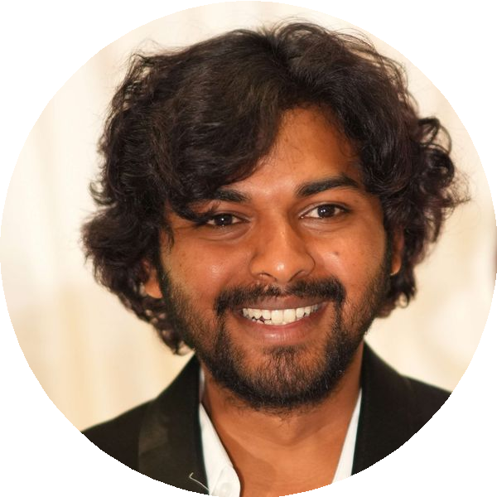

English
Fluent

German
A2

LANGUAGES

Positive, proactive, and hands-on approach with strong responsibility and reliability. Thrive working independently and collaboratively with diverse teams, balancing detailed PMO documentation work with direct stakeholder coordination. Passionate about infrastructure development and genuinely motivated to deepen expertise in JIRA and Planner Premium while supporting RÖDL's Global Function Digital Process Transformation initiatives. Enthusiastic about transformation, innovation, and contributing to RÖDL's entrepreneurial, high-performance culture.

