**CSCI 1630**

**Chapter 1. In-class Exercise**

Create a **Refrigerator** class which requires the dimensions of an actual refrigerator to build an object.

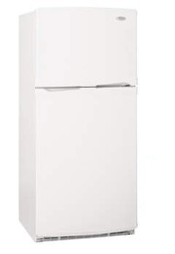

An object of class **Refrigerator** can report:

* Its dimensions
* The area of its base
* Its brand
* Its serial number
* **Student Home Assignment –** add new code to the **Refrigerator** class so that the object reports:
  + Its volume
  + Its temperature:
    - The temperature range is 37.0 – 41.0 degrees Fahrenheit.
    - When a refrigerator is constructed, its initial temperature is the range average
    - The **SetTemperature()** method accepts a given temperature value. The method sets the refrigerator’s temperature only when the given value is within the acceptable range. When the given temperature value is not within the range, the method sets the refrigerator temperature to the range average.

Create an application class which creates **Refrigerator** objects and displays information about them.