Distributed and Cloud Database Discussion
Overview
Miva Hospital should use a distributed database on a managed cloud platform, in my opinion. When we say "distributed," we imply that the data is dispersed among a number of interconnected servers, possibly located in various nations, but the staff and applications still see it as a single database. The provider owns that hardware, which operates in the cloud.
This is critical since the hospital's data (patients, physicians, appointments, prescriptions, lab results) must be accessible day and night, endure hardware malfunctions and natural disasters, and expand in tandem with the number of patients. That cannot be guaranteed by a single server in a hospital room, and no one will be able to access a record if that server goes down.
Proposed architecture
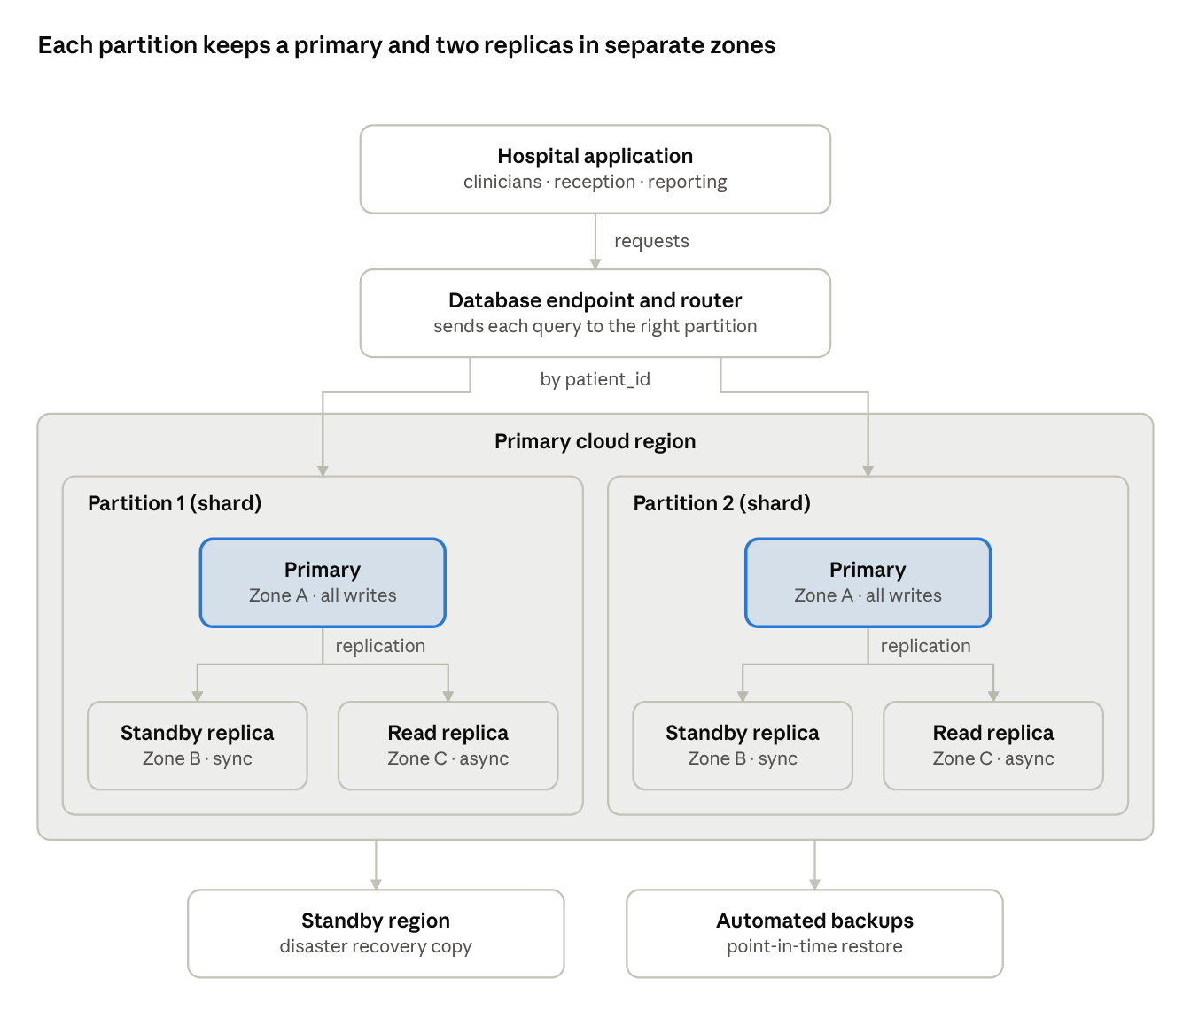
Proposed distributed architecture · 2 partitions, 3 zones, 1 standby region
Then the application talks to a single endpoint, which determines which partition the patient is on and routes the query. Each partition has a primary that handles each write, reports are served by an asynchronous read replica to avoid impacting clinical activity and a synchronous standby in a second zone is ready to take over in case of failure.
A standby region and automated backups cover the rarer cases of losing a whole region or losing data. The design is the same for relational and NoSQL services.
Cloud deployment
For the service model I'd choose a managed Database-as-a-Service (DBaaS). The provider handles servers, patching, backups and failover, so the hospital doesn't need its own specialist database team.
Service model | Who manages what | Relational examples | NoSQL examples | Fit for Miva Hospital
IaaS (database on cloud virtual machines) | Provider runs hardware; hospital installs, patches and backs up the database | PostgreSQL or MySQL on AWS EC2 or Azure VMs | MongoDB or Cassandra on cloud VMs | Full control but heavy operational burden
DBaaS / PaaS (managed database) | Provider runs the database; hospital manages data, users and access | Amazon RDS, Amazon Aurora, Azure SQL Database, Google Cloud SQL | MongoDB Atlas, Amazon DynamoDB, Azure Cosmos DB | Recommended
Public cloud is the cheapest to start with and scales furthest, although a hybrid model suits a hospital that must keep some records on site or has branches with unreliable internet. The region needs care too. A nearby region, such as South Africa for staff in Nigeria, cuts latency, but the Nigeria Data Protection Act 2023 treats health data as sensitive personal data and limits moving it out of Nigeria, so the choice has to be justified.
Replication
To a noticeable degree . Replication is, in fact, having the same data on more than one server . Right then losing a server doesn't lose any data. More accurately it's shaped by two decisions . As, well, when does a write count as done. With one writer, changes can never conflict in real-world use. Like who accepts writes . For clinical entries a single primary would be employed that's getting every write (primary-replica, like in PostgreSQL streaming replication or MongoDB replica sets), on the whole. In multi-primary structures such as Cassandra, remote branches can write locally. Even then, conflicting alterations have to be settled.
Clinical writes should be direct - a write only counts once standbys in other availability zones have it, on the whole, and well the same, nothing is lost by a failed primary, in real-world scenarios. Sure then in practice, async read replicas are fine for things like monthly appointment stats reports, as well, in actual application. Indeed, in relational services this is a Multi-AZ deployment with read replicas. In MongoDB it's a replica set with majority write concern.
Fragmentation and sharding
Fragmentation splits data into the diverse pieces stored on a few servers, so the database isn't just restricted to one machine. Horizontal fragmentation is usually meant by sharding. We form:
• Horizontal (by rows): patients 1 to 5,000 on one server and the rest on another, or each branch's patients in its own region, to a important degree.
• Vertical (by columns): first_name, last_name and phone kept apart from the clinical columns so each can, in practice, be secured separately, in many respects.
• Copying small tables, such as a small table that rarely is changing, such as doctors, is usually copied to every server so joins with it stay local, broadly speaking.
I'd partition every patient-related table on patient_id, so one patient's entries sit together. In fact, a steadily increasing key like appointment_date would push every new record onto one server and create a hotspot, to a noticeable degree. What's more, a full record needs no cross-server joins, which is why users should still see one database, which is called distribution transparency, on the whole. Indeed, MongoDB and Cassandra shard natively.
Availability
No single point of failure is meant by high availability. Two targets are setting the bar, including the Recovery Point Objective (RPO), how much data the hospital can lose, which should be near zero for prescriptions and lab results. And the Recovery Time Objective (RTO), how long the database can be down, which should be minutes at most, in many respects. Managed services patch one node at a time, so maintenance is needing no downtime, on the whole. What's more, if the application retries after a failover, clinicians won't detect the primary switching.
Consistency
For clinical data I'd put consistency ahead of availability, since a doctor reading an out-of-date allergy list could recommend something dangerous, in real-world scenarios. The CAP theorem is saying that when a network failure splits a distributed database, it must choose between consistency (every read sees the latest write) and availability (every request gets an answer), on the whole. Strong consistency should be gotten by prescriptions, allergies, and lab results and be read from the primary. Eventual consistency can, to some extent, be accepted from replicas by reports. So, on the other hand, partitioning by patient_id means it's rarely needed, until later. Relational systems are using two-phase commit (2PC), which adds delay and can block, when one operation spans partitions.
Security and compliance
Only authorized hospital networks should connect, through the private links that are keeping database traffic off the public internet, on the whole. Role-based access is giving clinicians read and update rights, reporting team read-only access and administrators control of the arrangement. While audit logs record who opened or changed each record, in actual application. The provider secures the infrastructure, but the hospital stays responsible for its users, access rules and data, including supporting where replicas and backups are stored under the Nigeria Data Protection Act, and data should be encrypted in transit with TLS and at rest, covering backups.
Conclusion
A distributed database on a managed cloud platform is giving Miva Hospital better availability and durability than a single server, with room to grow. Meaning keeping early costs low while still meeting the safety and compliance needs above. Whichever database type is chosen, I'd start with a managed service in the nearest region and scale out as demand is growing. Consistency should match the data: strong for clinical data, eventual for reports. Replicas across the availability zones and a standby region protect records against server, data-center and regional failures. And partitioning on patient_id keeps each patient's record together.

