PART 1:

- All heroes aged 18 or older, oldest first.

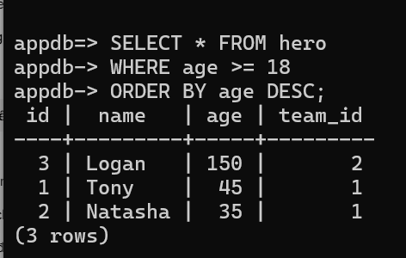

- Each hero's name next to their team's name (heroes without a team must also appear).
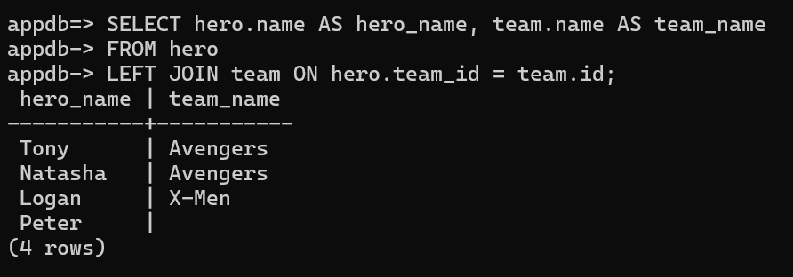

- The number of heroes per team.
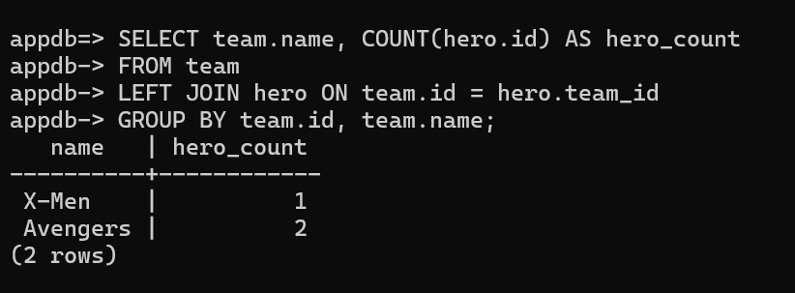

- The 2nd page of heroes when a page has 2 rows, ordered by id

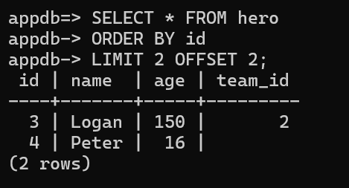

PART 2:

Question 1. For each of the four statements, which constraint blocked it ( PRIMARY KEY , UNIQUE , NULL , FOREIGN KEY ) and why?

- Command 1 (INSERT INTO team... 'Avengers'): Blocked by a UNIQUE constraint. The value 'Avengers' already exists in the `name` column of the `team` table, violating the column's requirement for unique data.
- Command 2 (INSERT INTO hero... team_id = 99): Blocked by a FOREIGN KEY constraint. The value `team_id = 99` does not exist in the `team` table; therefore, the `hero` table cannot reference non-existent data.
- Command 3 (INSERT INTO hero (age) VALUES (30)): Blocked by a NOT NULL constraint. The statement fails to provide a value for the `name` column, resulting in a null value (missing data) that violates the requirement for the column to contain data.
- Command 4 (DELETE FROM team WHERE id = 1): Blocked by a FOREIGN KEY constraint. The record with `id = 1` in the `team` table is currently referenced by records in the `hero` table; the database blocks this deletion to prevent the creation of "orphaned" records in the `hero` table.

Question 2. The relationship team → hero is one-to-many. Why is the foreign key on NOT hero and not on team ?

- In a one-to-many relationship (where one team has multiple heroes), each hero record belongs to at most one team; therefore, a single `team_id` column suffices to store the value. If the foreign key were placed in the `team` table, each cell in a team record would have to store a list of multiple hero IDs, which violates a fundamental principle of relational databases (that each row-column intersection must contain only a single atomic value).
Question 3. Heroes can go on many missions and a mission has many heroes (many-to-many). Sketch the tables you need (names, columns, PK, FK). Hint: you need a link table.

- To handle the many-to-many relationship between heroes and missions, we need to use an intermediary table (link table). The structure will consist of the following: a `hero` table with a primary key (PK) of `id`; a `mission` table with a primary key (PK) of `id` and informational columns such as `title`; and an intermediary table named `hero_mission_link`, which serves as the connector using two foreign key (FK) columns: `hero_id` (referencing `hero.id`) and `mission_id` (referencing `mission.id`). The primary key (PK) for this intermediary table will be a composite primary key formed by combining both of the aforementioned foreign key columns.

Question 4: Why read the URL from an environment variable instead of writing it in database.py? Give two reasons.

- There are two main reasons for reading the URL from an environment variable instead of hardcoding it into the `database.py` file: Security—avoiding hardcoding credentials (such as the application username and secret password) in the source code prevents the risk of exposing sensitive data when sharing the code or pushing it to repositories like GitHub. Flexibility—the application can easily switch connections between different databases (e.g., from a local development machine to a production server) simply by changing the external environment variable, without needing to modify the code itself.

PART 3:

Question 5: Why is id typed int | None with default=None , when every row in the database has an id?

- In SQLModel (and SQLAlchemy), before an object (such as a new hero) is saved—or committed—to the database, it does not yet exist in the database and therefore lacks an ID. Declaring it as `None` allows us to create the object in Python memory without encountering errors. Only after the object is `INSERT`ed into PostgreSQL is the ID automatically generated and assigned back to the object.

Question 6: Which attributes of Hero become columns, and which one does not? What is back_populates for?

- Attributes representing basic data—such as `id`, `name`, `age`, `secret_name`, and `team_id`—will become actual columns in the PostgreSQL database table. The `team` attribute (defined using the `Relationship` function) will not become a database column; instead, it serves as an ORM (Object-Relational Mapping) tool that allows us to easily access team information directly from a `hero` object within Python. The `back_populates="heroes"` parameter links this relationship to the `heroes` attribute in the `Team` table, enabling SQLModel to understand that both attributes refer to the same one-to-many relationship.

PART 4:

Question 7. Compare the CREATE TABLE hero printed by SQLAlchemy with the one you wrote by hand in Part 1. List the differences (types, NOT NULL , indexes, constraints).
- SQLAlchemy automatically optimizes and adds further details. It creates `NOT NULL` constraints for required columns, defines primary keys, specifies data types precisely according to the PostgreSQL dialect, and automatically generates indexes—using the `CREATE INDEX` command—for fields configured with `index=True` (such as the `name` fields for `Team` and `Hero`) to accelerate query performance.

Question 8: Stop and restart the server. Is CREATE TABLE printed again? Why? What does create_all do when a table already exists?
- The CREATE TABLE command will no longer be printed. This is because the `create_all` function includes an existence check (an "if not exists" mechanism); if it detects that the `hero` and `team` tables already exist in the database, it skips the operation and takes no action, thereby preserving the existing data.

Question 9: create_all only knows about models that have been imported. Which line in main.py makes sure Hero and Team are registered?
- It is the line `from app.models import Hero, Team` at the beginning of the `main.py` file. This import statement invokes the classes defined with `table=True`, thereby registering them with `SQLModel.metadata` before the `create_all` function is called.

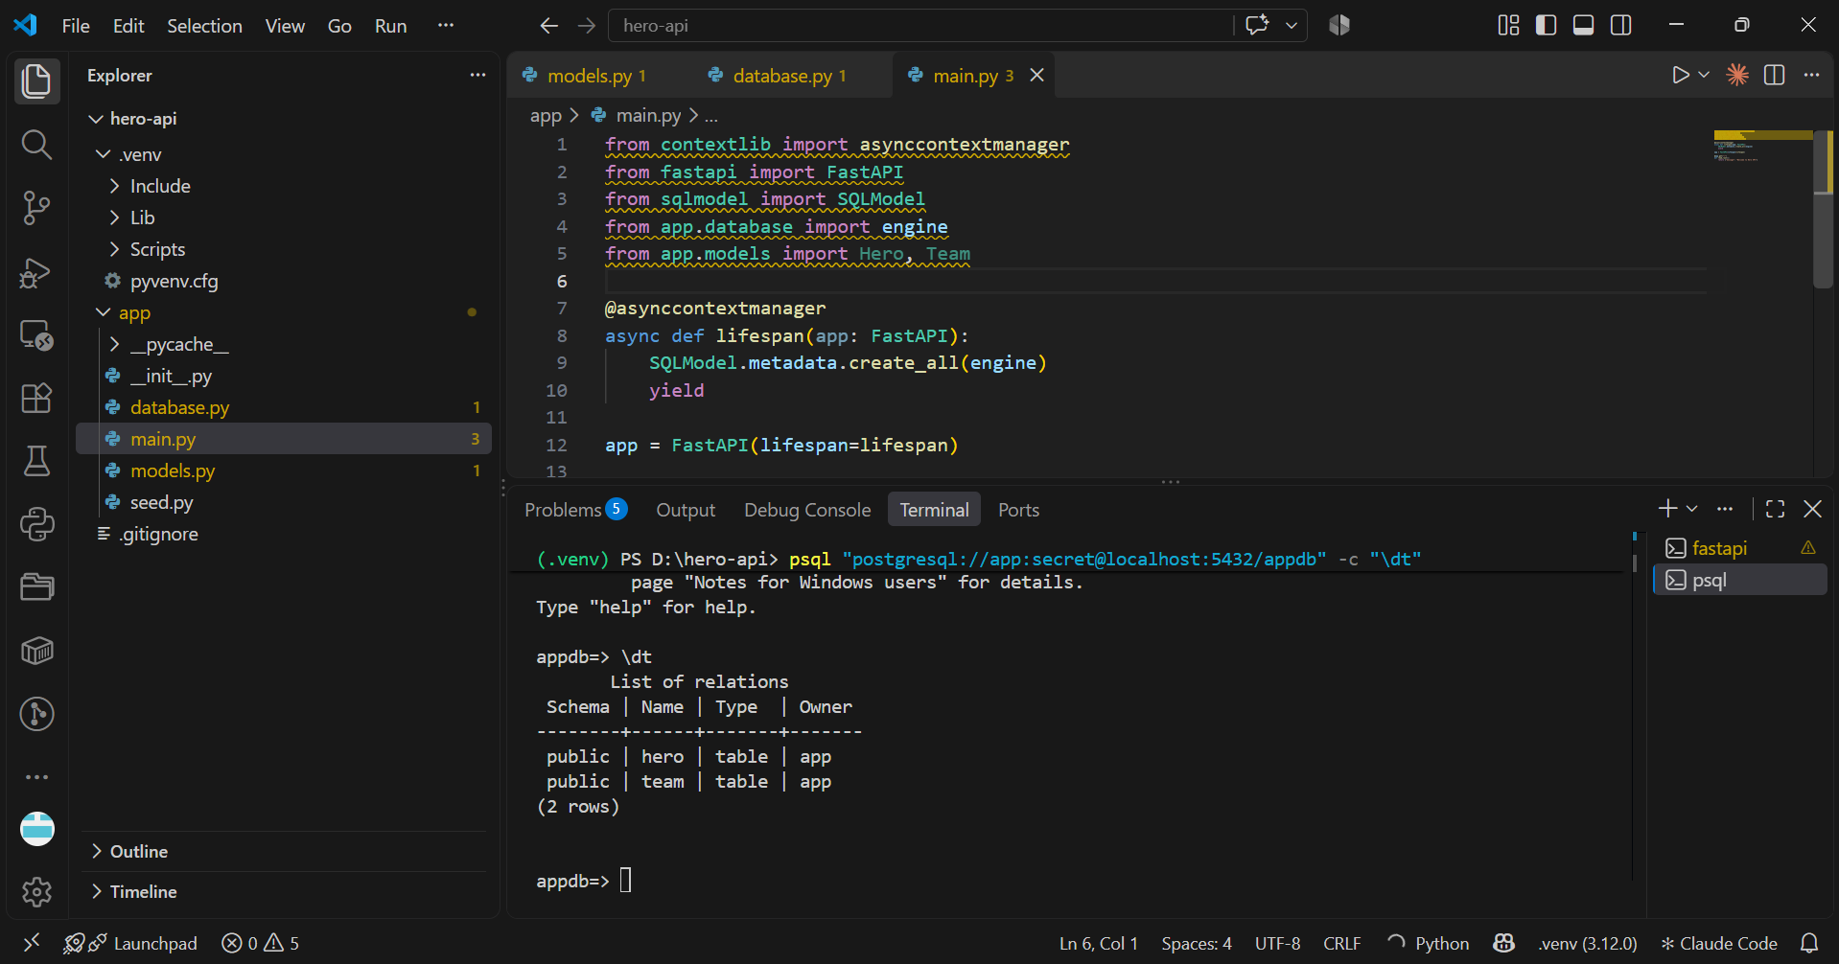

Question 7. Compare the CREATE TABLE hero printed by SQLAlchemy with the one you wrote by hand in Part 1. List the differences (types, NOT NULL , indexes, constraints).
- The difference: When using SQLAlchemy/SQLModel, the table creation commands are far more detailed and automatically optimized compared to the manual approach in Part 1. Specifically: Types & Constraints: SQLModel automatically infers and adds `NOT NULL` constraints for mandatory columns (such as `secret_name`) and automatically sets the primary key (`PRIMARY KEY`) using the `SERIAL` type for the `id` column. Indexes: SQLModel automatically generates `CREATE INDEX` statements for fields defined with `index=True` (such as the `name` column in the `Hero` and `Team` tables), thereby optimizing future search performance. This feature was entirely absent from the handwritten SQL in Part 1.1.

Question 8. Stop and restart the server. Is CREATE TABLE printed again? Why? What does create_all do when a table already exists?
- Logging status: The `CREATE TABLE` command will no longer be printed. Reason: SQLAlchemy's `create_all` function operates similarly to the "IF NOT EXISTS" syntax. Upon server startup, it scans the database; if it detects that tables (e.g., `hero`, `team`) already exist, it automatically skips them and refrains from executing any table creation commands, thereby preserving existing data.

Question 9. create_all only knows about models that have been imported. Which line in makes sure Hero and Team are registered?
- The necessary line of code: The ability of `create_all` to recognize and create tables depends entirely on the model classes having been loaded into memory beforehand. The line of code that accomplishes this in `main.py` is the import statement for the model classes from the `models` module, typically written as: `from app.models import Hero, Team`.

Part 5:

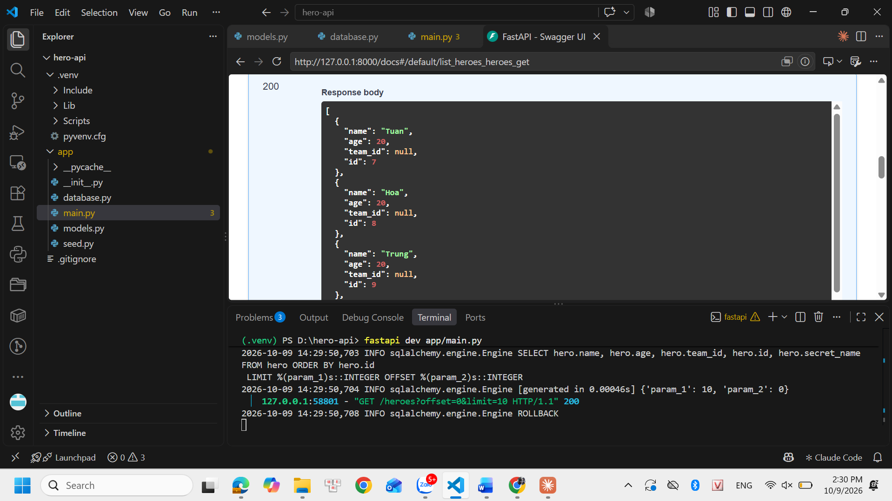

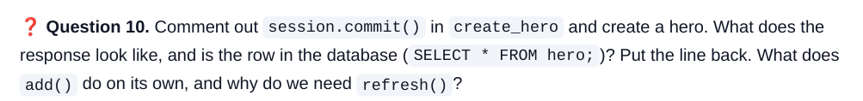

- Behavior: If we comment out the `session.commit()` line, the API still returns the hero information, but the `id` field is `null`. When checking PostgreSQL with the command `SELECT * FROM hero;`, we will not see any newly saved data rows. Explanation of `add()`: The `session.add(obj)` function merely places the object into SQLAlchemy's tracking buffer; it does not generate an `INSERT` statement to write to the database. We must call `commit()` to finalize the transaction. Explanation of `refresh()`: The `session.refresh(obj)` function queries the database and synchronizes the latest data with the Python object. Its primary purpose is to retrieve the primary key (`id`) value—automatically generated by PostgreSQL after the commit—so it can be returned to the user.

- SQL Output: The system generates a statement in the format `UPDATE hero SET age=? WHERE id=?`. Update Scope: It updates only the `age` column; other columns such as `name` or `secret_name` remain unchanged. Reason: This behavior is achieved via the `hero_in.model_dump(exclude_unset=True)` command in the PATCH handling logic. The `exclude_unset=True` parameter instructs Pydantic to extract only the fields actually submitted in the client request, ignoring any fields that were not included.
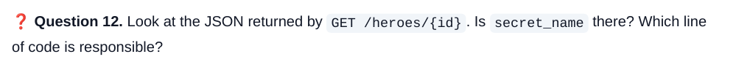
- Result: The returned JSON completely lacks the `secret_name` field. The code responsible: This security measure is determined by the `response_model=HeroPublic` declaration in the decorators (e.g., `@app.get(...)` or `@app.post(...)`). Since the `HeroPublic` model—defined in Part 3—does not include the `secret_name` attribute, FastAPI automatically filters this sensitive field out of the table object before converting it to JSON.

Part 6:

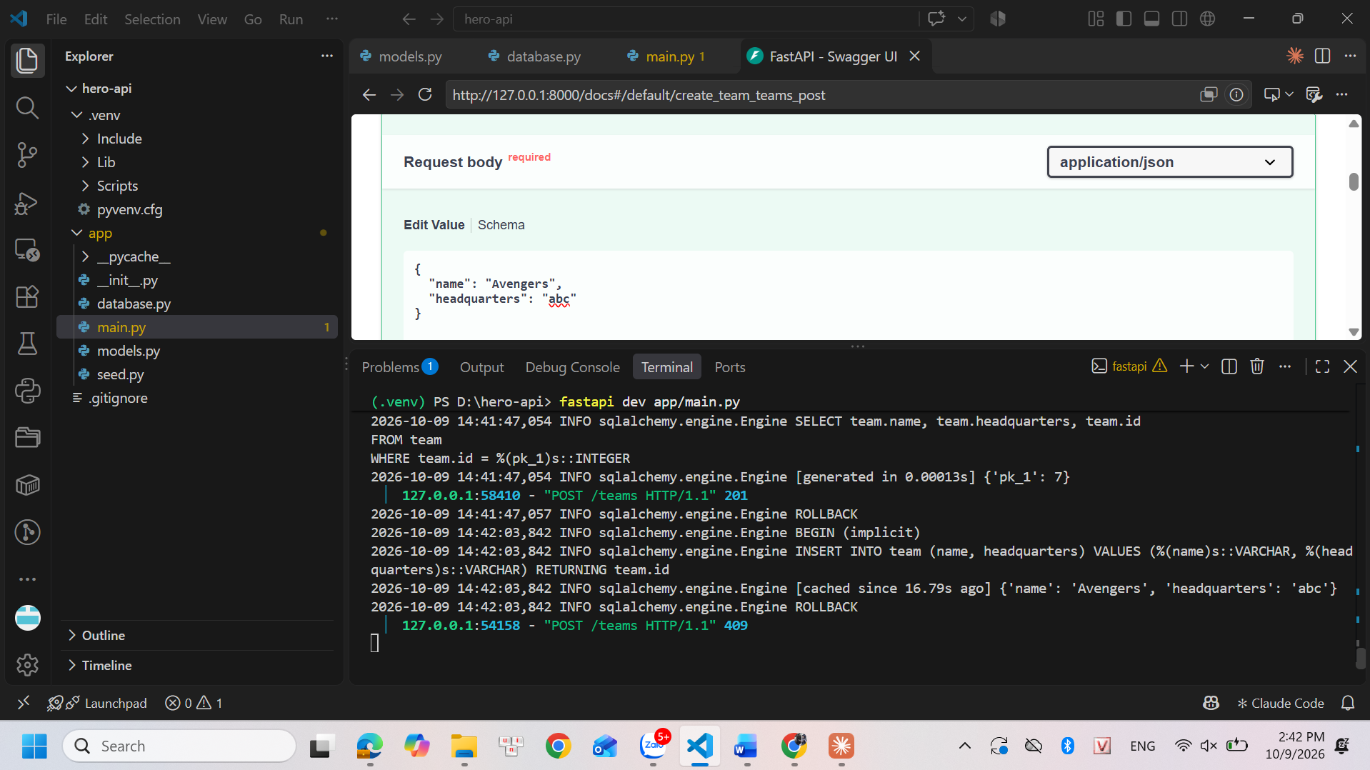

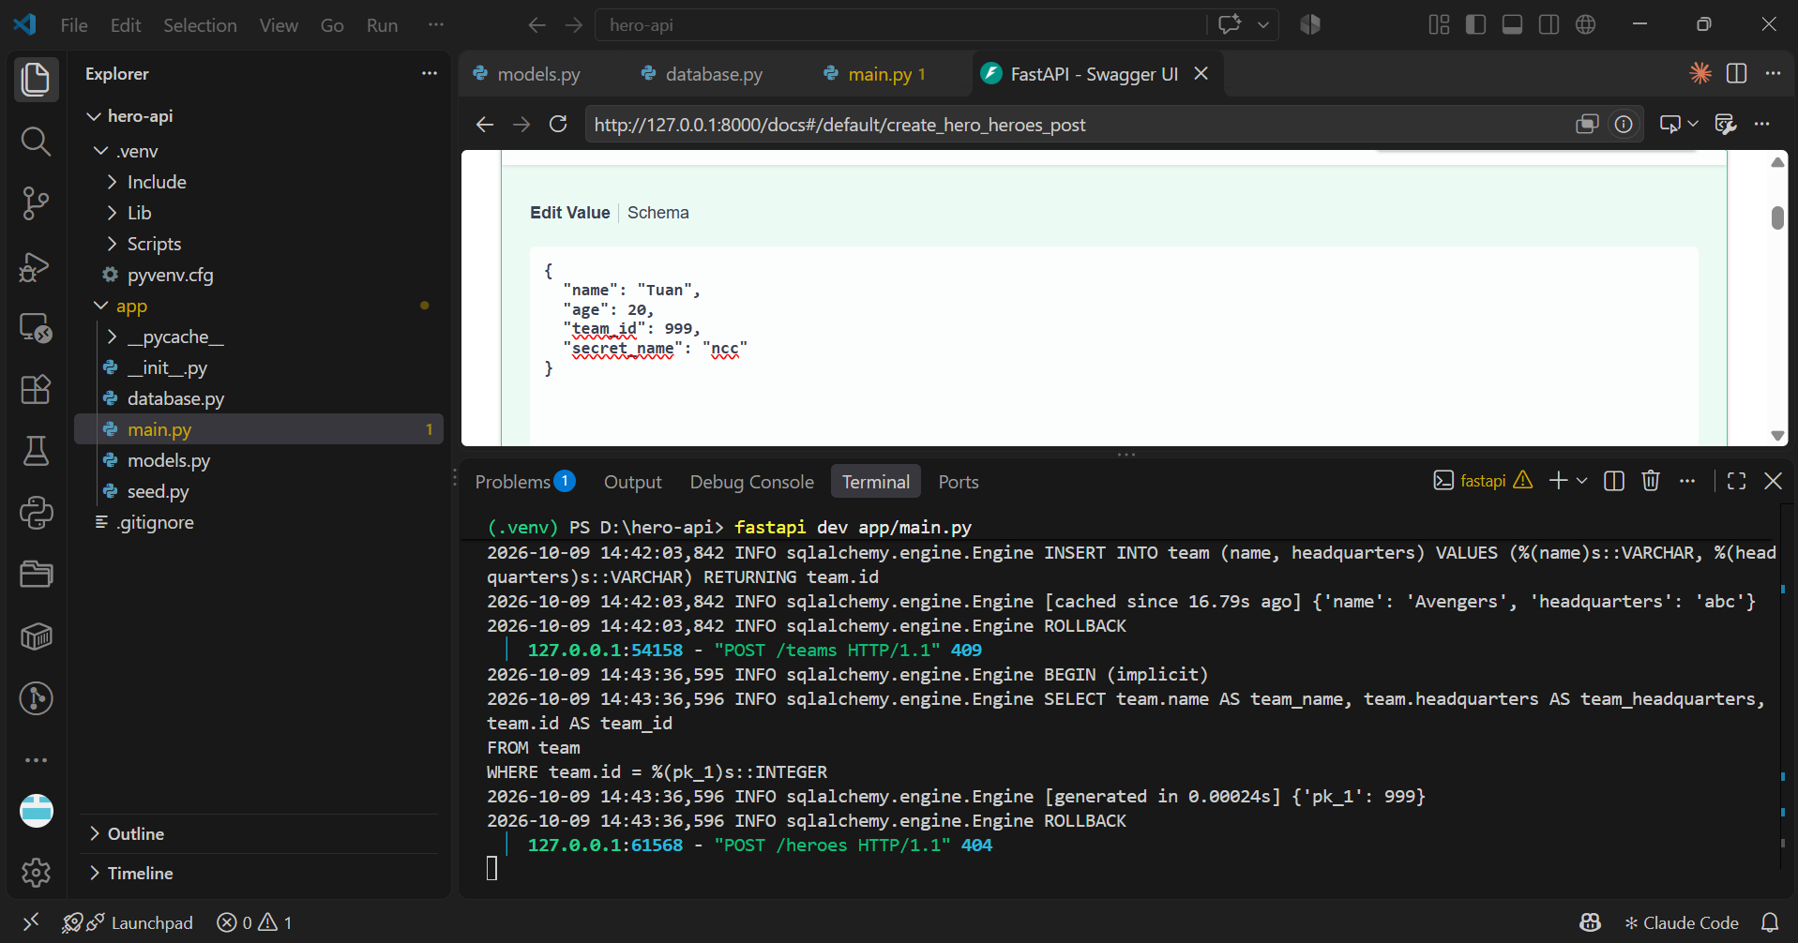

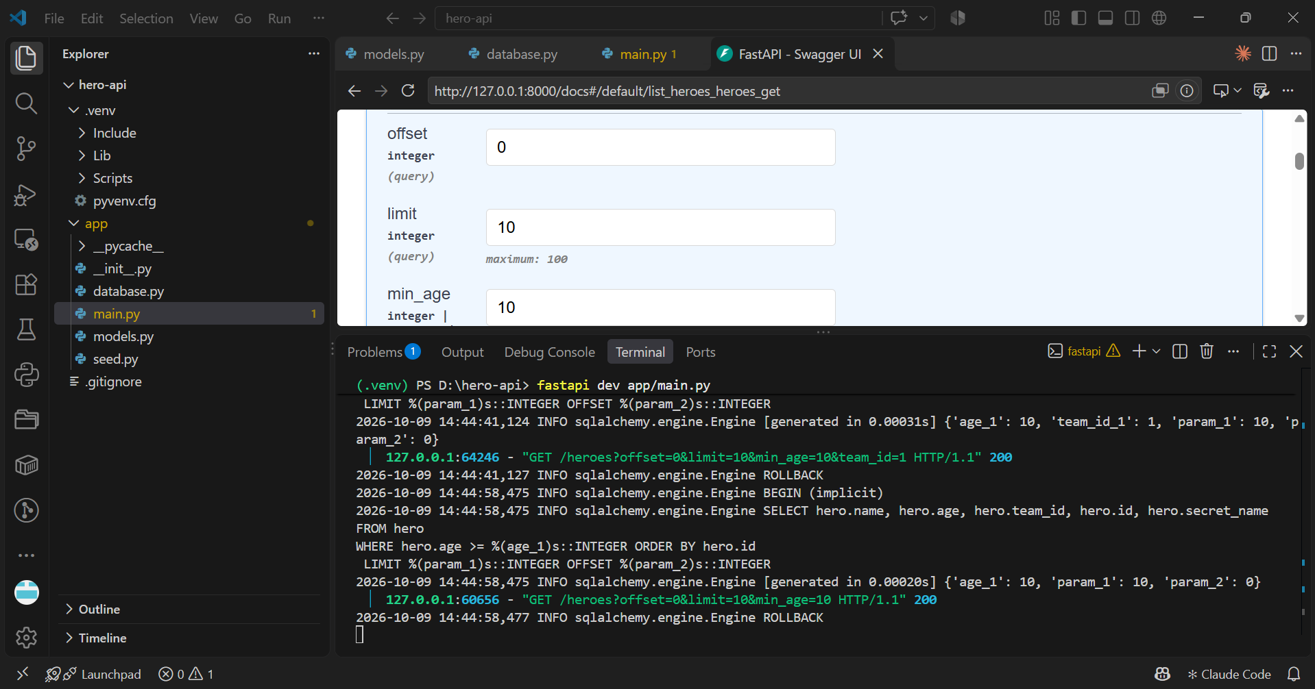

Question 13. Call GET /heroes?min_age=18&team_id=1 and copy the SELECT printed by echo=True. Where do the values 18 and 1 appear? Why is this safe against SQL injection?

- Appearance: In the terminal, we will see the printed SQL command in a format like `SELECT ... WHERE hero.age >= %(age_1)s AND hero.team_id = %(team_id_1)s`. The actual values—18 and 1—do not appear directly within the `SELECT` string itself. Instead, they appear separately on the line immediately following the log output (a process known as parameter binding): `[cached since Xs ago] {'age_1': 18, 'team_id_1': 1}`.

- Security: This mechanism is known as a parameterized query. SQLAlchemy does not directly concatenate user input into the SQL command; instead, it sends the command template (containing placeholders like `?` or `%(name)s`) and the associated values ​​to PostgreSQL as two separate components. Consequently, even if a hacker attempts to inject malicious code via the URL (SQL Injection), the database treats the input merely as a plain data string, rendering it completely harmless.

Question 14. Why filter in the database instead of [h for h in session.exec(select(Hero)).all() if h.age >= 18]?

- Performance and Bandwidth: Using a list comprehension causes PostgreSQL to read the entire `hero` table from disk and transmit thousands—or even millions—of records over the network to the Python server's RAM, only for Python to subsequently filter out and discard the vast majority of them.

- Filtering with `.where()` directly within the database is far more efficient because PostgreSQL is specifically optimized for this task (leveraging indexes). It retrieves only the relevant rows and transmits a minimal amount of data over the network for Python to process further.

Part 7:

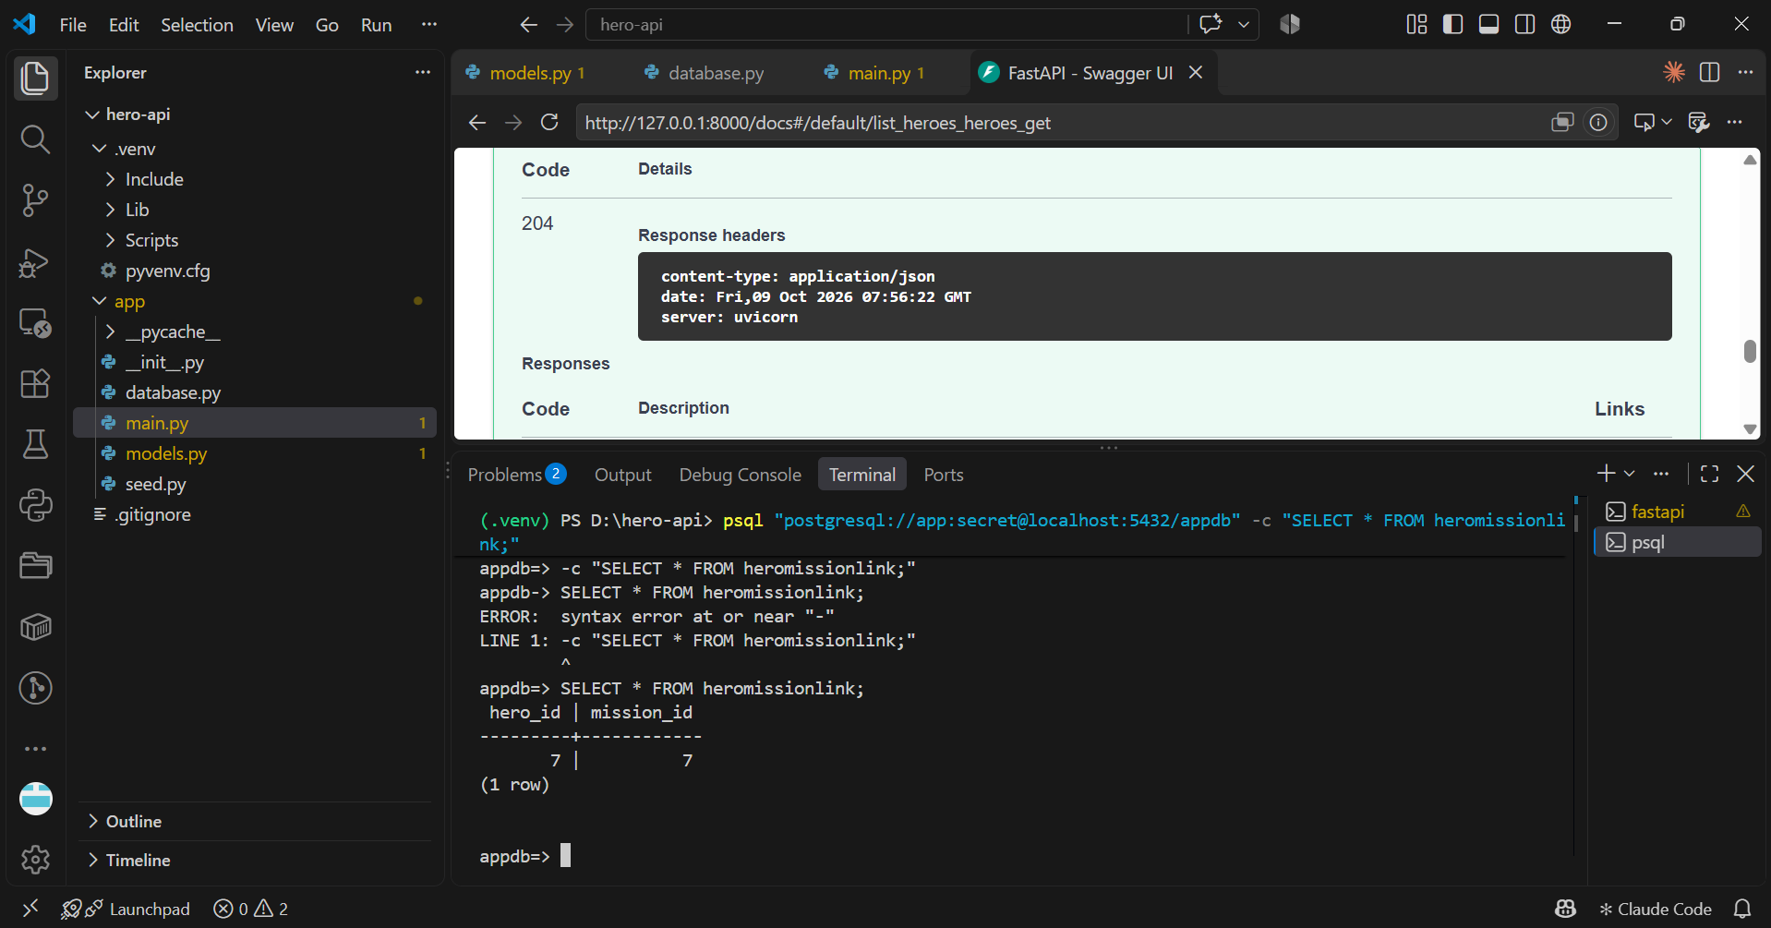
Question 15. On restart, create_all did create mission and nothing for hero . What is the rule?

- The core rule of SQLAlchemy's `create_all` function is that it only creates tables that do not yet exist in the database. When we define the new `Mission` and `HeroMissionLink` tables in our code, PostgreSQL does not yet contain them, so `create_all` issues `CREATE TABLE` commands to generate them. However, since the `hero` table was already created in Part 4 and remains in the database, `create_all` automatically skips it to preserve the existing data within that table.

Part 8:

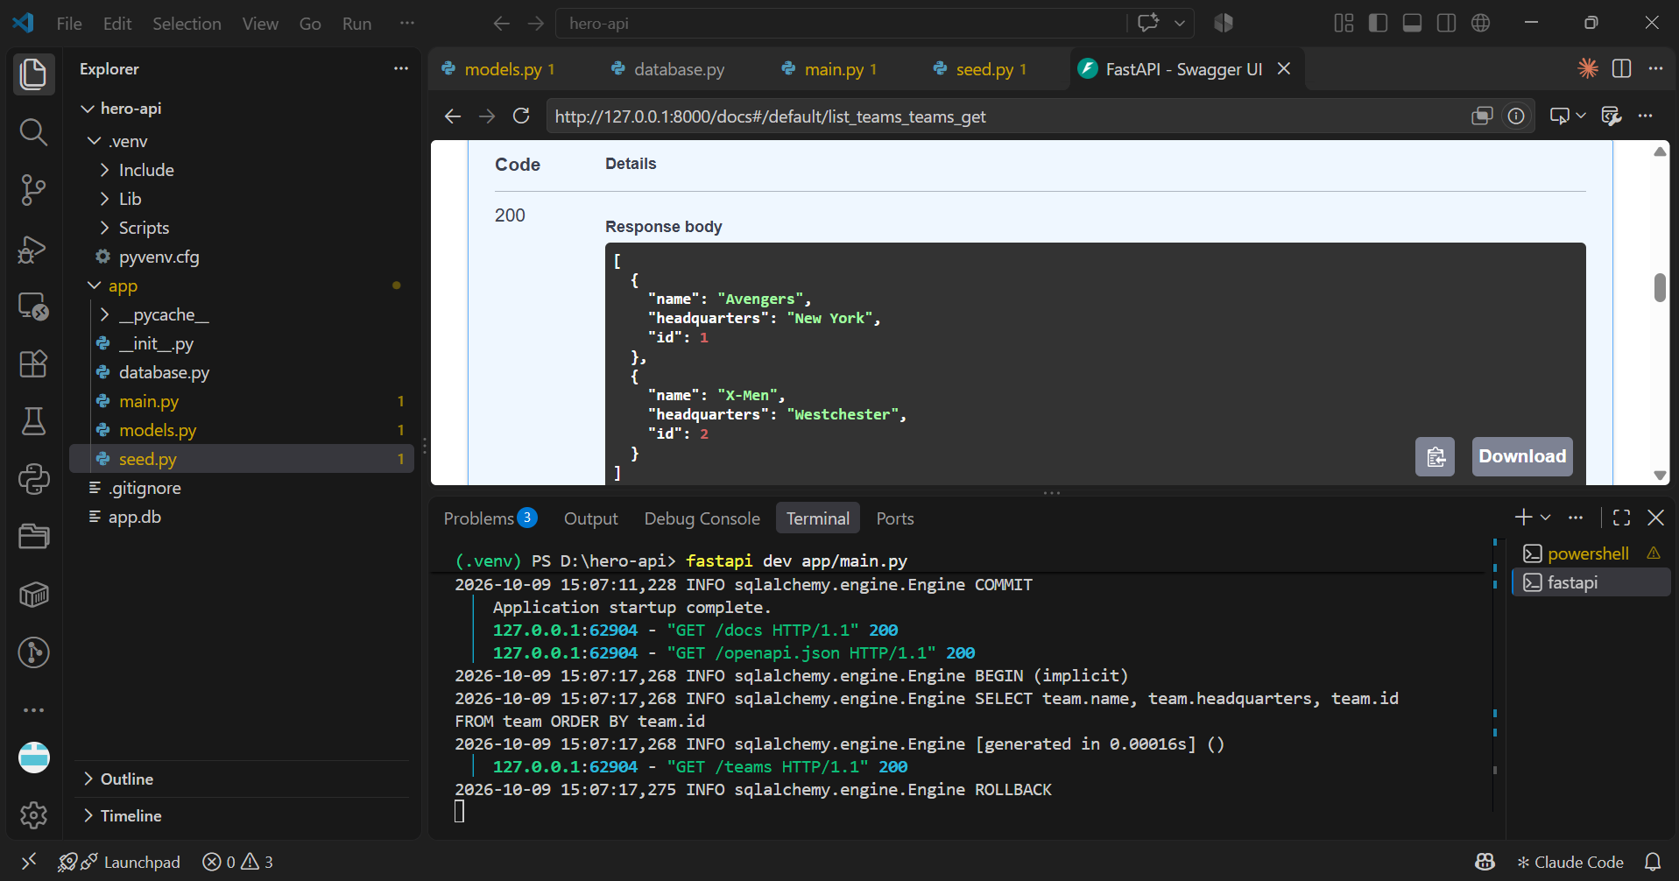
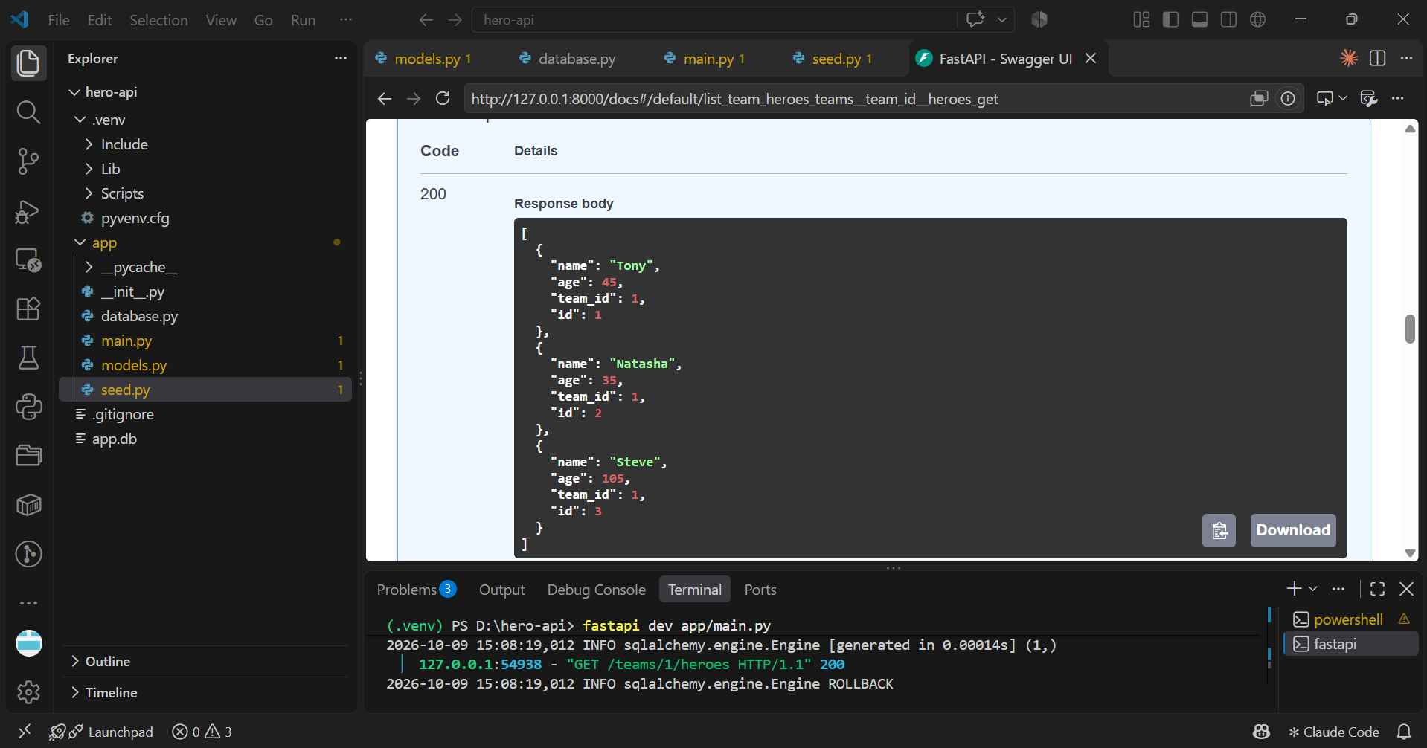
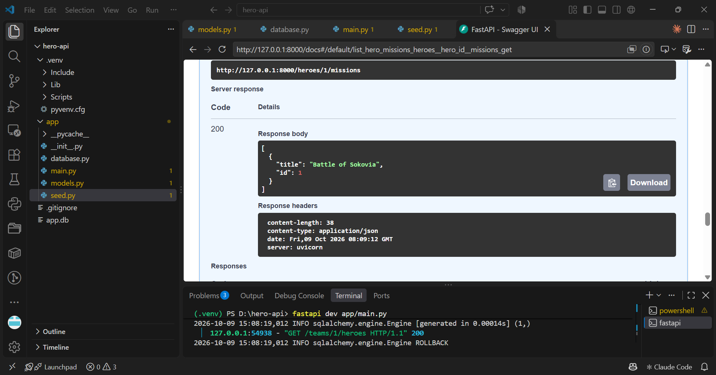

Question 16. You never set team_id in the seed script. Read the echo=True output: in which order were the INSERT s executed, and how did hero.team_id get its value?

- When the `session.commit()` method is called, the execution order of the INSERT statements proceeds as follows:

- SQLAlchemy first inserts data into the `team` and `mission` tables, as these are independent parent tables; PostgreSQL automatically generates and returns the primary keys (IDs) for them.

- SQLAlchemy automatically retrieves these newly assigned IDs and assigns them to the corresponding `team_id` and `mission_id` fields of the `Hero` objects currently held in RAM.

- Finally, the system executes the INSERT statements for the `hero` table and the `heromissionlink` association table, ensuring the validity of all foreign keys.

Part 9:

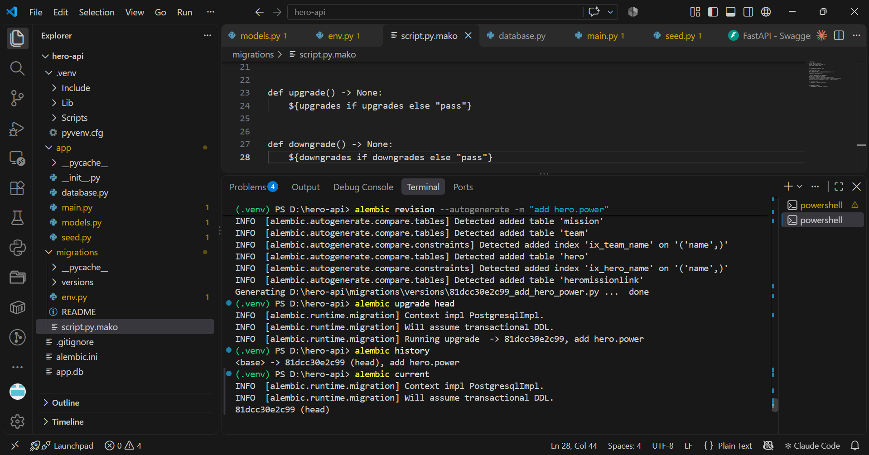

Question 17. Is there a power column? Now call GET /heroes . What happens and why? Why is "drop all tables and run create_all again" not an acceptable fix in production?

- After adding `power: str | None = None` to `HeroBase` and restarting, the `power` column does not appear in PostgreSQL (when running `\d hero`). When calling `GET /heroes`, the API returns an error (usually a 500) because the Python code attempts to select the `power` column, but it does not exist in the database. "Dropping all tables and running `create_all` again" is not an acceptable approach in a production environment, as it would wipe out all customer data.

Question 18. Copy the bodies of upgrade() and downgrade() . What does each one do?

- upgrade(): Contains the command to add a new column—for example, `op.add_column('hero', sa.Column('power', sqlmodel.sql.sqltypes.AutoString(), nullable=True))`. This function is responsible for advancing the database to the new version. downgrade(): Contains the command to remove that column—for example, `op.drop_column('hero', 'power')`. This function is used to revert the database to the previous version (rollback) in the event of an error.

Question 19. Where does Alembic store "which revision this database is at"? (Hint: \dt .) Why should the migrations/ folder be committed to Git?

- Alembic tracks the current database version in an automatically created table named `alembic_version` (which can be seen when running `\dt`). The `migrations/` directory must be committed to Git so that other team members (or the server during deployment) can synchronize their databases to match the latest code structure using the `alembic upgrade head` command.

Question 20. Rename secret_name to alias in the model and run revision --autogenerate (do not apply it). What did Alembic generate? Why is that dangerous for existing data, and how would you fix the script? Afterwards, delete that revision file and undo the rename.

- When renaming a column from `secret_name` to `alias`, Alembic does not recognize it as a rename operation. Instead, it generates an `upgrade()` script containing two commands: dropping the `secret_name` column and adding a new `alias` column. This is extremely dangerous because all data in the original `secret_name` column would be lost. The safe way to handle this is to open the revision file, remove those two lines, and replace them with a single rename command: `op.alter_column('hero', 'secret_name', new_column_name='alias')`.

