1.

**package** Single;

**import** java.util.HashSet;

**import** java.util.Set;

**public** **class** Employee {

**private** **int** empId;

**private** String empName;

**private** **int** empSalary;

**private** String empdepartment;

**public** Employee(**int** empId, String empName, **int** empSalary, String empdepartment ) {

**super**();

**this**.empId = empId;

**this**.empName = empName;

**this**.empSalary = empSalary;

**this**.empdepartment = empdepartment;

}

**public** **final** **int** getEmpId() {

**return** empId;

}

**public** **final** **void** setEmpId(**int** empId) {

**this**.empId = empId;

}

**public** **final** String getEmpName() {

**return** empName;

}

**public** **final** **int** getempSalary() {

**return** empSalary;

}

**public** **final** **void** setempSalary(**int** empSalary) {

**this**.empSalary = empSalary;

}

**public** **final** String getEmpdepartment() {

**return** empdepartment;

}

**public** **final** **void** setEmpName(String empName) {

**this**.empName = empName;

}

**public** **static** **void** main(String[] args) {

Set<Employee> employees = **new** HashSet<>();

employees.add(**new** Employee(1, "Raj", 10000, "Science"));

employees.add(**new** Employee(1, "Pradeep", 20000, "Social"));

employees.add(**new** Employee(1, "Kumar", 30000,"maths"));

employees.add(**new** Employee(2, "Chandan", 40000,"hindi"));

employees.add(**new** Employee(2, "Amitava", 50000,"english"));

System.***out***.println(employees);

}

}

2. Hashmap to display 10 value as keys

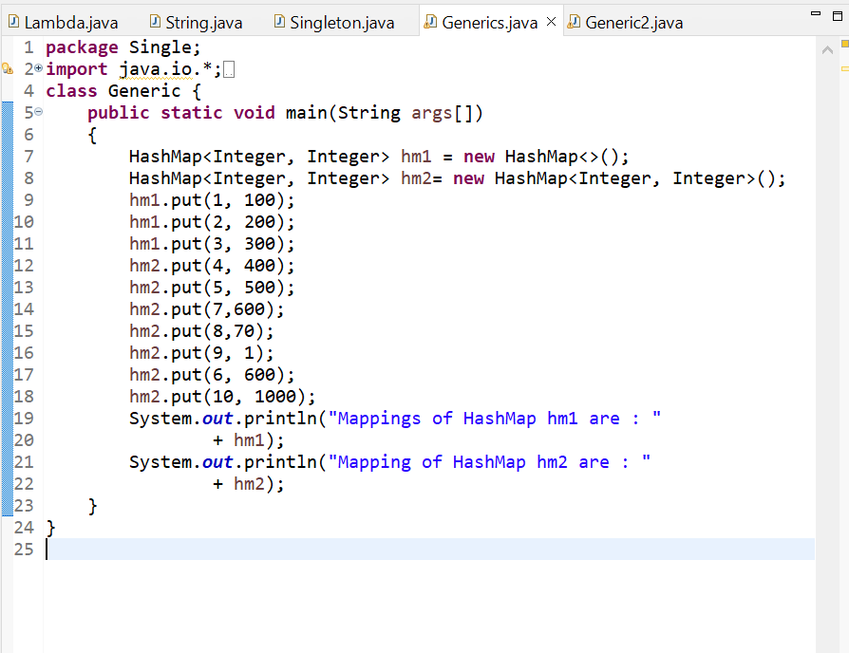

3.

